Contents

Pre setups: 1

Tools installed: 1

Step 2: Start the Appium Server 4

Step 3: Define Desired Capabilities for Your Device and App 4

Step 4: Write the Automation Script Using Appium: automate page navigation through buttons such as **“Get Started”** 4

Step 5: Running and Verifying the script 4

# Pre setups:

1. For automating the page navigation within the **Norton VPN app** using **AI-powered navigation** and **Appium**.

## Tools installed:

1. **Appium**: mobile application automation tool to work with Android
2. **Python**: To write the automation script.
3. **OpenCV** (optional for AI-based image recognition): To dynamically detect visual elements if they cannot be located using traditional locators

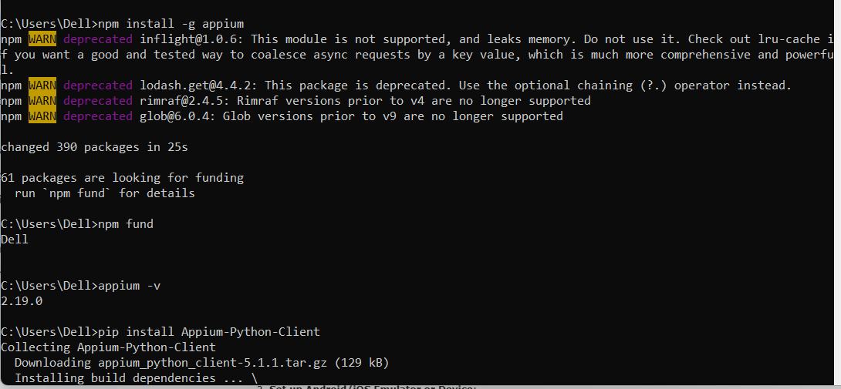

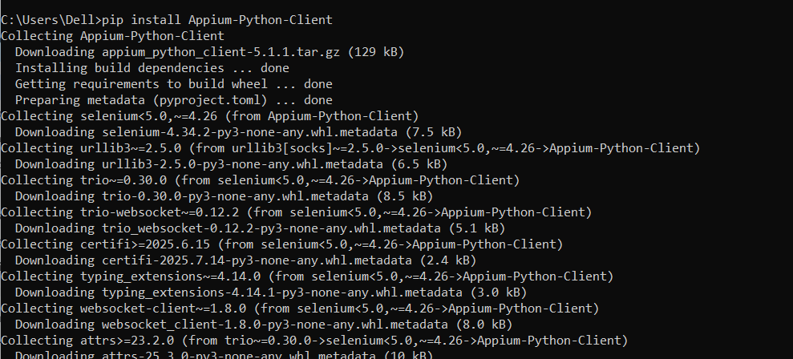

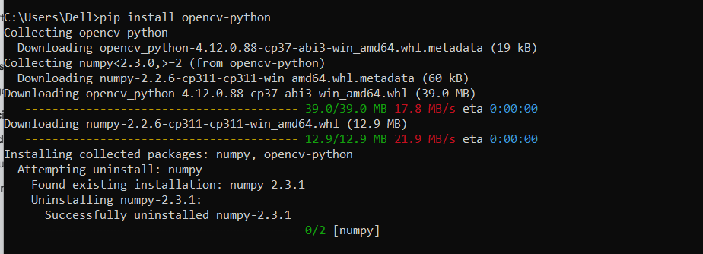

1. Change phone to debugging mode
2. Install UIautomator2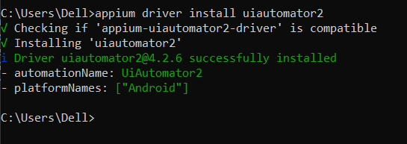
3. Add path in env variable

In the **System Properties** window, click **Environment Variables**.>Under **System variables**, find Path and click **Edit**> Click **New** → paste:

1. Adb devices – makes sure connected

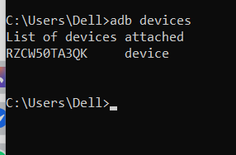

1. Appium Inspector to inspect element

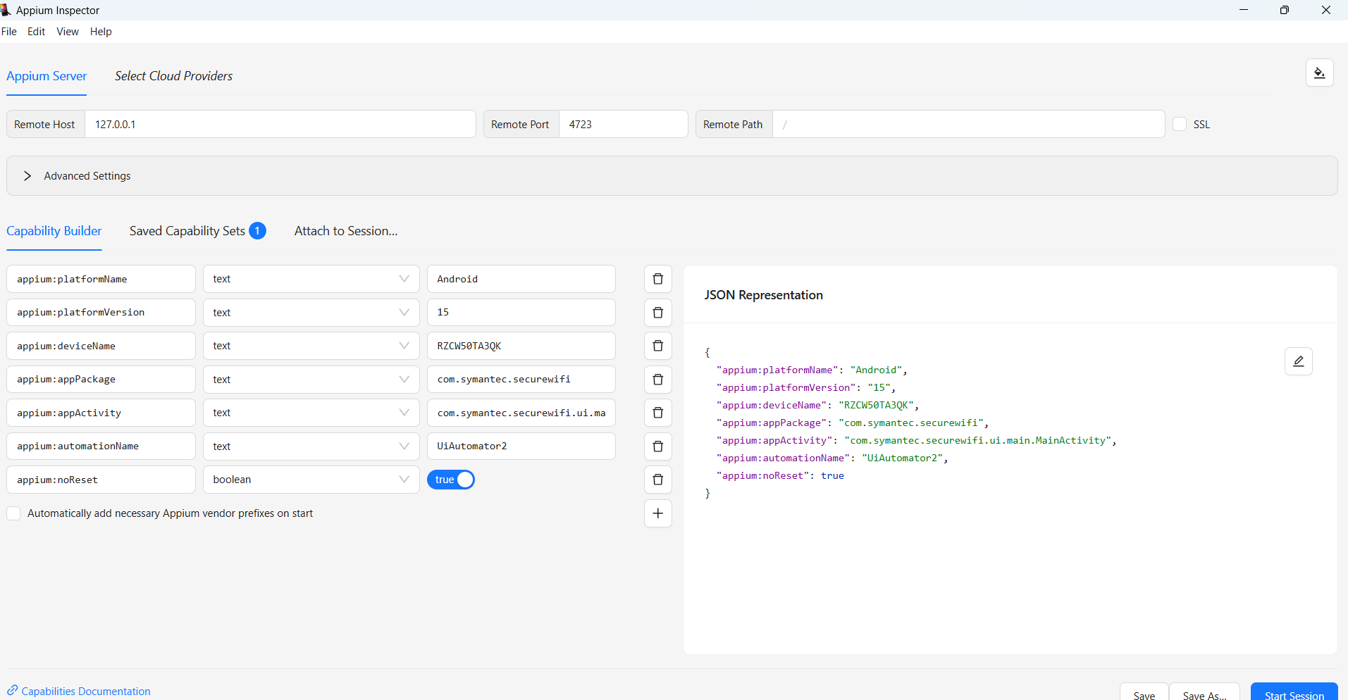

1. Install SAMSUNG_USB_Driver_for_Mobile_Phones_v1.9.0.0.exe
2. Setup platform-tools-latest-windows (2).zip
3. Setup android-studio-2025.1.1.14-windows.exe
4. Setup UniversalAdbDriverSetup.msi
5. Setup scrcpy-win64-v3.3.1.zip
6. Setup Appium-Inspector-2025.7.1-win-x64.exe
7. Start Appium via CMD
8. Start scrcpy to connect mobile screen in windows machine

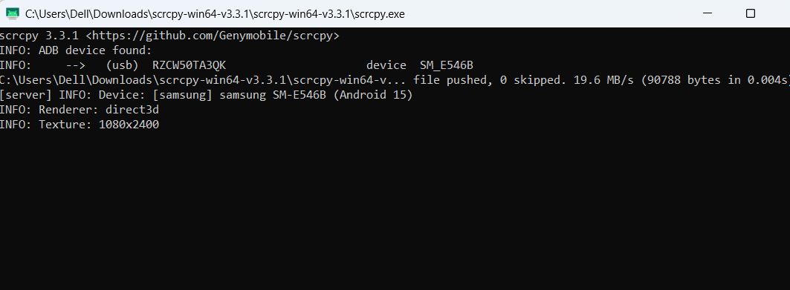

1. Execute script and view progress via scrcpy connect

## Step 2: Start the Appium Server

## Step 3: Define Desired Capabilities for Your Device and App

## Step 4: Write the Automation Script Using Appium: automate page navigation through buttons such as “Get Started”

1. refer fer [getstarted.py](https://github.com/jollyjerinjoy/AITask/blob/main/getstarted.py)

|  |  |
| --- | --- |
| 1. [Appium_Automate_Get started button_Recording.mp4](https://github.com/jollyjerinjoy/AITask/blob/main/Appium_Automate_Get%20started%20button_Recording.mp4) |  |

## Step 5: Running and Verifying the script

1. Captures the screen of the device and matches a given template image (like a button or icon) to locate its position on the screen.
2. find_element_using_image function to find and tap buttons (e.g., "Get Started",) by providing their image paths.

Step 6: future

* **Gesture-based AI**: You can use AI-based models to recognize gestures instead of using fixed locators or images.
* **Advanced Image Recognition**: can integrate a machine learning model for enhanced dynamic detection of UI elements.