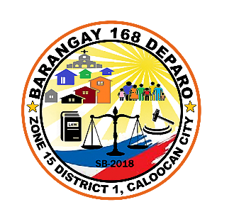

Republic of the Philippines

**CALOOCAN CITY**

**BARANGAY 168, ZONE 15, DISTRICT 1**

**DEPARO, CALOOCAN CITY**

Telephone no. 936-59-03

**TANGGAPAN NG PUNONG BARANGAY**

**HON. CRISANTA S. DEL ROSARIO**

**PUNONG BARANGAY**

**BARANGAY KAGAWAD:**

**KGD. TRISTAN JOHN A. CASTILLO**

**KGD.PHILIP DG DOMINGO**

**KGD. CHRISTOPHER M. PACHECO**

**KGD. GLORIA ASARAL ARELLANO**

**KGD. JULIUS D.R. ROQUE JR.**

**KGD. FERNANDO A. DAYA JR.**

**KGD. CECILIA L. MATIAS**

**PRECIOUS XENA L. BOLICHE  
 SK-CHAIRPERSON**

**JO SEPHINE A. MARTIN**BARANGAY SECRETARY

**FRANCIA D.R. ANDES**BARANGAY TREASURER

**CERTIFICATION**

This is to certify that **Mr./Mrs. Candy H. Carreon Jr.** is a bona fide resident of this barangay, with postal address at **63 San Pedro St., Barangay 168 Deparo, Caloocan City 1121.**

This is to further certify that **Candy H. Carreon Jr.** is the parent/guardian of:

**NAME OF CHILD**: **pampanga**

**BORN: SEPTEMBER 5, 2025**

**BORN PLACE: manila**

**MOTHER’S NAME: none**

**NAME OF FATHER: none**

This certification is being issued upon the request of the above-mentioned name for **none**.

Issued this **5th Day** of **September 2025**, at the office of the Punong Barangay, Barangay 168, Zone 15, District 1 Deparo, Caloocan City.

***Issued By:***

***JOSEPHINE A. MARTIN***

***BARANGAYSECRETARY***

***Attested By:***

***HON. CRISANTA S. DEL ROSARIO***

***PUNONG BARANGAY***

