**Icon VS Colour Reaction Test**

**Evaluation**

COSC 441 – 001

**Arjay Andal**

**Adam Delfs**

**Lluis Escolano**

**Jolo Sesbreno**

November 2024

**Table of Contents**

**Introduction & Background ……………………………………………………………………3**

**Study Design ……………………………………………………………………………………..4**

**Analysis Approach ………………………………………………………………………………8**

**Results & Discussion …………………………………………………………………………….9**

**Conclusion ……………………………………………………………………………………...13**

**Introduction & Background:**

This study evaluates the effectiveness of colour-based and shape-based visual cues in influencing reaction times, with user interface (UI) designs in mind. Efficient UIs rely on quick and accurate decision-making, especially in everyday contexts such as navigation menus, action buttons, and accessibility features. By comparing reaction times between colour and shape cues, the study aims to provide insights into optimizing visual elements for improved usability.

Inspired by the Stroop test, which demonstrates cognitive interference when conflicting visual stimuli are presented, this study explores how users respond to distinct visual cues while ignoring distractors. The results aim to inform the design of interfaces that minimize cognitive load, and provide quick and efficient user performance. By creating a controlled reaction time test, this study focuses on identifying whether colour or shape provides a more reliable basis for visual recognition in interactive tasks.

**Study Design:**

**Factors**

The study examines two primary factors:

* **Technique**:
  + **Colour-Based Cue**: Participants respond to a target colour, ignoring the shape of the icon.
  + **Shape-Based Cue**: Participants respond to a target shape, ignoring the colour of the icon.
* **Distractor Icons**: Random distractors are introduced to simulate real-world conditions where users must distinguish relevant information from irrelevant elements.

Performance is measured using two metrics:

* **Reaction Time**: The time taken by participants to correctly identify the target.
* **Error Rate**: The frequency of incorrect or missed responses.

**Techniques**

The study involves two distinct interaction techniques:

1. **Colour Test**: Participants are prompted to react to a specific target colour displayed alongside distractor shapes of varying colours.
2. **Icon Test**: Participants are prompted to react to a specific target shape displayed alongside distractor shapes of varying colours.

**Technologies Used**

The test was implemented as a web-based application using the following technologies:

* **Web-Application**:
  + Basic HTML, CSS, and JavaScript for the user interface and interactivity.
  + SVG to render all icons and shapes.
  + JavaScript was used to summarize data which was collected in CSV format for subsequent statistical analysis.
* **Analysis:**
  + CSV files were then analyzed in SPSS using techniques and methods learned in class/lab.

**Sample Run (with screenshots):**

* Greeted with 2 input areas, enter participant ID and number of trials (set by experimenter).
* Select test type, participant does both tests once.
* See instruction, then complete the test as normal.
* See summarized data, and an option to download the results and restart the test.
* Downloaded CSV shows all study factors and performance metrics.

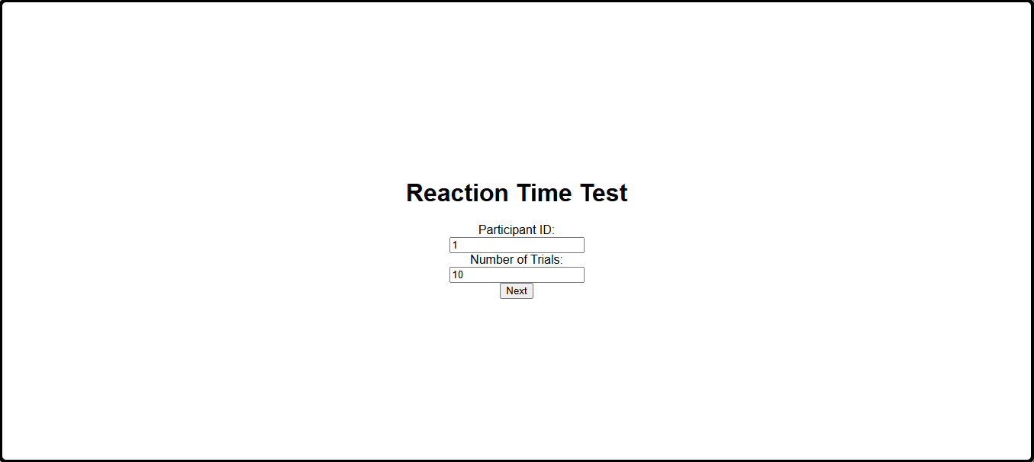

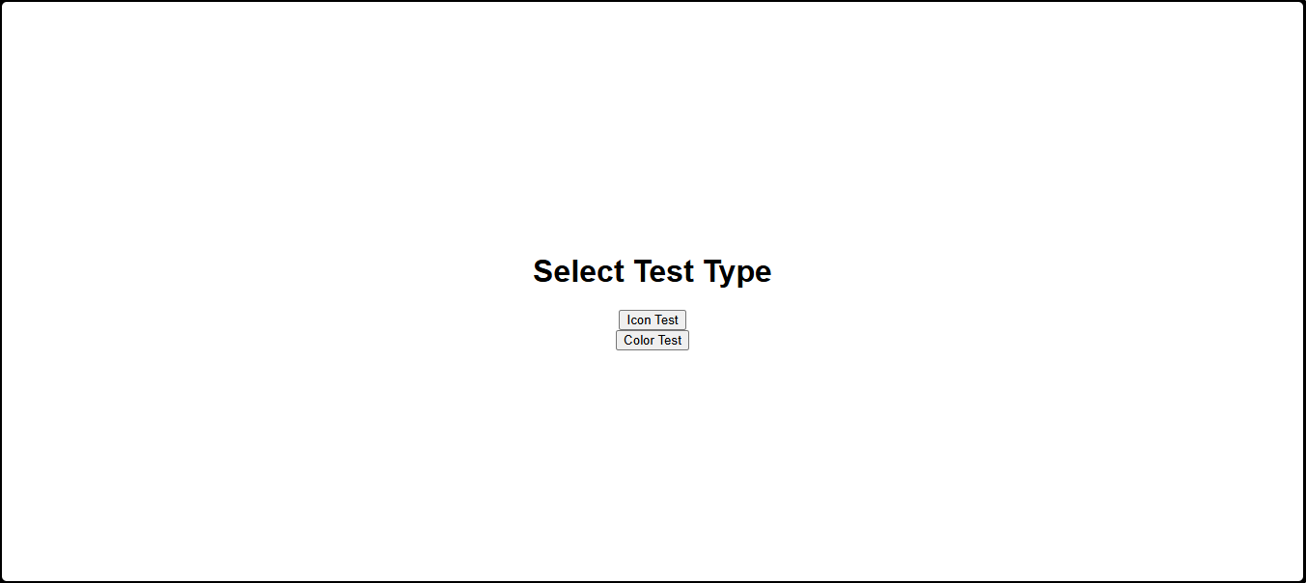

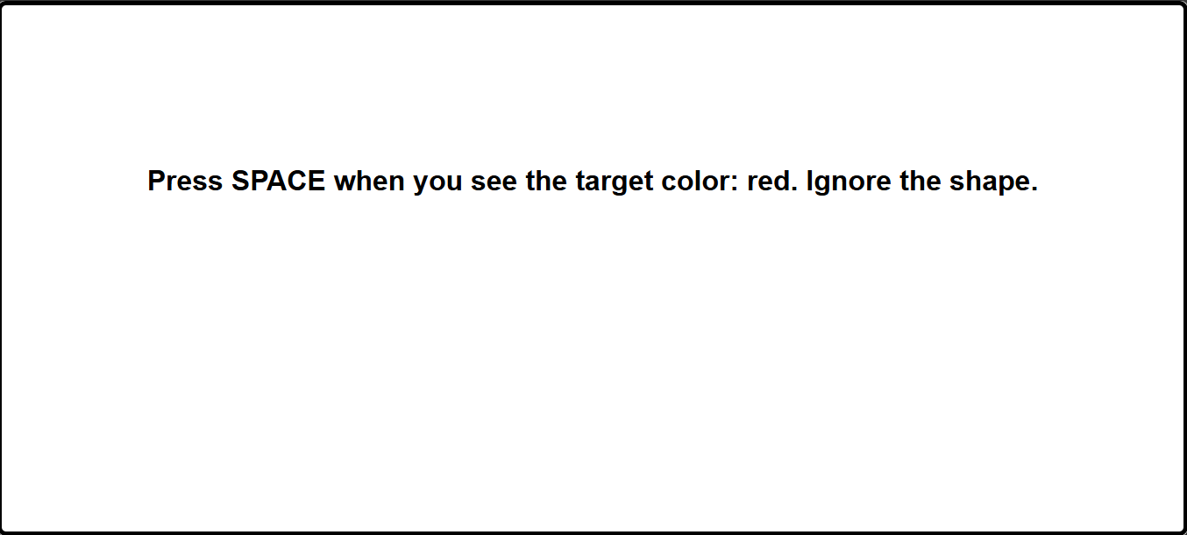

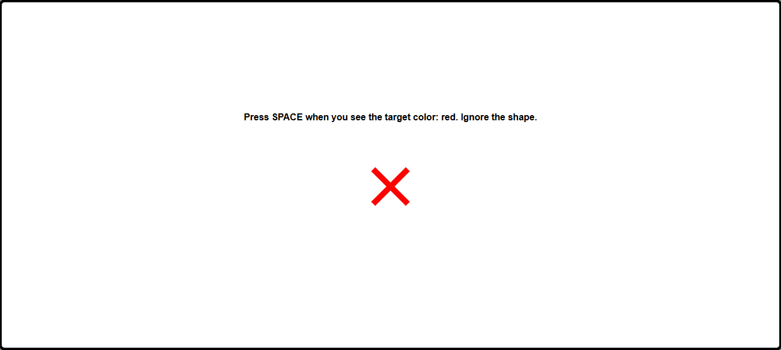

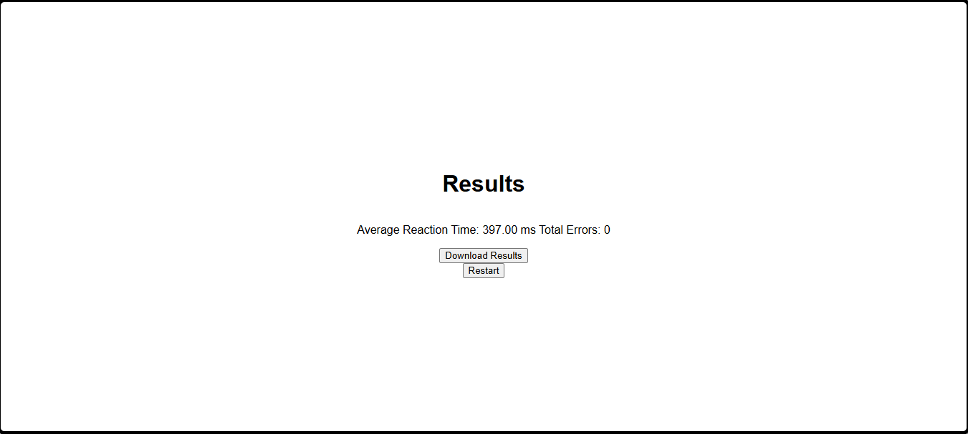

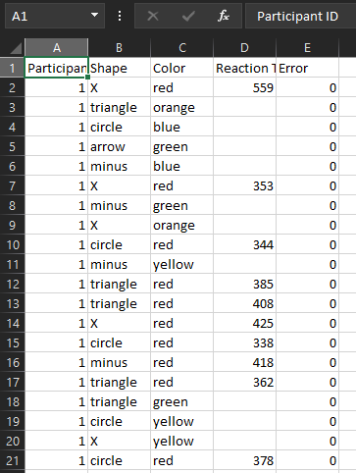

**Analysis Approach**

**Data Collection:**

Data were collected from 10 participants, with each performing both tests once, for a total of 20 datasets. Each participant started with alternating tests, to reduce bias of learning effects when it came to the second test. Their results were collected in a CSV file, where each trials cues were recorded along with the participants reaction time, and error rate (if applicable).

**Analysis Techniques:**

* Descriptive Statistics: to find the mean, standard deviation, and 95% confidence intervals of reaction times for each test type.
* Inferential Statistics: through paired t-tests to compare the means and figure out if the difference is significant or is only due to participant variability.

**Visualizations:**

* Boxplots to visualize the reaction times for both test types.

**Extras:**

* Summarized data can be used to find if any specific combinations of shapes and colours stood out in terms of reaction times (i.e. Users had significantly faster reaction times in Red X’s).
  + Visualized as a bar chart with supporting table.

**Results & Discussion**

**Error (Note):** It’s worth noting that there is an insignificant number of errors for both tests, only 1 for colours and 3 for icons. For this reason, error rates may not be considered for the analysis; but with a bigger participant pool, it can be applicable.

**Descriptive Statistics:**

* Colour Test: 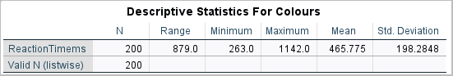

Figure 1. Descriptive Statistics for Colour Test

* + As shown, the colour test had a mean time of **465.775 ms** with a standard deviation of **198.2848**.
* Icon Test: 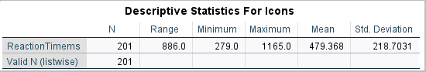

Figure 2. Descriptive Statistics for Icon Test

* + As shown, the icon test had a mean time of **479.368 ms** with a standard deviation of **218.7031**.

From these initial results, it can be concluded that **colours** appeared more consistent, and efficient in visual cues than **icons**, as reaction times had a faster mean, and a lower standard deviation.

**Visualizations:**

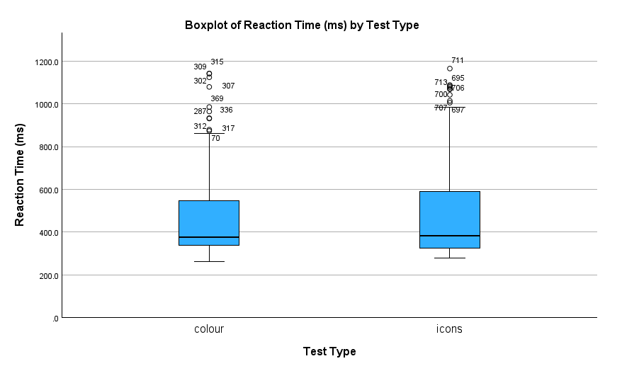

Figure 3. Comparison of reaction times for Colour and Icon Test using boxplots.

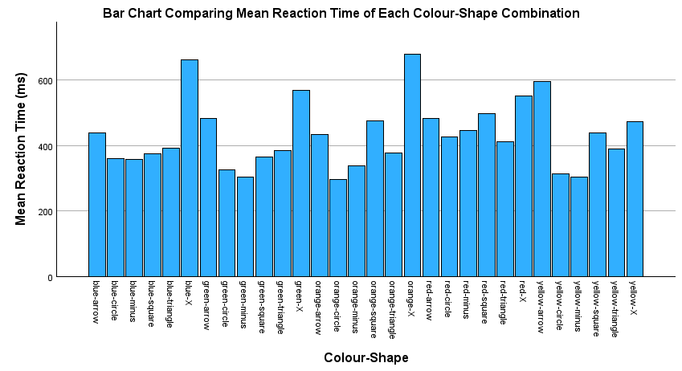

Figure 4. Comparison of mean reaction times for each Colour-Shape Combination.

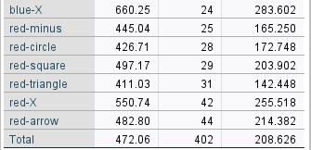

Figure 5. To support Figure 4, these are the colour-shape combinations that appeared most in the test. The headers appear from left-right: Colour-Shape, Mean, N (# of appearances), Std. Deviation.

**Extra Analysis:**

* The bar chart helps in visualizing mean reaction time for all combination of colour and shape that appeared in the test, but they all had varying amounts of appearance. The
* It is worth noting that from the top six most appearing combination of colour and shape, the **red triangle** netted the fastest mean reaction time of 411.03 ms, while the **red x** had the slowest with 550.74 ms.

**Inferential Statistics:**

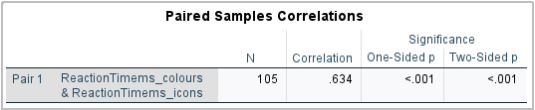

Figure 6. Paired Samples Correlations table through a paired t-test.

* The 0.634 correlation is a strong positive correlation that indicates that participants who responded well to the first test tended to do just as well in the second test.

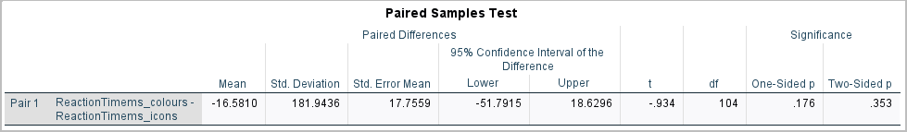

Figure 7. Paired Samples Test table through a paired t-test

* The p-value featured here is 0.353. This states that there is no significant difference in reaction times between the two tests.
* Since it is greater than 0.05, we fail to reject the null hypothesis and that the difference in mean reaction times could be due to random variable.
* We can account the small sample size for this conclusion, and the simplicity of the task which may not be relevant in real use-cases.

**Conclusion**

This study investigated the effectiveness of colour-based and shape-based visual cues in influencing reaction times, with applications for user interface design. While descriptive statistics suggested faster and more consistent reaction times in the Colour Test (465.78 ms) compared to the Icon Test (479.37 ms), inferential analysis revealed no statistically significant difference (p = 0.353). This suggests that the difference in the results could simply be a random variance in participant performance. A strong positive correlation (r = 0.634) between reaction times in the two tests indicated consistent participant performance, likely influenced by individual cognitive processing abilities. Additionally, a supplementary analysis of colour-shape combinations with sufficient test appearances identified the red triangle as the fastest cue and the red X as the slowest, offering potential insights for optimizing specific visual elements.

Although the study's small sample size limits the generalizability of its findings, it provides a foundation for future research. Expanding the participant pool and incorporating more complex tasks could yield stronger insights. The results suggest that both colour- and shape-based cues can be effective in eliciting responses, with colour showing slightly greater consistency. These findings highlight the importance of evaluating visual elements in creating efficient and user-friendly interfaces, paving the way for further refinement of visual cue design in various applications.