EXTENDED SUPPORTING DOCUMENT

REBALANCE: Quantifying the Racial Bias
Accuracy-Fairness Trade-off in Machine Learning Across Criminal Justice and Employment

Joshua Oghosasehe Ekogiawe
MSc. Computer science and Technology
Ulster University
London, United Kingdom
Student ID: B01045839
ekogiawe-JO@ulster.ac.uk

Supporting evidence for the experimental study of racial bias mitigation and accuracy-fairness trade-offs

Contents
1. Purpose and Scope of the Supporting Document 6
2. Literature Review and Theoretical Foundation 6
2.1 Racial Bias in Automated Decision Systems 6
2.2 Fairness Definitions and the Measurement Problem 7
2.3 The Fairness Impossibility Result 8
2.4 Debiasing Interventions and AIF360 9
2.5 Accuracy-Fairness Trade-offs and Evaluation Protocol 10
2.6 Cross-Domain Evidence and Research Gap 10
3. Research Questions, Variables and Hypotheses 11
3.1 Research Questions 11
3.2 Conceptual Model 11
3.3 Hypothesis Development 12
4. Research and Development Life Cycle 12
4.1 Requirements and Research Planning 13
4.2 Experimental Scope Definition 13
4.3 Dataset Acquisition and Preparation 14
4.4 Protected-Attribute Operationalisation 14
4.5 Intervention and Classifier Configuration 14
4.6 Pilot Execution and Full Experimental Runs 15
4.7 Statistical Analysis and Pareto Construction 15
4.8 Interpretation and Reporting 15
5. Experimental Design and Implementation 16
5.1 Dataset Construction 16
5.2 Debiasing Techniques 16
5.3 Classifier Families 17
5.4 Evaluation Metrics 17
5.5 Random Seeds and Experimental Replication 18
5.6 Statistical Testing 18
5.7 Pareto Frontier Analysis 18
6. Development Tools and Implementation Evidence 18
6.1 Software Stack 18
6.2 Reproducibility Controls 20
6.3 Experiment Matrix 20
6.4 Implementation Logic 21
6.5 Result Artefacts 21
7. Experimental Findings and Interpretation 22
7.1 Accuracy Cost 22
7.2 Fairness Improvement 23
7.3 Domain-Specific Pareto Frontiers 24
7.4 Domain Comparison 26
7.5 Technique Ranking 27
7.6 Statistical Reliability 28
8. Professional Considerations 29
9. Ethical Considerations 29
10. Social Considerations 29
11. Sustainability Considerations 30
12. Critical Appraisal 30
12.1 Outcome Evaluation 30
12.2 Design Decisions 31
12.3 Implementation Decisions 31
12.4 Threats to Validity 31
12.5 Limitations 32
13. Lessons Learned and Reflective Evaluation 32
13.1 Lessons from Experimental Design 32
13.2 Lessons from Implementation 33
13.3 Lessons from Statistical Analysis 33
13.4 Reflection on the Research Process 33
14. Future Development 34
15. Conclusion 34
References 35
Appendix A. Experimental Artefacts 38
Appendix B. Figures and Design Evidence 39

Table of Figures
Figure 1. The fairness impossibility theorem, illustrating the incompatibility of demographic parity, equalised odds and predictive parity. 8
Figure 2. AIF360 debiasing taxonomy showing the three intervention stages and the five techniques evaluated. 9
Figure 3. Research and development life cycle used to structure the investigation from problem formulation to critical evaluation. 12
Figure 4. Full factorial experimental design across two datasets, five techniques and up to four classifiers. 14
Figure 5. Experimental measurement pipeline linking data preparation, intervention, classifier training and evaluation. 16
Figure 6. Mean accuracy cost by debiasing technique and domain. 22
Figure 7. Mean fairness improvement by technique and domain, expressed as Δ|SPD| relative to the matched baseline. 23
Figure 8. Accuracy-fairness operating points for COMPAS and Adult Income. 26
Figure 9. Cost-effectiveness ratio by classifier family for COMPAS and Adult Income. 27
Figure 10. Statistical significance and effect size by technique and classifier family. 28
Figure 11. REBALANCE software architecture, showing the data, processing and fairness, analysis, and reporting layers. 19

1. Purpose and Scope of the Supporting Document
The supporting evidence documents the research decisions, experimental development, implementation controls and critical evaluation underlying REBALANCE. The central analytical problem is not whether fairness can be defined in abstract terms, but how the pursuit of racial fairness changes predictive performance when a common protected attribute is evaluated across materially different application domains, a question made urgent by regulatory instruments such as the EU AI Act [1], which require demonstrable non-discrimination in high-risk systems without specifying a quantitative accuracy-cost threshold. The investigation addresses this problem through a controlled comparison of criminal justice and employment datasets, five interventions implemented through AI Fairness 360, and four classifier families.
The value of the supporting evidence lies in making the reasoning behind the experimental design explicit. The study contains 42 technique-classifier-dataset conditions, each repeated over three random seeds, producing 126 empirical runs. This scale is sufficient to expose variation that would remain invisible in a single-model or single-dataset experiment, while remaining sufficiently controlled for the effects of dataset, intervention and classifier to be compared systematically.
Particular attention is given to the distinction between fairness improvement and accuracy cost. A mitigation method cannot be assessed adequately by reporting that a fairness metric moved closer to parity. The practical question is what predictive performance was surrendered to obtain that movement, whether the cost is stable, and whether the same intervention remains effective when the data distribution or classifier changes.
The document therefore complements the empirical paper by examining the reasoning chain from literature and hypothesis formulation through data preparation, intervention selection, repeated execution, statistical testing, Pareto analysis and reflection. It also addresses professional, ethical, social and sustainability considerations that arise when fairness evaluation concerns decisions with consequences for liberty and employment.

2. Literature Review and Theoretical Foundation

2.1 Racial Bias in Automated Decision Systems
Algorithmic discrimination is increasingly understood as a socio-technical phenomenon rather than a property that can be diagnosed solely by inspecting a model's coefficients. Historical decisions, feature construction, sampling, labels, model objectives and deployment practices can all contribute to unequal outcomes, a mechanism formalised in the legal and computational literature on disparate impact [31]. Kaur, Raza and Ahmad [2] distinguish formal approaches to fairness from broader socio-technical considerations, reinforcing the need to interpret statistical disparity alongside the mechanisms through which data and decisions are produced.
Criminal justice provides an especially consequential setting because algorithmic risk scores can influence decisions about supervision, bail and sentencing. The original investigative analysis of COMPAS [30] made racial differences in false-positive rates a central fairness concern and subsequently stimulated formal work on the incompatibility of competing fairness criteria [5], [6]. Employment presents a different mechanism of harm. A screening model can influence access to work before an applicant has an opportunity to demonstrate capability, and historical employment data may encode previous discriminatory practices. The Adult Income dataset is therefore valuable not because it reproduces a current labour market directly, but because it provides a widely studied benchmark in which racial outcome differences are explicit and comparable with prior fairness research [3], [4].
The comparison of these domains is analytically useful because the same protected attribute, Black versus White, is maintained while the prediction task, feature structure and outcome mechanism change. The research can therefore ask whether the observed price of fairness is portable across settings rather than assuming that a mitigation method has a fixed cost independent of the data on which it operates.

2.2 Fairness Definitions and the Measurement Problem
Fairness is not represented by a single universally accepted statistic, and the field has produced a proliferation of formal definitions since the foundational individual-fairness proposal of Dwork et al. [28] and the group-conditional equal-opportunity criterion of Hardt et al. [29]. Statistical parity difference evaluates whether favourable prediction rates are equal between protected groups. Equal opportunity difference focuses on true-positive rates, while average odds difference considers both true-positive and false-positive rates. Disparate impact expresses the relationship as a ratio. These measures answer different questions and can therefore produce different assessments of the same intervention [16].
This plurality creates a methodological problem for accuracy-fairness trade-off research. If an intervention is optimised against one criterion, improvement in that criterion does not guarantee improvement in another. Calibrated Equalised Odds illustrates this issue directly in the present evaluation: its effect differs substantially between Adult Income and COMPAS, and its statistical parity improvement can move in the opposite direction from the desired fairness measure. The result reinforces the argument that fairness must be specified as an explicit operational criterion rather than treated as a single latent property.
The decision to report four fairness metrics therefore serves two purposes. First, it reduces the risk of drawing a conclusion from a single measure whose definition may not align with the substantive concern. Second, it permits the supporting analysis to distinguish between a general reduction in disparity and a technique's alignment with the particular criterion it was designed to address.

2.3 The Fairness Impossibility Result
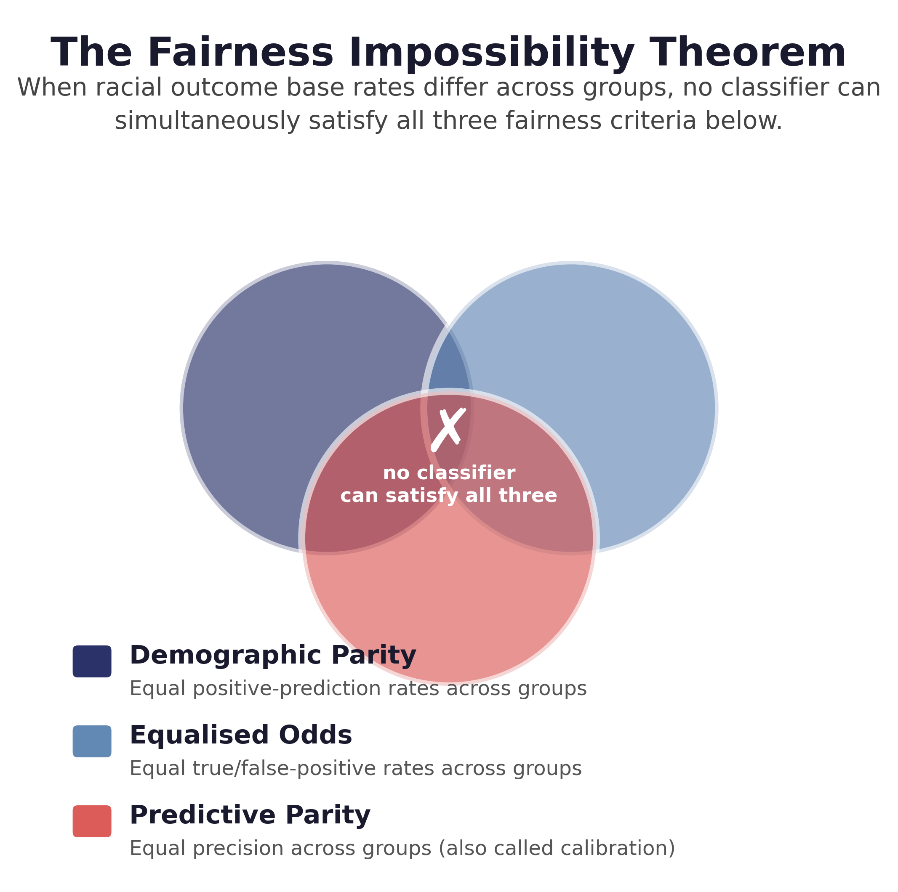
Figure 1. The fairness impossibility theorem. The visualisation is reproduced from the experimental study and illustrates the incompatibility of demographic parity, equalised odds and predictive parity when outcome base rates differ.
The Chouldechova-Kleinberg result provides the theoretical foundation for the accuracy-fairness trade-off examined here [5], [6]. When outcome base rates differ across protected groups, calibration and equalised odds cannot generally be satisfied simultaneously except in degenerate circumstances. Demographic parity introduces a further constraint on the distribution of positive predictions. The theorem therefore establishes that fairness criteria can be in structural tension rather than merely difficult to optimise simultaneously.
The theorem does not directly provide a numerical prediction of the accuracy cost associated with a fairness intervention. It establishes incompatibility between criteria. The research extends this theoretical intuition into an empirical question: whether domains with different racial outcome base rates exhibit different trade-off severity.
This distinction is important. Treating the impossibility theorem as a complete explanation would overstate what the mathematics establishes. The empirical design instead tests whether the relationship suggested by the theorem is visible in real datasets after classifier and intervention effects are introduced. The observed result is especially informative because the racial outcome base-rate differences are almost identical between COMPAS and Adult Income, yet baseline statistical parity disparity is approximately twice as large on COMPAS.

2.4 Debiasing Interventions and AIF360
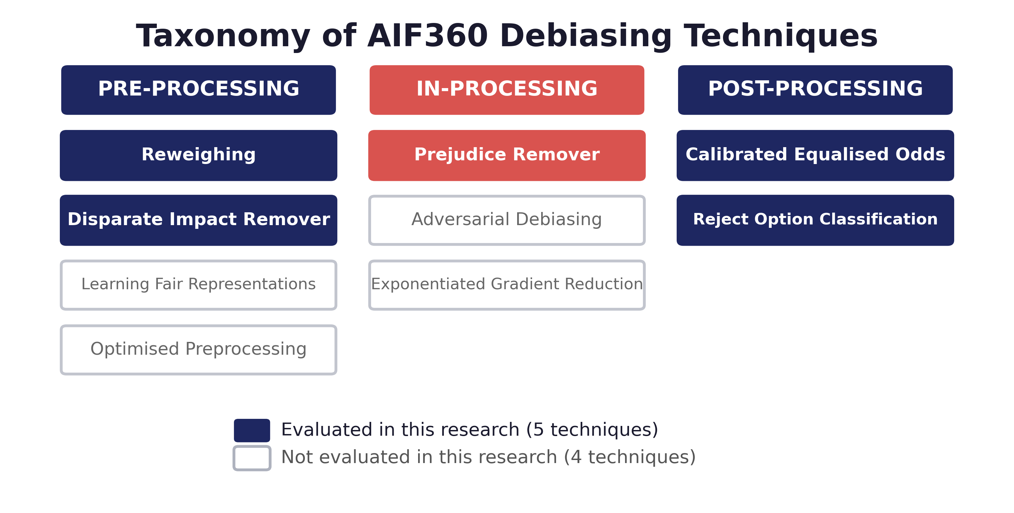
Figure 2. AIF360 debiasing taxonomy showing the three intervention stages and the five techniques evaluated.
AI Fairness 360 provides a common implementation framework through which interventions operating at different stages of the machine learning pipeline can be compared [3]. The taxonomy distinguishes pre-processing, in-processing and post-processing. The five selected techniques provide coverage across all three stages while remaining sufficiently tractable for repeated evaluation across four classifier families.
Stage | Technique | Mechanism | Experimental rationale
Pre-processing | Reweighing | Assigns instance weights to balance group-outcome frequencies [15] | Model-agnostic intervention with low implementation intrusion
Pre-processing | Disparate Impact Remover | Repairs feature distributions towards group parity [21] | Tests feature-level intervention across classifier families
In-processing | Prejudice Remover | Adds mutual-information regularisation to the learning objective [22] | Tests whether modifying optimisation produces a larger cost
Post-processing | Calibrated Equalised Odds | Mixes classifier outputs to satisfy a fairness criterion under a cost constraint [23] | Tests output-level fairness adjustment
Post-processing | Reject Option Classification | Reassigns uncertain decisions within a confidence band [24] | Tests a threshold/output intervention designed for statistical parity

The choice of five methods rather than all nine available in AIF360 is a scope decision rather than an assertion that the remaining techniques are less important. The selected set permits the experimental design to cover the three intervention stages and preserve repeated execution across two datasets, four classifiers and three seeds. The untested techniques remain a clear avenue for subsequent extension.

2.5 Accuracy-Fairness Trade-offs and Evaluation Protocol
Previous empirical studies show that fairness interventions can change predictive performance, but reported costs are sensitive to experimental design [4], [10], [12], [13], and the trade-off has been theorised more broadly as extending beyond accuracy and fairness into a triangular relationship that also implicates model robustness [11]. Tan et al. [8] further show that post-processing interventions can approach the fairness gains of in-processing methods at inference time without retraining, motivating the inclusion of two post-processing techniques in the present design. Classifier architecture, random initialisation, hyperparameter selection and fairness definition can all influence the observed result. Ganesh et al. [17] demonstrate that randomness itself can alter group fairness outcomes, supporting the decision to repeat every condition across multiple seeds.
The research therefore treats experimental control as part of the fairness measurement. The protected attribute is held constant, the train-test protocol is fixed, hyperparameters are fixed rather than separately optimised for each intervention, and each condition is repeated using the same three seeds. This makes the resulting comparisons less likely to reflect unequal optimisation effort.
This choice involves a deliberate trade-off. Per-condition hyperparameter optimisation might improve the absolute performance of individual techniques, but it would make it harder to distinguish the effect of the mitigation method from the effect of additional tuning. Fixed hyperparameters instead strengthen internal comparative validity while limiting the extent to which absolute costs should be interpreted as deployment-ready performance budgets.

2.6 Cross-Domain Evidence and Research Gap
Broader surveys of bias and fairness in machine learning [9] confirm that the literature contains substantial single-dataset and single-technique evidence, but this does not answer whether a fairness intervention has a portable accuracy cost. A result obtained on Adult Income cannot establish the cost that the same intervention will incur in criminal justice because the two prediction tasks have different outcome structures and feature relationships. Similarly, a classifier-specific result cannot establish that a technique will retain its cost-effectiveness under a different learning architecture.
The central gap addressed by REBALANCE is therefore comparative. The design keeps race as the fixed protected attribute and varies domain, classifier family and intervention under a common protocol. This creates a controlled basis for asking whether the trade-off is technique-specific, domain-specific and classifier-specific.
Evidence limitation | Response in REBALANCE | Analytical value
Single-dataset fairness evaluation | COMPAS and Adult Income | Separates technique effects from domain effects
Single classifier family | Logistic Regression, Random Forest, XGBoost and MLP | Tests portability across model architectures
Single random seed | Seeds 42, 7 and 123 | Makes run-to-run variability observable
Single fairness measure | SPD, AOD, EOD and disparate impact | Reduces dependence on one fairness definition
Point estimates without trade-off structure | Accuracy-fairness Pareto frontiers | Identifies non-dominated operating points
Assumed universal intervention ranking | Classifier-level cost-effectiveness analysis | Tests whether technique ranking is stable

3. Research Questions, Variables and Hypotheses

3.1 Research Questions
- RQ1. What is the magnitude of the racial bias accuracy-fairness trade-off across the evaluated conditions?
- RQ2. Does the magnitude of the trade-off vary systematically between COMPAS and Adult Income?
- RQ3. Is cross-domain variation related to the racial outcome base-rate difference predicted by the fairness impossibility result?
- RQ4. Which debiasing technique provides the most cost-effective racial bias reduction, measured as fairness improvement relative to accuracy cost?
- RQ5. Does the cost-effectiveness ranking remain consistent across the four classifier families?

3.2 Conceptual Model
The conceptual structure treats debiasing technique category as the primary independent variable, racial group comparison as the fixed protected attribute, application domain as a moderating variable, and accuracy-fairness trade-off magnitude as the principal dependent variable. Classifier family is an additional experimental factor used to test the portability of intervention effects.
Variable | Operationalisation | Role
Protected attribute | White privileged, Black unprivileged | Fixed across datasets
Domain | COMPAS; Adult Income | Moderating experimental factor
Debiasing method | Five AIF360 techniques | Primary intervention variable
Classifier | Logistic Regression; Random Forest; XGBoost; MLP | Model-family factor
Accuracy | Accuracy, F1, AUC-ROC, MCC | Predictive utility
Fairness | SPD, AOD, EOD, disparate impact | Group fairness
Trade-off | ΔAccuracy relative to matched baseline | Primary cost measure
Cost-effectiveness | Δ|SPD| / accuracy cost | Technique comparison

3.3 Hypothesis Development
Hypothesis 1 states that racial bias mitigation will produce measurable accuracy costs in both domains, with magnitude varying in relation to the underlying outcome structure. The hypothesis is grounded in the incompatibility between competing fairness criteria and the expectation that moving a classifier away from its unconstrained optimum will generally require some loss in predictive performance.
Hypothesis 2 predicts that post-processing will impose the smallest accuracy cost because it acts on model outputs rather than changing the learned representation or training objective, while in-processing will impose the largest cost because it modifies the optimisation process. The hypothesis is intentionally mechanistic and falsifiable. The observed results provide only partial support, which is analytically valuable because the failure of the predicted hierarchy reveals that intervention cost depends on more than pipeline location.

4. Research and Development Life Cycle
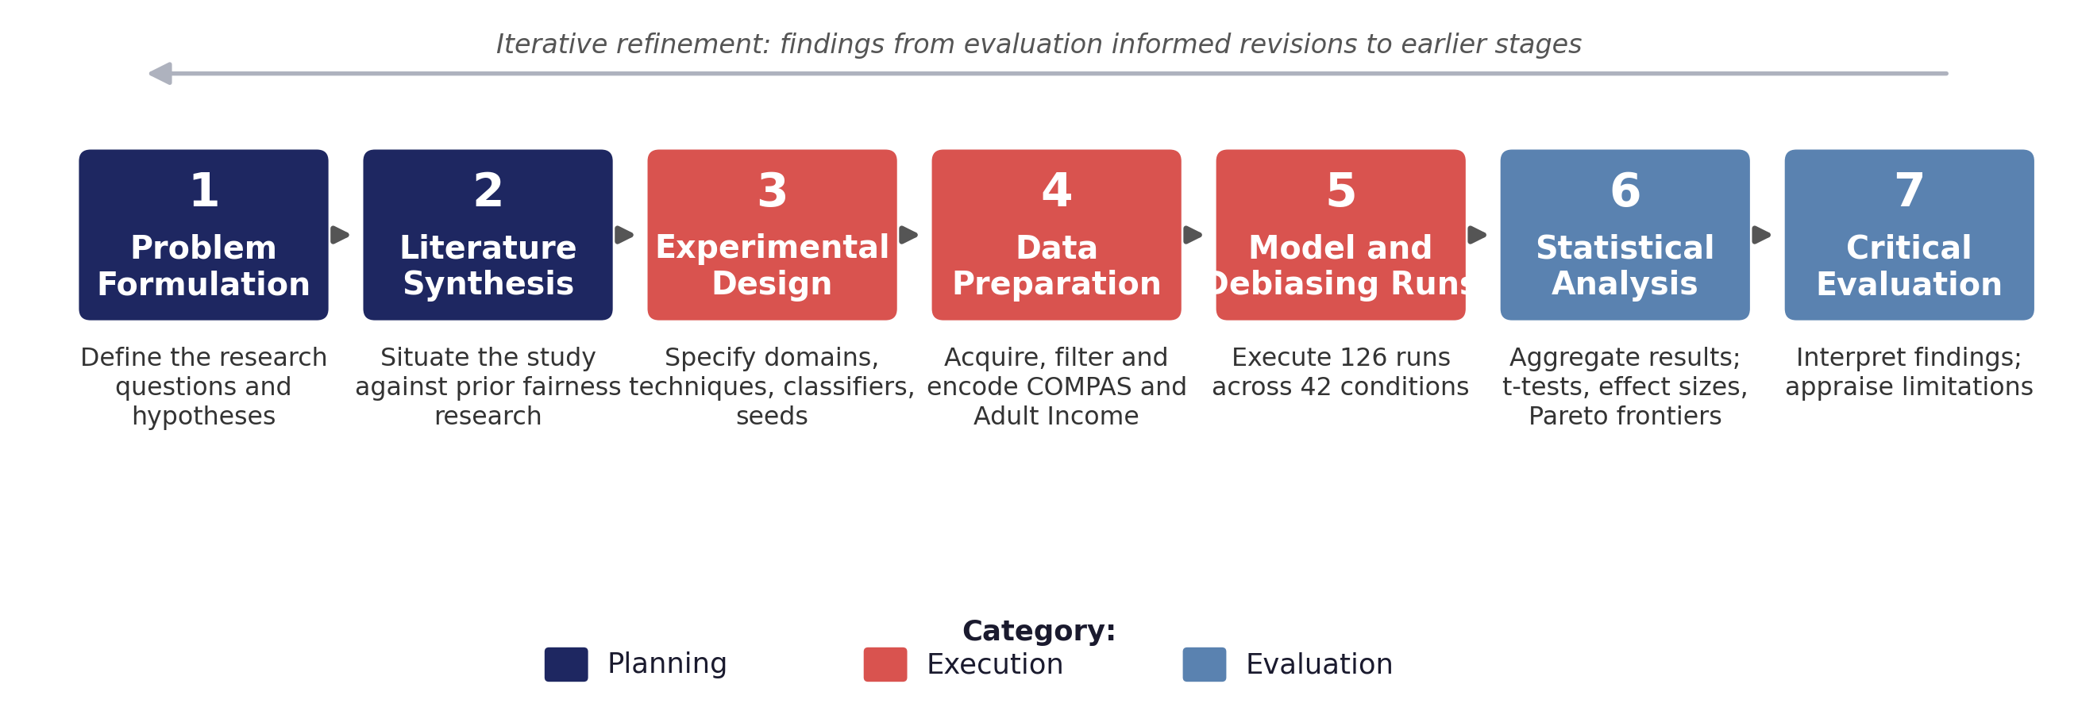
Figure 3. Research and development life cycle used to structure the investigation from problem formulation to critical evaluation.
The development sequence followed a research-led iterative cycle. Requirements were translated into measurable research questions, the questions into an experimental matrix, the matrix into controlled data and model pipelines, and the outputs into statistical comparisons. The cycle was iterative because results from early execution informed checks on data preparation, metric behaviour and experimental sufficiency.

4.1 Requirements and Research Planning
The first requirement was comparability. The research needed to determine whether the cost of fairness mitigation changed between application domains without allowing changes in the protected attribute, classifier family or experimental protocol to become uncontrolled sources of variation. This requirement shaped the entire design.
The second requirement was practical interpretability. Reporting only a large collection of fairness and accuracy metrics would make it difficult to identify which interventions represented efficient choices. Accuracy change, fairness improvement and Pareto dominance were therefore incorporated into the evaluation plan before the full experimental runs.
The third requirement was reproducibility. The study was designed so that every reported condition could be linked to a dataset, classifier, technique and seed. Fixed dependencies and explicit seed values were adopted to make the experimental state reconstructable.

4.2 Experimental Scope Definition
The scope was constrained to two datasets, five interventions, four classifier families and three seeds. This was necessary because each additional dimension multiplies the number of empirical runs. The final design creates 21 conditions per dataset: the unmitigated baseline for each classifier plus the applicable technique-classifier combinations. Across three seeds and two datasets, the resulting total is 126 runs.
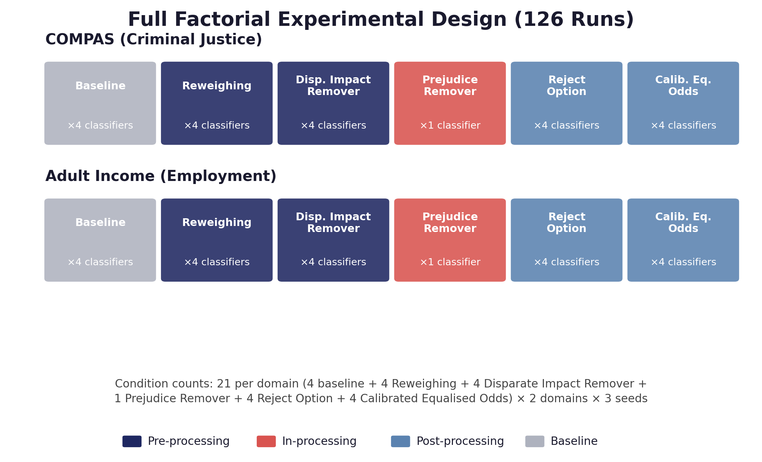
Figure 4. Full factorial experimental design. Each of the two datasets contributes 21 conditions (4 baseline plus five techniques, Prejudice Remover crossed with one classifier and the remaining four techniques each crossed with four classifiers), repeated over three random seeds, producing 63 runs per dataset and 126 runs overall.
The scope also reflects comparability constraints. Prejudice Remover is tied to a logistic-regression architecture within AIF360, so it is not treated as a directly comparable technique across all four classifier families. The analysis retains its value as an intervention-stage comparison while excluding it from classifier-wide cost-effectiveness ranking where such a comparison would be structurally misleading.

4.3 Dataset Acquisition and Preparation
COMPAS is used for criminal justice and Adult Income for employment. The COMPAS preparation excludes records with implausible screening-to-arrest gaps and undefined recidivism status, producing the 5,278-record analytical dataset. Adult Income begins with 48,842 records and is restricted to the White and Black racial groups, with records containing missing categorical employment values removed, yielding 43,800 records.
Adult Income is based on a 1994 census extraction. Retaining it introduces a temporal limitation, but the dataset's extensive use in fairness research provides a strong comparative advantage because results can be positioned against a large body of previous work. The decision illustrates a recurring principle in empirical research: a dataset can be imperfect while remaining valuable when its limitations are explicit and its role is clearly defined.
Categorical features are one-hot encoded and continuous variables standardised. The favourable outcome for Adult Income is annual income above USD 50,000. The racial outcome base rates are 0.263 for the privileged group and 0.127 for the unprivileged group, producing a base-rate difference of 0.136.

4.4 Protected-Attribute Operationalisation
Race is encoded consistently as a binary protected attribute, with White treated as the privileged group and Black as the unprivileged group. Records outside these two categories are excluded rather than pooled into an 'other' category. Pooling heterogeneous racial groups would create a group definition whose statistical interpretation is unclear and would undermine comparability between the two datasets.
The protected attribute remains available to the fairness pipeline. Removing race alone would not remove proxy information encoded through correlated variables such as geography, occupational sector or prior arrest history. The decision therefore supports explicit measurement and mitigation rather than fairness through unawareness.

4.5 Intervention and Classifier Configuration
The five interventions were implemented with fixed parameters. Reweighing modifies instance weights without changing features or labels. Disparate Impact Remover operates on feature distributions and was applied at full repair. Prejudice Remover introduces a mutual-information regularisation term into the logistic objective. Calibrated Equalised Odds adjusts outputs to satisfy a specified criterion, while Reject Option Classification reassigns decisions within an uncertainty band to favour the unprivileged group within the configured tolerance.
Four classifier families were used: Logistic Regression, Random Forest, XGBoost and Multi-Layer Perceptron. Fixed hyperparameters were used across the relevant conditions. The purpose was not to establish the best possible model for each dataset, but to establish comparable conditions in which the effect of the intervention could be observed.

4.6 Pilot Execution and Full Experimental Runs
The experimental harness was first used to establish that the complete scope was executable. The full study then comprised 126 runs. Each run applied the same train-test protocol, intervention configuration, classifier family and seed assignment. The use of repeated seeds creates three observations per condition, allowing both mean behaviour and variability to be reported.
The pilot stage was also important for identifying implementation assumptions that could otherwise remain hidden. In fairness research, a pipeline can produce numerically plausible outputs even when a protected group has been mapped incorrectly or a fairness metric is being interpreted in the wrong direction. The development process therefore relied on explicit group definitions and matched baseline comparisons.

4.7 Statistical Analysis and Pareto Construction
The primary comparison is the change in accuracy relative to the matched baseline for the same dataset and classifier. Fairness improvement is represented as the reduction in absolute statistical parity difference. Paired t-tests compare each technique condition with its matched baseline across the three seeds, while Cohen's d is reported to communicate effect magnitude.
The three-seed design is statistically limited. A non-significant paired test cannot be interpreted as evidence that an intervention has no effect. It can indicate that the effect is small, inconsistent or simply difficult to detect with three observations. The supporting analysis therefore treats p-values and effect sizes as complementary rather than collapsing the results into a binary significance classification.
Following the statistical formalisation of the accuracy-fairness Pareto frontier [7], Pareto frontiers are constructed by plotting accuracy against absolute statistical parity difference and retaining non-dominated operating points. A point is non-dominated when no other point achieves both equal or greater accuracy and equal or lower disparity. This avoids imposing an arbitrary numerical weight on fairness and accuracy and instead shows the efficient set from which a deployment decision could be made.

4.8 Interpretation and Reporting
The reporting stage was designed around the research questions rather than around the chronology of execution. Accuracy cost is assessed first, followed by frontier structure, domain comparison and classifier-level ranking. This order allows the statistical result to be interpreted within the larger multi-objective structure rather than treating each metric as an isolated outcome.

5. Experimental Design and Implementation
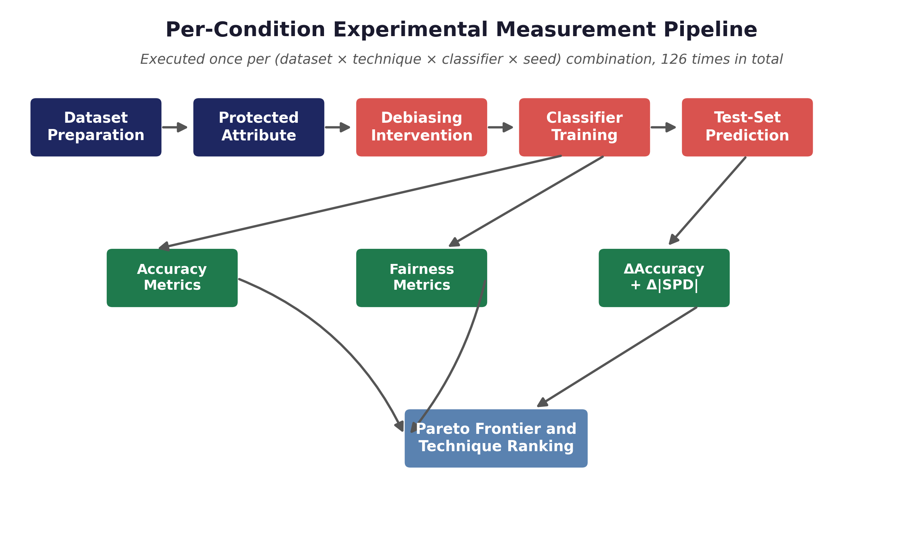
Figure 5. Experimental measurement pipeline linking data preparation, protected-attribute handling, intervention, classifier training and multi-objective evaluation.

5.1 Dataset Construction
Dataset | Domain | Records used | Protected groups | Favourable outcome | Base-rate difference
COMPAS | Criminal justice | 5,278 | White / Black | Recidivism outcome | 0.132
Adult Income | Employment | 43,800 | White / Black | Income > USD 50,000 | 0.136

The near equality of the base-rate differences is a particularly important feature of the design. It creates a controlled empirical test of the expectation that base-rate disparity alone should explain the severity of the accuracy-fairness trade-off. The subsequent results do not support a simple one-variable explanation.

5.2 Debiasing Techniques
Technique | Stage | Fairness mechanism | Expected cost logic
Reweighing | Pre | Rebalances group-outcome weights | Expected to preserve much of classifier structure
Disparate Impact Remover | Pre | Repairs feature distributions | May alter predictive information in features
Prejudice Remover | In | Regularises learning objective | Expected to impose a larger optimisation cost
Calibrated Equalised Odds | Post | Adjusts output probabilities/decisions | Cost depends on target criterion and score structure
Reject Option | Post | Changes uncertain decisions | Expected to preserve much of the model outside the rejection region

5.3 Classifier Families
The four classifier families were selected to cover linear, bagging/ensemble, gradient-boosted and neural-network learning paradigms. This diversity is important because a fairness intervention that appears effective with one decision boundary may interact differently with another. The classifier factor therefore acts as a stress test of technique portability.
Classifier | Role in comparison | Reason for inclusion
Logistic Regression | Linear decision boundary | Provides a transparent linear reference and supports Prejudice Remover
Random Forest | Bagged tree ensemble | Represents non-linear, ensemble-based learning
XGBoost | Gradient-boosted trees | Represents a high-performing tabular ensemble family
MLP | Neural network | Tests whether ranking persists beyond tree and linear models

5.4 Evaluation Metrics
Predictive utility is measured using accuracy, F1-score, AUC-ROC and Matthews Correlation Coefficient. The latter two are useful where class imbalance makes accuracy alone potentially misleading. Fairness is evaluated using statistical parity difference, average odds difference, equal opportunity difference and disparate impact.
For the principal trade-off analysis, accuracy cost is calculated relative to the matched baseline and fairness improvement is expressed as the reduction in absolute statistical parity difference. The resulting cost-effectiveness ratio is Δ|SPD| divided by the accuracy cost. A ratio is useful for ranking interventions but should not be mistaken for a universal utility function because it embeds the choice of SPD and treats the accuracy denominator as the cost measure.

5.5 Random Seeds and Experimental Replication
Every condition is repeated using seeds 42, 7 and 123. The seeds govern the stratified 70/30 train-test split and model initialisation where applicable. The use of the same seed set across every condition makes variability comparable rather than allowing different interventions to benefit from different random states.
Three seeds do not provide strong statistical power. Their purpose is therefore better understood as a minimum replication layer than as a fully powered inferential sample. Reporting standard deviations and effect sizes alongside paired tests prevents the analysis from hiding variability behind a single mean.

5.6 Statistical Testing
Paired t-tests are applied between each intervention and its matched baseline within dataset and classifier. The paired structure is preferable to comparing unrelated means because the baseline and intervention share the same dataset, split structure and seed. Cohen's d is reported to quantify the magnitude of the accuracy change.
The interpretation follows the small-sample limitation explicitly. Thirteen of 33 technique-classifier comparisons reach p < 0.05. The concentration of statistically significant effects in Reject Option and Calibrated Equalised Odds does not imply that the other techniques have no effect; rather, the evidence is stronger where effects are both large and consistent across the three seeds.

5.7 Pareto Frontier Analysis
The Pareto analysis transforms a large table of results into an operational view of the feasible trade-off. For COMPAS, the frontier includes very low-disparity MLP conditions produced by Reweighing and Reject Option, while higher-accuracy points occur at higher residual disparity. For Adult Income, Reject Option anchors the low-disparity end of the frontier and the unmitigated XGBoost baseline anchors the high-accuracy end.
The method is particularly appropriate because it does not assume that a practitioner values one percentage point of accuracy and one unit of fairness equally. The frontier identifies efficient choices and leaves the final policy-level preference to the decision-maker.

6. Development Tools and Implementation Evidence

6.1 Software Stack
Tool / library | Function
Python | Experimental orchestration, preprocessing, model training and analysis
IBM AI Fairness 360 0.6.1 | Fairness metrics and debiasing algorithms
scikit-learn 1.8.0 | Preprocessing, classifiers and evaluation utilities
XGBoost 3.3.0 | Gradient-boosted classifier
Pandas / NumPy | Tabular transformation and numerical computation
Matplotlib | Experimental figures and visualisation
Statistical testing utilities | Paired tests, effect sizes and summary statistics
Version-controlled repository | Source preservation, dependency specification and result traceability

Version pinning is particularly important for fairness analysis because metric implementations and algorithm defaults can change between library releases. A reproducibility failure can therefore appear as a fairness change when the underlying data and intervention have not changed. Pinning AIF360 0.6.1, scikit-learn 1.8.0 and XGBoost 3.3.0 reduces this source of variation.
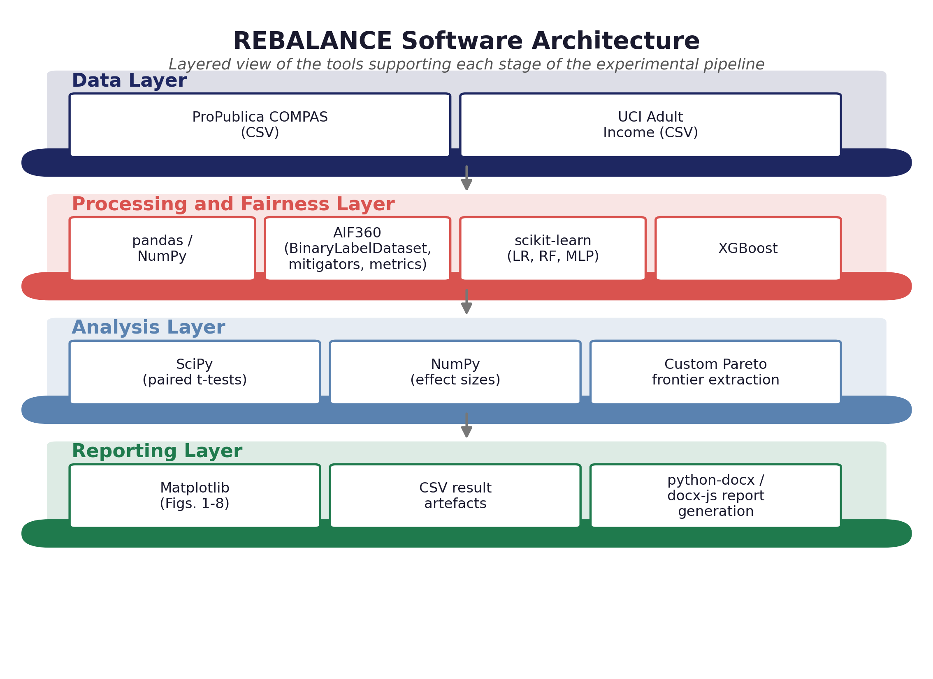
Figure 11. REBALANCE software architecture, showing the data, processing and fairness, analysis, and reporting layers and the tools supporting each. The layered structure separates data acquisition from fairness intervention, statistical analysis and result generation, supporting the traceability requirement discussed in Section 6.2.
The architecture reflects a deliberate separation of concerns rather than an accidental accumulation of libraries. Each layer depends only on the layer beneath it, so a change to the reporting layer, for example switching from python-docx to a different document-generation approach, cannot alter the numerical results produced by the analysis layer beneath it. This separation supported the iterative documentation process described in Section 4.8, since figures and tables could be regenerated from the same underlying result artefacts without re-running the experimental pipeline.

6.2 Reproducibility Controls
The implementation records the seed values, hyperparameter configuration, preprocessing rules and per-run results. The combination of fixed versions and fixed seeds is sufficient to define the experimental state at a level suitable for independent reconstruction, subject to the availability of the same public datasets and compatible execution environment.
Implementation Evidence 1. Experimental seed specification. Source: Reconstructed from the documented experimental protocol; the excerpt expresses the control logic rather than claiming to reproduce the unpublished source verbatim.
SEEDS = [42, 7, 123]

for seed in SEEDS:
split = stratified_train_test_split(
data,
test_size=0.30,
random_state=seed
)
result = run_condition(
split=split,
classifier=classifier,
technique=technique,
seed=seed
)
save_result(result)

The code excerpt is included as implementation evidence of the experimental logic. It is deliberately identified as a reconstruction of the documented protocol rather than being presented as a verbatim source-code extract. This avoids confusing an explanatory representation with the original implementation.

6.3 Experiment Matrix
Dimension | Levels | Count
Datasets | COMPAS, Adult Income | 2
Classifiers | Logistic Regression, Random Forest, XGBoost, MLP | 4
Debiasing methods | Reweighing, DIR, Prejudice Remover, CEO, Reject Option | 5
Baseline | Unmitigated classifier | Included
Seeds | 42, 7, 123 | 3
Total empirical runs | 42 conditions × 3 seeds | 126

6.4 Implementation Logic
The implementation separates the experimental dimensions so that the same evaluation functions can be applied consistently to every condition. Dataset preparation establishes the protected attribute and favourable outcome; the intervention is applied at its designated pipeline stage; the classifier is trained using the resulting data or outputs; predictions are generated on the held-out test set; and the same evaluation functions calculate predictive and fairness metrics.
Implementation Evidence 2. Condition-level processing logic. Source: Analytical structure derived from the published experimental matrix.
for dataset in DATASETS:
prepared = prepare_dataset(dataset)

for classifier in CLASSIFIERS:
baseline = fit_and_evaluate(
prepared, classifier, seed
)

for technique in APPLICABLE_TECHNIQUES:
transformed = apply_debiasing(
prepared, technique
)
result = fit_and_evaluate(
transformed, classifier, seed
)
compare_to_baseline(result, baseline)

The important implementation property is the matched-baseline comparison. Each intervention is evaluated against the same dataset and classifier family under the same seed structure. Without this pairing, the reported accuracy cost could be contaminated by unrelated differences in train-test partitioning or model initialisation.

6.5 Result Artefacts
Artefact | Purpose | Use in evaluation
Preprocessed dataset | Defines the analytical sample | Reconstructs input population
Seed-specific predictions | Stores model outputs | Supports metric calculation
Per-condition metrics | Stores accuracy and fairness measures | Supports paired comparison
Seed summaries | Mean and standard deviation | Quantifies central tendency and variability
Effect-size results | Cohen's d | Communicates magnitude
Pareto points | Accuracy and |SPD| pairs | Identifies non-dominated conditions
Ranking ratios | Δ|SPD| / accuracy cost | Compares technique efficiency
Pinned dependencies | Software environment | Supports reproducibility

7. Experimental Findings and Interpretation

7.1 Accuracy Cost
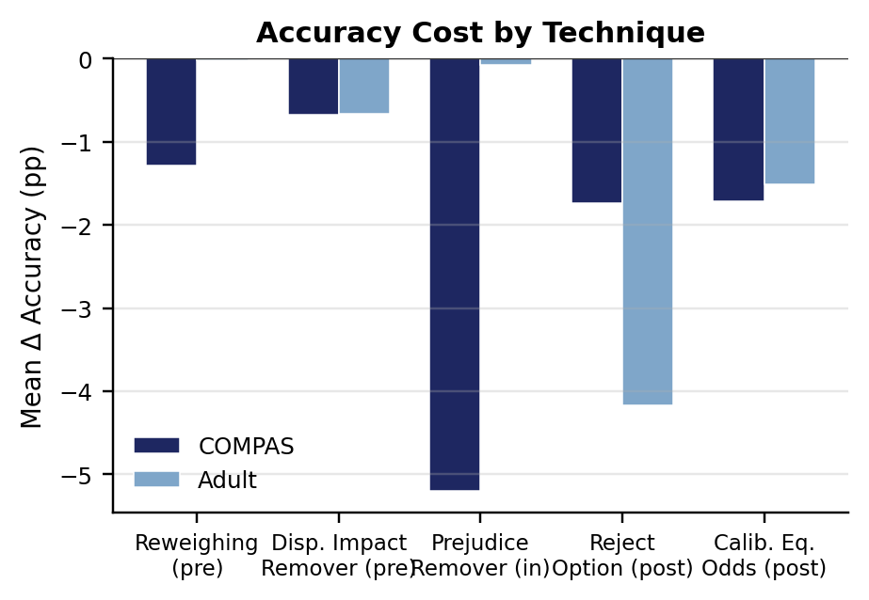
Figure 6. Mean accuracy cost by debiasing technique and domain. Values are changes in predictive accuracy relative to matched baselines.
The accuracy results establish that fairness mitigation is not cost-free. On COMPAS, Reweighing produces a mean accuracy reduction of 0.013 while improving absolute statistical parity difference by 0.191. Disparate Impact Remover incurs a smaller 0.007 accuracy reduction with a smaller fairness improvement of 0.037. Prejudice Remover has the largest COMPAS accuracy cost at 0.052, while Reject Option and Calibrated Equalised Odds each incur a mean cost of approximately 0.017.
Adult Income exhibits a different cost structure. Reweighing has an approximately negligible mean accuracy cost, whereas Reject Option reduces accuracy by 0.042 and Calibrated Equalised Odds by 0.015. The fact that the same intervention can be inexpensive in one domain and materially expensive in another is central to the research question.
Dataset | Technique | ΔAccuracy | Δ|SPD|
COMPAS | Reweighing | -0.013 | +0.191
COMPAS | Disparate Impact Remover | -0.007 | +0.037
COMPAS | Prejudice Remover | -0.052 | +0.183
COMPAS | Reject Option | -0.017 | +0.215
COMPAS | Calibrated Equalised Odds | -0.017 | -0.203
Adult | Reweighing | -0.000 | +0.046
Adult | Disparate Impact Remover | -0.007 | -0.011
Adult | Prejudice Remover | -0.001 | +0.003
Adult | Reject Option | -0.042 | +0.086
Adult | Calibrated Equalised Odds | -0.015 | +0.034

7.2 Fairness Improvement
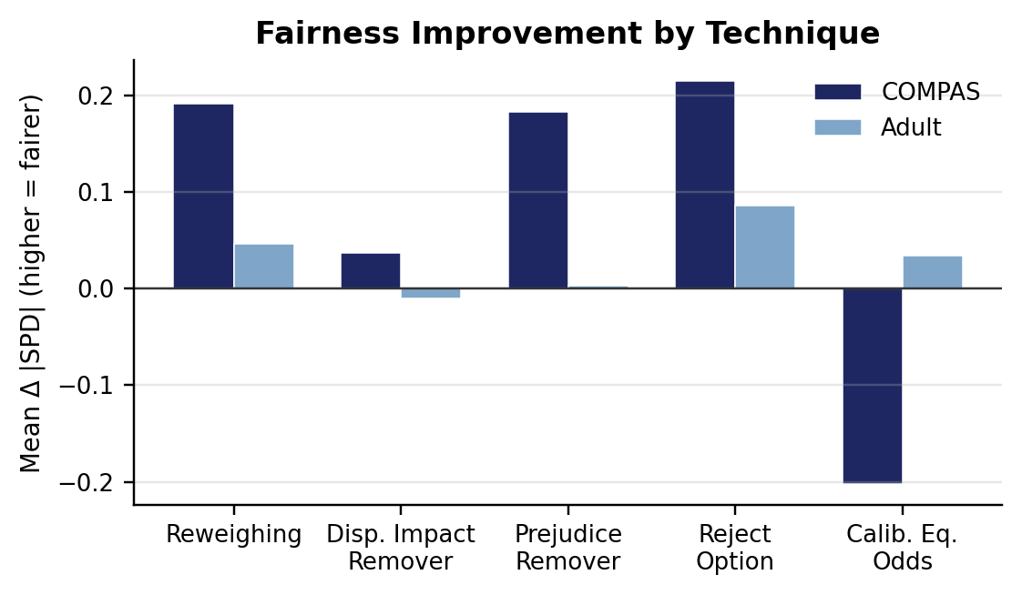
Figure 7. Mean fairness improvement by technique and domain, expressed as Δ|SPD| relative to the matched baseline.
Reject Option produces the largest fairness improvement in both domains, but the associated accuracy cost is very different. This illustrates why fairness improvement alone is insufficient for selecting an intervention. The appropriate question is whether the improvement is obtained at an acceptable predictive cost and whether the intervention behaves consistently under the relevant classifier and dataset.
Calibrated Equalised Odds is especially informative because its effect changes direction across domains. It improves fairness on Adult by approximately 0.034 but worsens the statistical parity measure on COMPAS by approximately 0.203. This is not evidence that the algorithm is defective. It demonstrates that a technique designed around one fairness criterion can produce an undesirable result when the target criterion does not correspond to the structure of the disparity being measured.

7.3 Domain-Specific Pareto Frontiers
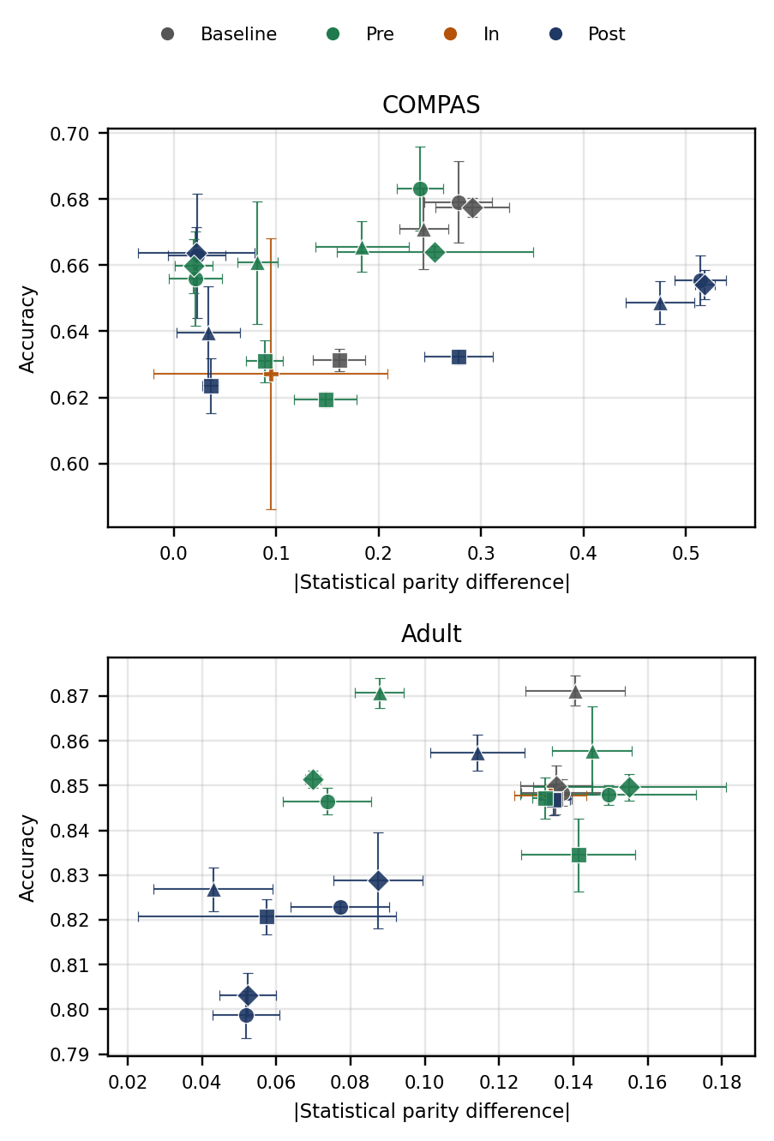
Figure 8. Accuracy-fairness operating points for COMPAS and Adult Income. Error bars show variation across the three seeds.
The COMPAS frontier is compressed into a comparatively narrow accuracy range while spanning substantial changes in absolute statistical parity disparity. The Adult frontier spans a wider accuracy range with a gentler fairness exchange. The shape therefore indicates that the two domains do not merely differ in the amount of bias; they present different feasible relationships between predictive performance and fairness.
Domain | Classifier | Technique | Accuracy | |SPD|
COMPAS | MLP | Reweighing | 0.660 | 0.020
COMPAS | MLP | Reject Option | 0.664 | 0.022
COMPAS | XGBoost | Disparate Impact Remover | 0.666 | 0.184
COMPAS | Logistic Regression | Disparate Impact Remover | 0.683 | 0.241
Adult | XGBoost | Reject Option | 0.827 | 0.043
Adult | MLP | Reweighing | 0.851 | 0.070
Adult | XGBoost | Reweighing | 0.871 | 0.088
Adult | XGBoost | Baseline | 0.871 | 0.141

7.4 Domain Comparison
The racial outcome base-rate differences are almost identical: 0.132 for COMPAS and 0.136 for Adult Income. However, the mean baseline absolute statistical parity difference is approximately 0.244 across COMPAS classifiers and 0.137 across Adult classifiers. COMPAS therefore exhibits roughly twice the baseline disparity despite the similarity in the base-rate gap.
Because only two domains are available, a formal correlation coefficient would not provide meaningful statistical evidence. The appropriate conclusion is qualitative: base-rate difference alone does not explain the observed variation. Other properties, including how strongly features encode racial proxies and how the prediction target relates to the available variables, are plausible contributors.
This is an important refinement of the theoretical expectation. The impossibility result remains relevant because it establishes structural tension between fairness criteria, but the empirical magnitude of the resulting cost depends on the data and intervention through which that tension is expressed. This finding is consistent with an independent recidivism-focused study reporting that fairness interventions can be ineffective or counterproductive when not carefully tailored to the specific dataset [18], and it contrasts with prior work in public-policy resource allocation reporting negligible fairness-accuracy trade-offs in practice [19]; taken together, these findings suggest that trade-off severity is a property of the domain and intervention pairing rather than a fixed quantity.

7.5 Technique Ranking
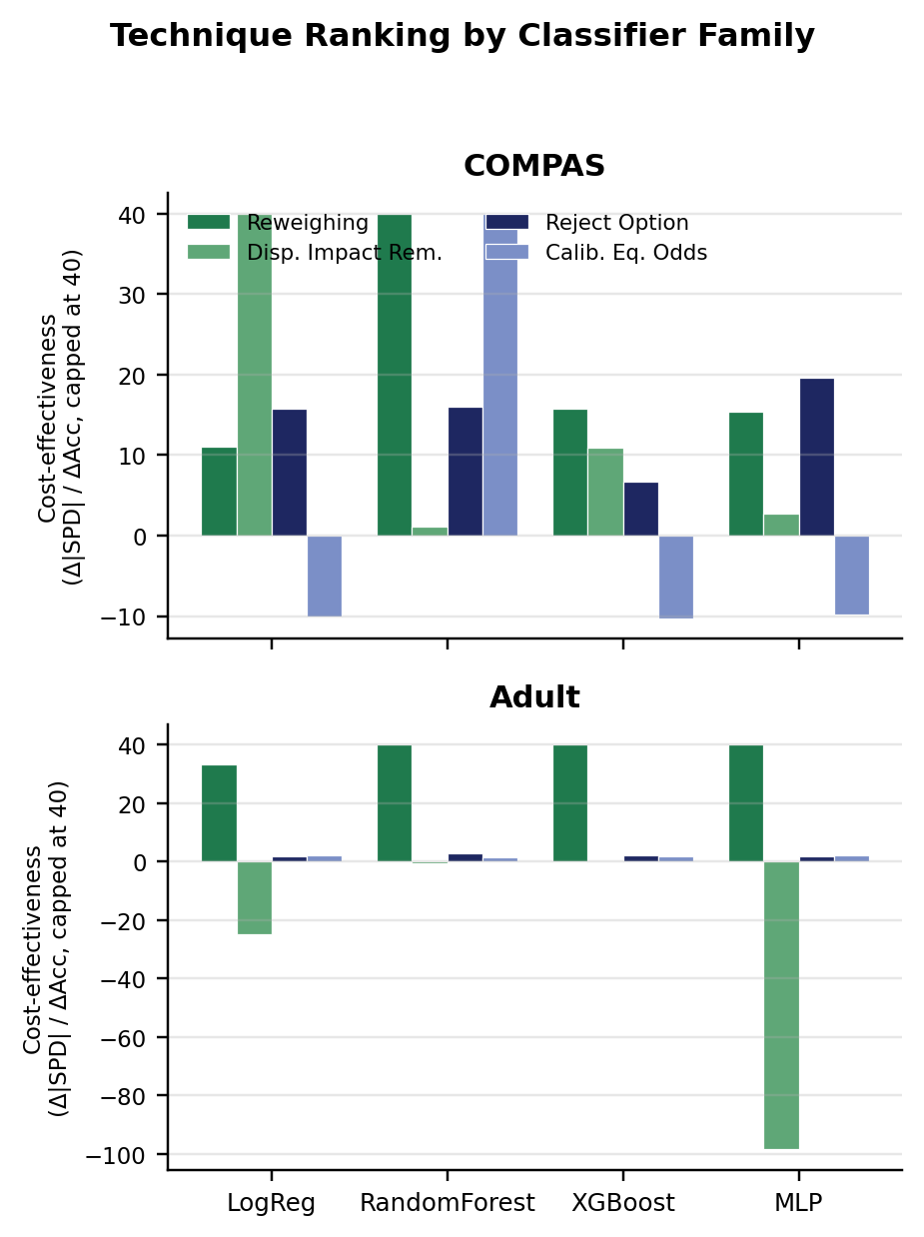
Figure 9. Cost-effectiveness ratio by classifier family for COMPAS and Adult Income. The ratio is Δ|SPD| divided by accuracy cost and capped at 40 for visual readability.
Cost-effectiveness is domain-dependent. Reweighing is the most cost-effective technique on COMPAS, whereas Reject Option is the most cost-effective on Adult Income. The ranking therefore cannot be fixed once and transferred across applications.
Classifier-level analysis strengthens this finding. On Adult Income, Reweighing is the leading technique across all four classifier families, indicating a stable ranking within that domain. On COMPAS, the leading technique changes with the classifier: Disparate Impact Remover performs best with Logistic Regression, Reject Option with the MLP, Calibrated Equalised Odds with Random Forest, and Reweighing with XGBoost. This instability means that a fairness intervention should be evaluated against the specific model architecture rather than selected solely from a domain-level average, echoing evidence that pairing bias mitigators with different classifier families can itself alter fairness outcomes [14].

7.6 Statistical Reliability
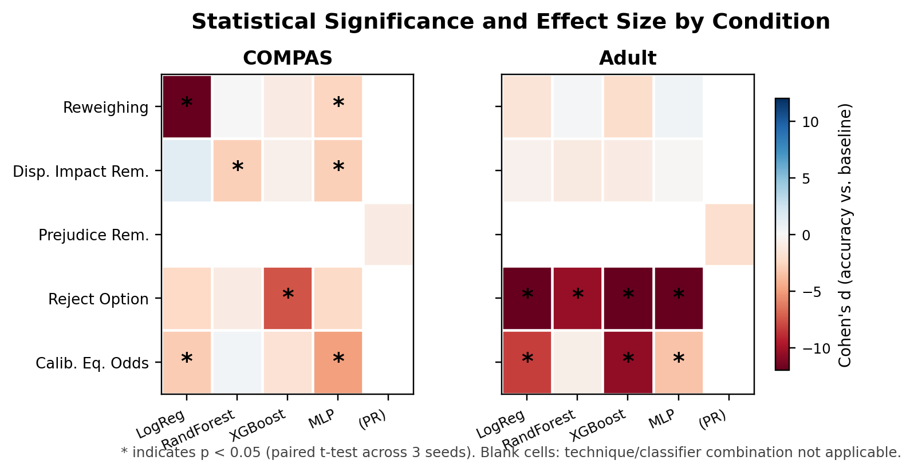
Figure 10. Statistical significance and effect size by technique and classifier family. Asterisks indicate p < 0.05 in paired tests across three seeds.
Thirteen of the 33 non-baseline technique-classifier comparisons reach p < 0.05. The strongest concentration occurs in Reject Option and Calibrated Equalised Odds, especially on Adult Income. Pre-processing interventions more often show smaller or less consistent effects. The result should not be read as a ranking of statistical significance; rather, it illustrates how effect magnitude and seed variability interact.
The Adult MLP Reject Option condition illustrates the distinction particularly clearly: the mean accuracy reduction is approximately 0.047 and the effect is extremely consistent across the three seeds. By contrast, a small mean change with larger relative variability may remain non-significant despite having practical relevance. This is why the analysis retains effect sizes and standard deviations alongside p-values.

8. Professional Considerations
Professional practice requires more than obtaining a statistically interesting result. A fairness study can influence decisions about whether an intervention is acceptable for deployment, so the analytical chain must be auditable. The use of fixed seeds, pinned dependencies, matched baselines, explicit protected-group definitions and documented evaluation metrics supports this requirement, consistent with emerging professional norms for dataset and model documentation such as datasheets for datasets [32] and model cards for model reporting [33].
The professional responsibility is especially high in criminal justice. A model evaluation cannot be reduced to whether the overall accuracy appears competitive. A practitioner must understand which groups experience false positive or false negative disparities, what fairness criterion is being prioritised, and what predictive performance is sacrificed to obtain the intervention.
The research also demonstrates responsible statistical communication. The three-seed limitation is stated explicitly, non-significant results are not interpreted as proof of equivalence, and the cross-domain comparison avoids calculating a misleading correlation from only two observations. These practices reduce the risk that technically correct numbers are presented with an unjustified level of certainty.

9. Ethical Considerations
The protected attribute is used because racial disparity cannot be measured or mitigated without identifying the groups being compared. This creates an ethical distinction between using race as an analytical variable for fairness auditing and using race as a basis for discriminatory decision-making. The study belongs to the former category: race is fixed as an evaluation attribute and is not treated as a justification for unequal treatment.
The use of COMPAS requires particular caution because the underlying prediction concerns future criminal justice outcomes. Even an intervention that reduces a statistical disparity does not automatically establish that the resulting decisions are substantively just. Statistical parity can be achieved while other forms of error or validity remain unequal. Consequently, fairness metrics should inform rather than replace substantive ethical and legal review.
The employment analysis raises a related issue. Equalising a statistical measure does not establish that historical employment labels are themselves fair. A model can reproduce a historically biased outcome distribution while being statistically balanced according to a chosen metric. The evaluation therefore treats fairness intervention as a mitigation mechanism, not as proof that the underlying social process has become fair.

10. Social Considerations
Algorithmic decisions in employment and criminal justice can distribute opportunities and burdens at scale. A small group-level disparity repeated across thousands of decisions can become a substantial social effect. Conversely, reducing a disparity by imposing a large accuracy cost can create a different set of risks if the model's predictions become substantially less informative.
The findings support a social interpretation in which fairness is domain-specific. An intervention that is efficient in employment cannot automatically be assumed to be efficient in criminal justice. This matters for public-sector procurement and governance because standardised fairness requirements should not be implemented as if a single technical recipe applies to every decision system.
The results also demonstrate why transparency matters. The cost-effectiveness ranking changes with the domain and, for COMPAS, with the classifier. Communicating these dependencies enables affected stakeholders and governance bodies to understand why a particular intervention was selected rather than presenting fairness as a single post-processing switch.

11. Sustainability Considerations
The computational sustainability of the investigation is shaped by the repeated execution required to compare 42 conditions across three seeds. A larger technique set, more classifiers or more seeds would improve coverage but would increase compute requirements multiplicatively. The controlled scope therefore represents not only a research constraint but a sustainability decision.
Reproducibility also has a sustainability dimension. Fixed dependencies and stored results reduce the need to rerun expensive experiments merely to reconstruct a previous finding. The modular design makes it possible to extend one component without recomputing unrelated components.
The most important sustainability improvement for future work would be to increase statistical replication only when the additional compute produces a clear evidential benefit. More seeds should be prioritised for conditions where variability is high or where conclusions depend strongly on a small number of runs, rather than applied indiscriminately to every experiment.

12. Critical Appraisal

12.1 Outcome Evaluation
The investigation successfully demonstrates that the accuracy-fairness trade-off is measurable, technique-dependent and domain-dependent within the evaluated scope. The most important contribution is not a universal numerical cost, because no such cost emerges. Instead, the results show that the price of mitigation depends on the interaction between intervention mechanism, data distribution, classifier and fairness criterion.
Hypothesis 1 is supported. Debiasing produces measurable accuracy costs, and 13 of 33 technique-classifier conditions reach p < 0.05. Hypothesis 2 receives partial support. Prejudice Remover produces the largest individual COMPAS accuracy cost, consistent with the expectation that modifying the learning objective can be expensive. However, Reject Option is among the costliest interventions on Adult Income, contradicting the assumption that post-processing is always the cheapest approach.
The domain comparison is equally important. COMPAS has approximately twice the baseline statistical parity disparity of Adult Income despite nearly identical outcome base-rate differences. The result weakens a simple interpretation in which base-rate difference is sufficient to determine trade-off severity and points towards the interaction between feature representation, prediction target and intervention mechanism.

12.2 Design Decisions
Decision | Reason | Benefit | Cost / limitation
Fixed Black/White comparison | Preserve comparability across domains | Isolates domain and technique effects | Does not represent all racial groups
Two public benchmark datasets | Enable controlled cross-domain comparison | Strong comparability with literature | Limited external validity
Five of nine AIF360 methods | Cover all three intervention stages within feasible compute | Tractable full factorial design | Four methods remain untested
Four classifier families | Test intervention portability | Exposes classifier-specific ranking | Increases computational burden
Three random seeds | Capture basic run variability | Allows mean and variance estimation | Low inferential power
Fixed hyperparameters | Prevent unequal tuning effort | Strengthens internal validity | May disadvantage methods needing tuning
Four fairness metrics | Avoid dependence on one definition | Shows criterion sensitivity | Increases interpretive complexity
Pareto analysis | Avoid arbitrary fairness/accuracy weighting | Shows efficient operating points | Requires practitioner interpretation

12.3 Implementation Decisions
The implementation strategy prioritised comparability over per-condition optimisation. This is appropriate for the research question because the principal outcome is a relative cost, not the best achievable score for each individual algorithm. If one technique were extensively tuned while another used fixed defaults, the comparison would measure both intervention quality and optimisation effort.
The use of matched baselines is another strong implementation decision. Each intervention is compared with the corresponding unmitigated classifier rather than with a single global baseline. This isolates the incremental effect of the intervention and prevents the classifier factor from being confused with the mitigation effect.
The decision to exclude Prejudice Remover from classifier-wide cost-effectiveness ranking is also methodologically sound. Its fixed logistic architecture makes direct comparison with all four classifier families structurally different from the model-agnostic techniques. Treating it as if it were equivalent would create a misleading ranking.

12.4 Threats to Validity
Internal validity is strengthened by the controlled protected attribute, fixed seeds, matched baselines and common evaluation protocol. Nevertheless, fixed hyperparameters introduce a potential threat because some interventions may be more sensitive to configuration than others. The observed accuracy cost may therefore reflect the selected configuration rather than the minimum achievable cost of the technique.
Construct validity is affected by the choice of fairness metrics. Statistical parity, equal opportunity and average odds capture different concepts. The study mitigates this by reporting several metrics, but no combination can resolve the underlying normative question of which fairness criterion is appropriate for a real deployment.
External validity is limited by the two datasets. COMPAS and Adult Income demonstrate that domain dependence exists, but they cannot establish the full landscape of regulated machine learning. A third domain could reveal a different trade-off regime.
Statistical validity is constrained by three seeds. The use of effect sizes and standard deviations reduces the risk of over-reliance on p-values, but it cannot create statistical power that the design does not possess.

12.5 Limitations
Four limitations are particularly consequential. First, the seed budget is small. Second, hyperparameters are fixed rather than optimised per condition. Third, four of the nine AIF360 techniques are not evaluated. Fourth, only two domains are studied. These limitations restrict the precision and generality of the numerical estimates but do not undermine the central comparative finding that mitigation cost is dependent on technique and domain.
The limitations also define the next logical experiments. Additional seeds would strengthen uncertainty estimates; additional techniques would test whether the observed cost hierarchy generalises across the full AIF360 taxonomy; and additional domains would determine whether COMPAS and Adult represent two isolated cases or points on a broader continuum.

13. Lessons Learned and Reflective Evaluation

13.1 Lessons from Experimental Design
- A fairness study must define its comparison structure before collecting results. Without a matched baseline, an accuracy difference can be incorrectly attributed to the intervention.
- Holding race constant was essential. Changing the protected attribute between datasets would have made the cross-domain comparison substantially harder to interpret.
- The number of experimental dimensions grows multiplicatively. Adding one technique or one classifier has consequences for every dataset and seed, so scope must be planned quantitatively.
- A fairness metric is not a neutral definition of fairness. Reporting several metrics exposed cases where an intervention improved one criterion but not another.
- The Pareto frontier was preferable to a single weighted score because the appropriate balance between accuracy and fairness is ultimately a governance decision rather than a universally correct numerical constant.

13.2 Lessons from Implementation
The development process demonstrates that reproducibility is a technical property, not a statement of intent. Pinning versions and seeds makes the computational state more explicit. Separating baseline and intervention evaluation makes the comparison auditable. Recording per-seed results preserves information that would be lost if only the final mean were stored.
The implementation also showed the importance of respecting algorithmic constraints. Prejudice Remover is not simply another interchangeable intervention; its architecture creates a different comparison structure. Recognising this before ranking results prevents a technically convenient but methodologically invalid comparison.

13.3 Lessons from Statistical Analysis
The most significant statistical lesson is that non-significance and absence of effect are not equivalent. With three seeds, the analysis can confidently identify large and consistent effects but is less capable of resolving small or noisy changes. Effect sizes and variability are therefore essential to interpretation.
A second lesson is that domain-level averages can hide classifier-specific behaviour. The COMPAS ranking analysis shows that the most efficient intervention changes with classifier family. A practitioner relying only on a domain average could therefore select a technique that is not the best choice for the actual model being deployed.

13.4 Reflection on the Research Process
The research process progressed from a broad question about whether fairness mitigation is costly to a more precise question about how that cost varies with intervention, domain and classifier. This refinement improved the study because it converted a general ethical concern into a measurable experimental design.
A particularly important methodological insight is that a controlled experiment does not eliminate all uncertainty; it makes the remaining uncertainty more interpretable. Fixed seeds, matched baselines and a common protected attribute do not make the datasets representative of every deployment. They make the observed differences easier to attribute to the factors being studied.
With hindsight, the next iteration should increase the seed budget before expanding the number of techniques. Greater replication would improve confidence in the existing findings and clarify which apparent ranking differences are stable. Only after that would a larger technique and domain set provide the greatest additional value.
The strongest lesson is therefore methodological rather than purely technical: fairness evaluation should be treated as an experimental science in which the comparison protocol is itself part of the result. A mitigation method cannot be judged independently of the data, classifier, fairness criterion and uncertainty under which it was measured.

14. Future Development
The first priority is replication with a larger seed budget. Increasing the number of seeds would improve the statistical characterisation of conditions with substantial run-to-run variability and would make paired comparisons more informative.
The second priority is expansion of the AIF360 technique set. Learning Fair Representations [25], Optimised Preprocessing, Adversarial Debiasing [26] and Exponentiated Gradient Reduction [27] were not included in the present controlled design. Their evaluation would test whether the observed pre-processing cost advantage persists when the full taxonomy is considered.
The third priority is additional domains. A larger set of regulated application domains, including healthcare settings where debiasing has already been shown to interact with domain-specific operational constraints [20], would permit more meaningful analysis of the relationship between outcome base rates and trade-off severity. With more than two domains, formal association analysis would become more defensible.
A fourth extension would examine condition-specific hyperparameter optimisation under a second experimental arm. The current fixed-parameter design is appropriate for internal comparison, while a separate optimisation study could estimate the practical best-case cost of each intervention. Keeping these two designs separate would prevent optimisation from contaminating the controlled comparison.

15. Conclusion
The supporting evidence establishes a coherent research and development process for quantifying the racial accuracy-fairness trade-off in machine learning. The investigation combines a theoretically motivated fairness framework with controlled experimentation across two high-stakes domains, five mitigation techniques, four classifier families and three random seeds.
The evidence shows that racial bias mitigation can impose measurable accuracy costs, but there is no universal cost and no universally optimal intervention. Pre-processing methods are generally inexpensive within the evaluated scope, but post-processing can become costly depending on the domain and criterion. COMPAS exhibits substantially greater baseline statistical parity disparity than Adult Income despite nearly identical outcome base-rate differences. Technique ranking is stable across classifiers on Adult but changes across classifiers on COMPAS.
These findings have direct implications for responsible machine learning practice. Fairness intervention should not be treated as a one-time technical configuration. The appropriate method depends on the domain, the classifier, the fairness criterion and the acceptable predictive cost. The supporting analysis further demonstrates that credible fairness research depends on reproducible engineering, explicit statistical limitations and careful separation between what the data demonstrate and what remains an interpretation.

References
[1] European Parliament and Council, “Regulation (EU) 2024/1689 (Artificial Intelligence Act),” Official Journal of the European Union, 2024.
[2] S. Kaur, M. Raza, and A. Ahmad, “Bias in AI systems: Integrating formal and socio-technical approaches,” Frontiers in Big Data, 2025.
[3] R. K. E. Bellamy et al., “AI Fairness 360: An extensible toolkit for detecting and mitigating unwanted algorithmic bias,” IBM Journal of Research and Development, vol. 63, no. 4/5, pp. 4:1–4:15, 2019.
[4] C. H. Blow, L. Qian, C. Gibson, P. Obiomon, and X. Dong, “Comprehensive validation on reweighting samples for bias mitigation via AIF360,” Applied Sciences, vol. 14, no. 9, p. 3826, 2024.
[5] A. Chouldechova, “Fair prediction with disparate impact: A study of bias in recidivism prediction instruments,” Big Data, vol. 5, no. 2, pp. 153–163, 2017.
[6] J. Kleinberg, S. Mullainathan, and M. Raghavan, “Inherent trade-offs in the fair determination of risk scores,” in Proc. 8th ITCS, 2017.
[7] E. Del Barrio, F. Gamboa, P. Gordaliza, and J.-M. Loubes, “Inference for an algorithmic fairness-accuracy frontier,” arXiv preprint arXiv:2402.08879, 2024.
[8] H. Tan, C. Liu, Z. Luo, and G. Niu, “You only debias once: Towards flexible accuracy-fairness trade-offs at inference time,” arXiv preprint arXiv:2503.07066, 2025.
[9] N. Mehrabi, M. Morstatter, N. Saxena, K. Lerman, and A. Galstyan, “A survey on bias and fairness in machine learning,” ACM Computing Surveys, vol. 54, no. 6, pp. 1–35, 2021.
[10] A. F. Cruz and M. Hardt, “Unprocessing seven years of algorithmic fairness,” in Proc. 12th International Conference on Learning Representations, 2024.
[11] J. Li and G. Li, “Triangular trade-off between robustness, accuracy, and fairness in deep neural networks: A survey,” ACM Computing Surveys, vol. 57, no. 6, art. 140, 2025.
[12] A. F. Cooper, E. Abrams, and N. Na, “Emergent unfairness in algorithmic fairness-accuracy trade-off research,” in Proc. AAAI/ACM Conference on AI, Ethics, and Society, 2021, pp. 46–54.
[13] Z. Chen, J. M. Zhang, F. Sarro, and M. Harman, “A comprehensive empirical study of bias mitigation methods for machine learning classifiers,” ACM Transactions on Software Engineering and Methodology, vol. 32, no. 4, art. 106, 2023.
[14] M. Feffer, M. Hirzel, S. C. Hoffman, K. Kate, P. Ram, and A. Shinnar, “An empirical study of modular bias mitigators and ensembles,” arXiv preprint arXiv:2202.00751, 2022.
[15] F. Kamiran and T. Calders, “Data preprocessing techniques for classification without discrimination,” Knowledge and Information Systems, vol. 33, no. 1, pp. 1–33, 2012.
[16] S. Corbett-Davies, J. D. Gaebler, H. Nilforoshan, R. Shroff, and S. Goel, “The measure and mismeasure of fairness,” Journal of Machine Learning Research, vol. 24, no. 312, pp. 1–117, 2023.
[17] P. Ganesh, H. Chang, M. Strobel, and R. Shokri, “On the impact of machine learning randomness on group fairness,” in Proc. 2023 ACM Conference on Fairness, Accountability, and Transparency, 2023, pp. 1789–1800.
[18] M. Farayola, I. Tal, T. Saber, R. Connolly, and M. Bendechache, “A fairness-focused approach to recidivism prediction: Implications for accuracy, trust, and equity,” AI & Society, 2025.
[19] K. T. Rodolfa, H. Lamba, and R. Ghani, “Empirical observation of negligible fairness-accuracy trade-offs in machine learning for public policy,” Nature Machine Intelligence, vol. 3, no. 10, pp. 896–904, 2021.
[20] R. Shanklin, M. Samorani, S. Harris, and M. A. Santoro, “Ethical redress of racial inequities in AI: Lessons from decoupling machine learning from optimization in medical appointment scheduling,” Philosophy & Technology, vol. 35, no. 4, art. 96, 2022.
[21] M. Feldman, S. A. Friedler, J. Moeller, C. Scheidegger, and S. Venkatasubramanian, “Certifying and removing disparate impact,” in Proc. 21st ACM SIGKDD International Conference on Knowledge Discovery and Data Mining, 2015, pp. 259–268.
[22] T. Kamishima, S. Akaho, H. Asoh, and J. Sakuma, “Fairness-aware classifier with prejudice remover regularizer,” in Machine Learning and Knowledge Discovery in Databases (ECML PKDD 2012), 2012, pp. 35–50.
[23] G. Pleiss, M. Raghavan, F. Wu, J. Kleinberg, and K. Q. Weinberger, “On fairness and calibration,” in Advances in Neural Information Processing Systems 30 (NeurIPS 2017), 2017, pp. 5680–5689.
[24] F. Kamiran, A. Karim, and X. Zhang, “Decision theory for discrimination-aware classification,” in Proc. IEEE 12th International Conference on Data Mining, 2012, pp. 924–929.
[25] R. Zemel, Y. Wu, K. Swersky, T. Pitassi, and C. Dwork, “Learning fair representations,” in Proc. 30th International Conference on Machine Learning, 2013, pp. 325–333.
[26] B. H. Zhang, B. Lemoine, and M. Mitchell, “Mitigating unwanted biases with adversarial learning,” in Proc. AAAI/ACM Conference on AI, Ethics, and Society, 2018, pp. 335–340.
[27] A. Agarwal, A. Beygelzimer, M. Dudík, J. Langford, and H. Wallach, “A reductions approach to fair classification,” in Proc. 35th International Conference on Machine Learning, 2018, pp. 60–69.
[28] C. Dwork, M. Hardt, T. Pitassi, O. Reingold, and R. Zemel, “Fairness through awareness,” in Proc. 3rd Innovations in Theoretical Computer Science Conference, 2012, pp. 214–226.
[29] M. Hardt, E. Price, and N. Srebro, “Equality of opportunity in supervised learning,” in Advances in Neural Information Processing Systems 29 (NIPS 2016), 2016, pp. 3315–3323.
[30] J. Angwin, J. Larson, S. Mattu, and L. Kirchner, “Machine bias,” ProPublica, 2016.
[31] S. Barocas and A. D. Selbst, “Big data’s disparate impact,” California Law Review, vol. 104, no. 3, pp. 671–732, 2016.
[32] T. Gebru et al., “Datasheets for datasets,” Communications of the ACM, vol. 64, no. 12, pp. 86–92, 2021.
[33] M. Mitchell et al., “Model cards for model reporting,” in Proc. Conference on Fairness, Accountability, and Transparency, 2019, pp. 220–229.

Appendix A. Experimental Artefacts
The artefacts listed below form the evidence chain between the experimental design and the reported results. Where a file is generated per seed or condition, the naming structure should preserve dataset, classifier, technique and seed identifiers so that every aggregate statistic can be traced to its component runs.
Artefact | Minimum information retained | Purpose
Dataset preparation record | Dataset version, filtering rules, protected groups | Defines analytical population
Experiment configuration | Classifier, technique, hyperparameters, seed | Defines condition
Per-run predictions | Predictions and ground truth | Enables metric reconstruction
Fairness metrics | SPD, AOD, EOD, disparate impact | Measures group outcomes
Utility metrics | Accuracy, F1, AUC-ROC, MCC | Measures predictive performance
Seed summary | Mean and standard deviation | Describes repeated-run behaviour
Statistical comparison | Paired test and Cohen's d | Evaluates intervention cost
Pareto dataset | Accuracy and |SPD| per condition | Constructs efficient frontier
Ranking output | Δ|SPD| / accuracy cost | Compares cost-effectiveness

The public release described in the study includes code, preprocessing scripts, hyperparameter settings and per-run results, with pinned dependency versions. This is particularly important because fairness libraries can change metric or algorithm behaviour between releases.
Code Listing 1 reproduces the two functions that convert a trained classifier's predictions on the held-out test set into the accuracy and fairness figures reported throughout Sections 7 and Appendix B. evaluate() wraps AIF360's ClassificationMetric to compute accuracy, F1-score, AUC-ROC, Matthews Correlation Coefficient, statistical parity difference, average odds difference, equal opportunity difference and disparate impact in a single call, using the same unprivileged and privileged group definitions across every condition. predict_bld() converts a scikit-learn or XGBoost model's probability output into the AIF360 BinaryLabelDataset structure that evaluate() expects, applying a fixed 0.5 decision threshold consistently across baseline and debiased conditions so that no condition receives a threshold advantage the others do not.
def evaluate(test_bld, pred_bld, prot):
priv, unpriv = [{prot: 1}], [{prot: 0}]
cm = ClassificationMetric(test_bld, pred_bld,
unprivileged_groups=unpriv,
privileged_groups=priv)
y, yp = test_bld.labels.ravel(), pred_bld.labels.ravel()
try:
auc = roc_auc_score(y, pred_bld.scores.ravel())
except Exception:
auc = np.nan
return {
"accuracy": accuracy_score(y, yp),
"f1": f1_score(y, yp),
"auc": auc,
"mcc": matthews_corrcoef(y, yp),
"stat_parity_diff": cm.statistical_parity_difference(),
"eq_odds_diff": cm.average_odds_difference(),
"eq_opp_diff": cm.equal_opportunity_difference(),
"disparate_impact": cm.disparate_impact(),
}

def predict_bld(model, test_scaled, test_raw, threshold=0.5):
pred = test_raw.copy(deepcopy=True)
proba = model.predict_proba(test_scaled.features)[:, 1]
pred.scores = proba.reshape(-1, 1)
pred.labels = (proba >= threshold).astype(int).reshape(-1, 1)
return pred
Code Listing 1. Per-condition metric computation from the experimental pipeline (rebalance_pipeline.py). This code was executed once for every one of the 126 runs underlying Tables 1-3 and Figures 4-10.

Appendix B. Figures and Design Evidence

Figure B1. Fairness impossibility theorem.

Figure B2. AIF360 intervention taxonomy.

Figure B3. Accuracy-fairness operating points.

Figure B4. Statistical significance and effect size.

Figure B5. Accuracy cost by technique.

Figure B6. Fairness improvement by technique.

Figure B7. Technique ranking by classifier family.

Figure B8. Research and development life cycle.

Figure B9. Experimental measurement pipeline.

Figure B10. Experimental allocation across datasets.

