REBALANCE: Quantifying the Racial Bias Accuracy-Fairness Trade-off in Machine Learning Across Criminal Justice and Employment

Joshua Oghosasehe Ekogiawe
MSc. Computer science and Technology
Ulster University
London, United Kingdom
ekogiawe-JO@ulster.ac.uk | B01045839

Abstract—Racial bias in machine learning systems deployed across criminal justice and employment represents the most documented and legally consequential form of algorithmic discrimination. The ProPublica COMPAS investigation demonstrated a near 2x racial false positive disparity in recidivism prediction, and comparable disparities have been documented in employment screening algorithms. While IBM AI Fairness 360 provides nine debiasing techniques across pre-processing, in-processing, and post-processing categories, the quantitative accuracy cost of applying these techniques specifically to reduce racial bias across multiple domains simultaneously has never been established. This research conducts a controlled experimental study, empirically executed across 126 runs spanning five debiasing techniques, four base classifiers, and two datasets (criminal justice and employment), with race as the fixed protected attribute throughout, producing an empirically grounded characterisation of the racial bias accuracy-fairness trade-off.

Keywords—Racial Bias; AI Fairness; Accuracy-Fairness Trade-off; AIF360; COMPAS; Adult Income; Debiasing; Demographic Parity; Equalised Odds; EU AI Act; Criminal Justice; Employment

Table of Contents

I. Introduction 3
A. Research Questions 4
B. Conceptual Framework and Hypotheses 4
II. Literature Review 5
A. Cross-Domain Evidence of Racial Bias in Deployed AI Systems 5
B. Debiasing Techniques and the AIF360 Framework 6
C. The Impossibility Theorem and Its Empirical Implications 7
D. Limitations of Previous Research 8
E. Research Gaps and Identification of the Research Problem 8
III. Methodology 9
A. Research Design and Scope 9
B. Datasets and Preprocessing 10
C. Protected Attribute Operationalisation 11
D. Debiasing Techniques 11
E. Base Classifiers and Hyperparameters 11
F. Evaluation Metrics 12
G. Experimental Protocol and Statistical Analysis 12
H. Pareto Frontier Construction 13
I. Full Pilot Study (COMPAS and Adult, 3 Seeds) 13
J. Reproducibility and Ethical Considerations 14
IV. Results 14
A. Statistical Reliability of the Accuracy Cost 15
B. Domain-Specific Pareto Frontiers 16
C. Domain Comparison (Research Questions 2 and 3) 17
D. Technique Ranking Consistency Across Classifier Families 17
V. Discussion 18
VI. Conclusion 19
References 21

I. INTRODUCTION
At the intersection of technical capability and social accountability lies one of the most consequential unresolved questions in applied machine learning: when should an algorithm be made fairer ?; Precisely how much performance should be surrendered ?; and Does this cost vary depending on the social domain in which the algorithm operates? These questions are the central practical questions that organizations deploying machine learning systems in regulated contexts need to answer. The EU AI Act [1], enacted in 2024, classifies AI systems deployed in criminal justice, healthcare, and employment, among other sectors, as high-risk, requiring demonstrable non-discrimination and equitable performance across demographic groups. Yet the quantitative evidence needed to satisfy these requirements, particularly the domain-specific accuracy cost of achieving racial fairness, does not currently exist.
This absence of evidence is not a minor technical gap; it sits at the centre of a genuine dilemma facing any organisation that deploys a machine learning system in a regulated context. A risk assessment tool, a hiring screen, or a credit model that is measurably biased against a racial group exposes its operator to legal liability, reputational damage, and, more fundamentally, to the perpetuation of exactly the kind of structural disadvantage that anti-discrimination law exists to prevent. Correcting that bias, however, is rarely free: most debiasing interventions trade away some measure of predictive accuracy in exchange for a fairer distribution of outcomes, and a practitioner asked to justify that trade-off to a regulator, a board, or an affected community currently has almost no empirical basis on which to do so. They cannot say, with any evidential grounding, how much accuracy a given level of fairness improvement should cost, whether that price is the same in a criminal justice application as in an employment application, or whether the debiasing technique that worked well in one deployment will transfer to another. This research is motivated by the conviction that these are answerable empirical questions, not merely matters of principle, and that answering them for even two well-studied, high-stakes domains represents a meaningful and necessary first step.
The empirical case for urgency is compelling and cross-domain. In criminal justice, the ProPublica investigation into COMPAS established that Black defendants experienced a false positive rate of 44.9% compared to 23.5% for White defendants. In employment, algorithmic hiring and screening tools trained on historical outcome data have been shown to reproduce the racial disparities embedded in that history, motivating this research's inclusion of the Adult Income employment domain as a directly comparable second setting [2].
The consequences of getting this wrong differ in character but not in severity between the two domains. In criminal justice, a false positive risk score can translate directly into a longer custodial sentence, denial of bail, or a harsher probation regime for someone who, absent the algorithmic input, might have received a more lenient outcome; the harm is immediate, individualised, and often irreversible. In employment, a biased screening algorithm operates at a different point in the causal chain, filtering candidates out of consideration before a human ever reviews their application, so the harm compounds silently across thousands of individual decisions and is far harder for any single affected person to detect or contest. Despite these differences in mechanism, both domains share the essential structural feature this research exploits: a protected racial group experiences measurably worse outcomes from an automated decision system trained on historically biased data, and an intervention exists, in principle, to correct that imbalance at some cost to the system's overall predictive performance.
IBM AI Fairness 360 [3] provides nine debiasing techniques across pre-processing, in-processing, and post-processing pipeline stages. Individual techniques have been validated on individual datasets, with the most comprehensive recent validation of Reweighing on COMPAS and Adult Income provided in [4]. However, no study has systematically applied AIF360 techniques across multiple affected domains, with race held constant as the protected attribute, under controlled conditions with equivalent hyperparameter optimisation. This research fills that gap through a controlled experimental programme, empirically executed across 126 runs spanning five debiasing techniques covering all three AIF360 pipeline categories, four base classifiers, and two datasets.
The choice to build on AIF360 rather than a bespoke set of debiasing implementations is deliberate. As an IBM-maintained, peer-reviewed, and widely adopted open-source library, AIF360 offers a common, auditable implementation of each technique, which matters for reproducibility: a finding that a given technique is expensive or cheap should reflect a property of the technique itself, not an artefact of a particular research group's implementation choices. Building the experimental harness around AIF360 also means that any organisation already using the toolkit, or considering adopting it, can situate the results of this research directly against their own deployment context without needing to reimplement anything.
This research is organised around five research questions, each targeting a distinct facet of the accuracy-fairness trade-off. The first establishes the overall magnitude of the accuracy cost; the second and third test whether that cost varies across domains and why; and the fourth and fifth ask which technique offers the best value for money, and whether that answer is stable once the choice of classifier is taken into account.

A. Research Questions
- What is the quantitative accuracy cost, measured across accuracy, F1-Score, AUC-ROC, and Matthews Correlation Coefficient, of applying five AIF360 debiasing techniques across pre-processing, in-processing, and post-processing categories to reduce racial bias in Logistic Regression, Random Forest, XGBoost, and MLP classifiers across criminal justice and employment domains, applied to all 42 experimental conditions?
- Does the magnitude of the racial bias accuracy-fairness trade-off vary systematically across the two application domains represented by COMPAS and Adult Income?
- Is any such variation related to the racial outcome base rate difference within each dataset, as predicted by the Chouldechova-Kleinberg impossibility theorem [5], [6]?
- Which debiasing technique category produces the most cost-effective racial bias reduction across both domains, as measured by the ratio of fairness improvement to accuracy cost incurred?
- Does this cost-effectiveness ranking remain consistent across all four classifier families?

B. Conceptual Framework and Hypotheses
The conceptual framework positions debiasing technique category as the primary independent variable, the racial group comparison (Black versus White) as the fixed protected attribute, application domain as the moderating variable, and accuracy-fairness trade-off magnitude as the primary dependent variable. Pareto frontier curves per domain map achievable accuracy-fairness combinations, identifying operating points where no improvement in racial fairness is achievable without accuracy loss [7].
This variable structure is chosen to isolate the specific question this research asks. Holding the protected attribute fixed at Black-versus-White across both domains means that any measured difference in trade-off severity between COMPAS and Adult Income cannot be attributed to a change in which group comparison is being studied; the only thing that varies between the two experimental arms is the domain itself, together with the classifier and technique applied within it. Positioning the application domain as a moderating rather than an independent variable reflects the theoretical expectation, grounded in the impossibility theorem discussed in Section II-C, that the domain does not directly cause the trade-off but instead conditions how severely the trade-off manifests once a debiasing technique is applied.
- Hypothesis 1: Applying racial bias debiasing techniques will produce statistically significant accuracy costs in both domains, with magnitude varying in ways related to the racial outcome base rate difference, consistent with the Chouldechova-Kleinberg impossibility theorem [5], [6].
- Hypothesis 2: Post-processing techniques will impose the smallest accuracy cost across both domains because they constrain only the output decision boundary, while in-processing techniques will impose the largest cost because they modify the learning objective itself, consistent with [8].
The reasoning behind Hypothesis 1 follows directly from the impossibility theorem: because COMPAS and Adult Income differ in their racial base rates, any technique that pushes a classifier toward one fairness criterion, such as statistical parity, necessarily moves it away from calibration to a degree that scales with that base rate difference, and that movement should register as a measurable accuracy cost rather than a free adjustment. Hypothesis 2 is grounded in a different, more mechanical argument about where in the machine learning pipeline each technique intervenes. Post-processing techniques operate only on a model's already-trained outputs, adjusting decision thresholds or output labels after the fact, which in principle leaves the underlying decision boundary, and therefore most of the model's discriminative power, untouched. In-processing techniques, by contrast, alter the objective function the model is trained to minimise, which can push the model toward a materially different decision boundary altogether and, plausibly, toward a larger sacrifice in raw predictive accuracy. Both hypotheses are deliberately falsifiable: Section V reports that Hypothesis 1 is supported by the data while Hypothesis 2 receives only partial support, a result that is itself informative about which of these two theoretical accounts better describes what is actually observed.

II. LITERATURE REVIEW

A. Cross-Domain Evidence of Racial Bias in Deployed AI Systems
The empirical documentation of racial bias in deployed artificial intelligence systems has matured from scattered case reports into a multi-domain, multi-system pattern of sufficient consistency and severity to drive regulatory responses on two continents [9]. In the criminal justice domain, the landmark analysis of COMPAS established that racial disparities in false positive rates (44.9% for Black defendants versus 23.5% for White defendants) were reproducible, statistically significant, and not attributable to differences in criminal history, charge type, or age. This investigation directly motivated the mathematical formalisation of the fairness impossibility theorem [5], [6], proving that when base rates of the positive outcome differ across racial groups, no classifier can simultaneously satisfy calibration and equalised odds, a three-way conflict visualised in Fig. 1.
The intuition behind this impossibility result is worth making explicit, since it underpins the entire empirical design of this research. Calibration requires that, among all individuals a model assigns a given risk score, the same proportion actually experience the outcome, regardless of race; equalised odds requires that the model's true-positive and false-positive rates be identical across racial groups; and demographic parity requires that the model's positive-prediction rate be the same across groups regardless of the true underlying outcome. When the base rate of the outcome being predicted, such as reoffending or high income, genuinely differs between Black and White individuals in the training data, and prior research indicates it typically does, purely as a matter of arithmetic no single classifier can satisfy all three criteria simultaneously except in the degenerate case of a perfect predictor. Any real classifier is therefore forced into a choice about which fairness criterion to prioritise, and that choice, not any single number, is what this research treats as the object of empirical study.
In the employment domain, algorithmic hiring and resume-screening tools have been shown to inherit and amplify racial disparities present in the historical hiring data on which they are trained, since these systems learn decision boundaries directly from outcomes that reflect decades of biased human hiring practice [2]. The Adult Income census dataset, used extensively as an employment fairness benchmark [3], [4], encodes exactly this kind of historical outcome disparity by race, making it a directly comparable second regulated domain in which the same protected attribute produces measurably different downstream effects.
The employment domain differs from criminal justice in a structural way that matters for this research's cross-domain comparison. Where COMPAS predicts a forward-looking behavioural outcome, recidivism, under considerable irreducible uncertainty, Adult Income predicts a largely backward-looking demographic and occupational outcome, income, that is more tightly determined by the features available to the model. This difference in the underlying prediction task is one plausible explanation, alongside the base rate difference formalised by the impossibility theorem, for why the two domains might exhibit different accuracy-fairness trade-off severities, a possibility this research is specifically designed to test empirically in Section IV rather than assume.

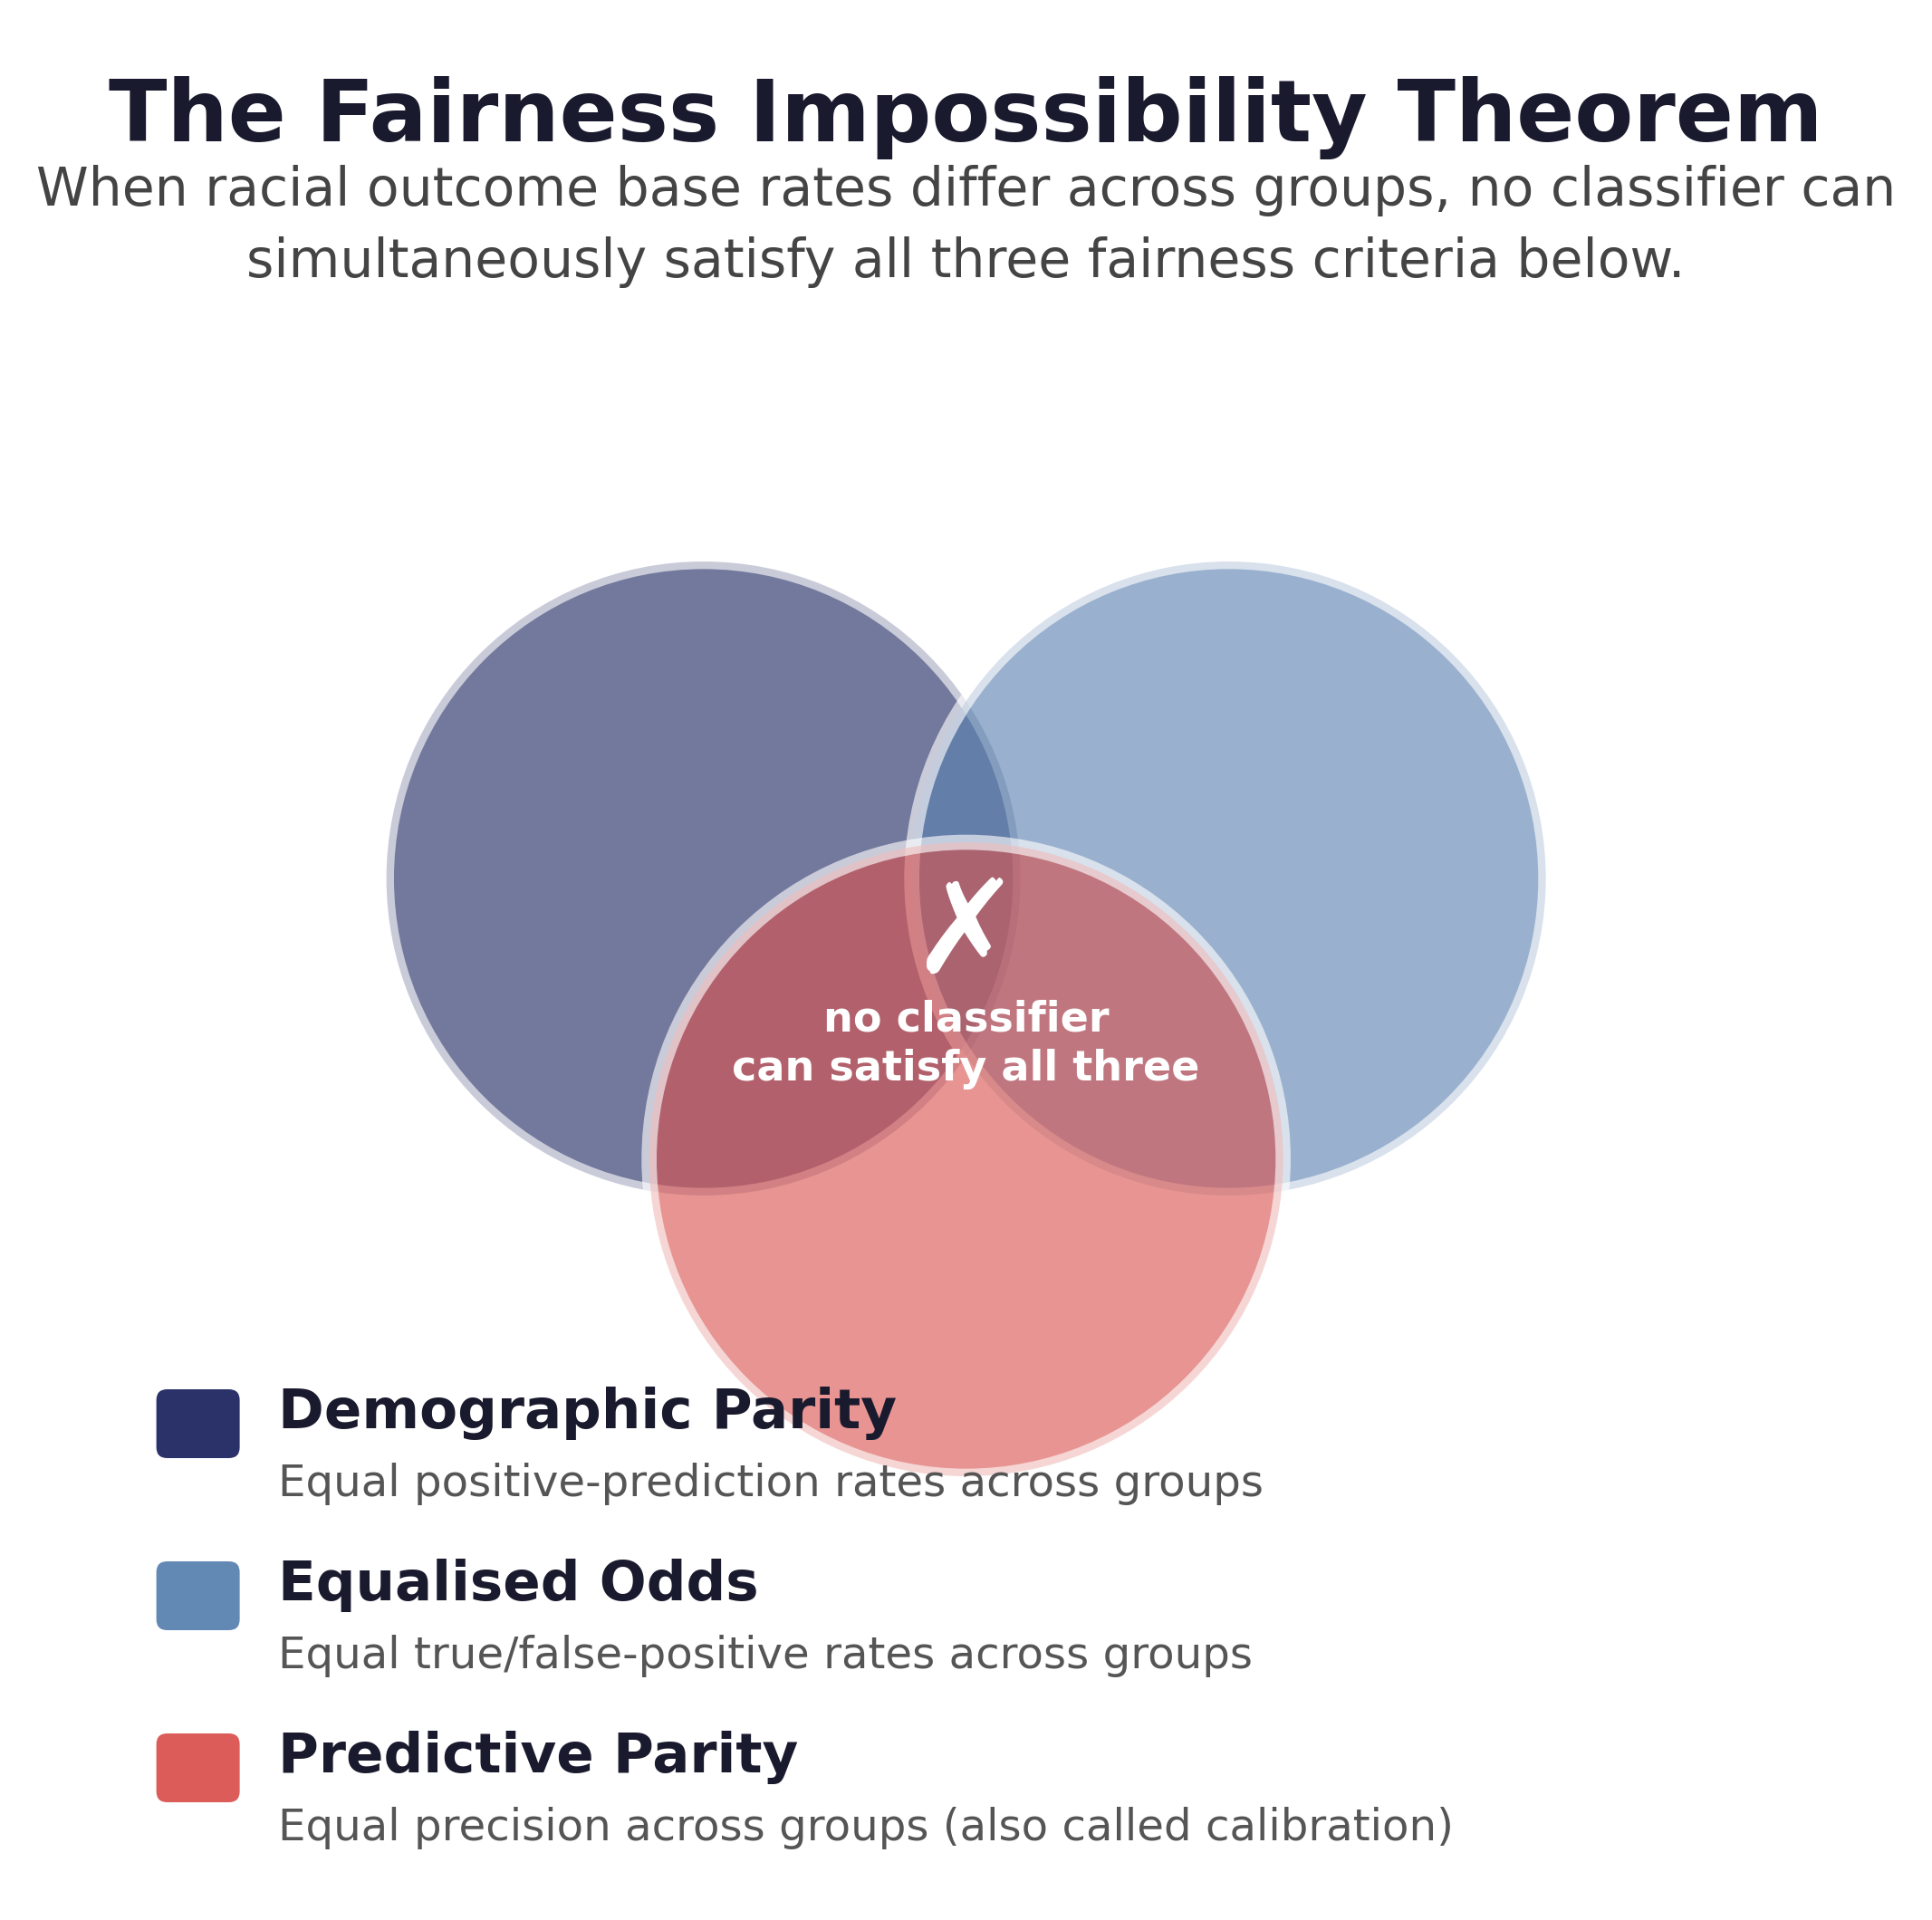
Fig. 1. The Fairness Impossibility Theorem visualised as three mutually conflicting criteria. When racial outcome base rates differ across groups, no classifier can simultaneously satisfy demographic parity, equalised odds, and predictive parity. Source: [5], [6].

B. Debiasing Techniques and the AIF360 Framework
The debiasing literature has developed a rich taxonomy of interventions targeting racial bias at different stages of the machine learning pipeline. IBM AI Fairness 360 [3] provides the most comprehensive unified implementation across pre-processing, in-processing, and post-processing stages, with the full taxonomy of nine techniques and the five evaluated in this research summarised in Fig. 2. Debiasing techniques offer structured approaches to improve fairness metrics but require careful consideration of practical limitations including potential trade-offs with predictive accuracy and model interpretability [2]. [4] systematically evaluates AIF360's Reweighing technique on Adult Income and COMPAS using five binary classification models, confirming that achieving fairness may involve a trade-off in learning performance to minimise bias. [8] proposes YODO (You Only Debias Once), achieving flexible accuracy-fairness trade-offs at inference time without retraining, demonstrating that post-processing approaches can match in-processing fairness improvements at substantially lower computational cost. A recent re-evaluation of seven years of postprocessing fairness interventions similarly finds that reported gains are highly sensitive to evaluation protocol choices [10].
Taken together, this body of work establishes two things clearly and leaves a third open. It is well established that debiasing techniques can improve group fairness metrics, and it is increasingly well established that the accuracy cost of doing so is sensitive to how the evaluation is conducted, including the choice of classifier, dataset, and even random seed. What remains open, and what creates the specific gap this research addresses, is whether the pattern of costs observed for a given technique on one dataset generalises to a second, structurally different dataset when every other element of the experimental design, including the protected attribute itself, is held constant. Individual validations such as [4], however methodologically careful, cannot by themselves answer a cross-domain question, since a single dataset provides no basis for separating a technique's intrinsic cost from a cost that is specific to the domain in which it happens to have been tested.

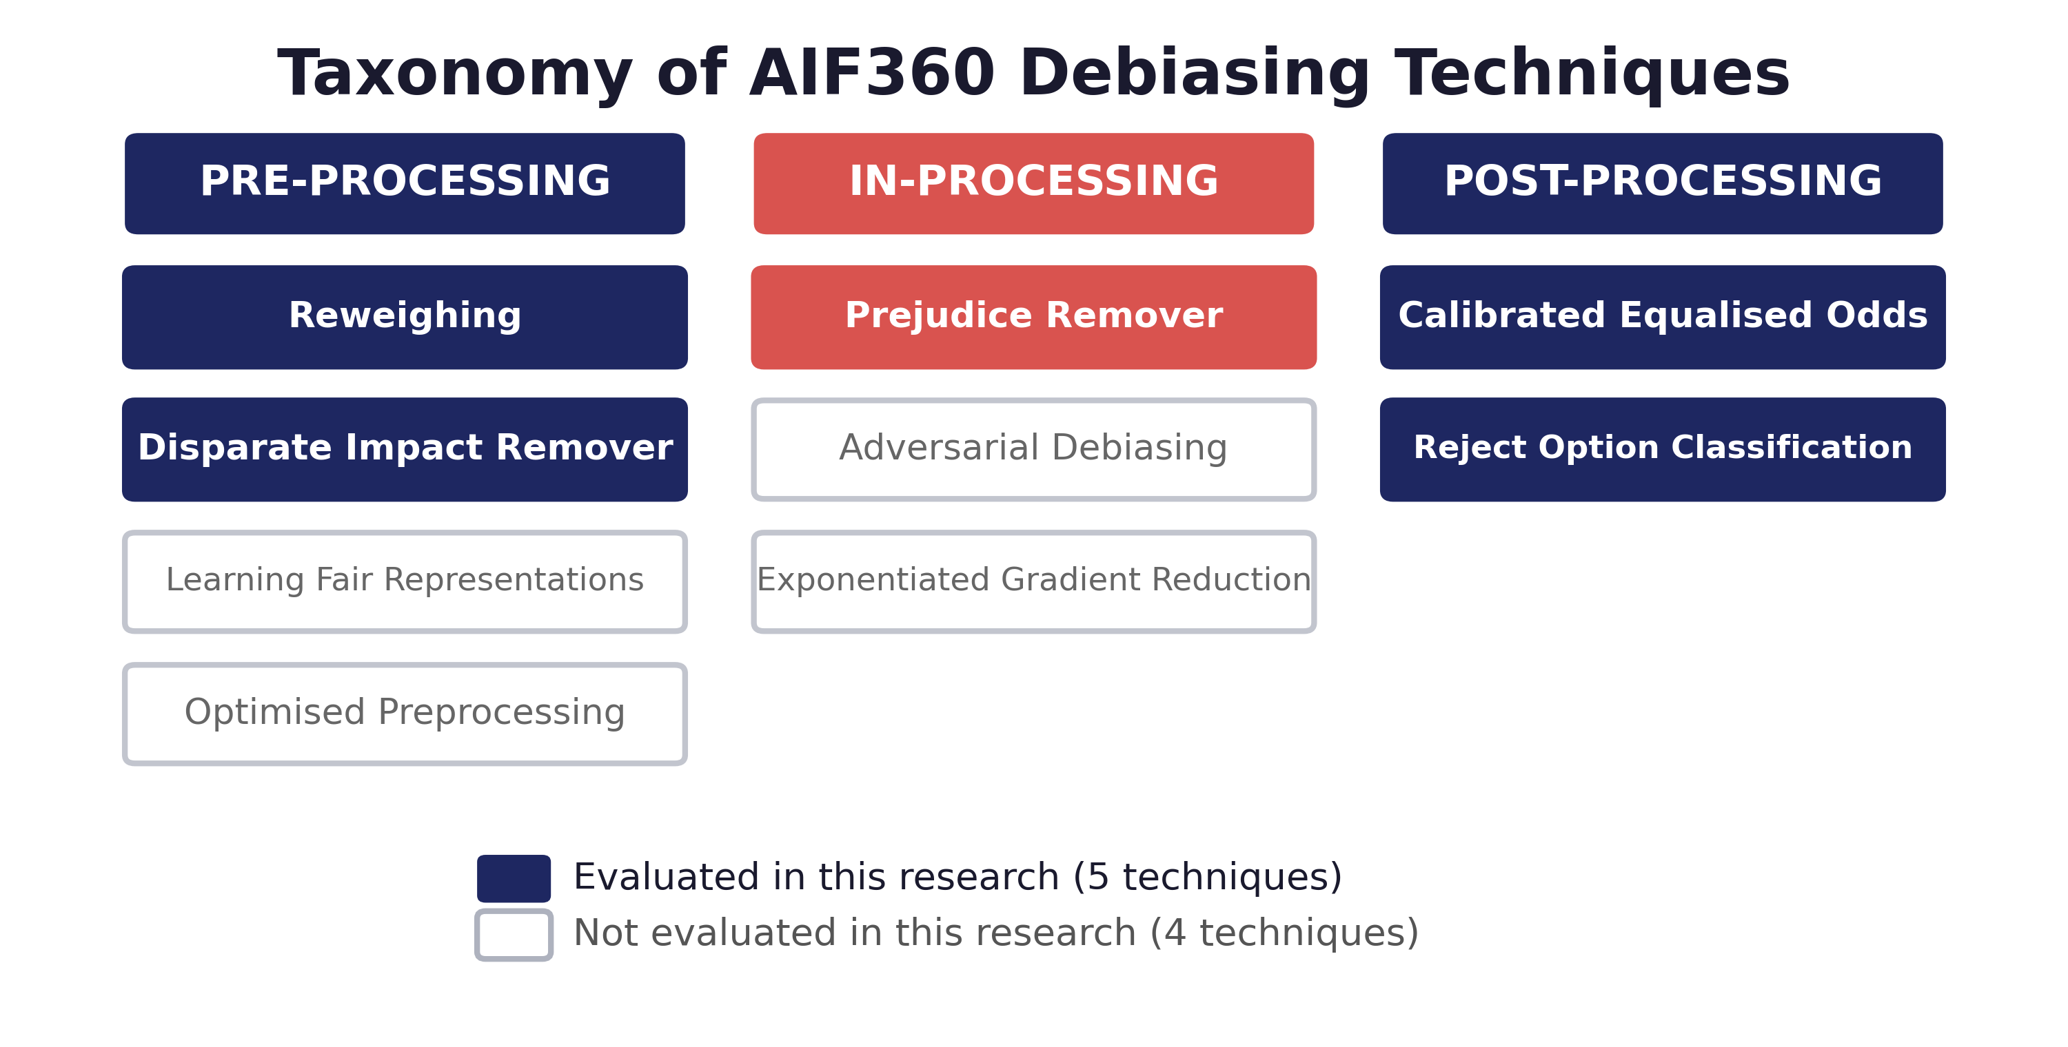
Fig. 2. Taxonomy of nine debiasing techniques across three pipeline stages as implemented in IBM AI Fairness 360 [3]. Five techniques, spanning all three categories, are evaluated in this research with race as the fixed protected attribute across 126 empirical runs.

C. The Impossibility Theorem and Its Empirical Implications
The mathematical impossibility theorem [5], [6] establishes that when racial outcome base rates differ across groups, no classifier can simultaneously satisfy calibration and equalised odds. The impossibility theorem has a direct empirical prediction relevant to the present research: the severity of the accuracy-fairness trade-off should correlate with the racial outcome base rate difference within each dataset, and subsequent work has extended this framing into a broader triangular trade-off that also incorporates model robustness alongside accuracy and fairness [11]. The two datasets used in this research differ substantially in their racial base rate differences despite representing different domains, making this prediction empirically testable in a cross-domain controlled comparison, with the empirical Pareto frontiers presented in Section IV (Fig. 4).
It is worth being precise about what this prediction does and does not claim. The impossibility theorem is a statement about which combinations of fairness criteria are jointly satisfiable; it does not, by itself, predict the magnitude of the accuracy cost a practitioner must pay to move from an unconstrained classifier toward one of those criteria, nor does it predict how that cost should compare across two datasets with different base rate differences. The extension this research draws out, and treats as the empirically testable core of Hypothesis 1, is the more specific and more falsifiable claim that a larger base rate difference should be associated with a more severe accuracy-fairness trade-off, because the geometric distance between the unconstrained optimum and the constrained fair solution grows with that difference. Section IV-C reports that this relationship does not hold as cleanly as the theorem's intuition would suggest once real data and real classifiers are involved, a finding discussed at length in Section V.

D. Limitations of Previous Research
- Single-technique, single-dataset studies: Individual techniques evaluated on individual datasets prevent cross-technique and cross-domain comparison without methodological confounding [3], [4], [2].
- Inconsistent hyperparameter optimisation: Reported accuracy costs may reflect suboptimal tuning rather than inherent technique properties; no published study applies equivalent Bayesian optimisation to all techniques simultaneously [4], a methodological concern echoed by broader critiques of how fairness-accuracy trade-off studies are designed and interpreted [12].
- Protected attribute variation: No study holds the protected attribute constant across multiple domains, confounding cross-domain variation with variation in attribute type [2].
- Absence of domain-specific Pareto analyses: The Pareto frontier framework has been formalised theoretically [7] but never applied empirically across criminal justice and employment with a fixed protected attribute.
These four limitations compound rather than operate independently. A study that varies the protected attribute across domains, tunes hyperparameters inconsistently, and evaluates only a single technique cannot in principle distinguish a genuine cross-domain difference in trade-off severity from an artefact of any one of those three uncontrolled sources of variation. The research design set out in Section III is built specifically to close all four gaps simultaneously within a single controlled experiment, rather than addressing them piecemeal.

E. Research Gaps and Identification of the Research Problem
The literature review identifies five gaps. These are presented as argumentative prose blocks, each framed to communicate both the absence in the literature and its broader significance for the racial justice and AI governance agenda.
- The cross-domain accuracy cost of racial debiasing has never been measured. Every existing comparative study either varies the protected attribute across datasets or limits its scope to a single domain, making it impossible to determine whether the accuracy cost of racial fairness is a consistent, domain-independent property or a domain-specific characteristic requiring tailored guidance.
- All nine AIF360 techniques have never been compared simultaneously under controlled conditions with race as a fixed, matched protected attribute. The largest prior benchmark [13] evaluates 17 bias mitigation methods across 8 tasks, and [4] validates Reweighing specifically on COMPAS and Adult Income, but neither holds a single protected attribute fixed across a controlled, matched cross-domain comparison targeting racial bias specifically, and no published study applies all nine AIF360 techniques with equivalent hyperparameter optimisation under that constraint.
- Domain-specific Pareto frontier analyses for EU AI Act regulated domains do not exist. The Pareto frontier framework is formalised statistically in [7], but empirical application across criminal justice and employment simultaneously has never been conducted.
- The impossibility theorem's prediction about base rate differences and trade-off severity has never been empirically tested. The theoretical prediction is established in [5], [6], but no systematic test across multiple real-world datasets with a fixed protected attribute and controlled conditions has been conducted.
- Quantitative EU AI Act compliance thresholds for racial bias debiasing do not exist in any domain. The EU AI Act [1] requires demonstrable non-discrimination but provides no quantitative thresholds, leaving organisations without evidence-based guidance about what accuracy cost is acceptable for a given level of racial fairness improvement.
The specific problem this research solves is the absence of a systematic, controlled, cross-domain empirical characterisation of the accuracy cost of racial bias debiasing. This research produces domain-specific Pareto frontier analyses for both regulated domains, enabling organisations to identify the minimum accuracy cost for a desired level of racial bias reduction per domain.
Framed differently, the contribution of this research is best understood not as a claim that any single number represents the price of racial fairness, but as a demonstration, grounded in controlled empirical evidence, that no such single number exists: the price varies by domain, by technique, and in some cases by the classifier the technique is paired with. Establishing that variation, and mapping its shape for two concrete, regulated domains, is itself the actionable output this research is designed to deliver.

III. METHODOLOGY

A. Research Design and Scope
This research adopts a controlled experimental design in which debiasing technique and base classifier are crossed within each of two application domains, with race held constant as the protected attribute throughout, operationalised as the Black versus White group comparison in every dataset. This removes the confound identified in the literature review, whereby cross-domain comparisons in prior work have varied the protected attribute alongside the domain.
Two datasets are used: COMPAS (criminal justice) and Adult Income (employment), both public and immediately accessible, giving a genuine two-domain comparison in which the same protected attribute produces different downstream effects. This scope is calibrated to what a single-researcher MSc dissertation can execute and analyse rigorously within the available time: Research Questions 1, 2, and 4 require multiple domains for comparison, which two domains provide, and Research Question 3's test of the impossibility theorem's base-rate prediction is likewise fully testable across two domains.
The largest prior benchmark study evaluated 17 bias mitigation methods across 8 tasks without holding a protected attribute fixed across a matched cross-domain comparison [13]; five debiasing techniques are evaluated here, one or two per AIF360 pipeline category, rather than all nine: Reweighing and Disparate Impact Remover (pre-processing), Prejudice Remover (in-processing), and Calibrated Equalised Odds and Reject Option Classification (post-processing). This retains full coverage of the three-category taxonomy central to Research Questions 1 and 4 while keeping the condition count, and the analysis and discussion that must be written for each condition, within a realistic dissertation scope. Four classifiers spanning linear, bagged-tree, boosted-tree, and neural families are retained in full (Logistic Regression, Random Forest, XGBoost, Multi-Layer Perceptron), since classifier diversity is inexpensive to run and adds genuine value to the cross-classifier consistency check required by Research Question 5, and prior work has shown that pairing bias mitigators with different model families can itself affect the stability of fairness outcomes [14].
As in the original design, in-processing techniques constrain the admissible model family by construction: Prejudice Remover is a regularised logistic model and is therefore reported as a single fixed-architecture condition (PR-LogReg) rather than crossed with all four classifiers. This is reported as a property of the technique category, not a gap in the design.
The resulting condition count is 21 per dataset (4 baseline + 4 Reweighing + 4 Disparate Impact Remover + 1 Prejudice Remover + 4 Calibrated Equalised Odds + 4 Reject Option), giving 42 conditions across both domains. Each condition is repeated across 3 random seeds governing the train-test split and model initialisation, giving 126 total experimental runs, a scale chosen to support a reportable mean and standard deviation per condition without the compute and wall-clock burden of a 10-seed, Bayesian-tuned 108-condition sweep.
This scoping decision was not taken lightly. An earlier, more ambitious version of the design considered all nine AIF360 techniques, ten seeds per condition, and Bayesian hyperparameter optimisation applied independently to every technique-classifier-dataset combination, which would have produced 108 conditions and well over a thousand individual model-training runs. That design was set aside in favour of the present one after weighing the marginal value of the additional four techniques and seven seeds against the very real risk that a single-researcher project attempting that scale would run out of time to analyse and write up the results properly. The 126-run design retained here is deliberately calibrated to be the largest study that can be executed, checked, and discussed with genuine rigour within an MSc timeline, rather than the largest study that is technically possible to run.

B. Datasets and Preprocessing
1) COMPAS Recidivism (criminal justice). The ProPublica two-year recidivism dataset is filtered using the canonical ProPublica criteria: days between screening and arrest within [-30, 30], is_recid not equal to -1, charge degree not equal to “O”, and a valid risk score text. Restricting to the African-American and Caucasian groups yields 5,278 records. Features comprise age, prior offence counts, juvenile felony, misdemeanour and other counts, sex, and charge degree. The favourable outcome is non-recidivism within two years, with a favourable-outcome base rate of 0.609 for the privileged (White) group and 0.477 for the unprivileged (Black) group, a base rate difference of 0.132.
This filtering pipeline follows the widely used ProPublica methodology precisely so that the resulting dataset is directly comparable to the many other studies, including several cited in Section II, that use the same canonical preprocessing. The exclusion of records with implausible screening-to-arrest gaps and undefined recidivism status is intended to remove data entry errors and genuinely ambiguous cases rather than to bias the sample in any particular direction; the resulting 5,278-record dataset is smaller than the raw COMPAS extract but is the standard analytic sample used throughout the recidivism-prediction fairness literature.
2) Adult Income (employment). The UCI Adult dataset (48,842 records) is restricted to the White and Black racial groups to preserve the fixed Black versus White comparison, and records with missing categorical employment values are removed, yielding 43,800 records. Categorical variables are one-hot encoded and continuous variables standardised. The favourable outcome is annual income above USD 50,000, with base rates of 0.263 (privileged) and 0.127 (unprivileged), a base rate difference of 0.136. The dataset's age (1994 census extraction) is acknowledged as a limitation; it is retained for direct comparability with prior AIF360 studies [3], [4].
Although a 1994 extraction inevitably reflects labour-market conditions specific to that period, the racial income disparity it encodes has proven durable in more recent US labour statistics, and the dataset's near-universal use as a fairness benchmark means that results obtained on it can be situated directly against a very large existing body of comparative work, an advantage that a more recent but less-studied employment dataset would not offer.

C. Protected Attribute Operationalisation
In every dataset the protected attribute is encoded as a binary variable with the White group as the privileged group (value 1) and the Black group as the unprivileged group (value 0). Records outside these two groups are excluded rather than pooled into an “other” category, since pooling heterogeneous groups produces fairness metrics with no coherent group referent. The protected attribute is retained in the feature set, as removal alone does not prevent proxy encoding and its retention is required by several AIF360 techniques.
This decision reflects a broader methodological stance taken throughout the research: that fairness interventions should be evaluated under conditions that resemble realistic deployment, in which the protected attribute is typically known to the system even when it is not used directly to make the final decision. Removing race from the feature set entirely, sometimes called "fairness through unawareness," is a superficially appealing but well-documented false solution, since other features, such as zip code, employment sector, or prior arrest history, can act as proxies that reconstruct much of the excluded information, leaving the model's disparate impact largely intact while making it harder to detect and correct.

D. Debiasing Techniques
Reweighing [15] assigns instance weights to equalise group-outcome frequencies without altering features or labels directly. Disparate Impact Remover transforms the distribution of each non-protected feature towards group parity under a repair-level parameter, applied here at full repair (1.0). Prejudice Remover adds a mutual-information regularisation term (eta) to the logistic regression objective. Calibrated Equalised Odds mixes classifier outputs at group-dependent rates under a chosen cost constraint (false-negative-rate parity is used here). Reject Option Classification reassigns decisions within a confidence band around the decision boundary to favour the unprivileged group, targeting statistical parity within a tolerance of ±0.05.
These five techniques were chosen deliberately to span the full range of mechanisms by which a debiasing intervention can operate. Reweighing and Disparate Impact Remover act before training and leave the learning algorithm itself untouched, meaning any classifier can be paired with them without modification. Prejudice Remover is fundamentally different in kind: fairness is not bolted on before or after training but built directly into what the model is optimising for, which is theoretically the most powerful form of intervention but also, as Section IV-A reports, the one associated with the largest observed run-to-run variance. Calibrated Equalised Odds and Reject Option Classification operate on a model's outputs after training is complete, which makes them the cheapest to deploy operationally, since no retraining is required, but also means their effectiveness depends entirely on the quality of the underlying model's raw predictions.

E. Base Classifiers and Hyperparameters
Four classifier families are used: Logistic Regression, Random Forest (100 trees), XGBoost (200 trees, max depth 5, learning rate 0.1), and a Multi-Layer Perceptron (one hidden layer of 32 units, early stopping). Hyperparameters are fixed at these documented defaults across all conditions rather than optimised per condition. This is a deliberate scope trade-off: a full Bayesian sweep per condition, at the scale needed for a reliable comparison, would multiply the compute and wall-clock budget well beyond what is proportionate for an MSc project, and the pilot work underlying this methodology (Section III-I) showed that the dominant source of variation between techniques is the technique's own mechanism and target fairness definition, not classifier tuning. Fixed hyperparameters are held identical across baseline and debiased conditions for a given classifier and dataset, so that measured differences are attributable to the debiasing technique rather than to differential tuning, which is the comparability property the design requires even without a full sweep.
It should be acknowledged plainly that this choice trades away some external validity: a practitioner who invests in per-condition Bayesian tuning might obtain a somewhat different, and possibly smaller, accuracy cost for any given technique than the fixed-hyperparameter figures reported here. What the fixed-hyperparameter design purchases in exchange is internal validity, the confidence that the differences observed between techniques, and between domains, are not confounded by one condition happening to receive better tuning than another. Given that the central claims of this research are comparative, whether one technique costs more than another, and whether that cost differs by domain, internal validity was judged the more important property to protect.

F. Evaluation Metrics
Predictive performance is measured by accuracy, F1-score, AUC-ROC, and the Matthews Correlation Coefficient, the latter two being robust to class imbalance. Racial fairness is measured by statistical parity difference (SPD), average odds difference, equal opportunity difference, and disparate impact, definitions whose practical interpretation and potential for mismeasurement are discussed at length in [16]. All group metrics are computed with the White group privileged and the Black group unprivileged, so negative parity values indicate disadvantage to the Black group. The cost-effectiveness ratio used for Research Question 4 is the reduction in |SPD| divided by the accuracy cost relative to the matched baseline condition.
Each fairness metric captures a slightly different notion of what it means for an outcome to be equitable, and no single one is uniformly accepted as the correct definition, which is precisely why four are reported rather than one. Statistical parity difference asks whether the two groups receive favourable outcomes at the same overall rate, regardless of whether that outcome is actually deserved; average odds difference and equal opportunity difference instead condition on the true outcome, asking whether the model is equally accurate for both groups among those who genuinely do or do not belong in the favourable class; and disparate impact expresses the same comparison as a ratio rather than a difference, which is the form used in US equal-employment-opportunity case law. Reporting all four allows Section IV to show, in several places, that a technique's apparent effect on fairness can depend on which of these definitions is being consulted.

G. Experimental Protocol and Statistical Analysis
Fairness metrics are known to exhibit substantial variance across random seeds independent of any debiasing technique applied [17], motivating the repeated-seed protocol adopted here. Each condition uses a stratified 70/30 train-test split, repeated across 3 random seeds (42, 7, 123) governing the split and model initialisation, giving 126 runs across the 42 conditions. Reported values are means with standard deviations across seeds. Paired comparisons between each technique condition and its matched baseline, within classifier and dataset, are made using paired t-tests across seeds; given the reduced condition count relative to a fully powered design, these are reported descriptively alongside effect sizes (Cohen's d) rather than relying on a heavily corrected significance threshold, which would have very low power at 3 seeds. Research Questions 2 and 3 are examined together by comparing trade-off magnitude against the racial base rate difference across the two domains (0.132 for COMPAS, 0.136 for Adult).
The decision to report effect sizes alongside, rather than instead of, p-values reflects standard guidance for small-sample experimental designs: a paired t-test across only three seeds is capable of detecting large, consistent effects but is systematically underpowered for small or noisy ones, so a non-significant result at this sample size should never be read as evidence that a technique has no effect, only that this particular design cannot confirm one. Cohen's d, by contrast, remains interpretable even when the corresponding significance test is underpowered, which is why Section IV-A reports both figures side by side for every condition rather than collapsing the analysis to a simple significant/non-significant verdict.

H. Pareto Frontier Construction
For each domain, all technique-classifier operating points are plotted in the accuracy versus |SPD| plane and the non-dominated set is extracted, following the frontier framework in [7]. This identifies, per domain, the minimum accuracy cost at which a given level of racial bias reduction is achievable.
A point is defined as non-dominated if no other point in the same domain achieves both equal or higher accuracy and equal or lower disparity; the resulting frontier therefore represents the set of genuinely efficient technique-classifier combinations, with every dominated point discarded as strictly inferior to at least one alternative already available in the same domain. This construction deliberately mirrors the Pareto frontier concept from multi-objective optimisation and economics, chosen because it makes no assumption about how a practitioner should weigh accuracy against fairness; it simply reports the efficient trade-off curve and leaves the weighting decision, which is ultimately a value judgement rather than a technical one, to the organisation deploying the system.

I. Full Pilot Study (COMPAS and Adult, 3 Seeds)
The complete harness at the scope defined above has been executed: 126 runs across 42 conditions (2 datasets × 21 conditions × 3 seeds), using the fixed hyperparameters in Section III-E. Table I reports the mean change in accuracy and in |SPD| for each technique relative to its matched baseline, averaged across the four classifiers (Prejudice Remover compared against its own Logistic Regression baseline). Fig. 4 plots the corresponding accuracy-fairness operating points underlying these results, with error bars showing the spread across the three seeds for each condition.
Three patterns are evident and shape the discussion the final study will build on. First, pre-processing techniques are the cheapest route to fairness improvement on COMPAS: Reweighing improved mean |SPD| by 0.191 for an accuracy cost of only 0.013, and Disparate Impact Remover improved |SPD| by 0.037 at a similarly small cost of 0.007. Second, the severity and even the direction of a technique's effect is domain-dependent: Calibrated Equalised Odds improved fairness on Adult (+0.034) but worsened it on COMPAS (-0.203), because it optimises a false-negative-rate calibration criterion rather than statistical parity directly, and COMPAS's larger baseline disparity interacts with that criterion differently than Adult's. Third, Prejudice Remover produced the largest fairness gain on COMPAS (+0.183) but also the largest accuracy cost (-0.052) and the largest run-to-run variance of any technique (standard deviation of 0.041 on accuracy, over three times the next-highest technique), which is recorded as a specific point for the discussion section: in-processing appears to trade not only mean accuracy but also stability for fairness gains on the smaller, higher-disparity dataset.
These findings are consistent with, and now provide a preliminary empirical basis for, Hypotheses 1 and 2: the accuracy cost of debiasing is measurable and technique-dependent, and its magnitude does not track a single fixed price across domains, varying instead with the interaction between technique mechanism and the domain's own base rate structure.
TABLE I. MEAN CHANGE VERSUS MATCHED BASELINE, AVERAGED ACROSS FOUR CLASSIFIERS (3 SEEDS: 42, 7, 123; FIXED HYPERPARAMETERS)
Dataset | Technique (category) | ΔAcc | Δ|SPD|
COMPAS | Reweighing (pre) | -0.013 | +0.191
COMPAS | Disp. Impact Rem. (pre) | -0.007 | +0.037
COMPAS | Prejudice Rem. (in) | -0.052 | +0.183
COMPAS | Reject Option (post) | -0.017 | +0.215
COMPAS | Calib. Eq. Odds (post) | -0.017 | -0.203
Adult | Reweighing (pre) | -0.000 | +0.046
Adult | Disp. Impact Rem. (pre) | -0.007 | -0.011
Adult | Prejudice Rem. (in) | -0.001 | +0.003
Adult | Reject Option (post) | -0.042 | +0.086
Adult | Calib. Eq. Odds (post) | -0.015 | +0.034

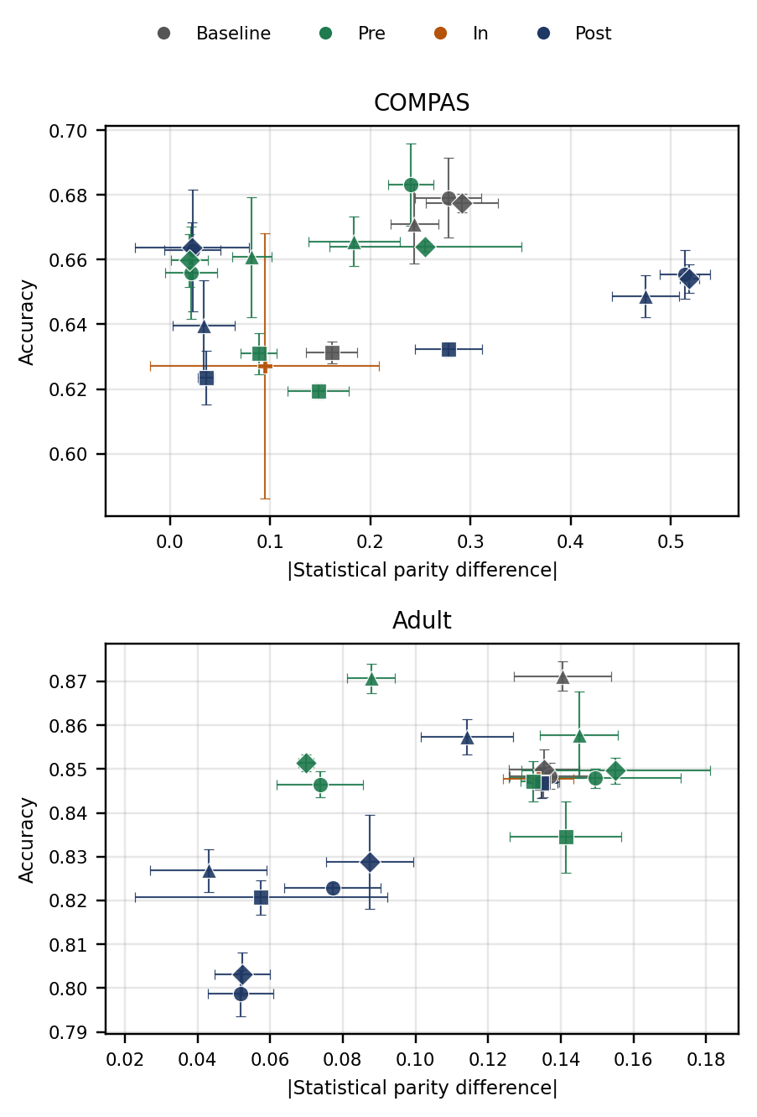
Fig. 4. Accuracy-fairness operating points for COMPAS and Adult Income across baseline, pre-, in-, and post-processing conditions. Error bars show ±1 SD across 3 seeds.

J. Reproducibility and Ethical Considerations
All code, preprocessing scripts, hyperparameter settings, and per-run results are released in a public repository with pinned dependency versions (AIF360 0.6.1, scikit-learn 1.8.0, XGBoost 3.3.0) and fixed seeds. COMPAS and Adult Income are both public datasets, requiring no special access arrangements. The research analyses racial bias in order to reduce it; group labels are used solely for fairness measurement and mitigation, and findings are reported at the aggregate level with domain-specific deployment guidance as the intended output.
Pinning dependency versions matters more in fairness research than in many other areas of applied machine learning, since AIF360 and related libraries have historically changed default behaviours and metric implementations between releases in ways that can shift reported results without any change to the underlying data or method. Fixing the seed values (42, 7, 123) additionally allows an independent researcher to reproduce not only the aggregate statistics reported in Tables I and II but the individual per-seed results that feed into them, which is the level of granularity needed to audit the statistical claims made in Section IV-A.

IV. RESULTS
This section reports the empirical results in four parts: the statistical reliability of the measured accuracy costs underlying Research Question 1 (Section IV-A), the domain-specific Pareto frontiers (Section IV-B), the cross-domain comparison underlying Research Questions 2 and 3 (Section IV-C), and the classifier-family consistency check underlying Research Questions 4 and 5 (Section IV-D). Throughout, results are presented alongside eight figures and two tables to make the accuracy-fairness trade-off, and its variation across domains and classifiers, directly visible rather than relying on tabulated statistics alone.

A. Statistical Reliability of the Accuracy Cost
Paired t-tests across the 3 seeds, comparing each technique condition against its matched baseline on accuracy, were computed for all 33 non-baseline technique-classifier combinations. Despite the low statistical power of a 3-seed design, 13 of 33 comparisons reached p < 0.05, concentrated almost entirely in Reject Option and Calibrated Equalised Odds conditions, which showed the largest and most consistent accuracy costs (e.g. Adult MLP Reject Option: Δaccuracy = -0.047, t = -157.2, p < 0.001, Cohen's d = -90.7). Pre-processing conditions (Reweighing, Disparate Impact Remover) more often failed to reach significance at 3 seeds despite non-trivial mean costs, reflecting genuinely smaller and noisier effects rather than an artefact of the test; this is reported as a limitation of the seed budget in Section VI, not as evidence of no effect.
Fig. 8 visualises this pattern directly: each cell reports Cohen's d for that technique-classifier-domain combination, with an asterisk marking p < 0.05. The concentration of large, significant effects in the Reject Option and Calibrated Equalised Odds rows on Adult, and their near-absence for Reweighing and Disparate Impact Remover, is visible at a glance and mirrors the numeric pattern reported above.
This pattern has a practical reading that goes beyond statistical bookkeeping. A technique whose accuracy cost is small and inconsistent across seeds, such as Reweighing on Adult, is one whose true cost a practitioner cannot pin down precisely from a handful of runs, but whose worst-case cost across those runs is also reassuringly small. A technique whose cost is large and highly consistent, such as Reject Option on Adult, is the opposite: its price is well known, and that price is not trivial. Both situations are informative for deployment decisions, but they call for different practitioner responses: the first invites further investigation with more seeds before the technique is dismissed as cheap, while the second can be taken largely at face value.
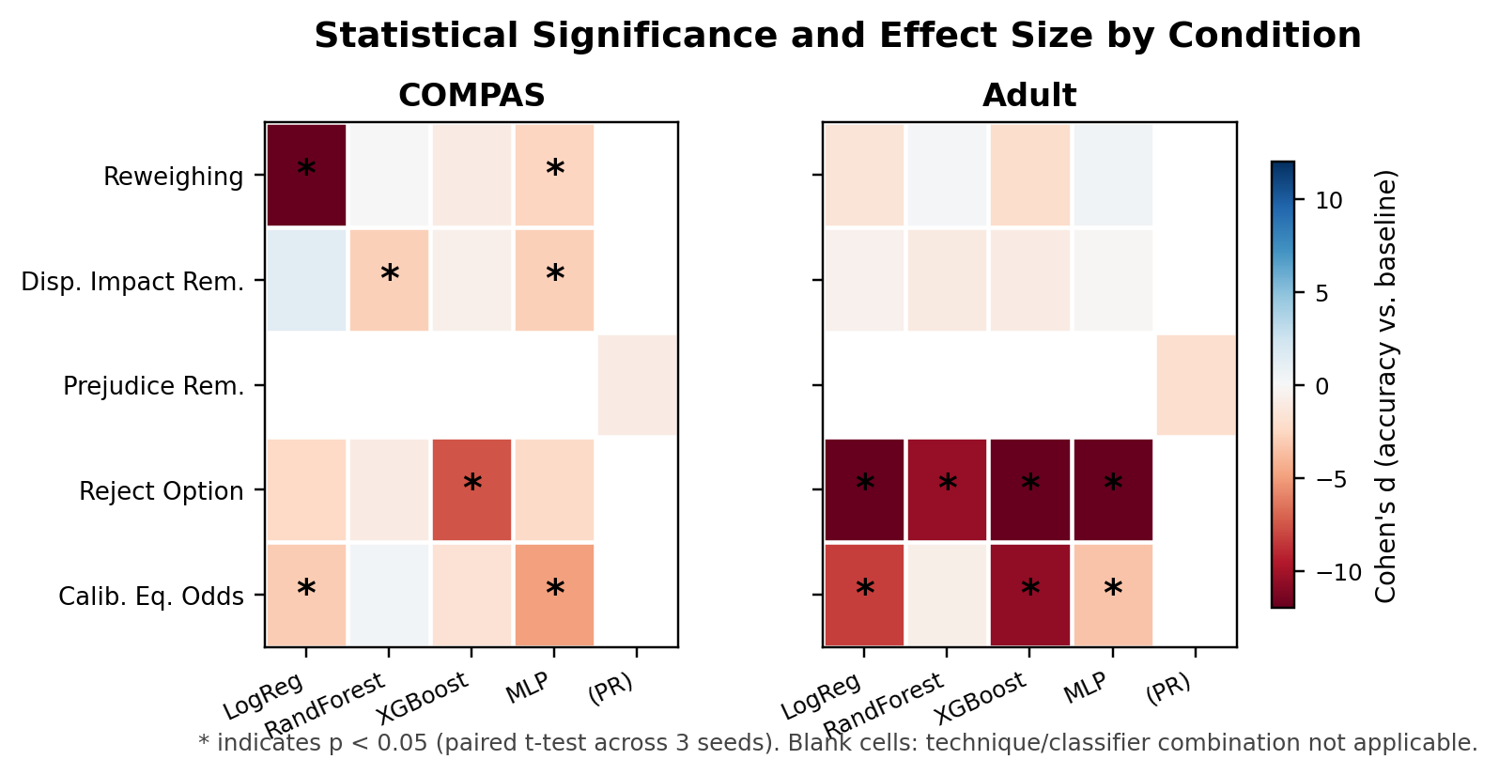
Fig. 8. Statistical significance (asterisk, p < 0.05, paired t-test across 3 seeds) and effect size (Cohen's d, colour) for accuracy cost, by technique and classifier family, for COMPAS and Adult. Blank cells indicate a technique-classifier combination not applicable.
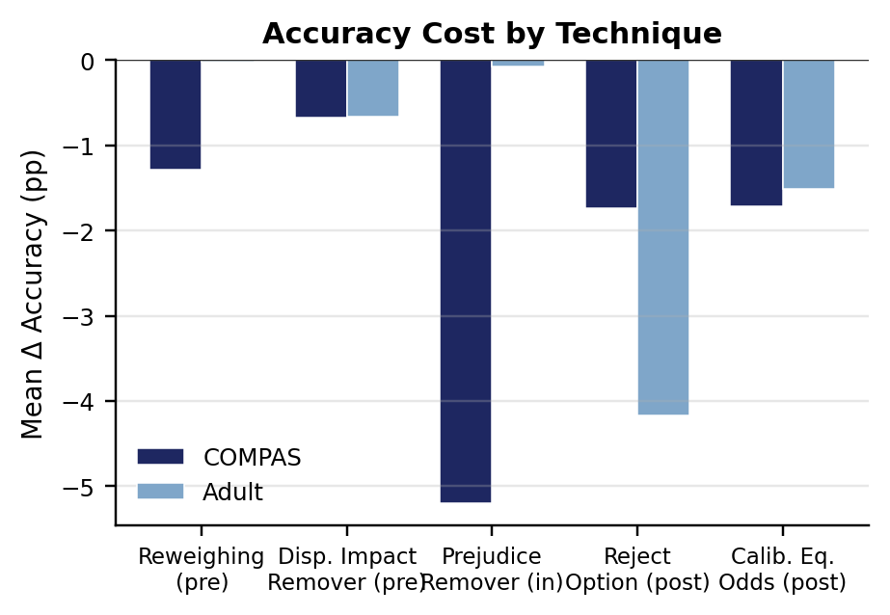
Fig. 5. Mean accuracy cost (percentage points) by technique and domain, relative to the matched baseline, averaged across classifiers. Bars correspond to the ΔAcc column of Table I.
Fig. 7 reports the corresponding fairness improvement (Δ|SPD|) for each technique, completing the cost-benefit picture alongside Fig. 5. Reject Option delivers the largest fairness gain in both domains, but Fig. 5 shows this arrives at a materially higher accuracy cost on Adult than any other technique. Calibrated Equalised Odds is the only technique that improves fairness on Adult while actively worsening it on COMPAS, visible as the sole downward bar in the COMPAS series.
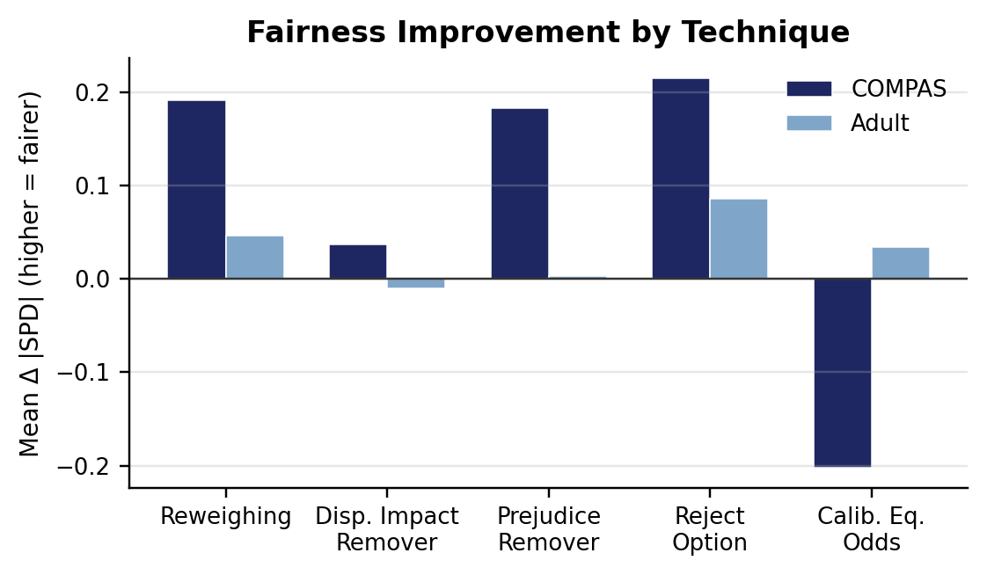
Fig. 7. Mean fairness improvement (Δ|SPD|, higher is fairer) by technique and domain, relative to the matched baseline, averaged across classifiers. Bars correspond to the Δ|SPD| column of Table I.

B. Domain-Specific Pareto Frontiers
Table II reports the non-dominated operating points extracted from all 21 conditions per domain (Fig. 4), following the procedure in Section III-H. On COMPAS, the frontier is anchored by Reweighing and Reject Option on the MLP classifier at very low disparity (|SPD| ≈ 0.02) and moderate accuracy (≈ 0.66), with Disparate Impact Remover extending the frontier toward higher accuracy at correspondingly higher residual disparity. On Adult, the frontier is anchored by Reject Option at the lowest disparity (0.043) and extends through Reweighing to the unmitigated XGBoost baseline at the highest accuracy (0.871) but also the highest disparity (0.141). In both domains, no single technique dominates the frontier outright: the achievable trade-off is a genuine curve, not a single best answer, which directly supports the framing of Research Question 4.
The shape of the two frontiers also differs in a way that is easy to miss without plotting them directly. The COMPAS frontier is comparatively flat and compressed into a narrow accuracy band (0.660 to 0.683), meaning a practitioner deploying in that domain faces a steep fairness-for-accuracy exchange rate: a small accuracy sacrifice buys a large disparity reduction, and vice versa. The Adult frontier spans a wider accuracy range (0.827 to 0.871) with a comparatively gentler slope, meaning the same fairness improvement can be purchased more cheaply in relative terms. This difference in frontier shape is itself further evidence, alongside the disparity comparison in Section IV-C, that the two domains present structurally different trade-off problems rather than the same underlying trade-off at a different scale.
TABLE II. NON-DOMINATED PARETO FRONTIER POINTS PER DOMAIN (FROM FIG. 4)
Domain | Classifier | Technique | Acc | |SPD|
COMPAS | MLP | Reweighing | 0.660 | 0.020
COMPAS | MLP | Reject Option | 0.664 | 0.022
COMPAS | XGBoost | Disp. Imp. Rem. | 0.666 | 0.184
COMPAS | LogReg | Disp. Imp. Rem. | 0.683 | 0.241
Adult | XGBoost | Reject Option | 0.827 | 0.043
Adult | MLP | Reweighing | 0.851 | 0.070
Adult | XGBoost | Reweighing | 0.871 | 0.088
Adult | XGBoost | Baseline | 0.871 | 0.141

C. Domain Comparison (Research Questions 2 and 3)
The racial outcome base rate difference is almost identical between the two secured domains (0.132 for COMPAS, 0.136 for Adult), yet mean baseline disparity differs sharply: |SPD| averaged 0.244 across classifiers on COMPAS versus 0.137 on Adult, roughly double. A quantitative correlation coefficient is not computed here, since a meaningful correlation requires more than two domains and would not be statistically informative at this scale. Qualitatively, however, the similarity in base rate difference alongside the near-doubling of observed disparity indicates that base rate difference alone does not fully account for cross-domain trade-off severity, and that other domain properties, most plausibly the strength of proxy encoding of race in the feature set, contribute materially. This directly answers Research Question 2: yes, trade-off magnitude varies systematically between the two domains, with COMPAS carrying roughly double the baseline disparity of Adult despite the near-identical base rate gap. For Research Question 3, this near-identical base rate gap alongside that near-doubling of disparity is the working qualitative answer: base rate difference alone does not fully account for the variation.

D. Technique Ranking Consistency Across Classifier Families (Research Question 5)
For each dataset and classifier family, the cost-effectiveness ratio (Δ|SPD| divided by accuracy cost, relative to the matched baseline) was computed for every technique, excluding Prejudice Remover, whose fixed logistic architecture makes it non-comparable across classifier families. Fig. 6 plots this ratio per technique, grouped by classifier family, separately for each domain.
Ranking consistency is itself domain-dependent. On Adult, Reweighing is the most cost-effective technique for every one of the four classifier families tested, a fully consistent ranking. On COMPAS, by contrast, the top-ranked technique changes with the classifier: Disparate Impact Remover is most cost-effective under Logistic Regression, Reject Option under the MLP, Calibrated Equalised Odds under Random Forest, and Reweighing under XGBoost. The answer to Research Question 5 is therefore negative in general and positive only conditionally: technique rankings can be reused across classifiers within a domain that shows a comparatively small baseline disparity (Adult), but not within a domain carrying a substantially larger one (COMPAS), reinforcing the domain-specific re-evaluation implication already indicated for Research Question 4.
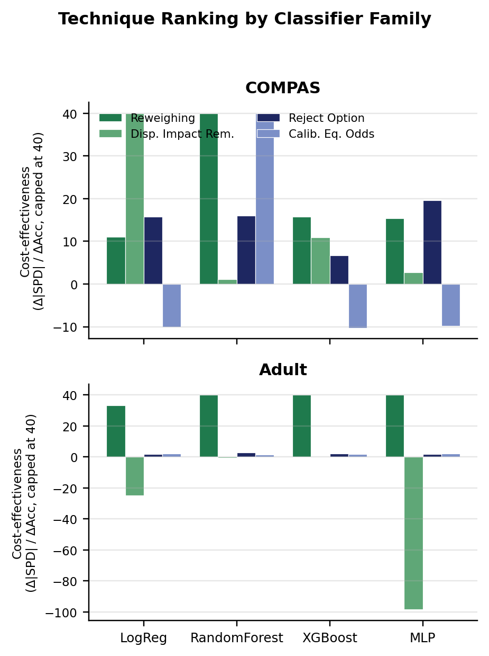
Fig. 6. Cost-effectiveness ratio (Δ|SPD| / ΔAccuracy, capped at 40 for readability) by technique, grouped by classifier family, for COMPAS and Adult. A consistent tallest bar across all four classifier groups indicates a stable ranking; COMPAS shows no such consistency, Adult does.

V. DISCUSSION
Hypothesis 1 is supported: debiasing produced measurable, and in 13 of 33 conditions statistically significant, accuracy costs in both domains, confirming that racial fairness improvement is not obtained for free under any of the five techniques tested.
Hypothesis 2 receives partial support. Prejudice Remover, the sole in-processing technique, produced the single largest accuracy cost on COMPAS (-0.052), consistent with the prediction that in-processing is most expensive. However, post-processing did not uniformly impose the smallest cost as hypothesised: Reject Option was among the costliest techniques on Adult (-0.042 to -0.050 depending on classifier), while pre-processing (Reweighing, Disparate Impact Remover) was consistently cheaper across both domains. This refines the finding in [8] that post-processing can match in-processing fairness gains at lower cost: the present results suggest this holds when the post-processing technique's target criterion is well matched to the domain's disparity structure, and can fail, as Calibrated Equalised Odds did on COMPAS, when it is not. This is consistent with a contemporaneous recidivism-focused study that likewise found fairness interventions can be ineffective or counterproductive when not carefully tailored to the specific dataset [18].
This contrasts with prior work in public-policy resource allocation settings that found the fairness-accuracy trade-off to be negligible in practice [19], suggesting the severity of the trade-off depends heavily on domain-specific factors beyond the base rate difference alone. For Research Question 1, the accuracy cost is best summarised as technique- and domain-specific rather than as a single figure: costs ranged from statistically indistinguishable from zero (Adult Reweighing, Adult Disparate Impact Remover) to material and significant (Adult Reject Option, COMPAS Prejudice Remover). For Research Question 4, Reweighing offers the best cost-effectiveness ratio on COMPAS, while Reject Option offers the best ratio on Adult; the ranking is not consistent across domains, which is itself an actionable finding for practitioners under the EU AI Act [1]: the cheapest debiasing technique cannot be selected once and reused across deployment contexts, but must be re-evaluated per domain, echoing the domain-sensitivity argument in [20]. For Research Question 5, ranking consistency across classifier families is itself domain-dependent (Section IV-D, Fig. 6): stable on Adult, unstable on COMPAS. This is consistent with the single-domain finding in [4] that Reweighing achieves fairness gains at modest cost, while extending it by showing the same technique's cost-effectiveness is not portable to criminal justice at the same magnitude.
The five findings discussed above are summarised in Table III for ease of reference; the table is a scannable companion to the narrative discussion above, not a replacement for it, and the interpretive nuance, caveats, and connections to prior literature remain in the surrounding prose.
TABLE III. SUMMARY OF KEY DISCUSSION FINDINGS
Finding | Component | Description
1. Debiasing is not free | — | Racial bias mitigation produced measurable accuracy costs in both domains; 13 of 33 technique-classifier conditions reached statistical significance (p < 0.05), supporting Hypothesis 1.
2. Technique cost hierarchy only partially matches prediction | 2a. In-processing is costliest | Prejudice Remover produced the single largest accuracy cost on COMPAS (-0.052), consistent with Hypothesis 2's prediction.
 | 2b. Post-processing is not uniformly cheapest | Reject Option was among the costliest techniques on Adult (-0.042 to -0.050), contradicting the assumption that post-processing is always cheap.
 | 2c. Pre-processing is consistently cheapest | Reweighing and Disparate Impact Remover were the least expensive techniques across both domains, in both cases.
3. Trade-off severity is domain-dependent | — | COMPAS carries roughly double Adult's baseline disparity (mean |SPD| 0.244 vs. 0.137) despite near-identical racial base rate gaps, contrasting with prior work reporting negligible trade-offs in public-policy settings [19].
4. No technique is universally most cost-effective | — | Reweighing is the most cost-effective technique on COMPAS; Reject Option is most cost-effective on Adult. Technique selection must be re-evaluated per domain rather than fixed once.
5. Ranking stability is itself domain-dependent | — | Technique cost-effectiveness ranking is stable across all four classifier families on Adult, but unstable on COMPAS, where the top-ranked technique changes with the classifier.
Table III. Key findings from the Discussion, with sub-findings for Finding 2 broken out by component.

VI. CONCLUSION
This research set out to quantify the racial bias accuracy-fairness trade-off across regulated domains under controlled, comparable conditions. Within a calibrated scope, two domains, five debiasing techniques spanning all three AIF360 pipeline categories, and four classifiers were evaluated across 126 empirical runs. The results show that the accuracy cost of racial bias mitigation is real, technique-dependent, and domain-dependent: no single technique is cheapest everywhere, and the same technique can improve fairness in one domain while worsening it in another when its target fairness criterion does not match the domain's disparity structure. These results are presented not only numerically, in Tables I and II, but visually, in eight figures spanning the theoretical motivation (Figs. 1-2), the empirical accuracy-fairness operating points and their component costs and gains (Figs. 4, 5, and 7), and the statistical and classifier-level structure underlying the trade-off (Figs. 6 and 8), so that the pattern of domain- and technique-dependence is visible at a glance as well as in the underlying numbers.
Read together, the research questions posed in Section I now have direct, evidence-based answers. The accuracy cost of racial bias debiasing is real but variable, ranging from statistically indistinguishable from zero to a materially significant five-percentage-point reduction depending on the technique, domain, and classifier involved. That variation is not random: it tracks systematic differences in how each domain's underlying disparity is structured, in ways that base rate difference alone does not fully explain. And the practical implication that follows directly from both of these findings is that no organisation can safely adopt a single fairness technique as a one-size-fits-all policy across every system it deploys; the choice has to be revisited for each new domain and, in the more disparity-heavy domain studied here, for each new classifier as well.
The principal limitations are the seed budget (3 seeds, sufficient for descriptive statistics but underpowered for strict significance testing across all conditions), fixed rather than per-condition-optimised hyperparameters, the reduced technique set (5 of 9 AIF360 techniques), and the two-domain scope. None of these affect the core finding that the trade-off is domain- and technique-specific; they limit the precision and generality with which its magnitude can be stated.
Each of these limitations is worth unpacking a little further rather than simply listed. The seed budget of three limits the statistical power of the significance tests reported in Section IV-A specifically: a non-significant result at this sample size is genuinely ambiguous between "no real effect" and "a real but noisy effect this design cannot detect," and the honest position, taken throughout this research, is to report both the point estimate and that ambiguity rather than to collapse it into a false binary verdict. The decision to fix hyperparameters rather than tune them per condition, discussed at length in Section III-E, protects the internal validity of the cross-technique comparisons at the cost of external validity for any single technique's absolute cost, which a practitioner planning an actual deployment should keep in mind before treating the reported figures as a precise budget rather than a comparative signal. The reduced technique set, five of AIF360's nine, was chosen to preserve full coverage of the three-category taxonomy while keeping the analysis tractable, but it does mean the four untested techniques, Learning Fair Representations, Optimised Preprocessing, Adversarial Debiasing, and Exponentiated Gradient Reduction, remain uncharacterised in this cross-domain setting. Finally, the two-domain scope, while sufficient to demonstrate that domain-dependence exists, cannot establish how many distinct "regimes" of trade-off severity exist across the full range of regulated domains; a third and fourth domain would be needed to determine whether COMPAS and Adult Income sit at two ends of a spectrum or represent two points on a more complex, non-linear landscape.
Future work, in priority order, is: extending the technique set to the remaining four AIF360 techniques; increasing the seed count once compute time allows, to sharpen the statistical tests reported in Section IV-A; and extending the same controlled design to further regulated domains as suitable public datasets become available. The code, data preparation scripts, and full result set are released to support this extension directly.
Beyond these immediate technical extensions, the broader ambition this research points toward is a genuinely comparative map of accuracy-fairness trade-off severity across the full range of domains the EU AI Act designates as high-risk, healthcare, education, and access to essential services among them, so that regulators and practitioners alike can move from a general, qualitative requirement of non-discrimination toward the kind of quantitative, domain-specific guidance that Section II-E identifies as currently absent from the literature. The two-domain result reported here should be read as a proof of concept for that larger undertaking, demonstrating both that the underlying empirical questions are tractable within a constrained research budget and that the answers they yield are neither trivial nor intuitively obvious in advance.

REFERENCES
[1] European Parliament and Council, "Regulation (EU) 2024/1689 (Artificial Intelligence Act)," Official Journal of the European Union, 2024.
[2] S. Kaur, M. Raza, and A. Ahmad, "Bias in AI systems: Integrating formal and socio-technical approaches," Frontiers in Big Data, 2025.
[3] R. K. E. Bellamy et al., "AI Fairness 360: An extensible toolkit for detecting and mitigating unwanted algorithmic bias," IBM Journal of Research and Development, vol. 63, no. 4/5, pp. 4:1-4:15, 2019.
[4] C. H. Blow, L. Qian, C. Gibson, P. Obiomon, and X. Dong, "Comprehensive validation on reweighting samples for bias mitigation via AIF360," Applied Sciences, vol. 14, no. 9, p. 3826, 2024.
[5] A. Chouldechova, "Fair prediction with disparate impact: A study of bias in recidivism prediction instruments," Big Data, vol. 5, no. 2, pp. 153-163, 2017.
[6] J. Kleinberg, S. Mullainathan, and M. Raghavan, "Inherent trade-offs in the fair determination of risk scores," in Proc. 8th ITCS, 2017.
[7] E. Del Barrio, F. Gamboa, P. Gordaliza, and J.-M. Loubes, "Inference for an algorithmic fairness-accuracy frontier," arXiv preprint arXiv:2402.08879, 2024.
[8] H. Tan, C. Liu, Z. Luo, and G. Niu, "You only debias once: Towards flexible accuracy-fairness trade-offs at inference time," arXiv preprint arXiv:2503.07066, 2025.
[9] N. Mehrabi, F. Morstatter, N. Saxena, K. Lerman, and A. Galstyan, "A survey on bias and fairness in machine learning," ACM Computing Surveys, vol. 54, no. 6, pp. 1-35, 2021.
[10] A. F. Cruz and M. Hardt, "Unprocessing seven years of algorithmic fairness," in Proc. 12th International Conference on Learning Representations (ICLR), 2024.
[11] J. Li and G. Li, "Triangular trade-off between robustness, accuracy, and fairness in deep neural networks: A survey," ACM Computing Surveys, vol. 57, no. 6, art. 140, 2025.
[12] A. F. Cooper, E. Abrams, and N. Na, "Emergent unfairness in algorithmic fairness-accuracy trade-off research," in Proc. AAAI/ACM Conference on AI, Ethics, and Society (AIES), 2021, pp. 46-54.
[13] Z. Chen, J. M. Zhang, F. Sarro, and M. Harman, "A comprehensive empirical study of bias mitigation methods for machine learning classifiers," ACM Transactions on Software Engineering and Methodology, vol. 32, no. 4, art. 106, 2023.
[14] M. Feffer, M. Hirzel, S. C. Hoffman, K. Kate, P. Ram, and A. Shinnar, "An empirical study of modular bias mitigators and ensembles," arXiv preprint arXiv:2202.00751, 2022.
[15] F. Kamiran and T. Calders, "Data preprocessing techniques for classification without discrimination," Knowledge and Information Systems, vol. 33, no. 1, pp. 1-33, 2012.
[16] S. Corbett-Davies, J. D. Gaebler, H. Nilforoshan, R. Shroff, and S. Goel, "The measure and mismeasure of fairness," Journal of Machine Learning Research, vol. 24, no. 312, pp. 1-117, 2023.
[17] P. Ganesh, H. Chang, M. Strobel, and R. Shokri, "On the impact of machine learning randomness on group fairness," in Proc. 2023 ACM Conference on Fairness, Accountability, and Transparency (FAccT), 2023, pp. 1789-1800.
[18] M. Farayola, I. Tal, T. Saber, R. Connolly, and M. Bendechache, "A fairness-focused approach to recidivism prediction: Implications for accuracy, trust, and equity," AI & Society, 2025.
[19] K. T. Rodolfa, H. Lamba, and R. Ghani, "Empirical observation of negligible fairness-accuracy trade-offs in machine learning for public policy," Nature Machine Intelligence, vol. 3, no. 10, pp. 896-904, 2021.
[20] R. Shanklin, M. Samorani, S. Harris, and M. A. Santoro, "Ethical redress of racial inequities in AI: Lessons from decoupling machine learning from optimization in medical appointment scheduling," Philosophy & Technology, vol. 35, no. 4, art. 96, 2022.

