https://www.ted.com/  
  
SEO Success Factor:

* Content Quality (Cq) Well-written content
* Fresh Content (Cf) About technology, recent global issues (e.g. north Korea)
* Verticals (Vc) Many videos and images used.
* Mobile (Am) Loads well on mobile
* Speed (As) Loads fast enough
* Https (Ah) Secure
* HTML Title (Ht) Contains keyword Ted, Ideas
* HTML descriptions (Hd) “Influential videos from expert speakers”
* HTML structure (Hs) Well-structured with divs, headers etc.
* Engage (Te) Spend a great deal of time scrolling through and watching talks
* History (Th) Been here since 1984
* Ads (Va) Not ad heavy
* Personal history (Ph) I visit the site a lot
* Social reputation (Sr) Mentioned by renowned brand accounts on Twitter and Facebook
* Social shares (Ss) Shared extensively on Twitter and Facebook

What Runs ted.com

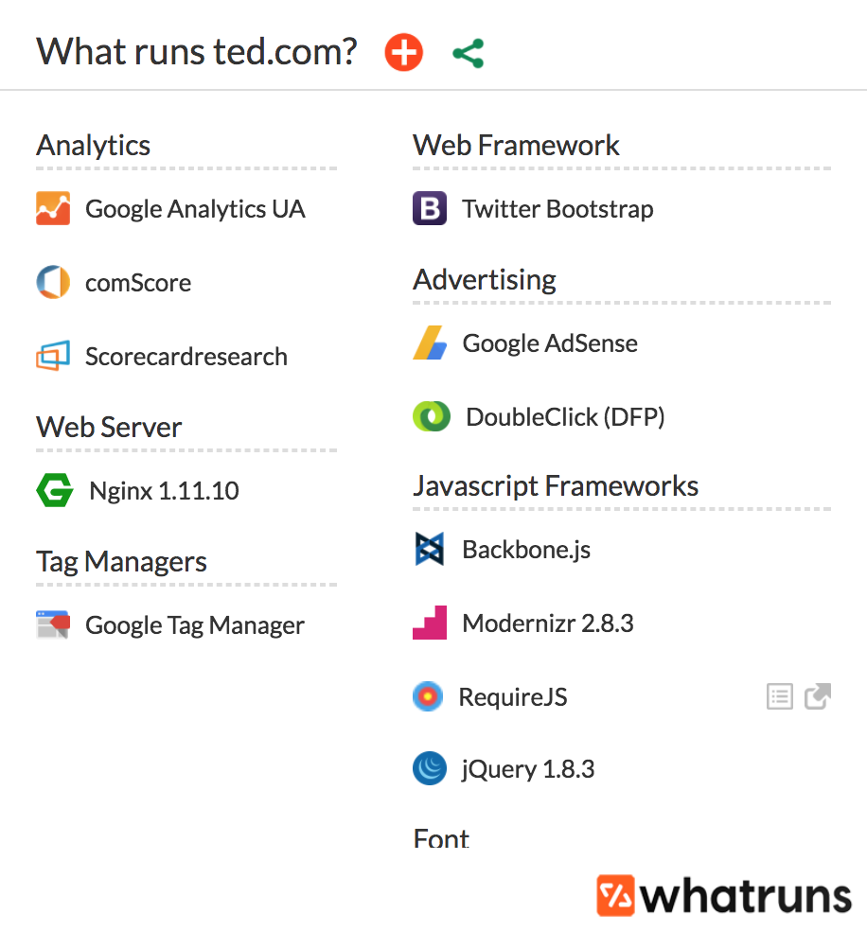

Analytics (Systematic analysis of data)

**Google Analytics UA:** Universal analytics allows Ted to track users by user ID and propose talks that will be interesting to the particular user based on their previous picks

**comScore:** Provides marketing data and analytics to Ted

**Scorecardresearch:** It provides market research data to Ted through a mixture of online surveys and the use of web beacons.

Web Server

**Nginx 1.11.10:** Help host and load Ted’s webpage

Tag Managers

**Google Tag Manager:** Tag management system that allows Ted to quickly and easily update tags and code snippets on their website or mobile app.

Web Framework

**Twitter Bootstrap:** Frontend toolkit for its website.

Advertising

**Google AdSense:** Allowing placement of relevant banners on Ted’s website

**DoubleClick (DFP):** Advertising Ted on other websites

Javascript Frameworks (backbone of single page web applications development)

**Backbone.js:** Gives structure to web app by providing models with key-value binding and custom events, collections with a rich API of enumerable functions, views with declarative event handlings, and connects all to an existing API.

**Modernizr 2.8.3:** Feature detection library for HTML5/CSS3 based on user’s browser

**RequireJS:** File and module loader that increases speed and quality of code

**jQuery 1.8.3:** Javascript library