Static and Dynamic Routing – Exploration s Verification
Submitted by:
Jom Joseph
24ubc137
II BCA A
PART A – Conceptual Grounding

STATIC ROUTING
- What it means to manually define a route
Imagine you’re giving turn-by-turn directions to a delivery driver. You don’t say “find the best way.”
You say:
“Go straight, take the second left, then the highway, then exit 5.” That’s exactly what static routing is.
When you manually define a route, you are telling the router:
  - If you want to reach Network X
  - Send the packet through THIS next router
  - No thinking, no checking alternatives
The router does zero discovery. It doesn’t ask neighbours.
It doesn’t learn from traffic.
It simply follows your instructions, every time.
You, the engineer, become the “brain” of the network.

Why static routes feel predictable but fragile Why they feel predictable
Static routes are comforting because:
  - Traffic always takes the same path
  - There are no surprises
  - Troubleshooting is easy:
    - “Why did the packet go there?”
→Because I told it to
This makes them great for learning and for controlled environments.

Why they are fragile
Now imagine that delivery route again. What happens if:
  - A road is closed?
  - The highway is under construction?
The driver will still follow your directions — and get stuck. That’s static routing.
If:
  - A link goes down
  - A router fails
  - A cable is unplugged

The static route:
  - Does not change
  - Does not reroute
  - Does not warn you
Packets are silently dropped until a human fixes it. So static routing is:
  - Predictable
  - Not resilient
It assumes the network never changes — which is rarely true.

Where static routing makes sense in real networks Static routing is not “bad” — it’s just situational.
- Small, simple networks
Example:
  - One router
  - One ISP
  - One path to the internet Here, static routing is perfect:
  - No complexity
  - Nothing dynamic is needed
  - Less CPU and memory usage

Edge or stub networks
A stub network is one that:
  - Has only one way out Example:
  - A branch office connected to HQ
  - A home router connected to ISP
Since there’s no alternative path, dynamic routing adds no value. Static route = clean and efficient.

Default routes (very common)
Most routers use a static default route:
“If you don’t know where to send the packet — send it to the ISP” This is static routing used intentionally and safely.

Security-sensitive paths
In some cases:
  - You don’t want the router to learn new paths
  - You want strict control over traffic flow Static routes:
  - Prevent unexpected routing changes
  - Reduce attack surfaces

2. Dynamic Routing – Letting Routers Learn

What changes when routers exchange routing information
With dynamic routing, routers stop being obedient followers and start becoming decision-makers.
Instead of you manually telling each router: “Send traffic this way”
Routers begin to:
  - Talk to their neighbours
  - Share what networks they can reach
  - Learn multiple possible paths
  - Update their decisions over time Think of it like GPS navigation.
Instead of fixed directions:
  - The router asks: “Who can get me there?”
  - Compares options
  - Chooses the best available path
  - Changes routes if conditions change So the biggest change is this:
The network starts adapting on its own, without human intervention.

Why dynamic routing protocols exist
Static routing assumes:
  - Links never fail
  - Topology never changes
  - Engineers are always watching Real networks don’t behave that way.
Dynamic routing protocols exist because:
  - Networks grow large
  - Links go up and down
  - Devices fail
  - Traffic patterns change
Manually updating routes in such environments becomes:
  - Slow
  - Error-prone
  - Impossible at scale
Dynamic routing was created to remove humans from constant route management and let routers:
  - Discover paths automatically
  - Keep routing tables updated
  - React faster than any person could In short:
Dynamic routing exists because networks are living systems, not static diagrams.

What problems dynamic routing solves that static routes cannot

- Automatic failure recovery
If a link goes down:
  - Static route → traffic dies
  - Dynamic routing → routers detect the failure and find another path
This happens in seconds, sometimes milliseconds — no engineer required.

Scalability
In small networks, static routes are manageable. In large networks:
  - Hundreds of routers
  - Thousands of networks
Manually defining routes would be a nightmare. Dynamic routing:
  - Learns routes automatically
  - Distributes knowledge across the network
  - Scales without exponential manual work

Path selection and optimization

Static routing:
  - One path, whether it’s good or bad Dynamic routing:
  - Multiple paths available
  - Chooses better ones based on conditions
  - Can shift traffic away from congestion or failures The network becomes responsive, not rigid.

Reduced operational risk
Static routing relies heavily on:
  - Human accuracy
  - Manual updates
  - Perfect documentation Dynamic routing reduces:
  - Configuration mistakes
  - Forgotten routes
  - Long outages caused by slow reaction times Routers continuously correct themselves.

Static vs Dynamic – A Thought Comparison Which one scales better?
Dynamic routing scales far better. As a network grows, static
routing grows linearly with human effort — every new network or path requires manual updates on multiple routers. This quickly becomes unmanageable.

Dynamic routing scales because routers share knowledge automatically. Adding new networks doesn’t require reconfiguring every device; the information propagates on its own. That’s why large enterprise and ISP networks depend on dynamic routing.
Which one fails faster?
Static routing fails faster. When a link or router goes down:
- Static routing keeps sending traffic into a dead path
- There is no correction or fallback
- Communication stops immediately

Dynamic routing may briefly reconverge, but it detects failures and adapts, often restoring connectivity without any human involvement. Static routing fails silently and stays broken until someone intervenes.
Which one requires more human effort?
Static routing requires more continuous human effort.
It may look simple at first, but:
- Every topology change needs manual updates

- Troubleshooting depends on human awareness
- Mistakes are easy and costly Dynamic routing requires more planning initially, but far less day-to-day effort. Once configured, routers handle discovery, updates, and recovery themselves.

PART B – Static Routing Lab
Circuit

Description: The topology consists of interconnected routers and LANs designed to demonstrate routing behavior. This setup helps analyze communication between different networks.
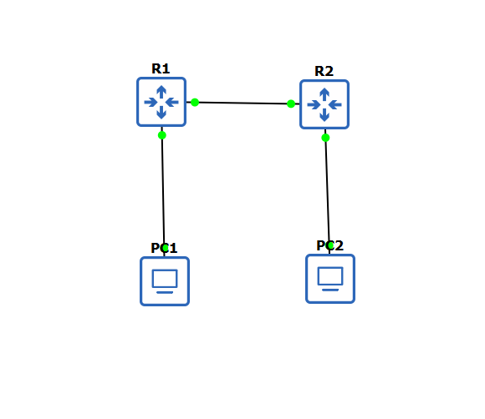

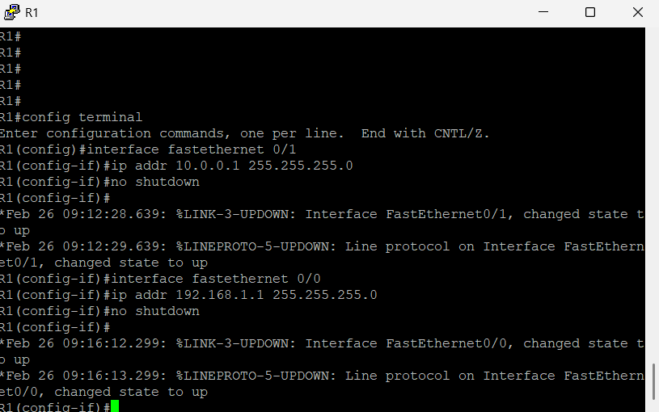
Assigning IP’s to 2 Router

Description: Router R1 was configured with appropriate IP addresses for its LAN interface and the inter-router link to ensure proper connectivity.

R2

Description: Router R2 was assigned IP addresses for its LAN and the link connecting to Router R1, completing the addressing configuration.
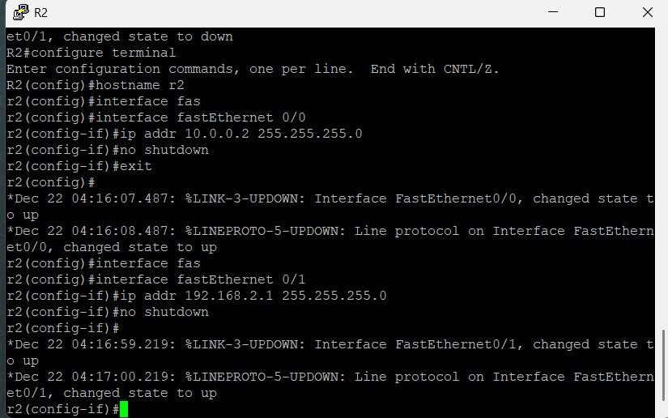

PING from PC1

Description: A ping test from PC1 was performed to verify connectivity. Initial results showed communication with the gateway but not with the remote LAN until routing was configured.
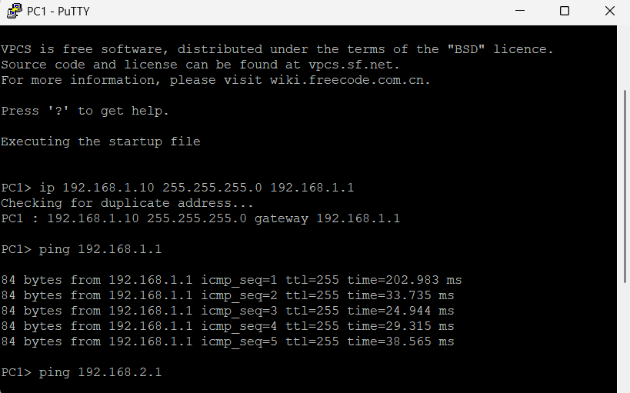

From PC2

Description: A ping from PC2 confirmed local connectivity. Communication with the remote network failed before routing entries were added.

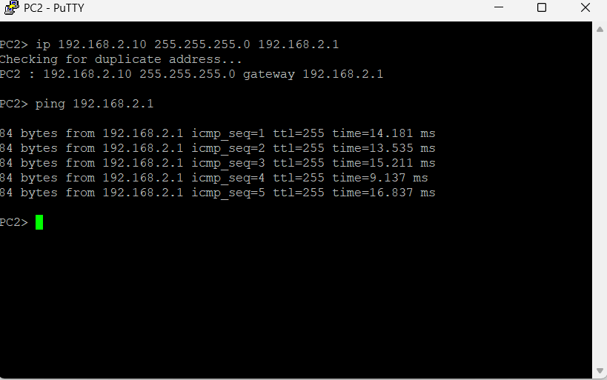

From PC1 to R1 (Unreachable)
Description: This output indicates that packets to the remote network were dropped due to missing route entries in the routing table.

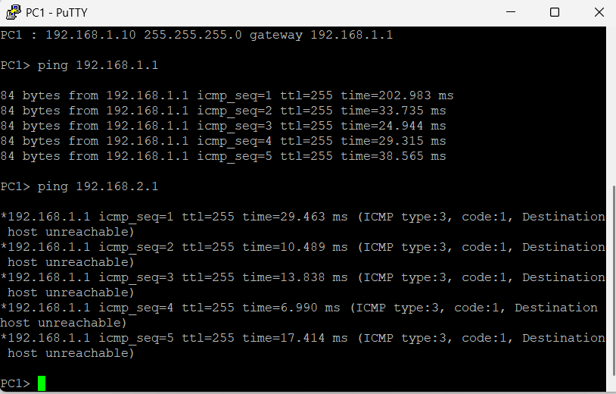s

Routing Table Before Static Routes
Before configuring static routes, the routing table contained only directly connected networks.
On Router 1, the table showed:
- The local LAN network 192.168.1.0/24
- The router-to-router link 10.0.0.0/30
There was no entry for the remote LAN (192.168.2.0/24). Because of this, Router 1 had no knowledge of where to send packets
destined for PC2’s network, and communication between the two LANs failed.
Routing Table After Static Routes
After adding static routes on both routers:
- Router 1 learned how to reach 192.168.2.0/24 via Router 2
- Router 2 learned how to reach 192.168.1.0/24 via Router 1
The routing table now included static (S) routes pointing to the next-hop IP address.
With this information available, routers were able to forward
packets correctly, and end-to-end connectivity between PC1 and PC2 was successful.

What Happens If a Static Route Is Removed?
When a static route is removed: • The router immediately loses knowledge of the remote network • Packets destined for that
network are dropped • Communication between the LANs fails again This shows that static routing depends entirely on manual configuration and does not provide automatic recovery.

PART C – Dynamic Routing Lab
- A network topology with multiple routers and LANs was created using GNS3.
- IP addresses were assigned to all router interfaces and end devices.
- Basic connectivity between PCs and their default gateways was verified. • Static routing was first tested to understand manual route configuration.
- Dynamic routing using RIP was enabled on all routers.
- Routers automatically learned routes to remote networks through RIP.
- End-to-end connectivity between PCs was successfully verified.
- A link failure was simulated by shutting down a router interface.
- Routing tables updated automatically and connectivity was affected

Circuit

Description: The topology consists of interconnected routers and LANs designed to demonstrate routing behavior. This setup helps analyze communication between different networks.
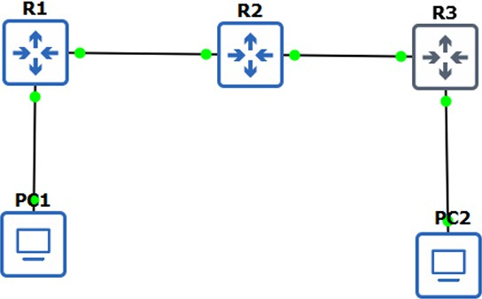

PING from PC1

Description: A ping test from PC1 was performed to verify connectivity. Initial results showed communication with the gateway but not with the remote LAN until routing was configured.
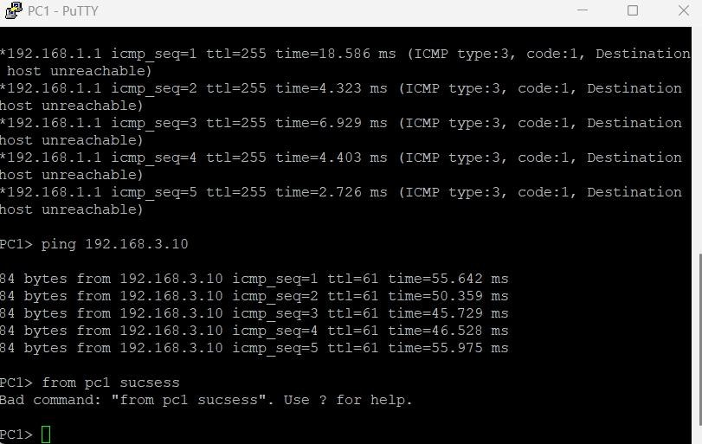

Show IP Routes

Description: The routing table output displays directly connected routes and dynamically learned routes, confirming successful route exchange.

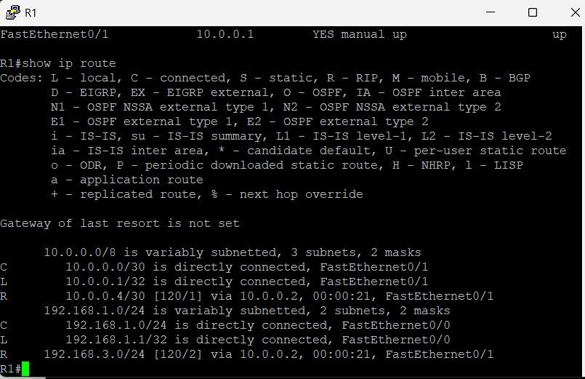

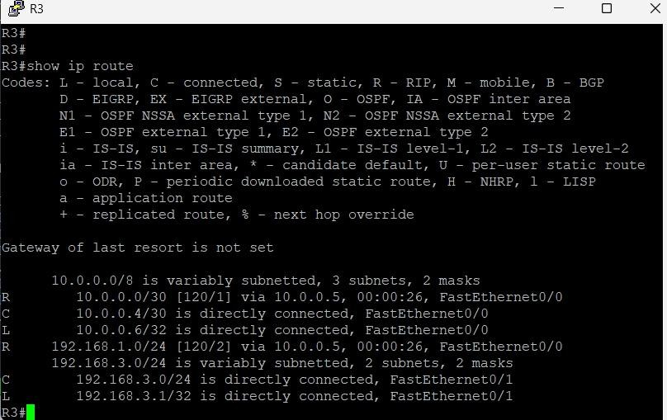

Shutdown Interface in R2

Description: The interface shutdown simulated a link failure. The routing protocol detected the failure and updated the routing table automatically.
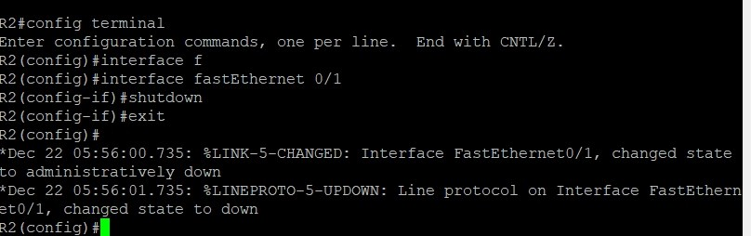

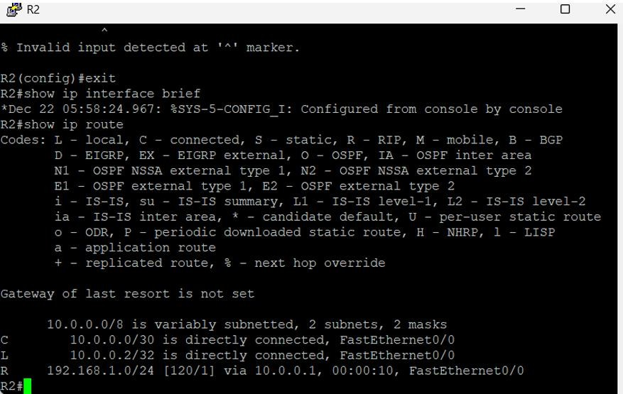

PART D – Static vs Dynamic Routing in Practice
How routing tables differed between static and dynamic routing
In static routing, the routing table contained only directly
connected networks and manually configured static routes. No new routes appeared unless they were added by the
administrator. In dynamic routing, the routing table was populated automatically with routes learned from neighbouring routers, marked with the routing protocol, without manual configuration.
What changed when a link failed
When a link failed in static routing, the routing table did not change and traffic was dropped immediately because no alternate path was available. In dynamic routing, the routing
protocol detected the failure, removed the affected routes from the routing table, and restored connectivity automatically once the link was brought back up.
Which approach felt more “alive”
Dynamic routing felt more “alive” because routers continuously exchanged information and adapted to network changes automatically. Static routing felt rigid and dependent on manual intervention.
One real-world scenario where static routing is better
Static routing is better in small or simple networks such as a
home network or a small branch office with only one path to the internet, where the network rarely changes.

One real-world scenario where dynamic routing is unavoidable
Dynamic routing is unavoidable in large enterprise networks or ISP networks where multiple routers, redundant paths, and frequent topology changes require automatic route discovery and fast failure recovery.

