Headphone Mix

Version 1.1.0

Welcome
Thank you for downloading this fine plug-in. HeadphoneMix is a GUIless plugin which applies a little inter-channel crosstalk to compensate the so called in-head-localisation known from listening with headphones.

In order to get the most out of the HeadphoneMix, please spend a few moments reading this brief manual.

License
HeadphoneMix has a very simple license:

- HeadphoneMix is freeware. This means that you are free to distribute it, give it to friends, or otherwise share it around. However, only the entire unaltered archive, including this document, may be re-distributed.
- Copyright of the code and the finished plug-in remain the property of Christian-W. Budde.
- This plug-in is provided at no cost; therefore the author Christian-W. Budde assume no responsibility for any negative effects that may occur to the end user or the equipment used to run the plug-in.
- Magazine editors are welcome to include the plug-in on cover mount discs or similar media; however, I request that am informed about it via e-mail. A few copies of the publication are always appreciated, but not expected.

The parameter
This plugin only has three parameter: effect, model and polarity.

Effect
The first of this three controls the amount of the effect. If set to zero, it’s bypassed. The maximum of 100% is slightly more effect than you would have in the reality. A setting of 80%-90% should just work fine normally.

Model
You can choose one out of three different models for the abandoned ear. In the below plot, green is the handcrafted curve, green a matched curve of the HDPHX and blue a matched curve to the average of the IRCAM HRTFs.
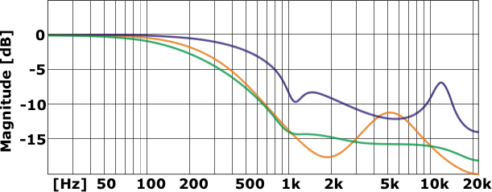

Polarity
The polarity parameter simply switches the polarity of the abandoned ear. The result is a loss of bass instead of a gain. This parameter was implemented for testing purpose only. The green curve is the normal state.
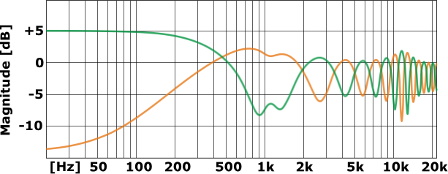
Feedback / Bug Reports
I am always eager to hear feedback or have bugs reported. The easiest
way is to send me a mail to: Christian@savioursofsoul.de

Version History
  - First release!
  - Added HRTF mode and released as open source

Credits

• Programming: Christian W. Budde
• Documentation based on a template by Greg Pettit

VST name and technology © Steinberg GmbH
The VST logo is a trademark of Steinberg GmbH

