**Particular circuit components for GPIO, Timers, and FSM lab**

The following components should be considered into the circuit design:

**Pull-Down Push Button**

Push button that can be configured as normally closed or normally open. (To choose wash states).

Change the switch for a push.

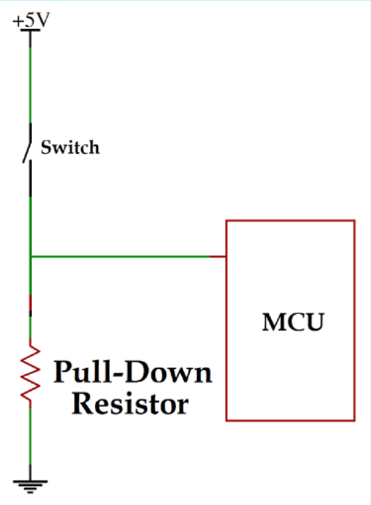 **Filter against rebound effect**

There is a rebound effect generated by the push of the button, that can generate the pushes would not recognize by the system. This is a passive filter to reduce this effect that should be considered in the design.

