**Name: Jomari Albert Langamon**

**Topics to Discuss**

* Adding File to a Repository
* Cloning the Repository
* Pushing the changes to a Remote Repository

**Opening Remarks**

A Git project is represented by a “repository”, which contains the complete history of the project from its inception.

Version control is a system that records changes to a file or set of files over time so that you can recall specific version later.

**The Three States**

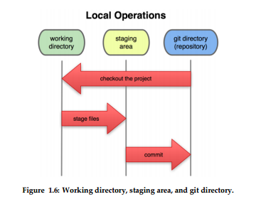

1. You modify files in your working directory
2. You stage the files, adding snapshots of them to your staging area
3. You do a commit, which takes the files as they are in the staging area and stores that snapshots permanently to your Git directory.

**Initializing Git**

Step 1: git config –global user.name “YOUR NAME”

Step 2: git config –global user.email “YOUR EMAIL ADDRESS”

**Create an account at Github.com – It’s Free!**

**Step 1:** Open your cmd.

**Step 2:** Get to the directory of your project to be tracked

**Step 3:** Type, git init

**Step 4:** to add all files in the remote repository, you must commit them first! Type git commit –m “Your Comment” (This commits the tracked changes and prepares them to be pushed to a remote repo)

**Step 5:** Add them to the repo! Type git push add origin REMOTE REPOSITORY URL

**Step 6:** Git remote –v (Verifies the new remote URL)

**Cloning your repository**

**Step 1:** At your github account you can see the clone or download section, click it and copy the link

**Step 2:** At your cmd, get to the directory to where you want to put the cloned repo

**Step 3:** type git clone “THE LINK YOU COPIED”

**You want to contribute to someone’s project? Why not? Use Fetch!**

Creating a Fork is producing a personal copy of someone else’s project. Forks act as a sort of bridge between the original repository and your personal copy. **Pull requests** can help make other people’s projects better by offering your changes up to the original project. Forking is the core of social coding at Github.

**Create a local Clone of your fork**

1. Fork your friend’s repo
2. Copy the link
3. git clone “LINK” at the desired destination

**Configure Git to sync your fork with the original Spoon-Knife repository**

1. On Github, get to the main profile of the person to where the project you want to work on belongs.
2. Under the clone/Download, get the link
3. Get to cmd and change your directory to where you want to put the cloned fork then follow the previous section.
4. Git remote add upstream “Original Link of the Forked Repo”

**Create a new branch with git and manage branch**