Website: https://encryptionchat-f6a78.web.app  
Android APK: https://drive.google.com/file/d/1PTsC_HvT0iHpg8IGEBXTZNLb3el1dfOa/view?usp=sharing

**Application:**

1. When you finish downloading the app or redirect from the browser you will be greeted to the login page then navigate to signup button to create an account

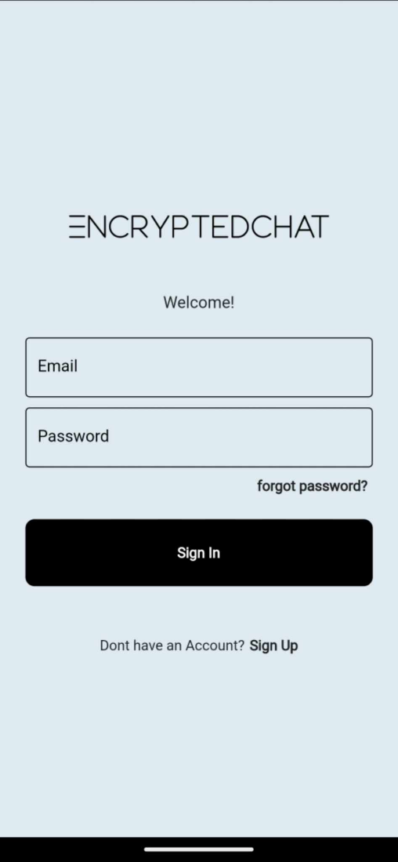

**Figure 8: Login page**

After created an account that you provide your information in the signup page login your account it you will be greeted to the HomePage

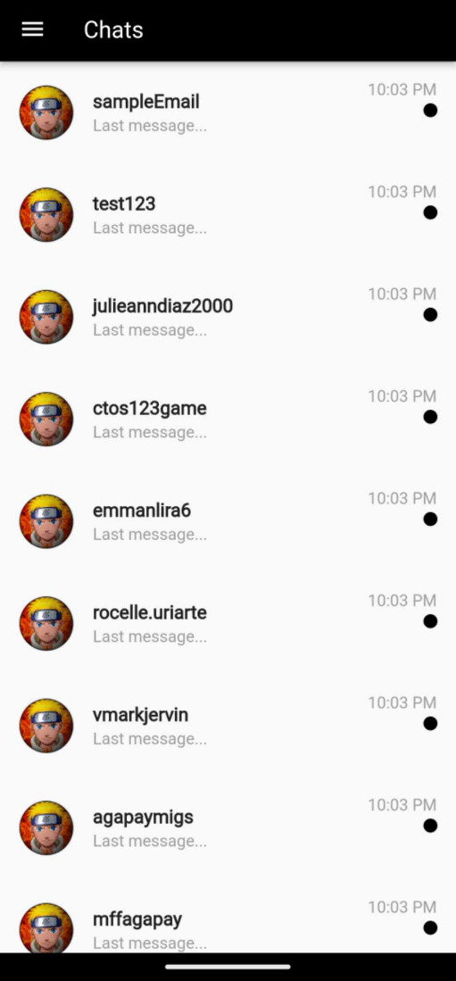

**Figure 9: Home page**

To check the user chatbox the specific user that you want to chat the after that you will be greeted of the messages of the user

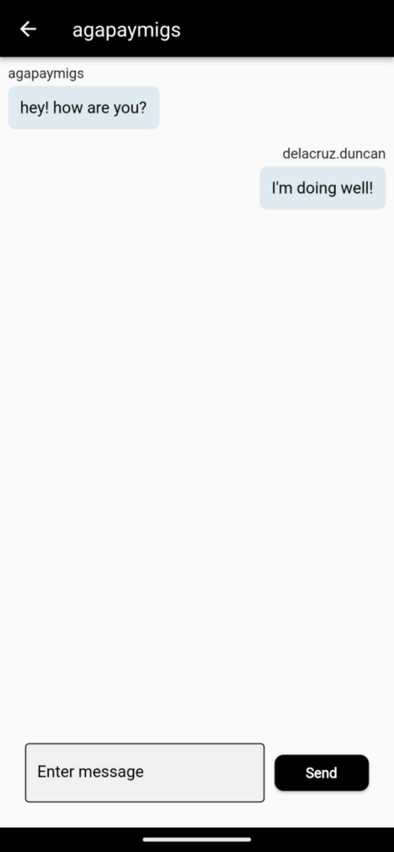

**Figure 10: Messages**

In the messages you can type the message that you want and just hit send when you are ready to send the message

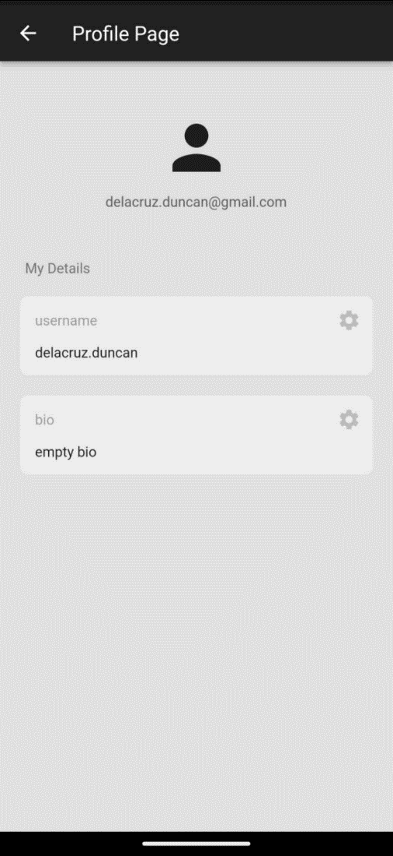

**Figure 11: Profile Page**

When you are in the HomePage still and you want to change your username Navigate to the Hamburger button (three line on the top left) then click profile you will be greeted the profile page then you can change your username and bio in there