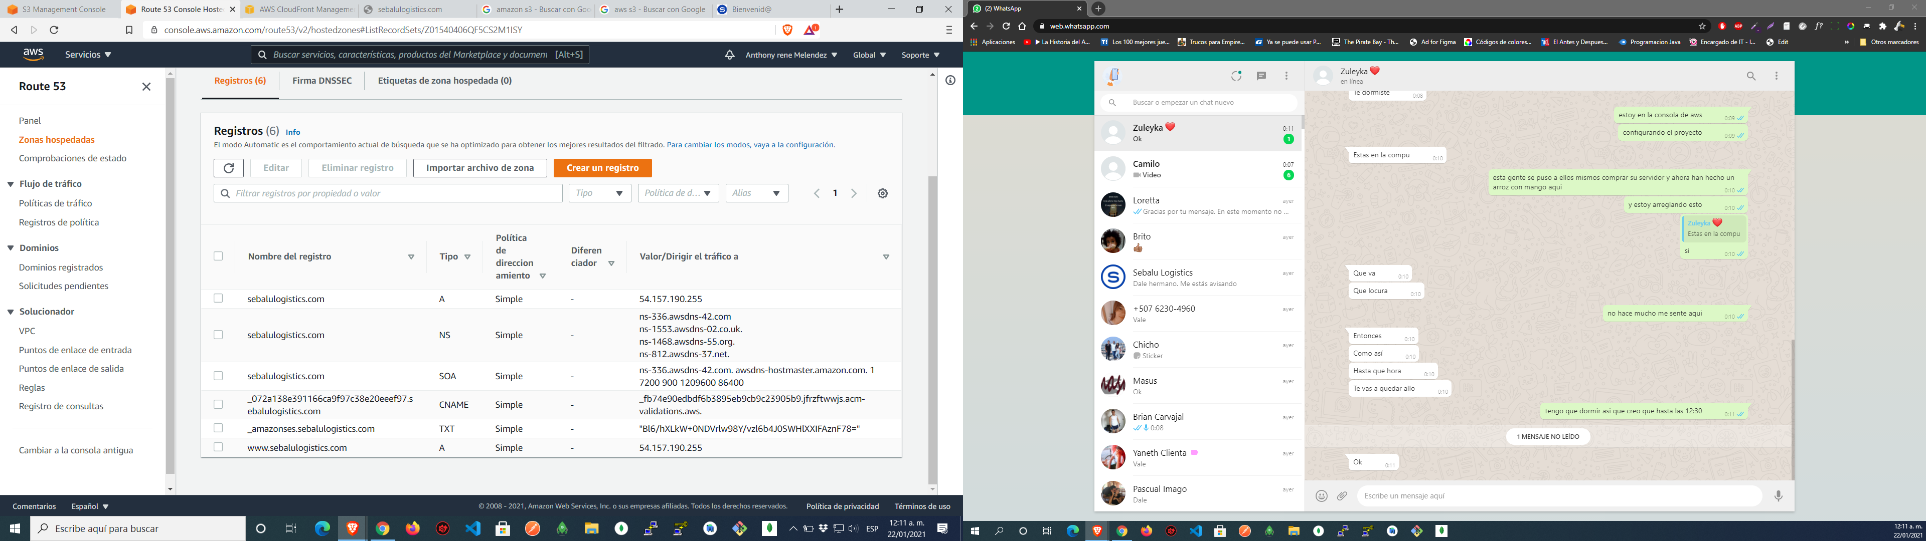

| **Nombre del registro** | **Tipo** | **Política de direccionamiento** | **Diferenciador** | **Valor/Dirigir el tráfico a** |
| --- | --- | --- | --- | --- |
|  | sebalulogistics.com | A | Simple | - | 54.157.190.255 |
|  | sebalulogistics.com | NS | Simple | - | ns-336.awsdns-42.com  ns-1553.awsdns-02.co.uk.  ns-1468.awsdns-55.org.  ns-812.awsdns-37.net. |
|  | sebalulogistics.com | SOA | Simple | - | ns-336.awsdns-42.com. awsdns-hostmaster.amazon.com. 1 7200 900 1209600 86400 |
|  | _072a138e391166ca9f97c38e20eeef97.sebalulogistics.com | CNAME | Simple | - | _fb74e90edbdf6b3895eb9cb9c23905b9.jfrzftwwjs.acm-validations.aws. |
|  | _amazonses.sebalulogistics.com | TXT | Simple | - | "Bl6/hXLkW+0NDVrlw98Y/vzl6b4J0SWHlXXIFAznF78=" |
|  | www.sebalulogistics.com | A | Simple | - | 54.157.190.255 |

172800