Poop – Face – Detection

Structure of the Project:

Sensor

and

Transmitter

Video editing

and

Receiver

Bluetooth

communication

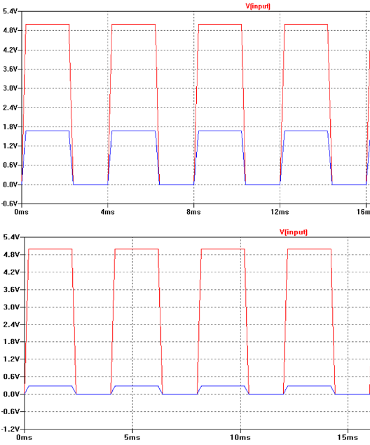

Sensorrequirements:

* Persistent
* Moisture resistent dry
* Medical uncritical
* Ergonomical form
* Not delicate

Function of a capacitive moisture sensor:

* Capacitor gets a recktangle signal wet
* Output voltage value changes
* If it’s wet 🡪 capacity increases
* If it’s dry 🡪 capacity decreases

Red = Input Blue = Output

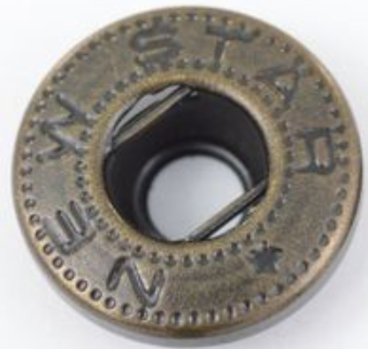

Setup in the napkin:

* Capacity plates 🡪 conductive threads
* Connection to the microcontroller 🡪 snaps

Microcontrollerrequirements:

* Bluetooth for communication
* Analog inputs for getting values of the sensor
* Analog-Digital-Transducer resolution at least 8 Bit
* Very small 🡪 ergonomical form

Perspective for further projects:

* Smartphone-Application
* Mimik recognition
* Timely alert system