CORPUS ENGINEERING · KIDAW'IDA–KISWAHILI
KIDAW'IDA–KISWAHILI Dataset Cleaning Report
I consolidated and cleaned the Kidaw'ida–Kiswahili parallel corpus for use in machine translation. The original data came from the thinkkenya and waleghwa/low-resource-language-data sources, which were found to contain essentially the same underlying dataset. After merging and removing duplicates, I obtained 22,151 sentence pairs.
The cleaning focused on identifying spelling inconsistencies without relying on an existing Kidaw'ida dictionary or NLP tool. I used a frequency-based approach to identify possible spelling variants, then reviewed the candidates sentence by sentence as a native Kidaw'ida speaker.
The main findings were:
- 100,324 Kidaw'ida word tokens were analyzed.
- 14,099 corrections were applied.
- 8,541 sentences (38.6%) were modified.
- The largest issue was inconsistent apostrophe usage. A general rule was identified: retain apostrophes in ng' and remove other apostrophe occurrences.
- This rule affected 13,328 tokens (13.3% of all tokens).
- Several apparent spelling variations were found to be legitimate different words, so they were deliberately not merged.
- Some issues, such as incorrect grammatical agreement, ambiguous words, and missing spaces, were identified but left for future work because they require contextual or grammatical analysis.
The numbers above, visualized
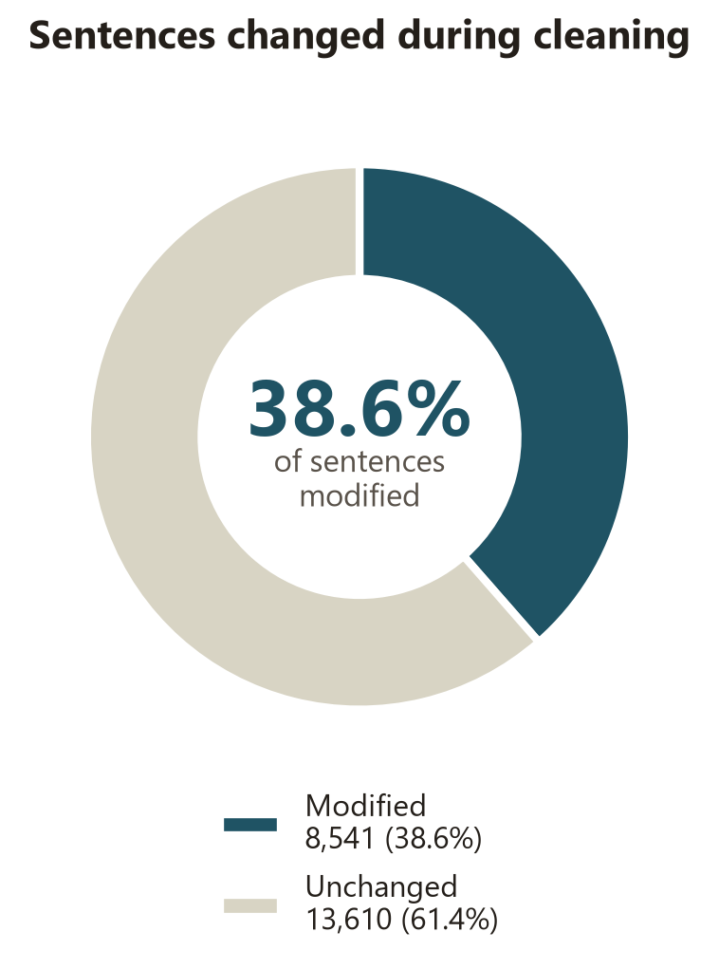 | 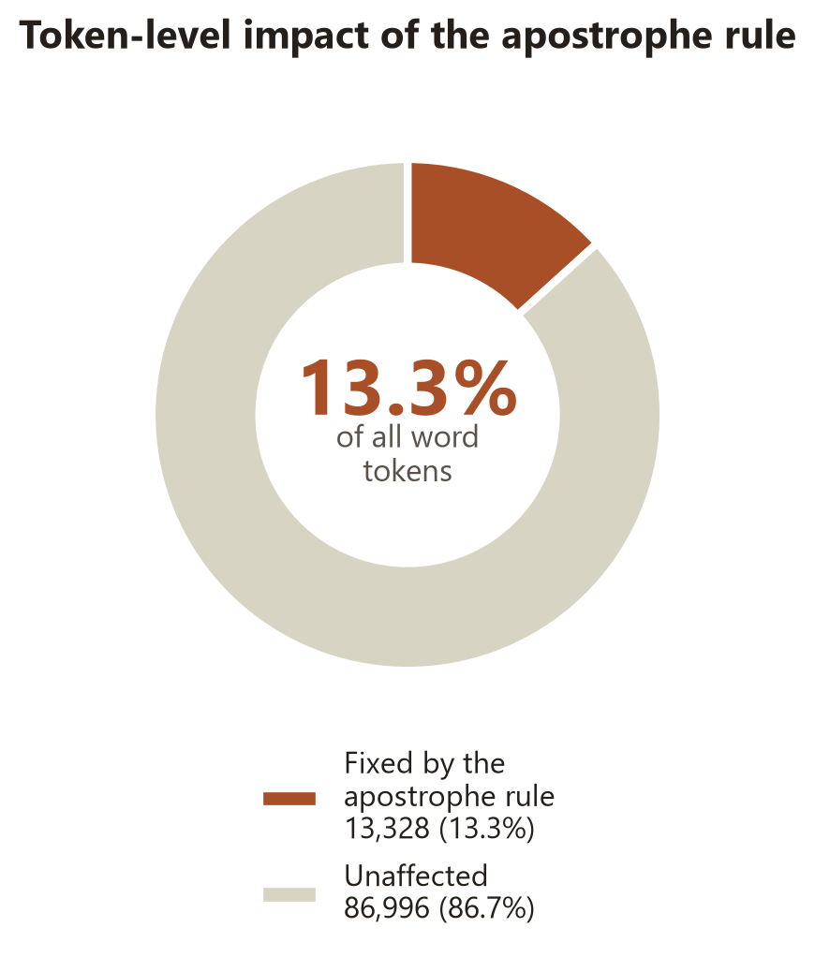
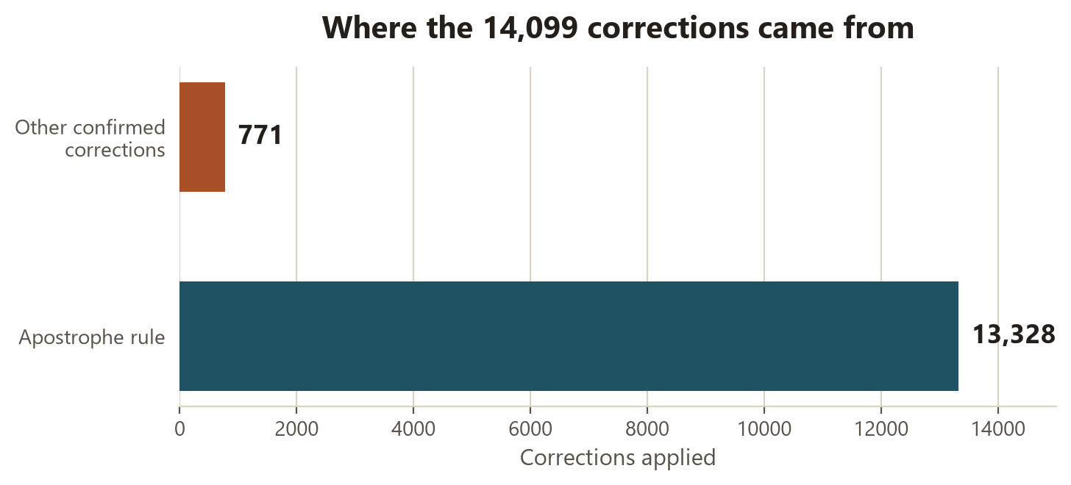

The cleaning process was implemented in taita_cleaner, which keeps a changelog for corrections and allows the corpus to be re-analyzed after each cleaning round. After the first round, 4,748 unsettled word pairs remained for further review.
The resulting corpus is substantially cleaner and more suitable for machine translation, while preserving cases where the correct form could not be determined reliably.
Source: Waleghwa et al. (2024), waleghwa/low-resource-language-data
License: Apache License 2.0
Tooling: taita_cleaner
Native-speaker review: Sentence-by-sentence review

