DATASET CLEANING & CONSOLIDATION REPORT
Kidawida–Kiswahili
Parallel Corpus for Machine Translation
Prepared for a Kidawida–Kiswahili machine translation project, covering the consolidation of two source datasets into a single corpus and a frequency-based spelling-correction pass carried out with a native Kidaw'ida speaker.
Corpus  waleghwa/low-resource-language-data | License  Apache License 2.0 | Tooling  taita_cleaner | Review method  Sentence-by-sentence, native speaker

Contents
Contents 2
1. Overview 3
Results at a glance 3
2. Source Data and Consolidation 3
3. Cleaning Method 4
Why not just reuse an existing cleaner? 4
4. Findings 4
4.1 Many apparent typos were actually different words 4
4.2 Frequency alone could not be trusted to pick the correct spelling 4
4.3 One rule resolved most of the apostrophe inconsistency 6
4.4 Remaining issues need more than a spelling rule 6
5. Corrections Applied 6
Confirmed word-level corrections 7
6. Tooling and Next Steps 7
Source and Credits 8

1. Overview
I consolidated and cleaned the Kidawida–Kiswahili parallel corpus for use in machine translation. The original data came from the thinkkenya and waleghwa/low-resource-language-data sources, which were found to contain essentially the same underlying dataset. After merging and removing duplicates, I obtained 22,151 sentence pairs.
The cleaning focused on identifying spelling inconsistencies without relying on an existing Kidawida dictionary or NLP tool. I used a frequency-based approach to identify possible spelling variants, then reviewed the candidates sentence by sentence as a native Kidawida speaker.

Results at a glance
22,151  sentence pairs in the final corpus | 100,324  Kidawida word tokens analyzed | 14,099  corrections applied
8,541  sentences modified (38.6%) | 13,328  tokens fixed by the apostrophe rule (13.3%) | 4,748  candidate pairs left for the next review round
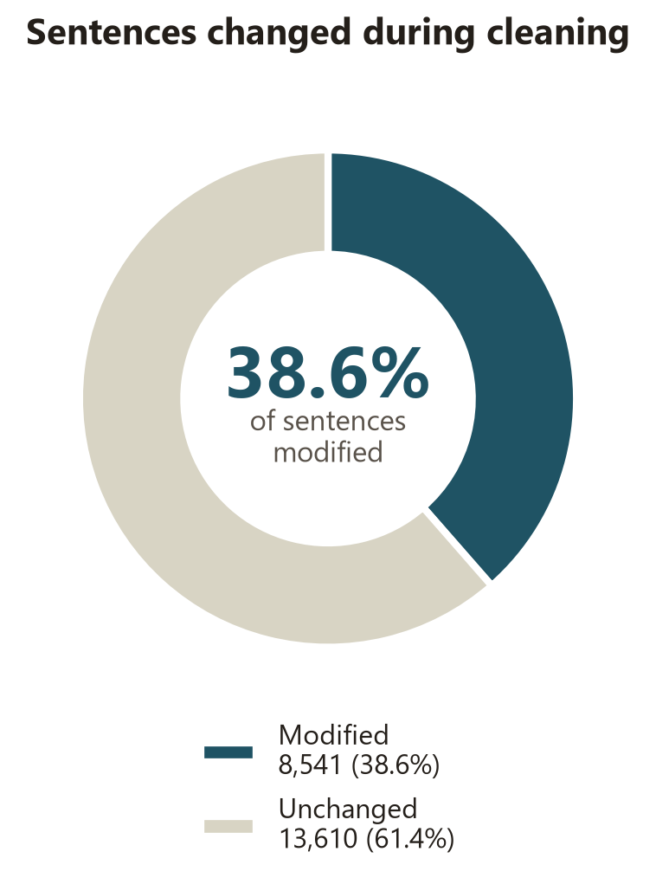
Figure 1. Share of the corpus's 22,151 sentences changed during cleaning.

2. Source Data and Consolidation
Two datasets were downloaded independently for this project: thinkkenya/kenyan-low-resource-language-data (Hugging Face) and waleghwa/low-resource-language-data (Zenodo). Comparing them directly showed the two were not independent.They credit the same authors and funder and the large majority of their sentence pairs were identical.Because of that overlap, the two were merged and exact-duplicate sentence pairs were removed rather than kept as separate files. The result is a single corpus of 22,151 unique Kidawida–Kiswahili sentence pairs, published under the Apache License 2.0 that governs the original waleghwa release.

3. Cleaning Method
Kidawida has no published dictionary, spellchecker or prior NLP tooling to check spelling against. The approach taken instead was frequency-based.Word forms were taken from the corpus and ranked by how often each form appears .I then reviewed every candidate pair as a native Kidawida speaker against real example sentences from the corpus, rather than corrected automatically.

Why not just reuse an existing cleaner?
A frequency-based cleaner already exists for Kikuyu, a related Bantu language and its overall pipeline count words, find close pairs, weigh by frequency, confirm with a human was a reasonable starting point. Its specific rules were not reusable since Kikuyu's confusable spellings are diacritics (ĩ/i, ũ/u), where the diacritic form is reliably correct. Kidawida has no diacritics and its actual confusable patterns .It’s just the Apostrophe placement and inconsistent "h" spellings that were discovered from this corpus directly.

4. Findings

4.1 Many apparent typos were actually different words
A large share of the short, frequent word pairs the mining step came out (cha/gha, aha/gha, agha/gha, kwa/lwa, andu/wandu and others) looked exactly like typo candidates.They were short, common, one edit apart. On review, these turned out to be a Bantu noun-class agreement pattern, the same phenomenon behind Swahili's cha/vya/la/ya/wa (all meaning roughly "of," varying by noun class). They are genuinely different words and merging them would have damaged the corpus rather than cleaned it. They were deliberately left unmerged.
kwa ≠ lwa | gha ≠ ghwa | agha ≠ gha
cha ≠ gha | aha ≠ gha | cha ≠ chia
mana ≠ mwana | andu ≠ wandu | andu ≠ mundu
koshi ≠ kosi | saa ≠ shaa

4.2 Frequency alone could not be trusted to pick the correct spelling
For the pairs that were genuine spelling variants of one word, the more common spelling in the corpus was wrong almost as often as it was right:
More frequent form | Less frequent form | Confirmed correct
w'andu (898×) | wandu (322×) | wandu - the minority spelling
mndu (301×) | mundu (234×) | mundu - the minority spelling
ja (245×) | jha (29×) | jha - outnumbered 8 to 1
uja (124×) | ujha (41×) | ujha — the minority spelling
Because of this, no correction in this project was applied automatically by frequency ratio alone, no matter how large the gap every one was confirmed against real sentences first and context-based .

4.3 One rule resolved most of the apostrophe inconsistency
The largest single source of spelling inconsistency was the apostrophe. Every candidate apostrophe pair in the corpus was classified by the letter immediately before the mark and one clear rule emerged .An apostrophe after g i.e. ng', the same nasal marker Swahili uses in ng'ombe could be meaningful and correct. Every other apostrophe (after w, after m or appearing in odd, one-off positions) was inconsistent transcription and was removed.
This one rule accounted for 13,328 of the corpus's 100,324 word tokens 13.3% of the entire corpus and by far the largest correction applied.
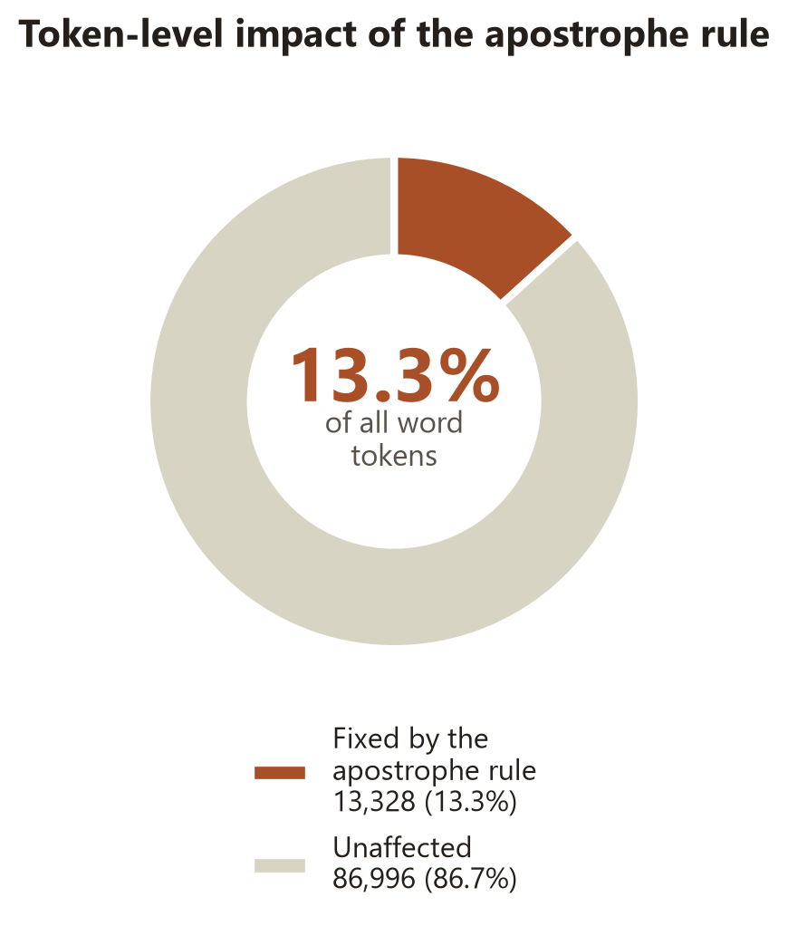
Figure 2. Proportion of all word tokens affected by the apostrophe rule.

4.4 Remaining issues need more than a spelling rule
A few problems surfaced that a word-level spelling correction cannot fix and were left for future work rather than forced into the correction map:
- Grammatical agreement errors. The right word used in the wrong grammatical slot (e.g. gha used where ghwa was needed) requires checking noun-class agreement, not spelling.
- Ambiguous words Mana is a real word with its own meaning, but is also sometimes a dropped-letter typo for mwana (child). Which applies depends on the sentence, so it was left untouched rather than guessed at.
- Missing spaces between fused words (e.g. izangajedu for isanga jedu) were found only incidentally and have not been systematically searched for.

5. Corrections Applied
In total, 14,099 corrections were applied across 8,541 sentences (38.6% of the corpus). The large majority came from the single apostrophe rule described in Section 4.3; the remainder are individually confirmed word-level fixes.
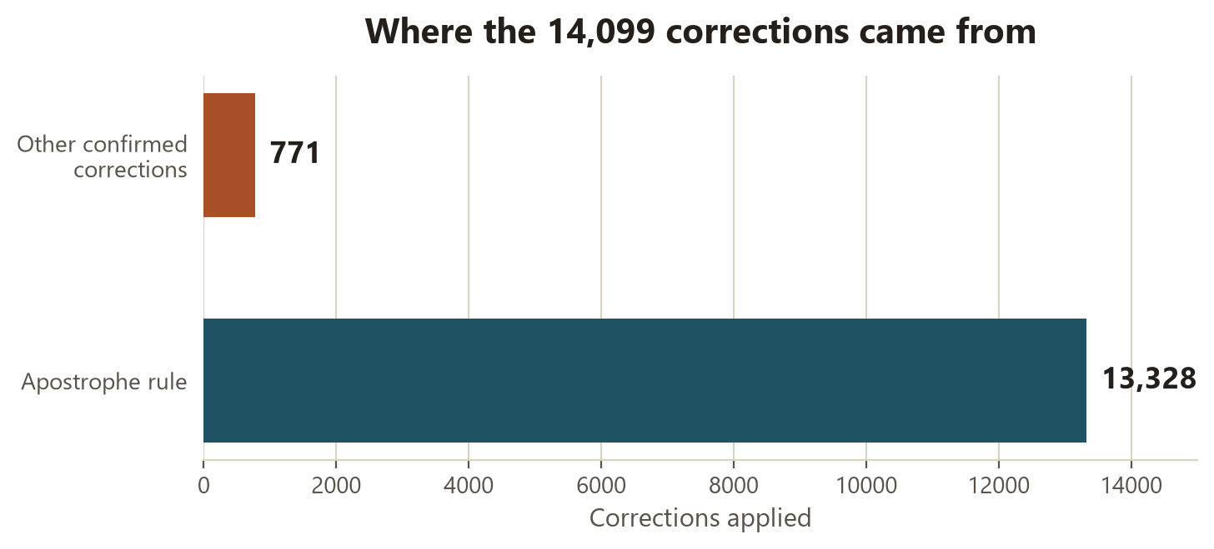
Figure 3. Where the 14,099 applied corrections came from.

Confirmed word-level corrections
Written as |  | Correct form | Why
mndu | → | mundu | missing vowel
izanga | → | isanga | z/s confusion
ghwmanyikie | → | ghwamanyikie | missing vowel
gwa | → | ghwa | missing h
kihi | → | kii | confirmed via matching sentence usage
ja | → | jha | confirmed via matching sentence usage
ata | → | hata | missing h
uja | → | ujha | missing h

6. Tooling and Next Steps
The cleaning process was implemented in taita_cleaner, which keeps a changelog for every correction and allows the corpus to be re-analyzed after each cleaning round rather than treating the process as one-off. After the first round, 4,748 unsettled word pairs remained for further review .The resulting corpus is substantially cleaner and more suitable for machine translation, while preserving cases where the correct form could not be determined reliably rather than guessing.

Source and Credits
Source: Waleghwa et al. (2024), waleghwa/low-resource-language-data
License: Apache License 2.0
Tooling: taita_cleaner
Native-speaker review: sentence-by-sentence review

