**Task 1: Getting Started**

· Overview of the project

· A brief overview of the Power BI interface

· Import the Customers and Sales data

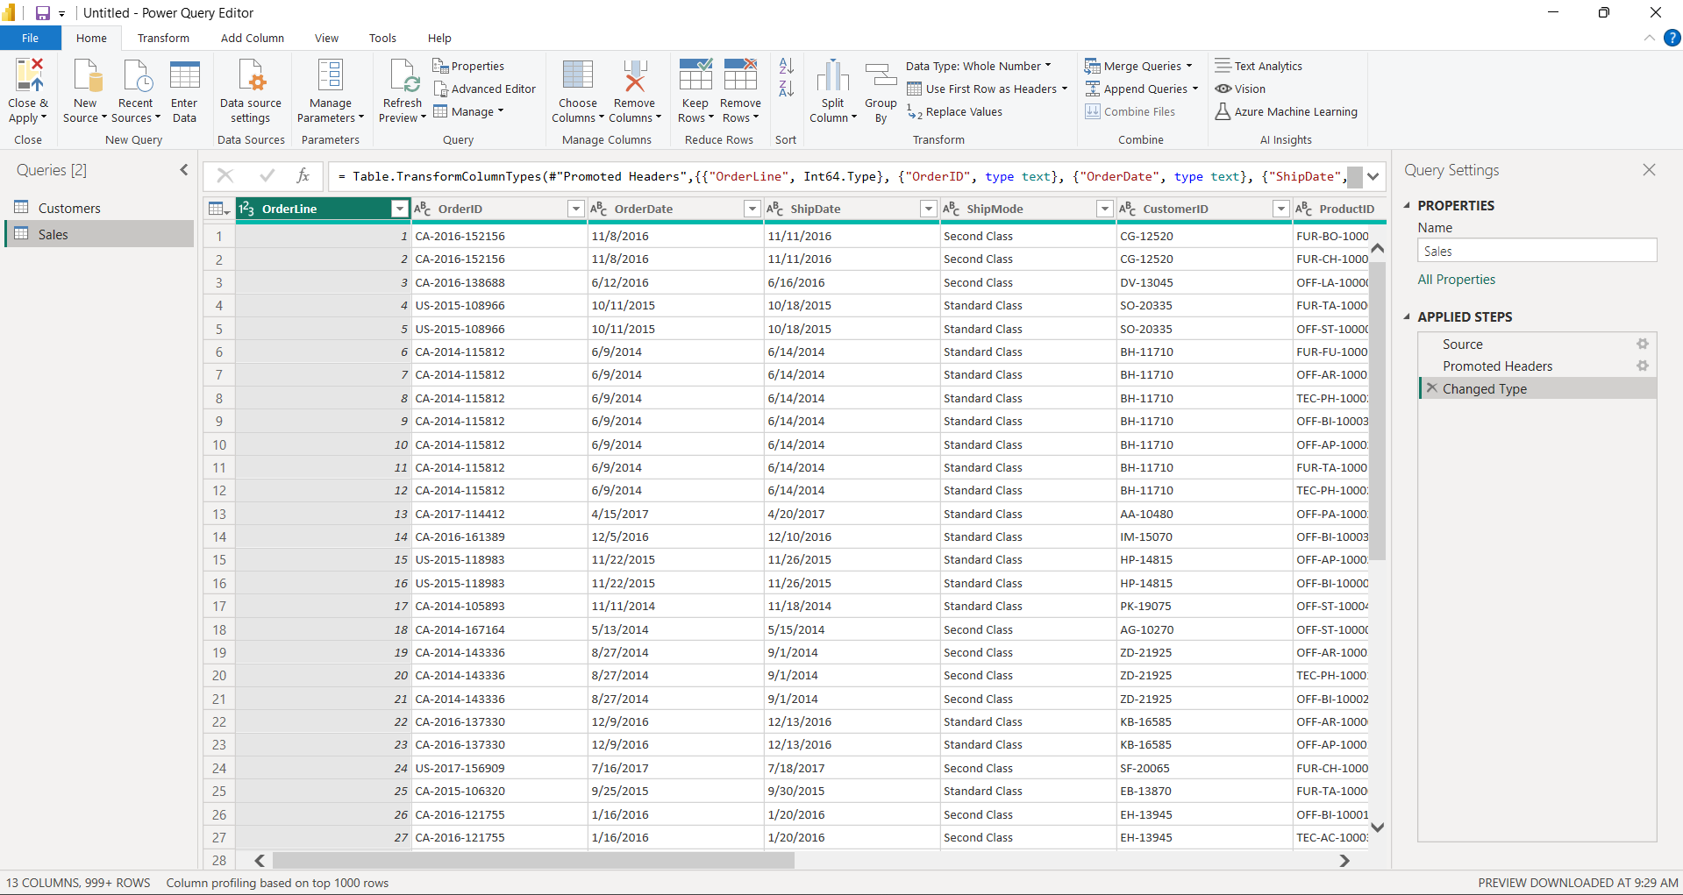

**Task 2: Split and Rename Columns**

· Explain the Power Query editor interface

· Split the **Customer Name** column

· Rename Customer Name.1 to **FirstName**

· Rename Customer Name.2 to **LastName**

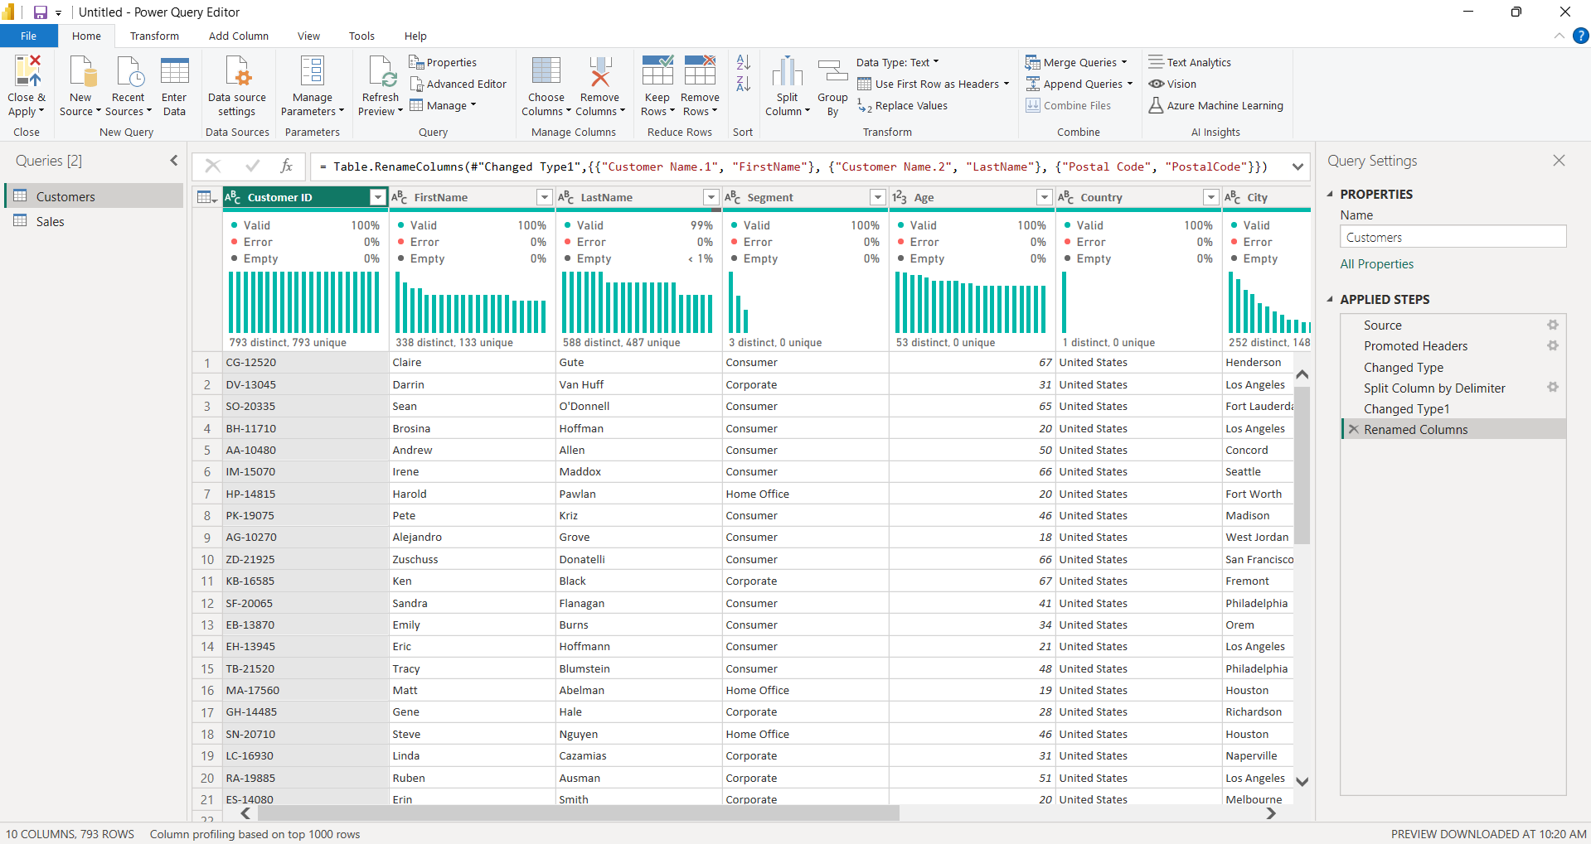

**Task 3: Add Columns**

· Add a conditional column called **Age Group**

· Add a column from examples called **Daily Sales**

· Add the **Year**and **Month Name** columns from the **Order Date**column

**Task 4: Remove Columns and Change Data Types**

· Remove the **Sales**and **Quarter**columns from the Sales table

· Remove the **Age**and **Country**columns from the Customers table

· Change the data types of the **PostalCode**and **AgeGroup**columns

· Rename, edit, remove applied steps

**Task 5: Merge Data**

· Merge the Customers and Sales queries

· Perform aggregation on merged data

**Task 6: Append Data**

· Import 2019 and 2020 Boxoffice data from the web

· Append the 2019 and 2020 Boxoffice data

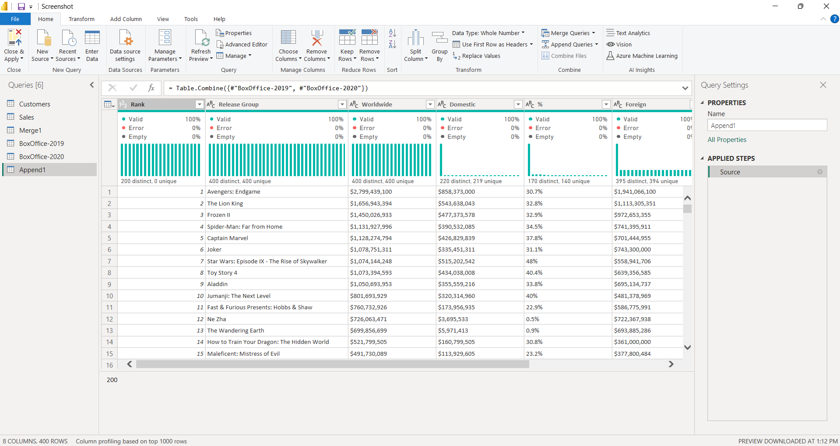

**Task 7: Unpivot Data**

· Replace errors in the **Domestic Sales**and **Foreign Sales**columns

· Unpivot the **Worldwide**, **Domestic**, and **foreign**columns

