Using Eclipse and Git/GitHub desktop for configuration management
In order to learn more about configuration management with GitHub I went to https://www.codeacademy.com/ web site and completed the four units of the configuration management course. See screenshot.
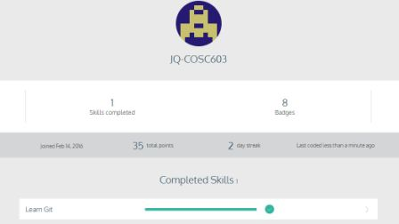
The tutorial was quite extensive and I can say, I went over some of the most useful git commands such as git init which is used to create a git project. Also, I learned about the three step process of editing files in the working directory, adding files to the staging area, and saving changes to a git repository. To permanently store changes into the repository, we commit our work using git commit –m “Message about the commit”.
In many cases, the most recently commit is the HEAD commit. To see it displayed, we use the git show HEAD command. If you want to backtrack to the part you made a big mistake, you can do that by going to the previous commit and use git reset SHA (7 first numbers of that previous commit). The HEAD will reset to that position.
Some other useful commands that I saw in this tutorial are:
The git branch branch_name command allows us to create another branch besides the current master branch. Also, with the git branch command, the user will know which branch he or she is on. Switch to a new branch by using git checkout branch_name command. You can commit code to this new branch.
The git merge branch_name, merges the changes in the newly created branch with the master branch. It is important to be in the master branch first (receiver) to be updated with the changes from other branches.

