Task 1. - Create a new repository
The new repository cosc603-Quinchuela-project2 was created in Github.

Task 2. - Summary of Refactory for Everyone
http://www.ibm.com/developerworks/library/os-ecref/
This article explains every refactoring available option in Eclipse. Personally, I liked the extract method, extract local variable, change signature method, extract interface and rename features.
These are the more generalized features for developers. Each one is designed for different types of design smells the developer could encounter throughout the entire project.
Pros:
- Features already built-in. There is no need to install external software or other plug-ins.
- Lets the user see a preview of the change and the change of other elements related to that particular element (class, method, variable) with subsequent steps.
- Useful for small code and larger code.
Limitations:
- Some of the changes with respect to other related expressions don’t happen automatically and there is some degree of manual refactoring especially with larger code.

Task 3. - Project setup
I downloaded the monopoly.zip eclipse project file from blackboard and set it up in Eclipse. Then I proceeded to synchronize this project with my local and remote repository.

Task 4. - Running the Unit Tests with JUnit
See expected output of JUnit test cases.
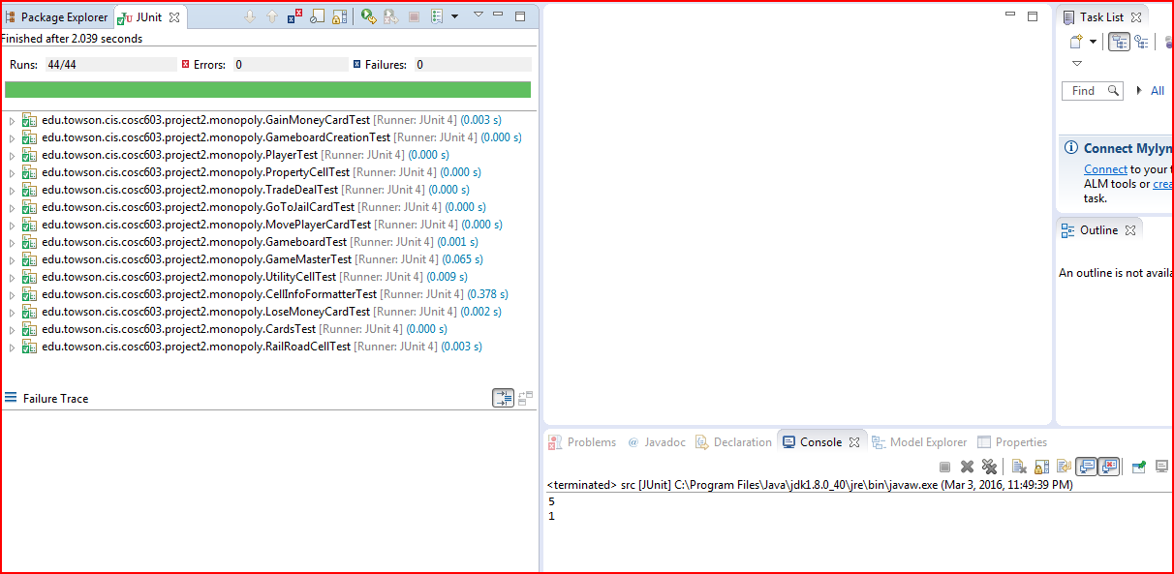

Task 5. - Modifying a test case
I modified the assertEquals statement in the CardsTest.java Junit test case to see if JUnit would report a test failure.

Task 6. - Refactoring: Renaming a Class Field.
Eclipse refactoring operation “rename” didn’t omit changing the parameter owner in the setTheOwner() method. The object owner is actually referenced in the method to the new or current field by using the key word “this”. E.g. this.theOwner = owner;
The rename operation works differently than find all and replace. Rename is able to identify instances and references to instances throughout the code ensuring an easy flow of changes among variables, class names, methods. Find all and Replace makes this task a little bit more confusing because the user is not entirely sure about the instances identified and also the elements implementing that instance. According to the reading, the rename feature reads the code semantically allowing it to look for these instances more easily than a find all and replace feature.

Task 7. - Refactoring: Changing a Class Hierarchy
My experience with this task would be the same as in task 6 in that Eclipse provides a rich interface where the user can see all the changes being performed in all subclasses of a particular abstract class. With the Preview tab, the user can see the difference and also make sure if the changes are correct.
The push down and push up refactoring feature helps identifying signs of poor cohesion in the code. This happens when related elements are not in the same class. It helps identifying feature envy design smells and provides an effective solution to make the code more cohesive such as moving the related methods and their elements into a separate and well defined class for such elements.

Task 8. - Refactoring: Extracting an Interface
My experience with this task is that by extracting an interface from an abstract class the user may have a choice on how to implement the interface methods. This means overriding the method being extracted from the original class or letting another nonabstract class implement those methods. In doing this, I chose the option of overriding the original methods selected since the behavior of owning things copied the behavior of owning properties.
The new IOwnable interface and methods were created with this operation. This operation helps detecting if with the addition of new data and implementation of new features, the resulting class is doing too much. In order to avoid large class design smells, it is better to separate it or see its implementation in another class or subpart.

Task 9. - Refactoring: Extracting a Method from Code.
I didn’t select the for loop correctly in my code. I omitted the parenthesis therefore I couldn’t see the Extract Method refactoring option, instead I saw the Change Signature Method. This was my first commit.
Later, well aware of my mistake I selected the for loop with the Extract Method option and I was able to notice the difference between selecting the for loop only and with the String array declaration as well.
I chose to extract the method from the String array declaration because I could see that I could solve more data clumps design smells doing it this way. Also, I saw this method could make my code more understandable and easy to maintain.

Task 10. - Refactoring: Creating a Local Variable from Repeated Code.
This is a helpful refactoring tool. It makes the code much easier to follow. It replaces calling expressions by adding a variable declaration to it and then replaces the expression with the variable reference. I can see this being used in long and duplicated calling expressions. I can see this feature eliminating data clumps, especially the ones seen in message chains design smells. I don’t see it affecting the correctness of the overall program as long as the parameters are well understood within their respective classes and methods.

Task 11. - Refactoring: Changing a Method’s Signature
My experience using this refactoring tool is that changing a method’s signature helps the user to identify legacy or spaghetti code. Code that has lost some of its functionality and purpose. This tool allows identifying extra methods that are not needed or need to be modified in order to work with the program. If the user modifies some methods by changing their method signature, some manual refactoring is needed as well.
I happened to do this for the program. I manually refactored subclasses sharing a common method with the super class. I added the missing return type to all methods sharing the modified method parameters.

Task 12. - Automatically Generating Documentation
I generated Javadoc comments using JAutodoc and their respective html files.

Task 13. - Detecting Design Smells.
I used JDeodorant refactoring tool to capture design smells for the monopoly program. I used the God Class feature to extract a class that probably was doing more work than it was supposed to. In God Class, when the refactoring is applied, the elements of the new class in the extractable concept column are seen.
JDeodorant created a new class and moved the relevant fields and methods from the old class into the new class.
I used the Feature Envy feature for extracting methods that were not easy to read. It works similarly like the Eclipse’s refactoring tool.
I wanted to use long method extracting feature but when I ran it, it came back negative.
I didn’t know how to clone imports when using the Duplicate code checking feature but I saved refactoring scripts in a JDeodorant folder and added it to the project directory.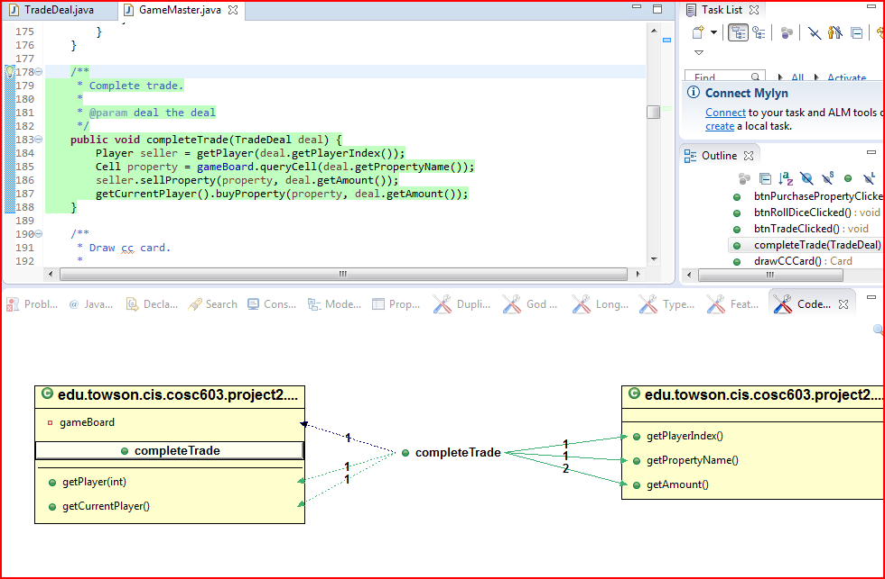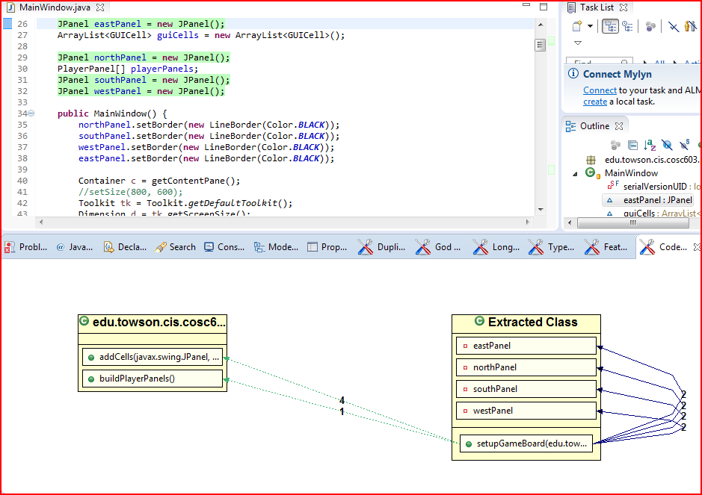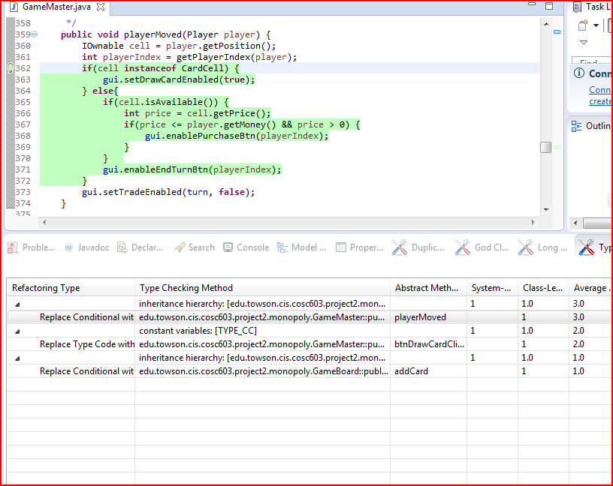

Task 14. - Design/Code Smells and Refactoring - On your Own

Nothing was generated for feature envy refactoring option.

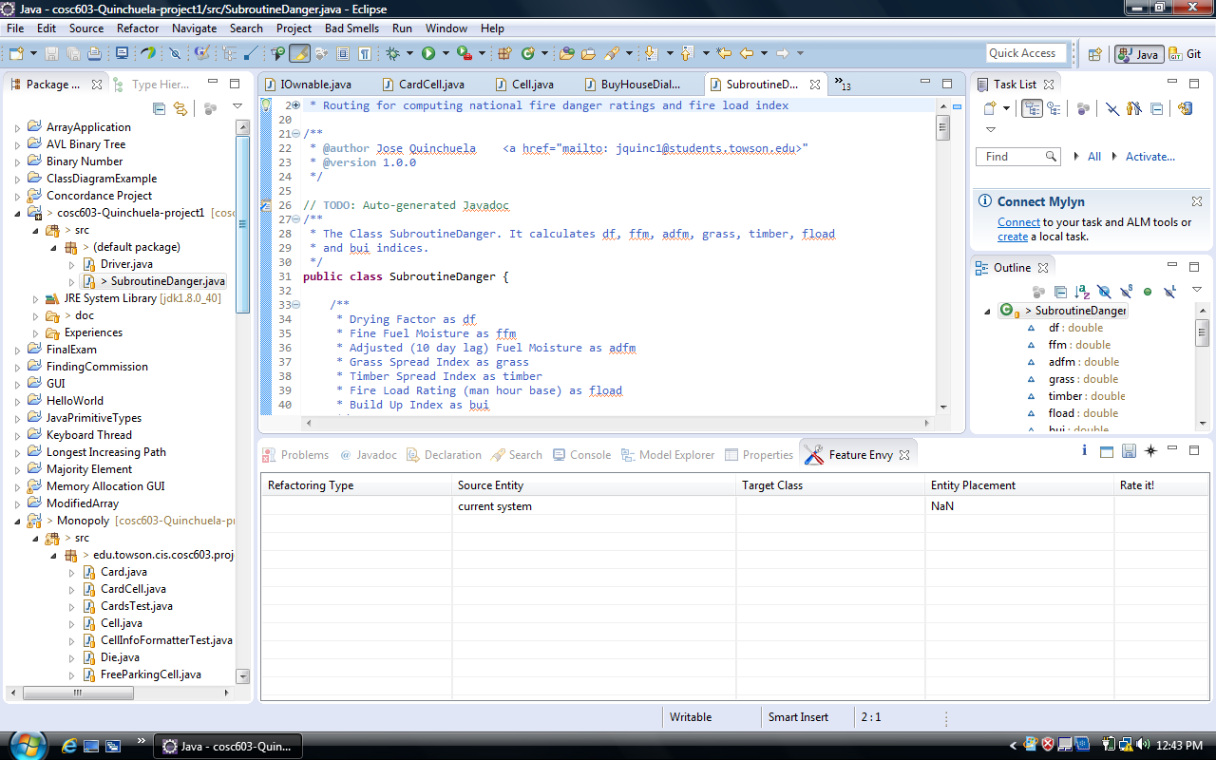
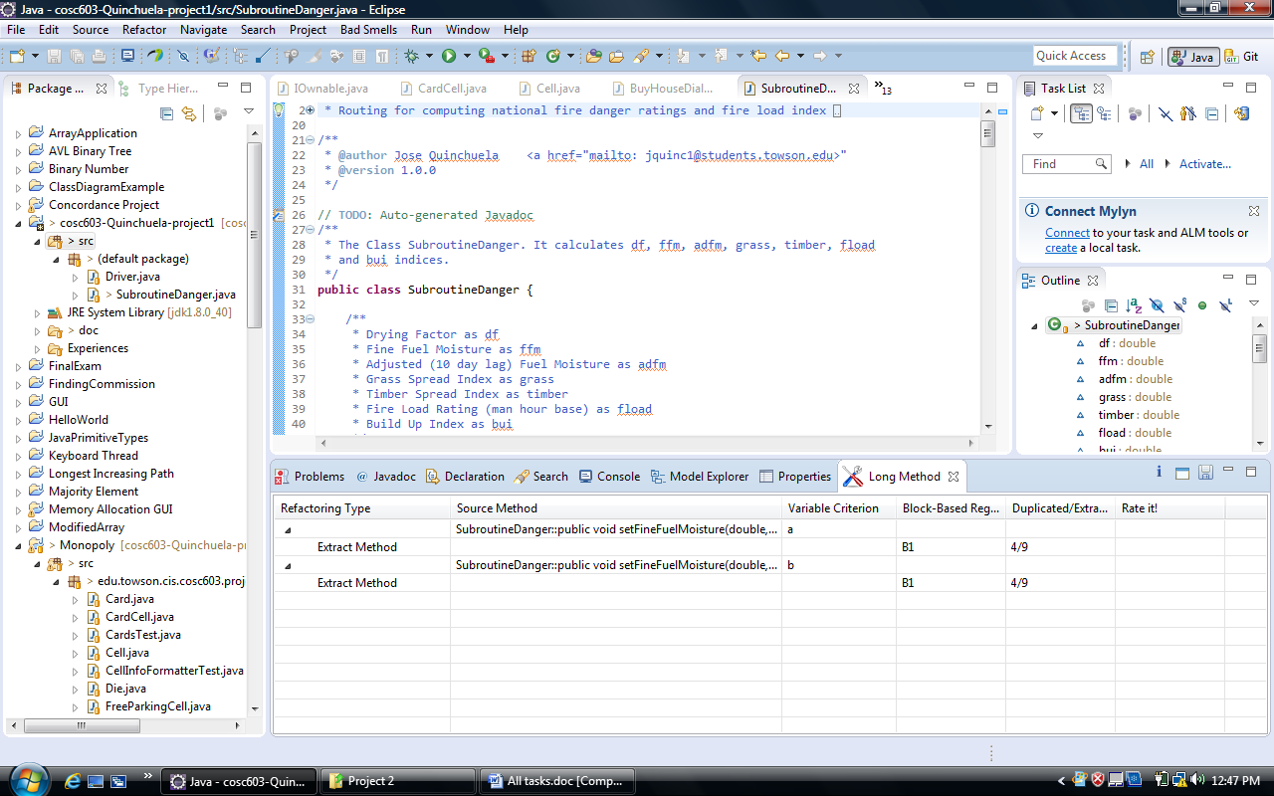
For long method refactoring tool, JDeodorant extracted two methods public double a() and public double b() out of statements that were used in a single method. Also, seeing that they were being heavily utilized in the SubroutineDanger class, it created two new classes with these new two methods. I renamed these classes using Eclipse’s rename tool and added javadoc documentation to the newly created methods and classes.

For God Class, I know what the tool was trying to do. It was gathering all functions related to one or two operations and putting them into one different private class.

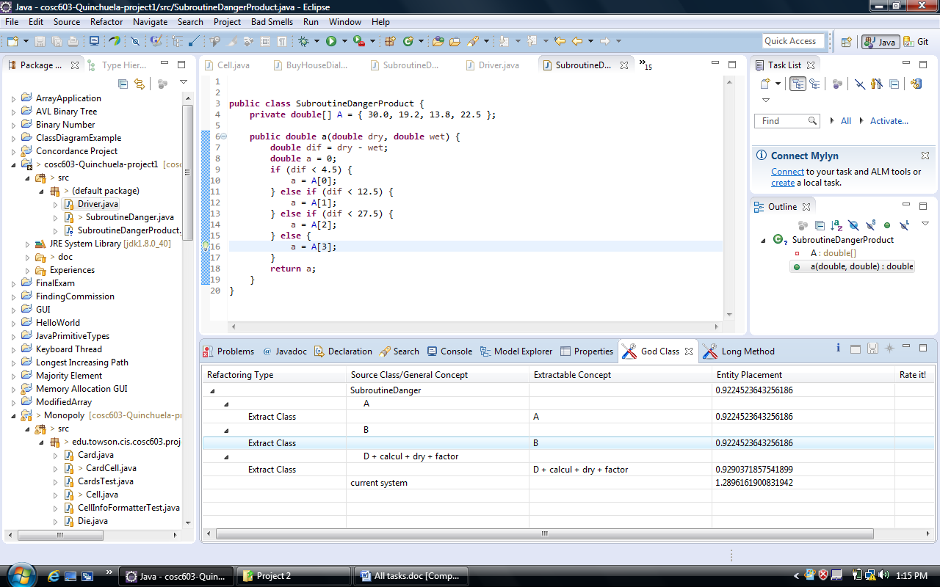

Summing it All Up
Going over all the activities in this refactoring project and reading the assigned material, I found out that there are tools that can automatically refactor a program. Using these refactoring tools in the different exercises, I learned the capabilities of Eclipse’s refactoring tools such as Extract method, Extract class, Rename class field, Extract local variable, etc.
I learned these tools serve a purpose to identify and correct design smells introduced by legacy code, data clumps and duplicate code. It is important to notice that refactoring tools help analyze cohesion in the structure of a program, especially when it becomes large over time and new features are introduced.
Eclipse’s refactoring tools are very helpful to the user. What I like about this tool suite is I don’t have to depend solely on writing my own refactoring and therefore rely on my own solution. Now, this set of tools provides the user with a great selection of refactoring options especially when the user can see too many logical expressions in a method or when there is the need to create a separate class for methods that are related and are being used more in a different class.
Eclipse provides the user with a preview screen of how the refactored element is going to change in all of the element’s subparts or subclasses. This to me it is an incredible feature because it makes me learn more about personal coding preferences and overall software development capabilities.
JDeodorant works along these lines and it is a tool better suited when doing refactoring for particular design smells and for different sections of the program. For example, with JDeodorant I was able to select the entire project and select one or all four of the different types of smells. The definitions of the smell types are very clear and they work similarly as the refactoring tools in Eclipse. The difference is that JDeodorant has included a visual aid to illustrate the point when a class needs to be separated and have its own elements, as well as a method when there is a calling expression enclosed in a different method.
Unit tests are very important because they allow the user to see the changes in the code after the refactoring has occurred. Normally, Unit tests are tested against logical expressions found in classes, methods, variables and are the best indicators for errors and failures in the code of a program. As the program increases in size or new features are included or deprecated, the best way to make maintenance easier would be to use refactoring and run unit tests cases so these new features will be free of errors.

