Run for Relief-Burma 2008

Event Information
For a million villagers in Burma, running is not a choice.

Purpose: To increase awareness about the situation in Burma and raise funds to support the relief efforts in Burma.

Registration $16 adults, $10 children, $ 45 families (4+ people). Extra T-shirt $10 (sold separately). Add
Fee: $2 for same day registration
Sign-up by April 5 to guarantee a t-shirt.

Date: Saturday, April 19, 2008

Time: 8:00 a.m. to 8:45 a.m. Race Day Registration and Packet Pick-Up for
Pre-Registered Participants
9:00 a.m. Race starts
10:00a.m. Kid’s Dash (for children 5 and under)
Awards ceremony for top three male and female and age groups will immediately follow.

Distance: 5K (3.1 miles) and Kid’s Dash (100 yard dash)

Location: Lake Padden Recreational Park, east entrance, playground shelter

Registration: Complete attached form and return to Brett Matulis by April 5, 2008 to guarantee your t-shirt order. Participants registering after this date are not guaranteed a t-shirt.
Please make registration and donation checks out to World Aide.

Mail to: Brett Matulis
2401 Lynn Street
Bellingham, WA 98225

Further Info: Call David Gerber at (360) 303-6531

Websites: www.prayforburma.org
www.freeburmarangers.org
www.chapelhillpc.org
www.ebuankthaiministries.org/index.html
www.students.washington.edu/burma
.
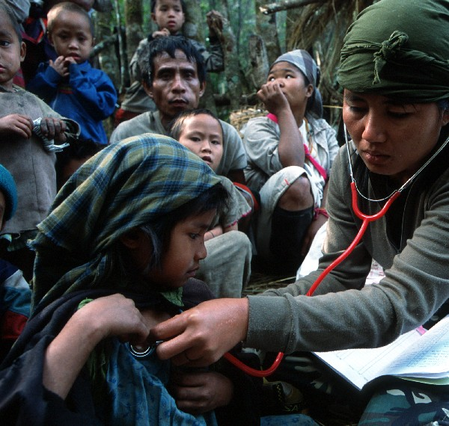
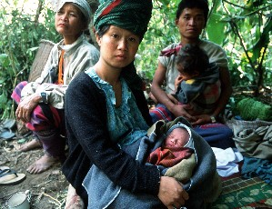
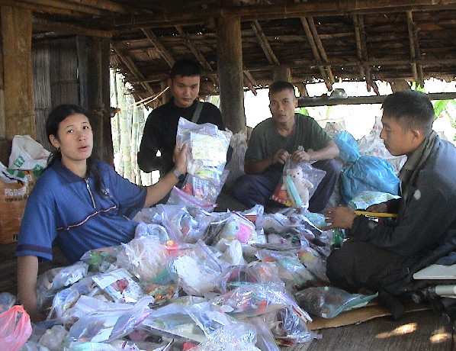

For one million villagers in Burma—Running is not a choice.

Run for Relief-Burma: April 21, 2007 - Entry Form
For a million villagers in Burma, running is not a choice.

Please complete the information below and return with payment to Brett Matulis by April 5, 2007 to guarantee t-shirt size and quantity. Race day registration is available but will include a $2/person extra charge. For further information, call (360) 303-6531.

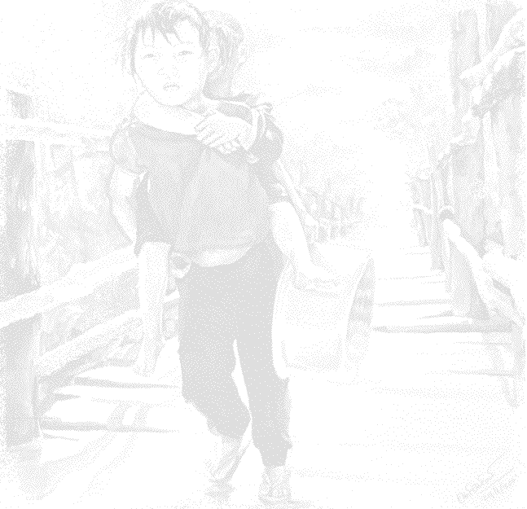
Name
Address
City |  | State |  | Zip |  | Phone
E-mail

Participant Information
Please print the information below. If you want the family rate, all must register on the same form. Circle the appropriate t-shirt size for each participant. There is no fee for children 5 and under to participate in the Kids’ Dash but registration is required and a t-shirt can be purchased for $6.*

Last Name | First Name M.I. | Sex | Age on 04-21-08 | Kids  Dash | Tee Shirt  (Y/N) | T-Shirt Size | Level  (Exper/  Begin
Child: S-M-L-XL
Adult: S-M-L-XL-XXL
Child: S-M-L-XL
Adult: S-M-L-XL-XXL
Child: S-M-L-XL
Adult: S-M-L-XL-XXL
Child: S-M-L-XL
Adult: S-M-L-XL-XXL
Child: S-M-L-XL
Adult: S-M-L-XL-XXL
Child: S-M-L-XL
Adult: S-M-L-XL-XXL

Entry Fees
Complete the appropriate lines and calculate a total at the bottom. Make check payable to World Aid.
Description |  |  | Number of  Participants |  | Price Per Person or Family |  | Total
Adult (18+) |  |  |  | x |  | =
Child/youth (6-17) |  |  |  | x |  | =
*Children 5 and under |  |  |  | x |  | =
Family (4+ people) |  |  |  | x |  | =
Tee-shirt only S – M – L – XL –XXL |  |  |  | x |  | =
=

Don’t forget to complete opposite side!

Release Information – All participants must read and sign this waiver.

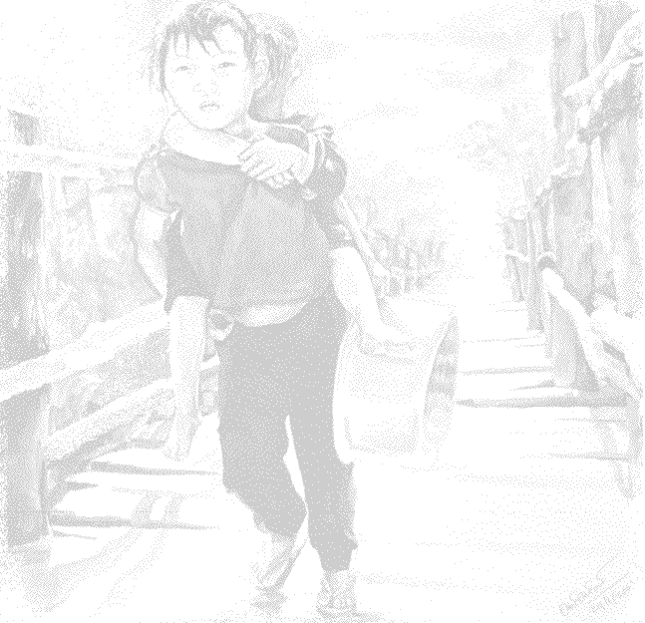
I know that running a road/trail race is a potentially hazardous activity. I should not enter and run unless I am medically able and properly trained. I agree to abide by any decision of a race official relative to my ability to safely complete the run. I assume all risks associated with running in this event including but not limited to falls, contact with other participants, the effects of the weather, including high heat and/or humidity, the conditions of the road and traffic on the course, all such risks being known and appreciated by me. Having read this waiver and knowing these facts, and in consideration of your acceptance of my entry, I, for myself and anyone entitled to act on my behalf, waive and release the city of Bellingham, Whatcom County, the State of Washington, World Aid, all sponsors, volunteers and their representatives and successors from all claims or liabilities of any kind arising out of my participation in this event even though that liability may arise out of negligence or carelessness on the part of the persons named in this waiver. I grant my permission to all of the foregoing to use photographs, motion pictures, recordings, or any other record of this event for any legitimate purpose. I also understand that my entry fee is nonrefundable. A parent must sign if entrant is under 18 years of age. This is to certify that my child has permission to compete in this event, is in good physical condition and the event officials may authorize necessary emergency medical treatment. I understand that bicycles, skateboards, roller skates or blades, animals are not allowed in the race, and I will abide by this guideline.

Signed (if under 18 signature of parent /guardian) ____________________________________ Date______________

Signed (if under 18 signature of parent /guardian) ____________________________________ Date______________

Signed (if under 18 signature of parent /guardian) ____________________________________ Date______________

Signed (if under 18 signature of parent /guardian) ____________________________________ Date______________

Signed (if under 18 signature of parent /guardian) ____________________________________ Date______________

Signed (if under 18 signature of parent /guardian) ____________________________________ Date______________

Donations:
If you would like to further support the relief efforts in Burma and/or are unable to participate in the Run for Relief, you can make a direct donation or sponsor a runner. Please complete the information below and make your check payable to World Aid.

Name
Phone |  | Donation Amount

THANK YOU!

