Run / Walk for Relief—Burma 2007

Event Information
For a million villagers in Burma, running is not a choice.

Purpose: Increase awareness about the situation in Burma and raise funds to support the relief efforts in Burma.

Date: Saturday, April 28, 2007

Time: 8:00 a.m. to 8:45 a.m. Race Day Registration and Packet Pick-Up for Pre-Registered Participants (pick up t-shirts and race numbers in the Narthex)
9:00 a.m. Race starts
10:00 a.m. Kid’s Dash (for children 5 and under)

Award ceremony will immediately follow for the top three male and female finishers overall. Separate awards will be given to the top three finishers in each age group. Note: overall finishers will not receive age group awards.

Age groups: 6-10, 11-14, 15-18, 19-29, 30-39, 40-49, 50-59, 60-69, 70-79, 80+

Distance: 5K (3.1 miles) and Kid’s Dash (small route in parking lot of church)

Location: Chapel Hill Presbyterian Church, 7700 Skansie Ave. NW, Gig Harbor

Registration: Complete attached form and return to Chapel Hill Church by April 13, 2007 to guarantee your t-shirt order. Participants registering after this date may not receive a shirt and/or may not get the size ordered. Runners can also seek sponsor donations using the Individual Sponsorship Form.

Mail to: Chapel Hill Church, Attn: Missions Office, P.O. Box 829, Gig Harbor, WA 98335

Further Info: Tamara Brathovde at 253-851-7779 x311 or tbrathovde@chapelhillpc.org

Websites: www.prayforburma.org
www.freeburmarangers.org
www.chapelhillpc.org
www.ebuankthaiministries.org/index.html
www.students.washington.edu/burma
www.geocities.com/run4relief

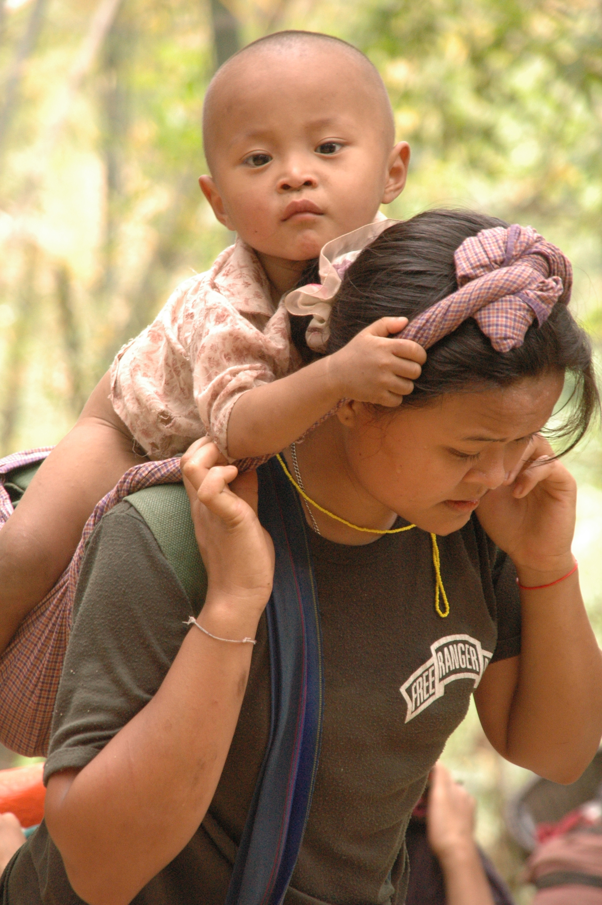
For one million villagers in Burma—Running is not a choice.

Run / Walk for Relief—Burma: April 28, 2007 - Entry Form
For a million villagers in Burma, running is not a choice.

Please complete the information below and return with payment to Chapel Hill Church, P.O Box 829, Gig Harbor, WA, 98335, Attn: Missions Department, by April 13, 2007 to guarantee t-shirt size and quantity. For further information, call 253-851-7779 x311.
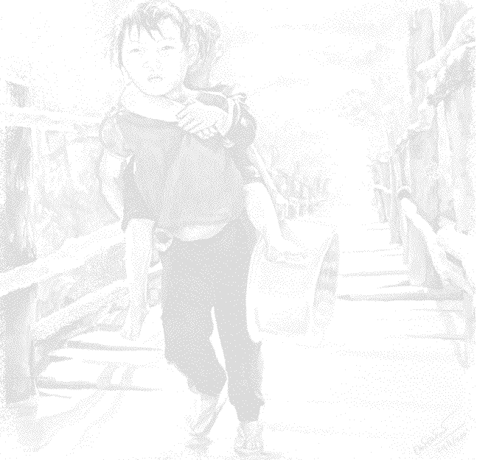
Name
Address
City |  | State |  | Zip |  | Phone
E-mail

Participant Information
Please print the information below. Circle the appropriate t-shirt size for each participant. (Note: Note: Adult t-shirts will be long-sleeve t-shirts and the sizes run smaller than normal.) There is no fee for children 5 and under to participate in the Kids’ Dash but registration is required and a short-sleeve child t-shirt can be purchased for $8.*

Last Name | First Name | Sex | Age on 4-28-07 | Kids  Dash | T-Shirt  (Y/N) | T-Shirt Size | Office use only
Child: S-M-L
Adult: M-L-XL-XXL
Child: S-M-L
Adult: M-L-XL-XXL
Child: S-M-L
Adult: M-L-XL-XXL
Child: S-M-L
Adult: M-L-XL-XXL
Child: S-M-L
Adult: M-L-XL-XXL
Child: S-M-L
Adult: M-L-XL-XXL

Entry Fees
Complete the appropriate lines and calculate a total at the bottom. Make check payable to Chapel Hill Church.
Description | T-Shirt | Number of  Participants |  | Price Per Person |  | Total
Adult (18+) with t-shirt | Yes |  | x | $18.00 | =
Adult (18+) without t-shirt | No |  | x | $10.00 | =
Child/youth (6-17) with t-shirt | Yes |  | x | $13.00 | =
Child/youth (6-17) without t-shirt | No |  | x | $5.00 | =
*Children 5 and under t-shirt S – M – L | Yes |  | x | $8.00 | =
Adult t-shirt only M – L – XL –XXL | Yes |  | x | $12.00 | =
EXTRA GIVING |  |  |  |  | =
GRAND TOTAL |  |  |  |  | =

Don’t forget to complete opposite side!

Release Information – All participants must read and sign this waiver.


I know that running a road race is a potentially hazardous activity. I should not enter and run unless I am medically able and properly trained. I agree to abide by any decision of a race official relative to my ability to safely complete the run. I assume all risks associated with running in this event including but not limited to falls, contact with other participants, the effects of the weather, including high heat and/or humidity, the conditions of the road and traffic on the course, all such risks being known and appreciated by me. Having read this waiver and knowing these facts, and in consideration of your acceptance of my entry, I, for myself and anyone entitled to act on my behalf, waive and release the cities of Gig Harbor, Pierce County, the State of Washington, Chapel Hill Presbyterian Church, World Aid, all sponsors, volunteers and their representatives and successors from all claims or liabilities of any kind arising out of my participation in this event even though that liability may arise out of negligence or carelessness on the part of the persons named in this waiver. I grant my permission to all of the foregoing to use photographs, motion pictures, recordings, or any other record of this event for any legitimate purpose. I also understand that my entry fee is nonrefundable. A parent must sign if entrant is under 18 years of age. This is to certify that my child has permission to compete in this event, is in good physical condition and the event officials may authorize necessary emergency medical treatment. I understand that bicycles, skateboards, roller skates or blades, animals and headsets are not allowed in the race, and I will abide by this guideline.

Signed (if under 18 signature of parent /guardian) ____________________________________ Date______________

Signed (if under 18 signature of parent /guardian) ____________________________________ Date______________

How did you hear about Run / Walk for Relief—Burma? _______________________________________

Donations:
If you would like to further support the relief efforts in Burma and/or are unable to participate in the Run / Walk for Relief, you can make a direct donation or sponsor a runner. Please complete the information below and make your check payable to Chapel Hill Church.

Name
Phone |  | Donation Amount

THANK YOU!

Don’t forget to complete opposite side!

