**Name: Jomol R.K**

**Roll No:09**

**Batch:S2 MCA-B**

**Date:10-6-2022**

**DATA BASE MANAGEMENT SYSTEM LAB**

**Experiment No.: 1**

**Aim**

Create  a student table with fields id,name,subject1,subject2,subject3 and total,percentage. For each entry of row, update total marks and percentage using triggers in SQL

**Procedure**

step 1: start

step 2: create table student

step 3: create trigger on student table

step 4: insert records

step 5: select the table to see if the triggers has been executed

step 6: stop

**Output Screenshot**

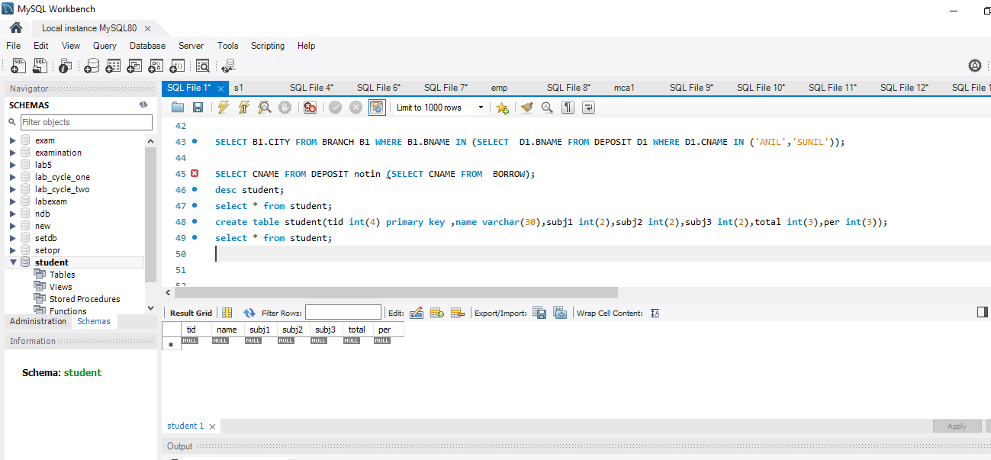

CREATE TABLE STUDENTINFO1(ID INT PRIMARY KEY , NAME VARCHAR(20) NOT NULL, SUBJ1 INT,SUBJ2 INT,TOTAL INT,per INT);

CREATE TRIGGER MARKCHANGE12 BEFORE INSERT ON STUDENTINFO1 FOR EACH ROW SET new.total=new.SUBJ1+new.SUBJ2,NEW.per = NEW.total * 60 / 100;

insert into STUDENTINFO1(ID,NAME,SUBJ1,SUBJ2)VALUES(100111,'R1O1VY',34,45);

SELECT *FROM STUDENTINFO1;

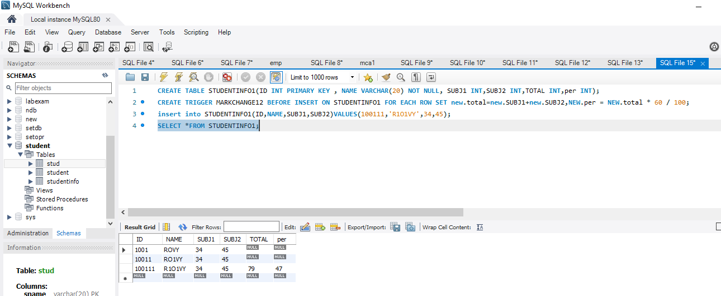

**Experiment No.: 2**

**Aim**

Create a Trigger for student table that will update another table shows the name, total marks and percentage .

**Procedure**

CREATE TABLE MARKS(MARKID INT PRIMARY KEY AUTO_INCREMENT,NAME VARCHAR(20),TOTAL_MARKS INT);

CREATE TRIGGER MARK_TRIGGER1 AFTER INSERT ON STUDENTINFO1 FOR EACH ROW

INSERT INTO MARKS(NAME,TOTAL_MARKS) VALUES(new.NAME,new.TOTAL);

INSERT INTO STUDENTINFO1(ID,NAME,SUBJ1,SUBJ2)

values(1002,'SALU',35,42),(1003,'SAN',44,38);

SELECT *FROM MARKS;

