**Angular React Frontend with Common Laravel Backend**

In this article, we’ll create a Insert Update Delete application using Angular 5 with Laravel API. Insert Update Delete Operations Insert Update and Delete will be implemented inside a Laravel API and then consumed from an Angular 5 Application and React.

*Setup a localhost in your PC. If you have a server with php7 just avoid this.*

MAC - https://coolestguidesontheplanet.com/install-apache-mysql-php-and-phpmyadmin-on-macos-high-sierra-10-13

Ubuntu - https://www.digitalocean.com/community/tutorials/how-to-install-linux-apache-mysql-php-lamp-stack-on-ubuntu-16-04

Windows - http://www.avelx.co.uk/xampp_php7_setup/

**Laravel 5.5 and DB setup**

*Copy the Angular and ReactLaravel folders to your host root (based on the server you are using)*

1. Now go to your database manager, for example, phpMyAdmin or MySQL work bench and create one database.

2. Go to .env file and enter your database credentials. (Its inside ReactLaravel folder)

DB_CONNECTION=mysql

DB_HOST=127.0.0.1

DB_PORT=3306

DB_DATABASE=test

DB_USERNAME=root

DB_PASSWORD=root

3. Next step, would be, go to the Laravel project root (ReactLaravel folder) and open the terminal and type the following command.

php artisan migrate

It ll create the necessory tables

4. If you want some default data, I provided it in sampledata.csv. You can edit it and Import according the option in your mysql client. (https://dev.mysql.com/doc/refman/5.7/en/load-data.html)

5. Go to the CMD and type the following command.

php artisan serve

It will boot up a development server, which is started at port 8000

**Angular 5 Setup**

Following tools and modules are used for this project :

– Angular CLI

– Angular 5

– ngx-Toastr (npm package)

– Bootstrap and Font-Awesome Icons

**Angular 5 Project Structure**

● src

+---● app

| +--● employees

| | |--employees.component.ts|.html|.css

| | +--● employee (employee form)

| | | |--employee.component.ts|.html|.css

| | |

| | +--● employee-list (list inserted employees)

| | | |--employee-list.component.ts|.html|.css

| | |

| | +--● shared

| | |--employee.service.ts

| | |--employee.model.ts

| |

| |--app.module.ts (configured firebase connection)

|

+---● environments

| |--environment.ts

|

|--index.html (cdn path for bootstrap and font awesome icon)

6. To run our angular application, you can use following command in CMD from the folder Angular.

ng serve --open

it will open our application from default port number 4200, that means – [http://localhost:4200](http://localhost:4200/)

**Screenshots**

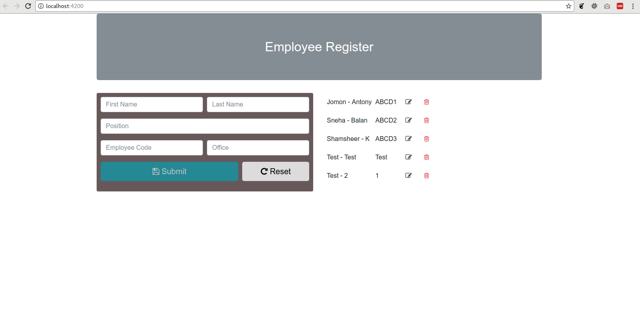

**React Setup**

Dont worry about Installing react. Its packed with Laravel. We alrady done it by preset command.

7. Go to terminal and type the following command.

npm run watch

8. now go to <http://localhost:8000/add-item>

**Screenshots**

