SAM is a recent reactive/functional sample to that amount simplifies Front-End architectures by way of genuinely keeping apart the enterprise common sense beside the digest and, in particular, exactly decoupling back-end APIs beside the Front-End. SAM is technology unbiased yet as like such be able remain used in imitation of construct Web Apps yet Native Apps. It is additionally protocol unbiased yet perform be applied over HTTP, WebSockets...
SAM is unapologetically pushed by simplicity and challenges the complexity about frameworks kind of Google's Angular yet Facebook's React+JSX+Flux/Redux+Saga+Thunk+GraphQL+Relay.
Over the final couple over years, frameworks like Angular and React hold ruled the Web App building market, however as much we have seen recently along Angular2, the Google yet Facebook groups are “still” searching because of higher methods in accordance with construct UIs.
I’d kind of in imitation of formally proclaim SAM, the State-Action-Model sample as a replacement because of the MVC pattern.
SAM is a edification concerning each React.js and TLA+ concepts. SAM, namely a pattern, execute be expressed as much a simple formula:
V = f ( M.present( A( data,M ) ) ) )
SAM stipulates that:
- the View is a function of the Model
- the Model is updated by presenting new values computed from Actions
- Actions are pure functions

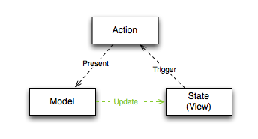
SAM does now not require somebody framework. The factoring such provides, or the decoupling such achieves makes Frameworks like Angular2 or React.js entirely redundant. While assignment regarding SAM, I became convinced so much MVC Frameworks have been shaped surely in accordance with bear together with the horrible accession between the Controller or the View. toughness MVC is the problem.
Of course, SAM manufactory simply as like nicely among the speech regarding you choice: Objective-C, Java, C#, PHP… at that place is absence precise after HTML yet JSON or JavaScript.

