package com.example.androidtoast;  
  
import androidx.appcompat.app.AppCompatActivity;  
  
import android.os.Bundle;  
import android.widget.Toast;  
  
public class MainActivity extends AppCompatActivity {  
  
 @Override  
 protected void onCreate(Bundle savedInstanceState) {  
 super.onCreate(savedInstanceState);  
 setContentView(R.layout.*activity_main*);  
 Toast.*makeText*(getApplicationContext(), "Welcome to simple android toast", Toast.*LENGTH_LONG*).show();  
 }  
}

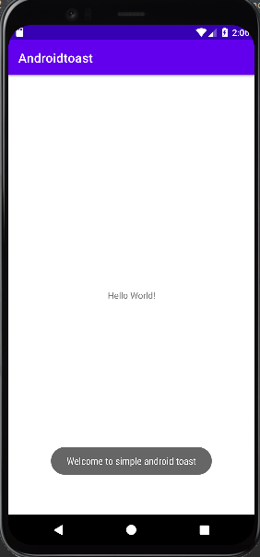

<?xml version="1.0" encoding="utf-8"?>  
<LinearLayout android:layout_width="match_parent"  
 android:layout_height="match_parent"  
 xmlns:android="http://schemas.android.com/apk/res/android"  
 xmlns:tools="http://schemas.android.com/tools"  
 android:orientation="vertical">  
 <EditText  
 android:layout_width="wrap_content"  
 android:layout_height="wrap_content"  
 android:id="@+id/entry1"  
 android:layout_alignParentTop="true"  
 android:layout_centerHorizontal="true"  
 android:layout_marginTop="61dp"  
 android:ems="10"  
 android:inputType="number"  
 tools:layout_editor_absoluteX="84dp"  
 tools:layout_editor_absoluteY="53dp"/>  
 <EditText  
 android:layout_width="wrap_content"  
 android:layout_height="wrap_content"  
 android:id="@+id/entry2"  
 android:layout_alignParentTop="true"  
 android:layout_centerHorizontal="true"  
 android:layout_marginTop="61dp"  
 android:ems="10"  
 android:inputType="number"  
 tools:layout_editor_absoluteX="84dp"  
 tools:layout_editor_absoluteY="127dp"/>  
 <Button  
 android:layout_width="wrap_content"  
 android:layout_height="wrap_content"  
 android:id="@+id/button"  
 android:text="ADD"  
 android:layout_marginTop="109dp"  
 tools:layout_editor_absoluteX="148dp"  
 tools:layout_editor_absoluteY="266dp"/>

</LinearLayout>

package com.example.sumofnum;  
  
import androidx.appcompat.app.AppCompatActivity;  
  
import android.os.Bundle;  
import android.view.View;  
import android.widget.Button;  
import android.widget.EditText;  
import android.widget.Toast;  
  
import com.example.sumofnum.R;  
  
public class MainActivity extends AppCompatActivity  
{  
 private EditText value1,value2;  
 private Button Sum;  
 @Override  
 protected void onCreate(Bundle savedInstanceState)  
 {  
 super.onCreate(savedInstanceState);  
 setContentView(R.layout.*activity_main*);  
 addListenerOnButton();  
 }  
 public void addListenerOnButton() {  
 value1 = (EditText) findViewById(R.id.*entry1*);  
 value2 = (EditText) findViewById(R.id.*entry2*);  
 Sum = (Button) findViewById(R.id.*button*);  
 Sum.setOnClickListener(new View.OnClickListener() {  
 @Override  
 public void onClick(View view) {  
 String edittext1 = value1.getText().toString();  
 String edittext2 = value2.getText().toString();  
 int a = Integer.*parseInt*(edittext1);  
 int b = Integer.*parseInt*(edittext2);  
 int sum = a + b;  
 Toast.*makeText*(getApplicationContext(), String.*valueOf*(sum),  
 Toast.*LENGTH_LONG*).show();  
 }  
 });  
 }  
}

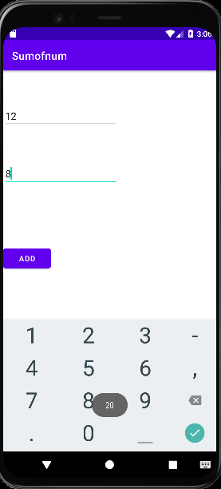

<LinearLayout android:layout_width="match_parent"  
 android:layout_height="match_parent"  
 xmlns:android="http://schemas.android.com/apk/res/android" android:orientation="vertical">  
 <EditText  
 android:layout_width="match_parent"  
 android:textColor="@color/black"  
 android:layout_height="wrap_content"  
 android:hint="Enter your Username"  
 android:layout_margin="10dp"  
 android:id="@+id/usr"/>  
  
 <EditText  
 android:layout_width="match_parent"  
 android:textColor="@color/black"  
 android:layout_height="wrap_content"  
 android:hint="Enter Password"  
 android:inputType="textPassword"  
 android:layout_margin="10dp"  
 android:id="@+id/pass"/>  
  
 <androidx.appcompat.widget.AppCompatButton  
 android:layout_width="match_parent"  
 android:layout_height="wrap_content"  
 android:id="@+id/btn"  
 android:layout_margin="10dp"  
 android:background="@color/white"  
 android:text="SUBMIT"  
 android:textColor="@color/black"/>  
  
  
</LinearLayout>

package com.example.loginpage;  
import androidx.appcompat.app.AppCompatActivity;  
import androidx.appcompat.widget.AppCompatButton;  
import android.os.Bundle;  
import android.view.View;  
import android.widget.EditText;  
import android.widget.Toast;  
  
import com.example.loginpage.R;  
  
public class MainActivity extends AppCompatActivity  
{  
 EditText ed1,ed2;  
 AppCompatButton b1;  
 String getUser,getPass;  
 @Override  
 protected void onCreate(Bundle savedInstanceState)  
 {  
 super.onCreate(savedInstanceState);  
 setContentView(R.layout.*activity_main*);  
 ed1=(EditText) findViewById(R.id.*usr*);  
 ed2=(EditText) findViewById(R.id.*pass*);  
 b1=(AppCompatButton) findViewById(R.id.*btn*);  
 b1.setOnClickListener(new View.OnClickListener(){  
 @Override  
 public void onClick(View v)  
 {  
 getUser=ed1.getText().toString();  
 getPass=ed2.getText().toString();  
 Toast.*makeText*(getApplicationContext(), getUser, Toast.*LENGTH_SHORT*).show();  
 Toast.*makeText*(getApplicationContext(),getPass,Toast.*LENGTH_SHORT*).show();  
 }  
 });  
 };  
}

