Evaluation of post-season Chinook FRAM performance

2021 PFMC Salmon Methodology Review

Jon Carey, National Marine Fisheries Service, [jonathan.carey@noaa.gov](mailto:jonathan.carey@noaa.gov)

Angelika Hagen-Breaux, Washington Department of Fish and Wildlife

Jeremiah Shrovnal, Washington Department of Fish and Wildlife

Derek Dapp, Washington Department of Fish and Wildlife

October 6, 2021

Table of Contents

## Introduction

As part of the annual preseason planning process for setting salmon fisheries in the marine waters of Washington and Oregon, the Pacific Fishery Management Council (PFMC) and Washington co-managers use the Fishery Regulation Assessment Model (FRAM) to estimate impacts of proposed fisheries on various coho and Chinook stocks. For Chinook specifically, FRAM is used to help plan PFMC ocean fisheries that occur north of Cape Falcon, OR as well as those that occur in the Strait of Juan de Fuca and Puget Sound. The FRAM is a deterministic single-pool model where each model run occurs over a single year and estimates fishery impacts by stock for specific time periods and age classes. For details on model structure and computational processes, in addition to a user manual, see the [FRAM Documentation Website](https://framverse.github.io/fram_doc/index.html).

The FRAM is rooted in a set of base period data derived through species-specific cohort analysis procedures that are founded primarily on coded-wire tag (CWT) recoveries. Key Chinook base period data include stock-age-fishery-time period specific exploitation rates, cohort sizes, maturation rates, adult equivalent (AEQ) rates, and growth function parameters. The original set of base period data for Chinook was derived from CWTs released during the 1974 - 1979 brood years and shared many of the same CWT tag groups that were used to represent exploitation rate indicator stocks and model stocks of the Pacific Salmon Commission (PSC) Chinook Model that is used for fishery management in accordance with the Pacific Salmon Treaty (PST). In recent years, a considerable amount of effort has been devoted to contemporizing and continually refining the Chinook FRAM base period data set, which is now derived from CWTs released during the 2005 - 2008 brood years. The most current base period calibration, referred to as "Round 7.1" was created in June 2021 and was produced along with a time series of postseason model runs (often referred to as validation runs) ranging from 1992 - 2018. These postseason model runs were updated in September 2021 to correct an error identified with inputs specific to Skagit Spring Chinook. FRAM-based results presented in this report are based on this September 2021 model output. Utilizing these more contemporary base period years for FRAM means that there is no longer overlap in the CWT tag groups used to represent many of the model stocks in the PSC Chinook model, as much of the base data for the PSC Chinook model are still rooted in earlier brood years. However, there is still considerable overlap between the tag codes used to represent many Chinook FRAM stocks and the brood year 2005 - 2008 tag codes used for exploitation rate indicator stocks as part of the Chinook Technical Committee's (CTC) annual Exploitation Rate Analysis (ERA).

Each year the CTC conducts its annual ERA, which relies on cohort analysis to compute stock-specific estimates of exploitation rates, maturation rates, survival rates, and fishery indices for specified exploitation rate indicator stocks relevant to the PST. Results of the ERA are used to evaluate postseason performance in fisheries that fall under the Individual Stock Based Management (ISBM) regime of the PST. Output from the annual ERA, including estimates of maturation rates, AEQ rates, and age- and fishery-specific exploitation rates are also used as input to the annual calibration of the PSC Chinook model, which has been used to set pre- and post-season annual catch limits for fisheries that fall under the Aggregate Abundance Based Management (AABM) regime of the PST.

The purpose of this assessment is to provide an evaluation of FRAM postseason performance by comparing it with independently derived metrics from the CTC's annual ERA for appropriate stocks. Here we compare annual estimates of ocean exploitation rates and age-specific maturation rates from both Chinook FRAM and the CTC's ERA for 1999 through 2018. This range of years was selected because it represents the entirety of two ten-year PST agreements (1999-2008 and 2009-2018). As there were changes to the fishing regimes between the 1999 and 2009 PST Agreements, we compare both across and between the two time periods. It is important to acknowledge that the exploitation rates and other parameters produced by FRAM and the ERA are all estimates of the true values, which remain unknown. While each model has strengths and weaknesses, in many cases it remains difficult to determine which is more accurate. That said, this exercise remains useful in that it can help to identify discrepancies between the two models. Subsequent investigations into these discrepancies can lead to identification of errors or other recommendations for improvement to either model. This exercise may be of particular value for some Puget Sound Chinook stocks, where ERA harvest rates are used to inform stock-recruit models and subsequent rebuilding exploitation rate (RER) analyses. In some cases these RERs have been used to inform fishery limitations under the Endangered Species Act (ESA), and in cases where discrepancies exist between ERA and FRAM exploitation rates, a translation to a "FRAM-equivalent" RER becomes necessary, as FRAM is the tool used to assess fishery impacts.

In its current state, we consider this product to be a work in progress and envision future iterations. Most notably, we have delveloped a framework for comparing postseason model run output from both FRAM and the ERA for which the results can be quickly and easily updated should more recent or improved output become available. The codebase used to conduct this assessment and produce this document is publicly available on GitHub [(https://github.com/jon-carey/FRAM_R-Code/blob/master/FRAM_v_ERA.Rmd)](https://github.com/jon-carey/FRAM_R-Code/blob/master/FRAM_v_ERA.Rmd). We seek feedback from attendees of the October 2021 Salmon Methodology Review meeting on ways to improve the comparisons, should there be any. Following the results, we present some case studies into potential reasons causing differences between model outputs for stocks with notable differences. This not intended to be a comprehensive evalutation, rather it provides some examples of factors that can cause differences between the models. Lastly, we close with some overall conclusions and next steps.

### Model similarities and differences

Before comparing output of these two models, it is important to highlight some of the key similarities and differences between them. Both processes are rooted in a standard CWT-based cohort analysis. A key difference, however, is that while FRAM uses a single cohort analysis to derive a set of base period data, the ERA conducts a separate cohort analysis for each individual brood year across the time series of available data. This difference is a result of the primary intended use of each model. The ERA is conducted in a postseason context only, as it requires CWT recoveries from a given year in order to produce output for that year. Chinook FRAM, however, can be used in both a preseason and postseason context, although the primary use is in a preseason context for estimating the impacts of proposed fisheries on various Chinook stocks during an upcoming fishing season. As such, the model employs a set of base period reference data, including stock-age-fishery-time period specific exploitation rates and maturation rates, which remain static between model runs. Given FRAM's reliance on a base period and the assumption of static parameters across years, we don't expect perfect agreement between FRAM and ERA exploitation rates across the entire time series. Rather, we expect to see a lower interannual variability in the FRAM exploitation rates, thus, a comparison of average exploitation rates over time may be more appropriate.

Given the need to accommodate the fishery management cycle and different fishing seasons (e.g., winter, spring, summer) during preseason model runs, Chinook FRAM operates over a series of four time steps within a given year: (1) the preceding October to April, (2) May to June, (3) July to September, and (4) October to the following April. In contrast, the ERA operates over a single annual time step for each calendar year. For the purposes of this assessment, FRAM exploitation rates are calculated by summing across time steps 1-3, thus a given year represents October of the preceding year through September of the year specified, resulting in a slight disconnect between the true calendar years represented in the ERA.

Both models incorporate natural mortality at the same assumed annual rates of 40% for age 2, 30% for age 3, 20% for age 4, and 10% for age 5. Both models also account for incidental fishing mortality (e.g., shaker mortality, legal and sublegal non-retention, drop-off), however, the assumed release mortality and drop-off mortality rates differ.

Chinook FRAM is a multi-stock model which, with a few notable exceptions, attempts to account for the majority of Chinook production from the Sacramento River in the South to Cape Caution, British Columbia in the north. Hence, model stocks account for most of the modeled fishery catch. During cohort reconstruction FRAM incorporates a step where the recoveries in a fishery are expanded to match the reported catch in a fishery. This can result in base period exploitation rate errors when catches are misreported. Conversely, it can improve estimates for fisheries with inaccurate "Estimated CWTs". Additionally, Chinook FRAM incorporates imputed recoveries into the base period cohort analyses for some fisheries where sampling has not occurred (i.e., certain Puget Sound freshwater sport fisheries), whereas in the ERA these recoveries are currently unaccounted for.

Another notable difference between Chinook FRAM and the ERA in its current state is that FRAM contains separate "marked" (adipose fin clipped) and "unmarked" (adipose intact) components for each stock and algorithms for processing mark-selective fisheries (MSFs) while the ERA does not. The CTC is currently in the process of developing MSF algorithms for the ERA to allow assessment of impacts on unmarked Chinook, however, an anticipated completion date is yet to be determined. Pairing FRAM with the associated Terminal Area Management Module (TAMM) excel file also allows for accounting of differential impacts to natural populations in selective fisheries (mark, area, gear, time, etc.) as well as processing of freshwater fisheries on a population level by splitting individual populations from existing model stock aggregates.

## Methods

### Stocks

The table below provides a list of FRAM and ERA stocks that were included in this evaluation and how they relate to each other, based on a review and comparison of the CWT codes used to represent each stock. In all cases there is at least some overlap in the tag codes used to represent the FRAM and ERA stocks. In some cases there is more than one ERA stock used to represent a single FRAM stock. In these cases, exploitation rates and maturation rates were averaged across all ERA stocks that correspond to a single FRAM stock. There are some FRAM stocks that were not included in this evaluation due to lack of a suitable ERA counterpart. Generally, these were Puget Sound yearling stocks with low abundances (e.g., South Puget Sound fall yearling, Hood Canal fall yearling), stocks without marked tag codes available to represent them, (e.g., White River spring, Strait of Juan de Fuca), or stocks that are outside the purview of the PST (e.g., Sacramento River Fall Chinook). Also note that there are some instances where stocks or hatchery programs included in a FRAM stock aggregate may differ slightly to those used in an ERA stock/stock aggregate, such as "Mid Puget Sound Fall Fingerlings" in FRAM including the Grovers, Issaquah, Soos Creek, and Voights tag releases, but the corresponding tag group in the ERA including Grovers, Issaquah, and Soos Creek tag releases (but not Voights). Differences in tag codes used to represent stocks via the FRAM and ERA are presented in the results section.

Table 1. Table relating FRAM stocks to ERA stocks

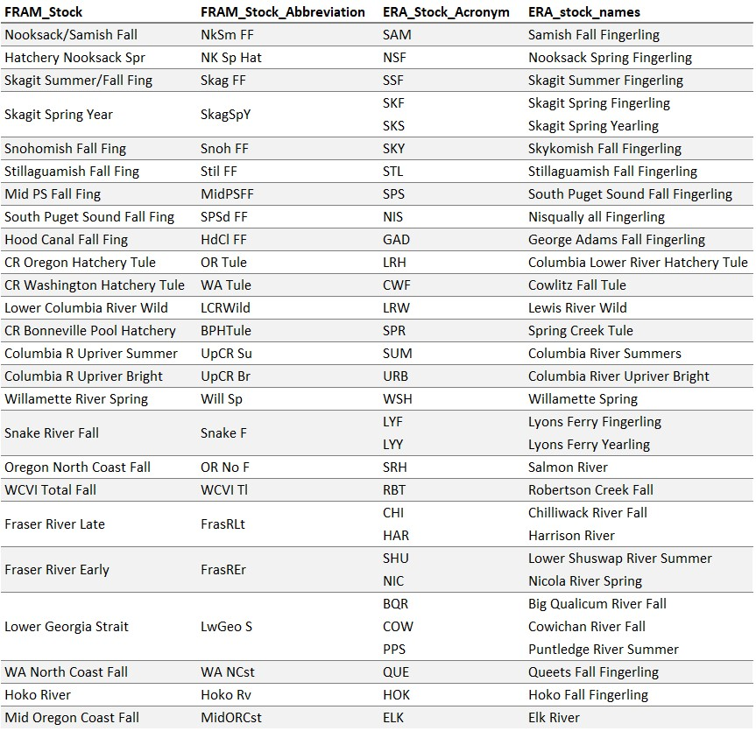

### Fisheries

The table below provides a crosswalk of FRAM fisheries and ERA fishery groupings to four regions as presented in figures below: Southeast Alaska (SEAK), Northern and Central British Columbia (NBC), Southern British Columbia (SBC), and Southern United States (SUS). FRAM includes 73 fisheries from southeast Alaska, Canada, Puget Sound and off the Coast of Washington, Oregon, and California. The ERA contains 233 fine scale fisheries encompassing the same range as those in FRAM, which get aggregated into 28 fishery groupings for reporting in "total mortality distribution tables," which get reported in annual ERA reports (see reference and link below). Efforts were made to ensure alignment between FRAM fisheries and ERA fisheries when assigning each fishery to a region for comparative purposes. There may, however, be unique, stock-specific instances where misalignments occur.

Table 2. Table relating FRAM fisheries to ERA fisheries

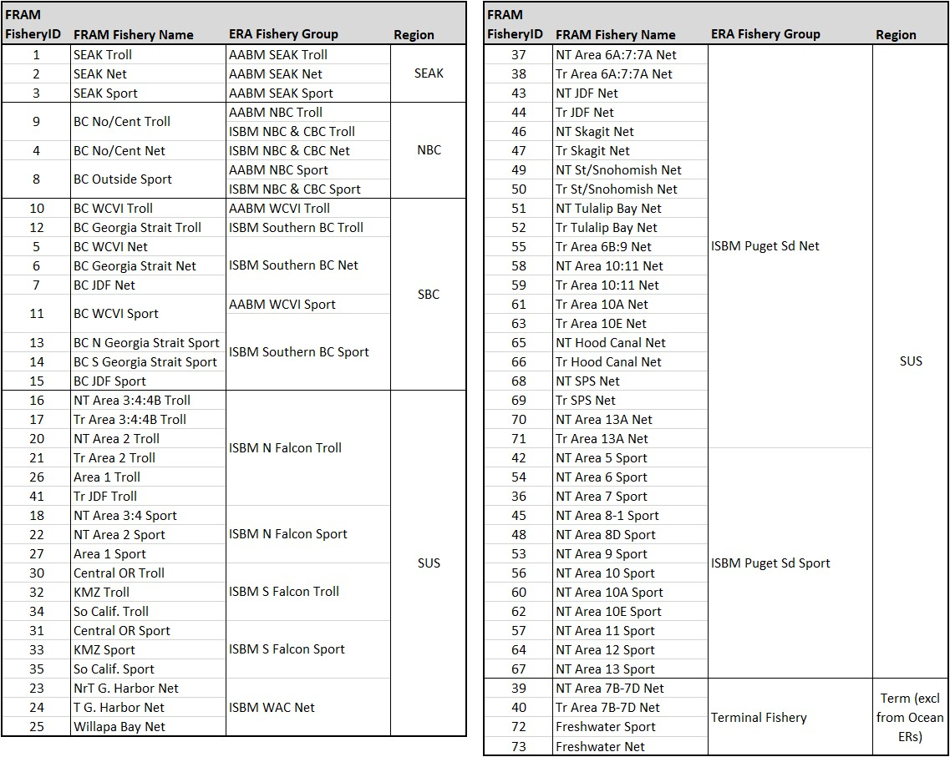

### Exploitation Rates

#### ERA

Each year the CTC conducts an "Exploitation Rate Analysis" (ERA), which involves brood year specific CWT-based cohort analyses that reconstruct the cohort size and exploitation rate history for a given set of exploitation rate indicator stocks. Methods and algorithms central to the ERA can be found in Appendix II, Supplement B of [CTC, 1988](https://www.psc.org/download/35/chinook-technical-committee/2150/tcchinook88-2app2.pdf). For this assessment we used results from the ERA conducted in 2020, which provides calendar year exploitation rate estimates through 2018 for all indicator stocks. Results of this analysis are published and available on the PSC website [(CTC, 2021)](https://www.psc.org/download/35/chinook-technical-committee/14106/tcchinook-21-05.pdf). Calendar year exploitation rates derived from the CTC's ERA can be obtained from AEQ total mortality distribution tables included in Appendix C of the published report, (also [available electronically](https://www.psc.org/download/638/data-sets/14107/tcchinook-21-05-appendix-c-mortality-distribution-tables-detailed.xlsx) on the PSC website) and are calculated for each stock (s) in a given calendar year (cy) for a subset of fisheries (F) as:

Where,  
  ER = exploitation rate  
  cy = calendar year  
  s = stock  
  F = ocean (pre-terminal) fisheries  
  a = age  
  MinAge = 2  
  MaxAge = 5  
  f = fishery  
  TotMort = total (landed plus non-landed) fishing mortality  
  AEQ = adult equivalent (proportion of fish that would have survived to maturity and escaped to spawn in the absence of fishing)  
  Esc = escapement

Ocean exploitation rates for a given stock/year are calculated by summing the percentage distributions across all AABM and ISBM fisheries (terminal fisheries are excluded). It is important to note that, as the ERA is conducted using CWT tag codes with marked releases, these are estimates of exploitation rates experienced by the marked component of each stock. For stocks that are not subjected to significant MSFs, the difference in exploitation rates between the unmarked and marked components of the stock would be expected to be minimal. It is possible, however, that even in the absence of exposure to MSFs, there could be differences in marked and unmarked exploitation rates on a stock due to differences in age composition between the two groups. The CTC is currently in the process of incorporating MSF algorithms into the ERA.

#### FRAM

FRAM exploitation rates were based on postseason validation runs conducted in September 2021, which used the latest version of the Chinook FRAM base period calibration, referred to as 'round 7.1'. Unlike the ERA, FRAM does account for differential impacts on the marked and unmarked components of a stock when exposed to MSFs, thus, in order to ensure comparability with exploitation rates from the ERA, FRAM exploitation rates presented in this document are derived using the marked component of each stock. For this analysis only preterminal (ocean) exploitation rates were evaluated, as FRAM does not account for terminal or freshwater fishery impacts for most stocks that originate outside of Puget Sound. FRAM exploitation rates for a subset of fisheries (F), are calculated for a given catch year (cy) and stock (s), as:

Where,  
  t = time step

Please note that the FRAM exploitation rates presented in this assessment will differ from those that may be reported in other forums in an effort to produce rates that are comparable to those produced by the ERA. These difference are primarily due to:  
  1. Use of the "marked" stock component rather than the "unmarked" stock component, which is often used to  
  estimate impacts on natural origin stocks.  
  2. Inclusion of age 2 fish in escapement and the resulting abundance which serves as the denominator of the  
  exploitation rate equation. Typically, FRAM derived exploitation rates do not include age 2 fish in escapement.  
  3. Summation of annual impacts across FRAM time steps 1 through 3 (October through September), rather than time  
  steps 2 through 4 (May through April), which is typically the practice when assessing Puget Sound stock impacts.

### Maturation Rates

Maturation rates are calculated similarly in both the ERA and FRAM base period cohort analyses as the mature portion of the total cohort after preterminal fishing, or:

A distinction is that while the ERA maturation rates are calculated on an annual basis, FRAM maturation rates are calculated separately for each Chinook FRAM time step (e.g., Oct-Apr, May-Jun, Jul-Sep). In order to provide FRAM maturation rates that are comparable to the annual rates produced by the ERA, annual maturation rates were calculated from the time step-specific rates for each FRAM stock (s) and age (a) as:

It is also worth noting that whereas the ERA maturation rates are calculated using CWT recovery data for each brood year across the time series, the FRAM maturation rates are calculated as part of the base period calibration, thus, as part of the base period data set they remain constant between model runs (i.e., are static across all years in this assessment). Maturation rates for five year old Chinook are assumed to be 100% in both models. As a result, age five maturation rates were not included in the maturation rate plots that follow to improve readability.

## Results

### Overall Summary Across Stocks

#### Regional Box Plots

##### Puget Sound

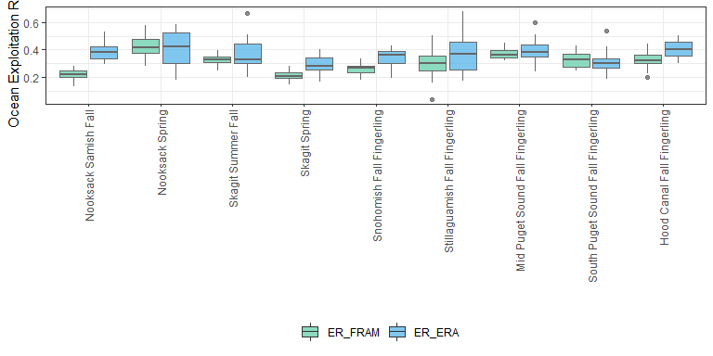

##### Columbia River

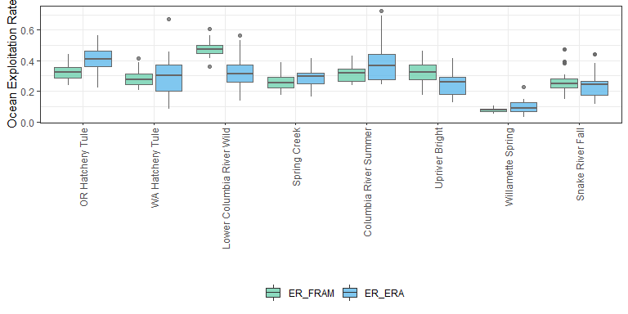

##### WA/OR Coast & Canada

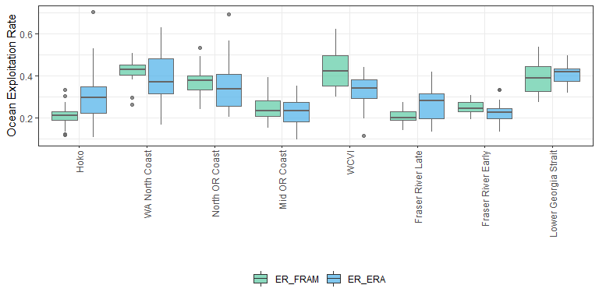

#### ER Scatterplots

##### Combined

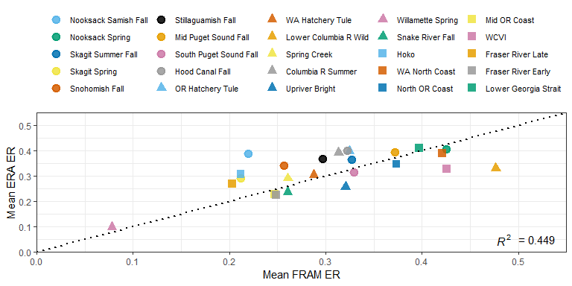

##### 1999 to 2008

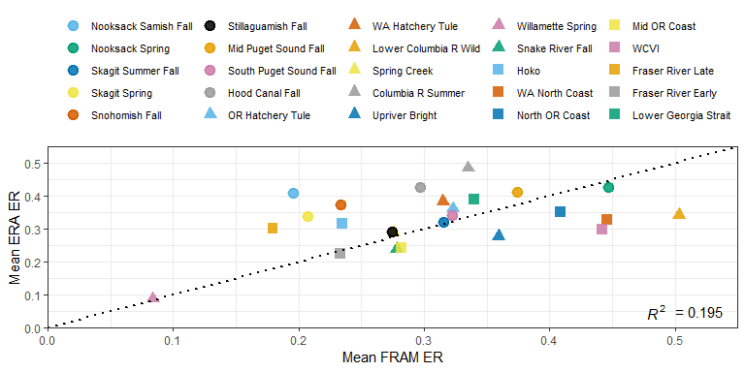

##### 2009 to 2018

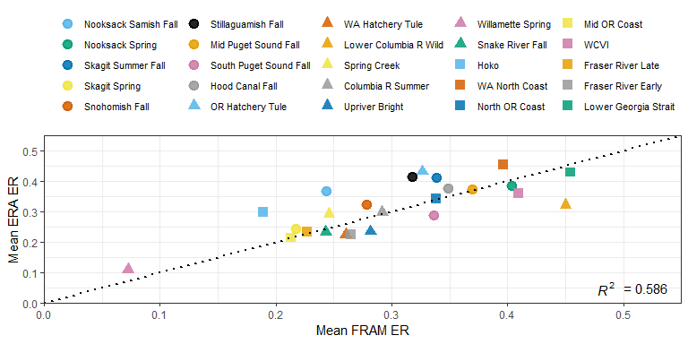

#### Maturation Rates

##### Age 2

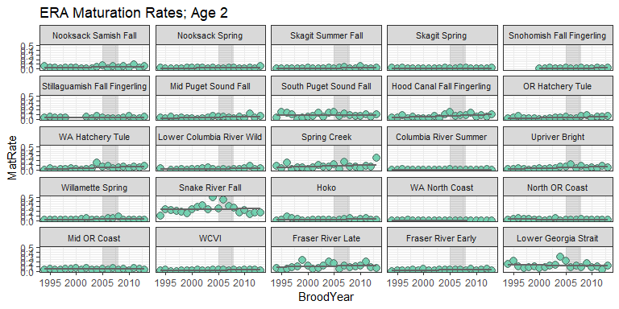

##### Age 3

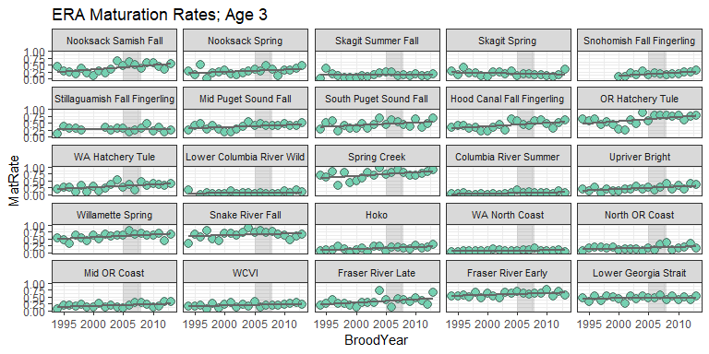

##### Age 4

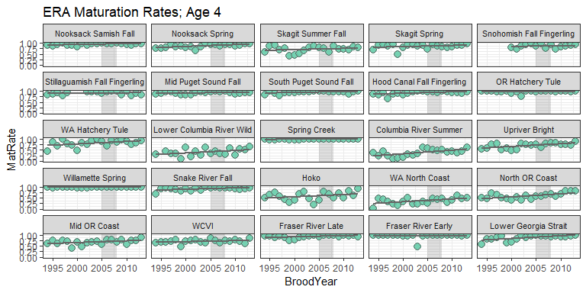

### Individual Stock Results

#### Nooksack Samish Fall

BroodYear

TagCode

Stock_ERA

ERA

FRAM

2005

633369

SAM

x

x

2005

633591

NA

x

2006

633389

SAM

x

x

2006

634080

NA

x

2007

634272

SAM

x

x

2007

634583

NA

x

2008

634841

SAM

x

x

2008

635081

NA

x

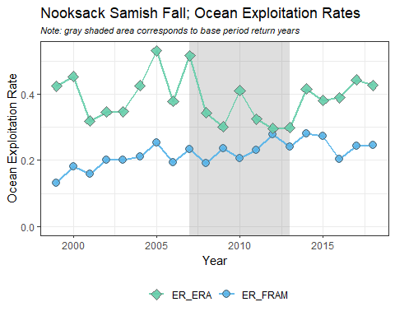  
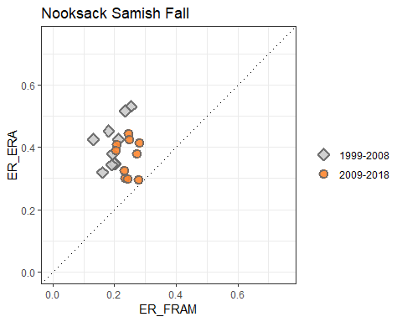  
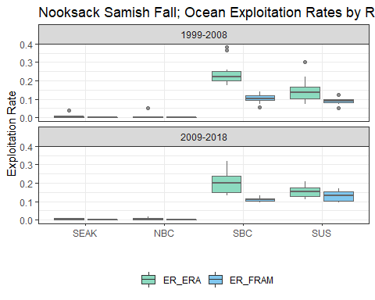  
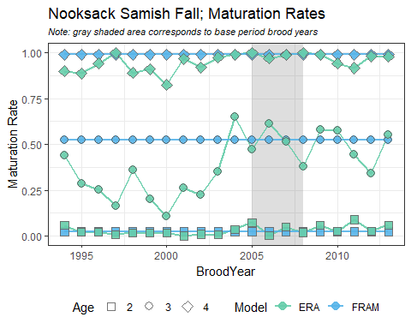

#### Nooksack Spring

BroodYear

TagCode

Stock_ERA

ERA

FRAM

2005

633172

NSF

x

x

2006

633387

NSF

x

x

2007

634274

NSF

x

x

2008

634797

NSF

x

x

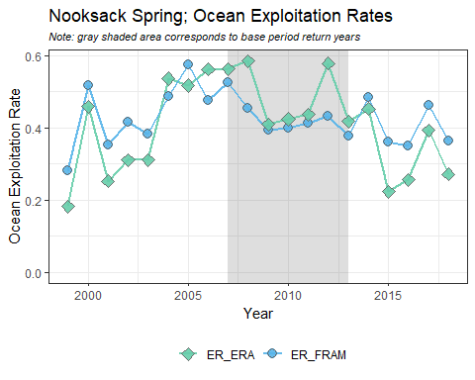  
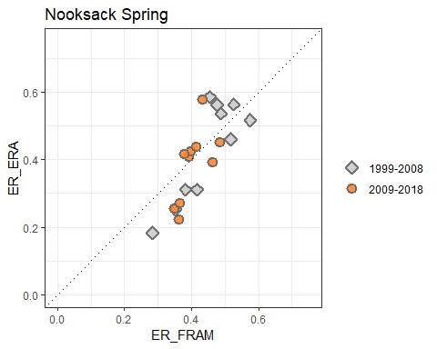  
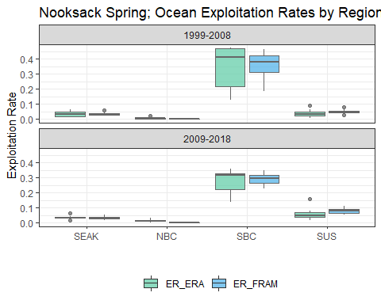  
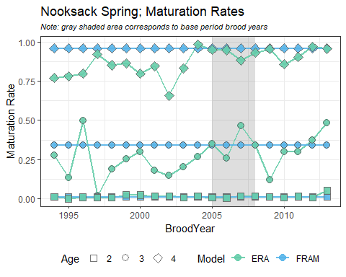

#### Skagit Summer Fall

BroodYear

TagCode

Stock_ERA

ERA

FRAM

2005

210677

SSF

x

x

2005

212827

SSF

x

x

2005

210685

NA

x

2006

210735

SSF

x

x

2006

210745

NA

x

2007

210789

SSF

x

x

2007

210278

NA

x

2008

210842

SSF

x

x

2008

210831

NA

x

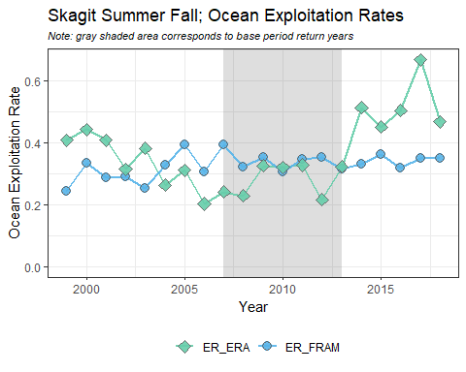  
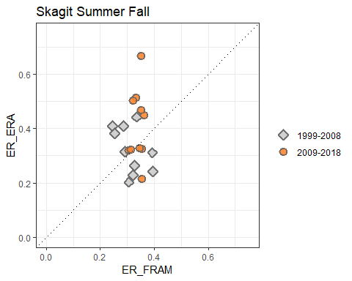  
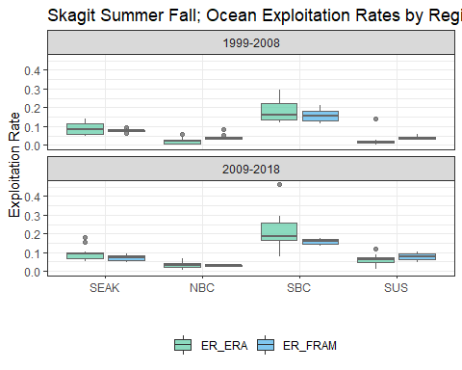  
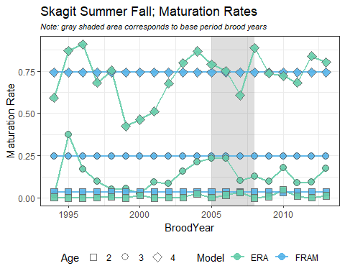

#### Skagit Spring

BroodYear

TagCode

Stock_ERA

ERA

FRAM

2005

633364

SKF

x

x

2005

633176

SKS

x

x

2006

633867

SKF

x

x

2006

633486

SKS

x

x

2006

633487

SKS

x

x

2006

633488

SKS

x

x

2007

633869

SKF

x

x

2007

634373

SKS

x

x

2008

634395

SKF

x

x

2008

634769

SKS

x

x

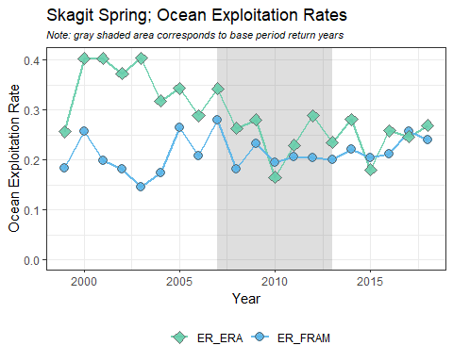  
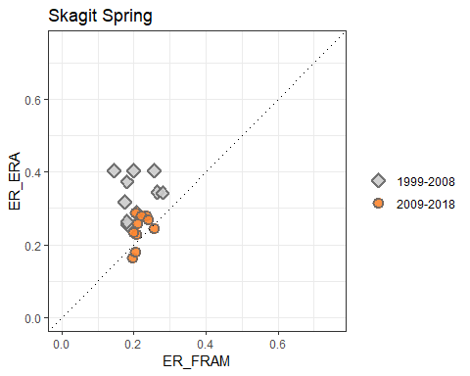  
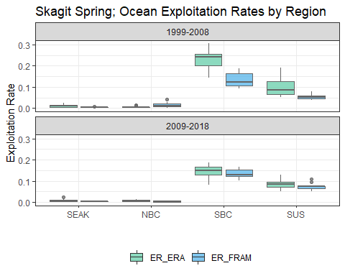  
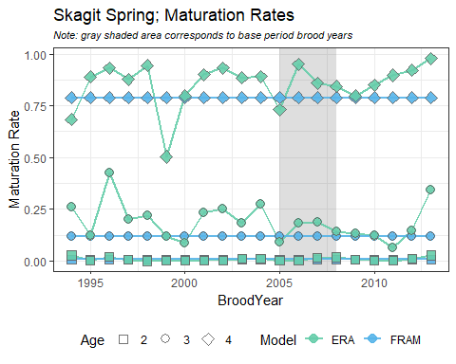

#### Snohomish Fall Fingerling

BroodYear

TagCode

Stock_ERA

ERA

FRAM

2005

633381

SKY

x

x

2006

633887

SKY

x

x

2007

634281

SKY

x

x

2008

634844

SKY

x

x

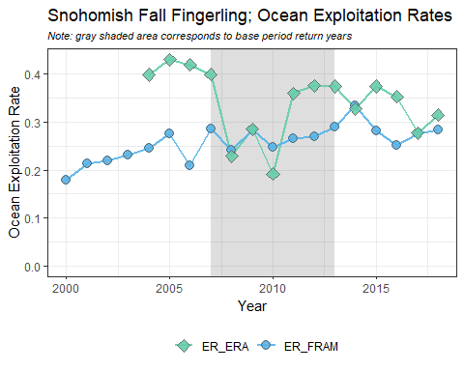  
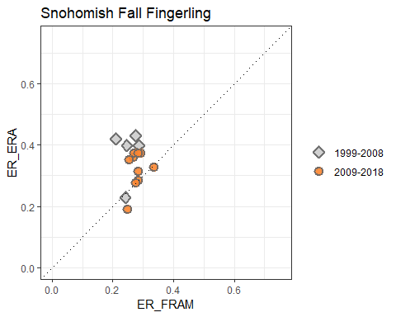  
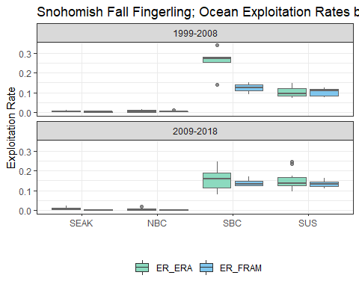  
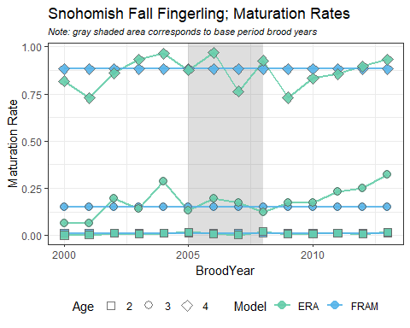

#### Stillaguamish Fall Fingerling

BroodYear

TagCode

Stock_ERA

ERA

FRAM

2005

210684

STL

x

x

2006

210733

STL

x

x

2006

210743

STL

x

x

2007

210741

STL

x

x

2007

210787

STL

x

x

2008

210840

STL

x

x

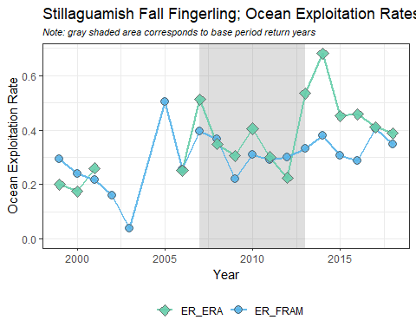  
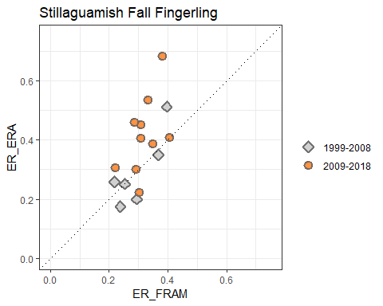  
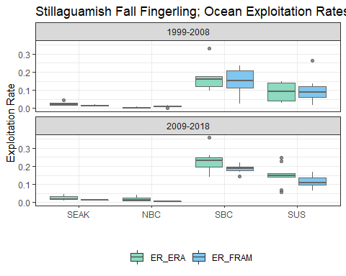  
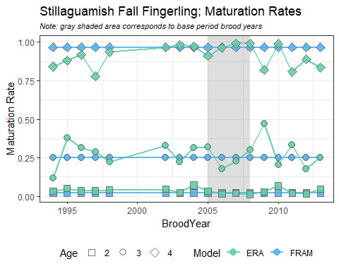

#### Mid Puget Sound Fall Fingerling

BroodYear

TagCode

Stock_ERA

ERA

FRAM

2005

633285

SPS

x

x

2005

633372

SPS

x

x

2005

633375

NA

x

2005

633383

NA

x

2006

633882

SPS

x

x

2006

633579

SPS

x

x

2006

633885

NA

x

2006

633889

NA

x

2007

634286

SPS

x

x

2007

210790

SPS

x

x

2007

634284

NA

x

2008

634864

SPS

x

x

2008

210822

SPS

x

x

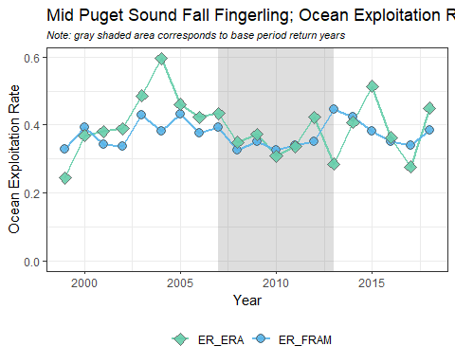  
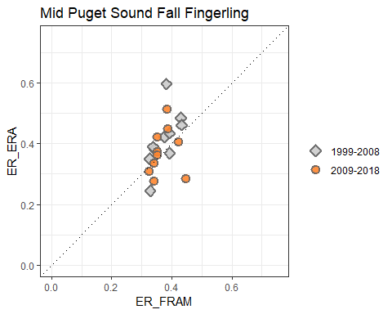  
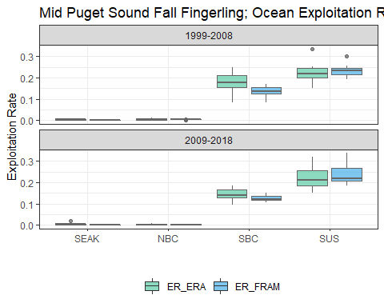  
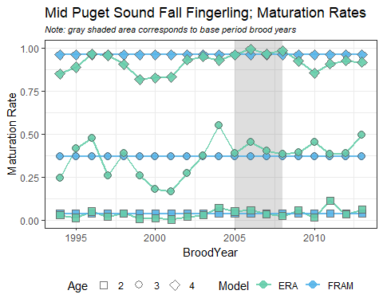

#### South Puget Sound Fall Fingerling

BroodYear

TagCode

Stock_ERA

ERA

FRAM

2005

633286

NIS

x

x

2005

632979

NA

x

2005

210671

NA

x

2005

632894

NA

x

2006

633391

NIS

x

x

2006

210744

NA

x

2006

633964

NA

x

2006

633968

NA

x

2007

210788

NIS

x

x

2007

210801

NA

x

2007

633466

NA

x

2007

634364

NA

x

2008

210824

NIS

x

x

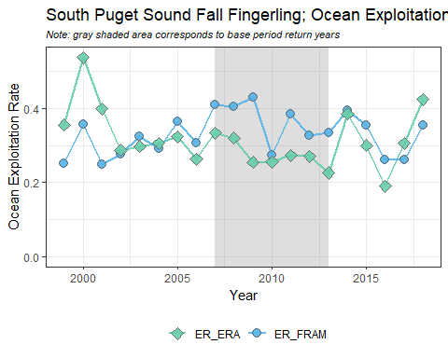  
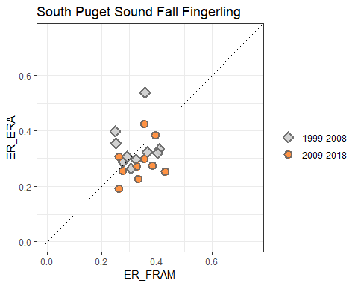  
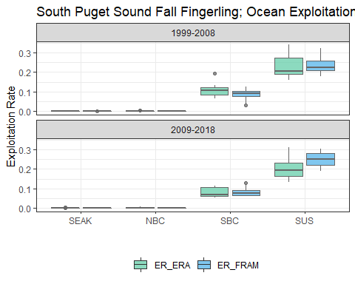  
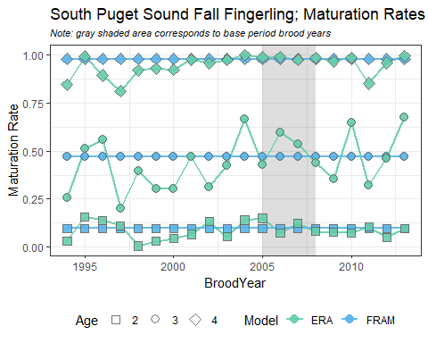

#### Hood Canal Fall Fingerling

BroodYear

TagCode

Stock_ERA

ERA

FRAM

2005

633366

GAD

x

x

2005

633382

NA

x

2005

633471

NA

x

2006

633875

GAD

x

x

2006

633886

NA

x

2006

633965

NA

x

2007

634271

GAD

x

x

2007

634283

NA

x

2008

634873

GAD

x

x

2008

634867

NA

x

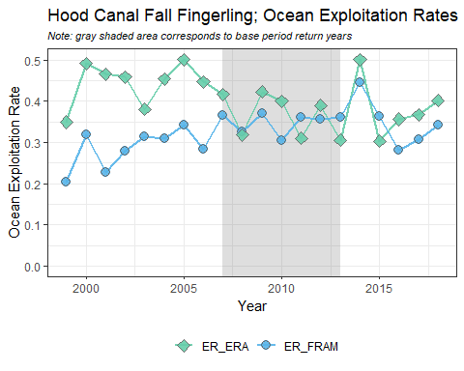  
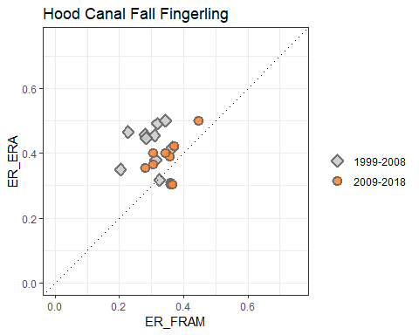  
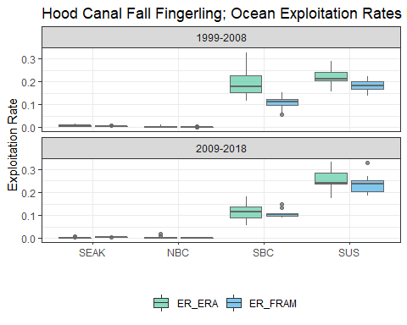  
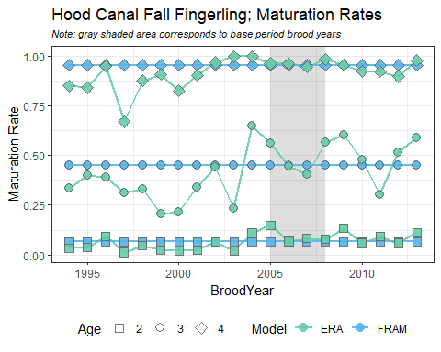

#### OR Hatchery Tule

BroodYear

TagCode

Stock_ERA

ERA

FRAM

2005

094423

LRH

x

x

2006

094526

LRH

x

x

2007

094646

LRH

x

x

2008

090199

LRH

x

x

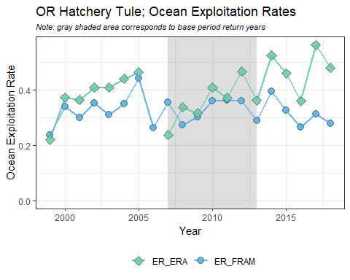  
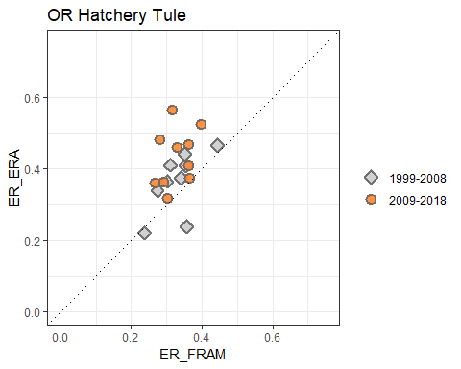  
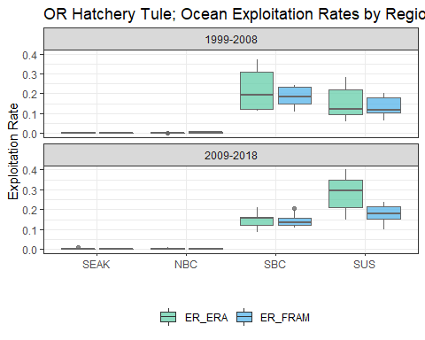  
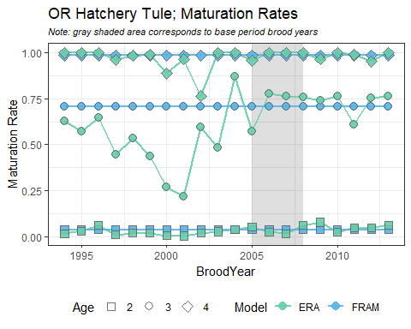

#### WA Hatchery Tule

BroodYear

TagCode

Stock_ERA

ERA

FRAM

2005

633287

CWF

x

x

2005

632883

NA

x

2005

632886

NA

x

2006

633877

CWF

x

x

2006

633976

NA

x

2006

633977

NA

x

2007

634280

CWF

x

x

2007

634369

NA

x

2007

634372

NA

x

2008

634279

CWF

x

x

2008

634774

NA

x

2008

634775

NA

x

2008

634385

NA

x

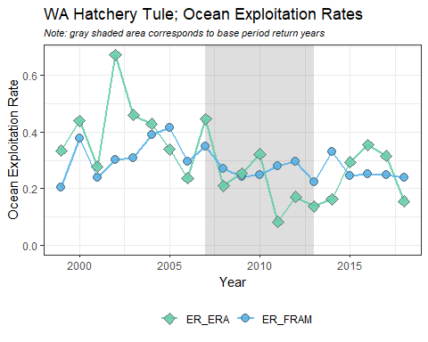  
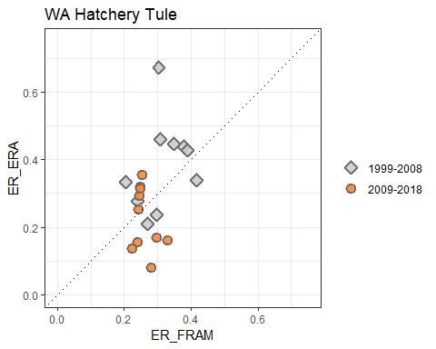  
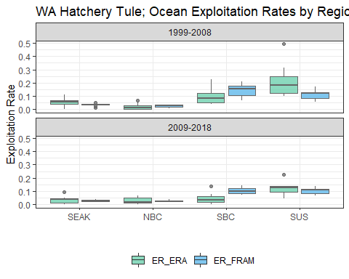  
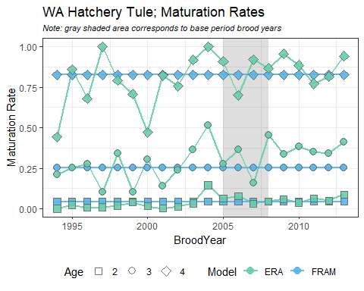

#### Lower Columbia River Wild

BroodYear

TagCode

Stock_ERA

ERA

FRAM

2005

632986

LRW

x

2005

632987

LRW

x

x

2006

633492

LRW

x

x

2006

633979

LRW

x

x

2007

634186

LRW

x

x

2008

634382

LRW

x

x

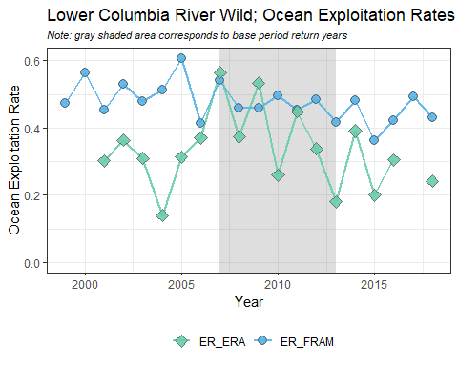  
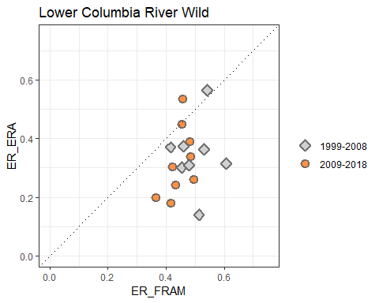  
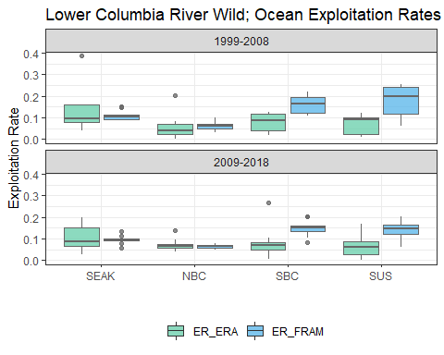  
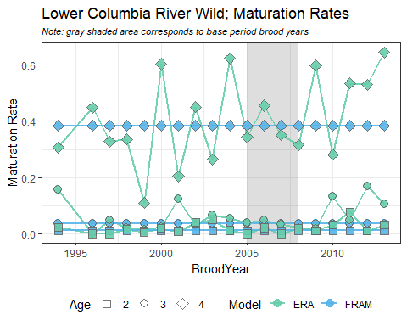

#### Spring Creek

BroodYear

TagCode

Stock_ERA

ERA

FRAM

2005

052873

SPR

x

x

2005

052874

SPR

x

x

2005

052971

SPR

x

x

2005

052972

SPR

x

x

2006

052570

SPR

x

x

2006

052577

SPR

x

x

2006

052588

SPR

x

x

2006

052895

SPR

x

x

2006

052897

SPR

x

x

2006

053592

SPR

x

x

2006

054318

SPR

x

x

2006

054336

SPR

x

x

2007

050685

SPR

x

x

2007

052978

SPR

x

x

2007

053767

SPR

x

x

2007

053776

SPR

x

x

2007

053778

SPR

x

x

2007

053780

SPR

x

x

2007

053782

SPR

x

x

2007

053874

SPR

x

x

2007

054274

SPR

x

x

2007

054276

SPR

x

x

2008

054864

SPR

x

x

2008

054866

SPR

x

x

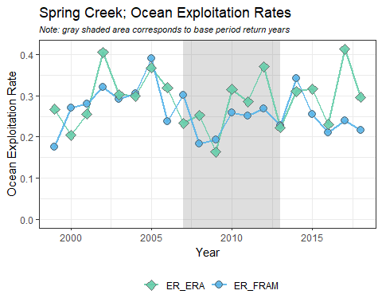  
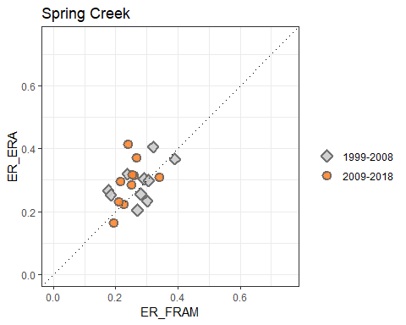  
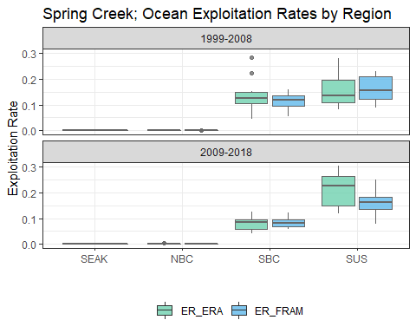  
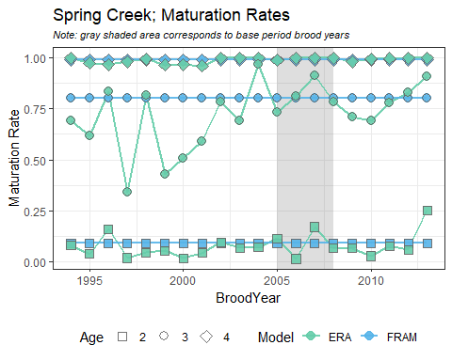

#### Columbia River Summer

BroodYear

TagCode

Stock_ERA

ERA

FRAM

2005

633298

SUM

x

x

2005

633299

SUM

x

x

2005

633596

SUM

x

x

2006

633385

SUM

x

x

2006

633386

SUM

x

x

2006

633799

SUM

x

x

2007

633871

SUM

x

x

2007

633872

SUM

x

x

2007

634287

SUM

x

x

2007

634390

SUM

x

x

2008

634876

SUM

x

x

2008

635092

SUM

x

x

2008

635093

SUM

x

x

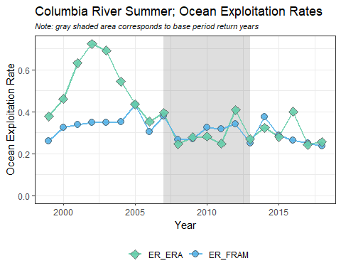  
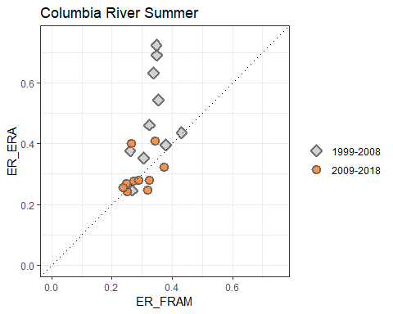  
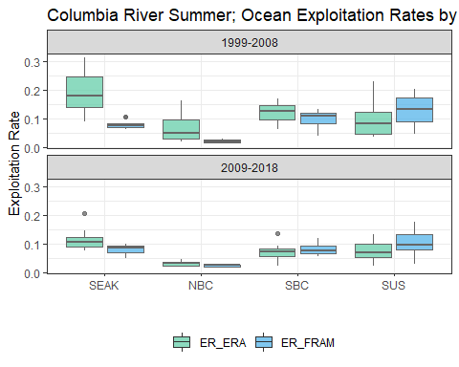  
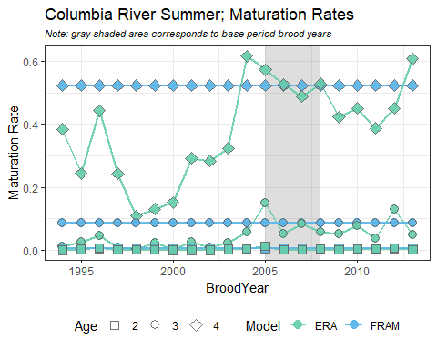

#### Upriver Bright

BroodYear

TagCode

Stock_ERA

ERA

FRAM

2005

633173

URB

x

x

2006

094504

URB

x

x

2006

633894

URB

x

x

2007

094663

URB

x

x

2007

634391

URB

x

x

2008

634799

URB

x

x

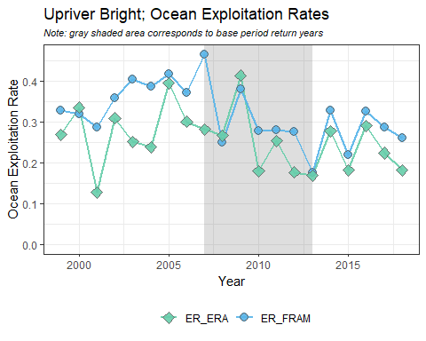  
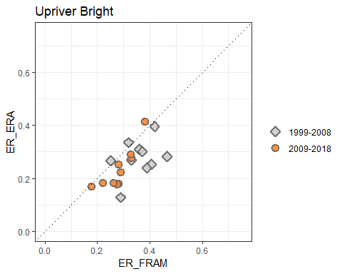  
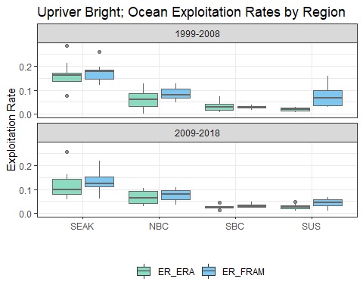  
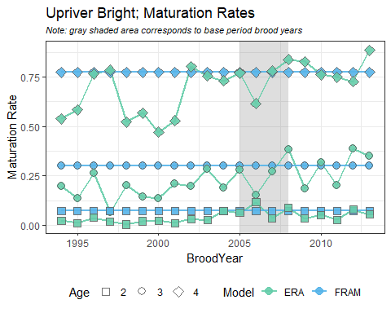

#### Willamette Spring

BroodYear

TagCode

Stock_ERA

ERA

FRAM

2005

094422

WSH

x

x

2005

092734

WSH

x

x

2005

094143

WSH

x

x

2005

094453

WSH

x

x

2005

094142

WSH

x

x

2005

094344

WSH

x

x

2005

094436

WSH

x

x

2005

094438

WSH

x

x

2005

094345

WSH

x

x

2005

094019

WSH

x

2005

094348

WSH

x

x

2005

094349

WSH

x

x

2005

094347

WSH

x

x

2005

094425

WSH

x

x

2005

094335

NA

x

2005

094346

NA

x

2005

094437

NA

x

2005

094333

NA

x

2005

094140

NA

x

2005

094439

NA

x

2005

094139

NA

x

2006

094549

WSH

x

x

2006

094556

WSH

x

x

2006

094557

WSH

x

x

2006

094558

WSH

x

x

2006

094559

WSH

x

x

2006

094560

WSH

x

x

2006

094561

WSH

x

x

2006

094562

WSH

x

x

2006

094563

WSH

x

x

2006

094601

WSH

x

x

2006

094602

WSH

x

x

2006

094603

WSH

x

x

2006

094609

WSH

x

x

2006

094610

WSH

x

x

2006

094612

WSH

x

x

2006

094614

WSH

x

x

2006

094615

WSH

x

x

2006

094616

WSH

x

x

2006

094617

WSH

x

2006

094627

WSH

x

x

2007

094650

WSH

x

x

2007

094529

WSH

x

x

2007

090169

WSH

x

x

2007

090171

WSH

x

x

2007

090177

WSH

x

x

2007

090178

WSH

x

x

2007

090188

WSH

x

x

2007

090190

WSH

x

x

2007

090189

WSH

x

x

2007

090187

WSH

x

x

2007

094657

WSH

x

x

2007

094652

NA

x

2007

094651

NA

x

2008

090193

WSH

x

x

2008

090269

WSH

x

x

2008

090238

WSH

x

x

2008

090237

WSH

x

x

2008

090197

WSH

x

x

2008

090239

WSH

x

x

2008

090196

WSH

x

x

2008

090280

WSH

x

x

2008

090194

WSH

x

x

2008

090271

WSH

x

x

2008

090279

WSH

x

x

2008

094653

WSH

x

x

2008

090278

WSH

x

x

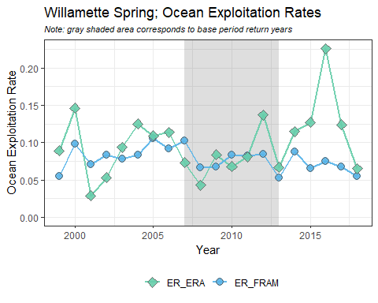  
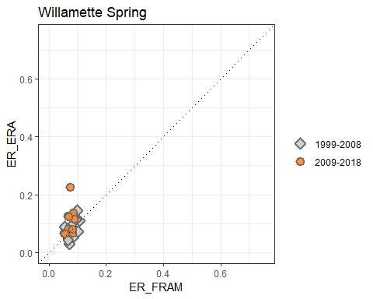  
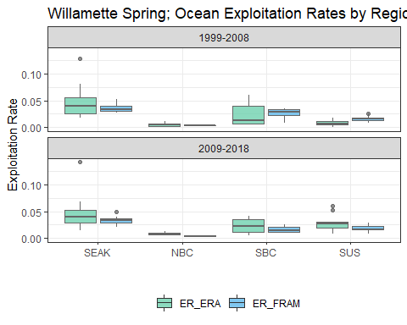  
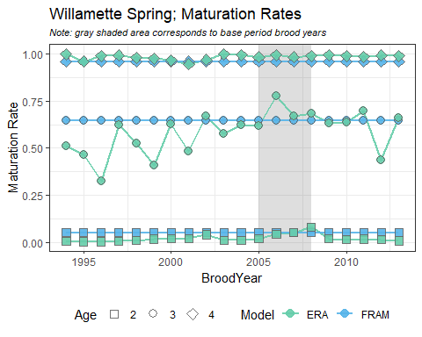

#### Snake River Fall

BroodYear

TagCode

Stock_ERA

ERA

FRAM

2005

633582

LYF

x

x

2005

633598

LYY

x

x

2006

633986

LYF

x

x

2006

633987

LYY

x

x

2007

634672

LYF

x

x

2007

634680

LYY

x

x

2007

634671

NA

x

2008

634995

LYF

x

x

2008

635166

LYY

x

x

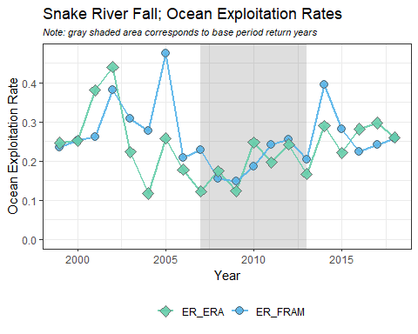  
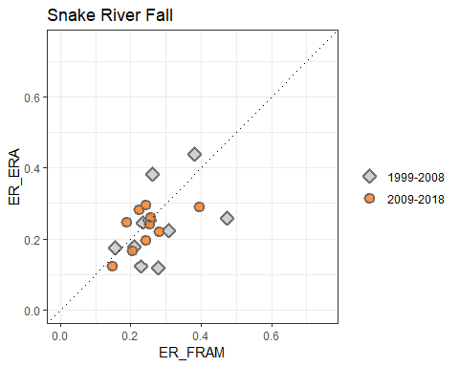  
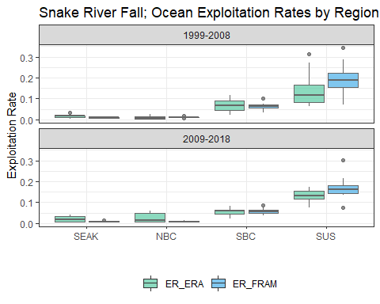  
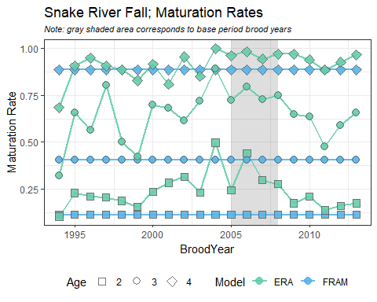

#### Hoko

BroodYear

TagCode

Stock_ERA

ERA

FRAM

2005

210678

HOK

x

x

2006

210739

HOK

x

x

2007

210786

HOK

x

x

2008

210841

HOK

x

x

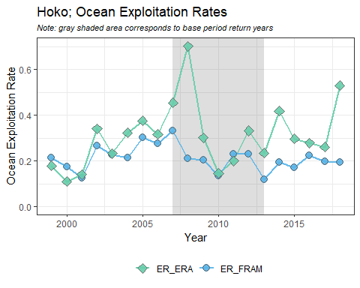  
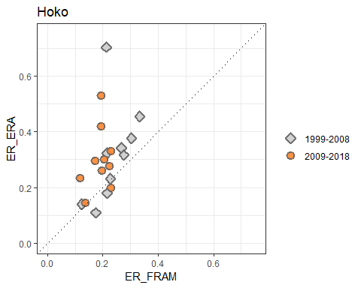  
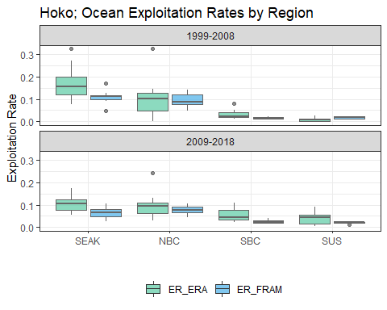  
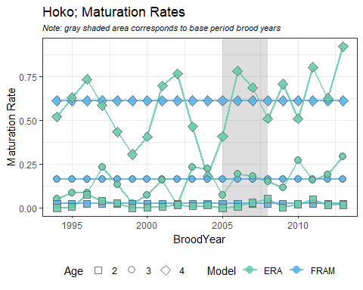

#### WA North Coast

BroodYear

TagCode

Stock_ERA

ERA

FRAM

2005

210679

QUE

x

x

2006

210738

QUE

x

x

2007

210791

QUE

x

x

2008

210843

QUE

x

x

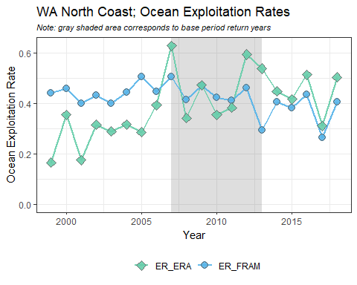  
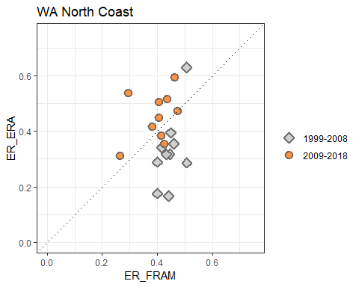  
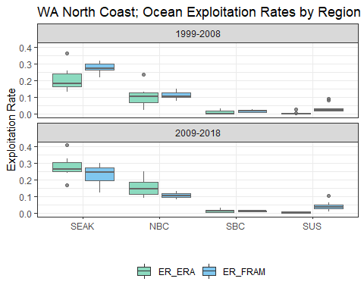  
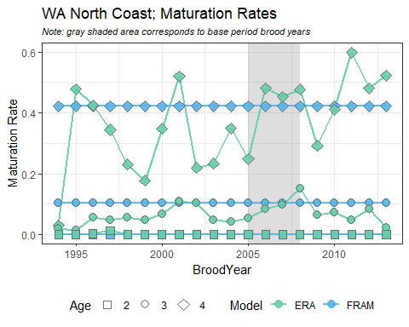

#### North OR Coast

BroodYear

TagCode

Stock_ERA

ERA

FRAM

2005

094428

SRH

x

x

2006

094525

SRH

x

x

2007

094645

SRH

x

x

2008

094701

SRH

x

x

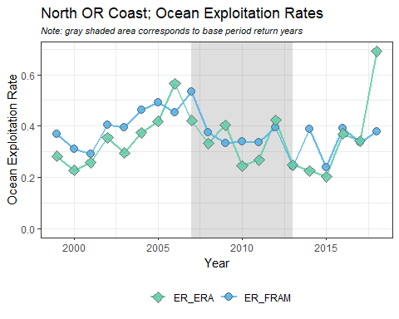  
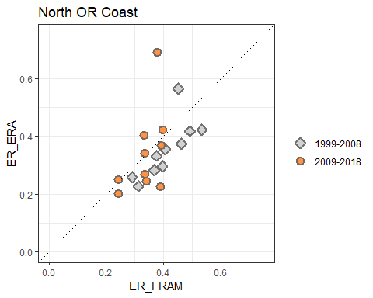  
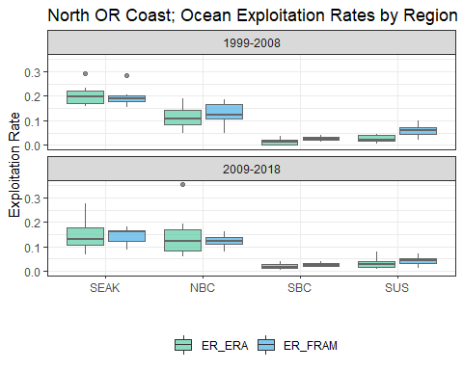  
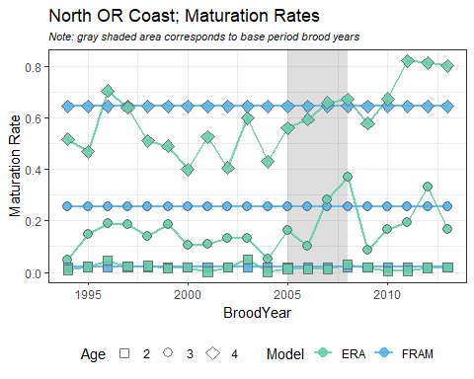

#### Mid OR Coast

BroodYear

TagCode

Stock_ERA

ERA

FRAM

2005

094343

ELK

x

x

2006

094643

ELK

x

x

2007

090157

ELK

x

x

2007

090165

ELK

x

x

2008

093938

ELK

x

x

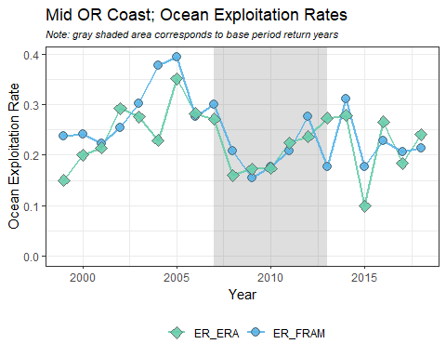  
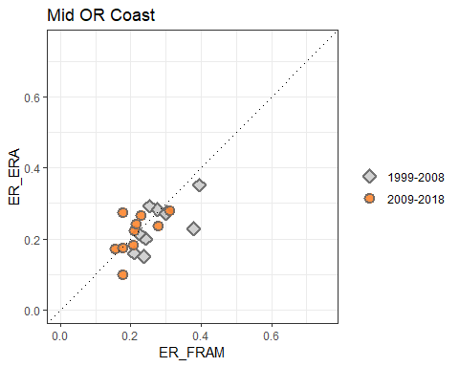  
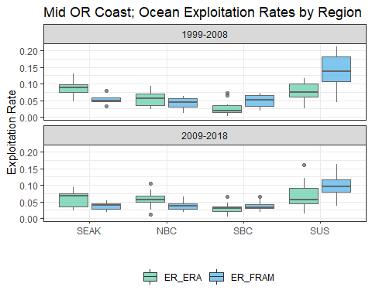  
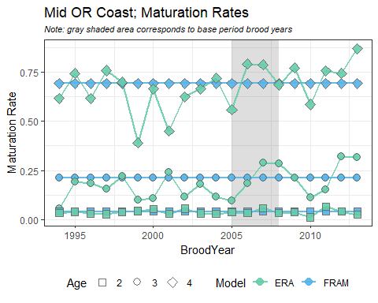

#### WCVI

BroodYear

TagCode

Stock_ERA

ERA

FRAM

2005

185257

RBT

x

x

2005

185258

RBT

x

x

2005

185259

RBT

x

x

2005

185260

RBT

x

x

2005

185948

RBT

x

x

2005

185949

RBT

x

x

2005

185950

RBT

x

x

2005

185951

RBT

x

x

2006

185821

RBT

x

x

2006

185822

RBT

x

x

2006

185823

RBT

x

x

2006

185824

RBT

x

x

2006

185825

RBT

x

x

2006

185826

RBT

x

x

2006

185827

RBT

x

x

2006

185828

RBT

x

x

2007

186134

RBT

x

x

2007

186301

RBT

x

x

2007

186302

RBT

x

x

2007

186303

RBT

x

x

2007

186304

RBT

x

x

2007

186305

RBT

x

x

2007

186306

RBT

x

x

2007

186343

RBT

x

x

2007

186344

RBT

x

x

2008

180386

RBT

x

x

2008

180387

RBT

x

x

2008

180388

RBT

x

x

2008

180389

RBT

x

x

2008

180390

RBT

x

x

2008

180391

RBT

x

x

2008

180392

RBT

x

x

2008

180393

RBT

x

x

2008

180394

RBT

x

x

2008

180685

RBT

x

x

2008

180881

RBT

x

x

2008

180882

RBT

x

x

2008

180883

RBT

x

x

2008

180884

RBT

x

x

2008

180885

RBT

x

x

2008

185960

RBT

x

x

2008

185961

RBT

x

x

2008

185962

RBT

x

x

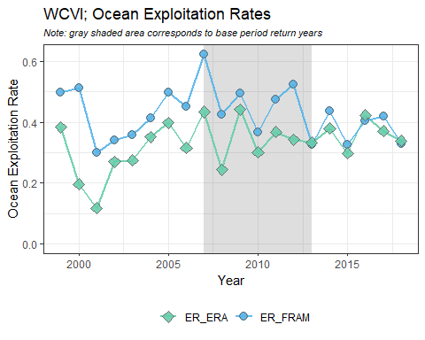  
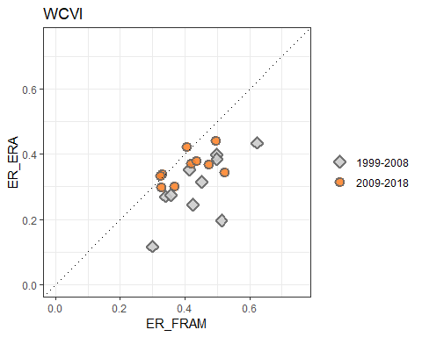  
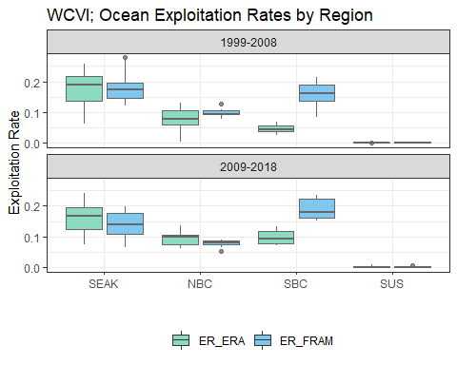  
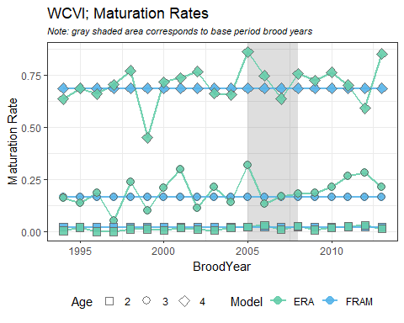

#### Fraser River Late

BroodYear

TagCode

Stock_ERA

ERA

FRAM

2005

185030

CHI

x

x

2005

185032

CHI

x

x

2005

185238

CHI

x

x

2005

185240

CHI

x

x

2005

025641

HAR

x

x

2005

025650

HAR

x

x

2006

185658

CHI

x

x

2006

185706

CHI

x

x

2006

185708

CHI

x

x

2006

185710

CHI

x

x

2006

184922

HAR

x

x

2006

185221

HAR

x

x

2006

185242

HAR

x

x

2006

185263

HAR

x

x

2006

186030

HAR

x

x

2006

186031

HAR

x

x

2006

186032

HAR

x

x

2007

186240

CHI

x

x

2007

186242

CHI

x

x

2007

185001

HAR

x

x

2007

185002

HAR

x

x

2007

185040

HAR

x

x

2007

185556

HAR

x

x

2007

185557

HAR

x

x

2007

185558

HAR

x

x

2007

185612

HAR

x

x

2007

185707

HAR

x

x

2008

180480

CHI

x

x

2008

180482

CHI

x

x

2008

180484

HAR

x

x

2008

180485

HAR

x

x

2008

180486

HAR

x

x

2008

180487

HAR

x

x

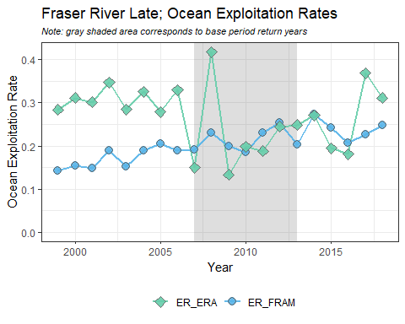  
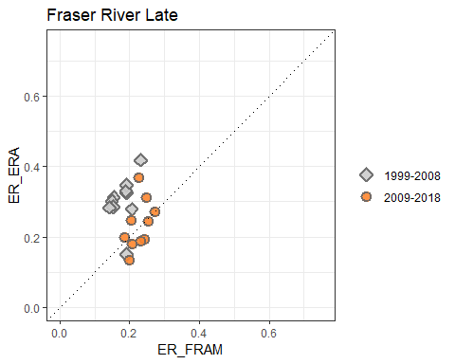  
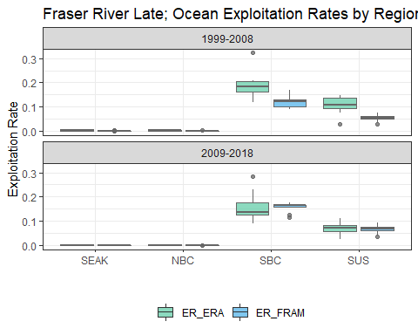  
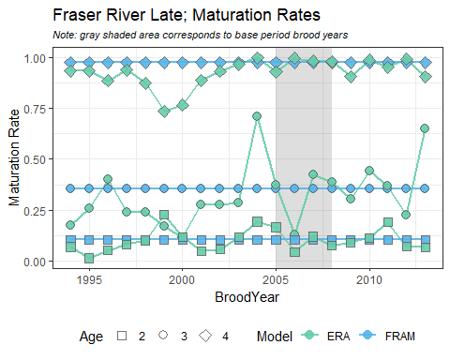

#### Fraser River Early

BroodYear

TagCode

Stock_ERA

ERA

FRAM

2005

025652

SHU

x

x

2005

025659

SHU

x

x

2005

184907

SHU

x

x

2005

185054

SHU

x

x

2005

185055

SHU

x

x

2005

185234

NIC

x

x

2005

185235

NIC

x

x

2005

185236

NIC

x

x

2005

185237

NIC

x

x

2005

185728

NIC

x

x

2006

185222

SHU

x

x

2006

185223

SHU

x

x

2006

185224

SHU

x

x

2006

185225

SHU

x

x

2006

186061

SHU

x

x

2006

186062

SHU

x

x

2006

185926

NIC

x

x

2006

185935

NIC

x

x

2006

185936

NIC

x

x

2007

186162

SHU

x

x

2007

186352

SHU

x

x

2007

186353

SHU

x

x

2007

186354

SHU

x

x

2007

186355

SHU

x

x

2007

186356

SHU

x

x

2007

186357

SHU

x

x

2007

186358

SHU

x

x

2007

186359

SHU

x

x

2007

186360

SHU

x

x

2007

186361

SHU

x

x

2007

180183

NIC

x

x

2007

180184

NIC

x

x

2007

180189

NIC

x

x

2008

180276

SHU

x

x

2008

180277

SHU

x

x

2008

180380

SHU

x

x

2008

180381

SHU

x

x

2008

180382

SHU

x

x

2008

180383

SHU

x

x

2008

180384

SHU

x

x

2008

180385

SHU

x

x

2008

180965

NIC

x

x

2008

180966

NIC

x

x

2008

180990

NIC

x

x

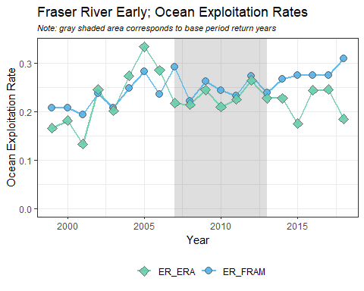  
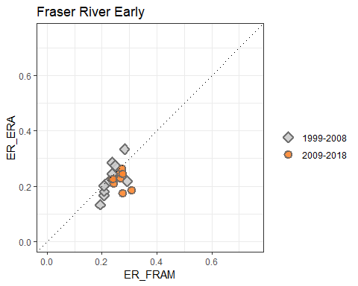  
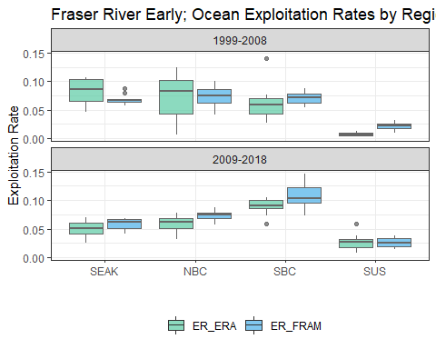  
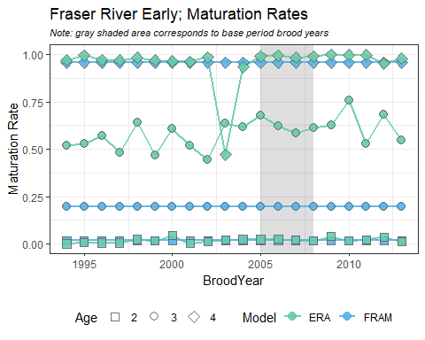

#### Lower Georgia Strait

BroodYear

TagCode

Stock_ERA

ERA

FRAM

2005

184304

BQR

x

x

2005

184840

BQR

x

x

2005

185301

BQR

x

x

2005

185302

BQR

x

x

2005

185303

BQR

x

x

2005

185649

BQR

x

x

2005

185650

BQR

x

x

2005

185651

BQR

x

x

2005

185817

BQR

x

x

2005

184422

COW

x

x

2005

184836

COW

x

x

2005

185810

COW

x

x

2005

185811

COW

x

x

2005

185812

COW

x

x

2005

185818

COW

x

x

2005

185819

COW

x

x

2005

185820

COW

x

x

2005

082339

PPS

x

x

2005

082343

PPS

x

x

2005

082344

PPS

x

x

2005

082345

PPS

x

x

2005

082350

PPS

x

x

2005

082414

PPS

x

x

2005

084327

PPS

x

x

2005

084328

PPS

x

x

2005

185808

PPS

x

x

2005

185809

PPS

x

x

2006

185644

BQR

x

x

2006

185743

BQR

x

x

2006

185744

BQR

x

x

2006

185745

BQR

x

x

2006

185746

BQR

x

x

2006

185813

BQR

x

x

2006

185814

BQR

x

x

2006

185815

BQR

x

x

2006

185832

COW

x

x

2006

185833

COW

x

x

2006

185834

COW

x

x

2006

186035

COW

x

x

2006

186036

COW

x

x

2006

186037

COW

x

x

2006

186039

COW

x

x

2006

186042

COW

x

x

2006

185910

PPS

x

x

2006

185911

PPS

x

x

2006

185912

PPS

x

x

2006

185913

PPS

x

x

2006

185914

PPS

x

x

2006

185915

PPS

x

x

2006

185916

PPS

x

x

2006

185917

PPS

x

x

2007

186161

BQR

x

x

2007

186345

BQR

x

x

2007

186346

BQR

x

x

2007

186347

BQR

x

x

2007

186348

BQR

x

x

2007

186349

BQR

x

x

2007

186350

BQR

x

x

2007

186351

BQR

x

x

2007

185339

COW

x

x

2007

185355

COW

x

x

2007

185356

COW

x

x

2007

185357

COW

x

x

2007

185358

COW

x

x

2007

185359

COW

x

x

2007

186015

COW

x

x

2007

186016

COW

x

x

2007

186219

COW

x

x

2007

186220

COW

x

x

2007

186225

COW

x

x

2007

186226

COW

x

x

2007

186227

COW

x

x

2007

180170

PPS

x

x

2007

186235

PPS

x

x

2007

186236

PPS

x

x

2007

186237

PPS

x

x

2007

186238

PPS

x

x

2007

186239

PPS

x

x

2008

180273

BQR

x

x

2008

183855

BQR

x

x

2008

185360

BQR

x

x

2008

185956

BQR

x

x

2008

185957

BQR

x

x

2008

185958

BQR

x

x

2008

185959

BQR

x

x

2008

180377

COW

x

x

2008

180395

COW

x

x

2008

180396

COW

x

x

2008

180469

COW

x

x

2008

180470

COW

x

x

2008

180471

COW

x

x

2008

180472

COW

x

x

2008

180473

COW

x

x

2008

185344

COW

x

x

2008

185345

COW

x

x

2008

185705

COW

x

x

2008

186137

COW

x

x

2008

186311

COW

x

x

2008

186312

COW

x

x

2008

186313

COW

x

x

2008

186314

COW

x

x

2008

186315

COW

x

x

2008

186316

COW

x

x

2008

186317

COW

x

x

2008

186318

COW

x

x

2008

180474

PPS

x

x

2008

180475

PPS

x

x

2008

180491

PPS

x

x

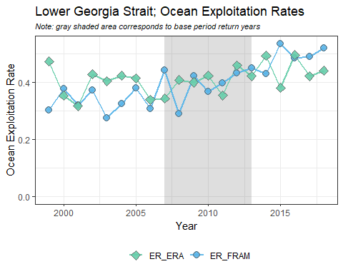  
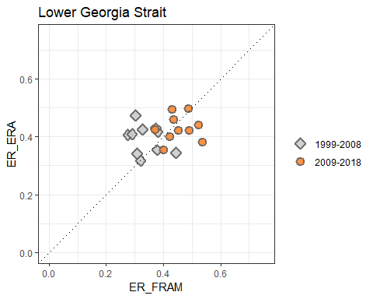  
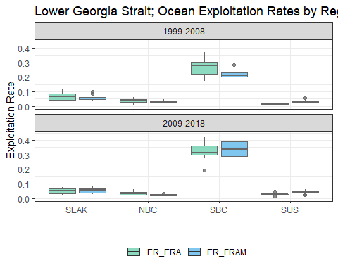  
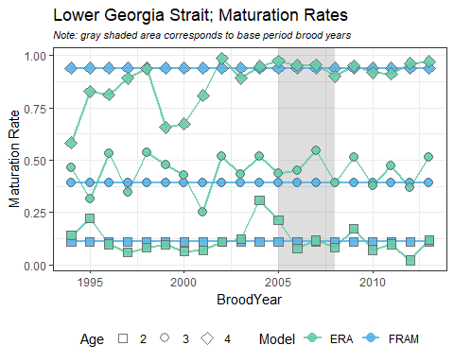

## Case Studies

### WCVI

In comparing ocean exploitatoin rates across stocks, WCVI stood out as one of the stocks with the largest differences (mean FRAM ocean ER = 43%, mean ERA ocean ER = 33%). It was clear from looking at exploitatoin rates by region that the source of the disconnect was in SBC fisheries (mean FRAM SBC ER = 17%, mean ERA SBC ER = 7%). Through further investigation of the fishery mapping, we identified a mismatch in how the part of the terminal marine catch of the WCVI sport fishery was being mapped between the two models. In FRAM, these recoveries are mapped to the WCVI sport fishery and included in the ocean exploitation rates. In the ERA, however, these terminal sport recoveries are mapped to the terminal Canada sport fishery in the mortality distribution tables, and thus excluded from the ocean exploitation rates. To align these fisheries for comparative purposes, we reproduced a set of mortality distribution tables using the same results of the ERA cohort analyses, but with a modified fishery mapping structure that assigned the relevant terminal sport fishery to the "Southern B.C. ISBM sport" fishery.

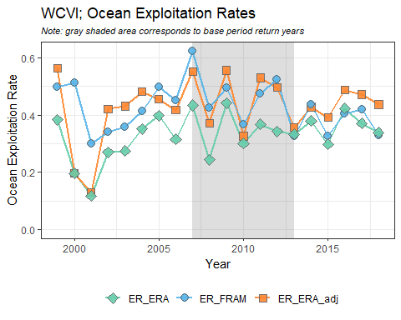  
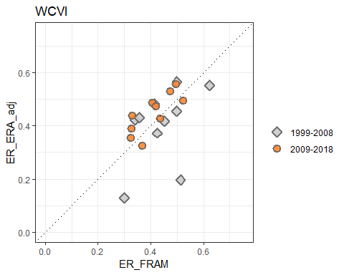  
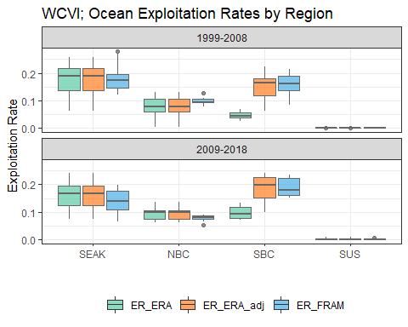

### Nooksack/Samish Fall

Unlike for WCVI, there does not appear to be a single factor that can explain the majority of the difference between FRAM and ERA ocean exploitation rates for Nooksack/Samish Fall Chinook. There is a substantial freshwater sport fishery that occurrs in the Samish River each year, however, this fishery is not regularly sampled for CWT recoveries. In an effort to account for these missing CWT recoveries during the FRAM base period cohort analysis, freshwater sport recoveries were imputed using information from the rate of CWT recoveries in escapement. Accounting for these missing CWT recoveries results in more accurate cohort sizes during the cohort analysis. Currently, these unaccounted for freshwater sport CWT recoveries are not included in the ERA, as no process is in place to impute these recoveries across the entire time series. This likely results in cohort sizes that are biased low and ocean exploitation rates that are biased high. In an effort to identify the magnitude of effect this issue has on ocean exploitation rates, we re-computed FRAM exploitation rates using abundances (the denominator of the ER calculation) that excluded the relevant freshwater sport catch. These re-computed "FRAM adjusted" ocean exploitation rates are included in the figures below for years where freshwater sport fisheries occurred but no CWT recoveries were included in the ERA. While investigating this, we also identified a fishery mapping error in the ERA ocean exploitation rates for 2007. In this year there were 117 Samish CWT recoveries designated as freshwater sport recovered in the Samish River, however, they were mapped to the North of Falcon sport fishery. Similar to the exercise for WCVI above, this error was corrected by reproducing a set of mortality distribution tables using the same results of the ERA cohort analyses, but with a modified fishery mapping structure that assigned the relevant freshwater sport fishery to the "Southern U.S. terminal sport" fishery. This corrected "ERA adjusted" ocean exploitation rate is also included in the figures below.

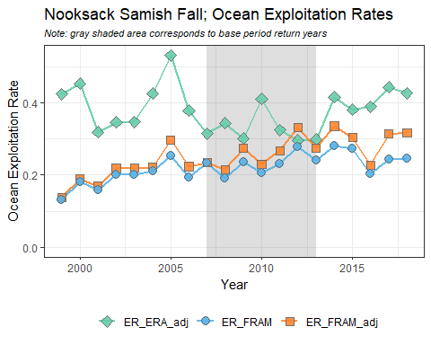

While this exercise of removing freshwater sport catch from the FRAM abundances used to calculate exploitation rates in order to generate a set of ocean exploitation rates that was more comparable to the ERA ocean exploitation rates, this problem would be better addressed by imputing and incorporating freshwater sport recoveries into the ERA. As evidenced in the above figure, this issue explains part but not all of the discrepancy between the FRAM and ERA ocean exploitation rates. Examinations at a finer scale fishery level suggest that the main source of remaining difference occurs in SBC sport fisheries (mean ER across the time series of 17% and 8% for ERA and FRAM, respectively). This appears to be a re-occurring theme for numerous other stocks as well, where estimated exploitation rates in SBC sport fisheries are notably higher in the ERA than in FRAM. We recommend continued investigation into the source of these differences.

### Other Puget Sound stocks with inadequate freshwater sport sampling

The issue with unsampled or inadequately sampled Puget Sound freshwater sport fisheries is not unique to the Nooksack/Samish fall stock. We selected four additional stocks to examine the benefits of adjusting FRAM abundance denominators to account for missing ERA freshwater sport recoveries. These stocks were selected because they were exposed to sizeable freshwater sport fisheries and display notable differences between FRAM and ERA exploitation rates. The stocks were Skagit Spring, Snohomish Fall Fingerling, South Puget Sound Fall Fingerling, and Hood Canal Fall Fingerling.

For Skagit Spring, sampling of freshwater sport fisheries occurred and CWT recoveries are included in the ERA for 2005 (the year the fishery was first implemented) through 2012, however, these recoveries are currently mapped to escapement rather than to the freshwater sport fishery, presumably due to the fact that this fishery is mark-selective. Once the CTC implements MSF algorithms into the ERA, they might consider correcting this fishery mapping so that the recoveries can be appropriately processed.

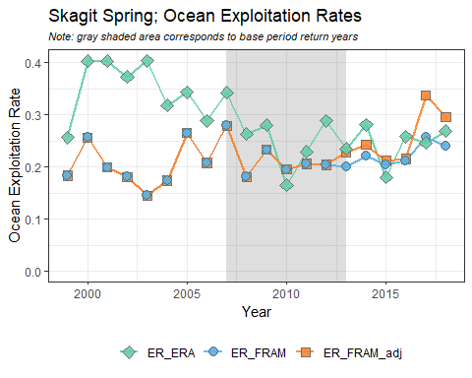

For Snohomish, sampling of freshwater sport recoveries occurred and CWT recoveries are included in the ERA for 2010 through 2012. For Hood Canal, freshwater sport sampling appears to have occurred in 2000 through 2007 and in 2011 through 2015, as CWTs are included in the ERA for these years. In all other years, FRAM adjusted exploitation rates were calculated using modified abundances in the denominator (freshwater sport removed). For both of these stocks, the adjusted exploitation rates result in slightly improved agreement between the two models.

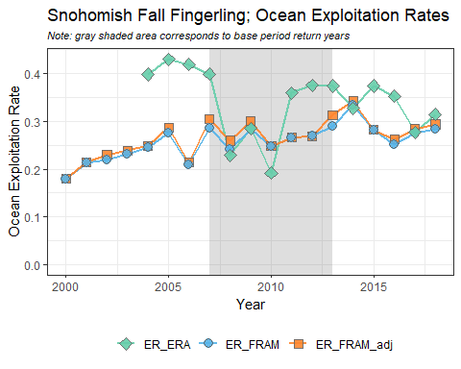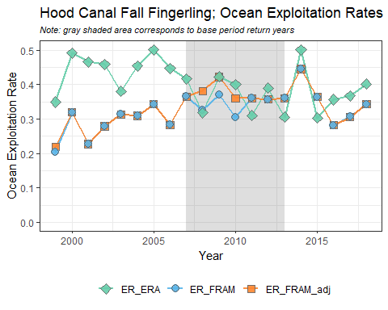

For South Puget Sound Fall Fingerlings, freshwater sport CWT recoveries were included in the ERA in 2002, 2003, and 2010 through 2013. For all other years, FRAM adjusted exploitation rates were calculated, but actually correlate less with ERA rates than unadjusted values. A preliminary investigation into the cause for this finding point towards a mismatch of stock definitions. The FRAM uses Nisqually and Chambers hatchery tag codes to represent this stock, while the ERA only uses Nisqually hatchery Chinook. Nisqually exploitation rates in Chambers Bay and other deep South Puget Sound net areas are considerably smaller than exploitation rates of Chambers Chinook. If adjusted, initial estimates show FRAM exploitation rate reduction for the Nisqually stock in the range of 2%-10% depending on the year examined.

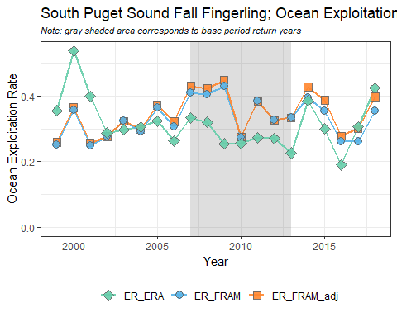

## Conclusions and Next Steps

This analysis compares ERA to FRAM exploitation and maturation rates. While there is good agreement for many stocks (Nooksack Springs, Mid Puget Sound, WA Hatchery Tules) this exercise also highlights stock/fishery combinations with significant differences. Further analysis is needed to explore the causes of these differences in depth. This work is expected to result in improvements to both methods. Based on preliminary examinations, likely causes are inadequate sampling and/or catch reporting, fisheries mismatches, insufficient tagging, and a lack of methods to account for impacts to untagged fish.

While differences in stock-specific exploitation rates in the FRAM and ERA vary in magnitude, bias across all the stocks modeled in FRAM and the ERA does not seem to trend strongly in a particular direction (see the "ER Scatterplots" subheading in the "Results" section). 15 of 25 stocks examined had higher average exploitation rates in the ERA analysis and 10 of 25 stocks examined had higher average exploitation rates in the FRAM analysis. When filtering to recent years (2009 through 2018), which are closer in temporal proximity to the base period years used in FRAM, it does appear that there is a linear relationship between exploitation rates in the ERA and in FRAM. Further exploration into ERA and FRAM exploitation rate differences may consider specifically examining calendar years 2007 through 2013, which represent the FRAM base period years and may have a greater relationship with the ERA exploitation rates. Additionally, examinations of stock-specific bias versus stock abundance may be of value to ensure that there isn't a consistent trend in bias for the most abundant stocks in the modeling, which could have an effect on exploitation rates in FRAM.

In general, we noted a greater variability in ERA exploitation rates than FRAM exploitation rates across stocks. This trend is likely to be caused by the use of base period exploitation rates (average across a particular set of years) in FRAM versus individual year exploitation rates in the ERA. Using individual years to examine exploitation rates can be advantageous because it may better capture yearly fluctuations in fish distribution relative to presuming an average exploitation rate distribution across multiple years. However, using individual years in an analysis has the disadvantage of decreasing tag sample sizes and, if sample sizes were small, it is possible that there would not be enough tags to accurately represent stock-mortality distributions. In an attempt to address this, the CTC has established minimum criteria for reporting of ERA calendar year mortality distributions, requiring at least three ages and 105 total estimated CWT recoveries (expanded for sampling rates) in a given year.

We note a trend towards increasing modeled maturation rates over time for many stocks, based on the maturation rates derived from the ERA (see the "Maturation Rates" subheading in the "Results" section). A similar trend was noted by the FRAM base period workgroup during the development of the new base period and in a recent publication by [Ohlberger et al., 2018](https://onlinelibrary.wiley.com/doi/full/10.1111/faf.12272). In FRAM, the increasing maturation rates are driven by a different age composition in returning fish during the new base period years (2007-2013), where a greater portion of the returns are comprised of younger fish than those that returned during the old base period years (1979-1982). Recent publications have suggested that sources of Chinook predation have increased [(Chasco et al., 2017)](https://www.nature.com/articles/s41598-017-14984-8) and may have a substantial effect on the age and size structure of Chinook [(Ohlberger et al., 2019)](https://www.pnas.org/content/116/52/26682). Additional research would be required to determine if changing predation patterns are the primary cause of changing age compositions in FRAM.

Future efforts could consider a sensitivity analysis to evaluate the effect of maturation rates on exploitation rates. While the effect of maturation rates on exploitation rates may be minor for some stocks/fisheries, maturation rates greatly influence estimates of prefishing abundances. This is particularly worth noting in relation to recent work conducted by the PFMC's Ad-Hoc Southern Resident Killer Whale Workgroup, which used FRAM-based prefishing cohort sizes to estimate Chinook abundances in across ocean regions. As maturation rates change and differ from the static rates assumed by the FRAM base period data set, it could affect the accuracy of stock-specific pre-fishing cohort sizes.

The CTC is currently investigating and intends to implement MSF algorithms into its ERA analysis. Once this occurs, it may be possible to compare FRAM and ERA unmarked stock exploitation rates. We recommend that this may be a useful comparison to further assess differences in the FRAM and ERA analyses.

## Acknowledgements

The authors would like to thank the Pacific Salmon Commission's Chinook Technical Committee for their permission and help in providing the relevant output data from their Exploitation Rate analysis for use in this assessment.

## Appendices

### Appendix A

List of CWT tag codes used for brood years 2005 - 2008 in in development of the FRAM base period and in the ERA. An 'x' indicates whether the tag code was included in each model. An ERA stock of "NA" indicates tag codes used in the development of the FRAM base period that are not associated with an ERA stock.

Stock_Name

BroodYear

TagCode

Stock_ERA

ERA

FRAM

Nooksack Samish Fall

2005

633369

SAM

x

x

Nooksack Samish Fall

2005

633591

NA

x

Nooksack Samish Fall

2006

633389

SAM

x

x

Nooksack Samish Fall

2006

634080

NA

x

Nooksack Samish Fall

2007

634272

SAM

x

x

Nooksack Samish Fall

2007

634583

NA

x

Nooksack Samish Fall

2008

634841

SAM

x

x

Nooksack Samish Fall

2008

635081

NA

x

Nooksack Spring

2005

633172

NSF

x

x

Nooksack Spring

2006

633387

NSF

x

x

Nooksack Spring

2007

634274

NSF

x

x

Nooksack Spring

2008

634797

NSF

x

x

Skagit Summer Fall

2005

212827

SSF

x

x

Skagit Summer Fall

2005

210677

SSF

x

x

Skagit Summer Fall

2005

210685

NA

x

Skagit Summer Fall

2006

210735

SSF

x

x

Skagit Summer Fall

2006

210745

NA

x

Skagit Summer Fall

2007

210789

SSF

x

x

Skagit Summer Fall

2007

210278

NA

x

Skagit Summer Fall

2008

210842

SSF

x

x

Skagit Summer Fall

2008

210831

NA

x

Skagit Spring

2005

633364

SKF

x

x

Skagit Spring

2005

633176

SKS

x

x

Skagit Spring

2006

633867

SKF

x

x

Skagit Spring

2006

633487

SKS

x

x

Skagit Spring

2006

633488

SKS

x

x

Skagit Spring

2006

633486

SKS

x

x

Skagit Spring

2007

633869

SKF

x

x

Skagit Spring

2007

634373

SKS

x

x

Skagit Spring

2008

634395

SKF

x

x

Skagit Spring

2008

634769

SKS

x

x

Snohomish Fall Fingerling

2005

633381

SKY

x

x

Snohomish Fall Fingerling

2006

633887

SKY

x

x

Snohomish Fall Fingerling

2007

634281

SKY

x

x

Snohomish Fall Fingerling

2008

634844

SKY

x

x

Stillaguamish Fall Fingerling

2005

210684

STL

x

x

Stillaguamish Fall Fingerling

2006

210733

STL

x

x

Stillaguamish Fall Fingerling

2006

210743

STL

x

x

Stillaguamish Fall Fingerling

2007

210787

STL

x

x

Stillaguamish Fall Fingerling

2007

210741

STL

x

x

Stillaguamish Fall Fingerling

2008

210840

STL

x

x

Mid Puget Sound Fall Fingerling

2005

633285

SPS

x

x

Mid Puget Sound Fall Fingerling

2005

633372

SPS

x

x

Mid Puget Sound Fall Fingerling

2005

633375

NA

x

Mid Puget Sound Fall Fingerling

2005

633383

NA

x

Mid Puget Sound Fall Fingerling

2006

633882

SPS

x

x

Mid Puget Sound Fall Fingerling

2006

633579

SPS

x

x

Mid Puget Sound Fall Fingerling

2006

633889

NA

x

Mid Puget Sound Fall Fingerling

2006

633885

NA

x

Mid Puget Sound Fall Fingerling

2007

634286

SPS

x

x

Mid Puget Sound Fall Fingerling

2007

210790

SPS

x

x

Mid Puget Sound Fall Fingerling

2007

634284

NA

x

Mid Puget Sound Fall Fingerling

2008

210822

SPS

x

x

Mid Puget Sound Fall Fingerling

2008

634864

SPS

x

x

South Puget Sound Fall Fingerling

2005

633286

NIS

x

x

South Puget Sound Fall Fingerling

2005

210671

NA

x

South Puget Sound Fall Fingerling

2005

632894

NA

x

South Puget Sound Fall Fingerling

2005

632979

NA

x

South Puget Sound Fall Fingerling

2006

633391

NIS

x

x

South Puget Sound Fall Fingerling

2006

210744

NA

x

South Puget Sound Fall Fingerling

2006

633968

NA

x

South Puget Sound Fall Fingerling

2006

633964

NA

x

South Puget Sound Fall Fingerling

2007

210788

NIS

x

x

South Puget Sound Fall Fingerling

2007

634364

NA

x

South Puget Sound Fall Fingerling

2007

210801

NA

x

South Puget Sound Fall Fingerling

2007

633466

NA

x

South Puget Sound Fall Fingerling

2008

210824

NIS

x

x

Hood Canal Fall Fingerling

2005

633366

GAD

x

x

Hood Canal Fall Fingerling

2005

633471

NA

x

Hood Canal Fall Fingerling

2005

633382

NA

x

Hood Canal Fall Fingerling

2006

633875

GAD

x

x

Hood Canal Fall Fingerling

2006

633886

NA

x

Hood Canal Fall Fingerling

2006

633965

NA

x

Hood Canal Fall Fingerling

2007

634271

GAD

x

x

Hood Canal Fall Fingerling

2007

634283

NA

x

Hood Canal Fall Fingerling

2008

634873

GAD

x

x

Hood Canal Fall Fingerling

2008

634867

NA

x

OR Hatchery Tule

2005

094423

LRH

x

x

OR Hatchery Tule

2006

094526

LRH

x

x

OR Hatchery Tule

2007

094646

LRH

x

x

OR Hatchery Tule

2008

090199

LRH

x

x

WA Hatchery Tule

2005

633287

CWF

x

x

WA Hatchery Tule

2005

632886

NA

x

WA Hatchery Tule

2005

632883

NA

x

WA Hatchery Tule

2006

633877

CWF

x

x

WA Hatchery Tule

2006

633976

NA

x

WA Hatchery Tule

2006

633977

NA

x

WA Hatchery Tule

2007

634280

CWF

x

x

WA Hatchery Tule

2007

634369

NA

x

WA Hatchery Tule

2007

634372

NA

x

WA Hatchery Tule

2008

634279

CWF

x

x

WA Hatchery Tule

2008

634385

NA

x

WA Hatchery Tule

2008

634775

NA

x

WA Hatchery Tule

2008

634774

NA

x

Lower Columbia River Wild

2005

632987

LRW

x

x

Lower Columbia River Wild

2005

632986

LRW

x

Lower Columbia River Wild

2006

633492

LRW

x

x

Lower Columbia River Wild

2006

633979

LRW

x

x

Lower Columbia River Wild

2007

634186

LRW

x

x

Lower Columbia River Wild

2008

634382

LRW

x

x

Spring Creek

2005

052873

SPR

x

x

Spring Creek

2005

052971

SPR

x

x

Spring Creek

2005

052972

SPR

x

x

Spring Creek

2005

052874

SPR

x

x

Spring Creek

2006

054318

SPR

x

x

Spring Creek

2006

054336

SPR

x

x

Spring Creek

2006

052897

SPR

x

x

Spring Creek

2006

053592

SPR

x

x

Spring Creek

2006

052588

SPR

x

x

Spring Creek

2006

052895

SPR

x

x

Spring Creek

2006

052570

SPR

x

x

Spring Creek

2006

052577

SPR

x

x

Spring Creek

2007

053767

SPR

x

x

Spring Creek

2007

054276

SPR

x

x

Spring Creek

2007

053776

SPR

x

x

Spring Creek

2007

050685

SPR

x

x

Spring Creek

2007

052978

SPR

x

x

Spring Creek

2007

053874

SPR

x

x

Spring Creek

2007

053778

SPR

x

x

Spring Creek

2007

053780

SPR

x

x

Spring Creek

2007

053782

SPR

x

x

Spring Creek

2007

054274

SPR

x

x

Spring Creek

2008

054864

SPR

x

x

Spring Creek

2008

054866

SPR

x

x

Columbia River Summer

2005

633298

SUM

x

x

Columbia River Summer

2005

633299

SUM

x

x

Columbia River Summer

2005

633596

SUM

x

x

Columbia River Summer

2006

633385

SUM

x

x

Columbia River Summer

2006

633799

SUM

x

x

Columbia River Summer

2006

633386

SUM

x

x

Columbia River Summer

2007

633871

SUM

x

x

Columbia River Summer

2007

634287

SUM

x

x

Columbia River Summer

2007

634390

SUM

x

x

Columbia River Summer

2007

633872

SUM

x

x

Columbia River Summer

2008

634876

SUM

x

x

Columbia River Summer

2008

635092

SUM

x

x

Columbia River Summer

2008

635093

SUM

x

x

Upriver Bright

2005

633173

URB

x

x

Upriver Bright

2006

094504

URB

x

x

Upriver Bright

2006

633894

URB

x

x

Upriver Bright

2007

094663

URB

x

x

Upriver Bright

2007

634391

URB

x

x

Upriver Bright

2008

634799

URB

x

x

Willamette Spring

2005

094422

WSH

x

x

Willamette Spring

2005

092734

WSH

x

x

Willamette Spring

2005

094143

WSH

x

x

Willamette Spring

2005

094453

WSH

x

x

Willamette Spring

2005

094142

WSH

x

x

Willamette Spring

2005

094344

WSH

x

x

Willamette Spring

2005

094436

WSH

x

x

Willamette Spring

2005

094438

WSH

x

x

Willamette Spring

2005

094345

WSH

x

x

Willamette Spring

2005

094019

WSH

x

Willamette Spring

2005

094348

WSH

x

x

Willamette Spring

2005

094349

WSH

x

x

Willamette Spring

2005

094347

WSH

x

x

Willamette Spring

2005

094425

WSH

x

x

Willamette Spring

2005

094335

NA

x

Willamette Spring

2005

094346

NA

x

Willamette Spring

2005

094437

NA

x

Willamette Spring

2005

094333

NA

x

Willamette Spring

2005

094140

NA

x

Willamette Spring

2005

094439

NA

x

Willamette Spring

2005

094139

NA

x

Willamette Spring

2006

094603

WSH

x

x

Willamette Spring

2006

094609

WSH

x

x

Willamette Spring

2006

094610

WSH

x

x

Willamette Spring

2006

094612

WSH

x

x

Willamette Spring

2006

094549

WSH

x

x

Willamette Spring

2006

094556

WSH

x

x

Willamette Spring

2006

094557

WSH

x

x

Willamette Spring

2006

094558

WSH

x

x

Willamette Spring

2006

094559

WSH

x

x

Willamette Spring

2006

094560

WSH

x

x

Willamette Spring

2006

094561

WSH

x

x

Willamette Spring

2006

094562

WSH

x

x

Willamette Spring

2006

094563

WSH

x

x

Willamette Spring

2006

094601

WSH

x

x

Willamette Spring

2006

094602

WSH

x

x

Willamette Spring

2006

094614

WSH

x

x

Willamette Spring

2006

094615

WSH

x

x

Willamette Spring

2006

094616

WSH

x

x

Willamette Spring

2006

094617

WSH

x

Willamette Spring

2006

094627

WSH

x

x

Willamette Spring

2007

090189

WSH

x

x

Willamette Spring

2007

090190

WSH

x

x

Willamette Spring

2007

090171

WSH

x

x

Willamette Spring

2007

090178

WSH

x

x

Willamette Spring

2007

090188

WSH

x

x

Willamette Spring

2007

090177

WSH

x

x

Willamette Spring

2007

094657

WSH

x

x

Willamette Spring

2007

090187

WSH

x

x

Willamette Spring

2007

094650

WSH

x

x

Willamette Spring

2007

094529

WSH

x

x

Willamette Spring

2007

090169

WSH

x

x

Willamette Spring

2007

094652

NA

x

Willamette Spring

2007

094651

NA

x

Willamette Spring

2008

090196

WSH

x

x

Willamette Spring

2008

090280

WSH

x

x

Willamette Spring

2008

090239

WSH

x

x

Willamette Spring

2008

090194

WSH

x

x

Willamette Spring

2008

090269

WSH

x

x

Willamette Spring

2008

090238

WSH

x

x

Willamette Spring

2008

090237

WSH

x

x

Willamette Spring

2008

090197

WSH

x

x

Willamette Spring

2008

090271

WSH

x

x

Willamette Spring

2008

090279

WSH

x

x

Willamette Spring

2008

094653

WSH

x

x

Willamette Spring

2008

090193

WSH

x

x

Willamette Spring

2008

090278

WSH

x

x

Snake River Fall

2005

633582

LYF

x

x

Snake River Fall

2005

633598

LYY

x

x

Snake River Fall

2006

633986

LYF

x

x

Snake River Fall

2006

633987

LYY

x

x

Snake River Fall

2007

634672

LYF

x

x

Snake River Fall

2007

634680

LYY

x

x

Snake River Fall

2007

634671

NA

x

Snake River Fall

2008

634995

LYF

x

x

Snake River Fall

2008

635166

LYY

x

x

North OR Coast

2005

094428

SRH

x

x

North OR Coast

2006

094525

SRH

x

x

North OR Coast

2007

094645

SRH

x

x

North OR Coast

2008

094701

SRH

x

x

WCVI

2005

185257

RBT

x

x

WCVI

2005

185258

RBT

x

x

WCVI

2005

185259

RBT

x

x

WCVI

2005

185260

RBT

x

x

WCVI

2005

185948

RBT

x

x

WCVI

2005

185949

RBT

x

x

WCVI

2005

185950

RBT

x

x

WCVI

2005

185951

RBT

x

x

WCVI

2006

185827

RBT

x

x

WCVI

2006

185828

RBT

x

x

WCVI

2006

185826

RBT

x

x

WCVI

2006

185821

RBT

x

x

WCVI

2006

185822

RBT

x

x

WCVI

2006

185823

RBT

x

x

WCVI

2006

185824

RBT

x

x

WCVI

2006

185825

RBT

x

x

WCVI

2007

186134

RBT

x

x

WCVI

2007

186301

RBT

x

x

WCVI

2007

186302

RBT

x

x

WCVI

2007

186303

RBT

x

x

WCVI

2007

186304

RBT

x

x

WCVI

2007

186305

RBT

x

x

WCVI

2007

186306

RBT

x

x

WCVI

2007

186343

RBT

x

x

WCVI

2007

186344

RBT

x

x

WCVI

2008

180386

RBT

x

x

WCVI

2008

180387

RBT

x

x

WCVI

2008

180388

RBT

x

x

WCVI

2008

180389

RBT

x

x

WCVI

2008

180390

RBT

x

x

WCVI

2008

180391

RBT

x

x

WCVI

2008

180392

RBT

x

x

WCVI

2008

180393

RBT

x

x

WCVI

2008

180394

RBT

x

x

WCVI

2008

180685

RBT

x

x

WCVI

2008

180881

RBT

x

x

WCVI

2008

180882

RBT

x

x

WCVI

2008

180883

RBT

x

x

WCVI

2008

180884

RBT

x

x

WCVI

2008

180885

RBT

x

x

WCVI

2008

185960

RBT

x

x

WCVI

2008

185961

RBT

x

x

WCVI

2008

185962

RBT

x

x

Fraser River Late

2005

185030

CHI

x

x

Fraser River Late

2005

185032

CHI

x

x

Fraser River Late

2005

185238

CHI

x

x

Fraser River Late

2005

185240

CHI

x

x

Fraser River Late

2005

025641

HAR

x

x

Fraser River Late

2005

025650

HAR

x

x

Fraser River Late

2006

185658

CHI

x

x

Fraser River Late

2006

185706

CHI

x

x

Fraser River Late

2006

185708

CHI

x

x

Fraser River Late

2006

185710

CHI

x

x

Fraser River Late

2006

186030

HAR

x

x

Fraser River Late

2006

186031

HAR

x

x

Fraser River Late

2006

186032

HAR

x

x

Fraser River Late

2006

184922

HAR

x

x

Fraser River Late

2006

185221

HAR

x

x

Fraser River Late

2006

185242

HAR

x

x

Fraser River Late

2006

185263

HAR

x

x

Fraser River Late

2007

186240

CHI

x

x

Fraser River Late

2007

186242

CHI

x

x

Fraser River Late

2007

185001

HAR

x

x

Fraser River Late

2007

185002

HAR

x

x

Fraser River Late

2007

185040

HAR

x

x

Fraser River Late

2007

185556

HAR

x

x

Fraser River Late

2007

185557

HAR

x

x

Fraser River Late

2007

185558

HAR

x

x

Fraser River Late

2007

185612

HAR

x

x

Fraser River Late

2007

185707

HAR

x

x

Fraser River Late

2008

180480

CHI

x

x

Fraser River Late

2008

180482

CHI

x

x

Fraser River Late

2008

180484

HAR

x

x

Fraser River Late

2008

180485

HAR

x

x

Fraser River Late

2008

180486

HAR

x

x

Fraser River Late

2008

180487

HAR

x

x

Fraser River Early

2005

185234

NIC

x

x

Fraser River Early

2005

185235

NIC

x

x

Fraser River Early

2005

185236

NIC

x

x

Fraser River Early

2005

185237

NIC

x

x

Fraser River Early

2005

185728

NIC

x

x

Fraser River Early

2005

025652

SHU

x

x

Fraser River Early

2005

025659

SHU

x

x

Fraser River Early

2005

184907

SHU

x

x

Fraser River Early

2005

185054

SHU

x

x

Fraser River Early

2005

185055

SHU

x

x

Fraser River Early

2006

185936

NIC

x

x

Fraser River Early

2006

185926

NIC

x

x

Fraser River Early

2006

185935

NIC

x

x

Fraser River Early

2006

185222

SHU

x

x

Fraser River Early

2006

185223

SHU

x

x

Fraser River Early

2006

185224

SHU

x

x

Fraser River Early

2006

185225

SHU

x

x

Fraser River Early

2006

186061

SHU

x

x

Fraser River Early

2006

186062

SHU

x

x

Fraser River Early

2007

180183

NIC

x

x

Fraser River Early

2007

180184

NIC

x

x

Fraser River Early

2007

180189

NIC

x

x

Fraser River Early

2007

186360

SHU

x

x

Fraser River Early

2007

186361

SHU

x

x

Fraser River Early

2007

186162

SHU

x

x

Fraser River Early

2007

186352

SHU

x

x

Fraser River Early

2007

186353

SHU

x

x

Fraser River Early

2007

186354

SHU

x

x

Fraser River Early

2007

186355

SHU

x

x

Fraser River Early

2007

186356

SHU

x

x

Fraser River Early

2007

186357

SHU

x

x

Fraser River Early

2007

186358

SHU

x

x

Fraser River Early

2007

186359

SHU

x

x

Fraser River Early

2008

180965

NIC

x

x

Fraser River Early

2008

180966

NIC

x

x

Fraser River Early

2008

180990

NIC

x

x

Fraser River Early

2008

180276

SHU

x

x

Fraser River Early

2008

180277

SHU

x

x

Fraser River Early

2008

180380

SHU

x

x

Fraser River Early

2008

180381

SHU

x

x

Fraser River Early

2008

180382

SHU

x

x

Fraser River Early

2008

180383

SHU

x

x

Fraser River Early

2008

180384

SHU

x

x

Fraser River Early

2008

180385

SHU

x

x

Lower Georgia Strait

2005

184304

BQR

x

x

Lower Georgia Strait

2005

184840

BQR

x

x

Lower Georgia Strait

2005

185301

BQR

x

x

Lower Georgia Strait

2005

185302

BQR

x

x

Lower Georgia Strait

2005

185303

BQR

x

x

Lower Georgia Strait

2005

185649

BQR

x

x

Lower Georgia Strait

2005

185650

BQR

x

x

Lower Georgia Strait

2005

185651

BQR

x

x

Lower Georgia Strait

2005

185817

BQR

x

x

Lower Georgia Strait

2005

184422

COW

x

x

Lower Georgia Strait

2005

184836

COW

x

x

Lower Georgia Strait

2005

185810

COW

x

x

Lower Georgia Strait

2005

185811

COW

x

x

Lower Georgia Strait

2005

185812

COW

x

x

Lower Georgia Strait

2005

185818

COW

x

x

Lower Georgia Strait

2005

185819

COW

x

x

Lower Georgia Strait

2005

185820

COW

x

x

Lower Georgia Strait

2005

082339

PPS

x

x

Lower Georgia Strait

2005

082343

PPS

x

x

Lower Georgia Strait

2005

082344

PPS

x

x

Lower Georgia Strait

2005

082345

PPS

x

x

Lower Georgia Strait

2005

082350

PPS

x

x

Lower Georgia Strait

2005

082414

PPS

x

x

Lower Georgia Strait

2005

084327

PPS

x

x

Lower Georgia Strait

2005

084328

PPS

x

x

Lower Georgia Strait

2005

185808

PPS

x

x

Lower Georgia Strait

2005

185809

PPS

x

x

Lower Georgia Strait

2006

185644

BQR

x

x

Lower Georgia Strait

2006

185743

BQR

x

x

Lower Georgia Strait

2006

185744

BQR

x

x

Lower Georgia Strait

2006

185745

BQR

x

x

Lower Georgia Strait

2006

185746

BQR

x

x

Lower Georgia Strait

2006

185813

BQR

x

x

Lower Georgia Strait

2006

185814

BQR

x

x

Lower Georgia Strait

2006

185815

BQR

x

x

Lower Georgia Strait

2006

185832

COW

x

x

Lower Georgia Strait

2006

185833

COW

x

x

Lower Georgia Strait

2006

185834

COW

x

x

Lower Georgia Strait

2006

186035

COW

x

x

Lower Georgia Strait

2006

186036

COW

x

x

Lower Georgia Strait

2006

186037

COW

x

x

Lower Georgia Strait

2006

186039

COW

x

x

Lower Georgia Strait

2006

186042

COW

x

x

Lower Georgia Strait

2006

185910

PPS

x

x

Lower Georgia Strait

2006

185911

PPS

x

x

Lower Georgia Strait

2006

185912

PPS

x

x

Lower Georgia Strait

2006

185913

PPS

x

x

Lower Georgia Strait

2006

185914

PPS

x

x

Lower Georgia Strait

2006

185915

PPS

x

x

Lower Georgia Strait

2006

185916

PPS

x

x

Lower Georgia Strait

2006

185917

PPS

x

x

Lower Georgia Strait

2007

186161

BQR

x

x

Lower Georgia Strait

2007

186345

BQR

x

x

Lower Georgia Strait

2007

186346

BQR

x

x

Lower Georgia Strait

2007

186347

BQR

x

x

Lower Georgia Strait

2007

186348

BQR

x

x

Lower Georgia Strait

2007

186349

BQR

x

x

Lower Georgia Strait

2007

186350

BQR

x

x

Lower Georgia Strait

2007

186351

BQR

x

x

Lower Georgia Strait

2007

185339

COW

x

x

Lower Georgia Strait

2007

185355

COW

x

x

Lower Georgia Strait

2007

185356

COW

x

x

Lower Georgia Strait

2007

185357

COW

x

x

Lower Georgia Strait

2007

185358

COW

x

x

Lower Georgia Strait

2007

185359

COW

x

x

Lower Georgia Strait

2007

186015

COW

x

x

Lower Georgia Strait

2007

186016

COW

x

x

Lower Georgia Strait

2007

186219

COW

x

x

Lower Georgia Strait

2007

186220

COW

x

x

Lower Georgia Strait

2007

186225

COW

x

x

Lower Georgia Strait

2007

186226

COW

x

x

Lower Georgia Strait

2007

186227

COW

x

x

Lower Georgia Strait

2007

180170

PPS

x

x

Lower Georgia Strait

2007

186235

PPS

x

x

Lower Georgia Strait

2007

186236

PPS

x

x

Lower Georgia Strait

2007

186237

PPS

x

x

Lower Georgia Strait

2007

186238

PPS

x

x

Lower Georgia Strait

2007

186239

PPS

x

x

Lower Georgia Strait

2008

180273

BQR

x

x

Lower Georgia Strait

2008

183855

BQR

x

x

Lower Georgia Strait

2008

185360

BQR

x

x

Lower Georgia Strait

2008

185956

BQR

x

x

Lower Georgia Strait

2008

185957

BQR

x

x

Lower Georgia Strait

2008

185958

BQR

x

x

Lower Georgia Strait

2008

185959

BQR

x

x

Lower Georgia Strait

2008

185705

COW

x

x

Lower Georgia Strait

2008

186137

COW

x

x

Lower Georgia Strait

2008

186311

COW

x

x

Lower Georgia Strait

2008

186312

COW

x

x

Lower Georgia Strait

2008

186313

COW

x

x

Lower Georgia Strait

2008

186314

COW

x

x

Lower Georgia Strait

2008

186315

COW

x

x

Lower Georgia Strait

2008

186316

COW

x

x

Lower Georgia Strait

2008

186317

COW

x

x

Lower Georgia Strait

2008

186318

COW

x

x

Lower Georgia Strait

2008

180377

COW

x

x

Lower Georgia Strait

2008

180395

COW

x

x

Lower Georgia Strait

2008

180396

COW

x

x

Lower Georgia Strait

2008

180469

COW

x

x

Lower Georgia Strait

2008

180470

COW

x

x

Lower Georgia Strait

2008

180471

COW

x

x

Lower Georgia Strait

2008

180472

COW

x

x

Lower Georgia Strait

2008

180473

COW

x

x

Lower Georgia Strait

2008

185344

COW

x

x

Lower Georgia Strait

2008

185345

COW

x

x

Lower Georgia Strait

2008

180474

PPS

x

x

Lower Georgia Strait

2008

180475

PPS

x

x

Lower Georgia Strait

2008

180491

PPS

x

x

WA North Coast

2005

210679

QUE

x

x

WA North Coast

2006

210738

QUE

x

x

WA North Coast

2007

210791

QUE

x

x

WA North Coast

2008

210843

QUE

x

x

Hoko

2005

210678

HOK

x

x

Hoko

2006

210739

HOK

x

x

Hoko

2007

210786

HOK

x

x

Hoko

2008

210841

HOK

x

x

Mid OR Coast

2005

094343

ELK

x

x

Mid OR Coast

2006

094643

ELK

x

x

Mid OR Coast

2007

090157

ELK

x

x

Mid OR Coast

2007

090165

ELK

x

x

Mid OR Coast

2008

093938

ELK

x

x

### Appendix B

Exploitation rate data used in generation of report figures. Total ocean exploitation rate is the result of summing the exploitation rate across all regions for a given stock, year, and model.

Stock_Name

Year

Region

ER_FRAM

ER_ERA

Nooksack Samish Fall

1999

NBC

0.002

0.051

Nooksack Samish Fall

1999

SBC

0.056

0.260

Nooksack Samish Fall

1999

SEAK

0.002

0.040

Nooksack Samish Fall

1999

SUS

0.071

0.073

Nooksack Samish Fall

2000

NBC

0.003

0.000

Nooksack Samish Fall

2000

SBC

0.123

0.381

Nooksack Samish Fall

2000

SEAK

0.002

0.000

Nooksack Samish Fall

2000

SUS

0.053

0.071

Nooksack Samish Fall

2001

NBC

0.003

0.005

Nooksack Samish Fall

2001

SBC

0.075

0.199

Nooksack Samish Fall

2001

SEAK

0.002

0.002

Nooksack Samish Fall

2001

SUS

0.080

0.113

Nooksack Samish Fall

2002

NBC

0.002

0.007

Nooksack Samish Fall

2002

SBC

0.107

0.232

Nooksack Samish Fall

2002

SEAK

0.001

0.009

Nooksack Samish Fall

2002

SUS

0.091

0.098

Nooksack Samish Fall

2003

NBC

0.002

0.000

Nooksack Samish Fall

2003

SBC

0.097

0.229

Nooksack Samish Fall

2003

SEAK

0.001

0.008

Nooksack Samish Fall

2003

SUS

0.100

0.110

Nooksack Samish Fall

2004

NBC

0.003

0.000

Nooksack Samish Fall

2004

SBC

0.108

0.198

Nooksack Samish Fall

2004

SEAK

0.002

0.004

Nooksack Samish Fall

2004

SUS

0.099

0.223

Nooksack Samish Fall

2005

NBC

0.003

0.003

Nooksack Samish Fall

2005

SBC

0.125

0.366

Nooksack Samish Fall

2005

SEAK

0.001

0.004

Nooksack Samish Fall

2005

SUS

0.125

0.158

Nooksack Samish Fall

2006

NBC

0.003

0.001

Nooksack Samish Fall

2006

SBC

0.101

0.204

Nooksack Samish Fall

2006

SEAK

0.002

0.005

Nooksack Samish Fall

2006

SUS

0.088

0.168

Nooksack Samish Fall

2007

NBC

0.004

0.000

Nooksack Samish Fall

2007

SBC

0.139

0.211

Nooksack Samish Fall

2007

SEAK

0.002

0.005

Nooksack Samish Fall

2007

SUS

0.089

0.300

Nooksack Samish Fall

2008

NBC

0.001

0.000

Nooksack Samish Fall

2008

SBC

0.096

0.175

Nooksack Samish Fall

2008

SEAK

0.002

0.002

Nooksack Samish Fall

2008

SUS

0.092

0.166

Nooksack Samish Fall

2009

NBC

0.003

0.000

Nooksack Samish Fall

2009

SBC

0.134

0.131

Nooksack Samish Fall

2009

SEAK

0.001

0.001

Nooksack Samish Fall

2009

SUS

0.097

0.169

Nooksack Samish Fall

2010

NBC

0.002

0.000

Nooksack Samish Fall

2010

SBC

0.098

0.199

Nooksack Samish Fall

2010

SEAK

0.002

0.001

Nooksack Samish Fall

2010

SUS

0.104

0.210

Nooksack Samish Fall

2011

NBC

0.001

0.000

Nooksack Samish Fall

2011

SBC

0.123

0.201

Nooksack Samish Fall

2011

SEAK

0.002

0.001

Nooksack Samish Fall

2011

SUS

0.105

0.123

Nooksack Samish Fall

2012

NBC

0.002

0.008

Nooksack Samish Fall

2012

SBC

0.113

0.139

Nooksack Samish Fall

2012

SEAK

0.002

0.003

Nooksack Samish Fall

2012

SUS

0.161

0.146

Nooksack Samish Fall

2013

NBC

0.001

0.000

Nooksack Samish Fall

2013

SBC

0.096

0.135

Nooksack Samish Fall

2013

SEAK

0.001

0.000

Nooksack Samish Fall

2013

SUS

0.143

0.164

Nooksack Samish Fall

2014

NBC

0.002

0.006

Nooksack Samish Fall

2014

SBC

0.108

0.219

Nooksack Samish Fall

2014

SEAK

0.001

0.008

Nooksack Samish Fall

2014

SUS

0.170

0.182

Nooksack Samish Fall

2015

NBC

0.001

0.011

Nooksack Samish Fall

2015

SBC

0.117

0.186

Nooksack Samish Fall

2015

SEAK

0.001

0.006

Nooksack Samish Fall

2015

SUS

0.154

0.177

Nooksack Samish Fall

2016

NBC

0.003

0.015

Nooksack Samish Fall

2016

SBC

0.103

0.243

Nooksack Samish Fall

2016

SEAK

0.002

0.009

Nooksack Samish Fall

2016

SUS

0.095

0.122

Nooksack Samish Fall

2017

NBC

0.002

0.004

Nooksack Samish Fall

2017

SBC

0.112

0.318

Nooksack Samish Fall

2017

SEAK

0.001

0.009

Nooksack Samish Fall

2017

SUS

0.129

0.112

Nooksack Samish Fall

2018

NBC

0.003

0.018

Nooksack Samish Fall

2018

SBC

0.107

0.267

Nooksack Samish Fall

2018

SEAK

0.001

0.002

Nooksack Samish Fall

2018

SUS

0.136

0.139

Nooksack Spring

1999

NBC

0.003

0.007

Nooksack Spring

1999

SBC

0.188

0.128

Nooksack Spring

1999

SEAK

0.040

0.022

Nooksack Spring

1999

SUS

0.052

0.026

Nooksack Spring

2000

NBC

0.002

0.000

Nooksack Spring

2000

SBC

0.428

0.396

Nooksack Spring

2000

SEAK

0.058

0.054

Nooksack Spring

2000

SUS

0.028

0.009

Nooksack Spring

2001

NBC

0.001

0.000

Nooksack Spring

2001

SBC

0.260

0.207

Nooksack Spring

2001

SEAK

0.044

0.018

Nooksack Spring

2001

SUS

0.047

0.028

Nooksack Spring

2002

NBC

0.003

0.021

Nooksack Spring

2002

SBC

0.333

0.210

Nooksack Spring

2002

SEAK

0.023

0.066

Nooksack Spring

2002

SUS

0.057

0.014

Nooksack Spring

2003

NBC

0.002

0.006

Nooksack Spring

2003

SBC

0.305

0.235

Nooksack Spring

2003

SEAK

0.029

0.036

Nooksack Spring

2003

SUS

0.046

0.034

Nooksack Spring

2004

NBC

0.003

0.003

Nooksack Spring

2004

SBC

0.409

0.472

Nooksack Spring

2004

SEAK

0.031

0.013

Nooksack Spring

2004

SUS

0.045

0.048

Nooksack Spring

2005

NBC

0.002

0.007

Nooksack Spring

2005

SBC

0.465

0.452

Nooksack Spring

2005

SEAK

0.028

0.039

Nooksack Spring

2005

SUS

0.080

0.019

Nooksack Spring

2006

NBC

0.002

0.011

Nooksack Spring

2006

SBC

0.396

0.472

Nooksack Spring

2006

SEAK

0.035

0.034

Nooksack Spring

2006

SUS

0.043

0.045

Nooksack Spring

2007

NBC

0.004

0.005

Nooksack Spring

2007

SBC

0.430

0.429

Nooksack Spring

2007

SEAK

0.038

0.066

Nooksack Spring

2007

SUS

0.054

0.063

Nooksack Spring

2008

NBC

0.003

0.004

Nooksack Spring

2008

SBC

0.364

0.473

Nooksack Spring

2008

SEAK

0.022

0.017

Nooksack Spring

2008

SUS

0.065

0.091

Nooksack Spring

2009

NBC

0.002

0.000

Nooksack Spring

2009

SBC

0.302

0.330

Nooksack Spring

2009

SEAK

0.034

0.036

Nooksack Spring

2009

SUS

0.055

0.044

Nooksack Spring

2010

NBC

0.003

0.010

Nooksack Spring

2010

SBC

0.293

0.323

Nooksack Spring

2010

SEAK

0.035

0.033

Nooksack Spring

2010

SUS

0.067

0.058

Nooksack Spring

2011

NBC

0.001

0.012

Nooksack Spring

2011

SBC

0.321

0.344

Nooksack Spring

2011

SEAK

0.038

0.031

Nooksack Spring

2011

SUS

0.053

0.050

Nooksack Spring

2012

NBC

0.002

0.000

Nooksack Spring

2012

SBC

0.302

0.356

Nooksack Spring

2012

SEAK

0.039

0.064

Nooksack Spring

2012

SUS

0.089

0.158

Nooksack Spring

2013

NBC

0.001

0.011

Nooksack Spring

2013

SBC

0.273

0.293

Nooksack Spring

2013

SEAK

0.021

0.034

Nooksack Spring

2013

SUS

0.082

0.080

Nooksack Spring

2014

NBC

0.002

0.030

Nooksack Spring

2014

SBC

0.337

0.305

Nooksack Spring

2014

SEAK

0.032

0.043

Nooksack Spring

2014

SUS

0.112

0.074

Nooksack Spring

2015

NBC

0.001

0.009

Nooksack Spring

2015

SBC

0.226

0.136

Nooksack Spring

2015

SEAK

0.033

0.031

Nooksack Spring

2015

SUS

0.102

0.047

Nooksack Spring

2016

NBC

0.001

0.014

Nooksack Spring

2016

SBC

0.233

0.182

Nooksack Spring

2016

SEAK

0.052

0.042

Nooksack Spring

2016

SUS

0.063

0.018

Nooksack Spring

2017

NBC

0.004

0.020

Nooksack Spring

2017

SBC

0.350

0.325

Nooksack Spring

2017

SEAK

0.016

0.015

Nooksack Spring

2017

SUS

0.093

0.033

Nooksack Spring

2018

NBC

0.003

0.023

Nooksack Spring

2018

SBC

0.258

0.197

Nooksack Spring

2018

SEAK

0.023

0.024

Nooksack Spring

2018

SUS

0.081

0.028

Skagit Summer Fall

1999

NBC

0.033

0.000

Skagit Summer Fall

1999

SBC

0.115

0.296

Skagit Summer Fall

1999

SEAK

0.071

0.112

Skagit Summer Fall

1999

SUS

0.026

0.000

Skagit Summer Fall

2000

NBC

0.085

0.000

Skagit Summer Fall

2000

SBC

0.138

0.186

Skagit Summer Fall

2000

SEAK

0.079

0.115

Skagit Summer Fall

2000

SUS

0.033

0.141

Skagit Summer Fall

2001

NBC

0.042

0.005

Skagit Summer Fall

2001

SBC

0.127

0.246

Skagit Summer Fall

2001

SEAK

0.074

0.130

Skagit Summer Fall

2001

SUS

0.043

0.028

Skagit Summer Fall

2002

NBC

0.031

0.025

Skagit Summer Fall

2002

SBC

0.151

0.146

Skagit Summer Fall

2002

SEAK

0.077

0.139

Skagit Summer Fall

2002

SUS

0.032

0.004

Skagit Summer Fall

2003

NBC

0.029

0.059

Skagit Summer Fall

2003

SBC

0.121

0.233

Skagit Summer Fall

2003

SEAK

0.064

0.073

Skagit Summer Fall

2003

SUS

0.040

0.017

Skagit Summer Fall

2004

NBC

0.036

0.028

Skagit Summer Fall

2004

SBC

0.186

0.157

Skagit Summer Fall

2004

SEAK

0.074

0.055

Skagit Summer Fall

2004

SUS

0.031

0.023

Skagit Summer Fall

2005

NBC

0.035

0.044

Skagit Summer Fall

2005

SBC

0.211

0.165

Skagit Summer Fall

2005

SEAK

0.088

0.090

Skagit Summer Fall

2005

SUS

0.059

0.012

Skagit Summer Fall

2006

NBC

0.039

0.018

Skagit Summer Fall

2006

SBC

0.157

0.122

Skagit Summer Fall

2006

SEAK

0.075

0.050

Skagit Summer Fall

2006

SUS

0.035

0.013

Skagit Summer Fall

2007

NBC

0.055

0.020

Skagit Summer Fall

2007

SBC

0.202

0.132

Skagit Summer Fall

2007

SEAK

0.093

0.072

Skagit Summer Fall

2007

SUS

0.044

0.018

Skagit Summer Fall

2008

NBC

0.033

0.028

Skagit Summer Fall

2008

SBC

0.165

0.130

Skagit Summer Fall

2008

SEAK

0.080

0.056

Skagit Summer Fall

2008

SUS

0.043

0.015

Skagit Summer Fall

2009

NBC

0.034

0.029

Skagit Summer Fall

2009

SBC

0.178

0.166

Skagit Summer Fall

2009

SEAK

0.071

0.095

Skagit Summer Fall

2009

SUS

0.070

0.035

Skagit Summer Fall

2010

NBC

0.031

0.069

Skagit Summer Fall

2010

SBC

0.135

0.116

Skagit Summer Fall

2010

SEAK

0.090

0.092

Skagit Summer Fall

2010

SUS

0.049

0.044

Skagit Summer Fall

2011

NBC

0.029

0.007

Skagit Summer Fall

2011

SBC

0.177

0.181

Skagit Summer Fall

2011

SEAK

0.076

0.054

Skagit Summer Fall

2011

SUS

0.064

0.086

Skagit Summer Fall

2012

NBC

0.029

0.023

Skagit Summer Fall

2012

SBC

0.165

0.077

Skagit Summer Fall

2012

SEAK

0.093

0.103

Skagit Summer Fall

2012

SUS

0.067

0.013

Skagit Summer Fall

2013

NBC

0.023

0.036

Skagit Summer Fall

2013

SBC

0.140

0.173

Skagit Summer Fall

2013

SEAK

0.058

0.064

Skagit Summer Fall

2013

SUS

0.093

0.049

Skagit Summer Fall

2014

NBC

0.025

0.019

Skagit Summer Fall

2014

SBC

0.157

0.254

Skagit Summer Fall

2014

SEAK

0.059

0.183

Skagit Summer Fall

2014

SUS

0.090

0.057

Skagit Summer Fall

2015

NBC

0.025

0.038

Skagit Summer Fall

2015

SBC

0.154

0.190

Skagit Summer Fall

2015

SEAK

0.078

0.155

Skagit Summer Fall

2015

SUS

0.104

0.067

Skagit Summer Fall

2016

NBC

0.033

0.046

Skagit Summer Fall

2016

SBC

0.141

0.294

Skagit Summer Fall

2016

SEAK

0.087

0.093

Skagit Summer Fall

2016

SUS

0.059

0.070

Skagit Summer Fall

2017

NBC

0.033

0.051

Skagit Summer Fall

2017

SBC

0.166

0.462

Skagit Summer Fall

2017

SEAK

0.057

0.082

Skagit Summer Fall

2017

SUS

0.094

0.073

Skagit Summer Fall

2018

NBC

0.036

0.027

Skagit Summer Fall

2018

SBC

0.169

0.262

Skagit Summer Fall

2018

SEAK

0.045

0.059

Skagit Summer Fall

2018

SUS

0.101

0.119

Skagit Spring

1999

NBC

0.011

0.004

Skagit Spring

1999

SBC

0.118

0.166

Skagit Spring

1999

SEAK

0.006

0.008

Skagit Spring

1999

SUS

0.048

0.077

Skagit Spring

2000

NBC

0.043

0.003

Skagit Spring

2000

SBC

0.170

0.256

Skagit Spring

2000

SEAK

0.005

0.016

Skagit Spring

2000

SUS

0.038

0.128

Skagit Spring

2001

NBC

0.029

0.004

Skagit Spring

2001

SBC

0.106

0.198

Skagit Spring

2001

SEAK

0.004

0.012

Skagit Spring

2001

SUS

0.060

0.190

Skagit Spring

2002

NBC

0.010

0.006

Skagit Spring

2002

SBC

0.112

0.252

Skagit Spring

2002

SEAK

0.005

0.023

Skagit Spring

2002

SUS

0.054

0.091

Skagit Spring

2003

NBC

0.004

0.014

Skagit Spring

2003

SBC

0.093

0.305

Skagit Spring

2003

SEAK

0.003

0.016

Skagit Spring

2003

SUS

0.045

0.069

Skagit Spring

2004

NBC

0.008

0.002

Skagit Spring

2004

SBC

0.126

0.252

Skagit Spring

2004

SEAK

0.003

0.001

Skagit Spring

2004

SUS

0.037

0.062

Skagit Spring

2005

NBC

0.009

0.012

Skagit Spring

2005

SBC

0.182

0.266

Skagit Spring

2005

SEAK

0.004

0.014

Skagit Spring

2005

SUS

0.070

0.051

Skagit Spring

2006

NBC

0.009

0.002

Skagit Spring

2006

SBC

0.151

0.229

Skagit Spring

2006

SEAK

0.004

0.005

Skagit Spring

2006

SUS

0.044

0.054

Skagit Spring

2007

NBC

0.024

0.000

Skagit Spring

2007

SBC

0.189

0.207

Skagit Spring

2007

SEAK

0.008

0.003

Skagit Spring

2007

SUS

0.058

0.133

Skagit Spring

2008

NBC

0.002

0.003

Skagit Spring

2008

SBC

0.096

0.142

Skagit Spring

2008

SEAK

0.004

0.002

Skagit Spring

2008

SUS

0.079

0.116

Skagit Spring

2009

NBC

0.006

0.000

Skagit Spring

2009

SBC

0.156

0.168

Skagit Spring

2009

SEAK

0.005

0.008

Skagit Spring

2009

SUS

0.066

0.104

Skagit Spring

2010

NBC

0.004

0.006

Skagit Spring

2010

SBC

0.123

0.085

Skagit Spring

2010

SEAK

0.004

0.002

Skagit Spring

2010

SUS

0.064

0.072

Skagit Spring

2011

NBC

0.006

0.005

Skagit Spring

2011

SBC

0.144

0.123

Skagit Spring

2011

SEAK

0.004

0.002

Skagit Spring

2011

SUS

0.052

0.098

Skagit Spring

2012

NBC

0.002

0.004

Skagit Spring

2012

SBC

0.124

0.152

Skagit Spring

2012

SEAK

0.003

0.004

Skagit Spring

2012

SUS

0.075

0.128

Skagit Spring

2013

NBC

0.002

0.002

Skagit Spring

2013

SBC

0.122

0.146

Skagit Spring

2013

SEAK

0.002

0.010

Skagit Spring

2013

SUS

0.074

0.076

Skagit Spring

2014

NBC

0.001

0.015

Skagit Spring

2014

SBC

0.109

0.161

Skagit Spring

2014

SEAK

0.003

0.023

Skagit Spring

2014

SUS

0.108

0.082

Skagit Spring

2015

NBC

0.003

0.003

Skagit Spring

2015

SBC

0.102

0.081

Skagit Spring

2015

SEAK

0.002

0.007

Skagit Spring

2015

SUS

0.097

0.089

Skagit Spring

2016

NBC

0.006

0.013

Skagit Spring

2016

SBC

0.137

0.143

Skagit Spring

2016

SEAK

0.005

0.016

Skagit Spring

2016

SUS

0.063

0.086

Skagit Spring

2017

NBC

0.009

0.005

Skagit Spring

2017

SBC

0.168

0.180

Skagit Spring

2017

SEAK

0.004

0.010

Skagit Spring

2017

SUS

0.076

0.051

Skagit Spring

2018

NBC

0.008

0.013

Skagit Spring

2018

SBC

0.155

0.188

Skagit Spring

2018

SEAK

0.003

0.008

Skagit Spring

2018

SUS

0.074

0.060

Snohomish Fall Fingerling

2000

NBC

0.001

NA

Snohomish Fall Fingerling

2000

SBC

0.092

NA

Snohomish Fall Fingerling

2000

SEAK

0.002

NA

Snohomish Fall Fingerling

2000

SUS

0.083

NA

Snohomish Fall Fingerling

2001

NBC

0.006

NA

Snohomish Fall Fingerling

2001

SBC

0.093

NA

Snohomish Fall Fingerling

2001

SEAK

0.002

NA

Snohomish Fall Fingerling

2001

SUS

0.113

NA

Snohomish Fall Fingerling

2002

NBC

0.005

NA

Snohomish Fall Fingerling

2002

SBC

0.137

NA

Snohomish Fall Fingerling

2002

SEAK

0.002

NA

Snohomish Fall Fingerling

2002

SUS

0.075

NA

Snohomish Fall Fingerling

2003

NBC

0.005

NA

Snohomish Fall Fingerling

2003

SBC

0.110

NA

Snohomish Fall Fingerling

2003

SEAK

0.004

NA

Snohomish Fall Fingerling

2003

SUS

0.112

NA

Snohomish Fall Fingerling

2004

NBC

0.007

0.015

Snohomish Fall Fingerling

2004

SBC

0.144

0.281

Snohomish Fall Fingerling

2004

SEAK

0.004

0.005

Snohomish Fall Fingerling

2004

SUS

0.091

0.097

Snohomish Fall Fingerling

2005

NBC

0.005

0.011

Snohomish Fall Fingerling

2005

SBC

0.141

0.339

Snohomish Fall Fingerling

2005

SEAK

0.004

0.007

Snohomish Fall Fingerling

2005

SUS

0.125

0.073

Snohomish Fall Fingerling

2006

NBC

0.003

0.005

Snohomish Fall Fingerling

2006

SBC

0.124

0.255

Snohomish Fall Fingerling

2006

SEAK

0.003

0.011

Snohomish Fall Fingerling

2006

SUS

0.080

0.148

Snohomish Fall Fingerling

2007

NBC

0.012

0.002

Snohomish Fall Fingerling

2007

SBC

0.152

0.272

Snohomish Fall Fingerling

2007

SEAK

0.006

0.004

Snohomish Fall Fingerling

2007

SUS

0.116

0.121

Snohomish Fall Fingerling

2008

NBC

0.002

0.000

Snohomish Fall Fingerling

2008

SBC

0.111

0.142

Snohomish Fall Fingerling

2008

SEAK

0.003

0.003

Snohomish Fall Fingerling

2008

SUS

0.125

0.084

Snohomish Fall Fingerling

2009

NBC

0.003

0.000

Snohomish Fall Fingerling

2009

SBC

0.147

0.111

Snohomish Fall Fingerling

2009

SEAK

0.004

0.000

Snohomish Fall Fingerling

2009

SUS

0.130

0.174

Snohomish Fall Fingerling

2010

NBC

0.001

0.000

Snohomish Fall Fingerling

2010

SBC

0.127

0.081

Snohomish Fall Fingerling

2010

SEAK

0.002

0.002

Snohomish Fall Fingerling

2010

SUS

0.118

0.109

Snohomish Fall Fingerling

2011

NBC

0.004

0.000

Snohomish Fall Fingerling

2011

SBC

0.149

0.120

Snohomish Fall Fingerling

2011

SEAK

0.003

0.006

Snohomish Fall Fingerling

2011

SUS

0.110

0.233

Snohomish Fall Fingerling

2012

NBC

0.001

0.003

Snohomish Fall Fingerling

2012

SBC

0.130

0.225

Snohomish Fall Fingerling

2012

SEAK

0.003

0.003

Snohomish Fall Fingerling

2012

SUS

0.135

0.144

Snohomish Fall Fingerling

2013

NBC

0.001

0.000

Snohomish Fall Fingerling

2013

SBC

0.169

0.245

Snohomish Fall Fingerling

2013

SEAK

0.001

0.006

Snohomish Fall Fingerling

2013

SUS

0.119

0.123

Snohomish Fall Fingerling

2014

NBC

0.002

0.002

Snohomish Fall Fingerling

2014

SBC

0.168

0.171

Snohomish Fall Fingerling

2014

SEAK

0.002

0.012

Snohomish Fall Fingerling

2014

SUS

0.162

0.142

Snohomish Fall Fingerling

2015

NBC

0.001

0.008

Snohomish Fall Fingerling

2015

SBC

0.122

0.104

Snohomish Fall Fingerling

2015

SEAK

0.002

0.018

Snohomish Fall Fingerling

2015

SUS

0.157

0.244

Snohomish Fall Fingerling

2016

NBC

0.002

0.012

Snohomish Fall Fingerling

2016

SBC

0.125

0.191

Snohomish Fall Fingerling

2016

SEAK

0.004

0.024

Snohomish Fall Fingerling

2016

SUS

0.121

0.125

Snohomish Fall Fingerling

2017

NBC

0.002

0.019

Snohomish Fall Fingerling

2017

SBC

0.127

0.149

Snohomish Fall Fingerling

2017

SEAK

0.001

0.013

Snohomish Fall Fingerling

2017

SUS

0.145

0.096

Snohomish Fall Fingerling

2018

NBC

0.003

0.000

Snohomish Fall Fingerling

2018

SBC

0.135

0.180

Snohomish Fall Fingerling

2018

SEAK

0.002

0.004

Snohomish Fall Fingerling

2018

SUS

0.143

0.130

Stillaguamish Fall Fingerling

1999

NBC

0.012

0.006

Stillaguamish Fall Fingerling

1999

SBC

0.155

0.147

Stillaguamish Fall Fingerling

1999

SEAK

0.017

0.013

Stillaguamish Fall Fingerling

1999

SUS

0.110

0.034

Stillaguamish Fall Fingerling

2000

NBC

0.016

0.000

Stillaguamish Fall Fingerling

2000

SBC

0.146

0.098

Stillaguamish Fall Fingerling

2000

SEAK

0.017

0.046

Stillaguamish Fall Fingerling

2000

SUS

0.059

0.030

Stillaguamish Fall Fingerling

2001

NBC

0.010

0.000

Stillaguamish Fall Fingerling

2001

SBC

0.109

0.111

Stillaguamish Fall Fingerling

2001

SEAK

0.011

0.016

Stillaguamish Fall Fingerling

2001

SUS

0.087

0.132

Stillaguamish Fall Fingerling

2002

NBC

0.002

NA

Stillaguamish Fall Fingerling

2002

SBC

0.112

NA

Stillaguamish Fall Fingerling

2002

SEAK

0.008

NA

Stillaguamish Fall Fingerling

2002

SUS

0.036

NA

Stillaguamish Fall Fingerling

2003

SBC

0.023

NA

Stillaguamish Fall Fingerling

2003

SUS

0.016

NA

Stillaguamish Fall Fingerling

2005

NBC

0.010

NA

Stillaguamish Fall Fingerling

2005

SBC

0.217

NA

Stillaguamish Fall Fingerling

2005

SEAK

0.014

NA

Stillaguamish Fall Fingerling

2005

SUS

0.263

NA

Stillaguamish Fall Fingerling

2006

NBC

0.008

0.000

Stillaguamish Fall Fingerling

2006

SBC

0.152

0.175

Stillaguamish Fall Fingerling

2006

SEAK

0.015

0.022

Stillaguamish Fall Fingerling

2006

SUS

0.079

0.054

Stillaguamish Fall Fingerling

2007

NBC

0.017

0.010

Stillaguamish Fall Fingerling

2007

SBC

0.237

0.330

Stillaguamish Fall Fingerling

2007

SEAK

0.022

0.022

Stillaguamish Fall Fingerling

2007

SUS

0.120

0.150

Stillaguamish Fall Fingerling

2008

NBC

0.010

0.000

Stillaguamish Fall Fingerling

2008

SBC

0.207

0.178

Stillaguamish Fall Fingerling

2008

SEAK

0.013

0.029

Stillaguamish Fall Fingerling

2008

SUS

0.138

0.142

Stillaguamish Fall Fingerling

2009

NBC

0.003

0.009

Stillaguamish Fall Fingerling

2009

SBC

0.143

0.142

Stillaguamish Fall Fingerling

2009

SEAK

0.011

0.016

Stillaguamish Fall Fingerling

2009

SUS

0.063

0.139

Stillaguamish Fall Fingerling

2010

NBC

0.005

0.005

Stillaguamish Fall Fingerling

2010

SBC

0.191

0.246

Stillaguamish Fall Fingerling

2010

SEAK

0.014

0.010

Stillaguamish Fall Fingerling

2010

SUS

0.098

0.144

Stillaguamish Fall Fingerling

2011

NBC

0.006

0.028

Stillaguamish Fall Fingerling

2011

SBC

0.186

0.189

Stillaguamish Fall Fingerling

2011

SEAK

0.013

0.016

Stillaguamish Fall Fingerling

2011

SUS

0.085

0.068

Stillaguamish Fall Fingerling

2012

NBC

0.004

0.008

Stillaguamish Fall Fingerling

2012

SBC

0.179

0.141

Stillaguamish Fall Fingerling

2012

SEAK

0.014

0.020

Stillaguamish Fall Fingerling

2012

SUS

0.104

0.055

Stillaguamish Fall Fingerling

2013

NBC

0.004

0.011

Stillaguamish Fall Fingerling

2013

SBC

0.208

0.259

Stillaguamish Fall Fingerling

2013

SEAK

0.008

0.038

Stillaguamish Fall Fingerling

2013

SUS

0.113

0.227

Stillaguamish Fall Fingerling

2014

NBC

0.005

0.031

Stillaguamish Fall Fingerling

2014

SBC

0.195

0.358

Stillaguamish Fall Fingerling

2014

SEAK

0.013

0.045

Stillaguamish Fall Fingerling

2014

SUS

0.168

0.248

Stillaguamish Fall Fingerling

2015

NBC

0.004

0.020

Stillaguamish Fall Fingerling

2015

SBC

0.166

0.240

Stillaguamish Fall Fingerling

2015

SEAK

0.011

0.035

Stillaguamish Fall Fingerling

2015

SUS

0.126

0.157

Stillaguamish Fall Fingerling

2016

NBC

0.004

0.039

Stillaguamish Fall Fingerling

2016

SBC

0.174

0.245

Stillaguamish Fall Fingerling

2016

SEAK

0.015

0.014

Stillaguamish Fall Fingerling

2016

SUS

0.094

0.161

Stillaguamish Fall Fingerling

2017

NBC

0.008

0.013

Stillaguamish Fall Fingerling

2017

SBC

0.221

0.224

Stillaguamish Fall Fingerling

2017

SEAK

0.012

0.019

Stillaguamish Fall Fingerling

2017

SUS

0.165

0.154

Stillaguamish Fall Fingerling

2018

NBC

0.006

0.005

Stillaguamish Fall Fingerling

2018

SBC

0.196

0.221

Stillaguamish Fall Fingerling

2018

SEAK

0.009

0.017

Stillaguamish Fall Fingerling

2018

SUS

0.137

0.145

Mid Puget Sound Fall Fingerling

1999

NBC

0.003

0.003

Mid Puget Sound Fall Fingerling

1999

SBC

0.083

0.082

Mid Puget Sound Fall Fingerling

1999

SEAK

0.001

0.006

Mid Puget Sound Fall Fingerling

1999

SUS

0.241

0.153

Mid Puget Sound Fall Fingerling

2000

NBC

0.004

0.000

Mid Puget Sound Fall Fingerling

2000

SBC

0.143

0.167

Mid Puget Sound Fall Fingerling

2000

SEAK

0.002

0.005

Mid Puget Sound Fall Fingerling

2000

SUS

0.244

0.197

Mid Puget Sound Fall Fingerling

2001

NBC

0.003

0.000

Mid Puget Sound Fall Fingerling

2001

SBC

0.093

0.150

Mid Puget Sound Fall Fingerling

2001

SEAK

0.001

0.002

Mid Puget Sound Fall Fingerling

2001

SUS

0.245

0.229

Mid Puget Sound Fall Fingerling

2002

NBC

0.003

0.011

Mid Puget Sound Fall Fingerling

2002

SBC

0.124

0.194

Mid Puget Sound Fall Fingerling

2002

SEAK

0.001

0.009

Mid Puget Sound Fall Fingerling

2002

SUS

0.210

0.175

Mid Puget Sound Fall Fingerling

2003

NBC

0.002

0.008

Mid Puget Sound Fall Fingerling

2003

SBC

0.124

0.219

Mid Puget Sound Fall Fingerling

2003

SEAK

0.001

0.007

Mid Puget Sound Fall Fingerling

2003

SUS

0.302

0.251

Mid Puget Sound Fall Fingerling

2004

NBC

0.003

0.006

Mid Puget Sound Fall Fingerling

2004

SBC

0.157

0.249

Mid Puget Sound Fall Fingerling

2004

SEAK

0.002

0.004

Mid Puget Sound Fall Fingerling

2004

SUS

0.220

0.337

Mid Puget Sound Fall Fingerling

2005

NBC

0.003

0.004

Mid Puget Sound Fall Fingerling

2005

SBC

0.171

0.245

Mid Puget Sound Fall Fingerling

2005

SEAK

0.001

0.000

Mid Puget Sound Fall Fingerling

2005

SUS

0.258

0.212

Mid Puget Sound Fall Fingerling

2006

NBC

0.003

0.009

Mid Puget Sound Fall Fingerling

2006

SBC

0.147

0.178

Mid Puget Sound Fall Fingerling

2006

SEAK

0.002

0.005

Mid Puget Sound Fall Fingerling

2006

SUS

0.224

0.231

Mid Puget Sound Fall Fingerling

2007

NBC

0.005

0.002

Mid Puget Sound Fall Fingerling

2007

SBC

0.170

0.180

Mid Puget Sound Fall Fingerling

2007

SEAK

0.002

0.002

Mid Puget Sound Fall Fingerling

2007

SUS

0.216

0.250

Mid Puget Sound Fall Fingerling

2008

NBC

0.002

0.003

Mid Puget Sound Fall Fingerling

2008

SBC

0.131

0.136

Mid Puget Sound Fall Fingerling

2008

SEAK

0.001

0.000

Mid Puget Sound Fall Fingerling

2008

SUS

0.192

0.210

Mid Puget Sound Fall Fingerling

2009

NBC

0.003

0.002

Mid Puget Sound Fall Fingerling

2009

SBC

0.145

0.181

Mid Puget Sound Fall Fingerling

2009

SEAK

0.002

0.001

Mid Puget Sound Fall Fingerling

2009

SUS

0.202

0.189

Mid Puget Sound Fall Fingerling

2010

NBC

0.002

0.007

Mid Puget Sound Fall Fingerling

2010

SBC

0.115

0.134

Mid Puget Sound Fall Fingerling

2010

SEAK

0.002

0.001

Mid Puget Sound Fall Fingerling

2010

SUS

0.206

0.167

Mid Puget Sound Fall Fingerling

2011

NBC

0.002

0.000

Mid Puget Sound Fall Fingerling

2011

SBC

0.151

0.128

Mid Puget Sound Fall Fingerling

2011

SEAK

0.002

0.004

Mid Puget Sound Fall Fingerling

2011

SUS

0.186

0.205

Mid Puget Sound Fall Fingerling

2012

NBC

0.002

0.001

Mid Puget Sound Fall Fingerling

2012

SBC

0.135

0.143

Mid Puget Sound Fall Fingerling

2012

SEAK

0.001

0.000

Mid Puget Sound Fall Fingerling

2012

SUS

0.214

0.279

Mid Puget Sound Fall Fingerling

2013

NBC

0.001

0.001

Mid Puget Sound Fall Fingerling

2013

SBC

0.107

0.095

Mid Puget Sound Fall Fingerling

2013

SEAK

0.001

0.005

Mid Puget Sound Fall Fingerling

2013

SUS

0.338

0.184

Mid Puget Sound Fall Fingerling

2014

NBC

0.002

0.002

Mid Puget Sound Fall Fingerling

2014

SBC

0.134

0.168

Mid Puget Sound Fall Fingerling

2014

SEAK

0.002

0.018

Mid Puget Sound Fall Fingerling

2014

SUS

0.285

0.219

Mid Puget Sound Fall Fingerling

2015

NBC

0.001

0.002

Mid Puget Sound Fall Fingerling

2015

SBC

0.117

0.184

Mid Puget Sound Fall Fingerling

2015

SEAK

0.001

0.005

Mid Puget Sound Fall Fingerling

2015

SUS

0.264

0.322

Mid Puget Sound Fall Fingerling

2016

NBC

0.003

0.005

Mid Puget Sound Fall Fingerling

2016

SBC

0.120

0.135

Mid Puget Sound Fall Fingerling

2016

SEAK

0.002

0.002

Mid Puget Sound Fall Fingerling

2016

SUS

0.226

0.221

Mid Puget Sound Fall Fingerling

2017

NBC

0.003

0.003

Mid Puget Sound Fall Fingerling

2017

SBC

0.125

0.119

Mid Puget Sound Fall Fingerling

2017

SEAK

0.001

0.002

Mid Puget Sound Fall Fingerling

2017

SUS

0.212

0.152

Mid Puget Sound Fall Fingerling

2018

NBC

0.003

0.006

Mid Puget Sound Fall Fingerling

2018

SBC

0.114

0.166

Mid Puget Sound Fall Fingerling

2018

SEAK

0.001

0.008

Mid Puget Sound Fall Fingerling

2018

SUS

0.267

0.269

South Puget Sound Fall Fingerling

1999

NBC

0.000

0.000

South Puget Sound Fall Fingerling

1999

SBC

0.039

0.064

South Puget Sound Fall Fingerling

1999

SEAK

0.001

0.000

South Puget Sound Fall Fingerling

1999

SUS

0.210

0.291

South Puget Sound Fall Fingerling

2000

NBC

0.001

0.000

South Puget Sound Fall Fingerling

2000

SBC

0.126

0.196

South Puget Sound Fall Fingerling

2000

SEAK

0.001

0.000

South Puget Sound Fall Fingerling

2000

SUS

0.229

0.341

South Puget Sound Fall Fingerling

2001

NBC

0.001

0.000

South Puget Sound Fall Fingerling

2001

SBC

0.033

0.073

South Puget Sound Fall Fingerling

2001

SEAK

0.000

0.002

South Puget Sound Fall Fingerling

2001

SUS

0.214

0.323

South Puget Sound Fall Fingerling

2002

NBC

0.002

0.000

South Puget Sound Fall Fingerling

2002

SBC

0.089

0.113

South Puget Sound Fall Fingerling

2002

SEAK

0.001

0.000

South Puget Sound Fall Fingerling

2002

SUS

0.184

0.174

South Puget Sound Fall Fingerling

2003

NBC

0.002

0.005

South Puget Sound Fall Fingerling

2003

SBC

0.095

0.083

South Puget Sound Fall Fingerling

2003

SEAK

0.001

0.001

South Puget Sound Fall Fingerling

2003

SUS

0.225

0.208

South Puget Sound Fall Fingerling

2004

NBC

0.002

0.000

South Puget Sound Fall Fingerling

2004

SBC

0.108

0.084

South Puget Sound Fall Fingerling

2004

SEAK

0.001

0.001

South Puget Sound Fall Fingerling

2004

SUS

0.181

0.221

South Puget Sound Fall Fingerling

2005

NBC

0.001

0.003

South Puget Sound Fall Fingerling

2005

SBC

0.092

0.114

South Puget Sound Fall Fingerling

2005

SEAK

0.001

0.000

South Puget Sound Fall Fingerling

2005

SUS

0.270

0.206

South Puget Sound Fall Fingerling

2006

NBC

0.001

0.000

South Puget Sound Fall Fingerling

2006

SBC

0.077

0.102

South Puget Sound Fall Fingerling

2006

SEAK

0.001

0.001

South Puget Sound Fall Fingerling

2006

SUS

0.227

0.160

South Puget Sound Fall Fingerling

2007

NBC

0.002

0.001

South Puget Sound Fall Fingerling

2007

SBC

0.118

0.125

South Puget Sound Fall Fingerling

2007

SEAK

0.001

0.000

South Puget Sound Fall Fingerling

2007

SUS

0.288

0.207

South Puget Sound Fall Fingerling

2008

NBC

0.001

0.000

South Puget Sound Fall Fingerling

2008

SBC

0.078

0.133

South Puget Sound Fall Fingerling

2008

SEAK

0.001

0.000

South Puget Sound Fall Fingerling

2008

SUS

0.323

0.186

South Puget Sound Fall Fingerling

2009

NBC

0.002

0.000

South Puget Sound Fall Fingerling

2009

SBC

0.121

0.069

South Puget Sound Fall Fingerling

2009

SEAK

0.001

0.000

South Puget Sound Fall Fingerling

2009

SUS

0.305

0.185

South Puget Sound Fall Fingerling

2010

NBC

0.000

0.000

South Puget Sound Fall Fingerling

2010

SBC

0.064

0.098

South Puget Sound Fall Fingerling

2010

SEAK

0.000

0.002

South Puget Sound Fall Fingerling

2010

SUS

0.210

0.155

South Puget Sound Fall Fingerling

2011

NBC

0.003

0.003

South Puget Sound Fall Fingerling

2011

SBC

0.130

0.068

South Puget Sound Fall Fingerling

2011

SEAK

0.001

0.000

South Puget Sound Fall Fingerling

2011

SUS

0.249

0.202

South Puget Sound Fall Fingerling

2012

NBC

0.001

0.000

South Puget Sound Fall Fingerling

2012

SBC

0.076

0.057

South Puget Sound Fall Fingerling

2012

SEAK

0.000

0.000

South Puget Sound Fall Fingerling

2012

SUS

0.249

0.214

South Puget Sound Fall Fingerling

2013

NBC

0.001

0.000

South Puget Sound Fall Fingerling

2013

SBC

0.082

0.071

South Puget Sound Fall Fingerling

2013

SEAK

0.000

0.000

South Puget Sound Fall Fingerling

2013

SUS

0.250

0.155

South Puget Sound Fall Fingerling

2014

NBC

0.001

0.007

South Puget Sound Fall Fingerling

2014

SBC

0.093

0.112

South Puget Sound Fall Fingerling

2014

SEAK

0.001

0.003

South Puget Sound Fall Fingerling

2014

SUS

0.299

0.263

South Puget Sound Fall Fingerling

2015

NBC

0.002

0.003

South Puget Sound Fall Fingerling

2015

SBC

0.075

0.059

South Puget Sound Fall Fingerling

2015

SEAK

0.000

0.001

South Puget Sound Fall Fingerling

2015

SUS

0.277

0.236

South Puget Sound Fall Fingerling

2016

NBC

0.001

0.000

South Puget Sound Fall Fingerling

2016

SBC

0.066

0.055

South Puget Sound Fall Fingerling

2016

SEAK

0.001

0.000

South Puget Sound Fall Fingerling

2016

SUS

0.192

0.135

South Puget Sound Fall Fingerling

2017

NBC

0.000

0.002

South Puget Sound Fall Fingerling

2017

SBC

0.063

0.115

South Puget Sound Fall Fingerling

2017

SEAK

0.001

0.000

South Puget Sound Fall Fingerling

2017

SUS

0.196

0.189

South Puget Sound Fall Fingerling

2018

NBC

0.000

0.003

South Puget Sound Fall Fingerling

2018

SBC

0.068

0.108

South Puget Sound Fall Fingerling

2018

SEAK

0.000

0.000

South Puget Sound Fall Fingerling

2018

SUS

0.285

0.313

Hood Canal Fall Fingerling

1999

NBC

0.001

0.000

Hood Canal Fall Fingerling

1999

SBC

0.060

0.131

Hood Canal Fall Fingerling

1999

SEAK

0.004

0.004

Hood Canal Fall Fingerling

1999

SUS

0.138

0.214

Hood Canal Fall Fingerling

2000

NBC

0.002

0.005

Hood Canal Fall Fingerling

2000

SBC

0.132

0.327

Hood Canal Fall Fingerling

2000

SEAK

0.009

0.003

Hood Canal Fall Fingerling

2000

SUS

0.176

0.156

Hood Canal Fall Fingerling

2001

NBC

0.002

0.000

Hood Canal Fall Fingerling

2001

SBC

0.056

0.170

Hood Canal Fall Fingerling

2001

SEAK

0.004

0.008

Hood Canal Fall Fingerling

2001

SUS

0.165

0.287

Hood Canal Fall Fingerling

2002

NBC

0.002

0.012

Hood Canal Fall Fingerling

2002

SBC

0.125

0.234

Hood Canal Fall Fingerling

2002

SEAK

0.005

0.016

Hood Canal Fall Fingerling

2002

SUS

0.147

0.196

Hood Canal Fall Fingerling

2003

NBC

0.002

0.000

Hood Canal Fall Fingerling

2003

SBC

0.122

0.167

Hood Canal Fall Fingerling

2003

SEAK

0.004

0.010

Hood Canal Fall Fingerling

2003

SUS

0.185

0.203

Hood Canal Fall Fingerling

2004

NBC

0.002

0.006

Hood Canal Fall Fingerling

2004

SBC

0.110

0.209

Hood Canal Fall Fingerling

2004

SEAK

0.003

0.008

Hood Canal Fall Fingerling

2004

SUS

0.194

0.231

Hood Canal Fall Fingerling

2005

NBC

0.002

0.001

Hood Canal Fall Fingerling

2005

SBC

0.116

0.285

Hood Canal Fall Fingerling

2005

SEAK

0.004

0.003

Hood Canal Fall Fingerling

2005

SUS

0.221

0.212

Hood Canal Fall Fingerling

2006

NBC

0.002

0.009

Hood Canal Fall Fingerling

2006

SBC

0.096

0.188

Hood Canal Fall Fingerling

2006

SEAK

0.005

0.007

Hood Canal Fall Fingerling

2006

SUS

0.180

0.243

Hood Canal Fall Fingerling

2007

NBC

0.003

0.000

Hood Canal Fall Fingerling

2007

SBC

0.154

0.145

Hood Canal Fall Fingerling

2007

SEAK

0.007

0.011

Hood Canal Fall Fingerling

2007

SUS

0.201

0.260

Hood Canal Fall Fingerling

2008

NBC

0.001

0.000

Hood Canal Fall Fingerling

2008

SBC

0.102

0.115

Hood Canal Fall Fingerling

2008

SEAK

0.004

0.000

Hood Canal Fall Fingerling

2008

SUS

0.218

0.203

Hood Canal Fall Fingerling

2009

NBC

0.002

0.002

Hood Canal Fall Fingerling

2009

SBC

0.135

0.181

Hood Canal Fall Fingerling

2009

SEAK

0.006

0.000

Hood Canal Fall Fingerling

2009

SUS

0.226

0.239

Hood Canal Fall Fingerling

2010

NBC

0.001

0.000

Hood Canal Fall Fingerling

2010

SBC

0.104

0.169

Hood Canal Fall Fingerling

2010

SEAK

0.004

0.002

Hood Canal Fall Fingerling

2010

SUS

0.195

0.229

Hood Canal Fall Fingerling

2011

NBC

0.002

0.000

Hood Canal Fall Fingerling

2011

SBC

0.149

0.071

Hood Canal Fall Fingerling

2011

SEAK

0.005

0.000

Hood Canal Fall Fingerling

2011

SUS

0.204

0.239

Hood Canal Fall Fingerling

2012

NBC

0.001

0.001

Hood Canal Fall Fingerling

2012

SBC

0.101

0.088

Hood Canal Fall Fingerling

2012

SEAK

0.003

0.002

Hood Canal Fall Fingerling

2012

SUS

0.252

0.299

Hood Canal Fall Fingerling

2013

NBC

0.001

0.002

Hood Canal Fall Fingerling

2013

SBC

0.104

0.124

Hood Canal Fall Fingerling

2013

SEAK

0.003

0.005

Hood Canal Fall Fingerling

2013

SUS

0.252

0.174

Hood Canal Fall Fingerling

2014

NBC

0.002

0.018

Hood Canal Fall Fingerling

2014

SBC

0.108

0.144

Hood Canal Fall Fingerling

2014

SEAK

0.004

0.007

Hood Canal Fall Fingerling

2014

SUS

0.331

0.332

Hood Canal Fall Fingerling

2015

NBC

0.001

0.003

Hood Canal Fall Fingerling

2015

SBC

0.090

0.057

Hood Canal Fall Fingerling

2015

SEAK

0.003

0.000

Hood Canal Fall Fingerling

2015

SUS

0.270

0.243

Hood Canal Fall Fingerling

2016

NBC

0.001

0.009

Hood Canal Fall Fingerling

2016

SBC

0.091

0.110

Hood Canal Fall Fingerling

2016

SEAK

0.003

0.001

Hood Canal Fall Fingerling

2016

SUS

0.186

0.236

Hood Canal Fall Fingerling

2017

NBC

0.002

0.002

Hood Canal Fall Fingerling

2017

SBC

0.098

0.120

Hood Canal Fall Fingerling

2017

SEAK

0.003

0.001

Hood Canal Fall Fingerling

2017

SUS

0.203

0.244

Hood Canal Fall Fingerling

2018

NBC

0.001

0.003

Hood Canal Fall Fingerling

2018

SBC

0.094

0.092

Hood Canal Fall Fingerling

2018

SEAK

0.003

0.001

Hood Canal Fall Fingerling

2018

SUS

0.245

0.305

OR Hatchery Tule

1999

NBC

0.003

0.000

OR Hatchery Tule

1999

SBC

0.119

0.115

OR Hatchery Tule

1999

SEAK

0.000

0.000

OR Hatchery Tule

1999

SUS

0.115

0.106

OR Hatchery Tule

2000

NBC

0.003

0.000

OR Hatchery Tule

2000

SBC

0.239

0.315

OR Hatchery Tule

2000

SEAK

0.000

0.000

OR Hatchery Tule

2000

SUS

0.099

0.059

OR Hatchery Tule

2001

NBC

0.002

0.000

OR Hatchery Tule

2001

SBC

0.108

0.114

OR Hatchery Tule

2001

SEAK

0.000

0.000

OR Hatchery Tule

2001

SUS

0.191

0.250

OR Hatchery Tule

2002

NBC

0.006

0.000

OR Hatchery Tule

2002

SBC

0.146

0.121

OR Hatchery Tule

2002

SEAK

0.000

0.004

OR Hatchery Tule

2002

SUS

0.201

0.284

OR Hatchery Tule

2003

NBC

0.007

0.000

OR Hatchery Tule

2003

SBC

0.154

0.192

OR Hatchery Tule

2003

SEAK

0.000

0.000

OR Hatchery Tule

2003

SUS

0.150

0.218

OR Hatchery Tule

2004

NBC

0.007

0.003

OR Hatchery Tule

2004

SBC

0.228

0.309

OR Hatchery Tule

2004

SEAK

0.000

0.005

OR Hatchery Tule

2004

SUS

0.116

0.124

OR Hatchery Tule

2005

NBC

0.007

0.003

OR Hatchery Tule

2005

SBC

0.241

0.369

OR Hatchery Tule

2005

SEAK

0.000

0.000

OR Hatchery Tule

2005

SUS

0.195

0.093

OR Hatchery Tule

2006

NBC

0.006

NA

OR Hatchery Tule

2006

SBC

0.193

NA

OR Hatchery Tule

2006

SEAK

0.000

NA

OR Hatchery Tule

2006

SUS

0.064

NA

OR Hatchery Tule

2007

NBC

0.007

0.000

OR Hatchery Tule

2007

SBC

0.234

0.143

OR Hatchery Tule

2007

SEAK

0.000

0.006

OR Hatchery Tule

2007

SUS

0.115

0.089

OR Hatchery Tule

2008

NBC

0.001

0.000

OR Hatchery Tule

2008

SBC

0.171

0.216

OR Hatchery Tule

2008

SEAK

0.000

0.000

OR Hatchery Tule

2008

SUS

0.102

0.122

OR Hatchery Tule

2009

NBC

0.004

0.000

OR Hatchery Tule

2009

SBC

0.199

0.158

OR Hatchery Tule

2009

SEAK

0.000

0.000

OR Hatchery Tule

2009

SUS

0.099

0.159

OR Hatchery Tule

2010

NBC

0.001

0.003

OR Hatchery Tule

2010

SBC

0.136

0.158

OR Hatchery Tule

2010

SEAK

0.000

0.003

OR Hatchery Tule

2010

SUS

0.225

0.246

OR Hatchery Tule

2011

NBC

0.004

0.010

OR Hatchery Tule

2011

SBC

0.207

0.163

OR Hatchery Tule

2011

SEAK

0.000

0.000

OR Hatchery Tule

2011

SUS

0.153

0.200

OR Hatchery Tule

2012

NBC

0.001

0.005

OR Hatchery Tule

2012

SBC

0.152

0.124

OR Hatchery Tule

2012

SEAK

0.000

0.000

OR Hatchery Tule

2012

SUS

0.209

0.339

OR Hatchery Tule

2013

NBC

0.003

0.006

OR Hatchery Tule

2013

SBC

0.111

0.086

OR Hatchery Tule

2013

SEAK

0.000

0.000

OR Hatchery Tule

2013

SUS

0.177

0.271

OR Hatchery Tule

2014

NBC

0.003

0.000

OR Hatchery Tule

2014

SBC

0.157

0.122

OR Hatchery Tule

2014

SEAK

0.000

0.002

OR Hatchery Tule

2014

SUS

0.236

0.401

OR Hatchery Tule

2015

NBC

0.003

0.008

OR Hatchery Tule

2015

SBC

0.108

0.095

OR Hatchery Tule

2015

SEAK

0.000

0.003

OR Hatchery Tule

2015

SUS

0.217

0.355

OR Hatchery Tule

2016

NBC

0.004

0.000

OR Hatchery Tule

2016

SBC

0.124

0.203

OR Hatchery Tule

2016

SEAK

0.000

0.009

OR Hatchery Tule

2016

SUS

0.138

0.148

OR Hatchery Tule

2017

NBC

0.002

0.000

OR Hatchery Tule

2017

SBC

0.131

0.212

OR Hatchery Tule

2017

SEAK

0.000

0.000

OR Hatchery Tule

2017

SUS

0.182

0.352

OR Hatchery Tule

2018

NBC

0.002

0.000

OR Hatchery Tule

2018

SBC

0.121

0.163

OR Hatchery Tule

2018

SEAK

0.000

0.000

OR Hatchery Tule

2018

SUS

0.157

0.318

WA Hatchery Tule

1999

NBC

0.022

0.068

WA Hatchery Tule

1999

SBC

0.066

0.041

WA Hatchery Tule

1999

SEAK

0.035

0.109

WA Hatchery Tule

1999

SUS

0.081

0.116

WA Hatchery Tule

2000

NBC

0.015

0.000

WA Hatchery Tule

2000

SBC

0.203

0.224

WA Hatchery Tule

2000

SEAK

0.042

0.037

WA Hatchery Tule

2000

SUS

0.117

0.178

WA Hatchery Tule

2001

NBC

0.013

0.000

WA Hatchery Tule

2001

SBC

0.083

0.051

WA Hatchery Tule

2001

SEAK

0.021

0.008

WA Hatchery Tule

2001

SUS

0.122

0.219

WA Hatchery Tule

2002

NBC

0.025

0.011

WA Hatchery Tule

2002

SBC

0.104

0.097

WA Hatchery Tule

2002

SEAK

0.032

0.071

WA Hatchery Tule

2002

SUS

0.142

0.493

WA Hatchery Tule

2003

NBC

0.029

0.013

WA Hatchery Tule

2003

SBC

0.117

0.133

WA Hatchery Tule

2003

SEAK

0.036

0.053

WA Hatchery Tule

2003

SUS

0.125

0.260

WA Hatchery Tule

2004

NBC

0.035

0.009

WA Hatchery Tule

2004

SBC

0.147

0.060

WA Hatchery Tule

2004

SEAK

0.038

0.047

WA Hatchery Tule

2004

SUS

0.169

0.312

WA Hatchery Tule

2005

NBC

0.037

0.026

WA Hatchery Tule

2005

SBC

0.212

0.077

WA Hatchery Tule

2005

SEAK

0.036

0.103

WA Hatchery Tule

2005

SUS

0.131

0.132

WA Hatchery Tule

2006

NBC

0.037

0.029

WA Hatchery Tule

2006

SBC

0.164

0.050

WA Hatchery Tule

2006

SEAK

0.039

0.057

WA Hatchery Tule

2006

SUS

0.056

0.100

WA Hatchery Tule

2007

NBC

0.035

0.055

WA Hatchery Tule

2007

SBC

0.170

0.144

WA Hatchery Tule

2007

SEAK

0.048

0.062

WA Hatchery Tule

2007

SUS

0.096

0.185

WA Hatchery Tule

2008

NBC

0.009

0.000

WA Hatchery Tule

2008

SBC

0.176

0.092

WA Hatchery Tule

2008

SEAK

0.012

0.000

WA Hatchery Tule

2008

SUS

0.072

0.118

WA Hatchery Tule

2009

NBC

0.023

0.011

WA Hatchery Tule

2009

SBC

0.120

0.065

WA Hatchery Tule

2009

SEAK

0.031

0.048

WA Hatchery Tule

2009

SUS

0.068

0.130

WA Hatchery Tule

2010

NBC

0.018

0.014

WA Hatchery Tule

2010

SBC

0.081

0.044

WA Hatchery Tule

2010

SEAK

0.022

0.038

WA Hatchery Tule

2010

SUS

0.127

0.225

WA Hatchery Tule

2011

NBC

0.026

0.009

WA Hatchery Tule

2011

SBC

0.146

0.017

WA Hatchery Tule

2011

SEAK

0.030

0.013

WA Hatchery Tule

2011

SUS

0.077

0.043

WA Hatchery Tule

2012

NBC

0.029

0.015

WA Hatchery Tule

2012

SBC

0.121

0.034

WA Hatchery Tule

2012

SEAK

0.035

0.000

WA Hatchery Tule

2012

SUS

0.111

0.121

WA Hatchery Tule

2013

NBC

0.020

0.000

WA Hatchery Tule

2013

SBC

0.071

0.019

WA Hatchery Tule

2013

SEAK

0.019

0.016

WA Hatchery Tule

2013

SUS

0.112

0.103

WA Hatchery Tule

2014

NBC

0.030

0.020

WA Hatchery Tule

2014

SBC

0.128

0.035

WA Hatchery Tule

2014

SEAK

0.036

0.044

WA Hatchery Tule

2014

SUS

0.136

0.063

WA Hatchery Tule

2015

NBC

0.021

0.052

WA Hatchery Tule

2015

SBC

0.079

0.007

WA Hatchery Tule

2015

SEAK

0.026

0.095

WA Hatchery Tule

2015

SUS

0.120

0.139

WA Hatchery Tule

2016

NBC

0.038

0.036

WA Hatchery Tule

2016

SBC

0.089

0.137

WA Hatchery Tule

2016

SEAK

0.042

0.041

WA Hatchery Tule

2016

SUS

0.083

0.140

WA Hatchery Tule

2017

NBC

0.022

0.066

WA Hatchery Tule

2017

SBC

0.096

0.077

WA Hatchery Tule

2017

SEAK

0.017

0.040

WA Hatchery Tule

2017

SUS

0.113

0.132

WA Hatchery Tule

2018

NBC

0.026

0.060

WA Hatchery Tule

2018

SBC

0.099

0.000

WA Hatchery Tule

2018

SEAK

0.024

0.000

WA Hatchery Tule

2018

SUS

0.091

0.095

Lower Columbia River Wild

1999

NBC

0.047

NA

Lower Columbia River Wild

1999

SBC

0.152

NA

Lower Columbia River Wild

1999

SEAK

0.145

NA

Lower Columbia River Wild

1999

SUS

0.128

NA

Lower Columbia River Wild

2000

NBC

0.029

NA

Lower Columbia River Wild

2000

SBC

0.189

NA

Lower Columbia River Wild

2000

SEAK

0.098

NA

Lower Columbia River Wild

2000

SUS

0.249

NA

Lower Columbia River Wild

2001

NBC

0.034

0.000

Lower Columbia River Wild

2001

SBC

0.110

0.126

Lower Columbia River Wild

2001

SEAK

0.093

0.084

Lower Columbia River Wild

2001

SUS

0.216

0.092

Lower Columbia River Wild

2002

NBC

0.059

0.000

Lower Columbia River Wild

2002

SBC

0.109

0.114

Lower Columbia River Wild

2002

SEAK

0.111

0.161

Lower Columbia River Wild

2002

SUS

0.251

0.088

Lower Columbia River Wild

2003

NBC

0.062

0.029

Lower Columbia River Wild

2003

SBC

0.114

0.061

Lower Columbia River Wild

2003

SEAK

0.088

0.107

Lower Columbia River Wild

2003

SUS

0.215

0.113

Lower Columbia River Wild

2004

NBC

0.072

0.038

Lower Columbia River Wild

2004

SBC

0.174

0.024

Lower Columbia River Wild

2004

SEAK

0.088

0.069

Lower Columbia River Wild

2004

SUS

0.179

0.008

Lower Columbia River Wild

2005

NBC

0.070

0.203

Lower Columbia River Wild

2005

SBC

0.194

0.044

Lower Columbia River Wild

2005

SEAK

0.087

0.041

Lower Columbia River Wild

2005

SUS

0.255

0.026

Lower Columbia River Wild

2006

NBC

0.099

0.082

Lower Columbia River Wild

2006

SBC

0.145

0.111

Lower Columbia River Wild

2006

SEAK

0.111

0.157

Lower Columbia River Wild

2006

SUS

0.060

0.020

Lower Columbia River Wild

2007

NBC

0.078

0.063

Lower Columbia River Wild

2007

SBC

0.197

0.019

Lower Columbia River Wild

2007

SEAK

0.151

0.386

Lower Columbia River Wild

2007

SUS

0.115

0.097

Lower Columbia River Wild

2008

NBC

0.061

0.042

Lower Columbia River Wild

2008

SBC

0.219

0.127

Lower Columbia River Wild

2008

SEAK

0.107

0.085

Lower Columbia River Wild

2008

SUS

0.072

0.120

Lower Columbia River Wild

2009

NBC

0.059

0.057

Lower Columbia River Wild

2009

SBC

0.203

0.267

Lower Columbia River Wild

2009

SEAK

0.134

0.199

Lower Columbia River Wild

2009

SUS

0.062

0.011

Lower Columbia River Wild

2010

NBC

0.061

0.075

Lower Columbia River Wild

2010

SBC

0.155

0.035

Lower Columbia River Wild

2010

SEAK

0.094

0.065

Lower Columbia River Wild

2010

SUS

0.185

0.085

Lower Columbia River Wild

2011

NBC

0.055

0.138

Lower Columbia River Wild

2011

SBC

0.202

0.084

Lower Columbia River Wild

2011

SEAK

0.091

0.133

Lower Columbia River Wild

2011

SUS

0.105

0.093

Lower Columbia River Wild

2012

NBC

0.068

0.066

Lower Columbia River Wild

2012

SBC

0.157

0.066

Lower Columbia River Wild

2012

SEAK

0.094

0.151

Lower Columbia River Wild

2012

SUS

0.166

0.055

Lower Columbia River Wild

2013

NBC

0.046

0.046

Lower Columbia River Wild

2013

SBC

0.150

0.049

Lower Columbia River Wild

2013

SEAK

0.056

0.026

Lower Columbia River Wild

2013

SUS

0.164

0.059

Lower Columbia River Wild

2014

NBC

0.054

0.066

Lower Columbia River Wild

2014

SBC

0.131

0.070

Lower Columbia River Wild

2014

SEAK

0.092

0.085

Lower Columbia River Wild

2014

SUS

0.204

0.170

Lower Columbia River Wild

2015

NBC

0.077

0.096

Lower Columbia River Wild

2015

SBC

0.082

0.005

Lower Columbia River Wild

2015

SEAK

0.076

0.073

Lower Columbia River Wild

2015

SUS

0.129

0.026

Lower Columbia River Wild

2016

NBC

0.080

0.038

Lower Columbia River Wild

2016

SBC

0.106

0.105

Lower Columbia River Wild

2016

SEAK

0.111

0.162

Lower Columbia River Wild

2016

SUS

0.126

0.000

Lower Columbia River Wild

2017

NBC

0.070

NA

Lower Columbia River Wild

2017

SBC

0.161

NA

Lower Columbia River Wild

2017

SEAK

0.099

NA

Lower Columbia River Wild

2017

SUS

0.164

NA

Lower Columbia River Wild

2018

NBC

0.069

0.066

Lower Columbia River Wild

2018

SBC

0.145

0.080

Lower Columbia River Wild

2018

SEAK

0.098

0.029

Lower Columbia River Wild

2018

SUS

0.120

0.066

Spring Creek

1999

NBC

0.001

0.000

Spring Creek

1999

SBC

0.055

0.045

Spring Creek

1999

SEAK

NA

0.000

Spring Creek

1999

SUS

0.120

0.222

Spring Creek

2000

NBC

0.002

0.000

Spring Creek

2000

SBC

0.140

0.104

Spring Creek

2000

SEAK

NA

0.000

Spring Creek

2000

SUS

0.128

0.100

Spring Creek

2001

NBC

0.001

0.000

Spring Creek

2001

SBC

0.060

0.048

Spring Creek

2001

SEAK

NA

0.000

Spring Creek

2001

SUS

0.219

0.207

Spring Creek

2002

NBC

0.001

0.000

Spring Creek

2002

SBC

0.093

0.124

Spring Creek

2002

SEAK

NA

0.000

Spring Creek

2002

SUS

0.226

0.281

Spring Creek

2003

NBC

0.001

0.000

Spring Creek

2003

SBC

0.118

0.136

Spring Creek

2003

SEAK

NA

0.000

Spring Creek

2003

SUS

0.173

0.167

Spring Creek

2004

NBC

0.001

0.000

Spring Creek

2004

SBC

0.122

0.154

Spring Creek

2004

SEAK

NA

0.000

Spring Creek

2004

SUS

0.183

0.145

Spring Creek

2005

NBC

0.001

0.000

Spring Creek

2005

SBC

0.160

0.284

Spring Creek

2005

SEAK

NA

0.000

Spring Creek

2005

SUS

0.229

0.083

Spring Creek

2006

NBC

0.001

0.000

Spring Creek

2006

SBC

0.129

0.224

Spring Creek

2006

SEAK

NA

0.000

Spring Creek

2006

SUS

0.108

0.095

Spring Creek

2007

NBC

0.001

0.000

Spring Creek

2007

SBC

0.159

0.105

Spring Creek

2007

SEAK

NA

0.000

Spring Creek

2007

SUS

0.141

0.128

Spring Creek

2008

NBC

0.000

0.000

Spring Creek

2008

SBC

0.096

0.124

Spring Creek

2008

SEAK

NA

0.000

Spring Creek

2008

SUS

0.088

0.128

Spring Creek

2009

NBC

0.001

0.003

Spring Creek

2009

SBC

0.116

0.042

Spring Creek

2009

SEAK

NA

0.000

Spring Creek

2009

SUS

0.077

0.119

Spring Creek

2010

NBC

0.000

0.000

Spring Creek

2010

SBC

0.074

0.088

Spring Creek

2010

SEAK

NA

0.000

Spring Creek

2010

SUS

0.184

0.227

Spring Creek

2011

NBC

0.001

0.000

Spring Creek

2011

SBC

0.121

0.124

Spring Creek

2011

SEAK

NA

0.000

Spring Creek

2011

SUS

0.129

0.161

Spring Creek

2012

NBC

0.001

0.000

Spring Creek

2012

SBC

0.095

0.095

Spring Creek

2012

SEAK

NA

0.000

Spring Creek

2012

SUS

0.172

0.275

Spring Creek

2013

NBC

0.000

0.000

Spring Creek

2013

SBC

0.065

0.079

Spring Creek

2013

SEAK

NA

0.000

Spring Creek

2013

SUS

0.162

0.144

Spring Creek

2014

NBC

0.000

0.004

Spring Creek

2014

SBC

0.092

0.053

Spring Creek

2014

SEAK

NA

0.000

Spring Creek

2014

SUS

0.249

0.253

Spring Creek

2015

NBC

0.000

0.000

Spring Creek

2015

SBC

0.059

0.050

Spring Creek

2015

SEAK

NA

0.000

Spring Creek

2015

SUS

0.195

0.266

Spring Creek

2016

NBC

0.001

0.000

Spring Creek

2016

SBC

0.090

0.092

Spring Creek

2016

SEAK

NA

0.000

Spring Creek

2016

SUS

0.119

0.138

Spring Creek

2017

NBC

0.000

0.000

Spring Creek

2017

SBC

0.076

0.110

Spring Creek

2017

SEAK

NA

0.000

Spring Creek

2017

SUS

0.163

0.303

Spring Creek

2018

NBC

0.000

0.000

Spring Creek

2018

SBC

0.068

0.071

Spring Creek

2018

SEAK

NA

0.000

Spring Creek

2018

SUS

0.148

0.225

Columbia River Summer

1999

NBC

0.025

0.034

Columbia River Summer

1999

SBC

0.042

0.065

Columbia River Summer

1999

SEAK

0.083

0.181

Columbia River Summer

1999

SUS

0.110

0.097

Columbia River Summer

2000

NBC

0.014

0.031

Columbia River Summer

2000

SBC

0.127

0.102

Columbia River Summer

2000

SEAK

0.106

0.285

Columbia River Summer

2000

SUS

0.076

0.043

Columbia River Summer

2001

NBC

0.013

0.023

Columbia River Summer

2001

SBC

0.074

0.171

Columbia River Summer

2001

SEAK

0.073

0.207

Columbia River Summer

2001

SUS

0.178

0.231

Columbia River Summer

2002

NBC

0.020

0.160

Columbia River Summer

2002

SBC

0.088

0.167

Columbia River Summer

2002

SEAK

0.069

0.263

Columbia River Summer

2002

SUS

0.170

0.133

Columbia River Summer

2003

NBC

0.017

0.165

Columbia River Summer

2003

SBC

0.085

0.126

Columbia River Summer

2003

SEAK

0.063

0.314

Columbia River Summer

2003

SUS

0.184

0.085

Columbia River Summer

2004

NBC

0.020

0.078

Columbia River Summer

2004

SBC

0.109

0.153

Columbia River Summer

2004

SEAK

0.063

0.174

Columbia River Summer

2004

SUS

0.161

0.139

Columbia River Summer

2005

NBC

0.026

0.102

Columbia River Summer

2005

SBC

0.125

0.134

Columbia River Summer

2005

SEAK

0.077

0.117

Columbia River Summer

2005

SUS

0.203

0.082

Columbia River Summer

2006

NBC

0.026

0.049

Columbia River Summer

2006

SBC

0.111

0.132

Columbia River Summer

2006

SEAK

0.084

0.131

Columbia River Summer

2006

SUS

0.084

0.040

Columbia River Summer

2007

NBC

0.032

0.055

Columbia River Summer

2007

SBC

0.133

0.092

Columbia River Summer

2007

SEAK

0.108

0.182

Columbia River Summer

2007

SUS

0.105

0.066

Columbia River Summer

2008

NBC

0.023

0.022

Columbia River Summer

2008

SBC

0.114

0.095

Columbia River Summer

2008

SEAK

0.081

0.092

Columbia River Summer

2008

SUS

0.048

0.037

Columbia River Summer

2009

NBC

0.029

0.023

Columbia River Summer

2009

SBC

0.111

0.138

Columbia River Summer

2009

SEAK

0.100

0.093

Columbia River Summer

2009

SUS

0.032

0.024

Columbia River Summer

2010

NBC

0.026

0.034

Columbia River Summer

2010

SBC

0.093

0.078

Columbia River Summer

2010

SEAK

0.098

0.090

Columbia River Summer

2010

SUS

0.106

0.079

Columbia River Summer

2011

NBC

0.022

0.025

Columbia River Summer

2011

SBC

0.121

0.056

Columbia River Summer

2011

SEAK

0.087

0.109

Columbia River Summer

2011

SUS

0.089

0.058

Columbia River Summer

2012

NBC

0.025

0.046

Columbia River Summer

2012

SBC

0.085

0.083

Columbia River Summer

2012

SEAK

0.092

0.146

Columbia River Summer

2012

SUS

0.141

0.133

Columbia River Summer

2013

NBC

0.018

0.036

Columbia River Summer

2013

SBC

0.070

0.060

Columbia River Summer

2013

SEAK

0.052

0.076

Columbia River Summer

2013

SUS

0.109

0.097

Columbia River Summer

2014

NBC

0.021

0.025

Columbia River Summer

2014

SBC

0.091

0.084

Columbia River Summer

2014

SEAK

0.085

0.112

Columbia River Summer

2014

SUS

0.177

0.102

Columbia River Summer

2015

NBC

0.018

0.021

Columbia River Summer

2015

SBC

0.061

0.024

Columbia River Summer

2015

SEAK

0.067

0.127

Columbia River Summer

2015

SUS

0.142

0.107

Columbia River Summer

2016

NBC

0.027

0.038

Columbia River Summer

2016

SBC

0.066

0.093

Columbia River Summer

2016

SEAK

0.096

0.208

Columbia River Summer

2016

SUS

0.074

0.061

Columbia River Summer

2017

NBC

0.028

0.037

Columbia River Summer

2017

SBC

0.070

0.070

Columbia River Summer

2017

SEAK

0.073

0.084

Columbia River Summer

2017

SUS

0.079

0.051

Columbia River Summer

2018

NBC

0.028

0.048

Columbia River Summer

2018

SBC

0.058

0.048

Columbia River Summer

2018

SEAK

0.071

0.107

Columbia River Summer

2018

SUS

0.080

0.053

Upriver Bright

1999

NBC

0.085

0.085

Upriver Bright

1999

SBC

0.026

0.008

Upriver Bright

1999

SEAK

0.184

0.169

Upriver Bright

1999

SUS

0.034

0.007

Upriver Bright

2000

NBC

0.067

0.000

Upriver Bright

2000

SBC

0.026

0.042

Upriver Bright

2000

SEAK

0.196

0.284

Upriver Bright

2000

SUS

0.030

0.009

Upriver Bright

2001

NBC

0.048

0.006

Upriver Bright

2001

SBC

0.017

0.018

Upriver Bright

2001

SEAK

0.128

0.078

Upriver Bright

2001

SUS

0.095

0.026

Upriver Bright

2002

NBC

0.071

0.026

Upriver Bright

2002

SBC

0.028

0.043

Upriver Bright

2002

SEAK

0.179

0.212

Upriver Bright

2002

SUS

0.081

0.028

Upriver Bright

2003

NBC

0.072

0.068

Upriver Bright

2003

SBC

0.025

0.014

Upriver Bright

2003

SEAK

0.148

0.159

Upriver Bright

2003

SUS

0.160

0.011

Upriver Bright

2004

NBC

0.092

0.053

Upriver Bright

2004

SBC

0.022

0.024

Upriver Bright

2004

SEAK

0.146

0.136

Upriver Bright

2004

SUS

0.128

0.026

Upriver Bright

2005

NBC

0.112

0.128

Upriver Bright

2005

SBC

0.033

0.074

Upriver Bright

2005

SEAK

0.175

0.172

Upriver Bright

2005

SUS

0.098

0.021

Upriver Bright

2006

NBC

0.110

0.083

Upriver Bright

2006

SBC

0.025

0.033

Upriver Bright

2006

SEAK

0.183

0.166

Upriver Bright

2006

SUS

0.053

0.019

Upriver Bright

2007

NBC

0.128

0.109

Upriver Bright

2007

SBC

0.038

0.018

Upriver Bright

2007

SEAK

0.259

0.137

Upriver Bright

2007

SUS

0.040

0.018

Upriver Bright

2008

NBC

0.059

0.049

Upriver Bright

2008

SBC

0.039

0.057

Upriver Bright

2008

SEAK

0.121

0.139

Upriver Bright

2008

SUS

0.032

0.022

Upriver Bright

2009

NBC

0.105

0.106

Upriver Bright

2009

SBC

0.046

0.025

Upriver Bright

2009

SEAK

0.219

0.255

Upriver Bright

2009

SUS

0.010

0.028

Upriver Bright

2010

NBC

0.077

0.030

Upriver Bright

2010

SBC

0.024

0.022

Upriver Bright

2010

SEAK

0.129

0.080

Upriver Bright

2010

SUS

0.049

0.048

Upriver Bright

2011

NBC

0.056

0.063

Upriver Bright

2011

SBC

0.048

0.045

Upriver Bright

2011

SEAK

0.138

0.120

Upriver Bright

2011

SUS

0.039

0.026

Upriver Bright

2012

NBC

0.059

0.037

Upriver Bright

2012

SBC

0.037

0.027

Upriver Bright

2012

SEAK

0.114

0.081

Upriver Bright

2012

SUS

0.066

0.032

Upriver Bright

2013

NBC

0.035

0.045

Upriver Bright

2013

SBC

0.023

0.029

Upriver Bright

2013

SEAK

0.062

0.057

Upriver Bright

2013

SUS

0.057

0.038

Upriver Bright

2014

NBC

0.079

0.064

Upriver Bright

2014

SBC

0.036

0.029

Upriver Bright

2014

SEAK

0.159

0.162

Upriver Bright

2014

SUS

0.055

0.023

Upriver Bright

2015

NBC

0.047

0.039

Upriver Bright

2015

SBC

0.022

0.013

Upriver Bright

2015

SEAK

0.094

0.106

Upriver Bright

2015

SUS

0.057

0.024

Upriver Bright

2016

NBC

0.100

0.094

Upriver Bright

2016

SBC

0.027

0.027

Upriver Bright

2016

SEAK

0.170

0.150

Upriver Bright

2016

SUS

0.030

0.020

Upriver Bright

2017

NBC

0.108

0.093

Upriver Bright

2017

SBC

0.028

0.025

Upriver Bright

2017

SEAK

0.120

0.090

Upriver Bright

2017

SUS

0.032

0.016

Upriver Bright

2018

NBC

0.080

0.095

Upriver Bright

2018

SBC

0.033

0.015

Upriver Bright

2018

SEAK

0.109

0.062

Upriver Bright

2018

SUS

0.039

0.010

Willamette Spring

1999

NBC

0.003

0.000

Willamette Spring

1999

SBC

0.008

0.007

Willamette Spring

1999

SEAK

0.032

0.081

Willamette Spring

1999

SUS

0.012

0.001

Willamette Spring

2000

NBC

0.003

0.006

Willamette Spring

2000

SBC

0.034

0.007

Willamette Spring

2000

SEAK

0.053

0.128

Willamette Spring

2000

SUS

0.008

0.005

Willamette Spring

2001

NBC

0.003

0.002

Willamette Spring

2001

SBC

0.020

0.005

Willamette Spring

2001

SEAK

0.032

0.017

Willamette Spring

2001

SUS

0.016

0.005

Willamette Spring

2002

NBC

0.004

0.011

Willamette Spring

2002

SBC

0.024

0.007

Willamette Spring

2002

SEAK

0.030

0.023

Willamette Spring

2002

SUS

0.026

0.012

Willamette Spring

2003

NBC

0.003

0.006

Willamette Spring

2003

SBC

0.024

0.026

Willamette Spring

2003

SEAK

0.035

0.057

Willamette Spring

2003

SUS

0.016

0.005

Willamette Spring

2004

NBC

0.004

0.007

Willamette Spring

2004

SBC

0.034

0.058

Willamette Spring

2004

SEAK

0.030

0.042

Willamette Spring

2004

SUS

0.016

0.018

Willamette Spring

2005

NBC

0.004

0.005

Willamette Spring

2005

SBC

0.035

0.061

Willamette Spring

2005

SEAK

0.042

0.032

Willamette Spring

2005

SUS

0.025

0.011

Willamette Spring

2006

NBC

0.005

0.012

Willamette Spring

2006

SBC

0.034

0.045

Willamette Spring

2006

SEAK

0.035

0.039

Willamette Spring

2006

SUS

0.018

0.018

Willamette Spring

2007

NBC

0.004

0.000

Willamette Spring

2007

SBC

0.033

0.014

Willamette Spring

2007

SEAK

0.052

0.052

Willamette Spring

2007

SUS

0.013

0.007

Willamette Spring

2008

NBC

0.005

0.005

Willamette Spring

2008

SBC

0.023

0.013

Willamette Spring

2008

SEAK

0.027

0.023

Willamette Spring

2008

SUS

0.012

0.002

Willamette Spring

2009

NBC

0.005

0.005

Willamette Spring

2009

SBC

0.022

0.035

Willamette Spring

2009

SEAK

0.031

0.036

Willamette Spring

2009

SUS

0.010

0.008

Willamette Spring

2010

NBC

0.005

0.007

Willamette Spring

2010

SBC

0.018

0.006

Willamette Spring

2010

SEAK

0.037

0.031

Willamette Spring

2010

SUS

0.023

0.024

Willamette Spring

2011

NBC

0.004

0.010

Willamette Spring

2011

SBC

0.025

0.013

Willamette Spring

2011

SEAK

0.037

0.043

Willamette Spring

2011

SUS

0.016

0.015

Willamette Spring

2012

NBC

0.004

0.005

Willamette Spring

2012

SBC

0.017

0.034

Willamette Spring

2012

SEAK

0.039

0.068

Willamette Spring

2012

SUS

0.025

0.030

Willamette Spring

2013

NBC

0.003

0.008

Willamette Spring

2013

SBC

0.012

0.013

Willamette Spring

2013

SEAK

0.021

0.029

Willamette Spring

2013

SUS

0.017

0.017

Willamette Spring

2014

NBC

0.004

0.009

Willamette Spring

2014

SBC

0.021

0.031

Willamette Spring

2014

SEAK

0.034

0.050

Willamette Spring

2014

SUS

0.029

0.025

Willamette Spring

2015

NBC

0.003

0.008

Willamette Spring

2015

SBC

0.011

0.005

Willamette Spring

2015

SEAK

0.029

0.054

Willamette Spring

2015

SUS

0.023

0.060

Willamette Spring

2016

NBC

0.004

0.013

Willamette Spring

2016

SBC

0.012

0.041

Willamette Spring

2016

SEAK

0.050

0.142

Willamette Spring

2016

SUS

0.009

0.030

Willamette Spring

2017

NBC

0.005

0.010

Willamette Spring

2017

SBC

0.013

0.036

Willamette Spring

2017

SEAK

0.034

0.026

Willamette Spring

2017

SUS

0.016

0.052

Willamette Spring

2018

NBC

0.005

0.010

Willamette Spring

2018

SBC

0.010

0.010

Willamette Spring

2018

SEAK

0.024

0.014

Willamette Spring

2018

SUS

0.016

0.031

Snake River Fall

1999

NBC

0.009

0.014

Snake River Fall

1999

SBC

0.035

0.032

Snake River Fall

1999

SEAK

0.012

0.023

Snake River Fall

1999

SUS

0.178

0.177

Snake River Fall

2000

NBC

0.012

0.002

Snake River Fall

2000

SBC

0.053

0.117

Snake River Fall

2000

SEAK

0.011

0.019

Snake River Fall

2000

SUS

0.177

0.114

Snake River Fall

2001

NBC

0.008

0.004

Snake River Fall

2001

SBC

0.039

0.096

Snake River Fall

2001

SEAK

0.007

0.010

Snake River Fall

2001

SUS

0.207

0.271

Snake River Fall

2002

NBC

0.010

0.015

Snake River Fall

2002

SBC

0.074

0.093

Snake River Fall

2002

SEAK

0.011

0.018

Snake River Fall

2002

SUS

0.286

0.313

Snake River Fall

2003

NBC

0.010

0.009

Snake River Fall

2003

SBC

0.059

0.060

Snake River Fall

2003

SEAK

0.010

0.035

Snake River Fall

2003

SUS

0.229

0.120

Snake River Fall

2004

NBC

0.009

0.004

Snake River Fall

2004

SBC

0.066

0.022

Snake River Fall

2004

SEAK

0.005

0.014

Snake River Fall

2004

SUS

0.198

0.076

Snake River Fall

2005

NBC

0.015

0.026

Snake River Fall

2005

SBC

0.103

0.074

Snake River Fall

2005

SEAK

0.013

0.019

Snake River Fall

2005

SUS

0.343

0.139

Snake River Fall

2006

NBC

0.017

0.026

Snake River Fall

2006

SBC

0.066

0.046

Snake River Fall

2006

SEAK

0.014

0.018

Snake River Fall

2006

SUS

0.112

0.088

Snake River Fall

2007

NBC

0.010

0.004

Snake River Fall

2007

SBC

0.063

0.048

Snake River Fall

2007

SEAK

0.006

0.008

Snake River Fall

2007

SUS

0.149

0.062

Snake River Fall

2008

NBC

0.005

0.007

Snake River Fall

2008

SBC

0.074

0.086

Snake River Fall

2008

SEAK

0.004

0.004

Snake River Fall

2008

SUS

0.072

0.078

Snake River Fall

2009

NBC

0.005

0.004

Snake River Fall

2009

SBC

0.062

0.040

Snake River Fall

2009

SEAK

0.006

0.005

Snake River Fall

2009

SUS

0.075

0.076

Snake River Fall

2010

NBC

0.005

0.012

Snake River Fall

2010

SBC

0.043

0.076

Snake River Fall

2010

SEAK

0.004

0.007

Snake River Fall

2010

SUS

0.135

0.154

Snake River Fall

2011

NBC

0.005

0.008

Snake River Fall

2011

SBC

0.088

0.064

Snake River Fall

2011

SEAK

0.005

0.007

Snake River Fall

2011

SUS

0.143

0.116

Snake River Fall

2012

NBC

0.005

0.007

Snake River Fall

2012

SBC

0.061

0.062

Snake River Fall

2012

SEAK

0.005

0.012

Snake River Fall

2012

SUS

0.183

0.162

Snake River Fall

2013

NBC

0.004

0.006

Snake River Fall

2013

SBC

0.036

0.036

Snake River Fall

2013

SEAK

0.003

0.007

Snake River Fall

2013

SUS

0.160

0.118

Snake River Fall

2014

NBC

0.007

0.020

Snake River Fall

2014

SBC

0.077

0.058

Snake River Fall

2014

SEAK

0.007

0.036

Snake River Fall

2014

SUS

0.303

0.175

Snake River Fall

2015

NBC

0.008

0.016

Snake River Fall

2015

SBC

0.048

0.020

Snake River Fall

2015

SEAK

0.009

0.042

Snake River Fall

2015

SUS

0.216

0.144

Snake River Fall

2016

NBC

0.015

0.057

Snake River Fall

2016

SBC

0.053

0.084

Snake River Fall

2016

SEAK

0.014

0.041

Snake River Fall

2016

SUS

0.142

0.098

Snake River Fall

2017

NBC

0.012

0.059

Snake River Fall

2017

SBC

0.058

0.059

Snake River Fall

2017

SEAK

0.007

0.023

Snake River Fall

2017

SUS

0.165

0.156

Snake River Fall

2018

NBC

0.011

0.056

Snake River Fall

2018

SBC

0.055

0.058

Snake River Fall

2018

SEAK

0.009

0.030

Snake River Fall

2018

SUS

0.182

0.116

North OR Coast

2007

SUS

0.040

0.006

North OR Coast

1999

NBC

0.104

0.085

North OR Coast

1999

SBC

0.014

0.000

North OR Coast

1999

SEAK

0.205

0.179

North OR Coast

1999

SUS

0.045

0.018

North OR Coast

2000

NBC

0.049

0.049

North OR Coast

2000

SBC

0.021

0.001

North OR Coast

2000

SEAK

0.180

0.160

North OR Coast

2000

SUS

0.062

0.017

North OR Coast

2001

NBC

0.054

0.052

North OR Coast

2001

SBC

0.019

0.004

North OR Coast

2001

SEAK

0.155

0.161

North OR Coast

2001

SUS

0.062

0.041

North OR Coast

2002

NBC

0.117

0.098

North OR Coast

2002

SBC

0.018

0.001

North OR Coast

2002

SEAK

0.197

0.221

North OR Coast

2002

SUS

0.073

0.035

North OR Coast

2003

NBC

0.118

0.082

North OR Coast

2003

SBC

0.020

0.002

North OR Coast

2003

SEAK

0.170

0.170

North OR Coast

2003

SUS

0.088

0.042

North OR Coast

2004

NBC

0.154

0.119

North OR Coast

2004

SBC

0.032

0.023

North OR Coast

2004

SEAK

0.178

0.217

North OR Coast

2004

SUS

0.099

0.015

North OR Coast

2005

NBC

0.187

0.151

North OR Coast

2005

SBC

0.033

0.025

North OR Coast

2005

SEAK

0.200

0.215

North OR Coast

2005

SUS

0.072

0.027

North OR Coast

2006

NBC

0.172

0.190

North OR Coast

2006

SBC

0.034

0.035

North OR Coast

2006

SEAK

0.200

0.294

North OR Coast

2006

SUS

0.046

0.046

North OR Coast

2007

NBC

0.180

0.161

North OR Coast

2007

SBC

0.030

0.020

North OR Coast

2007

SEAK

0.284

0.235

North OR Coast

2017

SEAK

0.112

0.116

North OR Coast

2017

SUS

0.047

0.017

North OR Coast

2018

NBC

0.142

0.354

North OR Coast

2018

SBC

0.025

0.033

North OR Coast

2018

SEAK

0.164

0.278

North OR Coast

2018

SUS

0.048

0.027

North OR Coast

2008

SUS

0.021

0.018

North OR Coast

2009

NBC

0.119

0.171

North OR Coast

2009

SBC

0.027

0.007

North OR Coast

2009

SEAK

0.174

0.215

North OR Coast

2009

SUS

0.013

0.010

North OR Coast

2010

NBC

0.127

0.086

North OR Coast

2010

SBC

0.021

0.003

North OR Coast

2010

SEAK

0.160

0.143

North OR Coast

2010

SUS

0.031

0.013

North OR Coast

2011

NBC

0.109

0.082

North OR Coast

2011

SBC

0.039

0.036

North OR Coast

2011

SEAK

0.154

0.117

North OR Coast

2011

SUS

0.033

0.033

North OR Coast

2012

NBC

0.124

0.121

North OR Coast

2012

SBC

0.033

0.042

North OR Coast

2012

SEAK

0.168

0.181

North OR Coast

2012

SUS

0.071

0.079

North OR Coast

2013

NBC

0.088

0.122

North OR Coast

2013

SBC

0.015

0.016

North OR Coast

2013

SEAK

0.087

0.067

North OR Coast

2013

SUS

0.053

0.044

North OR Coast

2014

NBC

0.125

0.077

North OR Coast

2014

SBC

0.040

0.018

North OR Coast

2014

SEAK

0.164

0.104

North OR Coast

2014

SUS

0.060

0.027

North OR Coast

2015

NBC

0.081

0.060

North OR Coast

2015

SBC

0.022

0.011

North OR Coast

2015

SEAK

0.097

0.084

North OR Coast

2015

SUS

0.041

0.048

North OR Coast

2016

NBC

0.162

0.165

North OR Coast

2016

SBC

0.022

0.021

North OR Coast

2016

SEAK

0.180

0.168

North OR Coast

2016

SUS

0.028

0.015

North OR Coast

2017

NBC

0.152

0.192

North OR Coast

2017

SBC

0.025

0.017

North OR Coast

2008

SEAK

0.185

0.176

North OR Coast

2008

NBC

0.128

0.120

North OR Coast

2008

SBC

0.041

0.018

WCVI

2017

SEAK

0.119

0.131

WCVI

2017

SUS

0.002

0.001

WCVI

2018

NBC

0.081

0.136

WCVI

1999

NBC

0.109

0.128

WCVI

1999

SBC

0.193

0.043

WCVI

1999

SEAK

0.197

0.213

WCVI

1999

SUS

0.000

0.000

WCVI

2000

NBC

0.092

0.055

WCVI

2000

SBC

0.151

0.068

WCVI

2000

SEAK

0.269

0.073

WCVI

2000

SUS

0.001

0.000

WCVI

2001

NBC

0.093

0.005

WCVI

2001

SBC

0.084

0.050

WCVI

2001

SEAK

0.122

0.062

WCVI

2001

SUS

0.000

0.000

WCVI

2002

NBC

0.084

0.081

WCVI

2002

SBC

0.120

0.039

WCVI

2002

SEAK

0.136

0.150

WCVI

2002

SUS

0.001

0.000

WCVI

2003

NBC

0.079

0.053

WCVI

2003

SBC

0.132

0.026

WCVI

2003

SEAK

0.144

0.196

WCVI

2003

SUS

0.002

0.000

WCVI

2004

NBC

0.093

0.072

WCVI

2004

SBC

0.164

0.037

WCVI

2004

SEAK

0.156

0.242

WCVI

2004

SUS

0.001

0.001

WCVI

2005

NBC

0.107

0.132

WCVI

2005

SBC

0.196

0.046

WCVI

2005

SEAK

0.191

0.220

WCVI

2005

SUS

0.003

0.000

WCVI

2006

NBC

0.098

0.075

WCVI

2006

SBC

0.157

0.060

WCVI

2006

SEAK

0.193

0.180

WCVI

2006

SUS

0.003

0.000

WCVI

2007

NBC

0.128

0.116

WCVI

2007

SBC

0.214

0.061

WCVI

2007

SEAK

0.278

0.257

WCVI

2007

SUS

0.003

0.000

WCVI

2008

NBC

0.093

0.080

WCVI

2008

SBC

0.180

0.033

WCVI

2008

SEAK

0.151

0.131

WCVI

2008

SUS

0.000

0.000

WCVI

2009

NBC

0.086

0.137

WCVI

2009

SBC

0.234

0.071

WCVI

2009

SEAK

0.173

0.234

WCVI

2009

SUS

0.001

0.000

WCVI

2010

NBC

0.077

0.105

WCVI

2010

SBC

0.159

0.075

WCVI

2010

SEAK

0.128

0.121

WCVI

2010

SUS

0.002

0.000

WCVI

2011

NBC

0.088

0.106

WCVI

2011

SBC

0.229

0.081

WCVI

2011

SEAK

0.150

0.175

WCVI

2011

SUS

0.007

0.006

WCVI

2012

NBC

0.089

0.086

WCVI

2012

SBC

0.232

0.074

WCVI

2012

SEAK

0.199

0.183

WCVI

2012

SUS

0.003

0.000

WCVI

2013

NBC

0.064

0.070

WCVI

2013

SBC

0.157

0.101

WCVI

2013

SEAK

0.102

0.162

WCVI

2013

SUS

0.002

0.000

WCVI

2014

NBC

0.075

0.062

WCVI

2014

SBC

0.179

0.107

WCVI

2014

SEAK

0.177

0.201

WCVI

2014

SUS

0.005

0.009

WCVI

2015

NBC

0.054

0.064

WCVI

2015

SBC

0.164

0.120

WCVI

2015

SEAK

0.106

0.105

WCVI

2015

SUS

0.002

0.009

WCVI

2016

NBC

0.079

0.093

WCVI

2016

SBC

0.151

0.088

WCVI

2016

SEAK

0.176

0.242

WCVI

2016

SUS

0.000

0.000

WCVI

2017

NBC

0.088

0.105

WCVI

2017

SBC

0.210

0.134

WCVI

2018

SEAK

0.067

0.075

WCVI

2018

SUS

0.001

0.001

WCVI

2018

SBC

0.179

0.127

Fraser River Late

2008

NBC

0.002

0.000

Fraser River Late

2007

SEAK

0.004

0.000

Fraser River Late

2007

SUS

0.038

0.028

Fraser River Late

1999

NBC

0.002

0.005

Fraser River Late

1999

SBC

0.089

0.126

Fraser River Late

1999

SEAK

0.002

0.004

Fraser River Late

1999

SUS

0.049

0.149

Fraser River Late

2000

NBC

0.002

0.004

Fraser River Late

2000

SBC

0.120

0.198

Fraser River Late

2000

SEAK

0.003

0.009

Fraser River Late

2000

SUS

0.029

0.100

Fraser River Late

2001

NBC

0.003

0.001

Fraser River Late

2001

SBC

0.092

0.164

Fraser River Late

2001

SEAK

0.001

0.002

Fraser River Late

2001

SUS

0.053

0.134

Fraser River Late

2002

NBC

0.002

0.002

Fraser River Late

2002

SBC

0.132

0.206

Fraser River Late

2002

SEAK

0.002

0.004

Fraser River Late

2002

SUS

0.054

0.136

Fraser River Late

2003

NBC

0.002

0.001

Fraser River Late

2003

SBC

0.095

0.162

Fraser River Late

2003

SEAK

0.002

0.009

Fraser River Late

2003

SUS

0.053

0.113

Fraser River Late

2004

NBC

0.002

0.006

Fraser River Late

2004

SBC

0.123

0.173

Fraser River Late

2004

SEAK

0.002

0.007

Fraser River Late

2004

SUS

0.063

0.140

Fraser River Late

2005

NBC

0.002

0.004

Fraser River Late

2005

SBC

0.126

0.200

Fraser River Late

2005

SEAK

0.002

0.000

Fraser River Late

2005

SUS

0.076

0.076

Fraser River Late

2006

NBC

0.002

0.006

Fraser River Late

2006

SBC

0.119

0.210

Fraser River Late

2006

SEAK

0.002

0.006

Fraser River Late

2006

SUS

0.066

0.108

Fraser River Late

2007

NBC

0.002

0.001

Fraser River Late

2007

SBC

0.147

0.121

Fraser River Late

2017

SEAK

0.001

0.000

Fraser River Late

2017

SUS

0.061

0.082

Fraser River Late

2018

NBC

0.001

0.005

Fraser River Late

2008

SBC

0.170

0.322

Fraser River Late

2008

SEAK

0.001

0.005

Fraser River Late

2008

SUS

0.058

0.091

Fraser River Late

2009

NBC

0.001

0.002

Fraser River Late

2009

SBC

0.155

0.091

Fraser River Late

2009

SEAK

0.002

0.000

Fraser River Late

2009

SUS

0.041

0.041

Fraser River Late

2010

NBC

0.001

0.002

Fraser River Late

2010

SBC

0.114

0.122

Fraser River Late

2010

SEAK

0.001

0.005

Fraser River Late

2010

SUS

0.070

0.070

Fraser River Late

2011

NBC

0.002

0.005

Fraser River Late

2011

SBC

0.166

0.126

Fraser River Late

2011

SEAK

0.002

0.002

Fraser River Late

2011

SUS

0.061

0.056

Fraser River Late

2012

NBC

0.001

0.000

Fraser River Late

2012

SBC

0.167

0.130

Fraser River Late

2012

SEAK

0.002

0.001

Fraser River Late

2012

SUS

0.084

0.114

Fraser River Late

2013

NBC

0.001

0.002

Fraser River Late

2013

SBC

0.126

0.144

Fraser River Late

2013

SEAK

0.001

0.002

Fraser River Late

2013

SUS

0.076

0.102

Fraser River Late

2014

NBC

0.001

0.000

Fraser River Late

2014

SBC

0.178

0.186

Fraser River Late

2014

SEAK

0.001

0.004

Fraser River Late

2014

SUS

0.093

0.082

Fraser River Late

2015

NBC

0.001

0.002

Fraser River Late

2015

SBC

0.167

0.130

Fraser River Late

2015

SEAK

0.001

0.001

Fraser River Late

2015

SUS

0.073

0.061

Fraser River Late

2016

NBC

0.001

0.001

Fraser River Late

2016

SBC

0.167

0.152

Fraser River Late

2016

SEAK

0.002

0.004

Fraser River Late

2016

SUS

0.038

0.024

Fraser River Late

2017

NBC

0.002

0.004

Fraser River Late

2017

SBC

0.162

0.284

Fraser River Late

2018

SEAK

0.001

0.002

Fraser River Late

2018

SUS

0.068

0.075

Fraser River Late

2018

SBC

0.178

0.229

Fraser River Early

2008

SEAK

0.068

0.047

Fraser River Early

2008

NBC

0.079

0.090

Fraser River Early

2008

SBC

0.065

0.064

Fraser River Early

1999

NBC

0.060

0.028

Fraser River Early

1999

SBC

0.060

0.026

Fraser River Early

1999

SEAK

0.067

0.108

Fraser River Early

1999

SUS

0.020

0.004

Fraser River Early

2000

NBC

0.041

0.034

Fraser River Early

2000

SBC

0.076

0.040

Fraser River Early

2000

SEAK

0.079

0.104

Fraser River Early

2000

SUS

0.012

0.003

Fraser River Early

2001

NBC

0.045

0.006

Fraser River Early

2001

SBC

0.068

0.072

Fraser River Early

2001

SEAK

0.063

0.048

Fraser River Early

2001

SUS

0.017

0.006

Fraser River Early

2002

NBC

0.071

0.103

Fraser River Early

2002

SBC

0.076

0.033

Fraser River Early

2002

SEAK

0.068

0.104

Fraser River Early

2002

SUS

0.022

0.005

Fraser River Early

2003

NBC

0.068

0.076

Fraser River Early

2003

SBC

0.055

0.056

Fraser River Early

2003

SEAK

0.058

0.062

Fraser River Early

2003

SUS

0.026

0.007

Fraser River Early

2004

NBC

0.084

0.102

Fraser River Early

2004

SBC

0.079

0.060

Fraser River Early

2004

SEAK

0.059

0.100

Fraser River Early

2004

SUS

0.026

0.011

Fraser River Early

2005

NBC

0.100

0.103

Fraser River Early

2005

SBC

0.081

0.140

Fraser River Early

2005

SEAK

0.069

0.084

Fraser River Early

2005

SUS

0.032

0.006

Fraser River Early

2006

NBC

0.086

0.124

Fraser River Early

2006

SBC

0.061

0.077

Fraser River Early

2006

SEAK

0.066

0.074

Fraser River Early

2006

SUS

0.023

0.011

Fraser River Early

2007

NBC

0.092

0.068

Fraser River Early

2007

SBC

0.088

0.056

Fraser River Early

2007

SEAK

0.088

0.087

Fraser River Early

2007

SUS

0.023

0.006

Fraser River Early

2018

SBC

0.146

0.105

Fraser River Early

2018

SEAK

0.050

0.026

Fraser River Early

2008

SUS

0.009

0.013

Fraser River Early

2009

NBC

0.075

0.054

Fraser River Early

2009

SBC

0.102

0.100

Fraser River Early

2009

SEAK

0.069

0.052

Fraser River Early

2009

SUS

0.016

0.038

Fraser River Early

2010

NBC

0.075

0.078

Fraser River Early

2010

SBC

0.074

0.058

Fraser River Early

2010

SEAK

0.069

0.059

Fraser River Early

2010

SUS

0.025

0.014

Fraser River Early

2011

NBC

0.068

0.065

Fraser River Early

2011

SBC

0.079

0.084

Fraser River Early

2011

SEAK

0.060

0.050

Fraser River Early

2011

SUS

0.026

0.026

Fraser River Early

2012

NBC

0.075

0.070

Fraser River Early

2012

SBC

0.100

0.088

Fraser River Early

2012

SEAK

0.063

0.047

Fraser River Early

2012

SUS

0.035

0.059

Fraser River Early

2013

NBC

0.059

0.064

Fraser River Early

2013

SBC

0.107

0.092

Fraser River Early

2013

SEAK

0.041

0.040

Fraser River Early

2013

SUS

0.032

0.031

Fraser River Early

2014

NBC

0.071

0.050

Fraser River Early

2014

SBC

0.095

0.090

Fraser River Early

2014

SEAK

0.063

0.060

Fraser River Early

2014

SUS

0.038

0.028

Fraser River Early

2015

NBC

0.058

0.032

Fraser River Early

2015

SBC

0.128

0.074

Fraser River Early

2015

SEAK

0.054

0.036

Fraser River Early

2015

SUS

0.035

0.033

Fraser River Early

2016

NBC

0.085

0.070

Fraser River Early

2016

SBC

0.106

0.104

Fraser River Early

2016

SEAK

0.069

0.062

Fraser River Early

2016

SUS

0.015

0.008

Fraser River Early

2017

NBC

0.080

0.061

Fraser River Early

2017

SBC

0.128

0.098

Fraser River Early

2017

SEAK

0.049

0.070

Fraser River Early

2017

SUS

0.017

0.016

Fraser River Early

2018

NBC

0.088

0.032

Fraser River Early

2018

SUS

0.024

0.022

Lower Georgia Strait

2018

SEAK

0.026

0.029

Lower Georgia Strait

2018

SUS

0.037

0.022

Lower Georgia Strait

1999

NBC

0.024

0.052

Lower Georgia Strait

1999

SBC

0.214

0.374

Lower Georgia Strait

1999

SEAK

0.046

0.040

Lower Georgia Strait

1999

SUS

0.018

0.008

Lower Georgia Strait

2000

NBC

0.043

0.002

Lower Georgia Strait

2000

SBC

0.231

0.240

Lower Georgia Strait

2000

SEAK

0.088

0.100

Lower Georgia Strait

2000

SUS

0.016

0.012

Lower Georgia Strait

2001

NBC

0.033

0.034

Lower Georgia Strait

2001

SBC

0.207

0.209

Lower Georgia Strait

2001

SEAK

0.055

0.064

Lower Georgia Strait

2001

SUS

0.025

0.010

Lower Georgia Strait

2002

NBC

0.026

0.059

Lower Georgia Strait

2002

SBC

0.285

0.276

Lower Georgia Strait

2002

SEAK

0.038

0.067

Lower Georgia Strait

2002

SUS

0.024

0.027

Lower Georgia Strait

2003

NBC

0.019

0.045

Lower Georgia Strait

2003

SBC

0.201

0.302

Lower Georgia Strait

2003

SEAK

0.031

0.044

Lower Georgia Strait

2003

SUS

0.025

0.014

Lower Georgia Strait

2004

NBC

0.031

0.027

Lower Georgia Strait

2004

SBC

0.207

0.285

Lower Georgia Strait

2004

SEAK

0.055

0.091

Lower Georgia Strait

2004

SUS

0.034

0.021

Lower Georgia Strait

2005

NBC

0.032

0.048

Lower Georgia Strait

2005

SBC

0.231

0.304

Lower Georgia Strait

2005

SEAK

0.061

0.039

Lower Georgia Strait

2005

SUS

0.056

0.024

Lower Georgia Strait

2006

NBC

0.028

0.020

Lower Georgia Strait

2006

SBC

0.177

0.217

Lower Georgia Strait

2006

SEAK

0.059

0.070

Lower Georgia Strait

2006

SUS

0.044

0.033

Lower Georgia Strait

2007

NBC

0.045

0.045

Lower Georgia Strait

2007

SBC

0.271

0.173

Lower Georgia Strait

2007

SEAK

0.102

0.119

Lower Georgia Strait

2007

SUS

0.026

0.007

Lower Georgia Strait

2008

NBC

0.024

0.037

Lower Georgia Strait

2008

SBC

0.189

0.311

Lower Georgia Strait

2008

SEAK

0.053

0.039

Lower Georgia Strait

2008

SUS

0.024

0.022

Lower Georgia Strait

2009

NBC

0.031

0.018

Lower Georgia Strait

2009

SBC

0.287

0.298

Lower Georgia Strait

2009

SEAK

0.083

0.060

Lower Georgia Strait

2009

SUS

0.022

0.025

Lower Georgia Strait

2010

NBC

0.022

0.025

Lower Georgia Strait

2010

SBC

0.245

0.317

Lower Georgia Strait

2010

SEAK

0.059

0.055

Lower Georgia Strait

2010

SUS

0.043

0.028

Lower Georgia Strait

2011

NBC

0.024

0.060

Lower Georgia Strait

2011

SBC

0.272

0.190

Lower Georgia Strait

2011

SEAK

0.049

0.076

Lower Georgia Strait

2011

SUS

0.054

0.029

Lower Georgia Strait

2012

NBC

0.023

0.041

Lower Georgia Strait

2012

SBC

0.303

0.299

Lower Georgia Strait

2012

SEAK

0.065

0.074

Lower Georgia Strait

2012

SUS

0.043

0.047

Lower Georgia Strait

2013

NBC

0.017

0.028

Lower Georgia Strait

2013

SBC

0.352

0.341

Lower Georgia Strait

2013

SEAK

0.036

0.019

Lower Georgia Strait

2013

SUS

0.047

0.034

Lower Georgia Strait

2014

NBC

0.015

0.021

Lower Georgia Strait

2014

SBC

0.321

0.418

Lower Georgia Strait

2014

SEAK

0.035

0.032

Lower Georgia Strait

2014

SUS

0.060

0.024

Lower Georgia Strait

2015

NBC

0.022

0.033

Lower Georgia Strait

2015

SBC

0.407

0.279

Lower Georgia Strait

2015

SEAK

0.063

0.045

Lower Georgia Strait

2015

SUS

0.044

0.025

Lower Georgia Strait

2016

NBC

0.023

0.039

Lower Georgia Strait

2016

SBC

0.370

0.376

Lower Georgia Strait

2016

SEAK

0.072

0.070

Lower Georgia Strait

2016

SUS

0.022

0.012

Lower Georgia Strait

2017

NBC

0.019

0.056

Lower Georgia Strait

2017

SBC

0.395

0.310

Lower Georgia Strait

2017

SEAK

0.028

0.039

Lower Georgia Strait

2017

SUS

0.048

0.018

Lower Georgia Strait

2018

NBC

0.021

0.024

Lower Georgia Strait

2018

SBC

0.438

0.367

WA North Coast

2008

SUS

0.023

0.000

WA North Coast

2010

SBC

0.012

0.005

WA North Coast

2010

SEAK

0.257

0.254

WA North Coast

2010

SUS

0.037

0.005

WA North Coast

2011

NBC

0.098

0.109

WA North Coast

2011

SBC

0.016

0.004

WA North Coast

2011

SEAK

0.234

0.268

WA North Coast

2011

SUS

0.065

0.003

WA North Coast

2012

NBC

0.114

0.160

WA North Coast

2012

SBC

0.019

0.018

WA North Coast

2012

SEAK

0.277

0.409

WA North Coast

2012

SUS

0.053

0.008

WA North Coast

2013

NBC

0.092

0.253

WA North Coast

2013

SBC

0.009

0.014

WA North Coast

2013

SEAK

0.152

0.260

WA North Coast

2013

SUS

0.042

0.012

WA North Coast

2014

NBC

0.100

0.136

WA North Coast

2014

SBC

0.015

0.013

WA North Coast

2014

SEAK

0.240

0.289

WA North Coast

2014

SUS

0.051

0.010

WA North Coast

2015

NBC

0.084

0.158

WA North Coast

2015

SBC

0.009

0.007

WA North Coast

2015

SEAK

0.182

0.244

WA North Coast

2015

SUS

0.107

0.009

WA North Coast

2016

NBC

0.126

0.199

WA North Coast

2016

SBC

0.009

0.003

WA North Coast

2016

SEAK

0.278

0.313

WA North Coast

2016

SUS

0.022

0.000

WA North Coast

2017

NBC

0.098

0.111

WA North Coast

2017

SBC

0.015

0.033

WA North Coast

2017

SEAK

0.125

0.168

WA North Coast

2017

SUS

0.027

0.000

WA North Coast

2018

NBC

0.134

0.232

WA North Coast

2018

SBC

0.010

0.019

WA North Coast

2018

SEAK

0.253

0.252

WA North Coast

2018

SUS

0.009

0.002

WA North Coast

2009

NBC

0.119

0.132

WA North Coast

2009

SBC

0.017

0.013

WA North Coast

2009

SEAK

0.303

0.329

WA North Coast

2009

SUS

0.033

0.000

WA North Coast

2010

NBC

0.118

0.092

WA North Coast

2000

NBC

0.079

0.096

WA North Coast

2000

SBC

0.022

0.000

WA North Coast

2000

SEAK

0.277

0.259

WA North Coast

2000

SUS

0.082

0.000

WA North Coast

2001

NBC

0.078

0.023

WA North Coast

2001

SBC

0.011

0.000

WA North Coast

2001

SEAK

0.221

0.146

WA North Coast

2001

SUS

0.090

0.007

WA North Coast

2002

NBC

0.104

0.065

WA North Coast

2002

SBC

0.009

0.002

WA North Coast

2002

SEAK

0.302

0.247

WA North Coast

2002

SUS

0.018

0.002

WA North Coast

2003

NBC

0.105

0.111

WA North Coast

2003

SBC

0.011

0.002

WA North Coast

2003

SEAK

0.268

0.172

WA North Coast

2003

SUS

0.016

0.004

WA North Coast

2004

NBC

0.128

0.129

WA North Coast

2004

SBC

0.024

0.020

WA North Coast

2004

SEAK

0.266

0.166

WA North Coast

2004

SUS

0.027

0.003

WA North Coast

2005

NBC

0.149

0.083

WA North Coast

2005

SBC

0.026

0.031

WA North Coast

2005

SEAK

0.308

0.169

WA North Coast

2005

SUS

0.024

0.003

WA North Coast

2006

NBC

0.130

0.132

WA North Coast

2006

SBC

0.027

0.034

WA North Coast

2006

SEAK

0.271

0.224

WA North Coast

2006

SUS

0.021

0.004

WA North Coast

2007

NBC

0.139

0.236

WA North Coast

2007

SBC

0.017

0.000

WA North Coast

2007

SEAK

0.318

0.367

WA North Coast

2007

SUS

0.032

0.027

WA North Coast

2008

NBC

0.111

0.128

WA North Coast

2008

SBC

0.018

0.017

WA North Coast

2008

SEAK

0.263

0.197

WA North Coast

1999

SUS

0.035

0.003

WA North Coast

1999

NBC

0.100

0.028

WA North Coast

1999

SBC

0.011

0.000

WA North Coast

1999

SEAK

0.295

0.135

Hoko

2000

SBC

0.020

0.010

Hoko

2000

SEAK

0.099

0.091

Hoko

2000

SUS

0.009

0.008

Hoko

2001

NBC

0.047

0.000

Hoko

2001

SBC

0.013

0.017

Hoko

2001

SEAK

0.049

0.117

Hoko

2001

SUS

0.015

0.006

Hoko

2002

NBC

0.098

0.088

Hoko

2002

SBC

0.021

0.034

Hoko

2002

SEAK

0.126

0.208

Hoko

2002

SUS

0.022

0.011

Hoko

2003

NBC

0.085

0.035

Hoko

2003

SBC

0.014

0.027

Hoko

2003

SEAK

0.104

0.170

Hoko

2003

SUS

0.024

0.000

Hoko

2004

NBC

0.089

0.119

Hoko

2004

SBC

0.012

0.045

Hoko

2004

SEAK

0.092

0.151

Hoko

2004

SUS

0.021

0.008

Hoko

2005

NBC

0.144

0.147

Hoko

2005

SBC

0.018

0.079

Hoko

2005

SEAK

0.119

0.135

Hoko

2005

SUS

0.022

0.015

Hoko

2006

NBC

0.126

0.117

Hoko

2006

SBC

0.019

0.021

Hoko

2006

SEAK

0.110

0.165

Hoko

2006

SUS

0.021

0.013

Hoko

2007

NBC

0.127

0.133

Hoko

2007

SBC

0.020

0.021

Hoko

2007

SEAK

0.172

0.274

Hoko

2007

SUS

0.014

0.027

Hoko

2008

NBC

0.077

0.326

Hoko

2008

SBC

0.008

0.051

Hoko

2008

SEAK

0.117

0.326

Hoko

2008

SUS

0.010

0.000

Hoko

2009

NBC

0.075

0.112

Hoko

2009

SBC

0.039

0.037

Hoko

2009

SEAK

0.067

0.126

Hoko

2009

SUS

0.022

0.026

Hoko

2010

NBC

0.055

0.055

Hoko

2010

SBC

0.030

0.021

Hoko

2010

SEAK

0.025

0.057

Hoko

2010

SUS

0.025

0.012

Hoko

2011

NBC

0.076

0.036

Hoko

2011

SBC

0.033

0.023

Hoko

2011

SEAK

0.101

0.126

Hoko

2011

SUS

0.019

0.014

Hoko

2012

NBC

0.086

0.132

Hoko

2012

SBC

0.015

0.033

Hoko

2012

SEAK

0.105

0.122

Hoko

2012

SUS

0.024

0.045

Hoko

2013

NBC

0.046

0.028

Hoko

2013

SBC

0.023

0.078

Hoko

2013

SEAK

0.025

0.055

Hoko

2013

SUS

0.024

0.074

Hoko

2014

NBC

0.078

0.107

Hoko

2014

SBC

0.025

0.091

Hoko

2014

SEAK

0.065

0.176

Hoko

2014

SUS

0.026

0.045

Hoko

2015

NBC

0.065

0.087

Hoko

2015

SBC

0.015

0.035

Hoko

2015

SEAK

0.072

0.083

Hoko

2015

SUS

0.020

0.091

Hoko

2016

NBC

0.107

0.105

Hoko

2016

SBC

0.019

0.049

Hoko

2016

SEAK

0.085

0.077

Hoko

2016

SUS

0.011

0.047

Hoko

2017

NBC

0.102

0.081

Hoko

2017

SBC

0.023

0.078

Hoko

2017

SEAK

0.051

0.096

Hoko

2017

SUS

0.020

0.006

Hoko

2018

NBC

0.093

0.244

Hoko

2018

SBC

0.029

0.110

Hoko

2018

SEAK

0.048

0.116

Hoko

2018

SUS

0.023

0.060

Hoko

1999

SUS

0.012

0.001

Hoko

1999

NBC

0.075

0.085

Hoko

1999

SBC

0.012

0.016

Hoko

1999

SEAK

0.116

0.077

Hoko

2000

NBC

0.047

0.000

Mid OR Coast

2009

SEAK

0.044

0.075

Mid OR Coast

2009

SBC

0.036

0.030

Mid OR Coast

2000

SEAK

0.049

0.084

Mid OR Coast

2000

SUS

0.134

0.084

Mid OR Coast

2001

NBC

0.011

0.025

Mid OR Coast

2001

SBC

0.037

0.013

Mid OR Coast

2001

SEAK

0.032

0.059

Mid OR Coast

2001

SUS

0.143

0.117

Mid OR Coast

2002

NBC

0.028

0.076

Mid OR Coast

2002

SBC

0.027

0.017

Mid OR Coast

2002

SEAK

0.047

0.100

Mid OR Coast

2002

SUS

0.152

0.099

Mid OR Coast

2003

NBC

0.035

0.059

Mid OR Coast

2003

SBC

0.032

0.015

Mid OR Coast

2003

SEAK

0.044

0.091

Mid OR Coast

2003

SUS

0.192

0.111

Mid OR Coast

2004

NBC

0.053

0.045

Mid OR Coast

2004

SBC

0.064

0.038

Mid OR Coast

2004

SEAK

0.050

0.085

Mid OR Coast

2004

SUS

0.211

0.061

Mid OR Coast

2005

NBC

0.063

0.093

Mid OR Coast

2005

SBC

0.073

0.066

Mid OR Coast

2005

SEAK

0.057

0.130

Mid OR Coast

2005

SUS

0.201

0.062

Mid OR Coast

2006

NBC

0.059

0.073

Mid OR Coast

2006

SBC

0.065

0.073

Mid OR Coast

2006

SEAK

0.058

0.072

Mid OR Coast

2006

SUS

0.094

0.064

Mid OR Coast

2007

NBC

0.058

0.053

Mid OR Coast

2007

SBC

0.057

0.019

Mid OR Coast

2007

SEAK

0.080

0.099

Mid OR Coast

2007

SUS

0.105

0.100

Mid OR Coast

2008

NBC

0.042

0.058

Mid OR Coast

2008

SBC

0.073

0.022

Mid OR Coast

2008

SEAK

0.050

0.047

Mid OR Coast

2008

SUS

0.044

0.033

Mid OR Coast

2009

NBC

0.037

0.055

Mid OR Coast

1999

NBC

0.045

0.032

Mid OR Coast

1999

SBC

0.019

0.002

Mid OR Coast

2009

SUS

0.037

0.013

Mid OR Coast

2010

NBC

0.037

0.049

Mid OR Coast

2010

SBC

0.028

0.004

Mid OR Coast

2010

SEAK

0.036

0.064

Mid OR Coast

2010

SUS

0.075

0.057

Mid OR Coast

2011

NBC

0.024

0.048

Mid OR Coast

2011

SBC

0.059

0.032

Mid OR Coast

2011

SEAK

0.044

0.071

Mid OR Coast

2011

SUS

0.082

0.073

Mid OR Coast

2012

NBC

0.039

0.026

Mid OR Coast

2012

SBC

0.045

0.065

Mid OR Coast

2012

SEAK

0.045

0.024

Mid OR Coast

2012

SUS

0.148

0.121

Mid OR Coast

2013

NBC

0.019

0.057

Mid OR Coast

2013

SBC

0.019

0.021

Mid OR Coast

2013

SEAK

0.019

0.034

Mid OR Coast

2013

SUS

0.119

0.161

Mid OR Coast

2014

NBC

0.042

0.067

Mid OR Coast

2014

SBC

0.065

0.032

Mid OR Coast

2014

SEAK

0.041

0.084

Mid OR Coast

2014

SUS

0.163

0.096

Mid OR Coast

2015

NBC

0.020

0.012

Mid OR Coast

2015

SBC

0.027

0.008

Mid OR Coast

2015

SEAK

0.025

0.034

Mid OR Coast

2015

SUS

0.104

0.045

Mid OR Coast

2016

NBC

0.066

0.105

Mid OR Coast

2016

SBC

0.033

0.024

Mid OR Coast

2016

SEAK

0.053

0.093

Mid OR Coast

2016

SUS

0.077

0.044

Mid OR Coast

2017

NBC

0.046

0.086

Mid OR Coast

2017

SBC

0.034

0.035

Mid OR Coast

2017

SEAK

0.026

0.029

Mid OR Coast

2017

SUS

0.100

0.034

Mid OR Coast

2018

NBC

0.051

0.069

Mid OR Coast

2018

SBC

0.033

0.046

Mid OR Coast

2018

SEAK

0.037

0.072

Mid OR Coast

2018

SUS

0.093

0.054

Mid OR Coast

1999

SUS

0.114

0.026

Mid OR Coast

2000

NBC

0.011

0.023

Mid OR Coast

2000

SBC

0.048

0.009

Mid OR Coast

1999

SEAK

0.059

0.090

### Appendix C

Maturation rate data used in generation of report figures.

Stock_Name

BroodYear

Age

FRAM

ERA

Nooksack Samish Fall

1994

2

0.023

0.057

Nooksack Samish Fall

1994

3

0.523

0.439

Nooksack Samish Fall

1994

4

0.991

0.898

Nooksack Samish Fall

1994

5

1.000

1.000

Nooksack Samish Fall

1995

2

0.023

0.020

Nooksack Samish Fall

1995

3

0.523

0.284

Nooksack Samish Fall

1995

4

0.991

0.886

Nooksack Samish Fall

1995

5

1.000

1.000

Nooksack Samish Fall

1996

2

0.023

0.020

Nooksack Samish Fall

1996

3

0.523

0.254

Nooksack Samish Fall

1996

4

0.991

0.941

Nooksack Samish Fall

1996

5

1.000

1.000

Nooksack Samish Fall

1997

2

0.023

0.008

Nooksack Samish Fall

1997

3

0.523

0.163

Nooksack Samish Fall

1997

4

0.991

1.000

Nooksack Samish Fall

1997

5

1.000

1.000

Nooksack Samish Fall

1998

2

0.023

0.016

Nooksack Samish Fall

1998

3

0.523

0.361

Nooksack Samish Fall

1998

4

0.991

0.890

Nooksack Samish Fall

1998

5

1.000

1.000

Nooksack Samish Fall

1999

2

0.023

0.016

Nooksack Samish Fall

1999

3

0.523

0.200

Nooksack Samish Fall

1999

4

0.991

0.911

Nooksack Samish Fall

1999

5

1.000

1.000

Nooksack Samish Fall

2000

2

0.023

0.018

Nooksack Samish Fall

2000

3

0.523

0.108

Nooksack Samish Fall

2000

4

0.991

0.825

Nooksack Samish Fall

2000

5

1.000

1.000

Nooksack Samish Fall

2001

2

0.023

0.000

Nooksack Samish Fall

2001

3

0.523

0.260

Nooksack Samish Fall

2001

4

0.991

0.966

Nooksack Samish Fall

2001

5

1.000

1.000

Nooksack Samish Fall

2002

2

0.023

0.009

Nooksack Samish Fall

2002

3

0.523

0.224

Nooksack Samish Fall

2002

4

0.991

0.920

Nooksack Samish Fall

2002

5

1.000

1.000

Nooksack Samish Fall

2003

2

0.023

0.005

Nooksack Samish Fall

2003

3

0.523

0.349

Nooksack Samish Fall

2003

4

0.991

0.974

Nooksack Samish Fall

2003

5

1.000

1.000

Nooksack Samish Fall

2004

2

0.023

0.035

Nooksack Samish Fall

2004

3

0.523

0.648

Nooksack Samish Fall

2004

4

0.991

0.991

Nooksack Samish Fall

2004

5

1.000

1.000

Nooksack Samish Fall

2005

2

0.023

0.074

Nooksack Samish Fall

2005

3

0.523

0.471

Nooksack Samish Fall

2005

4

0.991

0.998

Nooksack Samish Fall

2005

5

1.000

1.000

Nooksack Samish Fall

2006

2

0.023

0.004

Nooksack Samish Fall

2006

3

0.523

0.612

Nooksack Samish Fall

2006

4

0.991

0.968

Nooksack Samish Fall

2006

5

1.000

1.000

Nooksack Samish Fall

2007

2

0.023

0.048

Nooksack Samish Fall

2007

3

0.523

0.513

Nooksack Samish Fall

2007

4

0.991

0.987

Nooksack Samish Fall

2007

5

1.000

1.000

Nooksack Samish Fall

2008

2

0.023

0.019

Nooksack Samish Fall

2008

3

0.523

0.380

Nooksack Samish Fall

2008

4

0.991

1.000

Nooksack Samish Fall

2008

5

1.000

1.000

Nooksack Samish Fall

2009

2

0.023

0.057

Nooksack Samish Fall

2009

3

0.523

0.579

Nooksack Samish Fall

2009

4

0.991

0.990

Nooksack Samish Fall

2009

5

1.000

1.000

Nooksack Samish Fall

2010

2

0.023

0.025

Nooksack Samish Fall

2010

3

0.523

0.575

Nooksack Samish Fall

2010

4

0.991

0.940

Nooksack Samish Fall

2010

5

1.000

1.000

Nooksack Samish Fall

2011

2

0.023

0.089

Nooksack Samish Fall

2011

3

0.523

0.444

Nooksack Samish Fall

2011

4

0.991

0.916

Nooksack Samish Fall

2011

5

1.000

1.000

Nooksack Samish Fall

2012

2

0.023

0.027

Nooksack Samish Fall

2012

3

0.523

0.341

Nooksack Samish Fall

2012

4

0.991

0.981

Nooksack Samish Fall

2012

5

1.000

1.000

Nooksack Samish Fall

2013

2

0.023

0.059

Nooksack Samish Fall

2013

3

0.523

0.553

Nooksack Samish Fall

2013

4

0.991

0.979

Nooksack Samish Fall

2013

5

1.000

1.000

Nooksack Spring

1994

2

0.011

0.012

Nooksack Spring

1994

3

0.343

0.278

Nooksack Spring

1994

4

0.959

0.771

Nooksack Spring

1994

5

1.000

1.000

Nooksack Spring

1995

2

0.011

0.000

Nooksack Spring

1995

3

0.343

0.135

Nooksack Spring

1995

4

0.959

0.782

Nooksack Spring

1995

5

1.000

1.000

Nooksack Spring

1996

2

0.011

0.010

Nooksack Spring

1996

3

0.343

0.497

Nooksack Spring

1996

4

0.959

0.799

Nooksack Spring

1996

5

1.000

1.000

Nooksack Spring

1997

2

0.011

0.006

Nooksack Spring

1997

3

0.343

0.017

Nooksack Spring

1997

4

0.959

0.922

Nooksack Spring

1997

5

1.000

1.000

Nooksack Spring

1998

2

0.011

0.007

Nooksack Spring

1998

3

0.343

0.191

Nooksack Spring

1998

4

0.959

0.853

Nooksack Spring

1998

5

1.000

1.000

Nooksack Spring

1999

2

0.011

0.024

Nooksack Spring

1999

3

0.343

0.253

Nooksack Spring

1999

4

0.959

0.866

Nooksack Spring

1999

5

1.000

1.000

Nooksack Spring

2000

2

0.011

0.023

Nooksack Spring

2000

3

0.343

0.301

Nooksack Spring

2000

4

0.959

0.798

Nooksack Spring

2000

5

1.000

1.000

Nooksack Spring

2001

2

0.011

0.015

Nooksack Spring

2001

3

0.343

0.181

Nooksack Spring

2001

4

0.959

0.846

Nooksack Spring

2001

5

1.000

1.000

Nooksack Spring

2002

2

0.011

0.018

Nooksack Spring

2002

3

0.343

0.148

Nooksack Spring

2002

4

0.959

0.658

Nooksack Spring

2002

5

1.000

1.000

Nooksack Spring

2003

2

0.011

0.008

Nooksack Spring

2003

3

0.343

0.201

Nooksack Spring

2003

4

0.959

0.832

Nooksack Spring

2003

5

1.000

1.000

Nooksack Spring

2004

2

0.011

0.015

Nooksack Spring

2004

3

0.343

0.266

Nooksack Spring

2004

4

0.959

0.986

Nooksack Spring

2004

5

1.000

1.000

Nooksack Spring

2005

2

0.011

0.006

Nooksack Spring

2005

3

0.343

0.350

Nooksack Spring

2005

4

0.959

0.950

Nooksack Spring

2005

5

1.000

1.000

Nooksack Spring

2006

2

0.011

0.005

Nooksack Spring

2006

3

0.343

0.260

Nooksack Spring

2006

4

0.959

0.949

Nooksack Spring

2006

5

1.000

1.000

Nooksack Spring

2007

2

0.011

0.017

Nooksack Spring

2007

3

0.343

0.464

Nooksack Spring

2007

4

0.959

0.884

Nooksack Spring

2007

5

1.000

1.000

Nooksack Spring

2008

2

0.011

0.015

Nooksack Spring

2008

3

0.343

0.340

Nooksack Spring

2008

4

0.959

0.931

Nooksack Spring

2008

5

1.000

1.000

Nooksack Spring

2009

2

0.011

0.011

Nooksack Spring

2009

3

0.343

0.121

Nooksack Spring

2009

4

0.959

0.954

Nooksack Spring

2009

5

1.000

1.000

Nooksack Spring

2010

2

0.011

0.007

Nooksack Spring

2010

3

0.343

0.300

Nooksack Spring

2010

4

0.959

0.858

Nooksack Spring

2010

5

1.000

1.000

Nooksack Spring

2011

2

0.011

0.014

Nooksack Spring

2011

3

0.343

0.298

Nooksack Spring

2011

4

0.959

0.905

Nooksack Spring

2011

5

1.000

1.000

Nooksack Spring

2012

2

0.011

0.008

Nooksack Spring

2012

3

0.343

0.375

Nooksack Spring

2012

4

0.959

0.970

Nooksack Spring

2012

5

1.000

1.000

Nooksack Spring

2013

2

0.011

0.050

Nooksack Spring

2013

3

0.343

0.482

Nooksack Spring

2013

4

0.959

0.958

Nooksack Spring

2013

5

1.000

1.000

Skagit Summer Fall

1994

2

0.034

0.004

Skagit Summer Fall

1994

3

0.245

0.018

Skagit Summer Fall

1994

4

0.743

0.592

Skagit Summer Fall

1994

5

1.000

1.000

Skagit Summer Fall

1995

2

0.034

0.000

Skagit Summer Fall

1995

3

0.245

0.373

Skagit Summer Fall

1995

4

0.743

0.872

Skagit Summer Fall

1995

5

1.000

1.000

Skagit Summer Fall

1996

2

0.034

0.000

Skagit Summer Fall

1996

3

0.245

0.170

Skagit Summer Fall

1996

4

0.743

0.910

Skagit Summer Fall

1996

5

1.000

1.000

Skagit Summer Fall

1997

2

0.034

0.004

Skagit Summer Fall

1997

3

0.245

0.099

Skagit Summer Fall

1997

4

0.743

0.681

Skagit Summer Fall

1997

5

1.000

1.000

Skagit Summer Fall

1998

2

0.034

0.005

Skagit Summer Fall

1998

3

0.245

0.052

Skagit Summer Fall

1998

4

0.743

0.754

Skagit Summer Fall

1998

5

1.000

1.000

Skagit Summer Fall

1999

2

0.034

0.000

Skagit Summer Fall

1999

3

0.245

0.056

Skagit Summer Fall

1999

4

0.743

0.425

Skagit Summer Fall

1999

5

1.000

1.000

Skagit Summer Fall

2000

2

0.034

0.016

Skagit Summer Fall

2000

3

0.245

0.027

Skagit Summer Fall

2000

4

0.743

0.464

Skagit Summer Fall

2000

5

1.000

1.000

Skagit Summer Fall

2001

2

0.034

0.000

Skagit Summer Fall

2001

3

0.245

0.092

Skagit Summer Fall

2001

4

0.743

0.512

Skagit Summer Fall

2001

5

1.000

1.000

Skagit Summer Fall

2002

2

0.034

0.002

Skagit Summer Fall

2002

3

0.245

0.084

Skagit Summer Fall

2002

4

0.743

0.677

Skagit Summer Fall

2002

5

1.000

1.000

Skagit Summer Fall

2003

2

0.034

0.003

Skagit Summer Fall

2003

3

0.245

0.157

Skagit Summer Fall

2003

4

0.743

0.799

Skagit Summer Fall

2003

5

1.000

1.000

Skagit Summer Fall

2004

2

0.034

0.024

Skagit Summer Fall

2004

3

0.245

0.211

Skagit Summer Fall

2004

4

0.743

0.868

Skagit Summer Fall

2004

5

1.000

1.000

Skagit Summer Fall

2005

2

0.034

0.001

Skagit Summer Fall

2005

3

0.245

0.232

Skagit Summer Fall

2005

4

0.743

0.791

Skagit Summer Fall

2005

5

1.000

1.000

Skagit Summer Fall

2006

2

0.034

0.017

Skagit Summer Fall

2006

3

0.245

0.235

Skagit Summer Fall

2006

4

0.743

0.752

Skagit Summer Fall

2006

5

1.000

1.000

Skagit Summer Fall

2007

2

0.034

0.033

Skagit Summer Fall

2007

3

0.245

0.101

Skagit Summer Fall

2007

4

0.743

0.608

Skagit Summer Fall

2007

5

1.000

1.000

Skagit Summer Fall

2008

2

0.034

0.000

Skagit Summer Fall

2008

3

0.245

0.129

Skagit Summer Fall

2008

4

0.743

0.887

Skagit Summer Fall

2008

5

1.000

1.000

Skagit Summer Fall

2009

2

0.034

0.008

Skagit Summer Fall

2009

3

0.245

0.097

Skagit Summer Fall

2009

4

0.743

0.737

Skagit Summer Fall

2009

5

1.000

1.000

Skagit Summer Fall

2010

2

0.034

0.049

Skagit Summer Fall

2010

3

0.245

0.180

Skagit Summer Fall

2010

4

0.743

0.722

Skagit Summer Fall

2010

5

1.000

1.000

Skagit Summer Fall

2011

2

0.034

0.010

Skagit Summer Fall

2011

3

0.245

0.091

Skagit Summer Fall

2011

4

0.743

0.682

Skagit Summer Fall

2011

5

1.000

1.000

Skagit Summer Fall

2012

2

0.034

0.001

Skagit Summer Fall

2012

3

0.245

0.093

Skagit Summer Fall

2012

4

0.743

0.840

Skagit Summer Fall

2012

5

1.000

1.000

Skagit Summer Fall

2013

2

0.034

0.013

Skagit Summer Fall

2013

3

0.245

0.176

Skagit Summer Fall

2013

4

0.743

0.803

Skagit Summer Fall

2013

5

1.000

1.000

Skagit Spring

1994

2

0.008

0.028

Skagit Spring

1994

3

0.119

0.263

Skagit Spring

1994

4

0.789

0.683

Skagit Spring

1994

5

1.000

1.000

Skagit Spring

1995

2

0.008

0.004

Skagit Spring

1995

3

0.119

0.124

Skagit Spring

1995

4

0.789

0.889

Skagit Spring

1995

5

1.000

1.000

Skagit Spring

1996

2

0.008

0.020

Skagit Spring

1996

3

0.119

0.424

Skagit Spring

1996

4

0.789

0.933

Skagit Spring

1996

5

1.000

1.000

Skagit Spring

1997

2

0.008

0.006

Skagit Spring

1997

3

0.119

0.203

Skagit Spring

1997

4

0.789

0.878

Skagit Spring

1997

5

1.000

1.000

Skagit Spring

1998

2

0.008

0.000

Skagit Spring

1998

3

0.119

0.219

Skagit Spring

1998

4

0.789

0.945

Skagit Spring

1998

5

1.000

1.000

Skagit Spring

1999

2

0.008

0.001

Skagit Spring

1999

3

0.119

0.118

Skagit Spring

1999

4

0.789

0.504

Skagit Spring

1999

5

1.000

1.000

Skagit Spring

2000

2

0.008

0.001

Skagit Spring

2000

3

0.119

0.089

Skagit Spring

2000

4

0.789

0.799

Skagit Spring

2000

5

1.000

1.000

Skagit Spring

2001

2

0.008

0.003

Skagit Spring

2001

3

0.119

0.236

Skagit Spring

2001

4

0.789

0.900

Skagit Spring

2001

5

1.000

1.000

Skagit Spring

2002

2

0.008

0.004

Skagit Spring

2002

3

0.119

0.252

Skagit Spring

2002

4

0.789

0.933

Skagit Spring

2002

5

1.000

1.000

Skagit Spring

2003

2

0.008

0.011

Skagit Spring

2003

3

0.119

0.184

Skagit Spring

2003

4

0.789

0.885

Skagit Spring

2003

5

1.000

1.000

Skagit Spring

2004

2

0.008

0.013

Skagit Spring

2004

3

0.119

0.273

Skagit Spring

2004

4

0.789

0.892

Skagit Spring

2004

5

1.000

1.000

Skagit Spring

2005

2

0.008

0.002

Skagit Spring

2005

3

0.119

0.091

Skagit Spring

2005

4

0.789

0.731

Skagit Spring

2005

5

1.000

1.000

Skagit Spring

2006

2

0.008

0.004

Skagit Spring

2006

3

0.119

0.183

Skagit Spring

2006

4

0.789

0.952

Skagit Spring

2006

5

1.000

1.000

Skagit Spring

2007

2

0.008

0.015

Skagit Spring

2007

3

0.119

0.186

Skagit Spring

2007

4

0.789

0.860

Skagit Spring

2007

5

1.000

1.000

Skagit Spring

2008

2

0.008

0.018

Skagit Spring

2008

3

0.119

0.140

Skagit Spring

2008

4

0.789

0.843

Skagit Spring

2008

5

1.000

1.000

Skagit Spring

2009

2

0.008

0.007

Skagit Spring

2009

3

0.119

0.132

Skagit Spring

2009

4

0.789

0.798

Skagit Spring

2009

5

1.000

1.000

Skagit Spring

2010

2

0.008

0.003

Skagit Spring

2010

3

0.119

0.123

Skagit Spring

2010

4

0.789

0.851

Skagit Spring

2010

5

1.000

1.000

Skagit Spring

2011

2

0.008

0.001

Skagit Spring

2011

3

0.119

0.064

Skagit Spring

2011

4

0.789

0.897

Skagit Spring

2011

5

1.000

1.000

Skagit Spring

2012

2

0.008

0.010

Skagit Spring

2012

3

0.119

0.147

Skagit Spring

2012

4

0.789

0.921

Skagit Spring

2012

5

1.000

1.000

Skagit Spring

2013

2

0.008

0.028

Skagit Spring

2013

3

0.119

0.344

Skagit Spring

2013

4

0.789

0.979

Skagit Spring

2013

5

1.000

1.000

Snohomish Fall Fingerling

2000

2

0.012

0.001

Snohomish Fall Fingerling

2000

3

0.149

0.062

Snohomish Fall Fingerling

2000

4

0.882

0.818

Snohomish Fall Fingerling

2000

5

1.000

1.000

Snohomish Fall Fingerling

2001

2

0.012

0.003

Snohomish Fall Fingerling

2001

3

0.149

0.065

Snohomish Fall Fingerling

2001

4

0.882

0.730

Snohomish Fall Fingerling

2001

5

1.000

1.000

Snohomish Fall Fingerling

2002

2

0.012

0.012

Snohomish Fall Fingerling

2002

3

0.149

0.196

Snohomish Fall Fingerling

2002

4

0.882

0.859

Snohomish Fall Fingerling

2002

5

1.000

1.000

Snohomish Fall Fingerling

2003

2

0.012

0.008

Snohomish Fall Fingerling

2003

3

0.149

0.143

Snohomish Fall Fingerling

2003

4

0.882

0.932

Snohomish Fall Fingerling

2003

5

1.000

1.000

Snohomish Fall Fingerling

2004

2

0.012

0.011

Snohomish Fall Fingerling

2004

3

0.149

0.284

Snohomish Fall Fingerling

2004

4

0.882

0.964

Snohomish Fall Fingerling

2004

5

1.000

1.000

Snohomish Fall Fingerling

2005

2

0.012

0.018

Snohomish Fall Fingerling

2005

3

0.149

0.134

Snohomish Fall Fingerling

2005

4

0.882

0.876

Snohomish Fall Fingerling

2005

5

1.000

1.000

Snohomish Fall Fingerling

2006

2

0.012

0.008

Snohomish Fall Fingerling

2006

3

0.149

0.194

Snohomish Fall Fingerling

2006

4

0.882

0.970

Snohomish Fall Fingerling

2006

5

1.000

1.000

Snohomish Fall Fingerling

2007

2

0.012

0.002

Snohomish Fall Fingerling

2007

3

0.149

0.172

Snohomish Fall Fingerling

2007

4

0.882

0.762

Snohomish Fall Fingerling

2007

5

1.000

1.000

Snohomish Fall Fingerling

2008

2

0.012

0.020

Snohomish Fall Fingerling

2008

3

0.149

0.124

Snohomish Fall Fingerling

2008

4

0.882

0.925

Snohomish Fall Fingerling

2008

5

1.000

1.000

Snohomish Fall Fingerling

2009

2

0.012

0.007

Snohomish Fall Fingerling

2009

3

0.149

0.172

Snohomish Fall Fingerling

2009

4

0.882

0.730

Snohomish Fall Fingerling

2009

5

1.000

1.000

Snohomish Fall Fingerling

2010

2

0.012

0.009

Snohomish Fall Fingerling

2010

3

0.149

0.171

Snohomish Fall Fingerling

2010

4

0.882

0.834

Snohomish Fall Fingerling

2010

5

1.000

1.000

Snohomish Fall Fingerling

2011

2

0.012

0.013

Snohomish Fall Fingerling

2011

3

0.149

0.230

Snohomish Fall Fingerling

2011

4

0.882

0.856

Snohomish Fall Fingerling

2011

5

1.000

1.000

Snohomish Fall Fingerling

2012

2

0.012

0.008

Snohomish Fall Fingerling

2012

3

0.149

0.251

Snohomish Fall Fingerling

2012

4

0.882

0.896

Snohomish Fall Fingerling

2012

5

1.000

1.000

Snohomish Fall Fingerling

2013

2

0.012

0.017

Snohomish Fall Fingerling

2013

3

0.149

0.322

Snohomish Fall Fingerling

2013

4

0.882

0.932

Snohomish Fall Fingerling

2013

5

1.000

1.000

Stillaguamish Fall Fingerling

1994

2

0.021

0.033

Stillaguamish Fall Fingerling

1994

3

0.250

0.117

Stillaguamish Fall Fingerling

1994

4

0.967

0.842

Stillaguamish Fall Fingerling

1994

5

1.000

1.000

Stillaguamish Fall Fingerling

1995

2

0.021

0.050

Stillaguamish Fall Fingerling

1995

3

0.250

0.379

Stillaguamish Fall Fingerling

1995

4

0.967

0.881

Stillaguamish Fall Fingerling

1995

5

1.000

1.000

Stillaguamish Fall Fingerling

1996

2

0.021

0.035

Stillaguamish Fall Fingerling

1996

3

0.250

0.316

Stillaguamish Fall Fingerling

1996

4

0.967

0.919

Stillaguamish Fall Fingerling

1996

5

1.000

1.000

Stillaguamish Fall Fingerling

1997

2

0.021

0.036

Stillaguamish Fall Fingerling

1997

3

0.250

0.289

Stillaguamish Fall Fingerling

1997

4

0.967

0.779

Stillaguamish Fall Fingerling

1997

5

1.000

1.000

Stillaguamish Fall Fingerling

1998

2

0.021

0.040

Stillaguamish Fall Fingerling

1998

3

0.250

0.222

Stillaguamish Fall Fingerling

1998

4

0.967

0.937

Stillaguamish Fall Fingerling

1998

5

1.000

1.000

Stillaguamish Fall Fingerling

2002

2

0.021

0.046

Stillaguamish Fall Fingerling

2002

3

0.250

0.327

Stillaguamish Fall Fingerling

2002

4

0.967

0.967

Stillaguamish Fall Fingerling

2002

5

1.000

1.000

Stillaguamish Fall Fingerling

2003

2

0.021

0.025

Stillaguamish Fall Fingerling

2003

3

0.250

0.224

Stillaguamish Fall Fingerling

2003

4

0.967

0.983

Stillaguamish Fall Fingerling

2003

5

1.000

1.000

Stillaguamish Fall Fingerling

2004

2

0.021

0.072

Stillaguamish Fall Fingerling

2004

3

0.250

0.315

Stillaguamish Fall Fingerling

2004

4

0.967

0.973

Stillaguamish Fall Fingerling

2004

5

1.000

1.000

Stillaguamish Fall Fingerling

2005

2

0.021

0.034

Stillaguamish Fall Fingerling

2005

3

0.250

0.317

Stillaguamish Fall Fingerling

2005

4

0.967

0.911

Stillaguamish Fall Fingerling

2005

5

1.000

1.000

Stillaguamish Fall Fingerling

2006

2

0.021

0.015

Stillaguamish Fall Fingerling

2006

3

0.250

0.178

Stillaguamish Fall Fingerling

2006

4

0.967

0.963

Stillaguamish Fall Fingerling

2006

5

1.000

1.000

Stillaguamish Fall Fingerling

2007

2

0.021

0.019

Stillaguamish Fall Fingerling

2007

3

0.250

0.230

Stillaguamish Fall Fingerling

2007

4

0.967

0.991

Stillaguamish Fall Fingerling

2007

5

1.000

1.000

Stillaguamish Fall Fingerling

2008

2

0.021

0.012

Stillaguamish Fall Fingerling

2008

3

0.250

0.299

Stillaguamish Fall Fingerling

2008

4

0.967

0.992

Stillaguamish Fall Fingerling

2008

5

1.000

1.000

Stillaguamish Fall Fingerling

2009

2

0.021

0.028

Stillaguamish Fall Fingerling

2009

3

0.250

0.471

Stillaguamish Fall Fingerling

2009

4

0.967

0.819

Stillaguamish Fall Fingerling

2009

5

1.000

1.000

Stillaguamish Fall Fingerling

2010

2

0.021

0.067

Stillaguamish Fall Fingerling

2010

3

0.250

0.205

Stillaguamish Fall Fingerling

2010

4

0.967

0.988

Stillaguamish Fall Fingerling

2010

5

1.000

1.000

Stillaguamish Fall Fingerling

2011

2

0.021

0.020

Stillaguamish Fall Fingerling

2011

3

0.250

0.332

Stillaguamish Fall Fingerling

2011

4

0.967

0.809

Stillaguamish Fall Fingerling

2011

5

1.000

1.000

Stillaguamish Fall Fingerling

2012

2

0.021

0.016

Stillaguamish Fall Fingerling

2012

3

0.250

0.179

Stillaguamish Fall Fingerling

2012

4

0.967

0.888

Stillaguamish Fall Fingerling

2012

5

1.000

1.000

Stillaguamish Fall Fingerling

2013

2

0.021

0.045

Stillaguamish Fall Fingerling

2013

3

0.250

0.252

Stillaguamish Fall Fingerling

2013

4

0.967

0.835

Stillaguamish Fall Fingerling

2013

5

1.000

1.000

Mid Puget Sound Fall Fingerling

1994

2

0.039

0.030

Mid Puget Sound Fall Fingerling

1994

3

0.371

0.248

Mid Puget Sound Fall Fingerling

1994

4

0.962

0.853

Mid Puget Sound Fall Fingerling

1994

5

1.000

1.000

Mid Puget Sound Fall Fingerling

1995

2

0.039

0.014

Mid Puget Sound Fall Fingerling

1995

3

0.371

0.418

Mid Puget Sound Fall Fingerling

1995

4

0.962

0.890

Mid Puget Sound Fall Fingerling

1995

5

1.000

1.000

Mid Puget Sound Fall Fingerling

1996

2

0.039

0.051

Mid Puget Sound Fall Fingerling

1996

3

0.371

0.476

Mid Puget Sound Fall Fingerling

1996

4

0.962

0.967

Mid Puget Sound Fall Fingerling

1996

5

1.000

1.000

Mid Puget Sound Fall Fingerling

1997

2

0.039

0.021

Mid Puget Sound Fall Fingerling

1997

3

0.371

0.259

Mid Puget Sound Fall Fingerling

1997

4

0.962

0.959

Mid Puget Sound Fall Fingerling

1997

5

1.000

1.000

Mid Puget Sound Fall Fingerling

1998

2

0.039

0.042

Mid Puget Sound Fall Fingerling

1998

3

0.371

0.392

Mid Puget Sound Fall Fingerling

1998

4

0.962

0.907

Mid Puget Sound Fall Fingerling

1998

5

1.000

1.000

Mid Puget Sound Fall Fingerling

1999

2

0.039

0.010

Mid Puget Sound Fall Fingerling

1999

3

0.371

0.262

Mid Puget Sound Fall Fingerling

1999

4

0.962

0.818

Mid Puget Sound Fall Fingerling

1999

5

1.000

1.000

Mid Puget Sound Fall Fingerling

2000

2

0.039

0.014

Mid Puget Sound Fall Fingerling

2000

3

0.371

0.181

Mid Puget Sound Fall Fingerling

2000

4

0.962

0.829

Mid Puget Sound Fall Fingerling

2000

5

1.000

1.000

Mid Puget Sound Fall Fingerling

2001

2

0.039

0.005

Mid Puget Sound Fall Fingerling

2001

3

0.371

0.167

Mid Puget Sound Fall Fingerling

2001

4

0.962

0.834

Mid Puget Sound Fall Fingerling

2001

5

1.000

1.000

Mid Puget Sound Fall Fingerling

2002

2

0.039

0.021

Mid Puget Sound Fall Fingerling

2002

3

0.371

0.273

Mid Puget Sound Fall Fingerling

2002

4

0.962

0.932

Mid Puget Sound Fall Fingerling

2002

5

1.000

1.000

Mid Puget Sound Fall Fingerling

2003

2

0.039

0.030

Mid Puget Sound Fall Fingerling

2003

3

0.371

0.378

Mid Puget Sound Fall Fingerling

2003

4

0.962

0.952

Mid Puget Sound Fall Fingerling

2003

5

1.000

1.000

Mid Puget Sound Fall Fingerling

2004

2

0.039

0.074

Mid Puget Sound Fall Fingerling

2004

3

0.371

0.551

Mid Puget Sound Fall Fingerling

2004

4

0.962

0.931

Mid Puget Sound Fall Fingerling

2004

5

1.000

1.000

Mid Puget Sound Fall Fingerling

2005

2

0.039

0.052

Mid Puget Sound Fall Fingerling

2005

3

0.371

0.391

Mid Puget Sound Fall Fingerling

2005

4

0.962

0.962

Mid Puget Sound Fall Fingerling

2005

5

1.000

1.000

Mid Puget Sound Fall Fingerling

2006

2

0.039

0.060

Mid Puget Sound Fall Fingerling

2006

3

0.371

0.456

Mid Puget Sound Fall Fingerling

2006

4

0.962

0.996

Mid Puget Sound Fall Fingerling

2006

5

1.000

1.000

Mid Puget Sound Fall Fingerling

2007

2

0.039

0.037

Mid Puget Sound Fall Fingerling

2007

3

0.371

0.403

Mid Puget Sound Fall Fingerling

2007

4

0.962

0.968

Mid Puget Sound Fall Fingerling

2007

5

1.000

1.000

Mid Puget Sound Fall Fingerling

2008

2

0.039

0.026

Mid Puget Sound Fall Fingerling

2008

3

0.371

0.386

Mid Puget Sound Fall Fingerling

2008

4

0.962

0.986

Mid Puget Sound Fall Fingerling

2008

5

1.000

1.000

Mid Puget Sound Fall Fingerling

2009

2

0.039

0.058

Mid Puget Sound Fall Fingerling

2009

3

0.371

0.395

Mid Puget Sound Fall Fingerling

2009

4

0.962

0.925

Mid Puget Sound Fall Fingerling

2009

5

1.000

1.000

Mid Puget Sound Fall Fingerling

2010

2

0.039

0.017

Mid Puget Sound Fall Fingerling

2010

3

0.371

0.456

Mid Puget Sound Fall Fingerling

2010

4

0.962

0.857

Mid Puget Sound Fall Fingerling

2010

5

1.000

1.000

Mid Puget Sound Fall Fingerling

2011

2

0.039

0.116

Mid Puget Sound Fall Fingerling

2011

3

0.371

0.387

Mid Puget Sound Fall Fingerling

2011

4

0.962

0.909

Mid Puget Sound Fall Fingerling

2011

5

1.000

1.000

Mid Puget Sound Fall Fingerling

2012

2

0.039

0.034

Mid Puget Sound Fall Fingerling

2012

3

0.371

0.388

Mid Puget Sound Fall Fingerling

2012

4

0.962

0.927

Mid Puget Sound Fall Fingerling

2012

5

1.000

1.000

Mid Puget Sound Fall Fingerling

2013

2

0.039

0.062

Mid Puget Sound Fall Fingerling

2013

3

0.371

0.494

Mid Puget Sound Fall Fingerling

2013

4

0.962

0.919

Mid Puget Sound Fall Fingerling

2013

5

1.000

1.000

South Puget Sound Fall Fingerling

1994

2

0.097

0.032

South Puget Sound Fall Fingerling

1994

3

0.469

0.256

South Puget Sound Fall Fingerling

1994

4

0.978

0.846

South Puget Sound Fall Fingerling

1994

5

1.000

1.000

South Puget Sound Fall Fingerling

1995

2

0.097

0.158

South Puget Sound Fall Fingerling

1995

3

0.469

0.510

South Puget Sound Fall Fingerling

1995

4

0.978

0.992

South Puget Sound Fall Fingerling

1995

5

1.000

1.000

South Puget Sound Fall Fingerling

1996

2

0.097

0.139

South Puget Sound Fall Fingerling

1996

3

0.469

0.557

South Puget Sound Fall Fingerling

1996

4

0.978

0.894

South Puget Sound Fall Fingerling

1996

5

1.000

1.000

South Puget Sound Fall Fingerling

1997

2

0.097

0.111

South Puget Sound Fall Fingerling

1997

3

0.469

0.200

South Puget Sound Fall Fingerling

1997

4

0.978

0.812

South Puget Sound Fall Fingerling

1997

5

1.000

1.000

South Puget Sound Fall Fingerling

1998

2

0.097

0.005

South Puget Sound Fall Fingerling

1998

3

0.469

0.396

South Puget Sound Fall Fingerling

1998

4

0.978

0.920

South Puget Sound Fall Fingerling

1998

5

1.000

1.000

South Puget Sound Fall Fingerling

1999

2

0.097

0.030

South Puget Sound Fall Fingerling

1999

3

0.469

0.301

South Puget Sound Fall Fingerling

1999

4

0.978

0.930

South Puget Sound Fall Fingerling

1999

5

1.000

1.000

South Puget Sound Fall Fingerling

2000

2

0.097

0.044

South Puget Sound Fall Fingerling

2000

3

0.469

0.305

South Puget Sound Fall Fingerling

2000

4

0.978

0.922

South Puget Sound Fall Fingerling

2000

5

1.000

1.000

South Puget Sound Fall Fingerling

2001

2

0.097

0.066

South Puget Sound Fall Fingerling

2001

3

0.469

0.468

South Puget Sound Fall Fingerling

2001

4

0.978

0.977

South Puget Sound Fall Fingerling

2001

5

1.000

1.000

South Puget Sound Fall Fingerling

2002

2

0.097

0.133

South Puget Sound Fall Fingerling

2002

3

0.469

0.312

South Puget Sound Fall Fingerling

2002

4

0.978

0.958

South Puget Sound Fall Fingerling

2002

5

1.000

1.000

South Puget Sound Fall Fingerling

2003

2

0.097

0.052

South Puget Sound Fall Fingerling

2003

3

0.469

0.423

South Puget Sound Fall Fingerling

2003

4

0.978

0.975

South Puget Sound Fall Fingerling

2003

5

1.000

1.000

South Puget Sound Fall Fingerling

2004

2

0.097

0.141

South Puget Sound Fall Fingerling

2004

3

0.469

0.667

South Puget Sound Fall Fingerling

2004

4

0.978

1.000

South Puget Sound Fall Fingerling

2004

5

1.000

1.000

South Puget Sound Fall Fingerling

2005

2

0.097

0.150

South Puget Sound Fall Fingerling

2005

3

0.469

0.430

South Puget Sound Fall Fingerling

2005

4

0.978

0.989

South Puget Sound Fall Fingerling

2005

5

1.000

1.000

South Puget Sound Fall Fingerling

2006

2

0.097

0.074

South Puget Sound Fall Fingerling

2006

3

0.469

0.596

South Puget Sound Fall Fingerling

2006

4

0.978

0.989

South Puget Sound Fall Fingerling

2006

5

1.000

1.000

South Puget Sound Fall Fingerling

2007

2

0.097

0.124

South Puget Sound Fall Fingerling

2007

3

0.469

0.538

South Puget Sound Fall Fingerling

2007

4

0.978

0.974

South Puget Sound Fall Fingerling

2007

5

1.000

1.000

South Puget Sound Fall Fingerling

2008

2

0.097

0.081

South Puget Sound Fall Fingerling

2008

3

0.469

0.440

South Puget Sound Fall Fingerling

2008

4

0.978

0.985

South Puget Sound Fall Fingerling

2008

5

1.000

1.000

South Puget Sound Fall Fingerling

2009

2

0.097

0.077

South Puget Sound Fall Fingerling

2009

3

0.469

0.356

South Puget Sound Fall Fingerling

2009

4

0.978

0.966

South Puget Sound Fall Fingerling

2009

5

1.000

1.000

South Puget Sound Fall Fingerling

2010

2

0.097

0.074

South Puget Sound Fall Fingerling

2010

3

0.469

0.646

South Puget Sound Fall Fingerling

2010

4

0.978

0.985

South Puget Sound Fall Fingerling

2010

5

1.000

1.000

South Puget Sound Fall Fingerling

2011

2

0.097

0.104

South Puget Sound Fall Fingerling

2011

3

0.469

0.322

South Puget Sound Fall Fingerling

2011

4

0.978

0.852

South Puget Sound Fall Fingerling

2011

5

1.000

1.000

South Puget Sound Fall Fingerling

2012

2

0.097

0.050

South Puget Sound Fall Fingerling

2012

3

0.469

0.462

South Puget Sound Fall Fingerling

2012

4

0.978

0.959

South Puget Sound Fall Fingerling

2012

5

1.000

1.000

South Puget Sound Fall Fingerling

2013

2

0.097

0.095

South Puget Sound Fall Fingerling

2013

3

0.469

0.675

South Puget Sound Fall Fingerling

2013

4

0.978

0.994

South Puget Sound Fall Fingerling

2013

5

1.000

1.000

Hood Canal Fall Fingerling

1994

2

0.066

0.034

Hood Canal Fall Fingerling

1994

3

0.453

0.333

Hood Canal Fall Fingerling

1994

4

0.955

0.851

Hood Canal Fall Fingerling

1994

5

1.000

1.000

Hood Canal Fall Fingerling

1995

2

0.066

0.037

Hood Canal Fall Fingerling

1995

3

0.453

0.402

Hood Canal Fall Fingerling

1995

4

0.955

0.842

Hood Canal Fall Fingerling

1995

5

1.000

1.000

Hood Canal Fall Fingerling

1996

2

0.066

0.093

Hood Canal Fall Fingerling

1996

3

0.453

0.391

Hood Canal Fall Fingerling

1996

4

0.955

0.951

Hood Canal Fall Fingerling

1996

5

1.000

1.000

Hood Canal Fall Fingerling

1997

2

0.066

0.012

Hood Canal Fall Fingerling

1997

3

0.453

0.314

Hood Canal Fall Fingerling

1997

4

0.955

0.671

Hood Canal Fall Fingerling

1997

5

1.000

1.000

Hood Canal Fall Fingerling

1998

2

0.066

0.046

Hood Canal Fall Fingerling

1998

3

0.453

0.332

Hood Canal Fall Fingerling

1998

4

0.955

0.878

Hood Canal Fall Fingerling

1998

5

1.000

1.000

Hood Canal Fall Fingerling

1999

2

0.066

0.025

Hood Canal Fall Fingerling

1999

3

0.453

0.207

Hood Canal Fall Fingerling

1999

4

0.955

0.909

Hood Canal Fall Fingerling

1999

5

1.000

1.000

Hood Canal Fall Fingerling

2000

2

0.066

0.020

Hood Canal Fall Fingerling

2000

3

0.453

0.214

Hood Canal Fall Fingerling

2000

4

0.955

0.825

Hood Canal Fall Fingerling

2000

5

1.000

1.000

Hood Canal Fall Fingerling

2001

2

0.066

0.025

Hood Canal Fall Fingerling

2001

3

0.453

0.339

Hood Canal Fall Fingerling

2001

4

0.955

0.904

Hood Canal Fall Fingerling

2001

5

1.000

1.000

Hood Canal Fall Fingerling

2002

2

0.066

0.065

Hood Canal Fall Fingerling

2002

3

0.453

0.444

Hood Canal Fall Fingerling

2002

4

0.955

0.968

Hood Canal Fall Fingerling

2002

5

1.000

1.000

Hood Canal Fall Fingerling

2003

2

0.066

0.020

Hood Canal Fall Fingerling

2003

3

0.453

0.236

Hood Canal Fall Fingerling

2003

4

0.955

1.000

Hood Canal Fall Fingerling

2003

5

1.000

1.000

Hood Canal Fall Fingerling

2004

2

0.066

0.109

Hood Canal Fall Fingerling

2004

3

0.453

0.649

Hood Canal Fall Fingerling

2004

4

0.955

1.000

Hood Canal Fall Fingerling

2004

5

1.000

1.000

Hood Canal Fall Fingerling

2005

2

0.066

0.149

Hood Canal Fall Fingerling

2005

3

0.453

0.562

Hood Canal Fall Fingerling

2005

4

0.955

0.964

Hood Canal Fall Fingerling

2005

5

1.000

1.000

Hood Canal Fall Fingerling

2006

2

0.066

0.067

Hood Canal Fall Fingerling

2006

3

0.453

0.445

Hood Canal Fall Fingerling

2006

4

0.955

0.963

Hood Canal Fall Fingerling

2006

5

1.000

1.000

Hood Canal Fall Fingerling

2007

2

0.066

0.083

Hood Canal Fall Fingerling

2007

3

0.453

0.402

Hood Canal Fall Fingerling

2007

4

0.955

0.945

Hood Canal Fall Fingerling

2007

5

1.000

1.000

Hood Canal Fall Fingerling

2008

2

0.066

0.078

Hood Canal Fall Fingerling

2008

3

0.453

0.567

Hood Canal Fall Fingerling

2008

4

0.955

0.986

Hood Canal Fall Fingerling

2008

5

1.000

1.000

Hood Canal Fall Fingerling

2009

2

0.066

0.133

Hood Canal Fall Fingerling

2009

3

0.453

0.604

Hood Canal Fall Fingerling

2009

4

0.955

0.956

Hood Canal Fall Fingerling

2009

5

1.000

1.000

Hood Canal Fall Fingerling

2010

2

0.066

0.058

Hood Canal Fall Fingerling

2010

3

0.453

0.480

Hood Canal Fall Fingerling

2010

4

0.955

0.925

Hood Canal Fall Fingerling

2010

5

1.000

1.000

Hood Canal Fall Fingerling

2011

2

0.066

0.091

Hood Canal Fall Fingerling

2011

3

0.453

0.304

Hood Canal Fall Fingerling

2011

4

0.955

0.922

Hood Canal Fall Fingerling

2011

5

1.000

1.000

Hood Canal Fall Fingerling

2012

2

0.066

0.058

Hood Canal Fall Fingerling

2012

3

0.453

0.517

Hood Canal Fall Fingerling

2012

4

0.955

0.899

Hood Canal Fall Fingerling

2012

5

1.000

1.000

Hood Canal Fall Fingerling

2013

2

0.066

0.112

Hood Canal Fall Fingerling

2013

3

0.453

0.588

Hood Canal Fall Fingerling

2013

4

0.955

0.980

Hood Canal Fall Fingerling

2013

5

1.000

1.000

OR Hatchery Tule

1994

2

0.037

0.017

OR Hatchery Tule

1994

3

0.707

0.630

OR Hatchery Tule

1994

4

0.985

1.000

OR Hatchery Tule

1994

5

1.000

1.000

OR Hatchery Tule

1995

2

0.037

0.030

OR Hatchery Tule

1995

3

0.707

0.571

OR Hatchery Tule

1995

4

0.985

1.000

OR Hatchery Tule

1995

5

1.000

1.000

OR Hatchery Tule

1996

2

0.037

0.061

OR Hatchery Tule

1996

3

0.707

0.649

OR Hatchery Tule

1996

4

0.985

1.000

OR Hatchery Tule

1996

5

1.000

1.000

OR Hatchery Tule

1997

2

0.037

0.010

OR Hatchery Tule

1997

3

0.707

0.446

OR Hatchery Tule

1997

4

0.985

0.962

OR Hatchery Tule

1997

5

1.000

1.000

OR Hatchery Tule

1998

2

0.037

0.018

OR Hatchery Tule

1998

3

0.707

0.535

OR Hatchery Tule

1998

4

0.985

0.984

OR Hatchery Tule

1998

5

1.000

1.000

OR Hatchery Tule

1999

2

0.037

0.018

OR Hatchery Tule

1999

3

0.707

0.438

OR Hatchery Tule

1999

4

0.985

0.991

OR Hatchery Tule

1999

5

1.000

1.000

OR Hatchery Tule

2000

2

0.037

0.004

OR Hatchery Tule

2000

3

0.707

0.268

OR Hatchery Tule

2000

4

0.985

0.887

OR Hatchery Tule

2000

5

1.000

1.000

OR Hatchery Tule

2001

2

0.037

0.003

OR Hatchery Tule

2001

3

0.707

0.220

OR Hatchery Tule

2001

4

0.985

0.966

OR Hatchery Tule

2001

5

1.000

1.000

OR Hatchery Tule

2002

2

0.037

0.019

OR Hatchery Tule

2002

3

0.707

0.597

OR Hatchery Tule

2002

4

0.985

0.764

OR Hatchery Tule

2002

5

1.000

1.000

OR Hatchery Tule

2003

2

0.037

0.027

OR Hatchery Tule

2003

3

0.707

0.484

OR Hatchery Tule

2003

4

0.985

1.000

OR Hatchery Tule

2003

5

1.000

1.000

OR Hatchery Tule

2004

2

0.037

0.040

OR Hatchery Tule

2004

3

0.707

0.868

OR Hatchery Tule

2004

4

0.985

1.000

OR Hatchery Tule

2004

5

1.000

1.000

OR Hatchery Tule

2005

2

0.037

0.051

OR Hatchery Tule

2005

3

0.707

0.572

OR Hatchery Tule

2005

4

0.985

0.958

OR Hatchery Tule

2005

5

1.000

1.000

OR Hatchery Tule

2006

2

0.037

0.025

OR Hatchery Tule

2006

3

0.707

0.776

OR Hatchery Tule

2006

4

0.985

1.000

OR Hatchery Tule

2006

5

1.000

1.000

OR Hatchery Tule

2007

2

0.037

0.016

OR Hatchery Tule

2007

3

0.707

0.762

OR Hatchery Tule

2007

4

0.985

1.000

OR Hatchery Tule

2007

5

1.000

1.000

OR Hatchery Tule

2008

2

0.037

0.061

OR Hatchery Tule

2008

3

0.707

0.757

OR Hatchery Tule

2008

4

0.985

1.000

OR Hatchery Tule

2008

5

1.000

1.000

OR Hatchery Tule

2009

2

0.037

0.078

OR Hatchery Tule

2009

3

0.707

0.740

OR Hatchery Tule

2009

4

0.985

0.964

OR Hatchery Tule

2009

5

1.000

1.000

OR Hatchery Tule

2010

2

0.037

0.023

OR Hatchery Tule

2010

3

0.707

0.763

OR Hatchery Tule

2010

4

0.985

1.000

OR Hatchery Tule

2010

5

1.000

1.000

OR Hatchery Tule

2011

2

0.037

0.048

OR Hatchery Tule

2011

3

0.707

0.611

OR Hatchery Tule

2011

4

0.985

0.990

OR Hatchery Tule

2011

5

1.000

1.000

OR Hatchery Tule

2012

2

0.037

0.047

OR Hatchery Tule

2012

3

0.707

0.751

OR Hatchery Tule

2012

4

0.985

0.952

OR Hatchery Tule

2012

5

1.000

1.000

OR Hatchery Tule

2013

2

0.037

0.062

OR Hatchery Tule

2013

3

0.707

0.764

OR Hatchery Tule

2013

4

0.985

1.000

OR Hatchery Tule

2013

5

1.000

1.000

WA Hatchery Tule

1994

2

0.043

0.000

WA Hatchery Tule

1994

3

0.251

0.211

WA Hatchery Tule

1994

4

0.826

0.443

WA Hatchery Tule

1994

5

1.000

1.000

WA Hatchery Tule

1995

2

0.043

0.024

WA Hatchery Tule

1995

3

0.251

0.252

WA Hatchery Tule

1995

4

0.826

0.860

WA Hatchery Tule

1995

5

1.000

1.000

WA Hatchery Tule

1996

2

0.043

0.006

WA Hatchery Tule

1996

3

0.251

0.276

WA Hatchery Tule

1996

4

0.826

0.680

WA Hatchery Tule

1996

5

1.000

1.000

WA Hatchery Tule

1997

2

0.043

0.009

WA Hatchery Tule

1997

3

0.251

0.104

WA Hatchery Tule

1997

4

0.826

1.000

WA Hatchery Tule

1997

5

1.000

1.000

WA Hatchery Tule

1998

2

0.043

0.019

WA Hatchery Tule

1998

3

0.251

0.340

WA Hatchery Tule

1998

4

0.826

0.792

WA Hatchery Tule

1998

5

1.000

1.000

WA Hatchery Tule

1999

2

0.043

0.038

WA Hatchery Tule

1999

3

0.251

0.103

WA Hatchery Tule

1999

4

0.826

0.708

WA Hatchery Tule

1999

5

1.000

1.000

WA Hatchery Tule

2000

2

0.043

0.016

WA Hatchery Tule

2000

3

0.251

0.303

WA Hatchery Tule

2000

4

0.826

0.471

WA Hatchery Tule

2000

5

1.000

1.000

WA Hatchery Tule

2001

2

0.043

0.002

WA Hatchery Tule

2001

3

0.251

0.140

WA Hatchery Tule

2001

4

0.826

0.821

WA Hatchery Tule

2001

5

1.000

1.000

WA Hatchery Tule

2002

2

0.043

0.013

WA Hatchery Tule

2002

3

0.251

0.237

WA Hatchery Tule

2002

4

0.826

0.757

WA Hatchery Tule

2002

5

1.000

1.000

WA Hatchery Tule

2003

2

0.043

0.033

WA Hatchery Tule

2003

3

0.251

0.364

WA Hatchery Tule

2003

4

0.826

0.918

WA Hatchery Tule

2003

5

1.000

1.000

WA Hatchery Tule

2004

2

0.043

0.145

WA Hatchery Tule

2004

3

0.251

0.515

WA Hatchery Tule

2004

4

0.826

1.000

WA Hatchery Tule

2004

5

1.000

1.000

WA Hatchery Tule

2005

2

0.043

0.063

WA Hatchery Tule

2005

3

0.251

0.278

WA Hatchery Tule

2005

4

0.826

0.907

WA Hatchery Tule

2005

5

1.000

1.000

WA Hatchery Tule

2006

2

0.043

0.078

WA Hatchery Tule

2006

3

0.251

0.366

WA Hatchery Tule

2006

4

0.826

0.700

WA Hatchery Tule

2006

5

1.000

1.000

WA Hatchery Tule

2007

2

0.043

0.032

WA Hatchery Tule

2007

3

0.251

0.157

WA Hatchery Tule

2007

4

0.826

0.920

WA Hatchery Tule

2007

5

1.000

1.000

WA Hatchery Tule

2008

2

0.043

0.046

WA Hatchery Tule

2008

3

0.251

0.452

WA Hatchery Tule

2008

4

0.826

0.867

WA Hatchery Tule

2008

5

1.000

1.000

WA Hatchery Tule

2009

2

0.043

0.060

WA Hatchery Tule

2009

3

0.251

0.335

WA Hatchery Tule

2009

4

0.826

0.955

WA Hatchery Tule

2009

5

1.000

1.000

WA Hatchery Tule

2010

2

0.043

0.037

WA Hatchery Tule

2010

3

0.251

0.384

WA Hatchery Tule

2010

4

0.826

0.884

WA Hatchery Tule

2010

5

1.000

1.000

WA Hatchery Tule

2011

2

0.043

0.064

WA Hatchery Tule

2011

3

0.251

0.348

WA Hatchery Tule

2011

4

0.826

0.772

WA Hatchery Tule

2011

5

1.000

1.000

WA Hatchery Tule

2012

2

0.043

0.049

WA Hatchery Tule

2012

3

0.251

0.343

WA Hatchery Tule

2012

4

0.826

0.815

WA Hatchery Tule

2012

5

1.000

1.000

WA Hatchery Tule

2013

2

0.043

0.088

WA Hatchery Tule

2013

3

0.251

0.413

WA Hatchery Tule

2013

4

0.826

0.942

WA Hatchery Tule

2013

5

1.000

1.000

Lower Columbia River Wild

1994

2

0.011

0.024

Lower Columbia River Wild

1994

3

0.035

0.157

Lower Columbia River Wild

1994

4

0.384

0.306

Lower Columbia River Wild

1994

5

1.000

1.000

Lower Columbia River Wild

1996

2

0.011

0.000

Lower Columbia River Wild

1996

3

0.035

0.000

Lower Columbia River Wild

1996

4

0.384

0.449

Lower Columbia River Wild

1996

5

1.000

1.000

Lower Columbia River Wild

1997

2

0.011

0.000

Lower Columbia River Wild

1997

3

0.035

0.048

Lower Columbia River Wild

1997

4

0.384

0.329

Lower Columbia River Wild

1997

5

1.000

1.000

Lower Columbia River Wild

1998

2

0.011

0.016

Lower Columbia River Wild

1998

3

0.035

0.021

Lower Columbia River Wild

1998

4

0.384

0.336

Lower Columbia River Wild

1998

5

1.000

1.000

Lower Columbia River Wild

1999

2

0.011

0.005

Lower Columbia River Wild

1999

3

0.035

0.014

Lower Columbia River Wild

1999

4

0.384

0.109

Lower Columbia River Wild

1999

5

1.000

1.000

Lower Columbia River Wild

2000

2

0.011

0.018

Lower Columbia River Wild

2000

3

0.035

0.024

Lower Columbia River Wild

2000

4

0.384

0.604

Lower Columbia River Wild

2000

5

1.000

1.000

Lower Columbia River Wild

2001

2

0.011

0.006

Lower Columbia River Wild

2001

3

0.035

0.123

Lower Columbia River Wild

2001

4

0.384

0.204

Lower Columbia River Wild

2001

5

1.000

1.000

Lower Columbia River Wild

2002

2

0.011

0.040

Lower Columbia River Wild

2002

3

0.035

0.029

Lower Columbia River Wild

2002

4

0.384

0.450

Lower Columbia River Wild

2002

5

1.000

1.000

Lower Columbia River Wild

2003

2

0.011

0.050

Lower Columbia River Wild

2003

3

0.035

0.065

Lower Columbia River Wild

2003

4

0.384

0.265

Lower Columbia River Wild

2003

5

1.000

1.000

Lower Columbia River Wild

2004

2

0.011

0.012

Lower Columbia River Wild

2004

3

0.035

0.055

Lower Columbia River Wild

2004

4

0.384

0.624

Lower Columbia River Wild

2004

5

1.000

1.000

Lower Columbia River Wild

2005

2

0.011

0.000

Lower Columbia River Wild

2005

3

0.035

0.038

Lower Columbia River Wild

2005

4

0.384

0.344

Lower Columbia River Wild

2005

5

1.000

1.000

Lower Columbia River Wild

2006

2

0.011

0.021

Lower Columbia River Wild

2006

3

0.035

0.048

Lower Columbia River Wild

2006

4

0.384

0.456

Lower Columbia River Wild

2006

5

1.000

1.000

Lower Columbia River Wild

2007

2

0.011

0.000

Lower Columbia River Wild

2007

3

0.035

0.032

Lower Columbia River Wild

2007

4

0.384

0.352

Lower Columbia River Wild

2007

5

1.000

1.000

Lower Columbia River Wild

2008

2

0.011

0.018

Lower Columbia River Wild

2008

3

0.035

0.021

Lower Columbia River Wild

2008

4

0.384

0.316

Lower Columbia River Wild

2008

5

1.000

1.000

Lower Columbia River Wild

2009

2

0.011

0.011

Lower Columbia River Wild

2009

3

0.035

0.017

Lower Columbia River Wild

2009

4

0.384

0.598

Lower Columbia River Wild

2009

5

1.000

1.000

Lower Columbia River Wild

2010

2

0.011

0.031

Lower Columbia River Wild

2010

3

0.035

0.133

Lower Columbia River Wild

2010

4

0.384

0.282

Lower Columbia River Wild

2010

5

1.000

1.000

Lower Columbia River Wild

2011

2

0.011

0.078

Lower Columbia River Wild

2011

3

0.035

0.050

Lower Columbia River Wild

2011

4

0.384

0.535

Lower Columbia River Wild

2011

5

1.000

1.000

Lower Columbia River Wild

2012

2

0.011

0.010

Lower Columbia River Wild

2012

3

0.035

0.170

Lower Columbia River Wild

2012

4

0.384

0.530

Lower Columbia River Wild

2012

5

1.000

1.000

Lower Columbia River Wild

2013

2

0.011

0.032

Lower Columbia River Wild

2013

3

0.035

0.106

Lower Columbia River Wild

2013

4

0.384

0.646

Lower Columbia River Wild

2013

5

1.000

1.000

Spring Creek

1994

2

0.092

0.081

Spring Creek

1994

3

0.802

0.690

Spring Creek

1994

4

0.990

1.000

Spring Creek

1994

5

1.000

1.000

Spring Creek

1995

2

0.092

0.039

Spring Creek

1995

3

0.802

0.617

Spring Creek

1995

4

0.990

0.974

Spring Creek

1995

5

1.000

1.000

Spring Creek

1996

2

0.092

0.161

Spring Creek

1996

3

0.802

0.836

Spring Creek

1996

4

0.990

0.967

Spring Creek

1996

5

1.000

1.000

Spring Creek

1997

2

0.092

0.019

Spring Creek

1997

3

0.802

0.340

Spring Creek

1997

4

0.990

0.982

Spring Creek

1997

5

1.000

1.000

Spring Creek

1998

2

0.092

0.045

Spring Creek

1998

3

0.802

0.815

Spring Creek

1998

4

0.990

0.995

Spring Creek

1998

5

1.000

1.000

Spring Creek

1999

2

0.092

0.054

Spring Creek

1999

3

0.802

0.428

Spring Creek

1999

4

0.990

0.965

Spring Creek

1999

5

1.000

1.000

Spring Creek

2000

2

0.092

0.018

Spring Creek

2000

3

0.802

0.506

Spring Creek

2000

4

0.990

0.968

Spring Creek

2000

5

1.000

1.000

Spring Creek

2001

2

0.092

0.043

Spring Creek

2001

3

0.802

0.592

Spring Creek

2001

4

0.990

0.961

Spring Creek

2001

5

1.000

1.000

Spring Creek

2002

2

0.092

0.095

Spring Creek

2002

3

0.802

0.786

Spring Creek

2002

4

0.990

1.000

Spring Creek

2002

5

1.000

1.000

Spring Creek

2003

2

0.092

0.069

Spring Creek

2003

3

0.802

0.691

Spring Creek

2003

4

0.990

1.000

Spring Creek

2003

5

1.000

1.000

Spring Creek

2004

2

0.092

0.071

Spring Creek

2004

3

0.802

0.969

Spring Creek

2004

4

0.990

1.000

Spring Creek

2004

5

1.000

1.000

Spring Creek

2005

2

0.092

0.114

Spring Creek

2005

3

0.802

0.731

Spring Creek

2005

4

0.990

0.987

Spring Creek

2005

5

1.000

1.000

Spring Creek

2006

2

0.092

0.014

Spring Creek

2006

3

0.802

0.812

Spring Creek

2006

4

0.990

1.000

Spring Creek

2006

5

1.000

1.000

Spring Creek

2007

2

0.092

0.171

Spring Creek

2007

3

0.802

0.911

Spring Creek

2007

4

0.990

1.000

Spring Creek

2007

5

1.000

1.000

Spring Creek

2008

2

0.092

0.067

Spring Creek

2008

3

0.802

0.786

Spring Creek

2008

4

0.990

1.000

Spring Creek

2008

5

1.000

1.000

Spring Creek

2009

2

0.092

0.067

Spring Creek

2009

3

0.802

0.712

Spring Creek

2009

4

0.990

0.981

Spring Creek

2009

5

1.000

1.000

Spring Creek

2010

2

0.092

0.028

Spring Creek

2010

3

0.802

0.690

Spring Creek

2010

4

0.990

0.994

Spring Creek

2010

5

1.000

1.000

Spring Creek

2011

2

0.092

0.078

Spring Creek

2011

3

0.802

0.779

Spring Creek

2011

4

0.990

0.997

Spring Creek

2011

5

1.000

1.000

Spring Creek

2012

2

0.092

0.058

Spring Creek

2012

3

0.802

0.829

Spring Creek

2012

4

0.990

1.000

Spring Creek

2012

5

1.000

1.000

Spring Creek

2013

2

0.092

0.252

Spring Creek

2013

3

0.802

0.908

Spring Creek

2013

4

0.990

1.000

Spring Creek

2013

5

1.000

1.000

Columbia River Summer

1994

2

0.006

0.000

Columbia River Summer

1994

3

0.087

0.012

Columbia River Summer

1994

4

0.522

0.384

Columbia River Summer

1994

5

1.000

1.000

Columbia River Summer

1995

2

0.006

0.003

Columbia River Summer

1995

3

0.087

0.026

Columbia River Summer

1995

4

0.522

0.244

Columbia River Summer

1995

5

1.000

1.000

Columbia River Summer

1996

2

0.006

0.007

Columbia River Summer

1996

3

0.087

0.045

Columbia River Summer

1996

4

0.522

0.443

Columbia River Summer

1996

5

1.000

1.000

Columbia River Summer

1997

2

0.006

0.001

Columbia River Summer

1997

3

0.087

0.008

Columbia River Summer

1997

4

0.522

0.242

Columbia River Summer

1997

5

1.000

1.000

Columbia River Summer

1998

2

0.006

0.001

Columbia River Summer

1998

3

0.087

0.004

Columbia River Summer

1998

4

0.522

0.108

Columbia River Summer

1998

5

1.000

1.000

Columbia River Summer

1999

2

0.006

0.002

Columbia River Summer

1999

3

0.087

0.022

Columbia River Summer

1999

4

0.522

0.130

Columbia River Summer

1999

5

1.000

1.000

Columbia River Summer

2000

2

0.006

0.000

Columbia River Summer

2000

3

0.087

0.003

Columbia River Summer

2000

4

0.522

0.152

Columbia River Summer

2000

5

1.000

1.000

Columbia River Summer

2001

2

0.006

0.000

Columbia River Summer

2001

3

0.087

0.025

Columbia River Summer

2001

4

0.522

0.292

Columbia River Summer

2001

5

1.000

1.000

Columbia River Summer

2002

2

0.006

0.000

Columbia River Summer

2002

3

0.087

0.010

Columbia River Summer

2002

4

0.522

0.283

Columbia River Summer

2002

5

1.000

1.000

Columbia River Summer

2003

2

0.006

0.003

Columbia River Summer

2003

3

0.087

0.023

Columbia River Summer

2003

4

0.522

0.324

Columbia River Summer

2003

5

1.000

1.000

Columbia River Summer

2004

2

0.006

0.004

Columbia River Summer

2004

3

0.087

0.058

Columbia River Summer

2004

4

0.522

0.616

Columbia River Summer

2004

5

1.000

1.000

Columbia River Summer

2005

2

0.006

0.013

Columbia River Summer

2005

3

0.087

0.149

Columbia River Summer

2005

4

0.522

0.573

Columbia River Summer

2005

5

1.000

1.000

Columbia River Summer

2006

2

0.006

0.001

Columbia River Summer

2006

3

0.087

0.051

Columbia River Summer

2006

4

0.522

0.527

Columbia River Summer

2006

5

1.000

1.000

Columbia River Summer

2007

2

0.006

0.001

Columbia River Summer

2007

3

0.087

0.083

Columbia River Summer

2007

4

0.522

0.488

Columbia River Summer

2007

5

1.000

1.000

Columbia River Summer

2008

2

0.006

0.004

Columbia River Summer

2008

3

0.087

0.058

Columbia River Summer

2008

4

0.522

0.529

Columbia River Summer

2008

5

1.000

1.000

Columbia River Summer

2009

2

0.006

0.000

Columbia River Summer

2009

3

0.087

0.052

Columbia River Summer

2009

4

0.522

0.423

Columbia River Summer

2009

5

1.000

1.000

Columbia River Summer

2010

2

0.006

0.004

Columbia River Summer

2010

3

0.087

0.077

Columbia River Summer

2010

4

0.522

0.450

Columbia River Summer

2010

5

1.000

1.000

Columbia River Summer

2011

2

0.006

0.003

Columbia River Summer

2011

3

0.087

0.037

Columbia River Summer

2011

4

0.522

0.387

Columbia River Summer

2011

5

1.000

1.000

Columbia River Summer

2012

2

0.006

0.007

Columbia River Summer

2012

3

0.087

0.131

Columbia River Summer

2012

4

0.522

0.451

Columbia River Summer

2012

5

1.000

1.000

Columbia River Summer

2013

2

0.006

0.002

Columbia River Summer

2013

3

0.087

0.050

Columbia River Summer

2013

4

0.522

0.608

Columbia River Summer

2013

5

1.000

1.000

Upriver Bright

1994

2

0.072

0.023

Upriver Bright

1994

3

0.303

0.197

Upriver Bright

1994

4

0.775

0.539

Upriver Bright

1994

5

1.000

1.000

Upriver Bright

1995

2

0.072

0.011

Upriver Bright

1995

3

0.303

0.134

Upriver Bright

1995

4

0.775

0.584

Upriver Bright

1995

5

1.000

1.000

Upriver Bright

1996

2

0.072

0.038

Upriver Bright

1996

3

0.303

0.263

Upriver Bright

1996

4

0.775

0.766

Upriver Bright

1996

5

1.000

1.000

Upriver Bright

1997

2

0.072

0.019

Upriver Bright

1997

3

0.303

0.067

Upriver Bright

1997

4

0.775

0.784

Upriver Bright

1997

5

1.000

1.000

Upriver Bright

1998

2

0.072

0.004

Upriver Bright

1998

3

0.303

0.201

Upriver Bright

1998

4

0.775

0.523

Upriver Bright

1998

5

1.000

1.000

Upriver Bright

1999

2

0.072

0.021

Upriver Bright

1999

3

0.303

0.143

Upriver Bright

1999

4

0.775

0.568

Upriver Bright

1999

5

1.000

1.000

Upriver Bright

2000

2

0.072

0.024

Upriver Bright

2000

3

0.303

0.137

Upriver Bright

2000

4

0.775

0.471

Upriver Bright

2000

5

1.000

1.000

Upriver Bright

2001

2

0.072

0.010

Upriver Bright

2001

3

0.303

0.210

Upriver Bright

2001

4

0.775

0.529

Upriver Bright

2001

5

1.000

1.000

Upriver Bright

2002

2

0.072

0.032

Upriver Bright

2002

3

0.303

0.196

Upriver Bright

2002

4

0.775

0.803

Upriver Bright

2002

5

1.000

1.000

Upriver Bright

2003

2

0.072

0.026

Upriver Bright

2003

3

0.303

0.286

Upriver Bright

2003

4

0.775

0.755

Upriver Bright

2003

5

1.000

1.000

Upriver Bright

2004

2

0.072

0.072

Upriver Bright

2004

3

0.303

0.189

Upriver Bright

2004

4

0.775

0.730

Upriver Bright

2004

5

1.000

1.000

Upriver Bright

2005

2

0.072

0.063

Upriver Bright

2005

3

0.303

0.279

Upriver Bright

2005

4

0.775

0.770

Upriver Bright

2005

5

1.000

1.000

Upriver Bright

2006

2

0.072

0.116

Upriver Bright

2006

3

0.303

0.152

Upriver Bright

2006

4

0.775

0.616

Upriver Bright

2006

5

1.000

1.000

Upriver Bright

2007

2

0.072

0.035

Upriver Bright

2007

3

0.303

0.273

Upriver Bright

2007

4

0.775

0.781

Upriver Bright

2007

5

1.000

1.000

Upriver Bright

2008

2

0.072

0.088

Upriver Bright

2008

3

0.303

0.383

Upriver Bright

2008

4

0.775

0.838

Upriver Bright

2008

5

1.000

1.000

Upriver Bright

2009

2

0.072

0.034

Upriver Bright

2009

3

0.303

0.185

Upriver Bright

2009

4

0.775

0.828

Upriver Bright

2009

5

1.000

1.000

Upriver Bright

2010

2

0.072

0.053

Upriver Bright

2010

3

0.303

0.316

Upriver Bright

2010

4

0.775

0.762

Upriver Bright

2010

5

1.000

1.000

Upriver Bright

2011

2

0.072

0.027

Upriver Bright

2011

3

0.303

0.203

Upriver Bright

2011

4

0.775

0.750

Upriver Bright

2011

5

1.000

1.000

Upriver Bright

2012

2

0.072

0.079

Upriver Bright

2012

3

0.303

0.388

Upriver Bright

2012

4

0.775

0.728

Upriver Bright

2012

5

1.000

1.000

Upriver Bright

2013

2

0.072

0.054

Upriver Bright

2013

3

0.303

0.349

Upriver Bright

2013

4

0.775

0.886

Upriver Bright

2013

5

1.000

1.000

Willamette Spring

1994

2

0.051

0.005

Willamette Spring

1994

3

0.646

0.510

Willamette Spring

1994

4

0.960

1.000

Willamette Spring

1994

5

1.000

1.000

Willamette Spring

1995

2

0.051

0.004

Willamette Spring

1995

3

0.646

0.465

Willamette Spring

1995

4

0.960

0.959

Willamette Spring

1995

5

1.000

1.000

Willamette Spring

1996

2

0.051

0.003

Willamette Spring

1996

3

0.646

0.325

Willamette Spring

1996

4

0.960

0.990

Willamette Spring

1996

5

1.000

1.000

Willamette Spring

1997

2

0.051

0.007

Willamette Spring

1997

3

0.646

0.624

Willamette Spring

1997

4

0.960

0.992

Willamette Spring

1997

5

1.000

1.000

Willamette Spring

1998

2

0.051

0.010

Willamette Spring

1998

3

0.646

0.527

Willamette Spring

1998

4

0.960

0.981

Willamette Spring

1998

5

1.000

1.000

Willamette Spring

1999

2

0.051

0.017

Willamette Spring

1999

3

0.646

0.408

Willamette Spring

1999

4

0.960

0.975

Willamette Spring

1999

5

1.000

1.000

Willamette Spring

2000

2

0.051

0.018

Willamette Spring

2000

3

0.646

0.630

Willamette Spring

2000

4

0.960

0.967

Willamette Spring

2000

5

1.000

1.000

Willamette Spring

2001

2

0.051

0.021

Willamette Spring

2001

3

0.646

0.485

Willamette Spring

2001

4

0.960

0.947

Willamette Spring

2001

5

1.000

1.000

Willamette Spring

2002

2

0.051

0.041

Willamette Spring

2002

3

0.646

0.669

Willamette Spring

2002

4

0.960

0.968

Willamette Spring

2002

5

1.000

1.000

Willamette Spring

2003

2

0.051

0.011

Willamette Spring

2003

3

0.646

0.576

Willamette Spring

2003

4

0.960

1.000

Willamette Spring

2003

5

1.000

1.000

Willamette Spring

2004

2

0.051

0.011

Willamette Spring

2004

3

0.646

0.622

Willamette Spring

2004

4

0.960

0.994

Willamette Spring

2004

5

1.000

1.000

Willamette Spring

2005

2

0.051

0.019

Willamette Spring

2005

3

0.646

0.618

Willamette Spring

2005

4

0.960

0.984

Willamette Spring

2005

5

1.000

1.000

Willamette Spring

2006

2

0.051

0.044

Willamette Spring

2006

3

0.646

0.776

Willamette Spring

2006

4

0.960

0.995

Willamette Spring

2006

5

1.000

1.000

Willamette Spring

2007

2

0.051

0.051

Willamette Spring

2007

3

0.646

0.671

Willamette Spring

2007

4

0.960

0.982

Willamette Spring

2007

5

1.000

1.000

Willamette Spring

2008

2

0.051

0.081

Willamette Spring

2008

3

0.646

0.684

Willamette Spring

2008

4

0.960

0.990

Willamette Spring

2008

5

1.000

1.000

Willamette Spring

2009

2

0.051

0.020

Willamette Spring

2009

3

0.646

0.633

Willamette Spring

2009

4

0.960

0.995

Willamette Spring

2009

5

1.000

1.000

Willamette Spring

2010

2

0.051

0.014

Willamette Spring

2010

3

0.646

0.637

Willamette Spring

2010

4

0.960

0.990

Willamette Spring

2010

5

1.000

1.000

Willamette Spring

2011

2

0.051

0.017

Willamette Spring

2011

3

0.646

0.696

Willamette Spring

2011

4

0.960

0.985

Willamette Spring

2011

5

1.000

1.000

Willamette Spring

2012

2

0.051

0.015

Willamette Spring

2012

3

0.646

0.437

Willamette Spring

2012

4

0.960

0.993

Willamette Spring

2012

5

1.000

1.000

Willamette Spring

2013

2

0.051

0.008

Willamette Spring

2013

3

0.646

0.660

Willamette Spring

2013

4

0.960

0.989

Willamette Spring

2013

5

1.000

NA

Snake River Fall

1994

2

0.112

0.103

Snake River Fall

1994

3

0.407

0.323

Snake River Fall

1994

4

0.887

0.686

Snake River Fall

1994

5

1.000

1.000

Snake River Fall

1995

2

0.112

0.228

Snake River Fall

1995

3

0.407

0.657

Snake River Fall

1995

4

0.887

0.908

Snake River Fall

1995

5

1.000

1.000

Snake River Fall

1996

2

0.112

0.211

Snake River Fall

1996

3

0.407

0.563

Snake River Fall

1996

4

0.887

0.949

Snake River Fall

1996

5

1.000

1.000

Snake River Fall

1997

2

0.112

0.206

Snake River Fall

1997

3

0.407

0.803

Snake River Fall

1997

4

0.887

0.906

Snake River Fall

1997

5

1.000

1.000

Snake River Fall

1998

2

0.112

0.187

Snake River Fall

1998

3

0.407

0.500

Snake River Fall

1998

4

0.887

0.886

Snake River Fall

1998

5

1.000

1.000

Snake River Fall

1999

2

0.112

0.155

Snake River Fall

1999

3

0.407

0.420

Snake River Fall

1999

4

0.887

0.829

Snake River Fall

1999

5

1.000

1.000

Snake River Fall

2000

2

0.112

0.236

Snake River Fall

2000

3

0.407

0.698

Snake River Fall

2000

4

0.887

0.915

Snake River Fall

2000

5

1.000

1.000

Snake River Fall

2001

2

0.112

0.284

Snake River Fall

2001

3

0.407

0.680

Snake River Fall

2001

4

0.887

0.809

Snake River Fall

2001

5

1.000

1.000

Snake River Fall

2002

2

0.112

0.316

Snake River Fall

2002

3

0.407

0.613

Snake River Fall

2002

4

0.887

0.954

Snake River Fall

2002

5

1.000

1.000

Snake River Fall

2003

2

0.112

0.232

Snake River Fall

2003

3

0.407

0.718

Snake River Fall

2003

4

0.887

0.850

Snake River Fall

2003

5

1.000

1.000

Snake River Fall

2004

2

0.112

0.497

Snake River Fall

2004

3

0.407

0.892

Snake River Fall

2004

4

0.887

1.000

Snake River Fall

2004

5

1.000

1.000

Snake River Fall

2005

2

0.112

0.245

Snake River Fall

2005

3

0.407

0.725

Snake River Fall

2005

4

0.887

0.962

Snake River Fall

2005

5

1.000

1.000

Snake River Fall

2006

2

0.112

0.442

Snake River Fall

2006

3

0.407

0.794

Snake River Fall

2006

4

0.887

0.982

Snake River Fall

2006

5

1.000

1.000

Snake River Fall

2007

2

0.112

0.298

Snake River Fall

2007

3

0.407

0.729

Snake River Fall

2007

4

0.887

0.943

Snake River Fall

2007

5

1.000

1.000

Snake River Fall

2008

2

0.112

0.277

Snake River Fall

2008

3

0.407

0.749

Snake River Fall

2008

4

0.887

0.971

Snake River Fall

2008

5

1.000

1.000

Snake River Fall

2009

2

0.112

0.175

Snake River Fall

2009

3

0.407

0.648

Snake River Fall

2009

4

0.887

0.971

Snake River Fall

2009

5

1.000

1.000

Snake River Fall

2010

2

0.112

0.211

Snake River Fall

2010

3

0.407

0.635

Snake River Fall

2010

4

0.887

0.939

Snake River Fall

2010

5

1.000

1.000

Snake River Fall

2011

2

0.112

0.137

Snake River Fall

2011

3

0.407

0.475

Snake River Fall

2011

4

0.887

0.884

Snake River Fall

2011

5

1.000

1.000

Snake River Fall

2012

2

0.112

0.160

Snake River Fall

2012

3

0.407

0.588

Snake River Fall

2012

4

0.887

0.926

Snake River Fall

2012

5

1.000

1.000

Snake River Fall

2013

2

0.112

0.174

Snake River Fall

2013

3

0.407

0.655

Snake River Fall

2013

4

0.887

0.965

Snake River Fall

2013

5

1.000

NA

North OR Coast

1994

2

0.019

0.010

North OR Coast

1994

3

0.253

0.049

North OR Coast

1994

4

0.646

0.516

North OR Coast

1994

5

1.000

1.000

North OR Coast

1995

2

0.019

0.021

North OR Coast

1995

3

0.253

0.148

North OR Coast

1995

4

0.646

0.469

North OR Coast

1995

5

1.000

1.000

North OR Coast

1996

2

0.019

0.046

North OR Coast

1996

3

0.253

0.189

North OR Coast

1996

4

0.646

0.705

North OR Coast

1996

5

1.000

1.000

North OR Coast

1997

2

0.019

0.022

North OR Coast

1997

3

0.253

0.184

North OR Coast

1997

4

0.646

0.639

North OR Coast

1997

5

1.000

1.000

North OR Coast

1998

2

0.019

0.025

North OR Coast

1998

3

0.253

0.140

North OR Coast

1998

4

0.646

0.510

North OR Coast

1998

5

1.000

1.000

North OR Coast

1999

2

0.019

0.016

North OR Coast

1999

3

0.253

0.185

North OR Coast

1999

4

0.646

0.489

North OR Coast

1999

5

1.000

1.000

North OR Coast

2000

2

0.019

0.018

North OR Coast

2000

3

0.253

0.105

North OR Coast

2000

4

0.646

0.400

North OR Coast

2000

5

1.000

1.000

North OR Coast

2001

2

0.019

0.002

North OR Coast

2001

3

0.253

0.109

North OR Coast

2001

4

0.646

0.526

North OR Coast

2001

5

1.000

1.000

North OR Coast

2002

2

0.019

0.018

North OR Coast

2002

3

0.253

0.132

North OR Coast

2002

4

0.646

0.405

North OR Coast

2002

5

1.000

1.000

North OR Coast

2003

2

0.019

0.050

North OR Coast

2003

3

0.253

0.134

North OR Coast

2003

4

0.646

0.599

North OR Coast

2003

5

1.000

1.000

North OR Coast

2004

2

0.019

0.002

North OR Coast

2004

3

0.253

0.052

North OR Coast

2004

4

0.646

0.430

North OR Coast

2004

5

1.000

1.000

North OR Coast

2005

2

0.019

0.013

North OR Coast

2005

3

0.253

0.163

North OR Coast

2005

4

0.646

0.561

North OR Coast

2005

5

1.000

1.000

North OR Coast

2006

2

0.019

0.012

North OR Coast

2006

3

0.253

0.103

North OR Coast

2006

4

0.646

0.593

North OR Coast

2006

5

1.000

1.000

North OR Coast

2007

2

0.019

0.012

North OR Coast

2007

3

0.253

0.282

North OR Coast

2007

4

0.646

0.658

North OR Coast

2007

5

1.000

1.000

North OR Coast

2008

2

0.019

0.030

North OR Coast

2008

3

0.253

0.371

North OR Coast

2008

4

0.646

0.671

North OR Coast

2008

5

1.000

1.000

North OR Coast

2009

2

0.019

0.019

North OR Coast

2009

3

0.253

0.086

North OR Coast

2009

4

0.646

0.578

North OR Coast

2009

5

1.000

1.000

North OR Coast

2010

2

0.019

0.005

North OR Coast

2010

3

0.253

0.167

North OR Coast

2010

4

0.646

0.673

North OR Coast

2010

5

1.000

1.000

North OR Coast

2011

2

0.019

0.006

North OR Coast

2011

3

0.253

0.195

North OR Coast

2011

4

0.646

0.822

North OR Coast

2011

5

1.000

1.000

North OR Coast

2012

2

0.019

0.018

North OR Coast

2012

3

0.253

0.332

North OR Coast

2012

4

0.646

0.813

North OR Coast

2012

5

1.000

1.000

North OR Coast

2013

2

0.019

0.018

North OR Coast

2013

3

0.253

0.167

North OR Coast

2013

4

0.646

0.802

North OR Coast

2013

5

1.000

1.000

WCVI

1994

2

0.021

0.004

WCVI

1994

3

0.164

0.159

WCVI

1994

4

0.686

0.636

WCVI

1994

5

1.000

1.000

WCVI

1995

2

0.021

0.020

WCVI

1995

3

0.164

0.136

WCVI

1995

4

0.686

0.686

WCVI

1995

5

1.000

1.000

WCVI

1996

2

0.021

0.000

WCVI

1996

3

0.164

0.185

WCVI

1996

4

0.686

0.660

WCVI

1996

5

1.000

1.000

WCVI

1997

2

0.021

0.000

WCVI

1997

3

0.164

0.052

WCVI

1997

4

0.686

0.704

WCVI

1997

5

1.000

1.000

WCVI

1998

2

0.021

0.012

WCVI

1998

3

0.164

0.239

WCVI

1998

4

0.686

0.770

WCVI

1998

5

1.000

1.000

WCVI

1999

2

0.021

0.012

WCVI

1999

3

0.164

0.101

WCVI

1999

4

0.686

0.450

WCVI

1999

5

1.000

1.000

WCVI

2000

2

0.021

0.006

WCVI

2000

3

0.164

0.208

WCVI

2000

4

0.686

0.717

WCVI

2000

5

1.000

1.000

WCVI

2001

2

0.021

0.018

WCVI

2001

3

0.164

0.300

WCVI

2001

4

0.686

0.736

WCVI

2001

5

1.000

1.000

WCVI

2002

2

0.021

0.011

WCVI

2002

3

0.164

0.114

WCVI

2002

4

0.686

0.767

WCVI

2002

5

1.000

1.000

WCVI

2003

2

0.021

0.006

WCVI

2003

3

0.164

0.212

WCVI

2003

4

0.686

0.662

WCVI

2003

5

1.000

1.000

WCVI

2004

2

0.021

0.018

WCVI

2004

3

0.164

0.140

WCVI

2004

4

0.686

0.656

WCVI

2004

5

1.000

1.000

WCVI

2005

2

0.021

0.022

WCVI

2005

3

0.164

0.318

WCVI

2005

4

0.686

0.862

WCVI

2005

5

1.000

1.000

WCVI

2006

2

0.021

0.031

WCVI

2006

3

0.164

0.132

WCVI

2006

4

0.686

0.746

WCVI

2006

5

1.000

1.000

WCVI

2007

2

0.021

0.010

WCVI

2007

3

0.164

0.170

WCVI

2007

4

0.686

0.637

WCVI

2007

5

1.000

1.000

WCVI

2008

2

0.021

0.026

WCVI

2008

3

0.164

0.179

WCVI

2008

4

0.686

0.756

WCVI

2008

5

1.000

1.000

WCVI

2009

2

0.021

0.008

WCVI

2009

3

0.164

0.186

WCVI

2009

4

0.686

0.724

WCVI

2009

5

1.000

1.000

WCVI

2010

2

0.021

0.019

WCVI

2010

3

0.164

0.215

WCVI

2010

4

0.686

0.763

WCVI

2010

5

1.000

1.000

WCVI

2011

2

0.021

0.024

WCVI

2011

3

0.164

0.265

WCVI

2011

4

0.686

0.701

WCVI

2011

5

1.000

1.000

WCVI

2012

2

0.021

0.030

WCVI

2012

3

0.164

0.281

WCVI

2012

4

0.686

0.591

WCVI

2012

5

1.000

1.000

WCVI

2013

2

0.021

0.013

WCVI

2013

3

0.164

0.215

WCVI

2013

4

0.686

0.851

WCVI

2013

5

1.000

1.000

Fraser River Late

1994

2

0.104

0.068

Fraser River Late

1994

3

0.354

0.175

Fraser River Late

1994

4

0.976

0.934

Fraser River Late

1994

5

1.000

1.000

Fraser River Late

1995

2

0.104

0.013

Fraser River Late

1995

3

0.354

0.258

Fraser River Late

1995

4

0.976

0.935

Fraser River Late

1995

5

1.000

1.000

Fraser River Late

1996

2

0.104

0.050

Fraser River Late

1996

3

0.354

0.399

Fraser River Late

1996

4

0.976

0.886

Fraser River Late

1996

5

1.000

1.000

Fraser River Late

1997

2

0.104

0.080

Fraser River Late

1997

3

0.354

0.239

Fraser River Late

1997

4

0.976

0.940

Fraser River Late

1997

5

1.000

1.000

Fraser River Late

1998

2

0.104

0.100

Fraser River Late

1998

3

0.354

0.238

Fraser River Late

1998

4

0.976

0.875

Fraser River Late

1998

5

1.000

1.000

Fraser River Late

1999

2

0.104

0.227

Fraser River Late

1999

3

0.354

0.170

Fraser River Late

1999

4

0.976

0.737

Fraser River Late

1999

5

1.000

1.000

Fraser River Late

2000

2

0.104

0.118

Fraser River Late

2000

3

0.354

0.114

Fraser River Late

2000

4

0.976

0.766

Fraser River Late

2000

5

1.000

1.000

Fraser River Late

2001

2

0.104

0.049

Fraser River Late

2001

3

0.354

0.274

Fraser River Late

2001

4

0.976

0.888

Fraser River Late

2001

5

1.000

1.000

Fraser River Late

2002

2

0.104

0.056

Fraser River Late

2002

3

0.354

0.277

Fraser River Late

2002

4

0.976

0.932

Fraser River Late

2002

5

1.000

1.000

Fraser River Late

2003

2

0.104

0.116

Fraser River Late

2003

3

0.354

0.286

Fraser River Late

2003

4

0.976

0.966

Fraser River Late

2003

5

1.000

1.000

Fraser River Late

2004

2

0.104

0.193

Fraser River Late

2004

3

0.354

0.711

Fraser River Late

2004

4

0.976

1.000

Fraser River Late

2004

5

1.000

1.000

Fraser River Late

2005

2

0.104

0.165

Fraser River Late

2005

3

0.354

0.375

Fraser River Late

2005

4

0.976

0.930

Fraser River Late

2005

5

1.000

1.000

Fraser River Late

2006

2

0.104

0.044

Fraser River Late

2006

3

0.354

0.128

Fraser River Late

2006

4

0.976

0.997

Fraser River Late

2006

5

1.000

1.000

Fraser River Late

2007

2

0.104

0.118

Fraser River Late

2007

3

0.354

0.422

Fraser River Late

2007

4

0.976

0.982

Fraser River Late

2007

5

1.000

1.000

Fraser River Late

2008

2

0.104

0.074

Fraser River Late

2008

3

0.354

0.389

Fraser River Late

2008

4

0.976

0.982

Fraser River Late

2008

5

1.000

1.000

Fraser River Late

2009

2

0.104

0.091

Fraser River Late

2009

3

0.354

0.303

Fraser River Late

2009

4

0.976

0.907

Fraser River Late

2009

5

1.000

1.000

Fraser River Late

2010

2

0.104

0.113

Fraser River Late

2010

3

0.354

0.444

Fraser River Late

2010

4

0.976

0.988

Fraser River Late

2010

5

1.000

1.000

Fraser River Late

2011

2

0.104

0.190

Fraser River Late

2011

3

0.354

0.366

Fraser River Late

2011

4

0.976

0.954

Fraser River Late

2011

5

1.000

1.000

Fraser River Late

2012

2

0.104

0.070

Fraser River Late

2012

3

0.354

0.226

Fraser River Late

2012

4

0.976

0.992

Fraser River Late

2012

5

1.000

1.000

Fraser River Late

2013

2

0.104

0.067

Fraser River Late

2013

3

0.354

0.650

Fraser River Late

2013

4

0.976

0.907

Fraser River Late

2013

5

1.000

1.000

Fraser River Early

1994

2

0.018

0.000

Fraser River Early

1994

3

0.195

0.518

Fraser River Early

1994

4

0.958

0.970

Fraser River Early

1994

5

1.000

1.000

Fraser River Early

1995

2

0.018

0.008

Fraser River Early

1995

3

0.195

0.530

Fraser River Early

1995

4

0.958

0.994

Fraser River Early

1995

5

1.000

1.000

Fraser River Early

1996

2

0.018

0.005

Fraser River Early

1996

3

0.195

0.569

Fraser River Early

1996

4

0.958

0.972

Fraser River Early

1996

5

1.000

1.000

Fraser River Early

1997

2

0.018

0.005

Fraser River Early

1997

3

0.195

0.481

Fraser River Early

1997

4

0.958

0.969

Fraser River Early

1997

5

1.000

1.000

Fraser River Early

1998

2

0.018

0.023

Fraser River Early

1998

3

0.195

0.640

Fraser River Early

1998

4

0.958

0.983

Fraser River Early

1998

5

1.000

1.000

Fraser River Early

1999

2

0.018

0.015

Fraser River Early

1999

3

0.195

0.466

Fraser River Early

1999

4

0.958

0.969

Fraser River Early

1999

5

1.000

1.000

Fraser River Early

2000

2

0.018

0.044

Fraser River Early

2000

3

0.195

0.609

Fraser River Early

2000

4

0.958

0.964

Fraser River Early

2000

5

1.000

1.000

Fraser River Early

2001

2

0.018

0.001

Fraser River Early

2001

3

0.195

0.520

Fraser River Early

2001

4

0.958

0.962

Fraser River Early

2001

5

1.000

1.000

Fraser River Early

2002

2

0.018

0.012

Fraser River Early

2002

3

0.195

0.446

Fraser River Early

2002

4

0.958

0.985

Fraser River Early

2002

5

1.000

1.000

Fraser River Early

2003

2

0.018

0.021

Fraser River Early

2003

3

0.195

0.637

Fraser River Early

2003

4

0.958

0.472

Fraser River Early

2003

5

1.000

1.000

Fraser River Early

2004

2

0.018

0.023

Fraser River Early

2004

3

0.195

0.618

Fraser River Early

2004

4

0.958

0.934

Fraser River Early

2004

5

1.000

1.000

Fraser River Early

2005

2

0.018

0.023

Fraser River Early

2005

3

0.195

0.676

Fraser River Early

2005

4

0.958

0.991

Fraser River Early

2005

5

1.000

1.000

Fraser River Early

2006

2

0.018

0.025

Fraser River Early

2006

3

0.195

0.623

Fraser River Early

2006

4

0.958

0.995

Fraser River Early

2006

5

1.000

1.000

Fraser River Early

2007

2

0.018

0.020

Fraser River Early

2007

3

0.195

0.584

Fraser River Early

2007

4

0.958

0.982

Fraser River Early

2007

5

1.000

1.000

Fraser River Early

2008

2

0.018

0.015

Fraser River Early

2008

3

0.195

0.614

Fraser River Early

2008

4

0.958

0.990

Fraser River Early

2008

5

1.000

1.000

Fraser River Early

2009

2

0.018

0.040

Fraser River Early

2009

3

0.195

0.628

Fraser River Early

2009

4

0.958

1.000

Fraser River Early

2009

5

1.000

1.000

Fraser River Early

2010

2

0.018

0.015

Fraser River Early

2010

3

0.195

0.757

Fraser River Early

2010

4

0.958

0.997

Fraser River Early

2010

5

1.000

1.000

Fraser River Early

2011

2

0.018

0.021

Fraser River Early

2011

3

0.195

0.526

Fraser River Early

2011

4

0.958

0.996

Fraser River Early

2011

5

1.000

1.000

Fraser River Early

2012

2

0.018

0.036

Fraser River Early

2012

3

0.195

0.685

Fraser River Early

2012

4

0.958

0.953

Fraser River Early

2012

5

1.000

1.000

Fraser River Early

2013

2

0.018

0.011

Fraser River Early

2013

3

0.195

0.545

Fraser River Early

2013

4

0.958

0.978

Fraser River Early

2013

5

1.000

1.000

Lower Georgia Strait

1994

2

0.111

0.141

Lower Georgia Strait

1994

3

0.393

0.462

Lower Georgia Strait

1994

4

0.938

0.582

Lower Georgia Strait

1994

5

1.000

1.000

Lower Georgia Strait

1995

2

0.111

0.222

Lower Georgia Strait

1995

3

0.393

0.313

Lower Georgia Strait

1995

4

0.938

0.828

Lower Georgia Strait

1995

5

1.000

1.000

Lower Georgia Strait

1996

2

0.111

0.098

Lower Georgia Strait

1996

3

0.393

0.532

Lower Georgia Strait

1996

4

0.938

0.812

Lower Georgia Strait

1996

5

1.000

1.000

Lower Georgia Strait

1997

2

0.111

0.059

Lower Georgia Strait

1997

3

0.393

0.345

Lower Georgia Strait

1997

4

0.938

0.892

Lower Georgia Strait

1997

5

1.000

1.000

Lower Georgia Strait

1998

2

0.111

0.082

Lower Georgia Strait

1998

3

0.393

0.534

Lower Georgia Strait

1998

4

0.938

0.937

Lower Georgia Strait

1998

5

1.000

1.000

Lower Georgia Strait

1999

2

0.111

0.097

Lower Georgia Strait

1999

3

0.393

0.478

Lower Georgia Strait

1999

4

0.938

0.657

Lower Georgia Strait

1999

5

1.000

1.000

Lower Georgia Strait

2000

2

0.111

0.064

Lower Georgia Strait

2000

3

0.393

0.427

Lower Georgia Strait

2000

4

0.938

0.672

Lower Georgia Strait

2000

5

1.000

1.000

Lower Georgia Strait

2001

2

0.111

0.070

Lower Georgia Strait

2001

3

0.393

0.249

Lower Georgia Strait

2001

4

0.938

0.807

Lower Georgia Strait

2001

5

1.000

1.000

Lower Georgia Strait

2002

2

0.111

0.108

Lower Georgia Strait

2002

3

0.393

0.519

Lower Georgia Strait

2002

4

0.938

0.987

Lower Georgia Strait

2002

5

1.000

1.000

Lower Georgia Strait

2003

2

0.111

0.123

Lower Georgia Strait

2003

3

0.393

0.430

Lower Georgia Strait

2003

4

0.938

0.891

Lower Georgia Strait

2003

5

1.000

1.000

Lower Georgia Strait

2004

2

0.111

0.309

Lower Georgia Strait

2004

3

0.393

0.517

Lower Georgia Strait

2004

4

0.938

0.947

Lower Georgia Strait

2004

5

1.000

1.000

Lower Georgia Strait

2005

2

0.111

0.213

Lower Georgia Strait

2005

3

0.393

0.439

Lower Georgia Strait

2005

4

0.938

0.972

Lower Georgia Strait

2005

5

1.000

1.000

Lower Georgia Strait

2006

2

0.111

0.079

Lower Georgia Strait

2006

3

0.393

0.452

Lower Georgia Strait

2006

4

0.938

0.953

Lower Georgia Strait

2006

5

1.000

1.000

Lower Georgia Strait

2007

2

0.111

0.116

Lower Georgia Strait

2007

3

0.393

0.547

Lower Georgia Strait

2007

4

0.938

0.954

Lower Georgia Strait

2007

5

1.000

1.000

Lower Georgia Strait

2008

2

0.111

0.084

Lower Georgia Strait

2008

3

0.393

0.392

Lower Georgia Strait

2008

4

0.938

0.901

Lower Georgia Strait

2008

5

1.000

1.000

Lower Georgia Strait

2009

2

0.111

0.171

Lower Georgia Strait

2009

3

0.393

0.511

Lower Georgia Strait

2009

4

0.938

0.950

Lower Georgia Strait

2009

5

1.000

1.000

Lower Georgia Strait

2010

2

0.111

0.071

Lower Georgia Strait

2010

3

0.393

0.376

Lower Georgia Strait

2010

4

0.938

0.919

Lower Georgia Strait

2010

5

1.000

1.000

Lower Georgia Strait

2011

2

0.111

0.099

Lower Georgia Strait

2011

3

0.393

0.473

Lower Georgia Strait

2011

4

0.938

0.912

Lower Georgia Strait

2011

5

1.000

1.000

Lower Georgia Strait

2012

2

0.111

0.021

Lower Georgia Strait

2012

3

0.393

0.370

Lower Georgia Strait

2012

4

0.938

0.962

Lower Georgia Strait

2012

5

1.000

1.000

Lower Georgia Strait

2013

2

0.111

0.120

Lower Georgia Strait

2013

3

0.393

0.512

Lower Georgia Strait

2013

4

0.938

0.970

Lower Georgia Strait

2013

5

1.000

1.000

WA North Coast

1994

2

0.000

0.000

WA North Coast

1994

3

0.103

0.020

WA North Coast

1994

4

0.422

0.031

WA North Coast

1994

5

1.000

1.000

WA North Coast

1995

2

0.000

0.000

WA North Coast

1995

3

0.103

0.015

WA North Coast

1995

4

0.422

0.478

WA North Coast

1995

5

1.000

1.000

WA North Coast

1996

2

0.000

0.003

WA North Coast

1996

3

0.103

0.055

WA North Coast

1996

4

0.422

0.424

WA North Coast

1996

5

1.000

1.000

WA North Coast

1997

2

0.000

0.013

WA North Coast

1997

3

0.103

0.048

WA North Coast

1997

4

0.422

0.344

WA North Coast

1997

5

1.000

1.000

WA North Coast

1998

2

0.000

0.000

WA North Coast

1998

3

0.103

0.057

WA North Coast

1998

4

0.422

0.231

WA North Coast

1998

5

1.000

1.000

WA North Coast

1999

2

0.000

0.000

WA North Coast

1999

3

0.103

0.046

WA North Coast

1999

4

0.422

0.177

WA North Coast

1999

5

1.000

1.000

WA North Coast

2000

2

0.000

0.000

WA North Coast

2000

3

0.103

0.067

WA North Coast

2000

4

0.422

0.348

WA North Coast

2000

5

1.000

1.000

WA North Coast

2001

2

0.000

0.000

WA North Coast

2001

3

0.103

0.110

WA North Coast

2001

4

0.422

0.521

WA North Coast

2001

5

1.000

1.000

WA North Coast

2002

2

0.000

0.000

WA North Coast

2002

3

0.103

0.103

WA North Coast

2002

4

0.422

0.219

WA North Coast

2002

5

1.000

1.000

WA North Coast

2003

2

0.000

0.000

WA North Coast

2003

3

0.103

0.046

WA North Coast

2003

4

0.422

0.234

WA North Coast

2003

5

1.000

1.000

WA North Coast

2004

2

0.000

0.000

WA North Coast

2004

3

0.103

0.043

WA North Coast

2004

4

0.422

0.350

WA North Coast

2004

5

1.000

1.000

WA North Coast

2005

2

0.000

0.000

WA North Coast

2005

3

0.103

0.053

WA North Coast

2005

4

0.422

0.249

WA North Coast

2005

5

1.000

1.000

WA North Coast

2006

2

0.000

0.000

WA North Coast

2006

3

0.103

0.083

WA North Coast

2006

4

0.422

0.481

WA North Coast

2006

5

1.000

1.000

WA North Coast

2007

2

0.000

0.000

WA North Coast

2007

3

0.103

0.098

WA North Coast

2007

4

0.422

0.453

WA North Coast

2007

5

1.000

1.000

WA North Coast

2008

2

0.000

0.000

WA North Coast

2008

3

0.103

0.150

WA North Coast

2008

4

0.422

0.476

WA North Coast

2008

5

1.000

1.000

WA North Coast

2009

2

0.000

0.000

WA North Coast

2009

3

0.103

0.065

WA North Coast

2009

4

0.422

0.292

WA North Coast

2009

5

1.000

1.000

WA North Coast

2010

2

0.000

0.000

WA North Coast

2010

3

0.103

0.073

WA North Coast

2010

4

0.422

0.411

WA North Coast

2010

5

1.000

1.000

WA North Coast

2011

2

0.000

0.000

WA North Coast

2011

3

0.103

0.048

WA North Coast

2011

4

0.422

0.599

WA North Coast

2011

5

1.000

1.000

WA North Coast

2012

2

0.000

0.000

WA North Coast

2012

3

0.103

0.084

WA North Coast

2012

4

0.422

0.480

WA North Coast

2012

5

1.000

1.000

WA North Coast

2013

2

0.000

0.000

WA North Coast

2013

3

0.103

0.022

WA North Coast

2013

4

0.422

0.522

WA North Coast

2013

5

1.000

1.000

Hoko

1994

2

0.024

0.000

Hoko

1994

3

0.164

0.052

Hoko

1994

4

0.612

0.520

Hoko

1994

5

1.000

0.997

Hoko

1995

2

0.024

0.006

Hoko

1995

3

0.164

0.085

Hoko

1995

4

0.612

0.630

Hoko

1995

5

1.000

1.000

Hoko

1996

2

0.024

0.076

Hoko

1996

3

0.164

0.088

Hoko

1996

4

0.612

0.734

Hoko

1996

5

1.000

1.000

Hoko

1997

2

0.024

0.039

Hoko

1997

3

0.164

0.232

Hoko

1997

4

0.612

0.584

Hoko

1997

5

1.000

0.938

Hoko

1998

2

0.024

0.028

Hoko

1998

3

0.164

0.132

Hoko

1998

4

0.612

0.435

Hoko

1998

5

1.000

0.915

Hoko

1999

2

0.024

0.000

Hoko

1999

3

0.164

0.025

Hoko

1999

4

0.612

0.306

Hoko

1999

5

1.000

0.835

Hoko

2000

2

0.024

0.003

Hoko

2000

3

0.164

0.075

Hoko

2000

4

0.612

0.407

Hoko

2000

5

1.000

0.447

Hoko

2001

2

0.024

0.008

Hoko

2001

3

0.164

0.160

Hoko

2001

4

0.612

0.697

Hoko

2001

5

1.000

0.400

Hoko

2002

2

0.024

0.018

Hoko

2002

3

0.164

0.018

Hoko

2002

4

0.612

0.767

Hoko

2002

5

1.000

0.987

Hoko

2003

2

0.024

0.009

Hoko

2003

3

0.164

0.231

Hoko

2003

4

0.612

0.465

Hoko

2003

5

1.000

0.422

Hoko

2004

2

0.024

0.014

Hoko

2004

3

0.164

0.223

Hoko

2004

4

0.612

0.182

Hoko

2004

5

1.000

0.804

Hoko

2005

2

0.024

0.000

Hoko

2005

3

0.164

0.072

Hoko

2005

4

0.612

0.409

Hoko

2005

5

1.000

0.930

Hoko

2006

2

0.024

0.007

Hoko

2006

3

0.164

0.193

Hoko

2006

4

0.612

0.781

Hoko

2006

5

1.000

1.000

Hoko

2007

2

0.024

0.031

Hoko

2007

3

0.164

0.179

Hoko

2007

4

0.612

0.687

Hoko

2007

5

1.000

0.899

Hoko

2008

2

0.024

0.051

Hoko

2008

3

0.164

0.149

Hoko

2008

4

0.612

0.510

Hoko

2008

5

1.000

1.000

Hoko

2009

2

0.024

0.003

Hoko

2009

3

0.164

0.115

Hoko

2009

4

0.612

0.707

Hoko

2009

5

1.000

1.000

Hoko

2010

2

0.024

0.021

Hoko

2010

3

0.164

0.271

Hoko

2010

4

0.612

0.510

Hoko

2010

5

1.000

0.992

Hoko

2011

2

0.024

0.048

Hoko

2011

3

0.164

0.159

Hoko

2011

4

0.612

0.803

Hoko

2011

5

1.000

1.000

Hoko

2012

2

0.024

0.017

Hoko

2012

3

0.164

0.188

Hoko

2012

4

0.612

0.627

Hoko

2012

5

1.000

0.981

Hoko

2013

2

0.024

0.017

Hoko

2013

3

0.164

0.294

Hoko

2013

4

0.612

0.922

Hoko

2013

5

1.000

0.979

Mid OR Coast

1994

2

0.041

0.033

Mid OR Coast

1994

3

0.213

0.054

Mid OR Coast

1994

4

0.693

0.616

Mid OR Coast

1994

5

1.000

1.000

Mid OR Coast

1995

2

0.041

0.040

Mid OR Coast

1995

3

0.213

0.192

Mid OR Coast

1995

4

0.693

0.742

Mid OR Coast

1995

5

1.000

1.000

Mid OR Coast

1996

2

0.041

0.031

Mid OR Coast

1996

3

0.213

0.183

Mid OR Coast

1996

4

0.693

0.615

Mid OR Coast

1996

5

1.000

1.000

Mid OR Coast

1997

2

0.041

0.028

Mid OR Coast

1997

3

0.213

0.157

Mid OR Coast

1997

4

0.693

0.757

Mid OR Coast

1997

5

1.000

1.000

Mid OR Coast

1998

2

0.041

0.038

Mid OR Coast

1998

3

0.213

0.221

Mid OR Coast

1998

4

0.693

0.697

Mid OR Coast

1998

5

1.000

1.000

Mid OR Coast

1999

2

0.041

0.044

Mid OR Coast

1999

3

0.213

0.102

Mid OR Coast

1999

4

0.693

0.390

Mid OR Coast

1999

5

1.000

1.000

Mid OR Coast

2000

2

0.041

0.053

Mid OR Coast

2000

3

0.213

0.109

Mid OR Coast

2000

4

0.693

0.664

Mid OR Coast

2000

5

1.000

1.000

Mid OR Coast

2001

2

0.041

0.029

Mid OR Coast

2001

3

0.213

0.239

Mid OR Coast

2001

4

0.693

0.450

Mid OR Coast

2001

5

1.000

1.000

Mid OR Coast

2002

2

0.041

0.056

Mid OR Coast

2002

3

0.213

0.116

Mid OR Coast

2002

4

0.693

0.624

Mid OR Coast

2002

5

1.000

1.000

Mid OR Coast

2003

2

0.041

0.032

Mid OR Coast

2003

3

0.213

0.182

Mid OR Coast

2003

4

0.693

0.663

Mid OR Coast

2003

5

1.000

1.000

Mid OR Coast

2004

2

0.041

0.029

Mid OR Coast

2004

3

0.213

0.114

Mid OR Coast

2004

4

0.693

0.718

Mid OR Coast

2004

5

1.000

1.000

Mid OR Coast

2005

2

0.041

0.038

Mid OR Coast

2005

3

0.213

0.097

Mid OR Coast

2005

4

0.693

0.558

Mid OR Coast

2005

5

1.000

1.000

Mid OR Coast

2006

2

0.041

0.034

Mid OR Coast

2006

3

0.213

0.184

Mid OR Coast

2006

4

0.693

0.790

Mid OR Coast

2006

5

1.000

1.000

Mid OR Coast

2007

2

0.041

0.058

Mid OR Coast

2007

3

0.213

0.290

Mid OR Coast

2007

4

0.693

0.787

Mid OR Coast

2007

5

1.000

1.000

Mid OR Coast

2008

2

0.041

0.034

Mid OR Coast

2008

3

0.213

0.284

Mid OR Coast

2008

4

0.693

0.685

Mid OR Coast

2008

5

1.000

1.000

Mid OR Coast

2009

2

0.041

0.037

Mid OR Coast

2009

3

0.213

0.211

Mid OR Coast

2009

4

0.693

0.770

Mid OR Coast

2009

5

1.000

1.000

Mid OR Coast

2010

2

0.041

0.012

Mid OR Coast

2010

3

0.213

0.111

Mid OR Coast

2010

4

0.693

0.585

Mid OR Coast

2010

5

1.000

1.000

Mid OR Coast

2011

2

0.041

0.067

Mid OR Coast

2011

3

0.213

0.152

Mid OR Coast

2011

4

0.693

0.757

Mid OR Coast

2011

5

1.000

1.000

Mid OR Coast

2012

2

0.041

0.041

Mid OR Coast

2012

3

0.213

0.320

Mid OR Coast

2012

4

0.693

0.742

Mid OR Coast

2012

5

1.000

1.000

Mid OR Coast

2013

2

0.041

0.025

Mid OR Coast

2013

3

0.213

0.315

Mid OR Coast

2013

4

0.693

0.869

Mid OR Coast

2013

5

1.000

1.000