Evaluation of post-season Chinook FRAM performance

Some date, 2021

## To-do

* Update date and authors
* Add text to intro or methods explaining why 1999-2018 time frame (spans twenty years and two PST agreements..)
* Stock names in right-most column of legend in scatter plots getting cut off
* Maybe a sentence or two at the beginning of case studies section explaining how we selected the case studies
* In case studies section, expand upon methods for removal of FW sport from abundances for certain PS stock/years (add in AHB's table, identification of years with FW sport recoveries, years accounted for in Skagit, but mapped to escapement, recommendation for ERA to map to Terminal SUS sport instead of escapement).
* work in abundances and FRAM_adj ERs provided by Jeremiah/AHB for certain PS stocks
* Expand on text in "conclusions and next steps" section, specifically:
* add something about greater annual variability in ERA ERs compared to FRAM ERs, as expected given FRAM's reliance on a base period data set
* For review, include some focus on ERs for ERA stocks used by STT for overfishing determination
* Note that variability in maturation rates would affect cohort sizes, which is of relevance to SRKW assessments (maybe there's something to cite in risk assessment?)
* Add a recommendation to repeat this assessment for UM Chinook one MSF algorithms have been incorporated into the ERA
* Acknowledge CTC for their support in providing data

## Introduction

As part of the annual preseason planning process for setting salmon fisheries in the marine waters of Washington and Oregon, the Pacific Fishery Management Council (PFMC) and Washington co-managers use the Fishery Regulation Assessment Model (FRAM) to estimate impacts of proposed fisheries on various coho and Chinook stocks. For Chinook specifically, FRAM is used to help plan PFMC ocean fisheries that occur north of Cape Falcon, OR as well as those that occur in the Strait of Juan de Fuca and Puget Sound. The FRAM is a deterministic single-pool model where each model run occurs over a single year and estimates fishery impacts by stock for specific time periods and age classes. For details on model structure and computational processes, in addition to a user manual, see the [FRAM Documentation Website](https://framverse.github.io/fram_doc/index.html).

The FRAM is rooted in a set of base period data derived through species-specific cohort analysis procedures that are founded primarily on coded-wire tag (CWT) recoveries. Key Chinook base period data include stock-age-fishery-time period specific exploitation rates, cohort sizes, maturation rates, adult equivalent (AEQ) rates, and growth function parameters. The original set of base period data for Chinook was derived from CWTs released during the 1974 - 1979 brood years and shared many of the same CWT tag groups that were used to represent exploitation rate indicator stocks and model stocks of the Pacific Salmon Commission (PSC) Chinook Model that is used for fishery management in accordance with the Pacific Salmon Treaty (PST). In recent years, a considerable amount of effort has been devoted to contemporizing and continually refining the Chinook FRAM base period data set, which is now derived from CWTs released during the 2005 - 2008 brood years. The most current base period calibration, referred to as "Round 7.1.1" was created in September 2021 and was produced along with a time series of postseason model runs (referred to as validation runs) ranging from 1992 - 2018. Utilizing these more contemporary base period years for FRAM means that there is no longer overlap in the CWT tag groups used to represent many of the model stocks in the PSC Chinook model, as much of the base data for the PSC Chinook model are still rooted in earlier brood years. However, there is still considerable overlap between the tag codes used to represent many Chinook FRAM stocks and the brood year 2005 - 2008 tag codes used for exploitation rate indicator stocks as part of the Chinook Technical Committee's (CTC) annual Exploitation Rate Analysis (ERA).

The purpose of this assessment is to provide an evaluation of FRAM postseason performance by comparing it with independently derived metrics from the CTC's annual ERA for appropriate stocks. It is important to acknowledge that the exploitation rates and other parameters produced by FRAM and the ERA are all estimates of the true values, which remain unknown. While each model has strengths and weaknesses, in many cases it remains difficult to determine which is more accurate. That said, this exercise remains useful in that it can help to identify discrepancies between the two models. Subsequent investigations into these discrepancies can lead to identification of errors or other recommendations for improvement to either model. This exercise may be of particular value for some Puget Sound Chinook stocks, where ERA harvest rates are used to inform stock-recruit models and subsequent rebuilding exploitation rate (RER) analyses. In some cases these RERs have been used to inform fishery limitations under the Endangered Species Act (ESA), and in cases where discrepancies exist between ERA and FRAM exploitation rates, a translation to a "FRAM-equivalent" RER becomes necessary, as FRAM is the tool used to assess fishery impacts.

### Model similarities and differences

Before comparing output of these two models, it is important to highlight some of the key similarities and differences between them. Both processes are rooted in a standard CWT-based cohort analysis. A key difference, however, is that while FRAM uses a single cohort analysis to derive a set of base period data, the ERA conducts a separate cohort analysis for each individual brood year across the time series of available data. This difference is a result of the primary intended use of each model. The ERA is conducted in a postseason context only, as it requires CWT recoveries from a given year in order to produce output for that year. Chinook FRAM, however, can be used in both a preseason and postseason context, although the primary use is in a preseason context for estimating the impacts of proposed fisheries on various Chinook stocks during an upcoming fishing season. As such, the model employs a set of base period reference data, including stock-age-fishery-time period specific exploitation rates and maturation rates, which remain static between model runs. Given FRAM's reliance on a base period and the assumption of static parameters across years, we don't expect perfect agreement between FRAM and ERA exploitation rates across the entire time series. Instead, a comparison of average exploitation rates over time may be more appropriate.

Given the need to accommodate the fishery management cycle and different fishing seasons (e.g., winter, spring, summer) during preseason model runs, Chinook FRAM operates over a series of four time steps within a given year: (1) the preceding October to April, (2) May to June, (3) July to September, and (4) October to the following April. In contrast, the ERA operates over a single annual time step for each calendar year. For the purposes of this assessment, FRAM exploitation rates are calculated by summing across time steps 1-3, thus a given year represents October of the preceding year through September of the year specified, resulting in a slight disconnect between the true calendar years represented in the ERA.

Both models incorporate natural mortality at the same assumed annual rates of 40% for age 2, 30% for age 3, 20% for age 4, and 10% for age 5. Both models also account for incidental fishing mortality (e.g., shaker mortality, legal and sublegal non-retention, drop-off), however, the assumed release mortality and drop-off mortality rates differ.

Chinook FRAM is a multi-stock model which, with a few notable exceptions, attempts to account for the majority of Chinook production from the Sacramento River in the South to Cape Caution, British Columbia in the north. Hence, model stocks account for most of the modeled fishery catch. During cohort reconstruction FRAM incorporates a step where the recoveries in a fishery are expanded to match the reported catch in a fishery. This can result in base period exploitation rate errors when catches are misreported. Conversely, it can improve estimates for fisheries with inaccurate "Estimated CWTs". Additionally, Chinook FRAM incorporates imputed recoveries into the base period cohort analyses for some fisheries where sampling was known to have not occurred (i.e., certain Puget Sound freshwater sport fisheries), whereas in the ERA these recoveries are currently unaccounted for.

Another notable difference between Chinook FRAM and the ERA in its current state is that FRAM contains separate "marked" (adipose fin clipped) and "unmarked" (adipose intact) components for each stock and algorithms for processing mark-selective fisheries (MSFs) while the ERA does not. The CTC is currently in the process of developing MSF algorithms for the ERA to allow assessment of impacts on unmarked Chinook, however, an anticipated completion date is yet to be determined. Pairing FRAM with the associated Terminal Area Management Module (TAMM) excel file also allows for accounting of differential impacts to natural populations in selective fisheries (mark, area, gear, time, etc.) as well as processing of freshwater fisheries on a population level by splitting individual populations from existing model stock aggregates.

## Methods

### Stocks

The table below provides a list of FRAM and ERA stocks that were included in this evaluation and how they relate to each other, based on a review and comparison of the CWT codes used to represent each stock. In all cases there is at least some overlap in the tag codes used to represent the FRAM and ERA stocks. In some cases there is more than one ERA stock used to represent a single FRAM stock. In these cases, exploitation rates and maturation rates were averaged across all ERA stocks that correspond to a single FRAM stock. There are some FRAM stocks that were not included in this evaluation due to lack of a suitable ERA counterpart. Generally these were small Puget Sound yearling stocks (e.g., South Puget Sound fall yearling, Hood Canal fall yearling), stocks without marked tag codes to represent them, (e.g., White River spring, Strait of Juan de Fuca), or stocks that are outside the purview of the PST (e.g., Sacramento River Fall Chinook).

Table 1. Table relating FRAM stocks to ERA stocks

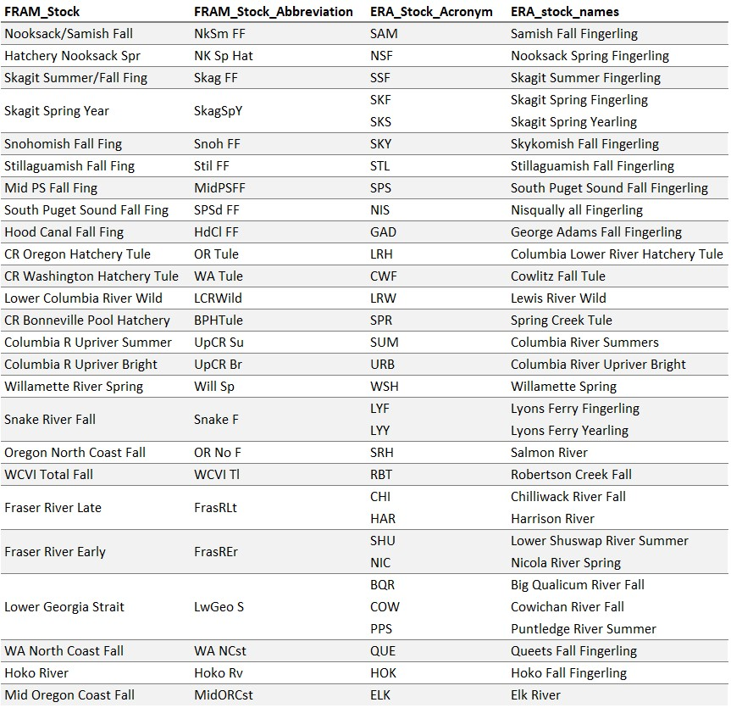

### Fisheries

The table below provides a crosswalk of FRAM fisheries and ERA fishery groupings to four regions as presented in figures below: Southeast Alaska (SEAK), Northern and Central British Columbia (NBC), Southern British Columbia (SBC), and Southern United States (SUS). FRAM includes 73 fisheries from southeast Alaska, Canada, Puget Sound and off the Coast of Washington, Oregon, and California. The ERA contains 233 fine scale fisheries encompassing the same range as those in FRAM, which get aggregated into 28 fishery groupings for reporting in "total mortality distribution tables," which get reported in annual ERA reports (see reference and link below). Efforts were made to ensure alignment between FRAM fisheries and ERA fisheries when assigning each fishery to a region for comparative purposes. There may, however, be unique, stock-specific instances where misalignments occur.

Table 2. Table relating FRAM fisheries to ERA fisheries

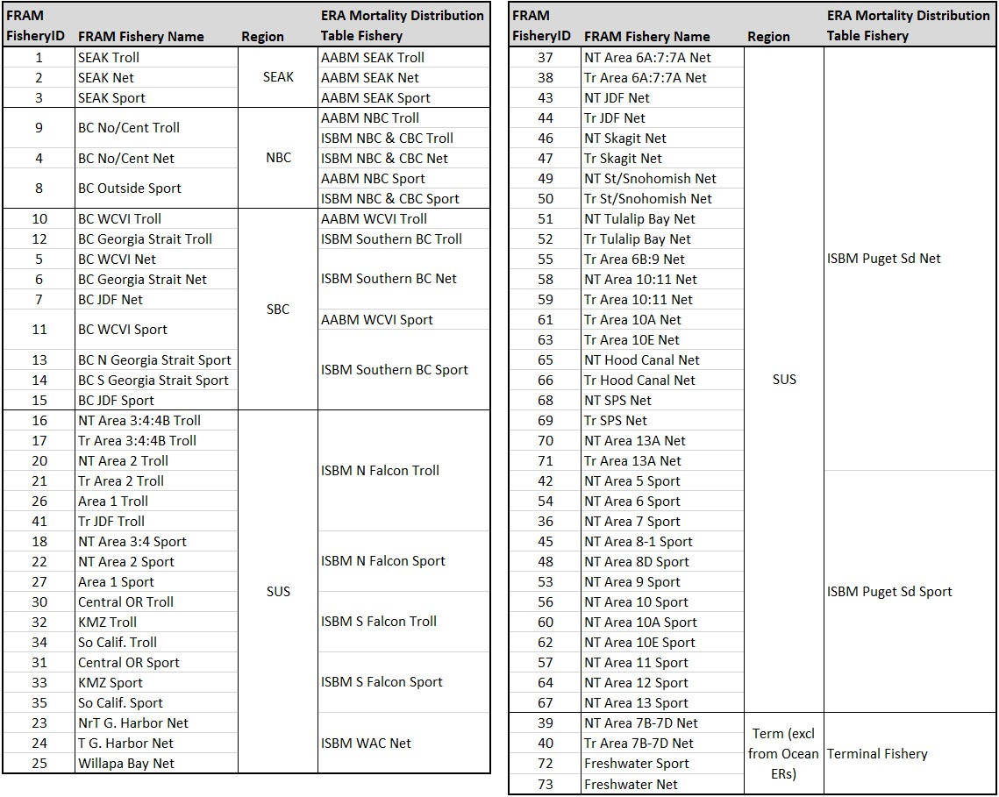

### Exploitation Rates

#### ERA

Each year the CTC conducts an "Exploitation Rate Analysis" (ERA), which involves brood year specific CWT-based cohort analyses that reconstruct the cohort size and exploitation rate history for a given set of exploitation rate indicator stocks. Methods and algorithms central to the ERA can be found in Appendix II, Supplement B of [CTC, 1988](https://www.psc.org/download/35/chinook-technical-committee/2150/tcchinook88-2app2.pdf). For this assessment we used results from the ERA conducted in 2020, which provides calendar year exploitation rate estimates through 2018 for all indicator stocks. Results of this analysis are published and available on the PSC website [CTC, 2021](https://www.psc.org/download/35/chinook-technical-committee/14106/tcchinook-21-05.pdf). Calendar year exploitation rates derived from the CTC's ERA can be obtained from adult equivalent (AEQ) total mortality distribution tables included in Appendix C of the published report, (also [available electronically](https://www.psc.org/download/638/data-sets/14107/tcchinook-21-05-appendix-c-mortality-distribution-tables-detailed.xlsx) on the PSC website) and are calculated for each stock (s) in a given calendar year (cy) for a subset of fisheries (F) as:

Where,  
  ER = exploitation rate  
  cy = calendar year  
  s = stock  
  F = ocean (pre-terminal) fisheries  
  a = age  
  MinAge = 2  
  MaxAge = 5  
  f = fishery  
  TotMort = total (landed plus non-landed) fishing mortality  
  AEQ = adult equivalency values (proportion of fish that would have survived to maturity and escaped to spawn in the absence of fishing)  
  Esc = escapement

Ocean exploitation rates for a given stock/year are calculated by summing the percentage distributions across all AABM and ISBM fisheries (terminal fisheries are excluded). It is important to note that, as the ERA is conducted using CWT tag codes with marked releases, these are estimates of exploitation rates experienced by the marked component of each stock. For stocks that are not subjected to significant mark-selective fisheries, the difference in exploitation rates between the unmarked and marked components of the stock would be expected to me minimal. It is possible, however, that even in the absence of exposure to mark-selective fisheries, there could be differences in marked and unmarked exploitation rates on a stock due to differences in age composition between the two groups. The CTC is currently in the process of incorporating MSF algorithms into the ERA.

#### FRAM

FRAM exploitation rates were based on postseason validation runs conducted in June 2021, which used the latest version of the Chinook FRAM base period calibration, referred to as 'round 7.1'. Unlike the ERA, FRAM does accommodate for differential impacts on the marked and unmarked components of a stock when exposed to MSFs, thus, in order to ensure comparability with exploitation rates from the ERA, FRAM exploitation rates presented in this document are derived using the marked component of each stock. For this analysis only preterminal (ocean) exploitation rates were evaluated, as FRAM does not account for terminal or freshwater fishery impacts for most stocks that originate outside of Puget Sound. FRAM exploitation rates for a subset of fisheries (F), are calculated for a given catch year (cy) and stock (s), as:

Where,  
  t = time step

Please note that the FRAM exploitation rates presented in this assessment will differ from those that may be reported in other forums in an effort to produce rates that are comparable to those produced by the ERA. These difference are primarily due to:  
  1. Use of the "marked" stock component rather than the "unmarked" stock component, which is often used to estimate impacts on natural origin stocks.  
  2. Inclusion of age 2 fish in escapement and the resulting abundance which serves as the denominator of the exploitation rate equation. Typically FRAM derived exploitation rates do not include age 2 fish in escapement.  
  3. Summation of annual impacts across FRAM time steps 1 through 3 (October through September), rather than time steps 2 through 4 (May through April), which is typically the practice when assessing Puget Sound stock impacts.

### Maturation Rates

Maturation rates are calculated similarly in both the ERA and FRAM base period cohort analyses as the mature portion of the total cohort after preterminal fishing, or:

A distinction is that while the ERA maturation rates are calculated on an annual basis, FRAM maturation rates are calculated separately for each Chinook FRAM time step (e.g., Oct-Apr, May-Jun, Jul-Sep). In order to provide FRAM maturation rates that are comparable to then annual rates produced by the ERA, annual maturation rates were calculated from the time step-specific rates for each FRAM stock (s) and age (a) as:

It is also worth noting that whereas the ERA maturation rates are calculated using CWT recovery data for each brood year across the time series, the FRAM maturation rates are calculated as part of the base period calibration, thus, as part of the base period data set they remain constant between model runs (i.e., are static across all years in this assessment). Maturation rates for five year old Chinook are assumed to be 100% in both models. As a result, age five maturation rates were not included in the maturation rate plots that follow in an effort to improve readability.

## Results

### Overall Summary Across Stocks

#### Regional Box Plots

##### Puget Sound

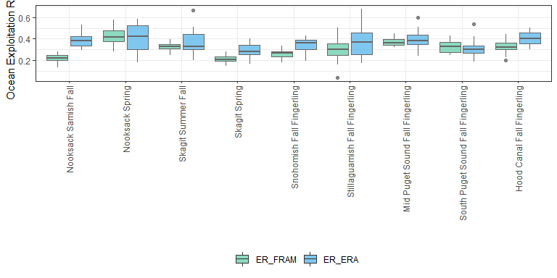

##### Columbia River

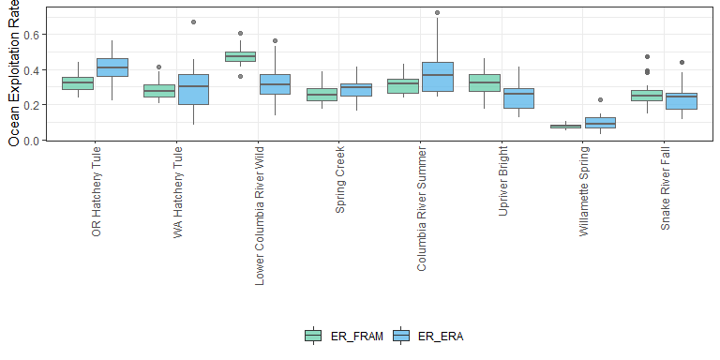

##### WA/OR Coast & Canada

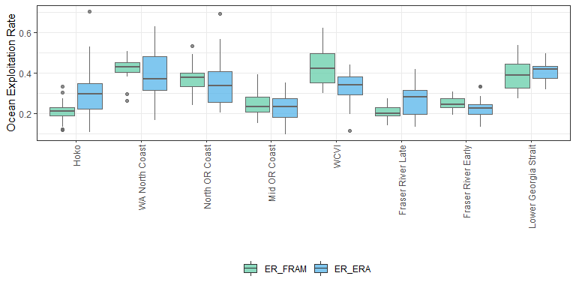

#### ER Scatterplots

##### Combined

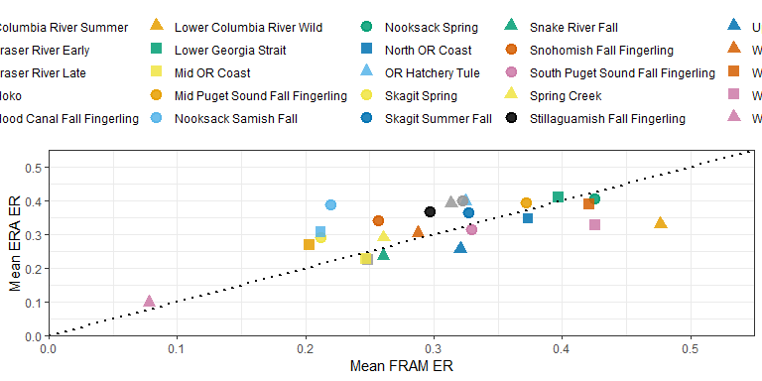

##### 1999 to 2008

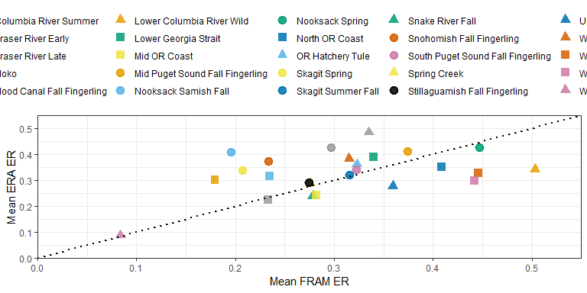

##### 2009 to 2018

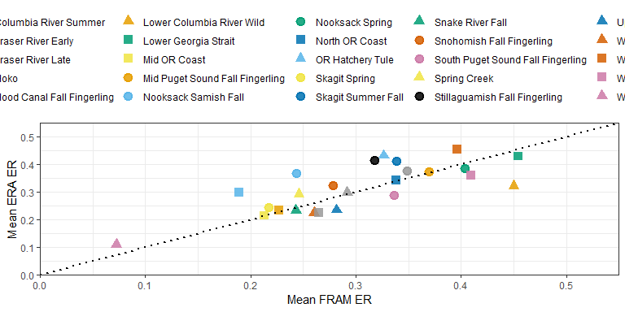

### Individual Stock Results

#### Nooksack Samish Fall

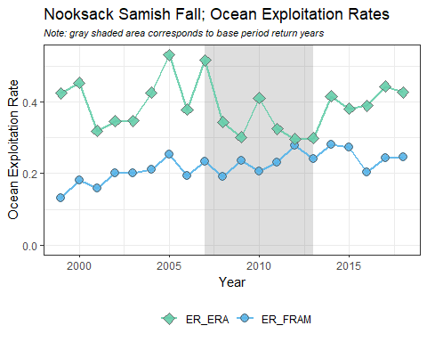  
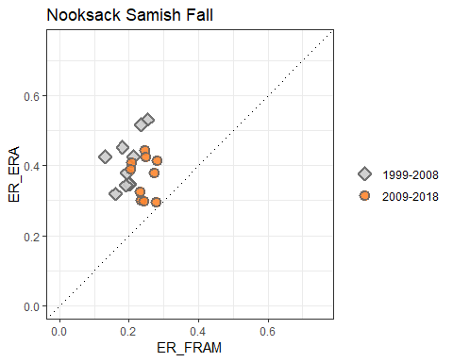  
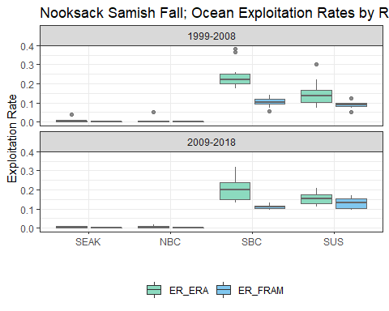  
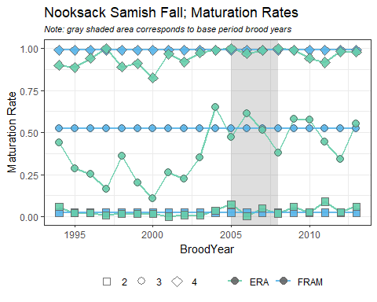

#### Nooksack Spring

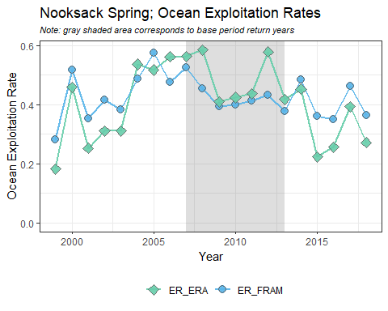  
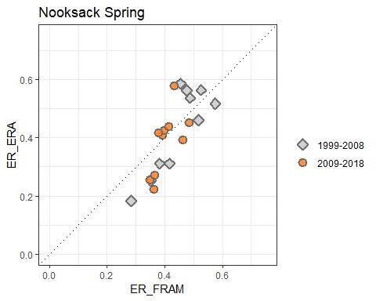  
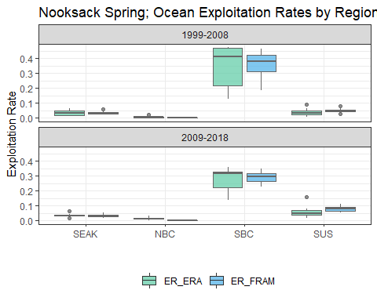  
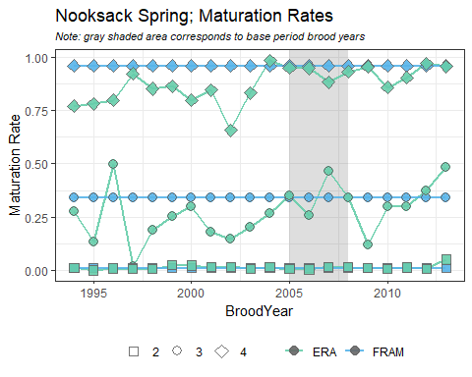

#### Skagit Summer Fall

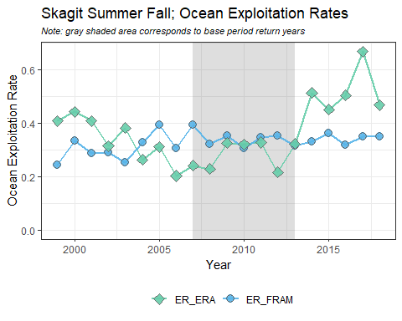  
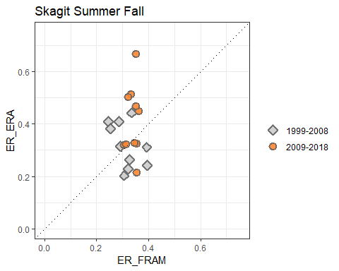  
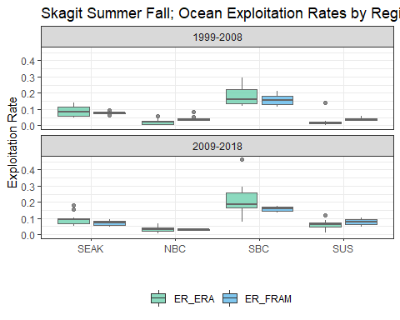  
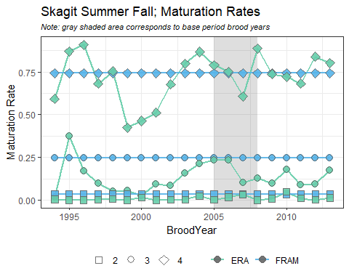

#### Skagit Spring

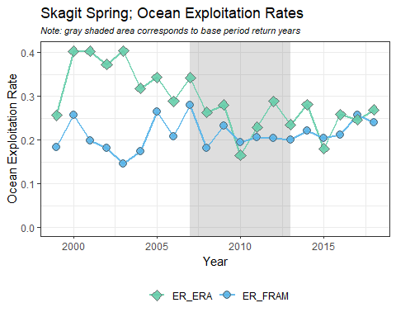  
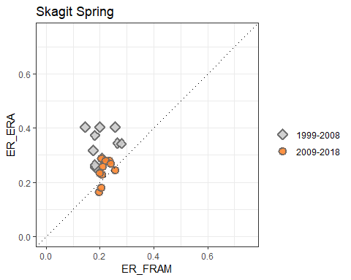  
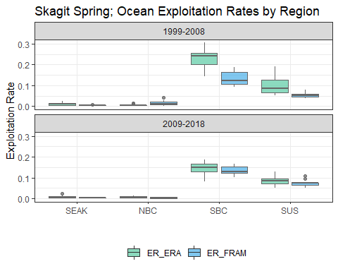  
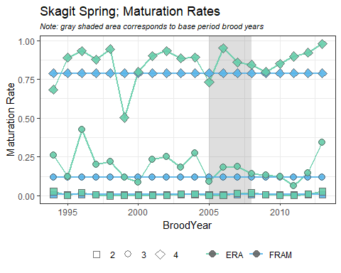

#### Snohomish Fall Fingerling

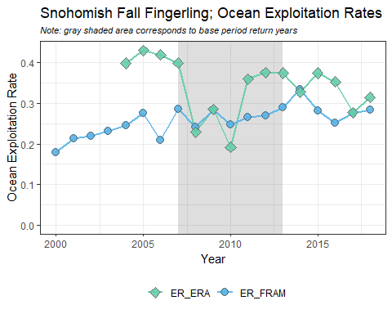  
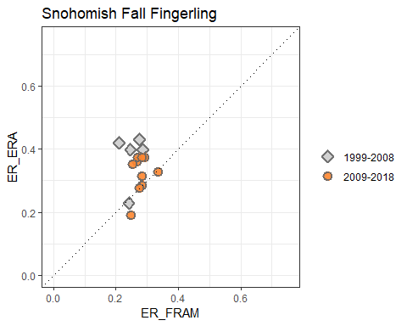  
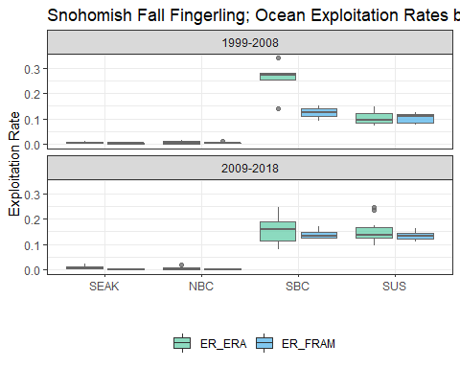  
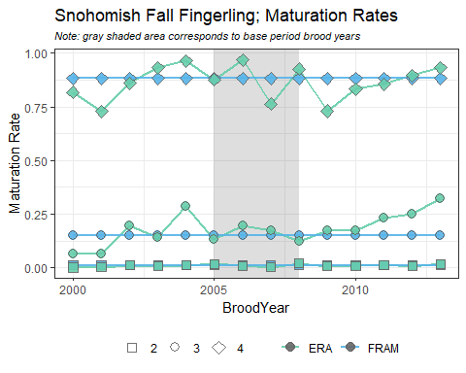

#### Stillaguamish Fall Fingerling

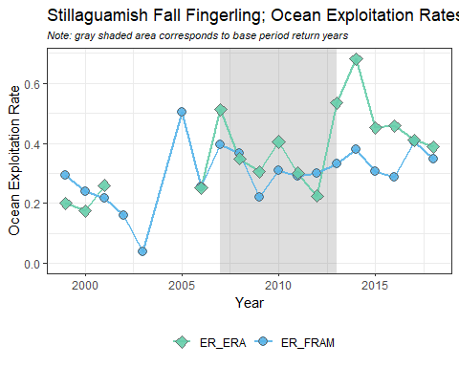  
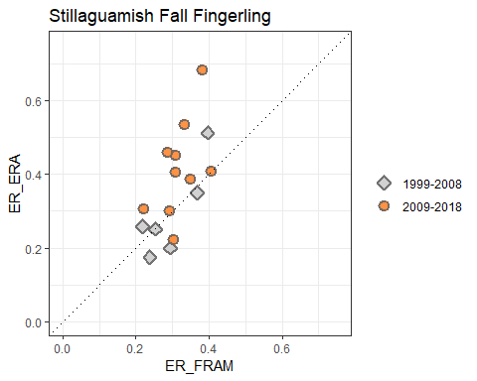  
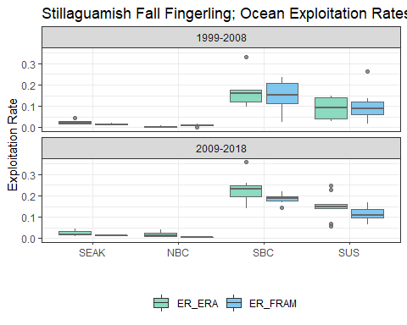  
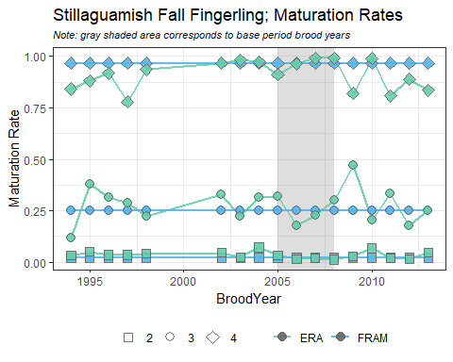

#### Mid Puget Sound Fall Fingerling

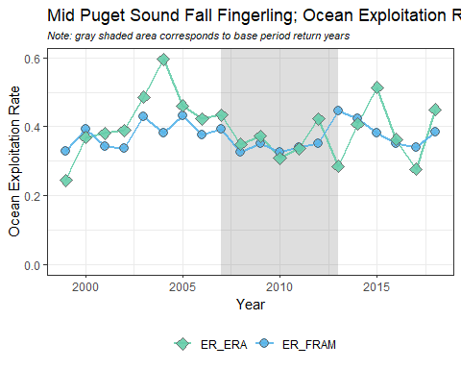  
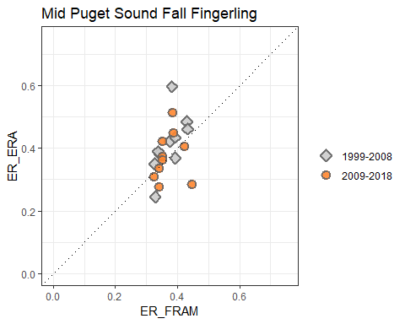  
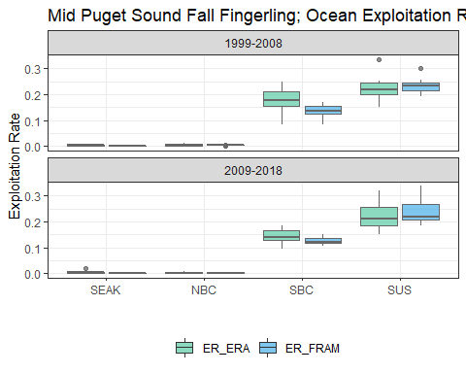  
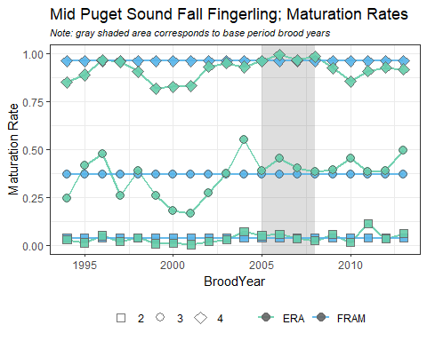

#### South Puget Sound Fall Fingerling

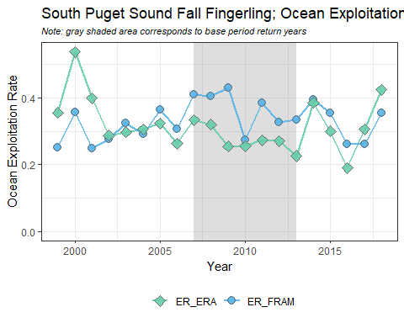  
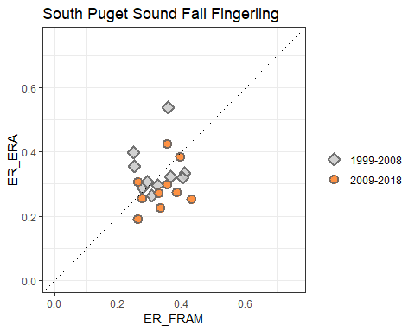  
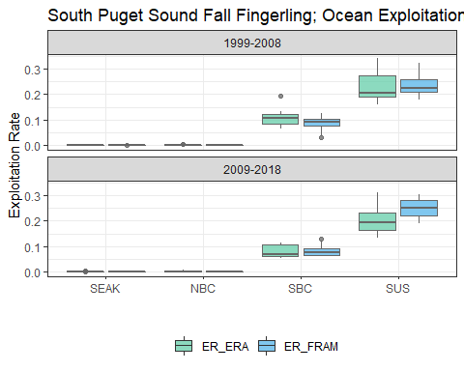  
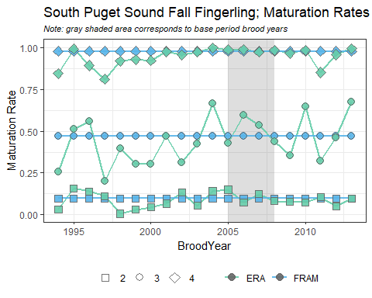

#### Hood Canal Fall Fingerling

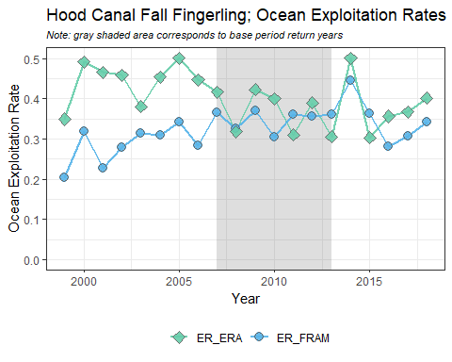  
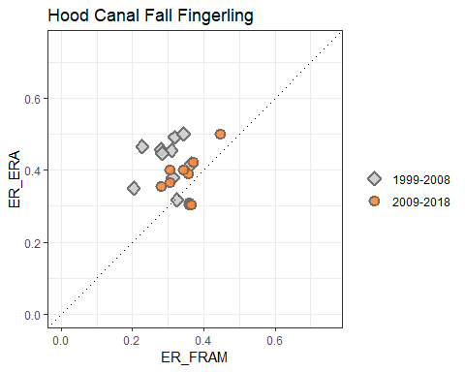  
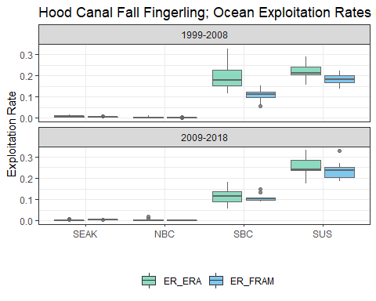  
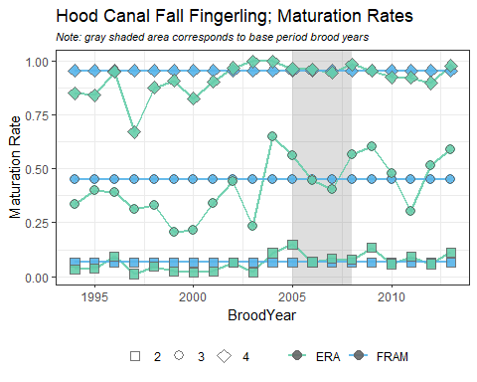

#### OR Hatchery Tule

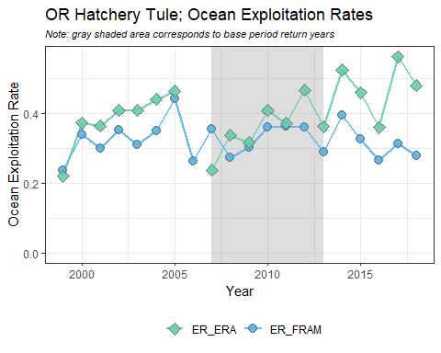  
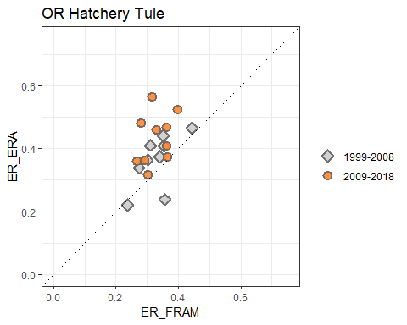  
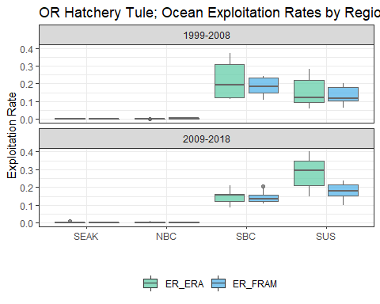  
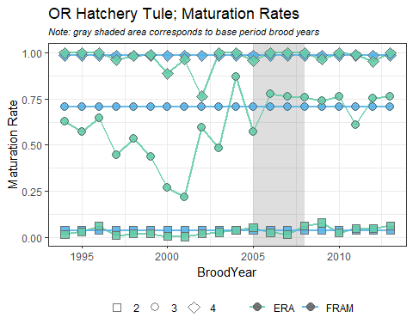

#### WA Hatchery Tule

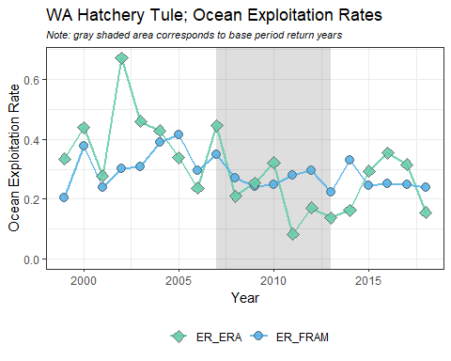  
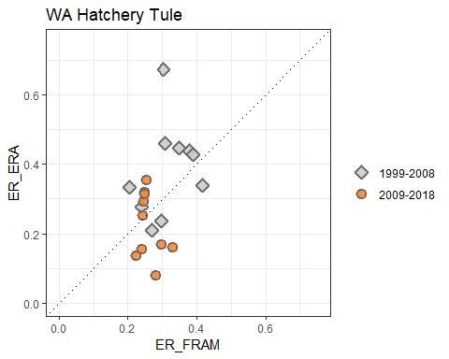  
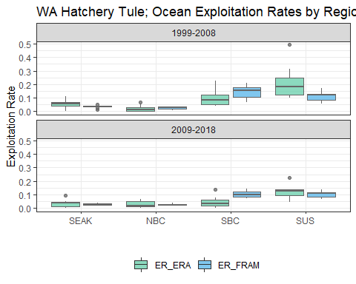  
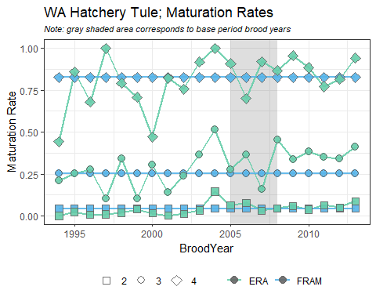

#### Lower Columbia River Wild

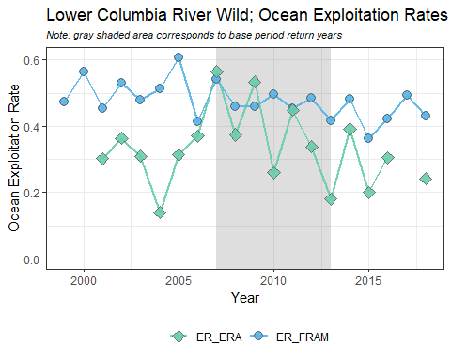  
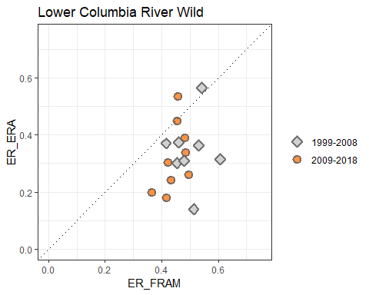  
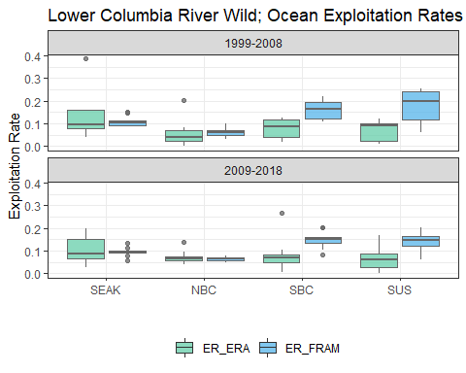  
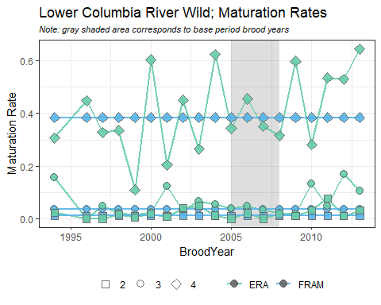

#### Spring Creek

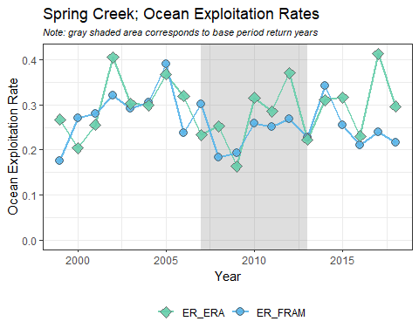  
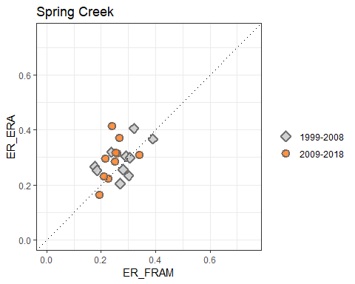  
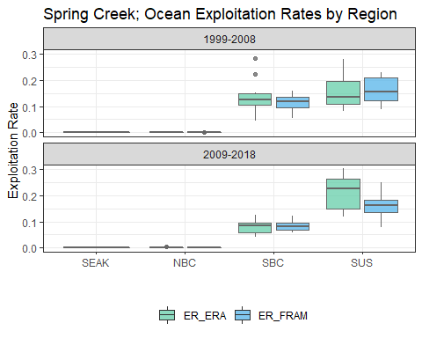  
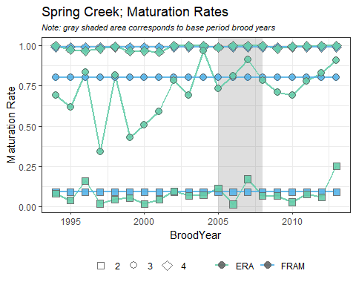

#### Columbia River Summer

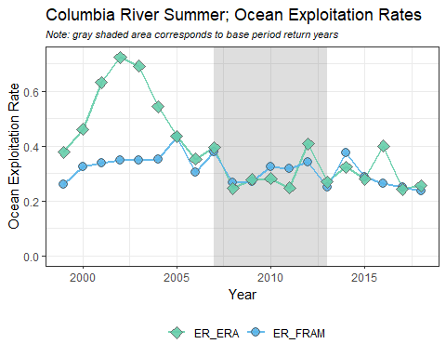  
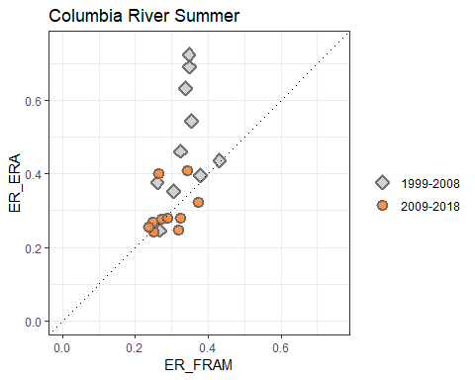  
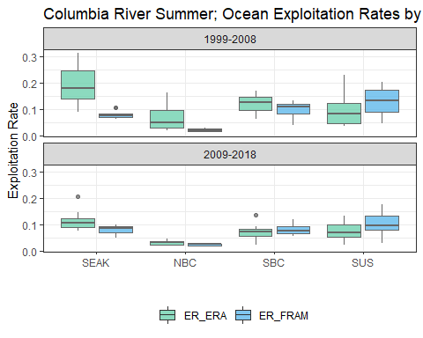  
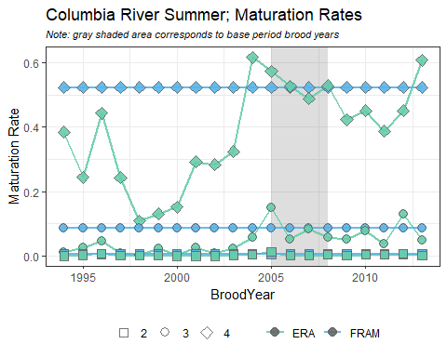

#### Upriver Bright

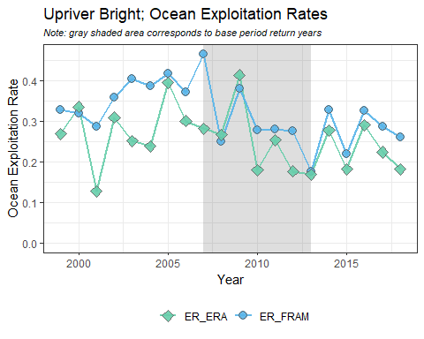  
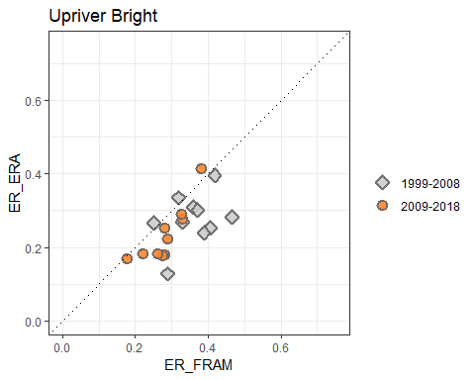  
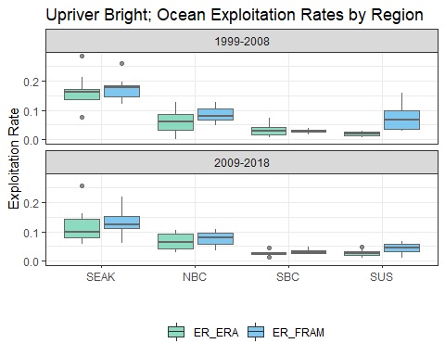  
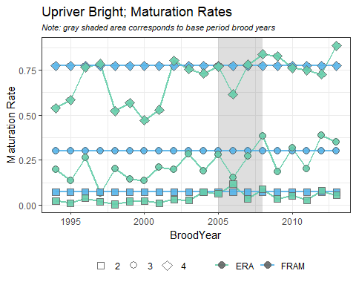

#### Willamette Spring

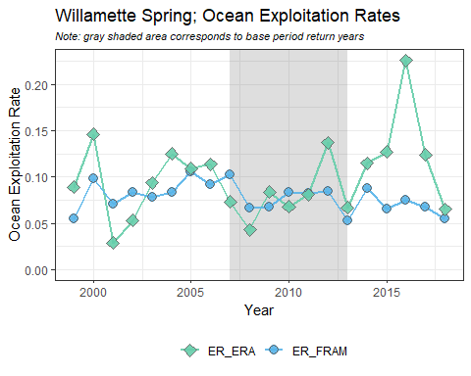  
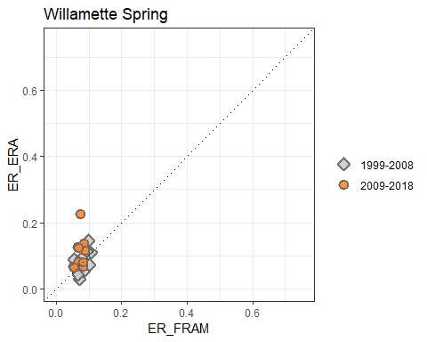  
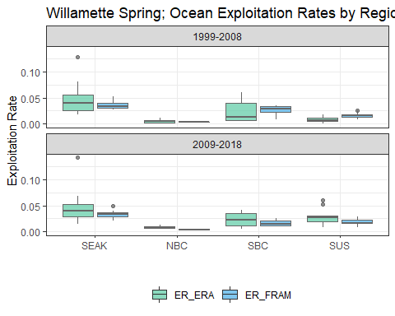  
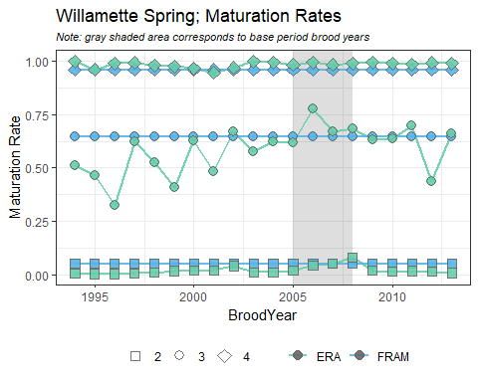

#### Snake River Fall

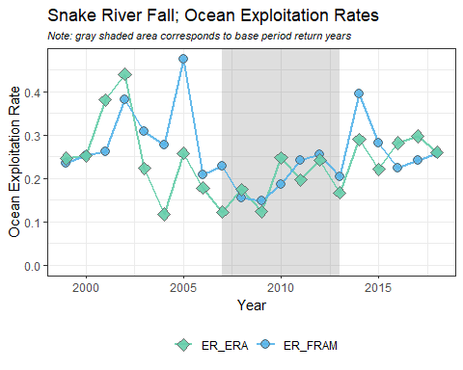  
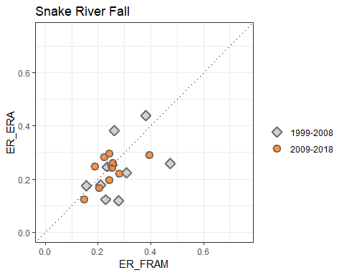  
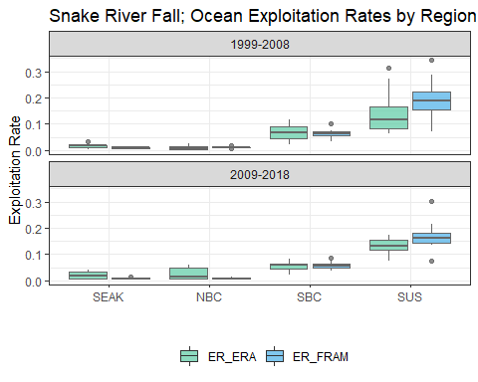  
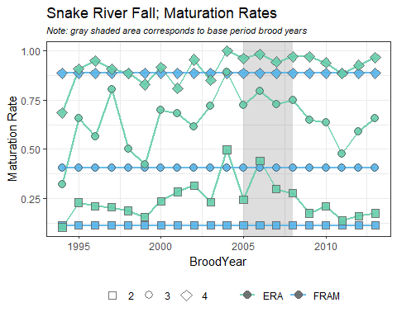

#### Hoko

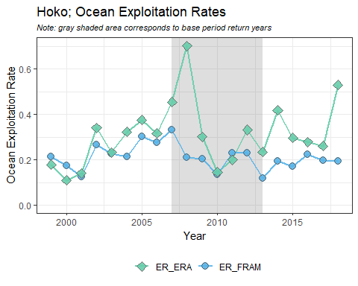  
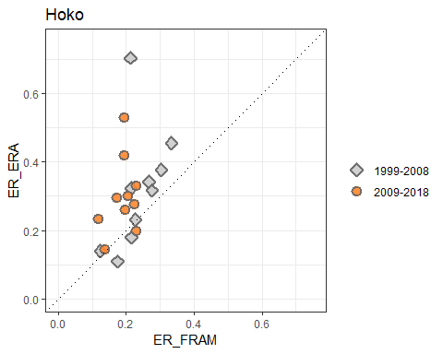  
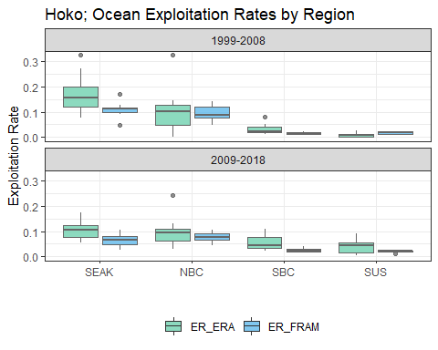  
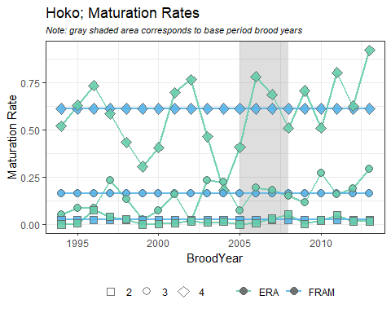

#### WA North Coast

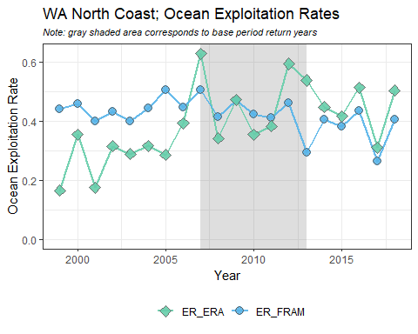  
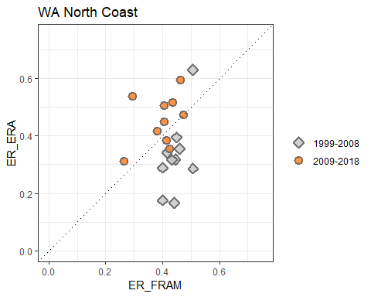  
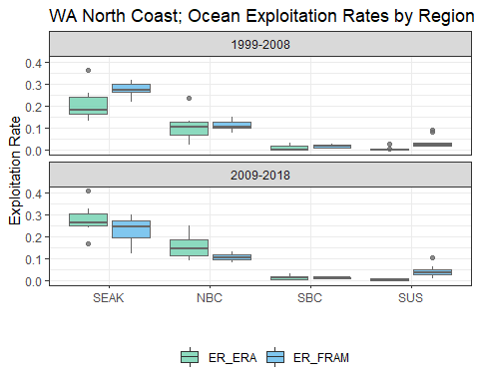  
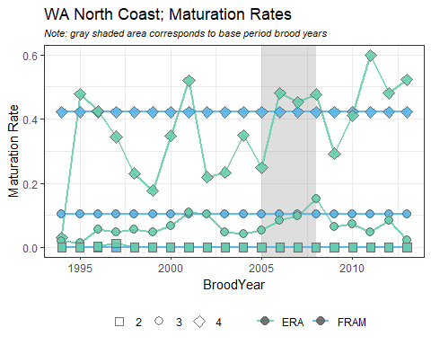

#### North OR Coast

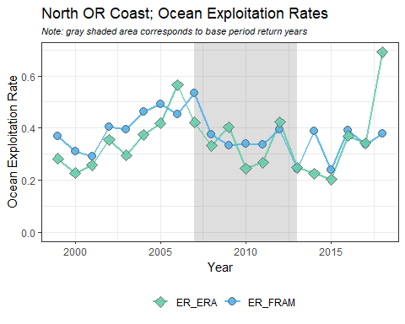  
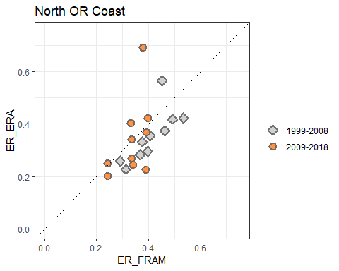  
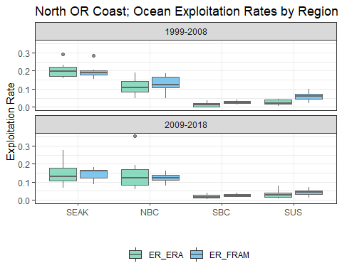  
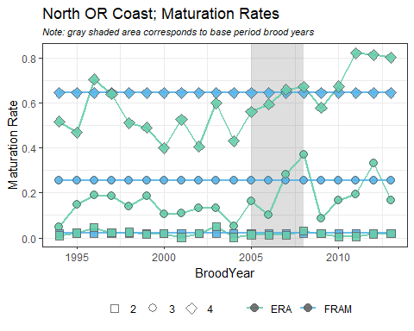

#### Mid OR Coast

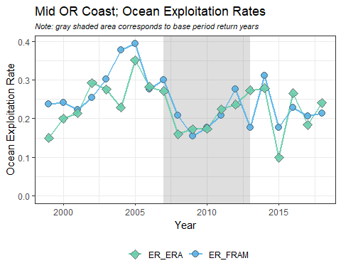  
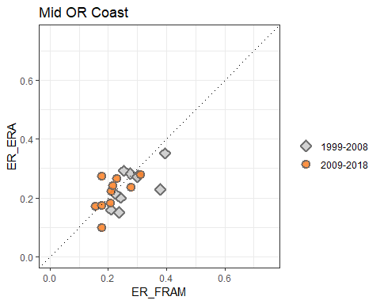  
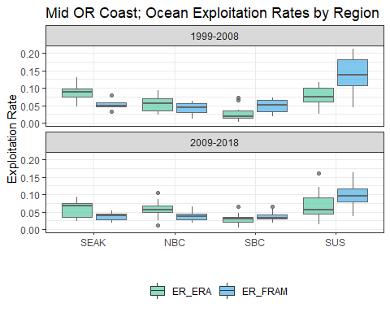  
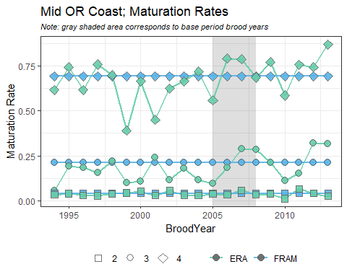

#### WCVI

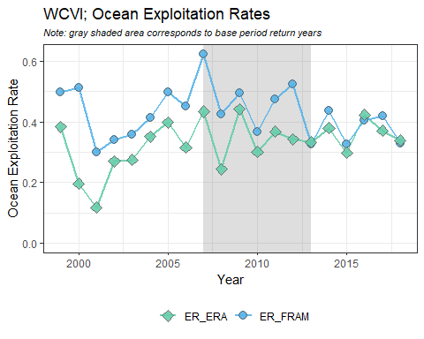  
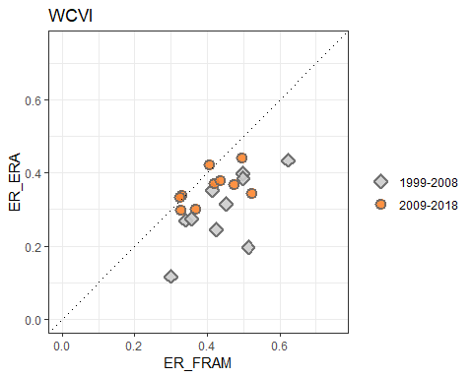  
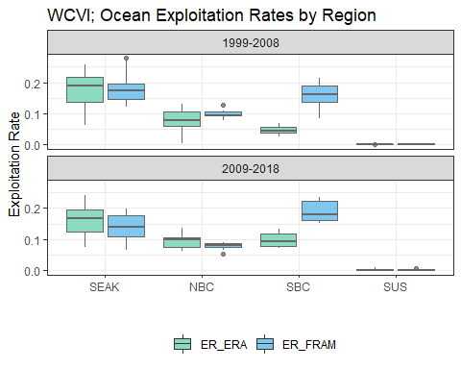  
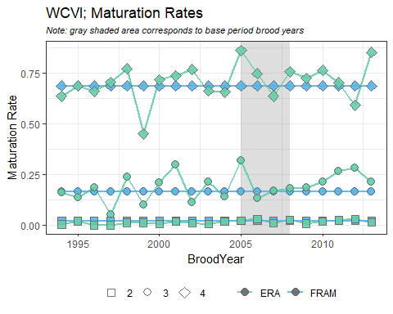

#### Fraser River Late

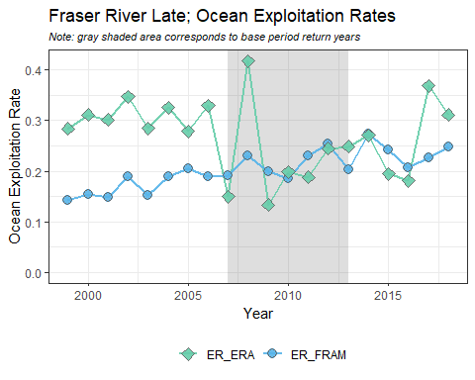  
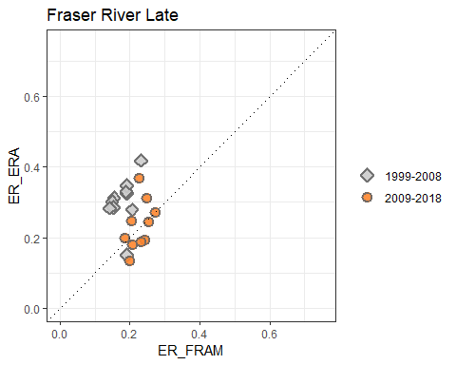  
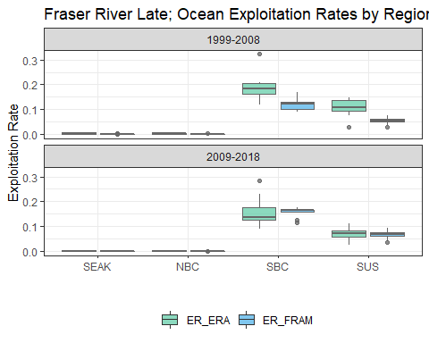  
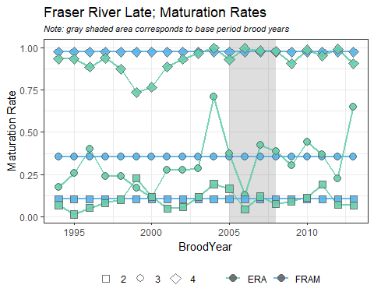

#### Fraser River Early

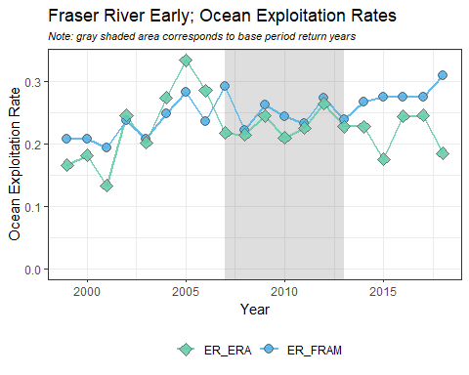  
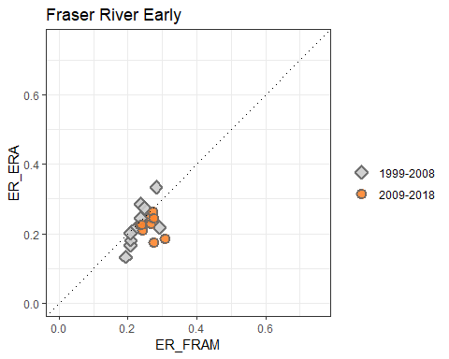  
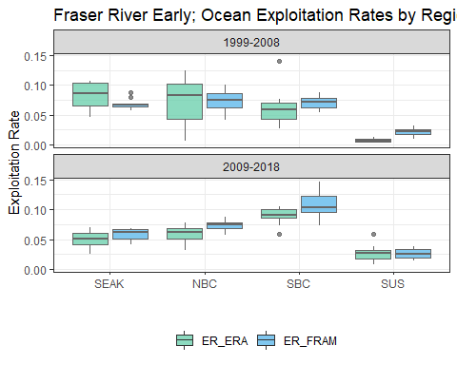  
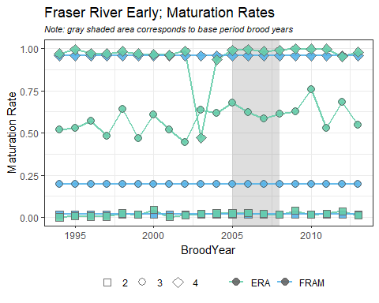

#### Lower Georgia Strait

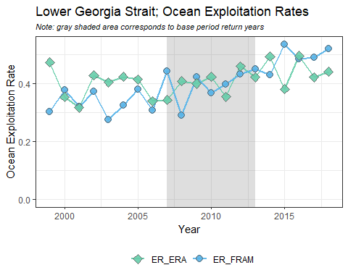  
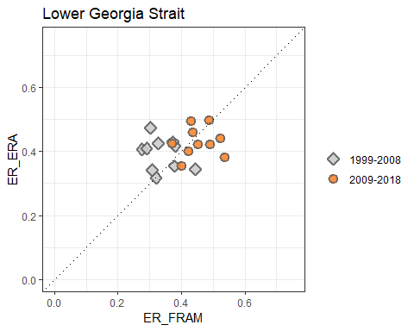  
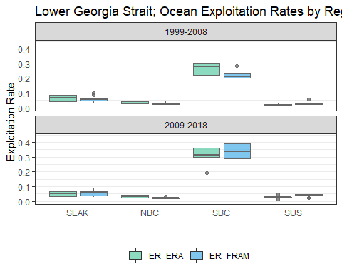  
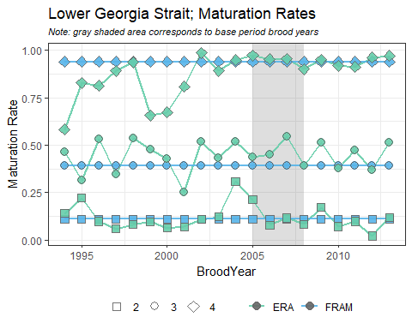

## Case Studies

### WCVI

In comparing model outputs for the WCVI stock, ocean exploitation rates in FRAM were notably higher, particularly in years prior to 2013. It was clear from looking at the regional box plots for WCVI that the source of the disconnect was in Southern B.C. fisheries. Through further investigation of the fishery mapping, we identified a mismatch in how the part of the terminal marine catch of the WCVI sport fishery was being mapped between the two models. In FRAM, these recoveries are mapped to the WCVI sport fishery and included in the ocean exploitation rates. In the ERA, however, these terminal sport recoveries are mapped to the terminal Canada sport fishery in the mortality distribution tables, and thus excluded from the ocean exploitation rates. To align these fisheries for comparative purposes, we reproduced a set of mortality distribution tables using the same results of the ERA cohort analyses, but with a modified fishery mapping structure that assigned the relevant terminal sport fishery to the "Southern B.C. ISBM sport" fishery.

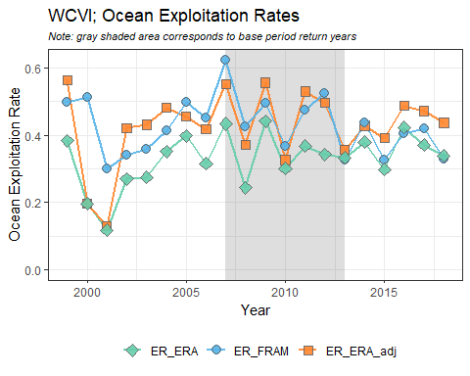  
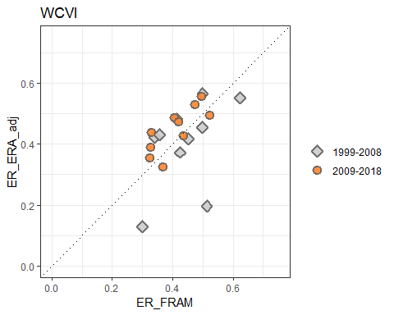  
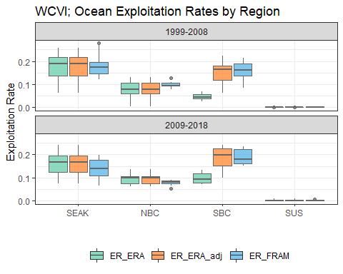

### Nooksack/Samish Fall

* add detail about imputing FW sport here?
* initial focus on Samish, than follow this section with a new section called "Puget Sound stocks with inadequate freshwater sport sampling"? In that section could provide FRAM_adj ER plots for the relevant stocks
* also include corrected 2007 ERA value (NOF sport including FW sport)

While freshwater sport fisheries have consistently occurred in some Puget Sound rivers, the level of CWT sampling in these fisheries has been inadequate or nonexistent in many years. Although freshwater sport fisheries were not evaluated in this study, which focused solely on ocean exploitation rates, missing CWT recoveries will result in smaller abundances and consequently higher exploitation rates in all fisheries. By contrast, FRAM/TAMM account for freshwater sport fisheries by assigning 100% of the reported catch to the local stock and adding this catch to the abundance. For this exercise, in order to increase consistency between ERA and FRAM, freshwater sport catch was excluded from the FRAM abundance for sport fisheries without CWT sampling. This resulted in increased ERs and has a significant effect on stocks with large freshwater sport fisheries, such as Skokomish (Hood Canal) or Nooksack/Samish Fall Chinook.

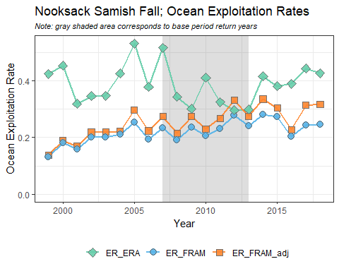

### Puget Sound stocks with inadequate freshwater sport sampling

## Conclusions and Next Steps

This analysis compares ERA to FRAM exploitation and maturation rates. While there is good agreement for many stocks (Nooksack Springs, Mid Puget Sound, WA Hatchery Tules) this exercise also highlights stock/fishery combinations with significant differences. Further analysis is needed to explore the causes of these differences in depth. This work is expected to result in improvements to both methods. Based on preliminary examinations, likely causes are inadequate sampling and/or catch reporting, fisheries mismatches, insufficient tagging and a lack of methods to account for impacts to untagged fish.

Further analysis should also focus on maturation rates. The authors recommend a sensitivity analysis to evaluate the effect of maturation rates on exploitation rates. Maturation rates have increased significantly for many stocks between FRAM's previous and the new base period. Studies to examine whether maturation rates have truly increased versus an increase in natural mortality could be very insightful. While the effect of maturation rates on exploitation rates may be minor for some stocks/fisheries, maturation rates greatly influence estimates of prefishing abundances .

## Appendices

### Appendix A

Exploitation rate data used in generation of report figures. Total ocean exploitation rate is the result of summing the exploitation rate across all regions for a given stock, year, and model.

### Appendix B

Maturation rate data used in generation of report figures.