SUDOKU
Table of Contents
1. Introduction 6
1.1. Background 6
1.2. Terminology 7
1.3. Cell Grammar 8
1.3.1. Location Specifiers 8
1.3.2. Operators 8
1.3.3. Pattern specifiers: 9
1.3.3.1. Counts 9
1.3.3.2. Fish (base-set house precedes cover-set house) 9
1.3.3.3. Chains 9
1.3.4. Examples 10
1.4. Sudoku Facts 11
2. Sudoku Logic Theory 12
2.1. Premises and Inferences 12
2.2. Ccells 12
2.3. Basic Logic 12
2.3.1. Singles 12
2.3.1.1. Exposed Single 13
2.3.1.2. Hidden Single 13
2.3.1.3. Locked Singles 13
2.3.2. Subsets 13
2.4. Links and Chains Logic 13
2.4.1. Connecting Ccells. 14
2.4.2. Links 14
2.4.2.1. Weak Links 14
2.4.2.2. Strong Links 14
2.4.2.3. Notes: 15
2.4.3. Creating Chains 15
2.4.3.1. Strongly Linked Chain 16
2.4.3.2. Weakly Linked Chain 16
2.4.3.3. Strongly Ended AIC 16
2.4.3.4. Weakly Ended AIC 16
2.4.4. Bringing Ccells, Links and Chains together. 18
2.4.5. Grouped Links 21
2.4.5.1. Properties of Group Links 22
2.5. Hidden Logic 25
2.6. Unique Logic 25
2.7. Almost Locked Sets (ALS) and Subset Exclusion Logic 25
2.8. Miscellaneous Logic 26
2.9. Base Sets and Cover Sets Logic 26
2.9.1. Constraints / Truths 26
2.9.2. Eliminations 27
2.9.3. The Concept of Rank 28
2.9.3.1. Rank 0 Logic 28
2.9.3.2. Rank 1 Logic 29
2.9.3.3. Rank R Logic 31
2.9.4. Triplets and Rank Regions 33
2.9.5. Guardian Candidates 33
2.10. Summarizing Robert Hanson’s Work. 33
3. Generating Puzzles 40
3.1. Puzzle Difficulty 40
3.1.1. Expertise Bands 40
3.1.2. Logic Techniques 40
3.2. Generating Puzzles 44
3.2.1. Generating a Board 44
3.2.2. Creating Puzzles 45
3.2.2.1. Symmetry 46
3.2.2.2. Digging Holes and Checking Puzzles 46
3.2.2.3. Grading Puzzles 47
3.2.2.4. Practical Considerations 47
. Foreground Puzzle Creation 47
. Background Puzzle Creation 47
3.2.3. Scrambling Puzzles 47
4. Solving Puzzles 49
4.1. Prefacing Comments 49
4.2. Solving Singles 49
4.2.1. Exposed Singles 49
4.2.2. Hidden Singles 49
4.2.3. Locked Singles 49
4.2.4. Empty Rectangles 49
4.2.5. Almost Locked Candidates 50
4.3. Solving Subsets 51
4.3.1. Exposed and Locked Exposed Pairs 51
4.3.2. Hidden Pairs 51
4.3.3. Exposed and Locked Exposed Triples 51
4.3.4. Hidden Triples 51
4.3.5. Exposed Quads 51
4.3.6. Hidden Quads 51
4.3.7. Bent Exposed Triples 51
4.3.8. Bent Exposed Quads 51
4.3.9. Some Notes 51
4.4. Chains and Loops 52
4.4.1. X-Chains and X-Loops 52
4.4.1.1. Skyscrapers (3 Link X-Chain) 53
4.4.1.2. 2 String Kites (3 Link X-Chains) 53
4.4.1.3. Turbot Fish (Other 3 Link X Chains) 53
4.4.1.4. Longer X-Chains 53
4.4.1.5. Even Number of Links X-Loops (Even X-Loops) 54
4.4.1.6. Odd Number of Links X-Loops (Strong and Weak X-Loops) 55
4.4.1.7. Grouped Linked X-Chains and Loops 56
4.4.2. XY-Chains and Loops 56
4.4.2.1. Y-Wings (XY-Chains) 57
4.4.2.2. Remote Pairs 57
4.4.2.3. XY-Chains 59
4.4.2.4. XY-Loops 59
4.4.3. AI-Chains and AI-Loops 61
4.4.3.1. AI Chains 61
4.4.3.2. Even AI Loops 62
4.4.3.3. Strong AI Loops 62
4.4.4. Wings and Bent Exposed Subsets 62
4.4.5. Y Wings (Bent Exposed Triple – BET) 63
4.4.6. W-Wings (AIC with 6 nodes) 64
4.4.7. XYZ-Wings (Bent Exposed Triple - BET) 64
4.4.8. WXYZ-Wings – Bent Exposed Quad (BEQ) 65
4.4.9. Bent Exposed Quads 66
4.4.10. Wrap Up. 69
4.5. Fish 69
4.5.1. Introduction 69
4.5.2. Basic Fish 73
4.5.2.1. X-Wing 73
4.5.2.2. Swordfish 73
4.5.2.3. Jellyfish 73
4.5.3. Finned Fish 73
4.5.3.1. Finned X-Wing 73
4.5.3.2. Finned Swordfish 73
4.5.3.3. Finned Jellyfish 73
4.5.4. Kraken Finned Fish 73
4.5.4.1. Kraken X-Wing 73
4.5.4.2. Kraken Swordfish 73
4.5.4.3. Kraken Jellyfish 74
4.5.5. Franken Fish. 74
4.5.6. Mutant Fish 74
4.6. A Note on Chain Length and Processing Time. 75
5. Operations 77
5.1. Modes: 77
5.1.1. Idle Mode 77
5.1.2. Entry Mode 77
5.1.3. Solve Mode 77
5.2. Creation (Enter Mode) 77
5.2.1. Creating Puzzles 77
5.2.2. Entering Puzzles 77
5.2.3. Modifying Puzzles 77
5.3. Solving (Solve Mode) 78
5.3.1. Entering Values and Candidates 78
5.3.2. Solving Puzzles Unassisted 78
5.3.3. Solving Puzzles with Assistance 78
5.3.4. Displaying Candidates and Candidate Assistance 78
5.3.5. Hinting 78
5.3.6. Listing Solution 78
5.4. Mode, Mouse and Keyboard Operations 79
5.4.1. Conflicts and Errors 80
5.4.2. Levels of assistance and relationship to candidates 80
5.4.2.1. Check on Finish. 80
5.4.2.2. Show Conflicts on Finish 80
5.4.2.3. Show Errors on Finish 80
5.4.2.4. Interactively Show Conflicts 81
5.4.2.5. Interactively Show Errors 81
6. Software Design 82
6.1. Top Level Objects and Relationships 82
6.2. Main module 82
6.3. Menus Module 82
6.4. Board Module 82
6.5. Sudoku Module 82
6.5.1. Major Data Structures. 82
6.5.1.1. Grid. 82
6.5.2. Control State machine 82
6.5.2.1. Idle State 82
6.5.2.2. Entry State 82
6.5.2.3. Solve State 82
6.5.3. Operation 82
6.6. Timer Module 82
7. Implementation 83
7.1. Config File 83
8. Appendix A: Development Environment Notes. 84
8.1. Directory Structure: 84
8.2. Development and Production Cython Builds 84
8.3. Python’s Module Importing Search Order. 84
8.4. Module Manipulation 85
8.5. Global Variables Hack 85
8.6. No Pure-Python Cython Files 86
8.7. Development Workflow 86
8.8. No Debugger, No Problem, TRCX Is Your Friend 86
8.9. Using Setuptools to Compile Cython Files 86
8.10. Using the Command Line aka IDE Independence. 87
8.10.1. Building Cython Compiled Modules 87
8.10.2. Running YAS 87
8.10.3. Command line scripts in PyCharm’s Run/Debug Configurations 88
8.11. YAS Setuptools Build Script 89
8.12. Environment Variables only for Command being Executed 89
8.13. Cython in a Nutshell / Implementation Comments 89
8.14. Cython / Python Interoperability 89
9. APPENDIX B: Tracing functionality 92
9.1. In interpreted Python Code 92
9.2. In Cython Compiled Code 92
9.2.1. Non-Viable Approaches Considered 92
9.2.2. Viable Approach First Attempt 93
9.2.3. Viable Approach Second Attempt 94
9.2.4. Building the Cython trc module. 94
9.2.5. Additional TRCX Helper Functions for Cython 95
9.2.5.1. cdef void TRCX_grid(int G[9][9]) 95
9.2.5.2. cdef void TRCX_cands(bint C[9][9][9]) 95
9.2.5.3. cdef void TRCX_memdump(void *Addr, int len) 95
9.2.5.4. cdef void *PyMem_TRCX_Malloc(size_t Bytes) 95
9.2.5.5. cdef void *PyMem_TRCX_Calloc(size_t Nr, size_t Bytes) 95
9.2.5.6. cdef void PyMem_TRCX_Free(void *Mem) 95
9.2.6. Additional Considerations 95
9.2.6.1. Interoperability with Python Interpreted Code 95
9.2.6.2. TRCX Usage / Limitations 95
10. APPENDIX C: Installing MinGW-w64 and Cython setup. 97
10.1. Some references: 97
10.2. Installing MinGW-w64 97
10.3. Changes to Distutils in Setuptools 97
10.4. Changes is the Python Distibution 99
10.5. A setup.py Example 100
11. Appendix D: Cython Code Optimisation 101
11.1. Cython Optimising Suggestions 101
11.2. General Python Optimising Suggestions 105
11.3. Benchmarking Examples 107
11.3.1. Primes 107
11.3.1.1. Base Code: 107
11.3.1.2. Dressed Code 108
11.3.1.3. .pyx Code 108
11.3.1.4. Benchmark.py 108
11.3.2. Factorials 109
11.3.2.1. Base facts.py 110
11.3.2.2. Dressed facts_c.py 110
11.3.2.3. Cython facts_cx.pyx 110
11.3.2.4. Dressed Tail Call Recursion facts_tcr.py 110
11.3.2.5. Cython Tail Call Recursion facts_tcrx.pyx 111
11.3.2.6. Dressed Iterative Solution 111
11.3.2.7. Cython Iterative Solution 111
11.3.2.8. benchmark.py 111
11.4. Sudoku Code Optimisations 113
11.4.1. gen_filled_grid() - ~ 25x 113
11.4.2. check_puzzle() - ~53x 113
11.4.3. minimalise_puzzle() - ~54x 113
11.4.4. scramble_puzzle() - ~1,9x 115
11.4.5. create_puzzle() - ~52x 115
12. Appendix E: Tools Tips and Tricks 116
12.1. GIT 116
12.2. Grep / Sed / Awk 116
12.3. Dropbox 116
12.3.1. Selectively Disable / Enable Folders from Syncing 116
12.4. Windows 10 116
12.4.1. Batch Scripting 116

Introduction

Background
“If you steal from one author it's plagiarism; if you steal from many it's research.” Wilson Mizner
In my journey of understanding Sudoku logic which is documented here, I owe credit to the following people and their websites.
Researching, I found the following refs for the basis of this work.
- Sudopedia: https://www.sudopedia.org. Most useful for its solving techniques reference. Not everything listed is explained or explained in sufficient detail but reference to search elsewhere.
- Hoduko: Bernhard Hobiger website. Bernhard passed away (last updates are 2013 on his website). Site and program contain a very comprehensive list of solving techniques, training and learning, a very good start for me to base my program on.
http://hodoku.sourceforge.net/en/index.php
- Pseudofish: This is a branch of the Hoduko code base and maintained upto 2020 releasing v2.3.0.
https://github.com/PseudoFish/Hodoku
- Systematic Sudoku: Methods for solving Sudoku puzzles in a systematic way.
https://sySudoku.com/
- https://www.stolaf.edu/people/hansonr/Sudoku/index.htm: Online solver: Techniques are explained in https://www.stolaf.edu/people/hansonr/Sudoku/explain.htm and https://www.stolaf.edu/people/hansonr/Sudoku/12rules.htm
The following links present solutions to solve less than evil/extreme puzzles without backtracking
- https://Sudokusolver.com/play/: look at the simple techniques and advanced techniques for explanations.
- https://www.kristanix.com/Sudokuepic/Sudoku-solving-techniques.php
- Simple soduko includes a program and many sample puzzles to work with. http://www.angusj.com/Sudoku/index.php. Techniques used explained here: www.angusj.com/Sudoku/hints.php
Puzzle Generation
- https://stackoverflow.com/questions/6924216/how-to-generate-Sudoku-boards-with-unique-solutions/7280517
- https://www.101computing.net/Sudoku-generator-algorithm/. Algorithm in python.
Backtracking algorithms
- https://hackernoon.com/Sudoku-and-backtracking-6613d33229af. High level explanation
- https://stackoverflow.com/questions/1518346/optimizing-the-backtracking-algorithm-solving-Sudoku
- https://www.101computing.net/backtracking-algorithm-Sudoku-solver/. Algorithm in Python. Explanation of code: https://medium.com/swlh/simple-Sudoku-with-backtracking-bb4813ddabb1
Sudoku swami,
enjoySudoku.com – Sudoku forum.
pauls pages
allanbarker.com
Sudokuwiki.

Terminology
Grid: 9x9 grid, subdivided into 9 – 3x3 grids (Blocks) on to which boards and puzzles are laid. Analogous to a chess board. A grid can be empty, filled, or a Puzzle. I tend to call a filled grid a board, but this defn is not used ubiquitously.
Board: Filled/solved puzzle. Analogous to a finished game of chess. (Except for Sudoko a completed game is when all the locations have numbers according to the rules, rather than a few chess remaining in check or stale mate).
Puzzle: Grid, populated with given values. A valid puzzle has only one unique solution.
Block / Box: One of the 9 - 3x3 sub grids that make up the grid. Blocks are labelled:

NW  1 | N  2 | NE  3
W  4 | C  5 | E  6
SW  7 | S  8 | SE  9

Chute/Band: 3 Boxes in a row or column. A horizontal chute is known as a floor, a vertical chute is known as a Tower.
Location or Cell: A position in the 9x9 Grid. Located as a 2 dimensional array. For example Grid[7,2] is the cell in the 7th row, and 2nd column. A cell can also be referenced by r7c2. A cell state can be:
- Given: Populated with a fixed value that defines the puzzle.
- Solved: Entered, possibly correct value
- Empty: No values. Often empty cells are annotated with candidate pencil marks.
Group/House/Sector/Unit: A group of cells forming either a block, a row, or a column. A group can be referenced by r7 for the 7th row, c2 for the 2nd column. Blocks can be referenced by NW for the NW block, or r123c456 for the N block. Blocks/Boxes, Rows and Columns are Groups/Houses.
Peers/Buddies: The Peers/Buddies of a cell are the other cells in the combined row, column and block groups. By Sudoku rules all Peers are have unique numbers, Peers cannot have the same values.. Peers/Buddies are said to “see” each other.
Lines: A line is either a row or a column.
Row: Horizontal House/Group or line.
Column: Vertical House/Group or line.
Intersection/Overlap: Where 2 Groups/Houses share one or more cells. The shared cell(s) where a row and column cross, or when a row or column crosses a block.
Conflict/Contradiction/Error: Where there are two or more cells with the same value in a Group/House.
Minimal Puzzle: A minimal puzzle is that where no more holes can be dug without the puzzle becoming invalid, that is having multiple solutions.
Candidate: A potential value for a cell that obeys Sudoku rules in an incomplete puzzle, and that can be eliminated by logic techniques / strategies. Empty cells can be “pencil marked” with the candidate values that obey Sudoku rules for that cell. In solving puzzles candidates are whittled away (eliminated) using logic techniques until only one candidate remains, which is the Solved value.
Slink: Strong link in a chain or a loop
Wink Weak link in a chain or a loop
Ccell Refers to a candidate value in a cell as a unique identifier comprising both the candidate and row and column coordinates as a tuple. For example 3r2c8 candidate 3 in row 2, column 8.. This reference is useful when working with many logic techniques and their algorithms.
Sudoku Rules The collective term for:
* The numbers 1 through 9 occur only once in each row, column and block.
* Only one unique solution.

Cell Grammar

Location Specifiers
r6c5
The cell in row six, column five
b4
Boxes are counted left to right, then top to bottom
r2
The cells in row two
c6
The cells in column six
r34c245
A grid of cells, r3c2, r3c4, r3c5, r4c2, r4c4 and r4c5
r2r5,r3c456,r56c56
A collection of cells in a comma separated list.

Operators
--
Presence of candidate or value in cell(s)
!-
Absence of candidate(s) in cell(c)
?=
Possibility of the presence of candidate(s) (phantom) in cells(s)
==
Presence of only specified candidate(s) or value in cell(s)
!=
Value or candidate not permitted in cell(s)
:=
Assignment of a value or candidates to cell(s)
+=
Add candidate(s) to cell(s)
-=
Eliminate candidate(s) from cell(s)
?
Query or test a condition
#
Number of occurrences or count of candidate(s) or value in cell(s)
=
Strong link symbol
-
Weak link symbol
~
A Strong link masquerading as a weak link.

Pattern specifiers:

Counts
2#3c2r357
Candidate 2 occurs 3 times in column 2, in rows 3, 5 and 7.
7#2r4c13
Candidate 7 occurs 2 times in row 4, columns 1 and 3.

5#2b2,r4c1,r6c2
5 occurs twice in box 2, cells r4c1 and r6c2.

Fish (base-set house precedes cover-set house)
9c234r135,r7c3
Candidate 9, base sets (mentioned first) in columns 2, 3 and 4, cover sets in rows 1, 3 and 5 with a fin in r7c3.

Chains
Follows AIC notation
4r2c7=5r2c7-5r2c2=4r2c2-4r3c1=5r3c1-5r6c1=4r6c1
(4=5)r2c7-(5=4)r2c2-(4=5)r3c1-(5=4)r6c1
Strong and weak link links occur in and between ccells
- =: strong link (slink) between two ccells
- -: weak link (wink) between two ccells.
- ~: strong link masquerading as a weak link between two ccells.

Single digit chains
4(r2c7=r2c2-r3c1=r6c1)
4r2c7=4r2c2-4r3c1=4r6c1
r2c7=4=r2c2-4-r3c1=4=r6c1

Examples
2r6, or 2—r6, or r6–2
Presence of value or candidate 2 amongst others in row 6 (hidden candidates)
7r4,b23, or 7—r4,b6 or r4,b6--7
Presence of value or candidate 7 amongst others in row 4 and box 2 down, 3 across. (hidden candidates)
34r6c2,r23c24, 34--r6c2,r23c24,
Presence of candidates 3 and 4 (amongst others) in the the collection of cells (hidden candidates)
5?-r5c3,r3c2, or r5c3,r3c2?-5
The possibility that 5 may be or may have been a (phantom) candidate in r5c3 and/or r3c2.
34!-r6c2,r23c24, or r6c2,r23c24!-34
Absence of both candidates 3 and 4 in the specified collection of cells
34==r6c2,r2c2, or r6c2,r2c2==34
Candidates 3 and 4 are the only values in that collection of cells (exposed candidates)
34!=r6c2,r23c24, or r6c2,r23c24!=34
Exclusion of 3 and 4, i.e. 3 or 4 are not or cannot be the value or candidates in that collection of cells
r6c2,r23c24:=34
Assign only candidate values 3 and 4 to the collection of cells (replaces existing)
r6c2,r23c24-=34
Eliminate candidate values 3 and 4 from the collection of cells
r6c2,r23c24+=34
Add candidate values 3 and 4 to the collection of cells

Sudoku Facts
- There are ~6.671E21 filled boards of which ~5.4725E9 are mathematically unique (Cannot be found by substituting one digit for another, rotation, permutation, or symmetry). A theoretical maximum to the number of possible puzzles is not precisely known. There are statistical estimates of 3.10E37 puzzles of which 2.55E25 are non equivalent.
- Unique solutions require at least 17 givens, but not all boards with 17 (or more) givens have unique solutions. To date only about about 4900 mathematically unique puzzles have been found with 17 givens. See section on scrambling below for discussion on mathematical equivalence.
- In a valid puzzle at least 8 of the 9 digits must occur one or more times as givens. A puzzle that has more that has no occurrence of more than one digit will not be valid. However, meeting this criteria does not presume a puzzle is valid.
- Statistically most boards require about 26 givens for a unique solution. All puzzles with more than 40 givens have unique solutions.
- There are other factors in addition to the number of clues that contribute to the logical difficulty of solving puzzles.

Sudoku Logic Theory

Premises and Inferences
Much of the logic used in Sudoku involves applying conditional logic to a situation. Conditional Logic is the asserting of a premise to the situation, identifying the inferences that can be made, and drawing conclusions from the inferences. Conclusions made from these inferences result in the assigning of candidate values to cells or the elimination of candidate values from cells.

- Starting with a premise, for example supposing a candidate value is False, for example. (Using a premise is different to guessing. A premise is used to infer logical conclusions, where as guessing is taking a chance on randomly selecting what might be the correct cell value.)
- It may be possible to make an inference as to what the value of another cell could be based on the initial premise. An inference is defined as: “Reaching a conclusion based on evidence or reasoning” An inference implies a relationship between two candidates in the same or separate cells. The relationship defines how the two candidates may be linked and influence each other.
- From the premise if an inference is made, it is possible to conclude how the linked cell may is influenced by the premise.

Ccells
Ccells refer to a candidate in cell and is specified by its candidate value, row and column. That is, a Ccell is the unique reference to a specific candidate in a cell. This is a very useful term and reference .(for me) in the application of conditional logic to Sudoko puzzles. A Ccell describes/specifies a unit of information in Sudodu; that is, the value and coordinates of a candidate or value in a cell. A candidate becomes a value if it is a given or is found to be the only possible candidate that can occupy a cell through the application of Sudoku rules and Sudoku logic as described throughout this document.

Mathematically a ccell is defined as a three dimensional tuple of value, row and column ranging between 1 and 9. An empty Sudoku grid has the 9 rows by 9 columns by 9 value possibilities = 729 ccell possibilities. A completed puzzle/board is a unique selection and ordering of 81 ccell possibilities out of the 729 possibilities that obey Suduko rules.

For example (See Cell Grammar above):
- 3r2c6: Refers to the ccell - candidate 3 in row 2, column 6.
- 3b7 Not a valid ccell reference as it does not identify the cell in the box
- 4r34c2: Refers to the two ccells – candidate 4 in cells r3c2 and r4c2
- 4#2r34c2: Refers to the only two ccells of candidate in r3.
- 27r5c2: Refers to the two ccells – candidate 2 in r5c2 and candidate 7 in r5c2
- 27==r5c2 Refers to the only two ccells in cell r5c2.

Basic Logic

Singles
The process of identifying Singles is the process of identifying single values that in houses that can be assigned as the value of that cell, that is solving that cells.

Exposed Single
If a cell only contains a single candidate, that candidate is the solution for that cell.

Hidden Single
If a candidate only occurs once in a house, that candidate is the solution for that cell.
A fenced single is a hidden single found by cross-hatching – a technique for implementing hidden single logic. Cross Hatching is the technique where for a specific candidate in all given and solved cells of that value draw a line through all the houses it intersects. If any of the remaining cells are the only cell in a house the candidate is the solution for that house.

Locked Singles
- In a box, if a candidate value is confined to a line, then all other same value candidates along that line outside the box can be eliminated.
- In a line, if a candidate value is confined to a box, then all other same value candidates in the box that are not part of the intersection can be eliminated.

Subsets
Subsets refer to group of “n” cells in a house, that between them contain between 2 and “n” instances of “n” different candidates. “n” == 1 takes us back to singles. For values of “n” > 4, there are reciprocal subset relationships of order 9 – “n”, so it is not necessary to look for subsets larger than 4 because there will be other solutions that are probably easier (in the eye of the beholder) to spot.

Subsets can be exposed or hidden:
- An exposed subset is where “n” candidate values are the only values occurring between 2 and “n” times in the same “n” cells. Here, any of the “n” candidate values outside the “n” cells can be eliminated.
- A hidden subset is where “n” candidate values can are confined to “n” cells. Eliminating all the other candidate values from the “n” cells exposes the subset.

Values of n being 2, 3, and 4, refer to pairs, triples and quads as subsets respectively.

Triple and Quad exposed subsets can also be bent, within a line and chute. It is impossible for a pair to have a bend. These bent exposed subset patterns and the logic behind their possible candidate eliminations are discussed in section Bent Exposed Triples and Bent Exposed Quads below. Bent Subsets can also be hidden subsets, but these patterns are next to impossible for a mere mortal like myself to recognise. However, with Hidden Logic, it is possible to transform hidden patterns into exposed patterns.

Links and Chains Logic
Understanding links is key to the understanding of chains, which is key to understanding the relationships between ccells and what can be inferred from those relationships.

A link simply describes a relationships between two cells related by their location and/or one or more candidate values they contain. A Ccell uniquely describes a candidate in a cell. A chain is the connecting of Ccell (nodes) with links.

This section expands on ccells, the the links between ccells including the inferences that can be drawn followed by discussion on creating chains.

Connecting Ccells.
Here the focus is on the ccells not the links or chains connecting them.

- Linked ccells are two ccells that see each directly. That is the ccells either:
  - Have the same candidate value and share at least one house, or
  - Have different candidate values and share the same cell.
- Chained ccells are two ccells that see each other through a chain of links. The chained ccells are the end nodes of a chain. Chained ccells (ends of the chain) can either:
  - Have the same candidate value, and:
    - Are in different chutes and house. In addition to the chain, both ccells “see” cells at their opposing diagonal ends..
    - Are in the same chute but not same house. Without the chain, both ccells see cells at the intersections of their boxes and lines.
    - Are in the same house. Without the chain, the ccells see all the other cells in the house.
  - Have different candidate values and belong to the same house. Nothing can be inferred between these two ccells without the chain connecting them. There are three situations to consider:
    - Starting ccell candidate is present in the ending cell, and ending ccell candidate is present in the starting cell.
    - Either the starting candidate is present in the ending ccell or ending candidate is present in starting ccell.
    - Starting and ending cells are bi-value cells each containing the exact same two candidates.

Links
Focusing on links, links describe a relationship between two ccells A and B that see each other, and have more in common than just being in the same house. There are basically two types of links that can occur between two ccells. Weak links and strong links.

Weak Links
A weak link is formed by two ccells A and B when they:
- Are both in the same house, contain the same candidate value, and other instances of that candidate value is found in the house.
- Two candidates out of three or more candidates in a cell.

With weak links, If A is True, Then B is False, and if A is False, B is unknown. (could be either True or False). In reverse: If B is True, then A is False, and if B is False, then A is unknown (could be either True or False). In Sudoku circles, the bold phrases define a Weak link.

Weak Link
A_____B and B_____A
T F F ?
F ? T F
Characteristics
- Single length
- Reversible.

Strong Links
A strong link is formed by two ccells A and B, when they:
- Are in the same house and contain the only two candidate values in that house, or.
- Are the only two (different valued) candidates in a cell.

With strong links, if A is True, then B is False, and if A is False, then B is True. In And in the reverse: If B is True, then A is False; and if B is False, then A is True. This definition of a strong link can masquerade as either a Sudoku weak or strong link, as it has the properties of both.

However the important characteristic of Strong links is: If A is False, the B is True, and if B is False then A is True. This is the opposite of the weak link characteristic, and in Sudoku circles is the definition of a Strong link.

Strong Link
A_____B
F T
T F
Characteristics
- Single length
- Reversible.
- Can masquerade as a weak link.

Sudoku Logic Strong Link
A_____B and B_____A
F T T ?
T ? F T
Characteristics
- Single length
- Reversible.
- Can only masquerade as a weak link when testing the False condition.

Notes:
- In a strong link, the matching candidate in the two ccells is referred to as a conjugate pair. The term conjugate pair refers to the candidates and not their link. A subtle distinction.
- A strong link also has the less restrictive properties of a weak link. A strong link can masquerade as a weak link.

Creating Chains
Creating chains leads to many solving techniques, which build on this general development of the base concepts links and chains.

Chains are constructed by connecting a number of ccell nodes with links. A chain of “n” links will have n-1 link nodes and two ends making up n+1 nodes.

A ccell can only be used once in the construction of a chain. The only exception to this is when returning to a starting cell in the creation of a loop.

There are different ways of combining links into chains from which inferences can be drawn and conclusions make.

Examples of concatenating alternating strong / weak link chains. Here a strong link is a line and a weak link is a dotted line. These chains are known as Alternating inference Chains abbreviated (AICs)

Strongly Linked Chain
A_____x_____x_____x_____x_____B
T F T F T F
F T F T F T
Characteristics:
- Odd number of links (3, 5, 7, . . .)
  - Reversible
  - Behaves as a strong link between A and B (Sudoku definition): If A is False, then B is True, and if B is False, then A is true.
  - Behaves as a weak link between A and B. If A is True, then B is False, and if A is True then B is False.
  - Also behaves as a Strong ended or Weak ended AIC (see below).
  - Can masquerade as a Strong or Weak ended AIC, or strong or weak link.
- Even number of links (2, 4, 6, . . . )
  - Reversable
  - Propagates the truth between A and B

Weakly Linked Chain
A.....x.....x.....x.....x.....B
T F ? ? ? ?
F ? ? ? ? ?
Characteristics:
- No inference can be drawn after the second link so useless.

Strongly Ended AIC
A_____x.....x_____x.....x_____B
T > F > ? > ? > ? > ?
F > T > F > T > F > T
T < F < T < F < T < F
? < ? < ? < ? < F < T
Characteristics:
- Odd Length (3, 5, 7, . . .)
  - Reversible
  - Behaves as a Strong link (Sudoku definition) and ends can be treated as such.
- Even Length – not reversible

Weakly Ended AIC
A.....x_____x.....x_____x.....B
T > F > T > F > T > F
F > ? > ? > ? > ? > ?
F < T < F < T < F < T
? < ? < ? < ? < ? < F
Characteristics:
- Odd Length (3, 5, 7, . . .)
  - Reversible
  - Behaves as a weak link and ends can be treated as such.
  - Simply a strongly ended AIC “seen” by two other cells (as in W-Wing).
- Even Length – not reversible

[ASIDE: Many Sudoku references refer to what I have defined as a Strongly Ended AIC, as simply an AIC. Going forward I use the terms AIC and Strongly Ended AIC synonymously. I will always distinguish a weakly ended AIC by referring to it as such.]

A Weakly linked pair of ccells are connected by a Weak Ended AIC. Similarly a Strongly linked pair of ccells are connected by a Strong Ended AIC. But, a Strongly Ended AIC cannot masquerade as a Weakly Ended AIC.

A couple of examples:(images from Hodoku)
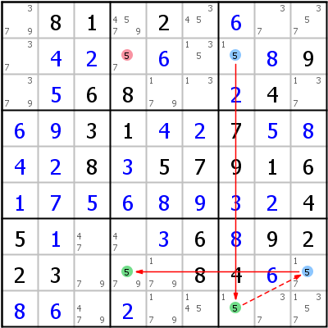
The chain in this example is 5(r2c7=r9c7-r8c9=r8c4). This is an alternating strong/weak link chain of length 3 (three links) starting an ending with a strong link. A 3 link chain was chosen for simplicity but the logic applies to any odd length chain.

Starting at with ccell 5r2c7, assert the premise that it is False. The strong link between 5r2c7 and 5r9c7, infers 5r9c7 True. The weak link between 5r9c7 and 5r8c9 infers 5r8c9 False. The strong link between 5r8c9 and 5r8c4 infers 5r8c4 True. Also walking the chain in the opposite direction starting with 5r8c4 as False will ultimately infer 5r2c7 True. Thus concluding neither 5r2c7 or 5r8c4 can be simultaneously False, one or the other has to be True.

But with this AIC if 5r2c7 is asserted True, then 5r8c4 is undefined and can be either True or False. For example, The premise that 5r2c7 is True, infers 5r9c7 False. Because 5r9c7 is weakly linked to 5r8c9 we cannot infer whether 5r8c9 is True or False which breaks the inferences for the rest of the chain.

One of the important conclusions to be drawn from AIC/Inferred links is that same value candidates that can see both ends of the AIC can be eliminated. This is because one or other or both candidates at the ends of the AIC is True, so none of the other candidate cells that sees the ends of the chain can be True. In this example 5 can be eliminated from r2c4 (r2c4-=5).

Another example from the same Hodoku page.
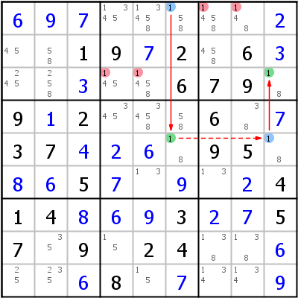
It is left as an exercise for the reader to work thought the AIC chain of this example. It is included to show the elimination of candidates when the ends of an inferred link are in the same chute. Here:
- Cell r1c6 sees all the cells b2, and r3c9 sees all the cells in r3. Therefore r1c6 and r3c9 see all the cells the intersection of box 2 and r3, being r3c456. It is interesting to note that r3c6 cannot contain a 1, if it did then the strong link between r1c6 and r5c6 would not exist. The 1 candidates in r3c46 can be eliminated (r3c46-=1).
- Cells r1c6 also sees all the cells in r1 and r3c9 sees all the cells in box in b3. Therefore, all 1 candidates in the cells in the intersection of b3 and r1 being r1c789 can be eliminated(r1c78-=1).

Both these examples are AICs that end with the same digit, in fact they are X-chains – a type of chain formed using only one candidate value. AICs can switch values (with strong or weak links) in cells) and have start and end points that are either the same or different values.

Bringing Ccells, Links and Chains together.
The following table summarises the inferences that are drawn based on their possible links. Note that the same also applies to the links being between two candidates in a cell. Note
Link / Chain | Candidate/Cells A & B. | (Premise)  If A is: | (Inference)  Then B is:
No Link | No link or chain of weak links. | True | ? (Either True or False)
No Link | No link or chain of weak links. | False | ? (Either True or False)
Strong Link | The only two candidates in a house/cell | True | False
Strong Link | The only two candidates in a house/cell | False | True
Weak Link | Two candidates in a house or cell. | True | False
Weak Link | Two candidates in a house or cell. | False | ? (Either True or False)
Strongly ended AIC Chain | Ends of an AIC chain starting and ending w/ strong links | True | ? (Either True or False)
Strongly ended AIC Chain | Ends of an AIC chain starting and ending w/ strong links | False | True
Weakly ended AIC Chain | Ends of an AIC chain starting and ending w/ weak links | True | False
Weakly ended AIC Chain | Ends of an AIC chain starting and ending w/ weak links | False | ? (Either True or False)
Even Length Strong Chain | Ends of even length chain of strong links. | True | True
Even Length Strong Chain | Ends of even length chain of strong links. | False | False
Odd Length Strong Chain | Ends of odd length chain of strong links. | True | False
Odd Length Strong Chain | Ends of odd length chain of strong links. | False | True

Notes:
- Much like a strong link can masquerade as a weak link, an odd length strongly linked chain can masquerade as a weakly linked chain. In fact when constructing an AIC or Weakly linked chain strong links can be substituted for (masquerade as) weak links, but not weak links for strong links.
- The only chain that is effective in advancing a sudoku solution in its own right is the Strongly Ended AIC. (The Odd Strong Chain is also a strongly ended AIC. The “If A is False then B is True of the Strongly Ended AIC is the only inference that results in progressing the solution. The “If A is True then B is False” inference is the same as a weak link. When cells “see” each other as discussed in Connected Ccells above., they are weakly linked. “Seeing” is equivalent to a Weak Link. Overlapping weak links (by seeing each other and from the chain) result in no inferences. However the overlapping of a “seeing” weak link with the link formed by the AIC linked chain results in inferences from which conclusions can be drawn. These are summarised below.
- Do not be too fast to discount the effectiveness of the other links. They can be used to:
  - Further propagate inferences.
    - Even strong chains propagate a Truth.
    - A weakly ended AIC permits two otherwise unconnected ccells to “see” each other.
  - A weakly ended AIC. can be substituted in other logic techniques for:
    - Any weak link
    - Where two cells are are required to see a Strong link – for example W-Wings.

The following conclusions can be made from AIC Chains connecting Ccells:

Table 1: AIC End Cell Characteristics, Outcomes and Logic
 | AIC End Ccell (strongly linked) Characteristics | Outcome | Logic
1 | - Same Value Candidates  - Different chutes | Eliminate candidates from opposing diagonal cells, (up to two eliminations). | Either the one end Ccell is True or the other is True, Both cannot be simultaneously True or False. Therefore any same value ccell that sees both ends must be False and can be eliminated.
2 | - Same Value Candidates  - Belong to same chute, but different houses | Eliminate the candidate from other cells in the line / box intersections along the chute that both ccells make (up to six eliminations). | Either the one end Ccell is True or the other is True, Both cannot be simultaneously True or False. Therefore any same value ccell that sees both ends must be False and can be eliminated.
3 | - Same Value Candidates  - Belong to same house | Eliminate the candidate from all other cells in the house (up to seven eliminations) | AIC strengthens an existing weak link in a house, forcing all the other same valued Ccells in that house to be False and therefore can be eliminated.
4 | - Different Value Candidates  - Belong to same house  - Both starting and ending candidate present in the other end cell. | Eliminate both the starting candidate value from the ending cell and the ending candidate from the starting cell. | Say chain links candidate A in cell X to candidate B in cell Y. From the Chain, If A is False in X, then B is True in Y forcing A False in Y. From the House, If A is True in X, A is False in Y. Because A is False in Y irrespective of the value of A in X, it can be eliminated. Similarly for B in X
5 | - Different Value Candidates  - Belong to same house  - Either starting or ending candidate present in other cell. | Eliminate whichever is present; either the starting candidate from the end cell, or the ending candidate from the starting cell. | Say chain links candidate A in cell X to candidate B in cell Y. From the Chain, If A is False in X, then B is True in Y forcing A False in Y. From the House, If A is True in X, A is False in Y. Because A is False in Y irrespective of the value of A in X, it can be eliminated. Similarly for B in X
6 | - Different Value Candidates  - Belong to same house  - Both starting or ending cells are identical bi-value cells. | Eliminate both the starting candidate value from the ending cell and the ending candidate from the starting cell. That leaves the starting and ending candidates as the sole candidates in their respective cells solving both those cells. | Say chain links candidate A in cell X to candidate B in cell Y. From the Chain, If A is False in X, then B is True in Y forcing A False in Y. From the House, If A is True in X, A is False in Y. Because A is False in Y irrespective of the value of A in X, it can be eliminated. Similarly for B in X
7 | - Different Value Candidates  - Belong to same cell | All other values can be eliminated from that cell. | The chain creates a strong link between the starting and ending candidates in the cell. As the two candidates are strongly linked, the cell can only be one of those two values and no other.

Grouped Links
By taking advantage of the Locked Singles property of line / box intersections, it it is possible to group ccells in these intersections as a grouped ccell. These grouped ccells in the line / box intersections behave much like regular ccells in the formation of links and chains.

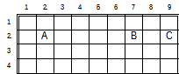
Consider same candidate value ccells A, B and C. Each ccell is weakly linked to the other two ccells, A-B, B-C and A-C. However because B and C are also housed in box 3, they can be grouped together and treated as a “Truth unit”. Now A and the grouping of B and C form a strong link. A=(BC). This linkage in isolation does not give us much, however when used in the formation of chains, may be able to give us a whole lot by creating validly linked chains, where links would have otherwise not existed.

Expressed in Cell Grammar, say for example the candidate value is 5:
- A is 5r2c2, B is 5r2c7 and C is 5r2c9
- The weak links are:
  - 5(r2c2-r2c7), 5(r2c2-r2c9) and 5(r2c7-r2c9)
- The strong grouped ccell link is:
  - 5(r2c2=r2c79). Note the two column values in the grouped ccell.

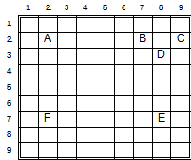
Extending the above example, in addition to A, B and C, consider additional same value ccells, D, E and F, where D and E are strongly linked, and both A and E “see” F. If A is strongly linked to E, then it is possible to eliminate ccell F. Only by grouping B and C, does it become possible to form the strong ended chain:
A=(BC)~D=E, or in cell grammar:
5(r2c2=r2c79~r3c8=r7c8), thus forcing the elimination of 5r7c2.
Note the use of “~” to denote a strong link masquerading as a weak link.

I have found that mastery of group links opens up the solution of many puzzle states with simpler chaining and looping techniques. I encourage its mastery with the mastery of chains and loops.

Properties of Group Links
- Group links are only formed as strong links:
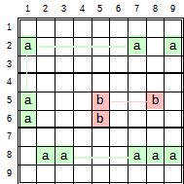
  - Along a line (row or column) where the only common candidates are bounded by two boxes.. For example:.
The green links are correct: a(r2c1=r2c79), a(r2c1=r56c1) and a(r8c23=r8c789). Incorrect link highlighted in red. No no inference can be drawn between ar5c8 and ar6c5. If ar5c8 is False, ar6c5 can be either true of False. Similarly if ar6c5 is True, are6c5 can be True or False.
  - Between the only common candidates in a box that form two lines or a cell and a line. The lines can be:
    - A cell and a line in the box, for example: b4, a(r5c123=r6c3)
    - Either two rows or columns in the box, for example: b5, a(r4c46=r6c56)
    - A row and column in box, for example: b1, a(r1c23=r23c1); b3, a(r1c79=r23c8); b4, a(r5c12=r56c3); b8, a(r789c4=r9c56) or a(r78c4=r9c456).
    - Observe that some patterns produce two sets of strong links.
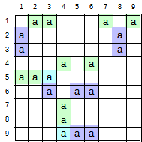

- Joining Grouped strong links in AI Chains. Best explained by following the construction of the following group linked AI Chain. Solid lines are strong links, dashed lines weak links.

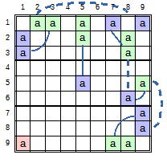
The Chain starts with the strong link a(r23c1=r1c23). This Strong link cannot connect to a(r12c5=r5c5) because: If both ar23c1 is False, then one of ar1c23 is True. Irrespective of which of ar1c23 is True, ar1c5 is False, but no inference can be drawn about ar2c5, it could be True or False. Therefore it is not possible to make an inference from ar1c23 that will cause both ar23c5 to be False, hence the chain cannot propagate along this path.

However if one of ar1c23 is True, then both ar1c79 are False, therefore one of strongly linked ar23c8 is True, making ar6c8 False, making ar5c9 True, making both ar78c9 False, making one of ar9c78 True. In this chain if all the candidates in blue cells are False, then of the cells in the green groupings are True. Therefore any cell grouping in the same house as the green group is False. The chain propagates in reverse from ar9c78 to ar23c1 where if all green cell groupings are False one of the cells in the blue groupings will be True. Therefore, because if both ar23c1 are False, one of ar9c78 is True, and if both ar9c78 are False, one of ar23c1 is True. Therefore this chain ensures a is True in column 1 and False in row 9 or True in row 9 and False in column 1. Therefore a will always be False in the intersection between column 1 and row 9 and can be eliminated if it exists.

There is another interesting condition in this chain pattern. Notice if one of ar23c8 is True, then ar6c8 is False, but also ar9c8 is False. And if ar6c8 False, the chain infers that one of ar23c8 is True. Therefore ar9c8 is False. That is ar9c8 can never be True and can be eliminated too. Similarly, following this colouring of alternating inference links, also results in the eliminations of ar1c5 and ar2c8. Colouring is not implement is YAS (at this stage) because any eliminations found by colouring can also be found by constructing chains. Colouring is achieved by making a net of alternating inferences, and assigning different colours to the odd and even links on the net.

http://forum.enjoysudoku.com/x-chain-optimalisation-t38330.html
Note can apply to AIC’s too. To be implemented.

Row-Column Subset (Fish) Logic
Row-Column Subset patterns isolate the intersections of single candidates over a subset of houses/groups. This differs from the Subset logic above where subset refers to the subset of candidates.

Fish are named according to their order, order defines the number of base sets and cover sets for that fish.
- 2 ==> X-Wing, 2 base sets of order two with 2 cover-sets.
- 3 ==> Swordfish, 3 base sets of order three with 3 cover-sets.
- 4 ==> Jellyfish, 4 base sets of order four with 4 cover sets.
The order of a base-set refers to the number of times the candidate appears in each base line(set).

Practically it is not necessary to look higher than 4 for, because for orders higher than four there is a reciprocal/complementary pattern of (9 – order) order pattern that can be found.

In principle, base-sets refer to the existence of a candidate occurring “n” times in “n” non- overlapping houses/groups. Each base-set is synonymous a house. Franken Fish refer to fish where one or more of the base-sets are blocks/boxes. All other fish have base-sets that are either rows or columns. Because the rows or columns are parallel it is impossible for them to overlap.

In a fish pattern of order “n”, there exist “n” cover-sets (houses) that intersect the n base-sets. Fraken Fish refer to fish where only one or more base-sets are boxes. Mutant Fish refer to fish where cover-sets as well as base-sets can be boxes. Franken and Mutant Fish patterns are difficult to recognise, and very often there are easier patterns to recognise that the Franken/Mutant fish for that step.

Fish where both the base sets and cover sets are lines are much easier to recognise and can be quite productive.

Basic Fish Patterns
Fish patterns rely on the fact that a candidate can only be True once in a house, be the house a base-set or cover-set. In recognising Fish patterns, base-sets are not allowed to overlap and must have between 2 and n occurrences of the candidate. Cover-sets also cannot overlap, and each cover set needs to intersect with the same value candidate in at least 2 of the base-sets. Any same-value candidates in the cover-set that is not intersecting the base-set can be eliminated.

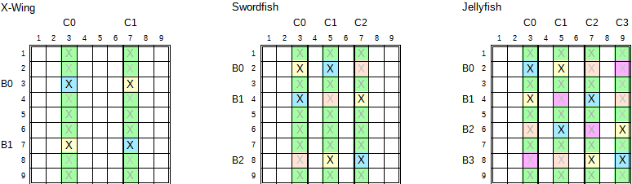
Consider the X-Wing example on the left. The first base-set B0 is row 2 with candidate X only occurring in r2c2 and r2c6. The second base-set B1 is row 6 with candidate X only occurring in r6c2 and r6c6. Cover-set C0 col2 intersects r2c2 and r6c2 and cover-C1 intersects r2c6 and r6c6.
In B0, either Xr2c2 or Xr2c6 can be True. Therefore if Xr2c2 is True, then Xr6c6 is True, and if Xr2c6 is True then Xr6c2 is True.

This logic condition describes the X from which the name X-Wing originates. That is either the two yellow X’s are True or the two blue X’s are True. A blue and a yellow X cannot be simultaneously True because they both exist in the same base-set and X can only be true once in a base set. Looking at the cover-sets (green lines), each which contain a yellow X and a blue X. We know that either the blue X or the yellow X will be True. Therefore any other candidate X along the cover-set (green lines) that does not belong to a base-set, cannot be True, and therefore can be eliminated.

The X-Wing Truth is that only either the blue X’s or the yellow X’s are True. Therefore any other X candidate ccell that can see (i.e. in this case, in the same house/group as) both a blue and a yellow X cannot be True and can be eliminated. As there are no other X’s along the base-sets (by definition of the pattern), the only possible eliminations occur along the cover sets. (The cover sets are the only other houses that contain an X of each colour)

Consider the Swordfish pattern with candidate X in the centre puzzle in the above figure. The base sets (lines) have been identified as Rows 1, 3 and 7. Each row can have between two and three occurrences of candidate X, The Swordfish pattern is recognised by the corresponding 3 column cover-sets each intersecting 2 to 3 base-sets on candidate X. (the blue and yellow X’s). This image shows a “minimal” Swordfish where each base-set has only two instances of candidate, and each cover set only intersects 2 base-sets. The light X white cells can also contain candidates optionally without influencing the outcome of this pattern. What is important is that the union of intersections over the three bases must equal 3.

In the Swordfish pattern only one of the (yellow, blue or orage)X’s can be True in any base-set, and in any cover-set. The yellow, blue and white X cells are the only cells where X can/may be True. As X can only occur once in each of the cover sets, and only has the possibility of occurring in a blue, yellow or white cell, all other occurrences of X along the green lines that is not part of a base-set can be eliminated.

The Swordfish Truth is that either the yellow, blue or Orange X’s are True. Therefore any other X candidate ccell that can see (same house as) one of each colour X cannot be True and can be eliminated. By definition of this this Pattern, there is no possibility of this happening along the base sets. The only other so the only possible eliminations can only occur along the cover-sets.

Consider the Jellyfish pattern with Candidate X in the right puzzle in the above figure. Rows 1, 3, 5 and 7 are base sets with between two and 4 occurrences of Candidate X. The Jellyfish pattern is recognised by the corresponding four column cover sets, each intersecting between 2 and 4 base-sets on the X candidate. The image shows a minimal Jellyfish with dark X’s in blue and yellow cells; where there are two candidates in each base set and two cover-set intersections (the yellow and blue cells). The presence of The light X candidates in the orange and magenta cells does not influence the outcome of this pattern. What is important to the Jellyfish pattern is that the union of intersecting Candidates in all base-sets must equal 4.

In this Jellyfish pattern, X can only occur once in each base (one of the blue, yellow, Orange or Magenta cells). As X can also only occur once in each cover set, and it is constrained to one of the blue, yellow, white of pink cells, any other occurrence of X along the cover-sets (green cells) can be eliminated.

The Jellyfish Truth is that either the yellow, blue, orange or magenta X’s are True. Therfore any other X candidate ccell that can see (in the same house as) one of each colour X cannot be True and can be eliminated. By definition there is no possibility of this happening along the base-sets, so the only possible eliminations can occur along the cover-sets.

Algorithmic rules for Basic Fish:
- Fish order (n): 2 – X-Wing, 3 – Swordfish, 4 – Jellyfish.
- (n) base-sets and (n) cover- set
- 2 to (n) candidates per base-set
- 2 to (n) candidates per cover-set
- (n) items in Union of all bases.
- All same value candidates in cover-sets that are not part of base-sets can be eliminated.

Finned Fish Patterns
Many times, fish patterns are almost formed, save for one of the base-sets having extra candidates. Those extra candidates along the base-set are known as Fins. Here, if certain conditions are met, eliminations are still possible.

The figure below modifies the above figure to include an additional fin or two for this explanation.

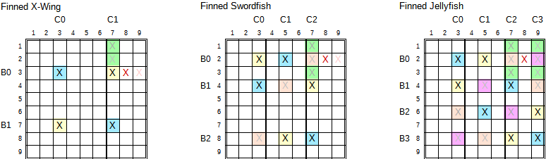

Finned X-Wing
Considering the Finned X-Wing on the left, A fin is added to the previous X-Wing in Base B0, Xr2c8. The fin can either be True or False. If the fin is False, then the original X-Wing as previously explained is True. That is, either the blue X’s or the yellow X’s are True. If the Fin is True, then any other Candidate that sees (that is, in it’s row, column or box/block house/group) the Fin cannot be be True. In this pattern, the Fin’s row house is also the X-Wing’s B0. If the Fin is True, neither the blue X and yellow X in B0 can be True negating the X-Chain’s Truth. Any Cover that can see all of a blue X, a yellow X and the Fin, can be eliminated, because we have shown that one of them must be True.

Another way of saying this is: Any Candidate that lies in the intersection of the Fish’s Truth set and the Fin’s Truth Set can be eliminated. The Fish’s Truth Set are the cover-set cells that are not part of the base-sets. And the Fin’s Truth Set are the other cells in the row, column and box/block in which that Fin resides. In the above X-Wing pattern, these are the light green cells r12c7. This assertion can be further narrowed to. Any candidate in the intersection of the Fish’s cover-set and Box of the Fin that is not part of the Finned Fish pattern can be eliminated.

A Finned Fish pattern can have multiple Fins. The Fins need be grouped such that they are present in the same X-Wing Base-Set in the same Box/Group as the Fin. Thus, if one of the Fins are True, the X-Wing Truth is negated, and if both Fins are False, the X-Wing Truth prevails. Both Fins cannot be simultaneously True because they are in the same house. It is clear to see there can only be 1 or 2 fins in Finned Fish.

Finned Swordfish
Considering the Finned Swordfish in the centre of the Figure, The intersection of the Red Fin’s Truth set with the Swordfish’s Truth set is r13c7. Any X candidate in these two cells r13c7 can be eliminated.

Finned Jellyfish
Considering the Finned Jellyfish on the left of the figure. The intersection of the Red Fin’s Truth set with the Jellyfish’s Truth set yields the four cells r13c79

Algorithmic rules for Finned Fish
- Fish order (n): 2 – X-Wing, 3 – Swordfish, 4 – Jellyfish.
- (n) base-sets and (n) cover- set
- 2 to (n) candidates in (n) – 1 base-sets,
- 2 to (n)+2 candidates in 1 base-set containing fins
- 2 to (n) candidates per cover-set (Fins confined to one base set).
- Fins do not have cover-sets (this is part of the definition of a fin).
- (n)+1 to (n)+2 items in Union of all bases, n for cover sets, 1 to 2 for fins.
- Fins are in the same box/block
- Any cover-set candidate that is not part of the base-set that can see all the fins can be eliminated.

Sashimi Fish Patterns
As with Finned Fish, many times Fish patterns are almost formed, save for one missing candidate. These patterns are also known as Degenerate Fish. If certain requirements are met, eliminations are possible. The general form of a Sashimi fish is (n) base-sets, (n)-1 cover-sets and 2 or 3 fins. A Sashimi pattern ensures that only one of the Fins can be True. Therefore any ccell that can see all fins, can be eliminated.

Sashimi X-Wing
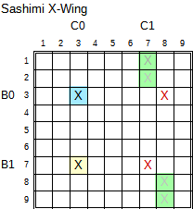
Consider the Sashimi X-Wing image on the right. There are two base-sets of two candidates each, B0, and B1, but only 1 cover-set of two candidates C0. As an aside this pattern is also recognised as a Skycraper. As the Red X’s are their only cover, like Fins, they are treated as fins (even though they are not confined to a single base-set.

If Fin Xr3c8 is True, Xr3c3 is False, Xr7c3 is True making Xr7c7. False. Similarly if Xr7c7 is True, Xr3c8 is False. One one Fin can be True, never both or none. If either fin is True, the candidate ccells that see both Fins can be eliminated. If X is present can be eliminated from the green cells. The two fins need to be at least confined to a single chute for eliminations to be made, the third Tower in this case. If the bases were in the same floor chute, then eliminations can be made from all other cells in the box/block containing the fins (floor – tower chute intersection) that are not in the base-sets with up to 3 fins across the 2 base-sets . If the Fins were in different chutes then only the ccell that sees both fins lies on a base-set row with no X candidate in that location.

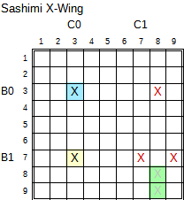
Consider the Sashimi X-Wing on the right. It is the same as the above Sashimi X-Wing, except for an additional Fin in B1, Xr7c9. In this case, the only ccells that can see all 3 fins are confined to the two green cells. If X is present in either of those two cells (that is the ccells exist), they can be eliminated.

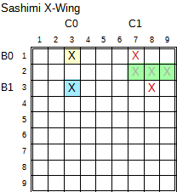
Consider the Sashimi X-Wing on the right. Not only are the 2 (or 3) fins confined to a cover chute, they are also confined to a base street. That is the fins are confined to a block/box. Applying the rule that ccells that are not part of the base-set that see all the fins can be eliminated, results in up to three ccells in the row in the base chute that is not a base set.

Sashimi Swordfish
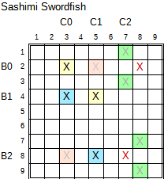
Considering the Sashimi Swordfish on the right. 3 Base-sets of between 2 and 3 candidates exist, B0, B1, B2, and only two cover-sets exist with two or more candidates, C0 and C1. There are fins in at least 2 base-sets (B0 and B2). Fins are bound to a cover chute (Third tower in this case). The two fins are Xr2c8 and Xr8c7.

Following the logic of this Sashimi Swordfish, if the fin Xr2c8 is True, then the other Candidates in B0 are False. Either the blue or yellow cell in B1 can be True. If B1 Blue is True, then B2 Blue is True making the other Fin Xr8c7 False. If B1 yellow is True, then if B2 orange existed it would be True, again making the Fin Xr8c7 False. Because it does not exist. This specific pattern also resolves B1 Blue and B2 Blue as True, which again keeps Xr8c7 False. If Xr8c7 is True, B2 Blue is False, Making B1 yellow True, B1 blue False, which forces B0 yellow True, making the Fin Xr8c7 False.

Thus we have determined that any ccell that is not part of the base-set that can see all the fins can be eliminated. The two identified fins are confined to a Cover chute (third tower). The only ccells that fit this criteria are shaded green.
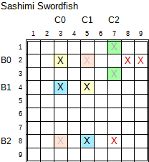
The Sashimi Swordfish image on the right is the same as above except for the additional fin in B0, Xr2c9. Here The Fins are confined to only two boxes in the cover chute. The only ccells that can see all Fins are highlighted green. If X is present in any of the green cells, the X can be eliminated.

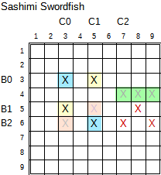
If the two or three fins are confined to a base chute (floors in this case), as shown on the right, all the ccells that are not part of a base-set that see all the fins can be eliminated. As the Fins are confined to a box in two of the bases, any ccell in the other non base line can be eliminated, as shown by the green cells.

Sashimi Jellyfish
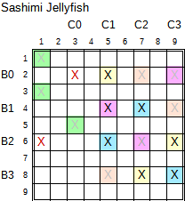
Considering the Sashimi Jellyfish in the above right figure. The 4 base sets of between 2 and candidates are B0, B1, B2 and B3 and the 3 covers are C1, C2, C3, and fins Xr2c3 and Xr6c1. If Fin Xr2c3 is True, then the other candidates in the Base-set B0 are False. The resulting (n)-1 (Swordfish) pattern in B1, B2 B3/C1, C2,C3 will ensure that Fin Xr6c1 is False. Similarly, if Fin Xr6c1 is True, the remaining candidates in B2 are False. The resulting (n)-1 (Swordfish) pattern in B0, B1, B3, C1,C2,C3, ensures that Fin Xr2c3 is False.

Thus we we have determined that either the Swordfish in Xr579c468 is valid or one of the Red Fins are True. Therefore any ccell that is not in a base-set that can see all the fins can be eliminated (as identified by the green shaded cells.

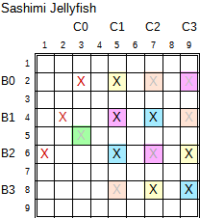
The Sashimi Jellyfish on the right is exactly the same as above, except it has an additional Fin in B1, Xr4c2. Here the Fins are confined to only two boxes in the cover chute. The only ccells that can see all Fins are highlighted green. If X is present in any of the green cells, the X can be eliminated.

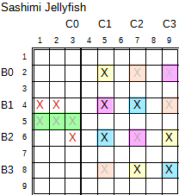
If the two or three fins are confined to a base chute (floors in this case), as shown on the right, all the ccells that are not part of a base-set that see all the fins can be eliminated. As the Fins are confined to a box in two of the bases, any ccell in the other non base line can be eliminated, as shown by the green cells.

Algorithmic rules for Sashimi Fish
- Fish order (n): 2 – X-Wing, 3 – Swordfish, 4 – Jellyfish.
- (n) base-sets and (n)-1 cover- set
- 2 to (n)+2 candidates in base-sets
- 2 to (n) candidates per cover-set
- Fins do not have cover-sets
- Between 2 and 3 fins.
- Fins are confined to a cover chute, and only one or two base chutes, never three base chutes
- (n)+1 to (n)+2 items in Union of all bases, (n)-1 for cover sets, 2 to 3 for fins.
- Any Candidate that is not part of base-set that can see all fins can be eliminated.

Kraken Fish Patterns
Recall from Weakly Ended AIC's above, a Weakly Ended AIC (WE-AIC) mimics all the characteristics of a Weak Link (two ccells seeing each other). Kraken is the application of this principle to Fish patterns for the further find covers that can see all fins. ly or with a WE-AIC. As Kraken finned fish patterns rely on more than just covers directly seeing all fins, the following restrictions are relaxed.
- Fins can occur in any base-set
- Fins are not confined to a cover chute.
- Kraken Finned Fish can have up to 9 – (n) fins and (9 – (n))*(n) possible eliminations Kraken Sashimi Fish can have up to 10 – (n) fins and 9 * (9 - (n)) possible eliminations

Algorithmic rules for Kraken Finned Fish
- Fish order (n): 2 – X-Wing, 3 – Swordfish, 4 – Jellyfish.
- (n) base-sets and (n) cover- set
- Up to 9 candidates per base set, 2 to (n) for base candidates, 9 – (n) for fins
- 2 to (n) candidates per cover-set
- Up to (9 – (n)) Fins
- Fins do not have cover-sets
- Up to 9 items in Union of all bases, (n) for cover-sets, up to (9-(n)) for or fins.
- No restrictions to the location of Fins in base-sets.
- Any cover-set candidate that is not part of the base-set that can see all the fins can be eliminated.

Algorithmic rules for Kraken Sashimi Fish
- Fish order (n): 2 – X-Wing, 3 – Swordfish, 4 – Jellyfish.
- (n) base-sets and (n)-1 cover- set
- Up to 9 candidates per base set, 1 to ((n) – 1) for base candidates 10 – (n) for fins.
- 2 to (n) candidates per cover-set
- Up to (10 – (n)) Fins
- Fins do not have cover-sets
- Up to 9 items in Union of all bases, (n) – 1 for cover-sets, 10 – (n) for fins.
- No restrictions to location of Fins in base-sets.
- Any Candidate that is not part of base-set that can see all fins can be eliminated.

Kraken Fish Practical issues
- Relaxing the number of fins in base-sets and in the number of base-sets greatly increasing the number of possible base patterns that can be found for scanning for cover to fin connections.
- The number of chains to scan for each possible base pattern is the product of fins x covers for each pattern.greatly increases the probability of patterns
- Chain Length Processing Time below estimates an average of 10^(n/2) iteration steps to build a chain of length n. A practical chain length to search before bottoming out is 10 – 14 nodes. Shorter than that it appears many opportunities to find and resolve patterns are missed, and there is a diminishing return for longer chain lengths. YMMV. An iteration step is in the order of a few micro seconds on my PC, say 4uSecs in Python.

Searching for kraken fish patterns is hugely expensive, and is done twice, first time in the search for regular scalar chains, and again for chains with group links. As Kraken Fish are considered rather exotic and because of the time taken to resolve, Kraken Fish are at the end of the list for patterns to search.

Therefore with Kraken fish, we search for the first found cover that can see all fins, rather than exhaustively searching for all covers that can see all fins.

Hidden Logic
This is developed from Denis Berthier’s Hidden Logic of Sudoku. In YAS, this still requires some investigation and implementation to assess it’s effectiveness.

Sudoku board (solved puzzle) can be defined as a unique ordering of 81 ccell (value, row, column) tuples out of the exhaustive set of 729 ccell tuples – where value row, column can assume any value between 1 and 9, and Sudoku rules apply. Sudoku boards and puzzles are spatially represented as values on a 9x9 row column grid. However this is not the only possible spacial representation of any Sudoku board or puzzle. The row/column grid can be transformed to a box/cell grid with say box numbers on the vertical axis and cell numbers on the horizontal axis of the grid. The same puzzle can be represented on the following spacial planes:
- values on a row/column grid (Which is what is conventionally used)
- row numbers on a value/column grid
- column numbers on a value/row grid
- values on a cell/box grid
- box number on a value/cell grid
- cell number on a value/box grid

Note: Worth repeating – these are simply different representations of the same puzzle board. There is nothing mathematically or logically different about a puzzle in any of these spatial representations. The spatial representations simply view the puzzle from different perspectives.

Each of these perspectives in the most literal sense, expose patterns that are hidden in other perspectives. For example, a single or subset patten that is is hidden in a row in the value, row/column perspective is exposed (can be seen as an equivalent exposed pattern) when viewed from the row, value/column perspective. Similarly any single or subset patterns hidden in a column is exposed when viewed from the column, value/row perspective.

The true power of this realisation is not really in resolving hidden singles and subsets as exposed ones from other perspectives, as the effort of transforming the perspectives exceeds that of resolving those hidden patterns. However, viewing puzzles from different perspectives, come into their own with more complex patterns such as chains/loops/nets, bent exposed subsets, etc., where it is near impossible to visualise what their equivalent hidden equivalents could be in the value, row/column perspective.

More work to be done here.

Unique Logic

Almost Locked Sets (ALS) and Subset Exclusion Logic
https://www.sudokuwiki.org/Almost_Locked_Sets
http://hodoku.sourceforge.net/en/tech_als.php

http://gamesudoku.blogspot.com/2007/02/advanced-aligned-pair-exclusion.html
https://www.sudokuwiki.org/Aligned_Pair_Exclusion
https://sudoku.ironmonger.com/howto/alignedPairExclusion/docs.tpl?setreferrertoself=true
https://sysudoku.com/guide/sysudoku-advanced/the-bv-scan/aligned-pair-exclusion-ape/

Miscellaneous Logic

# Sue de Coq.
# Exocet
# Double Exocet
# Bowman's bingo
# SK loops

Base Sets and Cover Sets Logic
This section is largely my understanding of Allan Barker’s explanation: http://Sudoku.allanbarker.com/sweb/general.htm

In my self-study of Sudoku, I found it useful to first understand the basics of singles, subsets, fish and chains before coming back to this general logic which pulls together and develops a common understanding of the logic used in the various techniques. Your mileage may vary.

Constraints / Truths
Sudoku is defined as a group of 9 rows, columns and boxes, making up 81 cells, where each cell contains a single value between 1 and 9 such that that value only ever occurs once in each row, column and box. This is often referred to as the 324 native constraints or truths of Sudoku.
- In the grid of 81 cells the 9 values can only occur 9 times. Each of the 81 cells can only contain a single value between 1 and nine: 9 values occurring 9 times = 81 or 81 single values making 81 constraints.
- Each of the nine rows of 9 cells must contain a single unique value. That is there are 9 constraints or truths for each row : 9x9 = 81 constraints.
- Each of the nine columns of 9 cells must contain a single unique value. That is there are 9 constraints or truths for each column 9x9 = 81 constraints
- Each of the nine boxes of 9 cells must contain a single unique value. That is there are 9 constraints for each box: 9x9 = 81 constraints.

A constraint/truth is defined as: any set of candidates in a row, col, box or cell where one candidate must be part of the solution.
The term “True Candidate” is an indirect reference to where the candidate will be true. That is: A truth identifies the locations where a True Candidate can be found – The true candidate will be in one of those locations.

This is further explained in the below example.

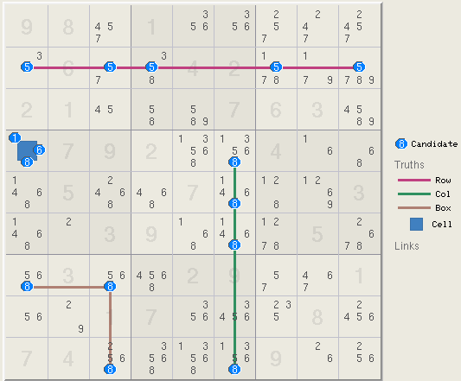
- In row 2 of the image above, candidate 5 can only be placed once. The truth is that 5 belongs to only one of the 5 cells of which it is a candidate (5#5r2c13479). Similarly, as other examples in row 2, 3 belongs to one of the two cells of which it is a candidate (3#2r2c14), and 8 belongs to one of the three cells of which it is a candidate(8#3r2c479).
- In column 6, candidate 8 can only be placed once in one of 4 cells demarcated by the green line (8#4569c6).
- In box 7, candidate 8 can only be placed once in one of 3 cells demarcated by the brown line (8#3b7,r7c1,r7c3,r9c3).
- In cell r1c4, only a 1, 6 or 8 can be placed. Different to row, columns and boxes, the cell location is unique, not the candidate value. Nevertheless, the Truth is that cell r1c4 can only be one of 1, 6, or 8 (168==r1c4)

The number of candidates in a truth defines the order of the truth. A pair for 2 candidates, a triple (trip) for 3, a quad for 4, a quint for 5 and so on. Often it is not necessary to look beyond order 4. As for every situation of order n larger than four, there is an alternate situation of order 9 – n. The reason for using the word often is that perhaps for some situations it is easier to spot and resolve the higher order situation.

Eliminations
Keep in mind that the whole purpose of developing this logic is for the elimination of candidates to the point of being able to identify exposed or hidden singles in houses so that values can be assigned to cells.

From Constraints / Truths above, there is only one true candidate in a Truth (link or set). It therefore follows that there needs to be “n” non intersecting/overlapping sets to be able to solve for “n” unknown True candidates. These sets are referred to as base sets, and in fact each base-set can contain between 2 and “n” candidates, much like the arrangement of unknowns in simultaneous equations. As in simultaneous equation, the the “n” unknowns (True Candidates in Base-Sets) are related by “n” equations (The intersections of True Candidates by Cover Sets).

The non-intersecting/Overlapping restriction of Base-Sets pretty much limit them to being a House (row, column box) or bi-value cell). Cover-Sets are also Truths, but a Cover-Set do not have the overlapping/intersecting restriction permitting them to be a variety of structures (including houses, cells with more than 2 values and chains) and overlapping/intersection combinations there of, so long as the Truth is maintained across the resulting Cover-Set.

Single order intersections are a single truth in a single house with a single cover intersection. Examples are hidden and exposed singles where there is only one candidate in a cell, or one candidate in house where there can only be one intersection.

Other single order examples are locked singles, where a single truth is either:
- Confined to a row or column and can be fully covered by a box, resulting in the rest of the candidates (i.e., not part of the base-set) in the box being eliminated.
- Confined to a box that can be fully covered by a column or row, resulting the the rest of the candidates (i.e., not part of the base-set) in the row or column being eliminated.

For orders greater than 1, eliminations can be made when “n” Base-Sets are intersected by “n” Cover-Sets covering all of the (between 2 and “n”) occurrences of the Candidates in all the Base-Sets, and two or more intersections occur in each Cover Set. Candidate that can be eliminated are those in the cover-sets that are not part of the base-sets (i.e., do not form part of the intersections. A review of how fish are solved may reinforce this understanding

An X-Wing is an example of two base-sets of order 2 (candidate possible in two locations), being linked by 2 cover-sets. And so on.

To me, it looks like a base set of order 2 is the same as a strong link used in chains. Base sets of higher orders and cover-sets are weak links. Similarly to weak and strong links, a base set can substitute for a cover set, but a cover set cannot substitute for a base set.

The Concept of Rank
Rank is defined as: # cover-sets - # base-sets.

Rank 0 Logic
When the number of cover-sets is equal to the number of non overlapping base-sets, then each cover-set will have a True Candidate (solved candidate value) at one of its intersections with the base-sets.

Rank 0 Rule: Any non-base-set candidates in cover-sets can be eliminated.

This is a general rule that is not restricted to single digits, and can be applied to any number, type or combination of base-sets (bases/sets), cover-sets (links), candidates and digits so long as base sets do not overlap.

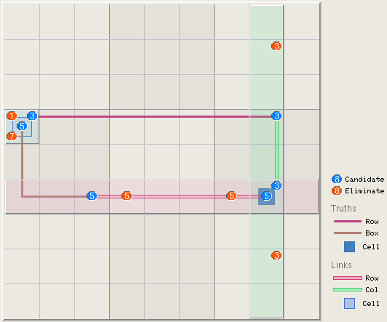
In the above example there are three truths, i.e. base-sets.
- 3#2r4c18, describing the 2 instances of candidate 3 in row 4.
- 5#2b4,r3c1,r6c3, describing the 2 instances of candidate 5 in box 4.
- 35r6c8, describing that r6c8 is constrained to either a 3 or 5.

The links ie cover-sets are:
- 3c8: Candidate 3 in column 8
- 5r6: Candidate 5 in row 6
- 35r4c1: The presence of 3 and 5 in cell r4c1.

As there are the same number of base and cover-sets, the joining candidates in the cover-sets that are not part of the base-sets can be eliminated.
- The 5’s in row 6 that are not part of the box and cell base-sets, ie r6c47-=5.
- The 3’s in column 8 that are not part of row and cell base-sets, ie r28c8-=3.
- The non linking values in cell r4c1, that are not part of the box and row base-sets, ie r4c1-=17.

Rank 0 logic is most common and includes singles, subsets, basic fish, and the like.

Rank 1 Logic
Rank 1 logic has one more cover-set than non-overlapping base-sets. That is N bases (collectively containing N True candidates or truths) are distributed among N+1 links. IOW, N non-overlapping base-sets are covered (intersected or overlapped) by N+1 cover-sets. Here, any combination of two cover-sets will contain at least one True Candidate (Truth) from the intersection with the base-set(s). Therefore, the intersection of any two cover-sets will be “True” because of this base-set truth. And therefore, all other non-base-set candidates in the intersection can be eliminated.

Rank 1 Rule: Any non-base-set candidates in the intersection with two cover-sets can be eliminated.

Like the Rank 0 Rule, the Rank 1 rule is a general rule that can be applied to any number, type or combination of base-sets (bases/sets), cover-sets (links), candidates and digits so long as base sets do not overlap.

Rank 1 logic is also common and includes chains, finned fish, Y Wings, discontinuous loops,

Below is a two string kite example with value 4.
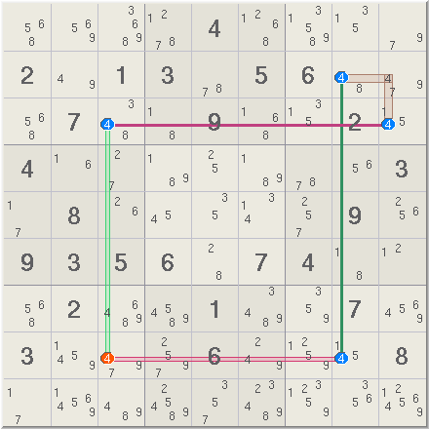
The two base-sets are 4#2r3c39, and 4#2r28c8. The three cover-sets are 4b3, 4r8 and 4c3. The 4 in r8c3 is seen by the overlap of the cover-sets 4r8, and 4c3, and can be eliminated. However the 4 in r2c9 cannot be eliminated as is part of the box b3 cover-set only and not the intersection of two cover-sets.

Another example, this time a finned swordfish, taken from Hodoku below.

Here, with candidate 7 three base-sets are found in columns: 7(#2c1r37,#2c5r57,#3c9r135). Three cover-sets can be made in rows: 7--r3, 7--r5 and 7--r7 But these cover-sets leave ccell 7r1c9 exposed. (Expressed as a finned fish: 7(c159r357,r1c9).

All base candidates can be covered by placing a box cover 7b3 Hence we have Rank 1 condition with 3 base sets and 4 cover sets. Additionally the covers 7b31 and 7r3 intersect each other along r3c789. Applying the Rank 1 rule, Any candidate in r3c789 that is not r3c9 can be eliminated. There is a 7 in r3c7 which is eliminated (r3c7-=7).

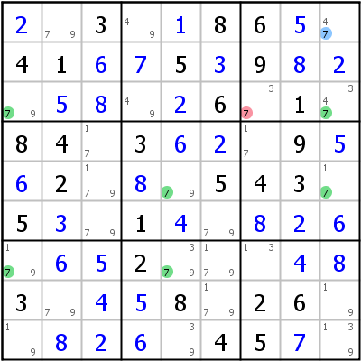

Rank R Logic
Rank R logic is the generalisation of rank 1 logic. In Rank R logic, R more covers are required to intersect all the candidates in N bases, that is N bases (collectively containing N true candidates or truths) are distributed among N+R links. IOW, N base sets are covered (intersected or overlapped) by N+R cover sets. Here any combination of R+1 cover sets will contain at least least one True Candidate (Truth) from the intersection with base-set(s). Therefore the intersection of any R+1 cover sets will be true because of the base-set truth. Therefore all other not base-set candidates in the intersection can be eliminated.

Rank R Rule: Any non base-set candidates in the intersection of R+1 cover-sets, can be eliminated.

Again like the Rank 0 and Rank 1 rules, the Rank R rule is a general rule that can be applied to any number, type or combination of base-sets (bases/sets), cover-sets (links), candidates and digits so long as base sets do not overlap. Rank rules apply beyond Sudoku, to any geometry and spacial dimension. Sudoku is limited to 3 spacial dimensions (row--> x axis, col --> y axis, box --> x and y axes, and cell value --> z axis), and four overlapping sets (rows, columns, boxes and cells).

Ranks 0 and 1 cover many Sudoku methods. Ranks higher than 3 are typically found in more complex eliminations – when combined with Triplets as discussed below.

Following is an example of a Rank 3 step that mixes rows, columns, boxes and cells in both base and cover sets:

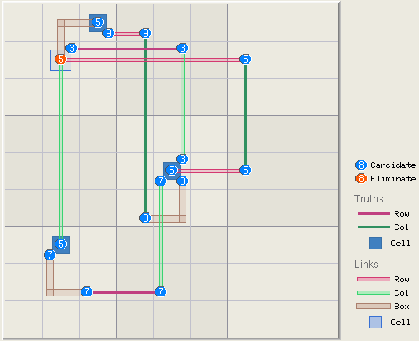
In this Rank 3 example, there are 7 base-sets covered by 10 cover sets. Thus 4 cover links need to intersect a non-base-set candidate to eliminate it.

The base sets are:
- 3579==r5c5
- 59==r1c3
- 57==r7c2
- 3#2r2c25
- 9#2c4r16
- 5#2c7r25
- 7#2r8c35

The cover sets are:
- 5b1,r1c3,r2c2
- 9-r2c34
- 34-r2c2
- 5r2c27
- 5r27c2
- 3r25c5
- 5r5c57
- 9b5,r5c5,r6c4
- 7r58c5
- 7b7r7c2r8c3

Note that the ends of each base-set is intersected by cover-sets. That is each base set has been intersected by a cover-set at it’s nodes.
For me, listing the base and cover sets on its own does not provide any clarity and point to any kind of a solution, so I set about to explore practical scenarios of how a solution could have evolved.

Perhaps it started by looking for bi-value cells to explore how they were related. In doing that maybe cells 59==r1c3, 53r2c253, 57==r7c257 were identified, and then perhaps cell r5c5 was noticed containing all the identified candidates 3579==r5c5. In this example, it is not clear that 35r2c2 may have contained more candidates; if this was so, then it probably would have made this initial pattern more difficult to spot, but does not alter the logic of the solution.

Other relationship connections were most probably explored before (perhaps randomly) coming to the relationship between 5r2c2 and 5r5c5.

[Aside: Keep in mind chains can be constructed in different ways because every strong link can also be a weak link, and every weak link can only be a weak link. When I am constructing chains I use a “~” to show a link that could be either weak or strong, and once the chain is made set about choosing which “~” makes sense to be an “-” and which a “=”. Often multiple variations are tried before settling on the chain for the solution In this example there is not enough candidate information to know which weak links where chosen from links that could have been strong.]

- 5r5c5~5r5c7=5r2c5~5r2c2
- 5r5c5-3r5c5~3r2c5=3r2c2~5r2c2
- 5r5c5-7r5c5~7r8c5=7r8c3~7r7c2=5r7c2~5r2c2
- 5r5c5-9r5c5~9r6c4=9r1c4~9r1c3=5r1c3~5r2c2

Is it a coincidence that four bi-value paths converging on 5r2c2 all originate from 5r5c5? Does that mean that 5r2c2 can also be eliminated as it has 4 bi-value paths converging on it, too?

Note:
- These four paths cover all the candidates in all the base-sets.
- Strong links outside of the base-sets are treated as weak links as they are not part of the base-sets.

Triplets and Rank Regions
Will come back to the following complexities later.
http://Sudoku.allanbarker.com/sweb/general.htm

Guardian Candidates

Summarizing Robert Hanson’s Work.
https://www.stolaf.edu/people/hansonr/sudoku/
https://www.stolaf.edu/people/hansonr/sudoku/12rules.htm

[In his 12 rules, attempt to translate his notation to “cell grammar”.]

I think this work is an articulation of Rank 1 logic where n+1 covers (intersections) are required when there are n-1 truths in n bases. More of my thinking needs to go into this.

I thought about posting this in the "mathematics of sudoku" forum, but really what it is is
a statement of the common (and maybe not so common) rules for solving Sudoku, both in plain
English and in logical notation. If you are just interested in solving Sudoku, ignore the
funny notation; if you are interested in the mathematics, enjoy the symmetry.

I suggest that the following set of rules may constitute the entire set of
"standard" methods (not including simple chain-based logic) used to solve Sudoku puzzles.

Included here are:

1. naked singles
2. hidden singles
3,4. locked candidates
5. naked tuples
6. hidden tuples
7. grid analysis (X-wings, Swordfish, etc.)
8-11. generalized rules for larger than standard Sudoku
12. uniqueness (added 12/4/05)

Not included here are:

chain-based logic (coloring, x-cycles, y-cycles, 3D medusa)
trial and error (hypothesis and proof, bifurcation)

I offer here a simple picture of all basic methods. The picture is one of
INTERSECTING sets. The principle behind all these methods is simply that if
a candidate is located only in the intersection area of one of two overlapping
sets, then it is solely in the intersection area of the other set as well.

The statement is this:

If a candidate k is possible in area A^B (A intersect B)
and not elsewhere in A, then k can be eliminated from
any other position in B as well.

---------------
| A |
| |
| |
| ---------------
| | k | |
| | A^B | k |
| | k| k |
--------------- |
| k |
| k |
| k B |
---------------

implies

---------------
| A |
| |
| |
| ---------------
| | k | |
| | A^B | |
| | k| |
--------------- |
| |
| |
| B |
---------------

Methods involving more than one candidate simply
require more than one A and/or more than one B.

Code:

method A B candidate

singles row col k
col row k
block cell k

locked block row k
candidates block col k

tuples row (col)n (k)n
col (row)n (k)n
block (cell)n (k)n

X-wing (row)2 (col)2 k
swordfish (row)3 (col)3 k
n-grid (row)n (col)n k

--------- 4x4 Sudoku or larger ---------

n-locked (block)n (row)n k
candidates (block)n (col)n k

something (block)n (row)n (k)n
new (block)n (col)n (k)n

OK, here are the rules. Ignore the math if you just want to read the rule.

Key:

r a row
c a column
b a block
k a candidate
X_n a set of n of one of the above (X being r, c, b, or k)
!X not that row, column, block, or candidate
() is possible
!() is not possible
^/v and/or

Thus, for example:

r ^ c an intersection of a row and a column (i.e., a cell)
r ^ !c the other cells in that row
b ^ (r ^ c) a certain cell in a given block
b ^ !(r ^ c) the other cells in that block
(r ^ c ^ k) a candidate k is possible in a certain cell
(r ^ c ^ !k) candidates other than k are possible in a certain cell
!(r ^ c ^ !k) candidates other than k are not possible in a certain cell

Here we go:

1. naked singles:

1r. (r ^ c ^ k) ^ !(r ^ c ^ !k) --> !(r ^ !c ^ k)
1c. (r ^ c ^ k) ^ !(r ^ c ^ !k) --> !(!r ^ c ^ k)
1b. (b ^ (r ^ c) ^ k) ^ !(b ^ (r ^ c) ^ !k) --> !(b ^ !(r ^ c) ^ k)

(1r) says, "If a candidate k is possible in a certain intersection of
row and column (i.e., a cell), and no other candidates are possible
in that cell, then k is not possible elsewhere in that row."

(1c) says the same for "that column." (1b) says the same for "that block."

2. hidden singles:

2r. (r ^ c ^ k) ^ !(r ^ !c ^ k) --> !(r ^ c ^ !k)
2c. (r ^ c ^ k) ^ !(!r ^ c ^ k) --> !(r ^ c ^ !k)
2b. (b ^ (r ^ c) ^ k) ^ !(b ^ !(r ^ c) ^ k) --> !(b ^ (r ^ c) ^ !k)

(2r) says, "If a candidate k is possible in a certain intersection of
row and column (i.e., a cell) but is not possible elsewhere in that
row, then no other candidates are possible in the that cell."

(2c) says the same for "elsewhere in that column."
(2b) says the same for "elsewhere in that block."

Replacing either the r or the c with b gives us locked candidate rules:

3. locked candidates, type 1:

3r. (r ^ b ^ k) ^ !(r ^ !b ^ k) --> !(!r ^ b ^ k)
3c. (c ^ b ^ k) ^ !(c ^ !b ^ k) --> !(!c ^ b ^ k)

(3r) says, "If a candidate k is possible in a certain intersection of
row and block but is not possible elsewhere in that row, then it is
also not possible elsewhere in that block."

(3c) says the same for columns.

4. locked candidates, type 2:

4r. (r ^ b ^ k) ^ !(!r ^ b ^ k) --> !(r ^ !b ^ k)
4c. (c ^ b ^ k) ^ !(!c ^ b ^ k) --> !(c ^ !b ^ k)

(4r) says, "If a candidate k is possible in a certain intersection of
row and block but is not possible elsewhere in that block,
then it is also not possible elsewhere in that row."

(4c) says the same, but for columns.

This basic logic generalizes to ALL of the standard types of analysis.
Here X_n means a "exactly n of X", where X=r is row, X=c is column,
and X=k is candidate.

5. naked tuples (includes Rules 1r, 1c, and 1b):

5r. (r ^ c_n ^ k_n) ^ !(r ^ c_n ^ !k_n) --> !(r ^ !c_n ^ k_n)
5c. (c ^ r_n ^ k_n) ^ !(c ^ r_n ^ !k_n) --> !(c ^ !r_n ^ k_n)
5b. (b ^ (r ^ c)_n ^ k_n) ^ !(b ^ (r ^ c)_n ^ !k_n) --> !(b ^ !(r ^ c)_n ^ k_n)

(5r) says, "If n candidates are possible in a set of n columns of a given row,
and no other candidates are possible and in those n cells, then those n
candidates are not possible elsewhere in that row."

(5c) says the same for columns. (3b) says the same for blocks.

6. hidden tuples (includes Rules 2r, 2c, and 2b):

6r. (r ^ c_n ^ k_n) ^ !(r ^ !c_n ^ k_n) --> !(r ^ c_n ^ !k_n)
6c. (c ^ r_n ^ k_n) ^ !(c ^ !r_n ^ k_n) --> !(c ^ r_n ^ !k_n)
6b. (b ^ (r ^ c)_n ^ k_n) ^ !(b ^ !(r ^ c)_n ^ k_n) --> !(b ^ (r ^ c)_n ^ !k_n)

(6r) says, "If n candidates are possible in a set of n columns of a given row,
and those n candidates are not possible elsewhere in that row, then no other
candidates are possible in those n cells."

(6c) says the same for columns. (6b) says the same for blocks.

Note that exchanging k_n and !k_n and exchanging c_n and !c_n in 6r gives an
alternative statement of 5r:

5r'. (r ^ !c_n ^ !k_n) ^ !(r ^ c_n ^ !k_n) --> !(r ^ !c_n ^ k_n)

This says: "If other than n candidates are possible in other than n cells of a row,
and those other candidates are not possible in this set of n cells, then this
set of n candidates is not possible in those other cells. (5r) says the same thing,
but in a simpler fashion. What this exchanging shows is that naked tuples are the same
as hidden tuples, just seen from different perspectives.

7. grid analysis (X-Wings, Swordfish, etc.)

7r. (r_n ^ c_n ^ k) ^ !(r_n ^ !c_n ^ k) --> !(!r_n ^ c_n ^ k)
7c. (r_n ^ c_n ^ k) ^ !(!r_n ^ c_n ^ k) --> !(r_n ^ !c_n ^ k)

(7r) says, "If a candidate k is possible in the interesection of n rows and n
columns but is not possible elsewhere in those n rows, then it is also not
possible elsewhere in those n columns."

(7c) says the same, but reversing rows and columns.

--------------------------------------------------------------------------------------

If 7 is seen as an n-dimensionalization of 1 and 2, why not have an
n-dimensionalization of 3 and 4? The answer is that this is unnecessary. To
state, for example, "(r_n ^ b_n ^ k) ^ !(r_n ^ !b_n ^ k) --> !(!r_n ^ b_n ^ k)"
is just to state n versions of 3r.

The following rules are not necessary for standard (9x9) Sudoku because
for these puzzles a block only intersects three rows and three columns.
In that case, n can meaningfully only be 1 or 2, and (b ^ r_1) = !(b ^ r_2'),
where r_1 is a row and r_2' is the complementary set of two rows that intersect
the block. That is, b = (b ^ r_1) v (b ^ r_2'), so both cases have already been
taken care of. But in larger Sudoku, b != (b ^ r_1) v !(b ^ r_2'), because
there are more than three rows in a block.

8. generalized nxn Sudoku locked candidates, type 1:

8r. (r_n ^ b_n ^ k) ^ !(r_n ^ !b_n ^ k) --> !(!r_n ^ b_n ^ k)
8c. (c_n ^ b_n ^ k) ^ !(c_n ^ !b_n ^ k) --> !(!c_n ^ b_n ^ k)

(8r) says, "If a candidate k is possible in a certain intersection of
n rows and n blocks but is not possible elsewhere in those n rows,
then it is also not possible elsewhere in those n blocks."

(8c) says the same for columns.

9. generalized nxn Sudoku locked candidates, type 2:

9r. (r_n ^ b_n ^ k) ^ !(!r_n ^ b_n ^ k) --> !(r_n ^ !b_n ^ k)
9c. (c_n ^ b_n ^ k) ^ !(!c_n ^ b_n ^ k) --> !(c_n ^ !b_n ^ k)

(9r) says, "If a candidate k is possible in a certain intersection of
n rows and n blocks but is not possible elsewhere in those n blocks,
then it is also not possible elsewhere in those n rows."

(9c) says the same, but for columns.

10. generalized naked tuples, type 1:

10r. (r_n ^ b_n ^ k_n) ^ !(r_n ^ !b_n ^ k_n) --> !(!r_n ^ b_n ^ k_n)
10c. (c_n ^ b_n ^ k_n) ^ !(c_n ^ !b_n ^ k_n) --> !(!c_n ^ b_n ^ k_n)

(10r) says, "If n candidates are possible in the intersection of a set of n blocks
and a set of n rows, but are not possible elsewhere in those n rows,
then those n candidates are also not possible elsewhere in those n blocks."

(10c) says the same for columns.

11. generalized naked tuples, type 2:

11r. (r_n ^ b_n ^ k_n) ^ !(!r_n ^ b_n ^ k_n) --> !(r_n ^ !b_n ^ k_n)
11c. (c_n ^ b_n ^ k_n) ^ !(!c_n ^ b_n ^ k_n) --> !(c_n ^ !b_n ^ k_n)

(11r) says, "If n candidates are possible in the intersection of a set of n blocks
and a set of n rows, but are not possible elsewhere in those n blocks,
then those n candidates are also not possible elsewhere in those n rows."

(11c) says the same for columns.

--------------------------------------------------------------------------------------

12. Uniqueness. The uniqueness issue has been introduced at
http://www.sudoku.com/forums/viewtopic.php?t=890
Basically (I think) it amounts to having n of everything.

12. (b_n ^ r_n ^ c_n ^ k_n) ^ !(b_n ^ c_n ^ r_n ^ !k_n) --> puzzle is not unique

This says, "If there are n candidates that can only be found in the intersection of n rows,
n columns, and n blocks, and there are no other candidates in these cells, then this puzzle
is not unique."

This is because there would then be no way of distinguishing permutations of the puzzle.
Simple uniqueness tests amount to checking for this potential and heading it off by sometimes
being able to eliminating k_n from one of the cells. But one must be careful -- it is critical
that there be n blocks as well as n rows and n columns. If there are 2n blocks, then uniqueness
isn't an issue. For example, if n=2, so there two rows and two columns, two of the intersection
cells must be in one block, and two must be in another. If all four cells are in different blocks,
then there isn't a uniqueness problem.
_________________
Bob Hanson
Professor of Chemistry
St. Olaf College
Northfield, MN
http://www.stolaf.edu/people/hansonr

Last edited by Bob Hanson on Sun Dec 04, 2005 3:49 am; edited 2 times in total

Generating Puzzles

Puzzle Difficulty
There are two components to puzzle difficulty:
- The expertise required to solve a puzzle
- The number of steps at that level and other levels of expertise.

Expertise is described by competency in logic techniques mastered to solve puzzles. Logic techniques are grouped into bands of expertise based on their perceived complexity. This is not an exact science and will not be the same when repeated.

It has been anecdotally noted that puzzle symmetry increase the ease of finding a solution for the same number of holes. Perhaps there is, or perhaps symmetric puzzles appear easier, because they are more aesthetically pleasing – sounds like a PhD topic of research.

The relationship between puzzle difficulty and number of holes/empties is a rather loose one. There are many minimal puzzles with number of givens in the low 20’s that are easy to solve with simple logic techniques (up to intermediate). Then there are other puzzles with more than 40 givens that can only be solved with the most complex of logic techniques.

Often with puzzles, there are multiple partial solution paths using simple techniques to a puzzle state that then requires one or more more complex techniques mixed in with simple techniques before reaching a state where the puzzle is again completed with simple techniques.

Expertise Bands
The expertise bands are enumerated as follows:
Category | Enumeration
1 | Beginner
2 | Novice
3 | Intermediate
4 | Proficient
5 | Accomplished
6 | Expert
7 | Guru

Logic Techniques
There are a plethora of logic techniques documented and implemented in other solutions. As the complexity of the logic techniques increase:
- The scarcer they are. They have a lower probability of being encountered in puzzles. [Need to find a way validate this sweeping anecdotal statement, even if it is just personal experience].
- The harder they are for us humans to master:
  - The harder they are to spot – the criteria to find the patterns become more complex.
  - The harder they are to solve – larger number of more convoluted steps.

Practically, there comes a point of diminishing returns as to the number and complexity of logic techniques to be implemented in this program. The tipping point of this balance is subjective and likely to change over time, driven both by implementers and users of the program. To maintain program extensibility, this points to the coding requirement of implenting logic techniques as program plugins. This provides the opportunity for others to implement and try out their logic technique plugins.

The fall back logic technique is “Brute Force” which is basically using the recursive backtracking algorithm to exhaustively search for a solution rather than the application of logic. “Brute force will not fail for a valid puzzle.

This plugin strategy points to an incremental implementation where the program can be fully functional with a minimum of logic techniques and more logic techniques can be added over time.
The proposed starting point table of logic techniques with assigned difficulty levels (which most likely will change over time) is listed below.
Level | Technique |  | Description
 | Singles:
1 |  | Last Digit | A house/group with a single empty cell. Exposed Single special case.
1 |  | Exposed Single | A cell with a single candidate remaining
1 |  | Hidden Single | A cell in a group with multiple candidates and one of those candidates is unique to that group (not a candidate in any other cell in the group
 | Intersections / Locked Candidates (intersection of a box and a line).
2 |  | Pointing | In the block, if a candidate is confined to a line (row or col), that candidate can be eliminated from the rest of the line.
2 |  | Claiming | In a line, if a candidate is confined to a block, that candidate can be eliminated from the rest of the line.
 | Straight Subsets
2 |  | Exposed pair | Two cells in a group that only contain the same two candidates – Those candidate values can be eliminated as candidates in the remaining empty cells in that group.
 |  | Locked exposed pair | Two cells in a row or column, that are also in a block. Those candidates can be eliminated from both the row or colum and the block.
2 |  | Hidden pair | Two cells in a group that both contain two or more candidates and two of the candidates in those cells are not candidates of any other empty cells in that group. The remaining candidates in those two cells can be eliminated.
3 |  | Locked eposed triple | Three cells in a row or column, that are also in a block. Those candidates can be eliminated from both the row or colum and the block.
3 |  | Hidden triple | Three cells in a group that contain two or more candidates that are unique to only those three cells. The remaining candidates in those three cells can be eliminated.
3 |  | Exposed quad | Four cells in a group that only contain two or more of a set of four candidates not found elsewhere in that group. Those candidate values can be eliminated as candidates in the remaining empty cells in that group.
4 |  | Hidden quad | Four cells in a group that contain two or more candidates that are unique to only those four cells. The remaining candidates in those four cells can be eliminated.
 | Single Digit Patterns – Row / Column subsets
4 |  | X-Wing
 |  | Y-Wing
 |  | Finned X-Wing
4 |  | Swordfish
 |  | Finned Swordfish
 |  | Jellyfish
4 |  | Finned Jellyfish
 | Single Digit Patterns – X Chains
4 |  | Skyscraper
5 |  | 2-String Kite
5 |  | Empty Rect.
6 |  | Other X-Chains | Sudokuwiki.org singles chains.
5 |  | Simple Colours | 2 Cases
6 |  | Multi Colours | 2 Cases
 | Double Digit Patterns
 |  | Remote Pair
5 |  | XY-Wing | Also known as a bent naked triple, Y wing or V wing, or Pivot.
5 |  | W-Wing
6 |  | XY Chains
 | Triple Digit Patterns
 |  | XYZ-Wing
 | Other Loops and Chains
 |  | Nice Loops
5
 | Uniqueness – Rely on only one unique solution existing in addition to Sudoku rules
 |  | Rectangle Type 1
 |  | Rectangle Type 2
 |  | Rectangle Type 3
 |  | Rectangle Type 4
 |  | Rectangle Type 5
 |  | Rectangle Type 6
 |  | Hidden
 |  | Bivalues + 1 | (BUG+1)
 |  | Avoidable Type 1
 |  | Avoidable Type 2
 |  | Incomplete Rectangles
 | Brute force
7 |  | Backtracking

Generating Puzzles
To generate a puzzle:
- Generate a board (a solved puzzle).
- Creating a puzzle by digging holes in the created board according to difficulty criteria

Generating a Board
Recurse through all the cells in a board randomly picking values and checking that they obey Sudoku rules in the currently populated grid. If they do, recurse down. If not backtrack up and select next value. This technique can yield one of 6.67E21 different boards, it is exhaustive and can be quite expensive. There are other techniques that are not exhaustive, but only able to yield a subset of boards.

Although expensive, this expense is significantly small in relation to the further expenses of creating a puzzles.

How expensive (as an aside)?
Considering the worst case number of iterations, down each of the 9 column, there are one of 9 values. The number of iterations down each column forms a geometric sequence as follows. In row 1 there are 9 iterations, In row 2 there are 9 iterations for each iteration in row 1, i.e. 9^2 iterations, and so on till row 9 where there will be 9^9 iterations. Therefore the number of iterations through column 1 is:

S = a * (1 – r^n) / (1 – r) = (1 – 9^9) / (1 – 9) = 48 427 561
(a = 1, r = n = 9)

And there are 9 columns, so the total number is:

T = 9 * S = 435 848 049

Just shy of half a billion iterations for the worst case.

Consider the more realistic case where the chances of finding a valid cell value is half that of the exhaustive search. That is on average, at each level the correct value is found after 9 / 2 = 4.5 iterations. Now T is

T = c * a * * (1-r^n) / (1 – r) = 9 * 1 * (1 – 9^4.5)/(1 – 9) = 22 142,25.
(c = 9 columns, a = 1, r = 9, n = 4.5)

Still a large number of iterations, but much less expensive.

Examples for creating and validating Sudoku puzzles using recusive backtracking:
https://hackernoon.com/Sudoku-and-backtracking-6613d33229af
https://www.101computing.net/backtracking-algorithm-Sudoku-solver/

Creating Puzzles
Puzzles are created by successively digging holes and verifying that it continues to satisfy valid Soduko criteria until the selected level of difficulty is reached or the puzzle is no longer valid. There is only a loose relationship between the number of holes dug and the difficulty of solving the puzzle with logic techniques. Puzzle difficulty depends on the sophistication of logic techniques required to find its solution. There are many puzzles with with the maximum possible number of holes dug (between 17 and 40, depending on the pattern of holes dug (not symmetry)) that can be solved by only applying simple logic techniques.

According to symmetry parameters, between one and eight holes can be dug in a step before checking if the puzzle is valid. For a puzzle to be valid, all values must obey Sudoku rules (one one of [1 through 9] in every possible group, and that the puzzle has only one unique solution. Checking the puzzle solution is an exhaustive expensive process that increases exponentially with the numbers of holes dug. The most economical puzzle solving method is a recursive backtracking algorithm, similar to that used in board creation.

In creating a puzzle this way, there is no guarantee that the puzzle will meet the difficulty criteria selected, in which case further attempts at creating a puzzle from the solved board are made until the difficulty criteria is met.

At this stage I do not know if the placement of numbers in the starting solved board influences the difficulty of the puzzle or if it is only influenced by the position of holes dug. If it is the former, then after a number of unsuccessful attempts to find a solution of required difficulty, new board solutions need to be tried.

Symmetry
Symmetry in Sudoko puzzles are more aesthetically pleasing than random puzzles. This is because the repetition creates a pattern, that the brain recognises. The types of symmetry in Suduko are listed below from most to least aesthetic (my subjective evaluation):
- Dihedral, 8 point symmetry: Rectangle double fold plus diagonal. Does not matter if the quadrants are rotated by 90° or mirrored, the diagonal fold makes both results the same.)
- Rectangular double fold rotated by 90°, 4 point symmetry. Folded vertically then horizontally. Q1 is rotated by 90° for Q2, a further 90° for Q3 and a final 90° for Q4. Quadrants arranged:
Q1,Q2
Q4,Q3
- Rectagular double fold mirrored, 4 point symmetry.
- Diagonal double fold rotated by 90°, 4 point symmetry. Folded diagonally from top left, then from bottom left. Each diagonal quatrant is a 90° rotation about the centre pivot
- Diagonal double fold mirrored, 4 point symmetry.
- Single fold vertical, rotated by 180°, 2 point symmetry.
- Single fold horizontal, rotated by 180°, 2 point symmetry.
- Single fold vertical mirrored, 2 point symmetry.
- Single fold horizontal mirrored, 2 point symmetry.
- Single fold diagonal top left, rotated by 180°, 2 point symmetry.
- Single fold diagonal bottom left, rotated by 180°, 2 point symmetry.
- Single fold diagonal top left mirrored, 2 point symmetry.
- Single fold diagonal bottom left mirrored, 2 point symmetry.
- Random – no symmery.

Note: Double fold is folding into quarters first folded horizontally and then vertical or vise-versa. Single fold is just folding in half. For QR, going from top left quad ccw, each successive quadrant is rotated by 90deg’s to the previous quadrant.

For each symmetry type, there is a list of the sets of holes that can be dug.

Digging Holes and Checking Puzzles
Each time a set of holes is dug (by randomly selected a set from the remaining list of sets of holes for that symmetry type):
- It is not necessary to check that the puzzle obeys Sudoku group rules as hole digging does not change the uniqueness of digits in the group.
- However, it is necessary to confirm that the puzzle has one unique solution.

As more holes are dug, the puzzle being created may be found to have none or multiple solutions. Finding a non-unique solution does not necessarily mean that the limit of holes dug for this puzzle has been reached. It is still possible to find puzzles with more holed dug, by putting that recent set of holes dug back, and digging a different set of holes. It will only be known that this is the puzzle with maximum holes dug, when all hole set possibilities have been attempted.

Grading Puzzles
The number of holes dug only has a weak influence on the difficulty of the puzzle. There are many puzzles with numbers of givens in the high teens, low 20’s that can be solved with relatively simple logic techniques. There are also many of puzzles with number of givens in high twenties to forties that are not easy to spot and require quite complex logic techniques to solve.

Logic techniques are assigned to to expertise bands based on their complexity as outlined in Expertise Bands above. A puzzle falls in a certain band when it can be solved with logic techniques up to and including that band.

To grade a created puzzle, it is solved using logic techniques and the category of the highest difficulty level logic techniques sets the difficulty grade for that puzzle.

Or if wanting to find a particular puzzle of a certain grade, the puzzle can be graded each time a set of holes is dug until it can no longer be solved with the logic techniques for that grade. It is possible to encounter situations where holes to dig runs out before the desired difficulty is reached. What to do in this situation? Start digging a new set of randomly selected holes, or create a new solved puzzle from which to start digging holes, or some combination of both?

The complexity of a puzzle is measured by summing the weighted difficulty value of a technique each time it is successfully used successfully to solve a puzzle. Therefore puzzle complexity is influenced by the number of times the more complex logic techniques are required to solve. For example, a puzzle is given a difficulty grade of say “3” if no difficulty technique higher than “3” is required to solve the puzzles. However a puzzles that requires say five logic techniques in level “3” is considered more complex than a puzzle just requiring one logic technique in level “3”.

Practical Considerations
It takes a lot of computational time and effort to generate and grade puzzles (especially difficult ones) and it is wasteful to discard perfectly valid puzzles that do not meet difficulty criteria. This time required to generate puzzles works against “user friendliness”. Here it could make sense to have a background program/task/threat that is busy generating and caching puzzles.

Foreground Puzzle Creation
If there are no puzzles in the cache for this level of difficultly the puzzle gets created in the foreground. As each set of holes, the puzzle is checked and graded, until the puzzle (hopefully) exceeds the difficulty grade. When the puzzle grading exceeds the difficulty grading reversing the last hole digging yields a puzzle of that difficulty. Again, what to do if the grading has not reached the selected grade when all hole sets have been attempted. Perhaps the best is putting up a message box empowering the user to choose.

Background Puzzle Creation
Puzzles for the cache are built by digging holes until the puzzle is no longer valid, replacing the last set of holes, and then using logic techniques to solve the puzzle. The logic techniques used to solve the puzzle determine the puzzle’s difficulty, and the puzzle is cached. Interim puzzles, where not all holes sets have been attempted, are too, valid puzzles to that difficulty grade and can be saved as such.

Scrambling Puzzles
From: https://www.sudocue.net/sudocueguide.php

Mathematically equivalent puzzles are scrambled by:
- Shuffle the rows within each floor
- Shuffle the three floors
- Shuffle the columns within each tower
- Shuffle the three towers
- Randomise the digits 1 though 9 and substitute the existing digits using them as indices into the randomised array of digits.
- Randomly select a transpose method, G[r][c] =: (for r and c in 0 to 8)
  - G[r][c] # no transposition
  - G[r][8-c]
  - G[8-r][c]
  - G[c][r]
  - G[c][8-r]
  - G[8-c][r]
  - G[8-c][8-r]

- There are 362 880 = 9 x 8 x 7 x 6 x 5 x 4 x 3 x 2 ways to permute the 9 digits.
- There are 46 656 = 6^6 = 6 ways to permute 3 rows or columns in a single chute over 6 chute , giving 6 x 6 x 6 x 6 x 6 x 6
- There are 36 ways to permute the 6 row or column chutes.
- There are 8 permutations for rotations mirroring and transposing.

This yields 4 875 992 432 640 (4.876E12) mathematically equivalent Sudoku puzzles. That is nearly 5 thousand billion puzzles that have the same mathematically equivalent solution. It is comforting to know that one will never run out of puzzles to practice spotting patterns and solving in more than 3000 lifetimes. But the symmetry of the original puzzle will be lost in the scrambling process. Symmetry can be preserved if only the permutations on digits and rotations, mirroring and transposing are performed. This reduces the number of equivalent puzzles by a factor of 46 656 leaving only 104 509 440 (1.045E8) symmetrical mathematically equivalent puzzles. Practising a 100 puzzles a day, will take almost three centuries to complete that set of puzzles.

Solving Puzzles

Prefacing Comments
- Often, a cell value can be determined using one of a number of logic techniques. There are a few recently discovered puzzles (I cannot remember the reference) where a solution cannot be found with current known logic techniques only trial and error or recursive search.
- All solving for singles (a value for a cell that is the only occurrence of candidate in a group (hidden single) or is a unique single candidate in a group (exposed (naked) single)) is possible using simple logic techniques that do not rely on pencil marks. When using candidate pencil marks, solving for singles becomes trivial. It is for this reason that I have aligned myself with a school of thought that considers using pencil marks to solve for singles as ‘bad form’. Although not ‘cheating’ per-se, I encourage all – even beginners to solve for all the singles without using pencil marks. Techniques such as cross hatching, testing possible candidates in cells trains one to better spot singles in a puzzle.
- Candidate pencil marks come into their own when employing techniques that eliminate candidates as possibilities. Some people have trained themselves to solve puzzles without candidates, relying on memory and a deeper understanding of the logic behind the techniques that rely on candidates. The more one practices the sharper the eye becomes at identifying patterns, and the better the memory at retaining the steps in finding the solution. http://forum.enjoySudoku.com/solving-without-pencilmarks-t3640.html
- As one’s Sudoku solving expertise develops one recognizes that there are a number of techniques that are subsets of wider reaching but more sophisticated Sudoku logic as outlined in Sudoku Logic above. Mastery (ability to spot and solve) a specific technique is often a necessary step on route to higher levels of Sudoku Logic solving mastery. At these higher levels patterns are seen in their wider Sudoku logic perspectives and can be solved by applying logic from basics over and above originally just recognising specific patterns and knowing empirically what can be placed or eliminated. In this document, I attempt to cater for both situations; first through the section on Sudoku Logic and in the description of specific techniques, the family of Sudoku logic the pattern belongs to with examples on how to solve it from basic logic.

Solving Singles

Exposed Singles

Hidden Singles

Locked Singles

Empty Rectangles
Covers 3 to 5 occurrences of the same candidate value in a box that only describe a row and column in that box. Occurrences of less than three same candidate values are always a Turbot fish variant of an X-Chain and are resolved as such in YAS.

Solving strategy is to look for boxes that contain 3 or more candidates and the candidates are confined to a single row (r) and a single column (c) in that box. Some authors go into an analysis of the 33 patterns in a block that lead to the candidates describing a single row and column. For this description, I do not see the necessity of this analysis, suffice to say that Empty Rectangles can be found where for any candidate in any box where a line for any of the three rows and a line for any of the three columns cover three or more candidates and there are no other candidates outside the lines in the box.

An optimisation of that strategy is to consider any of the 9 rows and any of the 9 columns observing that the box in which the row and column lines cross as the potential empty rectangle box. Within this box, search for candidates covered and not covered by the row and col lines as above. This approach greatly simplifies the techniques (both human and computer) for finding Empty rectangles.

Outside the block that has the intersecting row and column, scan the row and col lines for other candidates. For each encountered row and column candidate (blue cells), and there is a candidate in the opposing intersection (green cell). Empty Rectangle eliminations occur if one or both blue-green cells are a strong link. In this diagram if r37c8 is a strong link. If r7c8 is False, then r3c8 must be True. If r3c8 is True, then both r3c1 or r3c3 is False, forcing r1c2 True. If r1c2 is True, then r7c2 is False. And, if r7c8 is True, then r7c2 is False. Because r7c8 is False in both cases it can be eliminated. Similarly for the elimination of r3c8 if r7c28 is a strong link. See Links/Inferences below.
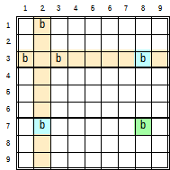

Empty Rectangles with two candidates in a block do exist, but these patterns are always also Turbot Fishes and are resolved as such in YAS.

Almost Locked Candidates
Need to add this technique to singles, perhaps not as it is not well covered and may be part of something else.

http://sudopedia.enjoySudoku.com/Almost_Locked_Candidates.html
http://www.sudocue.net/forum/viewtopic.php?t=607

Solving Subsets

Exposed and Locked Exposed Pairs

Hidden Pairs

Exposed and Locked Exposed Triples

Hidden Triples

Exposed Quads

Hidden Quads

Bent Exposed Triples

Bent Exposed Quads

Some Notes
- It is impossible to have a locked exposed quad as the four cells cannot fit in a box with a span of three.
- It is not necessary to look for subsets greater than quads, because for any subset, there is always a complementary (hidden <==> exposed) subset of less than nine minus that subset: Subsetc < 9 – Subset.

All singles, both exposed and hidden can be solved both by humans and computers without making use of candidate pencil marks.

In each group (row, column, and block) of a puzzle.
Identify the empty cells and the list of possible values.
# First search for hidden singles in that group
For each candidate:
For each empty cell in the group:
Note the empty cells where the candidate obeys Sudoku rules.
If the possible value is only found in one cell
That is the cell’s value.
Exit to start searching from the beginning again.
# Then seach for exposed singles.
For each empty cell in the group:
For each candidate:
Note the empty cells where the candidate obeys Sudoku rules
If only one candidate obeys Sudoku rule.
That is the cell’s value.
Exit to start searching from the beginning again.

Chains and Loops
Chains are odd length AIC’s either starting with Weak ended links or Strong Ended links.

In the YAS implementation, it is possible to switch on searching for grouped links when building chains. This functionality permits the searching of all non-group-links first before searching for links that include groups.

Another YAS characteristic when searching for chains is to search for chains of the same length before looking for chains of a longer length.

X-Chains and X-Loops
These are single same value candidate chains constrained so as to only permit one of either end of the chain to contain the candidate, never both, or none. That is the X chain will strongly link the ends of the chain – the chain ends behave like a strong link.

The imposed constraints are:
- Chain is formed using the same single digit candidate through all the links.
- Links must alternate between strong and weak. Remember a strong link is also a weak link and can be substituted for a weak link, however a a weak link cannot be substituted for strong link.
- Chain must begin and end with strong links.
- A strong link can be seen as an X-Chain of order 1.
  - Both ends are the start of strong links
  - There is an odd number of links, being 1.
  - The XOR relationship exists. One or other cell must contain the candidate value, neither both or none.

These constraints define other characteristics of X-Chains
- Even number of cells long
- Odd number of links
- Reversible – traversing the chain in either direction yields the same logic.
- Chain length is limited to 9 links as there can only be maximum 9 occurrences of a single digit in a puzzle. Remember all valid puzzles have at least one occurrence of eight of the nine digits as givens. If there are no occurrences of 2 or more given digit values, the puzzle cannot be valid.

An X Chain is validated by walking it, starting at one end with “not” the candidate value, to finish at the other end with the candidate value. Then doing the same from the other end, i.e. starting at the other end with “not” the candidate to finish with the candidate value at the starting end.

X Chain applications include:
- Eliminate candidates from cells that both ends of the chain can see. It is possible to eliminate a candidate that is in a chain if it is seen by both ends.
- Substituting for a strong-link when solving another pattern for example a W-Wing.
- In patterns where two cell are required to “see” each other. In addition to being in the same house (row, col, box), they can be either:
  - Directly connected by an X-Chain.
  - Each end “see” the opposing end of the X-chain (or strong link). The “See”ing links can be either weak or strong.
For example in finned fish, where the fin sees cover-set candidates outside the house containing the cover-set\base-set intersection.

An X-Loop is an X-Chain that links back on itself.
https://www.sudokuwiki.org/X_Cycles
https://www.sudokuwiki.org/X_Cycles_Part_2
https://www.sudokuwiki.org/Grouped_X_Cycles
http://zitowolf.net/sudoku/strategy.html#chains

X Loops can have an even number of alternating strong and weak links. I term these Even X-Loops. Here all same value candidates in the houses of the weak links that are not part of the chain can be eliminated.

Odd link X-loops have either an additional strong link or weak link, that is there will be one instance of joined same kind links. Weak X-Loops are the equivalent of X-chains, where two adjacent weak links close the loop. Here the joining candidate ccell is eliminated. Strong X-Loops are where two strong links close an X-Chain. Here the cell joining the two strong links can be assigned the candidate value for the loop.

Strategies to find X-Chains:
- Choose a candidate, identify all it’s conjugate pairs, try patterns of links between them to create chains and see if there are any candidates that can be eliminated from the cells that both ends see.
- Pick a start and end of a chain and build the alternating link chains simultaneously from both end seeing if they can connect.

Skyscrapers (3 Link X-Chain)
A skyscraper has two parallel strong links connected by a weak link. Any same value ccells that the two open ends of the skyscraper see, can be eliminated.

2 String Kites (3 Link X-Chains)
A 2 String Kite has a row strong link and a column strong link, weakly linked in a box. Any same value ccells that the two open ends of the skyscraper see, can be eliminated.

Turbot Fish (Other 3 Link X Chains)
All other 3 Link X Chain pattern. That is those three link X-Chains that start or end with a strong link in a box.

Longer X-Chains
These are X-Chains with an odd number of links > 3. As these X-Chains start and end with strong links, the ends are strongly linked, and therefore any same value candidate that both ends can see can be eliminated.

Also note that any subsection > 3 links of the X-Chain where same value ccells can see both ends of the chain can be eliminated. The YAS implementation searches for chains from short to long and only performs the first elimination it finds, because after that elimination there may be simpler elimination or assignment patterns. However as a human puzzle solver, your mileage may vary.

https://www.sudopedia.org/wiki/X-Chain

Even Number of Links X-Loops (Even X-Loops)
Even length X-Loops have the same number of strong and weak links. Note that a strong link can masquerade as a weak link. From Base/Cover Set Logic, and solving fish below, we are dealing with Rank Zero logic where the strong links form the base sets and the weak links form the cover sets. Here, the same value candidates in the houses of the weak links that are not part of the chain can be eliminated. This is because when the chain is closed becoming the loop, it forces either of the two connected candidates in the house of the weak links to be true. Because only one of those candidates is true, all other candidates in that weak link house can be eliminated.

Minimal fish are a type of X-Loops. A Minimal fish is is a fish where each cover only intersects the bases twice. X-loops, unlike minimal fish are not limited to rows and columns, and can include boxes/blocks when forming loops.

The following example identifies the following Even X-Loop of 6 links:
8(r3c2=r7c2-r8c3=r8c9-r9c7=r3c7-r3c2).
The weak link in r3 results in the eliminations r3c39-=8,
The weak link in b7 results in the elimination of r7c3-=8, and
The weak link in b9 results in the elimination of r7c9-=8.

By the way with the puzzle in it’s current state, it is also possible to identify other patterns. There are two – two string kites. 8(r1c7=r1c9-r3c7=r9,c7) resulting in r9c6-=8, and
8(r8c3=r8c9-r9c7=r3c7) resulting in r3c3-=8. There is also a Swordfish 8r128c369, resulting in the same eliminations as the 6 link X-Loop.

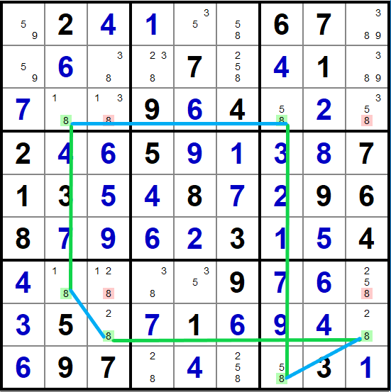
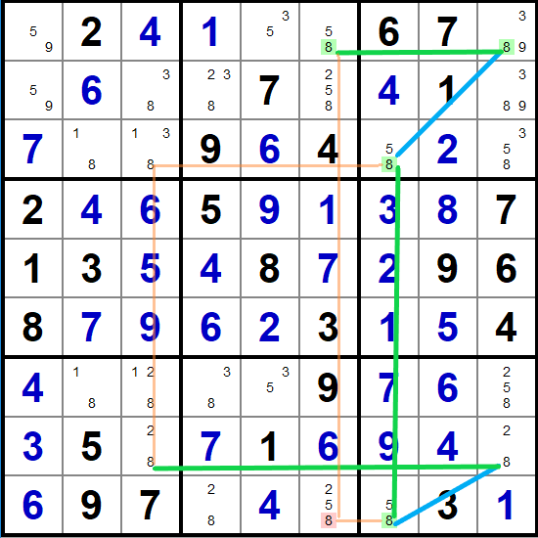

Odd Number of Links X-Loops (Strong and Weak X-Loops)
There are two types of odd number of links X-loops:

- Weak X-Loop:. This is an X-Loop with two adjacent weak links. This is equivalent to an X-Chain where the two strongly linked ends both “see” the same same value candidate which can be eliminated. As a Weak X-Loops is an X-Chains, and in YAS, is resolved as such.
- Strong X-Loop. This is an X-Loop with two adjacent strong links. In this pattern, the cell connecting the two strong links can be assigned the candidate value.

The following example illustrates and explains the logic behind Strong X-Loops.

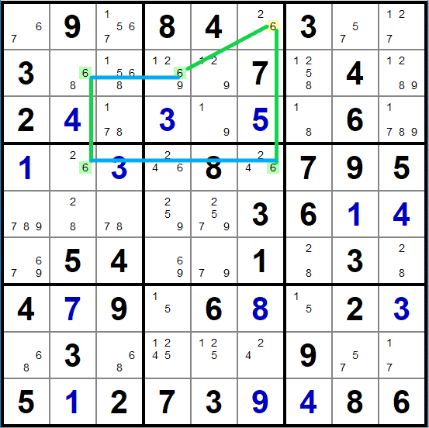
The pattern 6(r2c2=r4c2-r4c6=r1c6=r2c4-r2c2) is found, where ccell 6r1c6 joins two strong links.
- If ccell 6r1c6 is False, then both ccells 6r2c4 and 6r4c6 must be True. But the strong link 6(r2c2=r4c2) that sees both 6r2c4 and 6r4c6 restricts them from both being simultaneously True. Therefore it is not possible for 6r1c6 to be False.
- If ccell 6r1c6 is True, then both ccells 6r2c4 and 6r4c6 must be False. The strong link 6(r2c2=r4c2) that sees both 6r2c4 and 6r4c6 does not constrain them from both being simultaneously False. Therefore it is possible for 6r1c6 to be True.
- As 6r1c6 may be True and can’t be False. And 6r1c6 can only assume a value of True or False, 6r1c6 must be True: r1c6:= 6.

Grouped Linked X-Chains and Loops
It is very possible to find group linked x-chains, including Two-String Kites and Turbot Fish. Because a box and line intersection is required to make a group link, by definition a Skyscraper (which is two strong links along parallel lines weakly connected with a perpendicular line) which does not have a box cannot have a group linked variant.

XY-Chains and Loops
An XY-Chain is a chain made up of bi-value cells, linked by a common value in the cells and possessing a common ccell value at both ends. A Y-Wing is the shortest of XY-Chains made up of only 3 cells. A Y-Wing is also a Bent Exposed Triple. A minimal Bent Exposed Quad, is also an XY-Chain over 4 cells. (Minimal because each cell has only 2 candidates). XY-Chains make use of the fact that there is a strong link between the two candidates in a cell and therefore the linkages between the cells need only be weak links.

An XY-Loop is a XY-Chain that loops back on itself. That is the common end candidates are in the same house. Here, for any of the weak links, any candidate in the house of the link that is not part of the link can be eliminated.

The strategy to finding XY-chains is to identify all bi-value cells and try linking them together in various possible permutations in the attempt to build a chain that starts and ends with same value.

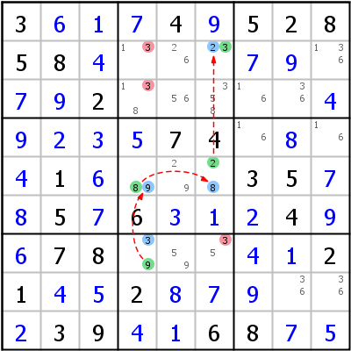
In the above example, courtesy of Hodoku, the following XY-Chain is constructed:
(3=9)r7c4-(9=8)r5c4-(8=2)r5c6-(2=3)r2c6.

Here the chain starts and ends ccells of value 3. Walking the chain from one end with the premise that 3 is False, infers a True 3 at the other end.

If 3r7c4 is False, 9r7c4 is True, 9r5c4 is False, 8r5c4 is True, 8r5c6 is False, 2r5c6 is True, 2r2c6 is False making 3r2c6 True. Similarly if 3r2c6 is False, 3r7c4 is True. The chain strongly links 3r2c6 and 3r7c4. Therefore any 3 ccell that sees both 3r7c4 and 3r2c6 can be eliminated as highlighted in red.

The various types of XY-Chains and loops are discussed below. Note that because XY-chains rely on two value patterns it is not possible to form group links in XY-chains as it is in X- and AI-Chains.

Y-Wings (XY-Chains)
These are the shortest possible XY-Chains, and in YAS are resolved as either a Bent Exposed Triples or an XY-Chain, whichever technique is encountered first in the pattern search order.

Remote Pairs
Remote pairs are 2 same value bi-value cells that are in different houses (unlike an exposed pair) that are connected through a net of same valued bi-value cells. The term remote comes from the pair not being in the same house. The net of same valued bi-value cells is a linking of exposed pairs, therefore all the links in the net are strong links, but following the convention of XY-Chains the links in the cell are strong and the links between cells are strong links masquerading as weak links.

When a net of four or more bi-value cells exist, any other ccell of either value that is not part of the net that can see both an odd net node and an even net node can be eliminated. Using different colours for odd and even net nodes is useful in explaining how this works.

How does this work. Firstly the first diagram shows why 4 or more cells are necessary for Remote Pairs to result in eliminations. Here the candidates alternate red and green to show that only all green or all red candidates are the truth.

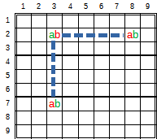
With only three nodes, the pattern presents as only two exposed pairs. It is only possible to eliminate ccells (candidates) that can see both a “ab” node and a “ab” node. There are no other cells outside of the houses in which both node values exist – which are the exposed pairs. Adding an additional fourth node, there now are now possibilities to for other ccells that are not in the houses of any adjoining nodes to see both a “ab” node and a “ab” node.

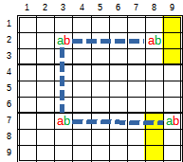
The “ab” and “ab” nodes alternate along the chain or net. Any pair of “ab” and “ab” nodes in the chain/net are strongly linked. Therefore any candidate “a” or “b” that is not part of the chain/net that can see both an “ab” and an “ab” node can be eliminated, as it is only those candidates along the chain or net that can be the truths. We do not know if green is true or red is true, but if an “a” or “b” candidate that is not part of the chain can see both a red and green same value candidate in the chain, then that candidate cannot be true.

Any “a” or “b” candidate in the yellow highlighted cells can be eliminated because those are the only cells (that are not part of exposed pair eliminations) that can see both a “ab” node and a “ab” node.

Another Hodoku example:

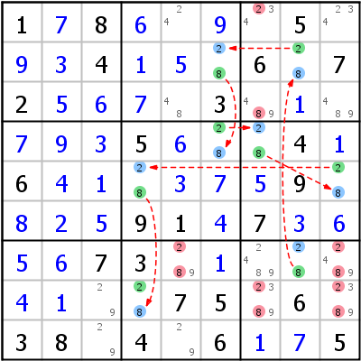
Here the chain can be described as:
(2=8)(r7c8-r2c8-r2c6-r4c6-r4c7-r5c9-r5c4-r8c4)
Which results in the red highlighted eliminations. Each eliminated ccell has the same value as one of the candidates in the chain and can see both a “28” and a “28” cell.

XY-Chains
As discussed in the parent section.

XY-Loops
An XY-loop is an XY-chain where both ends find themselves in the same house. Here, in the houses forming any of the weak links, any same valued ccell that is not part of that link can be eliminated, as shown in the following Sudokuwiki example:

XY-Loops, because all the strong links exist in cells and the weak (or strong masquerading as weak) links exist between cells, can only have an even number of weak and strong links.

Although both end ccells of an XY-Chain are able to see other possible same valued ccells as in the equivalent of a weakly ended Odd XY-Loop (which is an XY-Chain and handled as one in YAS), there is no such thing as a Strongly ended XY-Loop. The able to see both ends of

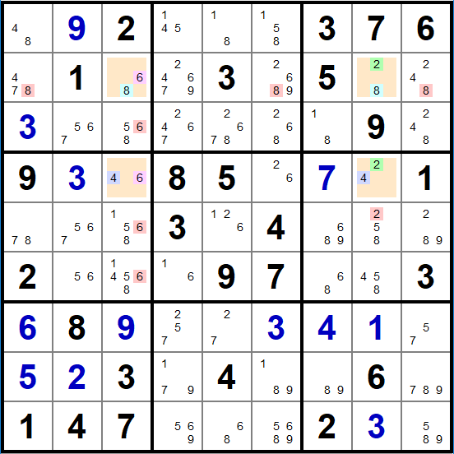
The XY-Loop pattern is identified as:
(6=8)r2c3-(8=2)r2c8-(2=4)r4c8-(4=6)r4c3
Because chain has closed on itself – ie formed a loop, all other same value candidates in the house of the weak links can be eliminated.

If 8r2c3 is False, 6r2c3 is True, 6r4c3 is False, 4r4c3 is True, 4r4c8 is False, 2r4c8 is True, 2r2c8 is False, making 8r2c8 True. Similarly in the reverse direction if 8r2c8 is False, 8r2c3 is True. Therefore the chain strongly links 8r2c3 to 8r2c8 eliminating all other 8 candidates in r2.

The same can be said for 6r2c3 and 6r4c3 in c3, 4r4c3 in r4, and 2r4c8 and 2r2c8 in c8.

XY-Loops, because all the strong links exist in cells and the weak (or strong masquerading as weak) links exist between cells, can only have an even number of weak and strong links.

Although both end ccells of an XY-Chain are able to see other possible same valued ccells as in the equivalent of a weakly ended Odd XY-Loop (which is an XY-Chain and handled as one in YAS), there is no such thing as a Strongly ended XY-Loop. The following diagram explains this.

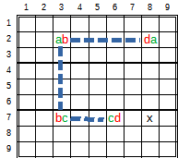
In the attempt to close Strong Odd length XY-Loop, candidate X can only be “d”. (r7c8 contains more candidates than X). But if X is “d”, it is eliminated by virtue of the XY-Chain described by (d=a)r2c8-(a=b)r2c3-(b=c)r7c3-(c=d)r7c6

AI-Chains and AI-Loops
AI- (Alternating Inference) Chains and loops is the most generalized linking of which X-Chains/Loops and XY-Chains/Loops are subsets. AIC’s are formed by linking any ccell nodes by alternating strong and weak links (keeping in mind that a strong link can masquerade as a weak link, but a weak link cannot masquerade as a strong link. See Links and Chains Logic above.

AI Chains
The location and content of AIC endpoints determine the type of outcomes the AIC can produce according to the table above. That is if the endpoints are different or same value candidates in different cells, and whether or not the end points are found in the same house, chute or neither.

Strongly ended, or weakly ended AI-Chain, ending with the same candidate value. These chains, ensure that if the one end is True, the other end is False.
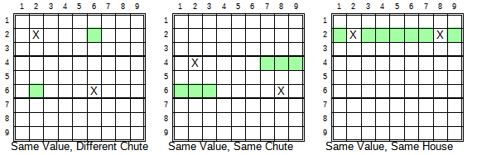
Depending on the locations of the ends of the same candidates with respect to chutes and houses per the examples illustrated above, any same candidate cell that see the end ccells of the chain can be eliminated. This applies to group links where all the grouped cells in the AI Chain ends need to be seen by a same candidate cell that is not part of the end group to be eliminated. If the same candidate cell is part of the chain other than the ends, then it’s elimination is still valid, and it is termed a cannibalistic elimination.
Strongly ended AI-Chain ending with different candidate value in the same house. Note that also different to to same value ends, different value ends must be individual cells and not part of a grouping for eliminations to be possible.
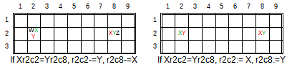
If the strongly ended cells are not an exposed pair then simply remove the starting candidate from the end cell and the end candidate from the starting cell. If the ends are an exposed pair then only the starting candidate remains in the start link and the ending candidate remains in the end link, making those remaining candidate the values for those cells. The logic behind this is as follows: Say there is a AIC resulting in Xr2c2=Yr2c8. Here, because of the strong chain link, if candidate X in r2c2 is False, then Y in r2c8 Y is True, and all other candidates (including X if present) are False. As well, because the ends “see” each other (in the same house), if X in r2c2 is True, X in r2c8 is False. Therefore irrespective of whether X in r2c2 is True or False, the intersection of the chain and house relationships ensure that X will always be False in r2c8. Because X in r2c8 is False irrespective of the value of X in r2c2 (True or False), X can be eliminated from r2c8. Similarly for the elimination of Y from r2c2.

If X and Y are the only values in r2c2 and r2c8 we have an Exposed Pair. The elimination of X from r2c8 and Y from r2c2 leaves only X in r2c2 and Y in r2c8, resolving them as the assigned values per the right grid in the above image.

Not illustrated, but if the strongly ended ccell are both in the same cell, then all other candidate values can be eliminated from that cell.

Even AI Loops
Like Even X-Loops, the weak links are strengthened, forcing these eliminations:
- If the Weak Link is two same value ccells in a house, then all other same value ccells in that house can be eliminated.
- If the Weak Link is two different valued ccells in a cell, then all other ccells (candidates) can be eliminated from that cell.

Strong AI Loops
Like Strong X-Loops, The ccell node that joins the two strong links can be assigned that candidate value, as it is the only possibility that forms a truth.

Wings and Bent Exposed Subsets
(X-Wing is a fish, not a wing).

A bent exposed subset of order ‘n’ is defined as: a group of ‘n’ cells containing between two and ‘n’ candidates out of a set of ‘n’ common candidates, spanning two houses where all the candidates but one can see all their peers in the ‘n’ cell group. The candidate that cannot see all its peers is called an “unrestricted candidate” as it is not restricted to only seeing its peers.

A bent exposed subset is resolved by recognising the reason the unrestricted candidate that cannot see all it’s peers is because it is the only candidate spanning both houses and can only see all it’s peers through a chain of links involving the ‘n’ cells. This chain of links through the pattern will connect the (group of) candidates(s) in the one house with the (group of) candidate(s) in the other house in a weakly linked relationship. (Note that strongly linked candidates can masquerade as weakly linked candidates). That is, neither can be False simultaneously, one or both has to be True.

The outcome is that any candidate outside the pattern that can see all the unrestricted candidates can be eliminated.

The Bent Exposed Subset definition is a more relaxed definition than the various Wing definitions, and are able to recognise more patterns and eliminations.

Aside: As a human solver, I advise getting the hang of the Bent Exposed Subset patterns, even if the Wing patterns are used as an interim learning step.]

Y Wings (Bent Exposed Triple – BET)
Also known as a XY wing. In addition to being a Bent Exposed Triple, it is also a 3 node XY Chain (which is actually a 5 node AIC), but because it occurs often and is easy to spot it has its own name.

A Y-Wing pattern is defined as: A three cell, three candidate {a, b, c} pattern where a pivot bi-value cell intersecting two houses (ab) that sees a bi-value pincer cell in one of the houses (ac) and sees another bi-value pincer (bc). and another bi-value pincer cell in the other house with it’s other candidate (ac) and where the other candidate in both pincer cells is the same value (c). The below diagram illustrates two Y-Wing examples, one with a row/column intersection and the other with a row/box intersection. example C in cells ac and bc are connected through cell ab.
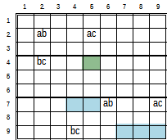
As a Y-Wing, this pattern is resolved by recognising that the ‘c’ candidates are strongly linked. It is easy to emperically show that ‘c’ cannot be False in both ‘ac’ and ‘bc’. ‘c’ can only be true in one or the other of ‘ac’ and ‘bc’. That is one of the ‘c’ candidates must be True. Therefore any other candidate ‘c’ that can see the ‘c’ in both pincers can be eliminated, as highlighted.

As a BET the three cells containing 2 or three candidates out of a set of three candidates {a, b, c}, spanning two houses (row/column in first example and row/box in second), and one candidate (‘c’) cannot see all it’s peers. Therefore any other candidate ‘c’ that can see all the instances of ‘c’ in the pattern can be eliminated as highlighted.

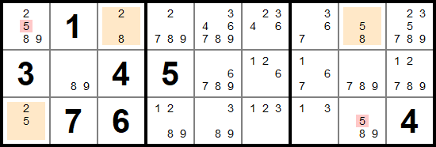

W-Wings (AIC with 6 nodes)
A W-Wing pattern is defined as: Two identical bi-value cells in different houses that can see a strong link with one of their candidates. The outcome is: Any candidate of the other value that can see both bi-value cells can be eliminated as shown by the highlights in the two diagrams below.
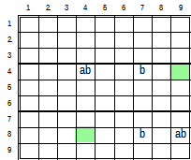
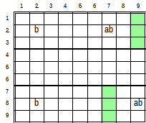
Recognize that W-Wings are also AIC’s of the form (using the second diagram as an example):
‘a’r2c7=’b’r2c7-’b’r2c2=’b’r8c2-’b’r8c9=a’r8c9 ==> ‘a’r2c7=’a’r8c9.

The AIC forms a strong link between ‘a’r2c7 and ‘a’r8c9, therefore any other candidate ‘a’ that sees the ends can be eliminated as shown by the highlights.

Note that the strong link between the two ‘b’ candidates can also be an AIC, thereby extending the length of the minimal W-Wing AIC of 6 nodes. It can have any even number of nodes greater than 6. As an AIC of greater than 6 nodes is a variation of the original definition, which the YAS implementation identifies as a “Kraken W-Wing”.

As with all AIC’s cannibalism is permitted, that is: an elimination in the chain does not break the chain.

XYZ-Wings (Bent Exposed Triple - BET)
A XYZ-Wing pattern is defined as: A three cell, three candidate pattern spanning two houses with a pivot tri-value cell in the intersection of two houses (abc) that sees a bi-value pincer (ac) in one house and a bi-value pincer (bc) in the other house.

The two houses can only be a line and a box because in any intersection between a row and column it is not possible for any other candidate ‘c’ to directly see all three ‘c’’s in the pattern. (It could be possible by exploring chains connecting that other candidate to each of the ‘c’s in the pattern, but now we are getting into the realm of diminishing returns for increased effort.).

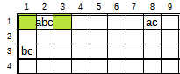
This pattern is resolved as an XYZ-Wing by recognising that ‘c’ is true in one of the three cells of this pattern, and if ‘c’ is True in any of the three locations of the pattern it blocks the green highlighted cells from being True, so ‘c’ can be eliminated from the green highlighted cells.

As a BET, recognise ‘c’ to be the unrestricted candidate. Therefore ‘c’ can be eliminated from any other cell that sees the ‘c’ in all the three cells in the pattern.

Note: Even though the BET permits up to three candidates in any cell, if there was ‘abc’r3c1 instead of ‘bc’r3c1, it would break the single unrestricted candidate criteria because both a and c would be unrestricted.

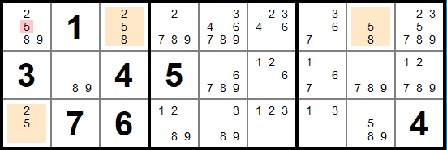

WXYZ-Wings – Bent Exposed Quad (BEQ)
A WXYZ Wing pattern is defined as: A four cell, four candidate pattern spanning two houses with a pivot four value cell in the intersection of the two houses (wxyz) that sees three bi-value pincer cells (wz, xz, yz) with two in one house and one in the other house, where one candidate (z) in present in all four cells.

For the same reason as XYZ-Wings, the houses can only be a line and a box. There are two variations of this pattern, one where two bi-value cells are in the line and one in the box, and the other where two bi-value cellls are in the box and one is in the line, as shown below.

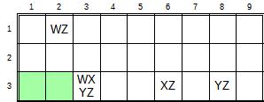
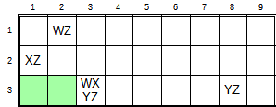
A WXYZ-Wing is resolved by recognizing that ‘z’ must be true in one of the four cells of the pattern, and therefore cannot be true in any other cell that can see all four cells of the pattern. Therefore ‘z’ can be eliminated form the green highlighted cells.

Bent Exposed Quads

In comparison, A Bent Exposed Quad is defined as: A four cell, four candidate pattern spanning a line and row with each of the four cells contain between two and four candidates from the set of common candidates and where one candidate is unrestricted. (That is, instances of this unrestricted candidate appears in both houses outside of the intersection). Note that can be one or two cells of the BEQ pattern in the intersection.

This pattern is relaxed from WXYZ-Wings in the following ways.
- No Pivot cell having all four candidates nor unique bi-value pincers, a Bent Exposed Quad can have any of the four candidates in any of the four cells.
- Instead of one candidate being present in all cells of pattern, the pattern only needs an un-restricted candidate in two or more of the pattern’s cells.

A Bent Exposed Quad is resolved by recognizing that the unrestricted candidate must be True in one of instances in the pattern. Therefore any candidate that can ‘see’ all instances of the unrestricted candidate can be eliminated.

The BEQ relaxed criteria finds many more patterns than the restricted WXYZ-Wing, and because the unrestricted candidate can occur fewer times in the pattern the number of cells that candidates outside the pattern need to see is reduced, increasing the probability of more eliminations. For these reasons, WXYZ-Wing is not implemented, only the BEQ.

Also a minimal BEQ, that is where each cell only contains 2 candidates is also an XY-Chain.

Below is an example of a WXYZ Wing.

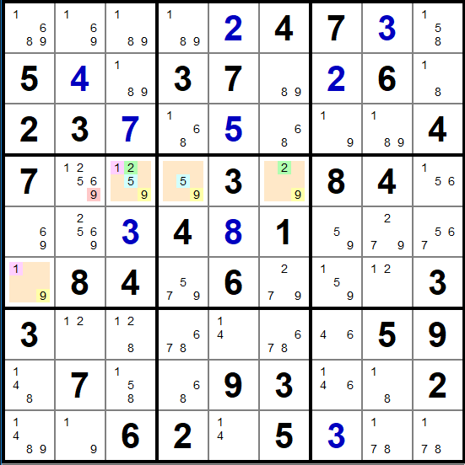
A WXYZ wing with candidates 1259 in row 4 and box 4, where 9 is the common candidate resulting in the elimination r4c2-=9. Courtesy sudokuwiki.

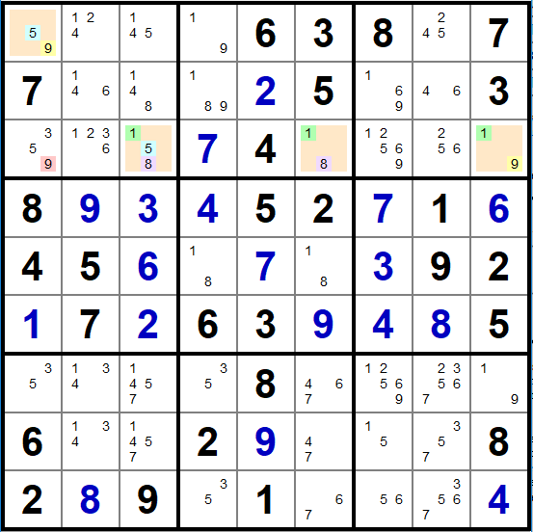
A BEQ, with no pivot containing four values. The unrestricted candidate is is 9. 9 only occurs in 2 cells but does result in the elimination r2c1-=9. Courtesy Cracking the Cryptic

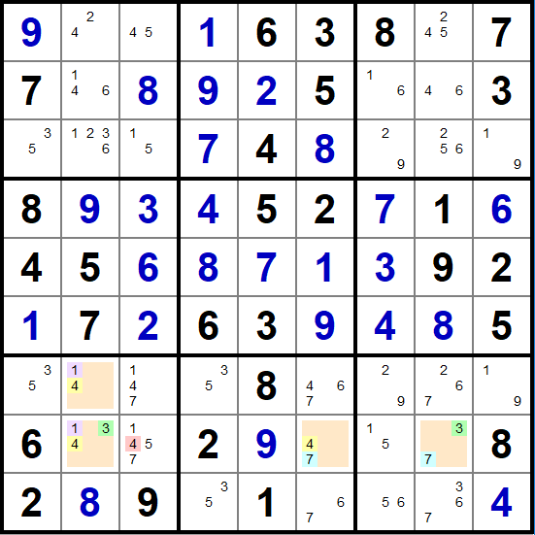
Same puzzle, solved a little further, another BEQ resulting in the elimination of r8c3-=4.

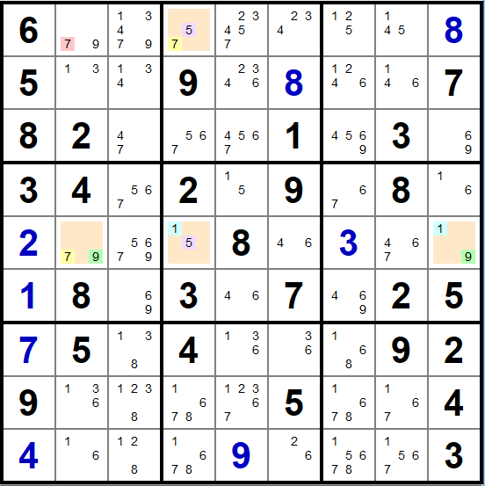
Here is a BEQ with cells: 79==r5c2, 15==r5c4, 19==r5c9 and 75==r1c4. 7 is the unrestricted candidate (only candidate that cannot see its peers in the pattern), and because both 7s in the pattern can see 7r1c2 this results in its elimination r1c2-=7.

Note this BEQ has a row / column pattern and not line / box pattern. This is only possible because the unrestricted candidate only appears in two cells in the pattern. Also because every cell only has two candidates, this is also a seven link AIC:
7r1c4==5r1c4-5r5c4=1r5c4~1r5c9=9r5c9-9r5c2=7r4c2.

The 7s at both ends of the chain can see 7r1c2 resulting in its elimination.

Wrap Up.
It appears that Y-Wings and XYZ-Wings cover the full set of Bent Exposed Triples. Also because Y-Wings and XYZ-Wings appear more prevalent in the literature, YAS uses these names.. YAS also distinguishes between the narrow pattern scope of a WXYZ-Wing and the wider scope of a BEQ.

Fish

Introduction
From the Sudoku General Logic discussion below, finned fish requires “order + 1” cover-sets. Eliminations can only be made from non base-set locations where two cover-sets intersect. In regular (row/column) finned fish patterns the overlapping cover-set is typically a box. All candidates in the intersection of the two cover-sets that are not part of the base-set can be eliminated. Another way of wording this additional cover set requirement: If a ccell in the cover-set that is not part of the base-set can see all the fins, the ccell (candidate in cover set cell) can be eliminated.

TODO: Describe how the algortithm recognises Fish, Finned Fish, and Sashimi Fish patterns for X-Wings, Swordfish and Jellyfish, then looks for eliminations if a cover can see all the fins directly or through a Weakly ended AICs (Kraken) or Weakly Ended Group-linked AICs. Also in YAS, as searching for Krakens (Building chains) is computationally very expensive only the first valid elimination is found. However all eliminations are found for all non Kraken Sashimi.

There is a further technique to solving for finned fish, known as Kraken Fish. Recognise that the box intersecting the cover Ccell(s) and all the fin Ccells simply forms Weak Links between each cover ccell and fin ccell. Further recognise that a Weakly Ended AIC (Chain) can masquerade as a Weak Link. With this realisation, the definition of of a Finned Fish is extended: In a Finned Fish pattern, any Cover Ccell (Candidate in a cover cell) that can see (be Weakly Linked to) all the fin ccells can be eliminated.

Expressed slightly differently: We know that for a regular Finned Fish, if one of the Fins is True, then any cover that sees the Fin must be False. If all the fins are False, then the pattern matches a regular X-Wings, where the covers can be eliminated. There for in a Fish, if the Cover is weakly linked to all the Fins, it can be eliminated. A strongly linked Fin to a cover is not valid logic here as as the Fins as the starting ends of the links to the cover in question must be presupposed True to force the Cover False. For Kraken logic, this weak link logic is extended to a Weakly Ended AIC. For Kraken Fish, any Cover that is Weakly linked to (can see) all the Fins can be eliminated.

An implementation note. This technique often finds patterns in puzzles that can also be solved with more difficult techniques, but easier to spot and solve as regular finned fish. Therefore in ordering logic techniques it makes sense to put these Kraken Fish after all Finned Fish techniques but before almost fish techniques. There is a second type of Kraken Fish that may be implemented at a later stage. Hodoku Kraken Fish Type II Here if a ccell can see all the base candidates in a cover set and the fins directly or through weak-ended AIC’s, then that ccell can be eliminated. The candidate value in that ccell need not be the same as that forming the fish.

The following example from Systematic Sudoku (taken from KrazyDad SuperTough 555) is interesting in that the X-Wing fin “sees” a candidate in the column cover-set by way of the Weakly linked AIC on 6: 6(r5c5~r2c5=r3c4~r3c3). [remember, “~” is the symbol for a strong link masquerading as a weak link]. In this example, it is the only way the fin 6r5c5 sees the cover ccell 6r3c3. The other cover ccell 6r6c3 is not visible from the fin. Other probably simpler solutions:
- Notice that the ERs in box 4 on both 6 and 1 candidates, coupled with the 61 conjugate pair (61r36c4) results in the elimination of both the 1 and 6 from r3c3 (r3c3-=61) solving r3c3:=2, and the rest of the puzzle is solved with simple singles.
- Noticing the exposed pair in 2(r18c2) causing r2c2-=1 and r6c2-=1. followed by r456c1 describing a pointing locked single in b2, causing the elimination of r3c3-=1. Followed by the Turbot Fish in 1(r2c1=r2c5-r8c5=r7c6) causing the elimination of r6c1-=1.
- A Skyscraper 1(r2c5=r2c1-r7c1=r7c6) or (Sashimi) Finned X-Wing (r27c1, r2c5, r7c6) both resulting in the elimination r8c5-= 1.

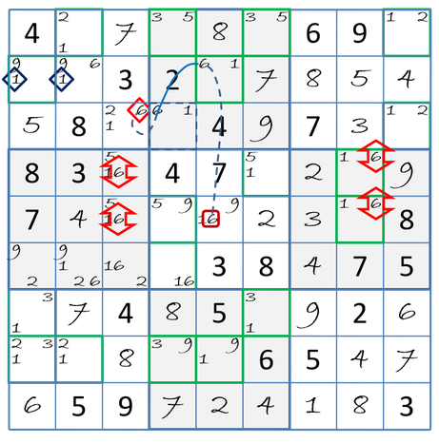Figure 1: Finned X Wing Elimination through a chain
In this example, the would-be 6-wing is spoiled by the extra fin 6r5c5. If the fin could be wished away, the perfected 6-wing would eliminate 6r3c3 and 6r6c3. But 6r3c3 sees that fin, via 6-chain. If 6r3c3 is true, it will erase the fin, allowing the fish to prove it false. Potential victim 6r6c3 escapes the fish because it cannot see the fin. https://sySudoku.com/guide/sySudoku-advanced/x-panel-methods/finned-and-kraken-fish/

Another Kraken X-Wing follows from Systematic Sudoku.

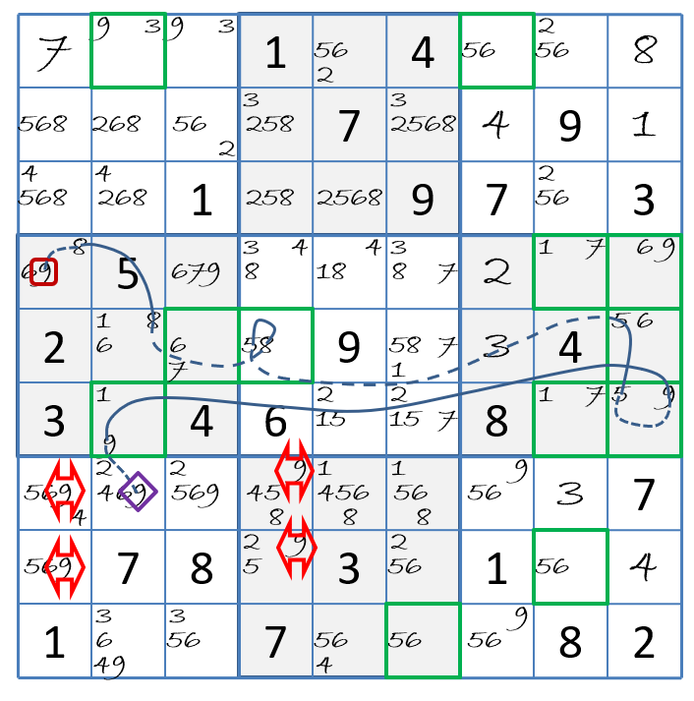
Here, YAS finds a different Kraken X-Wing solution. This one formed with base set rows, because YAS searches row bases before column bases.

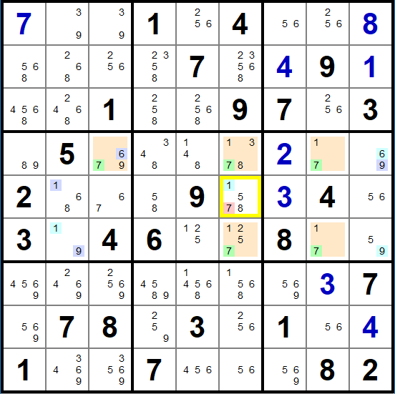
The pattern found is: 7r46c68,r4c3; together with the weakly linked chain from cover 7r5c6 to fin 7r4c3: 7r5c6-1r5c6=1r5c2~1r6c2=9r6c2~9r6c9=9r4c9~6r4c9=6r4c3-7r4c3. This results in the elimination of the cover r5c6-=7

But wait, there is more! Franken (Finned) Fish are fish where fish patterns include boxes in in base sets. Then there are Mutant (Finned) Fish (of which Franken fish are a subset) that mix and match rows, columns and boxes in bases and covers. These “General Logic rank 0 and rank 1 patterns are difficult to spot. Their implementation is left till later in YAS.

Basic Fish

X-Wing

Swordfish

Jellyfish

Finned Fish

Finned X-Wing

Finned Swordfish

Finned Jellyfish

Kraken Finned Fish

Kraken X-Wing

Kraken Swordfish

Kraken Jellyfish

Franken Fish.

Mutant Fish

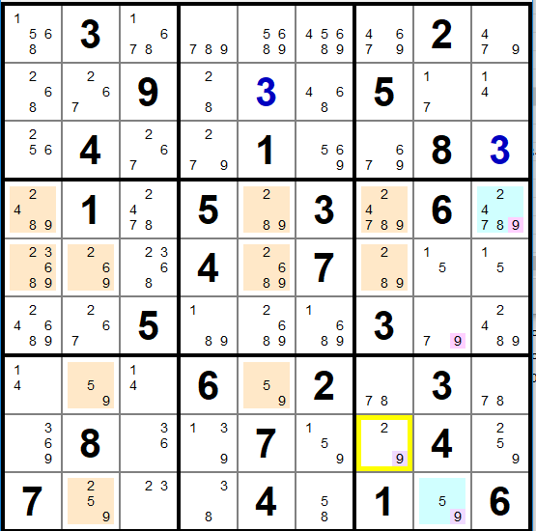
In the above example, the Kraken Jellyfish found on candidate 9 by YAS is shown. Here the base sets are rows {4, 5, 7, 9} and the cover sets are columns {1, 2, 5, 7} with Fins 9r4c9 and 9r9c8. The outcome of this pattern is r8c7-=9. Following this elimination the puzzle is still challenging to solve.

However, there is a simpler finned Jellyfish pattern at this stage in the puzzle.
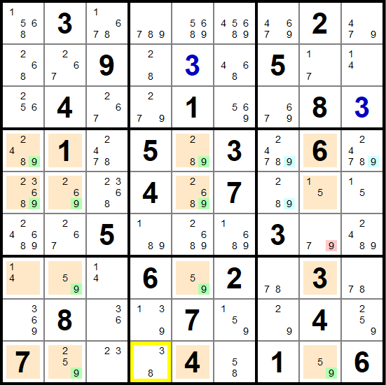
The Finned Jellyfish is 9r4579c1258,r4c7,r4c9,r5c7. Fish ccells highlighted green and Fish fin ccells highlighted blue.

Note that a finned fish is permitted to have only one or more base/cover intersection in the cover chute containing the fins, in addition to two base / cover intersections in the remaining cover sets. The fins are in the third tower and thus the finned fish pattern is value even with only the one base / cover intersection 9r9c8. 9r6c8 can be eliminated as it is not part of the base sets in the cover column and can see all the fins. Some literature term this pattern as a Sashimi Finned Fish. But since this same rule finds both regular finned fish and Sashimi Finned fish, the distinction is not made in YAS.

A Note on Chain Length and Processing Time.
This section is relevant to all chains and Kraken Fish, including Group links. As trees grow very exponentially, the time taken to seach for chain patterns to increases exponentially. In its use of trees to build chains, YAS builds a combination weak and strong link in each recursion step. Processing time is proportional to the number of child nodes that can grow at each level (chain node)

Each weak link has the worst potential for up 8 row nodes, 8 column nodes, 8 box nodes and 8 ccell nodes, that is 32 child nodes. Each Strong link has the worst case potential of 1 row node, 1 column node, 1 box node and 1 ccell node. Therefore in the absolute worst case (which can never occur) number of children/branches for an odd and even the combination step is 128. Compare this to a binary tree’s grown with a worst case of 2^n child nodes per level of tree depth (length of chain). Searching for a Sudoku chain whose worst case is 64^n child nodes. Thus the theoretical worst case searching for Sudoku chains is 32 times more intensive relative to binary trees.

Considering something closer to reality, a binary tree does not always make a node, nor does every node have two children. Thumb-sucking a processing improvement, let’s say the binary tree increases at 1.33^n per level. Similarly, anecdotally I have observed about 3-4children across 1 -to 2 of the 4 (row, col, box, ccell) options per weak link, and 1 - 2 to 4 of row, col, box, ccell nodes. That is about 8 to 10 children per odd and even level or 10^n per recursive iteration. Therefore in the normal course of events one can expect searching for Sudoku chains to be in the order of 3.33 times more intensive than binary searches. (Do not be deceived by the smallness of the 3.33 exponential scaling, it is actually massive).

More importantly, increasing the limit on the length of chain is going to increase processing time by 10 per recusion level. For example say it takes a second to exhaustively scan for a chain of 10 nodes.

# Nodes | Relative Time
4 | 000.1 s
6 | 00.1 s
8 | 0.1 s
10 | 1 s
12 | 10 s
14 | 100 s ~ 1:40
16 | 1000 s~ 16:40
18 | 10 000 s ~ 2:46:40
20 | 100 000 s ~ 1d, 3:46:40

These numbers loosely correlate to my anecdotal experience, with perhaps the increases for the larger number of links 14 through 20 increasing meteorically but not as meteorically as computed in the table.. I can explain this, because the number of available node possibilities reduces (as nodes cannot be reused in chains), therefore reducing the average possible number of nodes to consider at increasing lengths of chains.

A further interesting observation, I have found in the regression tests of over 1000 puzzles is that by reducing the chain length to 12 nodes from 20 nodes, YAS has always been able to find the same type of pattern, as the one it found with more nodes. That is YAS has always found the same type of pattern with shorter nodes behind the one it bottomed out on. As the recursive sample set increases, I am interested to see what percentages of puzzles exhibit this characteristic.

Currently setting a recursion limit of 6 that is 14 nodes, none of the regression test puzzles for these patterns has failed in the current sample set. This setting also permits patterns to be found in what I consider acceptable time constraints ( a few seconds).

Note these times are only for interpreted code. A 20 – 50 times improvement is expected in the port to Cython code. To be continued.

Operations

Modes:

Idle Mode
Blank slate – empty puzzle board, waiting for a puzzle to be entered or created.

Entry Mode
Entering, creating or modifying puzzles

Solve Mode
Solving puzzles – automagically or manually – with or without various levels of assistance.

Creation (Enter Mode)

Creating Puzzles
Invocation:
- Menu/Puzzle Generate: This menu option is only enabled in Idle Mode.

Operation:
- Generates a puzzle by creating a randomly filled board and then digging holes in the puzzle, checking every step until a minimal puzzle is created. Puzzle symmetry can be set in Menu/Options/Grid Symmetry.

Entering Puzzles
Invocation:
- Menu/Puzzle/Enter. This takes the program to Entry Mode.

Operation:
- Puzzle Given and placed values can be entered. Puzzle values can be entered in two ways.
  - By selecting a cell and typing the value. To select a cell simply click on the cell, the cell will be highlighted with a yellow border. To select multiple cells, hold the shift key down while clicking in the cells to select. Multiple clicks in cells toggles it’s selection.This will place a “Given value in the cell. To enter a placed value, hold the shift key down.

Modifying Puzzles

Solving (Solve Mode)

Entering Values and Candidates

Solving Puzzles Unassisted

Solving Puzzles with Assistance

Displaying Candidates and Candidate Assistance
Show unselected cands option as certain mouse button press operations are dependant on the arrow location relative to candidate locations in a cell. And it may be difficult to judge location of candidate value in cell.

Show Cands. W/out assistance (Options/Candidate Assistance off). Will simply display unconflicted candidate values without further processing. With Assistance will track candidates that have been eliminated so far, and remove conflicted candidates whenever a cell is placed.

Hinting

Listing Solution

Other Puzzle

Mode, Mouse and Keyboard Operations
State, Mouse and Keyboard Commands
STATE |  | MSE |  | KEYBOARD
EN | SV | LT | RT | SH | CT | AL | DL | “a” | “n” | a: alpha char, n:is a digit 1 though 9
X | X | 0 | 0 | 0 | 0 | 0 | 0 | 0 | 0 | Nothing happens
1 | 1 | X | X | X | X | X | X | x | X | Can’t happen
Entry State
1 | 0 | 1 | 0 | 0 | 0 | 0 | 0 | 0 | 0 | Select a value cell.
1 | 0 | 1 | 0 | 1 | 0 | 0 | 0 | 0 | 0 | Select multiple value cells
1 | 0 | 0 | 0 | 0 | 0 | 0 | 0 | 0 | n | Write digit to selected cells as entered
1 | 0 | 0 | 0 | 1 | 0 | 0 | 0 | 0 | n | Write digit to selected cells as placed
1 | 0 | 0 | 1 | 0 | 0 | 0 | 0 | 0 | 0 | Make cell value that of candidate cell value under pointer as entered
1 | 0 | 0 | 1 | 1 | 0 | 0 | 0 | 0 | 0 | Make cell value that of candidate cell value under pointer as placed
1 | 0 | 0 | 0 | 0 | 1 | 0 | 0 | 0 | 0 | Delete values in selected cells
1 | 0 | 0 | 0 | 0 | 0 | 0 | 1 | h | 0 | Delete values in selected cells
1 | 0 | 0 | 0 | 0 | 0 | 0 | 0 | c | 0 | Copies puzzle to the clipboard
1 | 0 | 0 | 0 | 0 | 1 | 0 | 0 | v | 0 | Paste clipboard into grid (Known formats only)
1 | 0 | 0 | 0 | 0 | 1 | 0 | 0 | z | 0 | Undo last entry
Solve State
0 | 1 | 1 | 0 | 0 | 0 | 0 | 0 | 0 | 0 | Select a value cell (a cell with a given can be selected)
0 | 1 | 1 | 0 | 1 | 0 | 0 | 0 | 0 | 0 | Select multiple cell values
0 | 1 | 0 | 0 | 0 | 0 | 0 | 0 | 0 | n | Write the digit to selected cells that are not givens as placed
0 | 1 | 0 | 0 | 0 | 1 | 0 | 0 | h | 0 | Delete values in selected cells
0 | 1 | 0 | 0 | 0 | 0 | 0 | 1 | 0 | 0 | Delete values in selected cells
0 | 1 | 0 | 0 | 0 | 1 | 0 | 0 | z | 0 | Undo last entry
0 | 1 | 0 | 0 | 0 | 1 | 0 | 0 | c | 0 | Copies puzzle state to the clipboard.
0 | 1 | 1 | 0 | 0 | 1 | 0 | 0 | 0 | 0 | Transient highlight the same values/cands of cell under pointer
0 | 1 | 1 | 0 | 0 | 1 | 1 | 0 | 0 | 0 | Transient highlight the group of the cell under pointer
0 | 1 | 1 | 0 | 0 | 0 | 1 | 0 | 0 | 0 | Colour picker for selected cells
Solve State Candidates
0 | 1 | 0 | 1 | 0 | 0 | 0 | 0 | 0 | 0 | Toggles the value of the candidate cell under pointer
0 | 1 | 0 | 1 | 1 | 0 | 0 | 0 | 0 | 0 | Make cell value that of candidate cell value under pointer
0 | 1 | 0 | 1 | 0 | 1 | 0 | 0 | 0 | 0 | Transient highlight of all cells containing candidate under cursor
0 | 1 | 0 | 1 | 0 | 0 | 1 | 0 | 0 | 0 | Colour picker for candidate cell under pointer
0 | 1 | 0 | 1 | 0 | 1 | 1 | 0 | 0 | 0 | Clear background colouring of all candidates

Conflicts and Errors
A conflict is when there are two or more cells in a group with the same value. Indicating conflicts highlights that one or more cell values are in error, but does not indicate which cells contain the error.

It is important to note that an incorrect value can be entered, that is not conflicted with the currently entered values and given. However that incorrect value will show as a conflict at some later stage when more (correct) values have been entered.

An error is when a value entered in a cell does not match that of the correct solution, i.e. it is an incorrect value.

Levels of assistance and relationship to candidates

Common to all the levels of assistance:
- If all but one candidate is selected in a cell, it is treated as this number has been selected and will be written in the cell as a value (as if the user keyed that value)
- Changing the background colour of cells or candidates is purely to provide visual assistance while solving to the user. Background colour is purely a front-end man-machine-interface activity and is not part of the Sudoku back-end processing.

Check on Finish.
There is no back-end Sudoku interactive processing checking the correctness of the solution until all the cells are filled. When all cells are filled the puzzle is checked and if there are errors, a message box displays giving the user a choice of either going back and correcting, or giving up.

While solving, the user can select/clear and change background of both cell values and candidates at will without constraint. The values of cells and candidates are matched in both the board front-end and Sudoku back-end but no back-end intelligence gets applied.

Show Conflicts on Finish
There is no back-end Sudoku interactive processing checking the correctness of the solution until all the cells are filled. When all cells are filled, the board is checked, and all conflict are highlighted and a message box displays giving the user a choice of either going back and correcting or giving up.

While solving, the user can select/clear and change background of both cell values and candidates at will without constraint. The values of cells and candidates are matched in both the board front-end and Sudoku back-end but no back-end intelligence gets applied.

Show Errors on Finish
There is no back-end Sudoku interactive processing checking the correctness of the solution until all the cells are filled. When all cells are filled, the board is checked, and all conflict are highlighted and a message box displays giving the user a choice of either going back and correcting or giving up.

While solving, the user can select/clear and change background of both cell values and candidates at will without constraint. The values of cells and candidates are matched in both the board front-end and Sudoku back-end but no back-end intelligence gets applied.

Interactively Show Conflicts
There is interactive processing checking the correctness of values entered and candidates selected. In this mode of operation conflicts are highlighted and the user is permitted to proceed. Only those remaining possible candidates (which is a subset of possible candidates in the group) are shown, irrespective of that one or more values are in error. For example if a user by applying some logic had determined that a possible candidate is no longer a candidate and toggled it off, that candidate value will still remain off.

While solving any value can be entered and those in conflict are highlighted. Only the possible candidates out of the user selected set of candidates is shown. Any candidate can be deselected, even if it is the correct one (because we do not want to make puzzle solving too easy). Selecting candidates for a cells is constrained to only those possible values after considering all givens and user entered values (irrespective of conflicts) in the group.

Interactively Show Errors
There is interactive processing checking the correctness of values entered and candidates selected. In this mode of operation errors are highlighted and the user is permitted to proceed. Only those remaining possible candidates (which is a subset of possible candidates in the group) are shown, irrespective of that one or more values are in error. For example if a user by applying some logic had determined that a possible candidate is no longer a candidate and toggled it off, that candidate value will still remain off.

While solving any value can be entered and those in error are highlighted. Only the possible candidates out of the user selected set of candidates is shown. Any candidate can be deselected, even if it is the correct one because we do not want to make puzzle solving too easy. Selecting candidates for a cells is constrained to only those possible values after givens and user entered values (irrespective of errors).

Software Design

Top Level Objects and Relationships
Describe how the Board object largely handles the front end man / machine interface thand the Sudoku module handles all the back end operations, managing the information about all the cells, driving the operations of the board and in the intelligence of automated solving. (The automated solving may at a later stage get pulled into its own module of supporting functions for the Sudoku module).

Main module

Menus Module

Board Module

Sudoku Module

Major Data Structures.

Grid.

Control State machine
Although the State machine has many states, most of the states are themselves transition states to one of the three major states, Idle, Entry, and Solve states.

Idle State

Entry State

Solve State
On exit from the states that transition to Solve State. Transitions to this state only can happen from the Validate State, or the Generate State. The game timer is started, the entered values are locked in as givens,

Operation

Timer Module

Implementation

Config File

Appendix A: Development Environment Notes.

Directory Structure:

Yet Another Sudoku/
+ .git/ # Created and used by git and github.
+ .idea/ # created and used by PyCharm
+ bat/ # batch scripts for command line running.
| + bat_data/ # data for batch scripts.
+ bench/ # benchmark scripts to evaluate and compare performance
+ build/ # created and used by Cython.
+ cmds/ # IDE independent scripts for building and running code.
+ doc/ # documentation, user manual, etc.
+ img/ # images, icons, etc use in the program
+ lib/ # local lib for Cython compiled production modules
+ libd/ # local lib for Cython compiled development modules
+ puzzles/ # store of puzzle files that can be read by YAS
+ setup/ # scripts and cfg’s to be used with setuptools
+ src/ # source code – both Python and Cython
+ tmp/ # scratch area during development and debugging
+ test/ # test and regression test scripts
| + test_data/ # test data and regression test data bases
+ venv/ # created and used by PyCharm / Python virt env.

In directories with Python source, when Python executes the code, it caches the parsed outputs in a __pycache__ directory off the source directory. To speed things up, Python looks for these parsed outputs with timestamps newer than the source and uses them instead of the source.

Development and Production Cython Builds
The Development Cython Build is the collection of Cython compiled binaries created from the .pyx sources and located in the libd/ directory. These binaries are line trace capable and include debug information which introduces some overhead making them execute slower and take up more space than Production binaries.

These binaries are not supported by PyCharm’s debugger, (actually break IDE debugging) but work in conjunction with TRCX to trace execution in the Cython compiled binaries. This is very useful when debugging Cython compiled modules being run (not debugged) from within the IDE (YAS... Run/Debug Configuration options) or from the command line. See Development Workflow below.

The Production Cython Build is the collection of Cython compiled binaries created from the .pyx sources and located in the lib/ directory. These binaries are optimised for speed and lean without any line trace support. Since they do not have line-trace support they can also be used as blackbox code (step over, no step into, exception trapping) when debuging Python code.

Python’s Module Importing Search Order.
I have yet to wrap my mind around the complexities of how python finds specified modules to import. However I have worked out that for any module, Python scans sys.path from beginning to end, and only loads the first module it encounters with that name. Therefore, by curating the order of search directories in sys.path, it is possible to influence which module of the same name gets gets imported. This development environment makes use of this functionality. Therefore by including or not including lib/ and/or libd/ directories in sys.path as well as the order in which they are included the locations and order in which the importer looks for modules is defined. For example: say there are modules src/utils.py, lib/utils.*.pxd and libd/utils.*.pxd. If src/ occurs ahead of lib/ or libd/ then when import utils is encountered in the code, src/utils.py will be imported. Similarly if libd/ occurs before the other directories in sys.path, then libd/utils.*.pxd will be imported.

Module Manipulation
Refs:
https://docs.python.org/3/library/sys.html#sys.modules
https://stackoverflow.com/questions/32234156/how-to-unimport-a-python-module-which-is-already-imported/57891909#57891909

For benchmarking it is necessary to run the parallel function in both the imported module and the compiled module. The search order of the module to load can be changed by manipulating sys.path as documented above.

del <object> Removes the reference to an object’s name so the garbage collector can flush it (when it gets around to it.) When the object is a module and it is reimported, it appears that the cached (unflushed) copy is restored rather than reloading it again. This is an issue for the benchmarking that want’s to load reload the same module name from a different location.

The way to get around this issue is with the sys.modules dictionary. Removing (with sys.modules.pop(<module_name>)) ensures that the module will be search for and reloaded again when a following import <module_name> is encountered. Note if that module loads other modules those modules also need to be popped.

Global Variables Hack
There is very seldom a true need for true global variable across modules, but occasionally there is a requirement that the changes to a global variable in one module are visible to all modules. Python does not truly support global variables across all modules. The method described in the Python docs, does not make the changes to that variable (it’s current state) available to all other modules.

It is possible to manage global variables in a file that gets opened read or written and closed for the global variable access, or an empty filename in the directory can be treated as a variable. But these approaches are quite involved and inefficient.

Creating a (single instance) class to store global variables creates the same chicken/egg situation because the instance handle needs to be global across all modules.

There is an approach that uses sys.path, which is a bit of a hack. From Python’s sys.path docs, “A program is free to modify this list for its own purposes. Only strings and bytes should be added to sys.path; all other data types are ignored during import.“. It is possible to append a “pseudo” path to the end of sys.path and treat it as a global variable.

For example, creating and setting a global variable at runtime:
>>>>
if Trc:
sys.path.append(".trc_true")
else:
sys.path.append(".trc_false")
<<<<

And accessing the global variable in another module:
>>>>>
TRC = True if path[len(path)-1] == ".trc_true" else False
<<<<<

Perhaps a Python feature request would be to add __global_vars__ system dictionary object that is accessible across a project irrespective of the module, where entries can be entered and accessed as in any dictionary structure, except it cannot be deleted.

No Pure-Python Cython Files
By convention:
- All .py files are interpreted python files which do not get compiled.
- All .pyx files are Cython source files which are compiled.
- There are many .py and .pyx with the same name. This is to maintain full functionality in the interpreted .py sources while optimising portions of that code for Cython in the .pyx file. Depending on the command line parameters specified to cmds/bld.py, cython compiled modules will be built and written to their appropriate locations. Likewise, the command line parameters to cmds/yas.py define the path search order in sys.path, (as well as switching TRCX on or off). The specific details are documented here.

Development Workflow
- Write code in .py files
- Develop / debug code in python. It s easiest to debug in the ide debugger.
- Test the interpreted code.
  - Unit Test
  - Regression Test
- Identify modules that contains code that needs to be sped up and copy them in to .pyx files with the same file name.
- Optimise / Debug the Cython code with development binaries.
  - Benchmark / profile the code to find the truly slow bits to optimise.
  - Aim to to minimise code and yellow in the .html Cython outputs.
  - Appendix D: Cython Code Optimisation contains some tips to speed up code.
- Test the optimised code
  - Unit Test
  - Regression Test.
- Release app version with production binaries

No Debugger, No Problem, TRCX Is Your Friend
As of this writing there is no Cython debugger support in PyCharm. For debugging the PyCharm GUI debugger is first prize which fully supports Python interpreted code. Therefore algorithms and code is mostly developed and debugged in interpreted Python first before being ported over to Cython for speed and optimising. In the absence of a debugger for Cython, second prize it printing output to trace code execution. Use TRCX to print out debugging statements, which implicitly prefixes a time-stamp and file, line, and function to the print statement.

Using Setuptools to Compile Cython Files
Ensure the latest Setuptools and Cython packages are installed. As of this writing, I am using setuptools 59.7.0 and Cython 3.0.0a9.

It is possible to specify distutils options and Cython options in both setup.py and at the top of source files as comments. See Configuring the C-Build. I have not found where it documented, that the options specified in setup.py take precedence over those specified at the top of .pyx file. By convention, rely only on setup.py script options and do not use top of file comment options.

The directory structure makes provision for two Cython binary builds:
- A development target located in libd/ which includes line trace support – required for profiling Cython compiled code and TRCX functionality. PyCharm’s debugger does not support, and therefore cannot be used with Cython binaries.
- A production build which is optimised and without any line trace support. The production binaries work fine in PyCharm’s Python debugger, treating the Cython module functions as blackboxes, (no step into only step over, and no exception trapping).

Using the Command Line aka IDE Independence.
IDE independence is achieved by writing scripts that can build Cython code and run the programs from the command line with no dependence on any configuration settings made by the IDE. The IDE can then call these scripts from it’s Run/Debug Configurations, or the they can be accessed from the command.These commands are placed in the cmds/ directory off the project . These scripts reside reside scripts for building and running code from the command line. By convention I decided to write batch scripts and have the IDE execute these scripts from the Run/Debug configurations rather than maintaining a build setup in both the IDE and the batch scripts.

The only configuration that is required for using the command line interface is to place the cmds/ directory in the PATH. To do this, click on the windows key. Type Environment Variables and select the control panel app. In the System Properties dialogue box, select the Environment Variables button. In the dialogue box that pops up, double click on the “path” user variable. Add an entry with the root directory and the cmds/ directory appended.

Building Cython Compiled Modules
The source explains everything. Based on the command line parameters, this script determines what it is to be Cython compiled (either TRC, or YAS Cython modules), whether it is a Development or Production build, and if a complete build is forced. The BLD environment variable is set accordingly as well as the appropriate command line parameters to call the correct setuptools script

Running YAS
The source explains everything in conjunction with the following table.

Run Type | Trace | PyCharm Debug | Tracing
Interpreted (INT) | No | Full | None
Interpreted (INT) | Yes | Full | Full
Development (DEV) | No | None | None
Development (DEV) | Yes | None | Full
Production (PROD) | No | Python code only | None
Production (PROD) | Yes | Python code only | Python code only

Note: “Python code only” implies that Cython compiled code is black-boxed, that is, no internal visibility.

Command line scripts in PyCharm’s Run/Debug Configurations
When setting up the Run/Debug configs in PyCharm remember that the working directory is the project root and unselect the adding of paths to PYTHONPATH

For example:
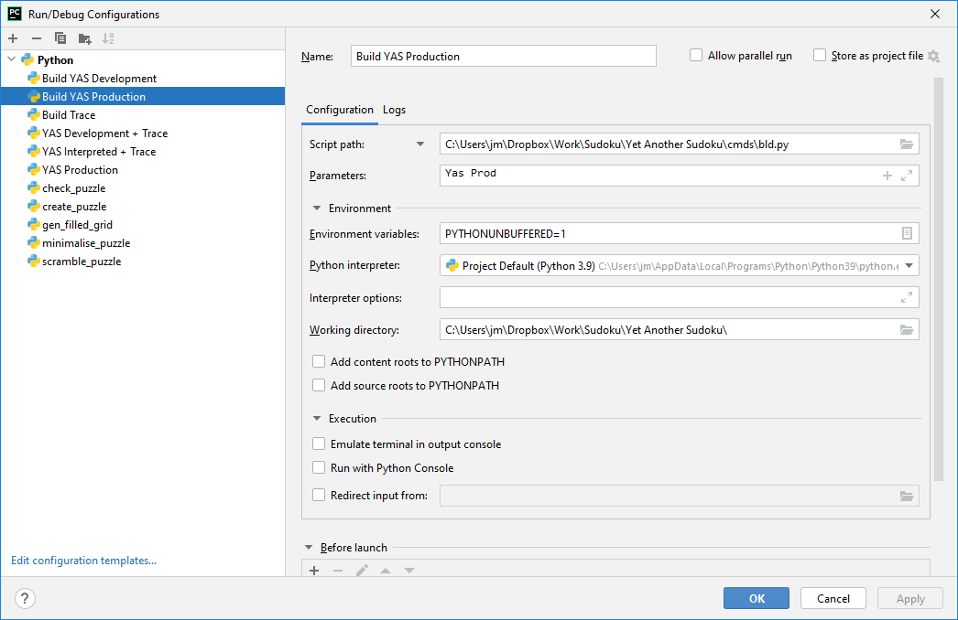
and/or
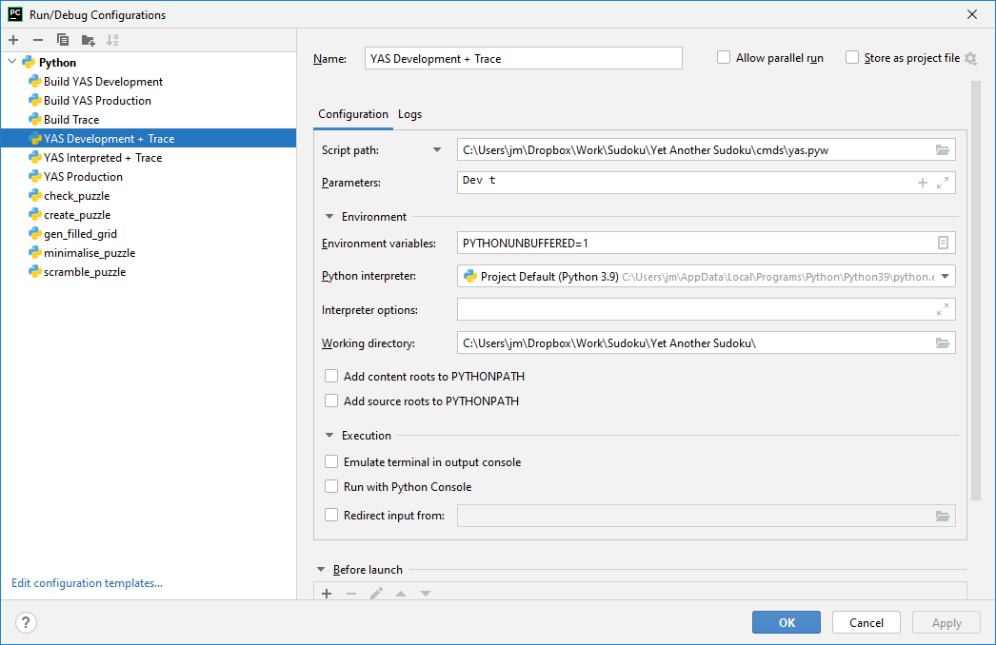

YAS Setuptools Build Script
Ref: https://docs.python.org/3.9/distutils/index.html

The latest source of the YAS setup.py script is found here.

This script accepts the command line parameters and BLD environment variable from the build script above, and uses those parameters to determine how to build and where to place the YAS Cython Compiled targets.

See: 9.APPENDIX C: Installing MinGW-w64 and Cython setup and https://docs.python.org/3.7/distutils/apiref.html

Environment Variables only for Command being Executed
This is the windows equivalent of executing the following in bash:
CYTHON = 1 <command>

In the windows command prompt:
cmd /v/c "set CYTHON=1&& <command>"

Cython in a Nutshell / Implementation Comments
- def: Defines python function in ,py and .pyx files. Functions parameters can be either Cython or Python declared in .pyx files.
- cdef: Define C constructs (functions, variables, etc.) in .pyx files. Expects function params to be Cython declared (parameter types know at compile time).
- cpdef: Define Python wrapped C constructs in .pyx files. Python wrapped means that the code is accessible from both Cython directly and Python via the wrapper. Function parameters can be either Cython or Python declared.

So if cpdef gives the best of both worlds why don’t we always use it?
- Often where speed is concerned, more efficiencies are achieved with a hand crafted wrapper specific to the purpose than the Cython generated one which needs to account for much more variability.
- Not necessary where Cython code is calling Cython code.

Cython code can call Python code implicitly irrespective of the Python code being compiled or interpreted. Where speed efficiency is concerned, where possible convert called Python code to Cython code. See: Appendix D: Cython Code Optimisation

Cython / Python Interoperability

 | Importing Module | Imported Module | Calling Code | Called Code | Comment
1 | Interpreted  .py | Interpreted  .py | Python | Python  def f() | Implicit – least efficient
2 | Interpreted  .py | Interpreted  .py | Python | Cython/C | Not using “Pure Python” Cython
3 | Interpreted  .py | Interpreted  .py | Cython/C | Python  def f() | Not using “Pure Python” Cython
4 | Interpreted  .py | Interpreted  .py | Cython/C | Cython/C | Not using “Pure Python” Cython
5 | Interpreted  .py | Compiled  .py or .pyx | Python | Python | Implicit
6 | Interpreted  .py | Compiled  .pyx | Python | Cython/C  cpdef f() | Automagic creation of Py wrapper around Cy code.
7 | Interpreted  .py | Compiled  .py or . pyx | Cython/C | Python  def f() | Not using “Pure Python” Cython.
8 | Interpreted  .py | Compiled  .pyx | Cython/C | Cython/C | Not using “Pure Python” Cython
9 | Compiled  .py or .pyx | Interpreted  .py | Python | Python  def f() | Implicit
10 | Compiled  .py or .pyx | Interpreted  .py | Python | Cython/C | Not using “Pure Python” Cython
11 | Compiled  .pyx | Interpreted  .py | Cython/C | Python | Implicit
12 | Compiled  .pyx | Interpreted  .py | Cython/C | Cython/C | Not using “Pure Python” Cython
13 | Compiled  .py or .pyx | Compiled  .py or .pyx | Python | Python  def f() | Implicit
14 | Compiled  .py or .pyx | Compiled  .pyx | Python | Cython/C  cpdef f() | Automagic creation of Py wrapper around Cy code.
15 | Compiled  .pyx | Compiled  .py or .pyx | Cython/C | Python | Implicit
16 | Compiled  .pyx | Compiled  .pyx | Cython/C | Cython/C  cdef f() | Implicit – most efficient

APPENDIX B: Tracing functionality
Tracing in this context refers to tracking the execution path through the code outputting relevant information. This is achieved in the most simplistic sense with print statements to the console. The tracing functionality here builds on this providing a perf count, file, line number and function in which the code is executing.

This functionality is borne out of the absence and apparent reluctance of Jetbrains to implement Cython debugging in their IDE. Tracing is the poorer cousin to an GUI IDE with breakpoints, single stepping, watches, etc. This requirement is different from Python’s trace support.

It took me some time to workout how to get this all to work. Here are some useful references I found along the way:
https://docs.python.org/3.9/library/inspect.html#the-interpreter-stack
https://stackoverflow.com/questions/5574702/how-to-print-to-stderr-in-python
https://stackoverflow.com/questions/24438976/debugging-get-filename-and-line-number-from-which-a-function-is-called
https://docs.python.org/3/library/functions.html#print
https://cython.readthedocs.io/en/latest/src/tutorial/profiling_tutorial.html
https://docs.python.org/3/c-api/init.html#profiling-and-tracing
https://stackoverflow.com/questions/28301931/how-to-profile-cython-functions-line-by-line

In interpreted Python Code
This effort resulted in the following very small module which can be found here.

This module relies on the boolean value TRC from globals.py enable trace output or not. Also unlike C, function stub is used when TRC is False rather than having a compile time wrapper.

But when these TRCX statements were used in Cython compiled code, the file-name, line number and function name where that of the of the interpreted line of code that called the compiled code, no matter the depth of subroutine calls in the compiled call. This is because the compiled C code uses a different stack frame than that used for interpreted code.

In Cython Compiled Code
Recognition goes to David Woods (dw-git@d-woods.co.uk) for assisting me with working towards a solution on the cython-users google group: https://groups.google.com/u/2/g/cython-users/c/OwHQUtsJKlQ

Non-Viable Approaches Considered
Initially I embarked on a search to find the equivalent of __FILE__, __LINE__, and __FUNCTION__ in the Cython compiler that I could compile into the CYTHON, if only life would be that easy.

Next following David’s first suggestion of embedding some C code, I was able to pull gcc’s __FILE__, __LINE__, and __FUNCTION__ defines and incorporate them into the trace statement. Having the trace statements output this information from the Cython generated C file is “kind of” useful as it is possible to work back to the location in the .pyx Cython file. This is a lot of extra work and deters from the attractiveness of what I am attempting to achieve. There has to be a better way.

After much searching and learning about Python’s inspect module, and Cython’s information on profiling and line tracing, I rephrased this challenge on the cython-user’s group: ‘From within Cython compiled code with "# cython: profile=True", how is the profiling stack frame interrogated to retrieve the names, cython (not C) source file line numbers, and function name, from within the executing code? ‘ This yeilded the clue to solving this challenge.

Viable Approach First Attempt
Developing on the suggestiion that David made in answer to the rephrased challenge, the first attempt became.

>>>>>>>>>>trc.pyx
from sys import stderr
from time import perf_counter
from inspect import getframeinfo
from cpython.pystate cimport PyFrameObject, Py_tracefunc
from cpython cimport PyObject
from globals import TRC
cdef extern from "frameobject.h":
pass
cdef extern from *:
void PyEval_SetTrace(Py_tracefunc, o)
Fi =(None, None, None, None, None, None)
cdef int tracefunc(PyObject* o, PyFrameObject* frame, int what, PyObject* arg):
global Fi
Fi = getframeinfo(<object>frame)
if TRC:
PyEval_SetTrace(tracefunc, None)
def TRCX(*args, **kwargs):
print(f"{perf_counter():0.6f}:{Fi.filename}:{Fi.lineno}:{Fi.function}:", *args, file = stderr, flush = True, **kwargs)
else:
def TRCX(*args, **kwargs):
pass
Basically PyEval_SetTrace() Python C-API function installs a line trace callback function, that passes information regarding the stack frame. This callback is executed for every line of code executed, both Python interpreted code and Cython code that is built with #cython: linetrace=True and #distutils: define_macros=CYTHON_TRACE=1.
In the tracefunc() callback, the frame structure is converted from the C PyFrameObject by the Python getframeinfo() function. getframeinfo() returns the frame information in a six field Python named tuple. This returned information is saved to the global Fi python variable.

If TRC is True then the TRCX function retrieves the relevant information from Fi for its print statement.

This worked well at first blush, . . . . but . . . .
- Code execution ground to an almost standstill for anything other than the most trivial examples.
- Debugging breaks as soon as the first Cython module compiled with #cython: linetrace=True and #distutils: define_macros=CYTHON_TRACE=1

Viable Approach Second Attempt
It did not take long to work out that the slow code execution was due to the overhead introduced in the callback function. All the conversion from C structures to Python as well as the time taken for getframeinfo() to do its magic were the culprits.

This second attempt modifies the linetrace() callback such that is simply copies the pointer to the C PyFrameObject structure to a (module wide) global variable pPFO. As this function is now pure c code with no Python interaction it is safe not to hold the GIL when this function executes which translates to better efficiencies. Furthermore all Cython code being compiled can be compiled with #distutils: define_macros=CYTHON_TRACE_NOGIL=1 instead of #distutils: define_macros=CYTHON_TRACE=1. #cython: linetrace=True is still required.

Coercing the Python Frame information out this structure now only happens when TRCX() is called. The latest version is here.

Building the Cython trc module.
From the command line, ensure the cmds/ directory off the project root is in the system path. From the command line execute:
bld.py trc f. (f overrides time dependency checks forcing the build).

Under the hood, the bld.py script invokes trc’s setup script to Cython compile it.

From within PyCharm, set up a Run/Debug Configuration as follows:
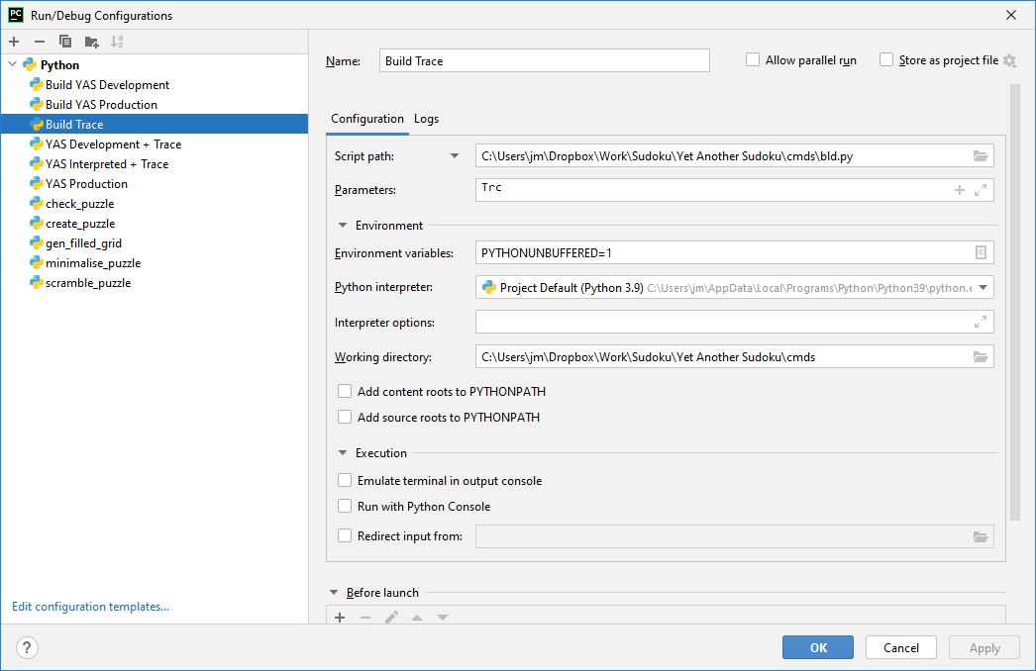
Change parameters to “Trc f” to force the build.

Additional TRCX Helper Functions for Cython

cdef void TRCX_grid(int G[9][9])

cdef void TRCX_cands(bint C[9][9][9])

cdef void TRCX_memdump(void *Addr, int len)

cdef void *PyMem_TRCX_Malloc(size_t Bytes)

cdef void *PyMem_TRCX_Calloc(size_t Nr, size_t Bytes)

cdef void PyMem_TRCX_Free(void *Mem)

Additional Considerations

Interoperability with Python Interpreted Code
This code works well with in both interpreted and compiled target modules. The src/trc.py module is also kept for running only interpreted code. See the ‘Run YAS Interpreted’ Run/Debug configuration in PyCharm in Appendix A above.

All Cython files that use TRCX statements need to be compiled with:
# cython: linetrace=True
# distutils: define_macros=CYTHON_TRACE_NOGIL=1

Line tracing support that Cython adds to the compiled code with linetrace=True can be significant. The CYTHON_TRACE_NOGIL=1 C macro is used to direct the C compiler (gcc) to compile in this line trace support.

This increased code can create a significant code execution slowdown which cuts against the whole purpose of using Cython. This points to having both development and production binaries built off the same Cython sources. The development binaries include this line trace support, and the production binaries are the most optimised code. This works around the second issue identified in the first viable approach attempt.

Note: Only the production binary of trcx is required. Trcx does not (must not) be built with linetrace enabled.

TRCX Usage / Limitations
- When using TRCX to print the contents of Cython objects (ie, arrays, structs, etc) or functions, do it this way:
  - zzz = f”H:{H}”
TRCX(zzz) # where H is a Cython declared array or struct of function.
  - Rather than
    - TRCX(f”H:{H}”)
    - or zzz = f”H:{H}”; TRCX(zzz)
- Always put TRCX_... and PyMem_TRCX_... functions on their own line. Undefined results can occur otherwise.
The last two latter captures the function calls to Python’s C-API rather than TRCXfor translating objects to strings in its trace prefix string. Note that with the last example Cython appears of optimize by collapsing related statements on the same line, but not on different lines. If there is a way to limit this Cython optimizing, I have yet to find it.

How this is all pulled together in a build environment is discussed in Appendix A: Development Environment Notes above.

APPENDIX C: Installing MinGW-w64 and Cython setup.

Some references:
https://docs.python.org/3/distutils/apiref.html for list of extension options.
https://cython.readthedocs.io/en/latest/src/userguide/source_files_and_compilation.html
https://cython.readthedocs.io/en/latest/src/tutorial/appendix.html

Installing MinGW-w64
- Retrieve archive from https://winlibs.com/. Obtained the latest version build.
- Extract archive in temp area.
- Copied mingw64 folder and below to C:\Program Files\WinLibs\mingw64.
- Added C:\Program Files\WinLibs\mingw64 to the path. (ensure this path entry is above the Cygwin entry, else that gcc gets found first.
- QED.

Changes to Distutils in Setuptools
Add distutils.cfg to C:\Users\jm\AppData\Local\Programs\Python\Python39\Lib\Distutils. Per: https://wiki.python.org/moin/WindowsCompilers

Remember to make this change everytime Python or Setuptools is upgraded.

>>>>>> distutils.cfg
[build]
compiler=mingw32

[build_ext]
compiler=mingw32
<<<<<<<<<

NOTE: Many of the changes shown here have been implemented in Setuptools 60.50. Next time I feel like a distraction, I could attempt to upgrade setuptools. Perhaps with Python 3.10 and wxpython with 3.10 support.

Patch required to C:\Users\jm\AppData\Local\Programs\Python\Python39\Lib\distutils/cygwincompiler.py (which also handles minGW-w64). See changes I made.

>>>>>>>
$ diff -u cygwinccompiler.py.old cygwinccompiler.py
--- cygwinccompiler.py.old 2021-08-30 20:35:24.000000000 +0200
+++ cygwinccompiler.py 2021-12-08 19:35:15.876490200 +0200
@@ -80,9 +80,12 @@
elif msc_ver == '1600':
# VS2010 / MSVC 10.0
return ['msvcr100']
- else:
- raise ValueError("Unknown MS Compiler version %s " % msc_ver)
-
+ elif msc_ver == '1700':
+ # VS2012 / MSVC 11.0
+ return ['msvcr110']
+ else: # if msc_ver == '1800':
+ # VS2013 / MSVC 12.0
+ return ['msvcr120'] # a hack to get it to work for me latest version of RT on my computer

class CygwinCCompiler(UnixCCompiler):
""" Handles the Cygwin port of the GNU C compiler to Windows.
@@ -109,22 +112,21 @@
"Compiling may fail because of undefined preprocessor macros."
% details)

- self.gcc_version, self.ld_version, self.dllwrap_version = \
- get_versions()
- self.debug_print(self.compiler_type + ": gcc %s, ld %s, dllwrap %s\n" %
+ self.gcc_version, self.ld_version = get_versions()
+ self.debug_print(self.compiler_type + ": gcc %s, ld %s\n" %
(self.gcc_version,
- self.ld_version,
- self.dllwrap_version) )
+ self.ld_version) )

# ld_version >= "2.10.90" and < "2.13" should also be able to use
# gcc -mdll instead of dllwrap
# Older dllwraps had own version numbers, newer ones use the
# same as the rest of binutils ( also ld )
# dllwrap 2.10.90 is buggy
- if self.ld_version >= "2.10.90":
- self.linker_dll = "gcc"
- else:
- self.linker_dll = "dllwrap"
+ # if self.ld_version >= "2.10.90":
+ # self.linker_dll = "gcc"
+ # else:
+ # self.linker_dll = "dllwrap"
+ self.linker_dll = "gcc"

# ld_version >= "2.13" support -shared so use it instead of
# -mdll -static
@@ -135,11 +137,11 @@

# Hard-code GCC because that's what this is all about.
# XXX optimization, warnings etc. should be customizable.
- self.set_executables(compiler='gcc -mcygwin -O -Wall',
- compiler_so='gcc -mcygwin -mdll -O -Wall',
- compiler_cxx='g++ -mcygwin -O -Wall',
- linker_exe='gcc -mcygwin',
- linker_so=('%s -mcygwin %s' %
+ self.set_executables(compiler='gcc',
+ compiler_so='gcc -mdll',
+ compiler_cxx='g++',
+ linker_exe='gcc',
+ linker_so=('%s %s' %
(self.linker_dll, shared_option)))

# cygwin and mingw32 need different sets of libraries
@@ -297,9 +299,9 @@
raise CCompilerError(
'Cygwin gcc cannot be used with --compiler=mingw32')

- self.set_executables(compiler='gcc -O -Wall',
- compiler_so='gcc -mdll -O -Wall',
- compiler_cxx='g++ -O -Wall',
+ self.set_executables(compiler='gcc',
+ compiler_so='gcc -mdll',
+ compiler_cxx='g++ ',
linker_exe='gcc',
linker_so='%s %s %s'
% (self.linker_dll, shared_option,
@@ -394,7 +396,7 @@

If not possible it returns None for it.
"""
- commands = ['gcc -dumpversion', 'ld -v', 'dllwrap --version']
+ commands = ['gcc -dumpfullversion', 'ld -v']
return tuple([_find_exe_version(cmd) for cmd in commands])

def is_cygwingcc():
<<<<<<

Changes is the Python Distibution
Patch required to C:\Users\jm\AppData\Local\Programs\Python\Python39\include/pyconfig.h
From https://github.com/cython/cython/issues/3405

Remember to carry out this update everytime Python is upgraded.

--- pyconfig.h 2016-01-27 10:54:56.000000000 +0300
+++ pyconfig.h 2016-03-28 11:46:48.000000000 +0300
@@ -100,6 +100,12 @@

/* Compiler specific defines */

+#ifdef __MINGW32__
+#ifdef _WIN64
+#define MS_WIN64
+#endif
+#endif
+
/* ------------------------------------------------------------------------*/
/* Microsoft C defines _MSC_VER */
#ifdef _MSC_VER

A setup.py Example
>>>>>>>>>>>>>>
from setuptools import setup
from Cython.Build import cythonize
from setuptools.command.build_ext import build_ext
# look at https://docs.python.org/3/distutils/apiref.html for list of extension options.
# https://cython.readthedocs.io/en/latest/src/userguide/source_files_and_compilation.html
# https://cython.readthedocs.io/en/latest/src/tutorial/appendix.html
# remember to add "build_ext --build_lib lib” in setup's run config in pycharm.
link_args = ['-static-libgcc',
'-static-libstdc++',
'-Wl,-Bstatic,--whole-archive',
'-lwinpthread',
'-Wl,--no-whole-archive']
compile_args = ['-O3', # optimising for speed
'-Wall'] # all warnings
class Build(build_ext):
def build_extensions(self):
if self.compiler.compiler_type == 'mingw32':
for e in self.extensions:
if link_args: e.extra_link_args = link_args
if compile_args: e.extra_compile_args = compile_args
super(Build, self).build_extensions()
setup(
cmdclass = {'build_ext': Build},
name ='Factorials',
ext_modules = cythonize(["facts_c.py", "facts_tcr_c.py", "facts_iter_c.py"],
compiler_directives = {'language_level': 3,
'boundscheck': False,
'wraparound': False},
annotate = True
),
zip_safe = False,
)
<<<<<<<<<<<

Appendix D: Cython Code Optimisation

Cython Optimising Suggestions
There is no "one size fits all" approach to Cython optimising. There are some general guidelines listed below that produce tighter code (less python or cython overhead). But the real speed improvements are achieved by identifying and isolating speed bottlenecks and converting that code to a .pyx with Cython optimisation syntax code. This is an iterative process which gets better with one’s experience. Examine the resulting html files – they are your friends. They show the translation to c and the python overheads and through trying things and seeing the code produced, one builds a knowledge base of experience on what and how to optimise.

- Pareto lives in the code. The majority of speed gains come from the optimisation of a small percentage of code. Identify and only focus on that code only. A profiler can be useful in identifying these bottlenecks.
- Generally, an order of magnitude or more speed improvement by using cython syntax in a .pyx file for complete functions (cdef the function declaration). Cython’s “Pure Python” approach only appears to give about a doubling in speed performance.
- Do not waste time on “Pure Python” code, working in .pyx file cdef’ing whole functions is much more productive.
- If Cython code returns nothing remember to cdef void <fn>(<vars>) Otherwise Cython compiler crates a Python Null object to return reduces efficency.
- Use cdef inline for small bits of code that enhance readability when in a function or for small functions in tight tight / deep or intensive looping or recursion. This eliminates the calling overhead, which albeit small adds up over many recursions or iterations.
- A python wrapper is required around a cdef’d function if it is to be accessed from another module. In most cases a simple hand-crafted wrapper is more effective than using Cython’s “cpdef” automagic wrapper generation.
- Use -O3 compiler optimisation - this gives the greatest speed improvements. Unoptimised compiled code often ran slower than interpreted code. See Appendix C on how to select compiler and change compiler options.
- Anecdotally, I have found:
  - Compiled pure python code without any cython dressing is between 50% to 250% faster than interpretted code.
  - Interpretted Cython dressed “Pure Python” code runs about same speed to 25% slower than interpretted undressed python code.
  - Compiled Cython dressed “Pure Python” code yields a 50% to 100% speed improvement over the same interpretted code.
  - There is mostly no significant improvement in complied Cython “Pure Python” dressed code and compiled base Python code. Many times the compiled base code targets run 10’s of % faster than compiled Cython dressed “Pure Python” code. This is my motivation for advising not to waste time on with Cython’s “Pure Python” compilations.
  - The greatest improvement of an order of magnitude or greater over interpreted base code is implementing cdef’d functions in .pyx files.
- Arrays are not pre-initialized to zero, must be explicitly done in the code eg:
cdef int G[9][9]
cdef int cell = r
for r in range(9):
G[r][:] = [0, 0, 0, 0, 0, 0, 0, 0, 0]
Here it is more efficient to use C’s memset() or memcpy() instead of specifying initial values in the code. See below.
- In places that need optimisation, rely on the c library equivalents, steer clear of anything in the python libraries. It took me a while to work this out and get it working, so here’s an example to get going:
cdef extern from "stdlib.h":
void srand (unsigned int)
int rand()
cdef extern from "time.h":
long int time(int)
cdef unsigned rr, t
cdef int[9] vals = [1, 2, 3, 4, 5, 6, 7, 8, 9]
srand(time(0))
# Fisher Yates shuffle
while len:
rr = rand() % len
len -= 1
t = vals[len]
vals[len] = vals[rr]
vals[rr] = t
- When calling Python functions from within Cython code (if you really really have to), make sure to it with Python vars and not cdef’d parameters. Will work with cdef’d variables but the implicit conversion to python parameters is most times much less efficient than using python variables. In the above code, calling Python’s random.shuffle() with Python variables ran three times faster than code that had to implicitly convert Cython variables to Python variables. Nevertheless the Cython implementation of the Fisher Yates shuffle ran 30 times faster than the Python code with Python variables.
- Add ‘boundscheck’: False / ‘wraparound’: False to setup.py above. See. https://cython.readthedocs.io/en/latest/src/userguide/source_files_and_compilation.html#compiler-directives. Code defensively, the training wheels and safety guards are off.
- Cython code: if x in y: where y is a Cython array crashes Cython compiler. https://github.com/cython/cython/issues/4483. Work around is (which produces very tight code.
for r1 in h1:
if v1 == r1:
print("True")
break
else:
print("False")
- For loops, this code generates the most speed optimal code, than any other alternatives. Note that Hr, H[], r and c are cdef’d Cython variables.
for Hr in H:
r = Hr//9; c = Hr%9
- The overhead referencing an array variable with it’s index (A[i]) is negligable. Very little if anything is gained by assigning A[i] to to a scalar, ie b = A[i], and then using b.
- The same cimport statement for a C function (declared with cdef) in a pyd file needs to exist in the caller and callee module, else compiler warns about an unused function which it optimises out because it believes it is not used in the callee module. This was not clear to me in the documentation, but the following link gave me the clues to resolving this: https://cython-users.narkive.com/zYmecug1/how-to-make-cython-generate-pyx-capi
- In list comprehensions the iterating variables are created in the scope of the comprehension and only exist in that name space. For example:
- cdef int r, c
cdef grid[9][9]
. . . . . .
G = [[grid[r][c] for c in range(9)] for r in range(9)]
The cdef declarations of r and c are unused and the r and c autogenerated in the comprehension name space will be used.
- Copying a Cython array back to a cython list.Following from the above, from examining the resulting Cython produced C code it is not clear which will produce the faster code between:
cdef int r, c
cdef int G[9][9]
G1 = [[0 * 9] * 9]
for r in range(9):
for c in range(9):
G1[r][c] = G[r][c]
return G1
and
return [[G[r][c] for c in range(9)] for r in range(9)]
That is, they both take approximately the same time to execute. The latter is more readable for Python coders and is therefore preferred.
- Use C’s memset() to initialise Cython arrays to same value, and memcpy() to bulk copy data from one Cython array to another for anything larger than about 16 bytes The following examples of c generated code justify this assertion:
  - Initialisation code:
+072: Cands[r][c1] = [False, False, False, False, False, False, False, False, False]
// Generated code
__pyx_t_6[0] = 0;
__pyx_t_6[1] = 0;
__pyx_t_6[2] = 0;
__pyx_t_6[3] = 0;
__pyx_t_6[4] = 0;
__pyx_t_6[5] = 0;
__pyx_t_6[6] = 0;
__pyx_t_6[7] = 0;
__pyx_t_6[8] = 0;
memcpy(&(((__pyx_v_Cands[__pyx_v_r])[__pyx_v_c1])[0]), __pyx_t_6, sizeof(((__pyx_v_Cands[__pyx_v_r])[__pyx_v_c1])[0]) * (9));
  - vs. Using memset()
+075: memset(<void *>&Cands[r][c1][0], False, 36) # 9 x 4bytes = 36
// Generated Code
(void)(memset(((void *)(&(((__pyx_v_Cands[__pyx_v_r])[__pyx_v_c1])[0]))), 0, 36));
- I have not found anything more efficient than looping to copy Python lists into Cython arrays.
- Consider using Python’s array and bytearray objects for single dimension structures.
- Python’s PyMem_Malloc(), PyMem_Realloc() and PyMem_Free() C_API functions are generally faster for memory allocations ~<= 512 bytes as they make use of python’s internal memory caching rather than going to the operating system for memory. This allocated memory falls under Python’s memory management, and requires the GIL to be held. For larger memory allocations these furnctions fall back to the PyMem_RawMalloc(), PyMem_RawRealloc(), and PyMem_RawFree() which are simply wrappers to standard C’s malloc(), realloc() and free(). As these PyMem_Raw...() functions do not require the GIL to be held, they can be used as alternatives to the PyMem_...() functions to avoid slowdowns caused by pending for the GIL in multi-threaded apps. There is nothing stopping one from using the ‘C’ memory functions directly either.
In YAS where there is no multi-threading (yet) and most memory allocations are for structs of less than 512 bytes, the PyMem_...() functions are the most appropriate choice for speed and efficiency.
See: https://docs.python.org/3/c-api/memory.html#memory-interface and https://docs.python.org/3/c-api/memory.html#the-pymalloc-allocator.
- PyMem_Calloc() is faster than PyMem_Malloc + memset(). If more than 3 or 4 individual fields need to be set, PyMem_Calloc() appears faster than Malloc and manually assigning the fields – YMMV on this last point.
- Cython (C) pointers to Cython (C) objects are very fast.
- Iterating over an index range to an array produces slightly tighter C code than directly iterating over the array, for example:
for i in range(ArrayLen):
do_something(Array[i])
produces slightly tighter/faster C code than:
for ArrayElem in Array:
do_something(ArrayElem)

General Python Optimising Suggestions
These comments/suggestions are more relevant for interpreted code than compiled .pyx code unless otherwise specified. No need to consider compiled .py solutions, their gains pale in significance against compiled cyx. improvements.

- Recursion:
  - Interpreted Code: Tail Call Recursion reduces speed performance by about 10%, and converting recursion to iteration increases performance by about 45% yielding an overall approximate 35% speed improvement.
  - Compiled Code: there is no significant performance gains between regular recursion, tail end conversion, and iterative code; so there is no impetus to convert existing recursive code.
- In interpreted code, converting for loops to while loops does not gain anything, and in many cases results in slower code.
- In interpretted code, while 1: runs slightly faster than while True:, no difference in compiled code.
- Compiled code: for x in range(y): produces tighter C code than for x in [0, 1, 2, . . . ,y-1]: This is because [0, 1, ...]: is a python structure with n C equiv.
- Using Python variables inside Cython functions just creates lots of python overhead in the compiled files.
- Compiled code: There is no significant gain playing with expressions with cython variables as they are efficiently compiled, not necessarily the case with interpreted. But generally for interpreted code <equation> <comp operator> <variable/literal> yields the fastest results.
- Python’s random.shuffle() function executes 10%– 15% faster than random.sample()
- Smallest amount of code (least number of lines of python instructions tends to produce faster code
- Dummy functions: both examples work with no perceivable performance boost or degredation.
  - def TRCX(*args, **kwargs)
pass
OR
  - TRCX = lambda *args, **kwargs: None
I have not yet found the equivalent C functionality:
#ifdef <cond>
#define <wrapped_fn>(args...) fn(__FILE__, ## args)
#else
#define <wrapped_fn(args...)
#endif
int fn(const char*, ...);
- Favour list comprehensions over deepcopy. See: https://stackoverflow.com/questions/24756712/deepcopy-is-extremely-slow and https://web.archive.org/web/20100507015024/http://blog.cdleary.com/2010/04/efficiency-of-list-comprehensions/
- Copying lists of sets. Needs to ‘deepcopy’ to copy the set values rather than the references. Instead of slow (but convenient) deepcopy(), do this with a shallow copy in the list comprehension
From copy import copy
LoS = [set(), set() . . . .]
LoS1 = [copy(s) for s in LoS]
- List comprehensions are faster than for equivalent for loops, especially for simple operations like copying, initialising, appending, accumulating, etc. type operations. As the complexity of the operations increases, the significance of the list comprehension saving is swamped by the time in the complex operations. For complex operations, execution times for list comprehensions and equivalent for loops are comparible.
- Importing module best practices.
  - Imports at top of files only. Importing in functions drastically reduces performance of that function.
  - Explict imports only.
  - From <module> import <obj1>, <obj2> For system, 3rd party, and local modules where only a few objects are being accessed. Mostly, import only what is needed.
  - Import <short module name> when making extensive use of many objects out of a third party module – for example “import wx”
  - Import <long module name> as <smn>, to assist in making code readable.
  - Favouring clarity and readability, only import what is needed for that module, be it other modules or objects from modules.
  - Globals.py is a common local file used across the project. Importing modules in globals.py makes those imported objects available to all files that import globals.py. However, cosider the following code snippet.
>>>>>>>a.py
import globals
import b
<<<<<<<
Anything declared in globals is available in a.py, but not in b.py. Say for example in this code snippet if globals.py imports wx., then there is no need to reimport wx in a.py. However if b.py needs to access objects from wx, b.py will need to import wx itself.
- Checking for multiple elements in a list. It is more than four times faster to check the individual elements than converting the list to a set and doing an intersection:
timeit("(1 not in M) or (4 not in M)", "M=[1,2,3]", number = 1000000)
0.065905199999861
timeit("not {2, 4} & set(M)", "M=[1,2,3]", number = 1000000)
0.2832971999999927

Benchmarking Examples

Primes
Runs, Interp., Compiled, Interp., Compiled, Compiled
, Base, Base py, Dressed, Dressed py, pyx.
1, 0.2096032, 0.0957458, 0.3199297, 0.2041336, 0.0174303
2, 0.3224971, 0.1098451, 0.2941512, 0.1846662, 0.0151573
3, 0.1878632, 0.1014700, 0.2831129, 0.1839496, 0.0161345
4, 0.2089307, 0.0926453, 0.2692851, 0.1757543, 0.0166516
5, 0.2511361, 0.0955674, 0.3426129, 0.1886763, 0.0178281
6, 0.2097355, 0.1005155, 0.3178017, 0.1845958, 0.0161769
7, 0.1933694, 0.0994195, 0.2802381, 0.1817224, 0.0150742
8, 0.3174478, 0.0955999, 0.3109823, 0.1749622, 0.0149917
9, 0.1865260, 0.0961703, 0.3331357, 0.1742634, 0.0151060
10, 0.2094037, 0.0929991, 0.3176092, 0.1917392, 0.0166424
Avg, 0.2296513, 0.0979978, 0.3068859, 0.1844463, 0.0161193
Min, 0.1865260, 0.0926453, 0.2692851, 0.1742634, 0.0149917
Imp, 2.01x, 0.69x, 1.07x, 12.44x

That is:
- About a 2x speed increase simply by compiling a base code.
- About a third speed decrease between interpreted base code and interpreted dressed code.
- No appreciable speed gain between interpreted base code and compiled dressed code.
- A 12x speed improvement between interpreted base code and compiled pyx file.

An examination of the cython generated html files showing the generated c code provides insight behind the performance gains losses.

Base Code:
>>>>>>>>
def primes(nb_primes):
p = []
n = 2
while nb_primes - len(p):
# Is n prime?
for i in p:
if n % i == 0:
break
else:
p.append(n)
n += 1
return p
<<<<<<<<<<

Dressed Code
>>>>>>>>>>
import Cython as cy
@cy.cfunc
def primes(nb_primes: cy.int):
# p = []
pc: cy.int[1000] = [0] * 1000
n: cy.int = 2
len_p: cy.int =0
while len_p < nb_primes:
# Is n prime?
for i in pc[:len_p]:
if n % i == 0: break
else:
pc[len_p] = n
len_p +=1
n += 1
return [pc[i] for i in range(len_p)]
<<<<<<<<<<

.pyx Code
>>>>>>>>>>
def primes(int nb_primes): # python wrapper
cdef int[1000] p
primesw(nb_primes, p)
return [p[i] for i in range(nb_primes)]
cdef void primesw(int nb_primes, int *p):
cdef int n = 2
cdef int i = 0
cdef int len_p = 0
while len_p < nb_primes:
for i in p[:len_p]:
if n % i == 0: break
# If no break occurred in the loop
else:
p[len_p] = n
len_p += 1
n += 1
<<<<<<<<<

Benchmark.py
>>>>>>>>>
#!/usr/bin/env python
import os, shutil
from timeit import timeit
NTESTS = 10
Ntimeits = 10
bn = "primes"
for f in [bn, bn+"_c"]:
fi = f+"i"
if os.path.exists(fi+".py"): os.remove(fi+".py")
shutil.copy(f+".py", fi+".py")
b = [[0.0 for j in range(6)] for i in range(NTESTS)]
Min = [0.0] * 5
Avg = [0.0] * 5
print("Runs, Interp., Compiled, Interp., Compiled, Compiled")
print(" , Base, Base py, Dressed, Dressed py, pyx.")
for i in range(NTESTS):
# Base code interpreted
b[i][0] = timeit(f"{bn}(1000)", f"from {bn}i import {bn}", number = Ntimeits)
# Base code compiled.
b[i][1] = timeit(f"{bn}(1000)", f"from {bn} import {bn}", number = Ntimeits)
# Dressed code interpreted
b[i][2] = timeit(f"{bn}(1000)", f"from {bn}_ci import {bn}", number = Ntimeits)
# Dressed code compiled
b[i][3] = timeit(f"{bn}(1000)", f"from {bn}_c import {bn}", number = Ntimeits)
# # Optimised code interpreted
b[i][4] = timeit(f"{bn}(1000)", f"from {bn}_o import {bn}", number = Ntimeits)
print(f"{i+1: 4d}, {b[i][0]:9.7f}, {b[i][1]:9.7f}, {b[i][2]:9.7f}, {b[i][3]:9.7f}, {b[i][4]:9.7f}")
for j in range(5):
A = 0.0
M = 999999.0
for i in range(NTESTS):
A += b[i][j]
M = min(M, b[i][j])
Avg[j] = A/NTESTS
Min[j] = M
print(f" Avg, {Avg[0]:9.7f}, {Avg[1]:9.7f}, {Avg[2]:9.7f}, {Avg[3]:9.7f}, {Avg[4]:9.7f}")
print(f" Min, {Min[0]:9.7f}, {Min[1]:9.7f}, {Min[2]:9.7f}, {Min[3]:9.7f}, {Min[4]:9.7f}")
print(f" Imp, {(Min[0]/Min[1]): 8.2f}x, {(Min[0]/Min[2]): 8.2f}x, {(Min[0]/Min[3]): 8.2f}x,"
f" {(Min[0]/Min[4]): 8.2f}x")
<<<<<<<<

Factorials
In this example we replace python’s infinite number of digits integer with long long. The purpose of this exercise is to demonstrate the efficiencies of compiling recursive algorithms. No mind that the dressed .py and .pyx compiled files with long long integers overflow for all but for factorials less than 20.

Runs, Interp., Compiled, Interp., Compiled, Compiled, Interp., Compiled, Compiled, Interp., Compiled, Compiled
, facts, facts, facts_c, facts_c, facts_cx, *_tcr, *_tcr, *_tcrx, *_iter, *_iter, *_iterx
1, 0.1963481, 0.0660121, 0.1828398, 0.0849679, 0.0041303, 0.2095067, 0.0960653, 0.0069669, 0.1507238, 0.0861653, 0.0046827
2, 0.2092988, 0.0657674, 0.1844881, 0.1041865, 0.0049771, 0.2517771, 0.1051880, 0.0048476, 0.1539427, 0.0806842, 0.0089224
3, 0.2022080, 0.0664236, 0.1817525, 0.0858783, 0.0041698, 0.2166974, 0.0960261, 0.0041206, 0.1313267, 0.0771676, 0.0040982
4, 0.1862203, 0.0674739, 0.1833521, 0.0862302, 0.0042347, 0.2129158, 0.1057102, 0.0040771, 0.1319091, 0.0788646, 0.0042187
5, 0.2087553, 0.0666806, 0.1861487, 0.0897212, 0.0043003, 0.2124415, 0.1072804, 0.0048729, 0.1492731, 0.0766808, 0.0042019
6, 0.2052217, 0.0687986, 0.2284450, 0.0950127, 0.0043136, 0.2063680, 0.0939267, 0.0042958, 0.1331135, 0.0777101, 0.0043281
7, 0.1866153, 0.0674839, 0.1911859, 0.0874474, 0.0043479, 0.2155365, 0.0946707, 0.0040614, 0.1326358, 0.0781504, 0.0040921
8, 0.1852918, 0.0657177, 0.1884430, 0.0853060, 0.0042239, 0.2080382, 0.0942969, 0.0040611, 0.1324209, 0.0781469, 0.0040745
9, 0.1872296, 0.0695334, 0.1835118, 0.0883630, 0.0041159, 0.2677817, 0.0949384, 0.0040678, 0.1334530, 0.0786649, 0.0041848
10, 0.1886884, 0.0693086, 0.1842105, 0.0881131, 0.0086653, 0.2209582, 0.0981765, 0.0040903, 0.1450568, 0.0830950, 0.0085901
Avg, 0.1955877, 0.0673200, 0.1894377, 0.0895226, 0.0047479, 0.2222021, 0.0986279, 0.0045461, 0.1393855, 0.0795330, 0.0051393
Min, 0.1852918, 0.0657177, 0.1817525, 0.0849679, 0.0041159, 0.2063680, 0.0939267, 0.0040611, 0.1313267, 0.0766808, 0.0040745
Imp, 2.82x, 1.02x, 2.18x, 45.02x, 0.90x, 1.97x, 45.63x, 1.41x, 2.42x, 45.48x

Considering the interpreted code times, dressing the code does not significantly change the performance. This I believe is because of a balancing out of introducing cython overhead and efficiencies of using long long over python’s int. Converting the recursion to tcr slows the code by about 10%, and using iteration over recursion yields approximately a 35% improvement over the base code and therefore an approximate 45% improvement over the tcr code.

Compiling the “Pure Python” dressed code yields a slightly better than doubling of speed for the base code and just less a doubling of speed for the dressed pure code versions.

However the real speed improvements come with the compiling of Cython .pcx files, approximately 45 times improvement over base interpreted code. That is something that took a minute to compute now takes about 1.3 seconds. The difference in performance between ordinary recursion, tail code recursion and iteration instead of recursion, are not really materially different with any significance. Therefore the most improvements are gained by converting Python syntax to Cython syntax and for complete functions and providing python wrappers.

Base facts.py
>>>>>>>>
def fact(n):
if n == 0: return 1
return n * fact(n - 1)
<<<<<<<<

Dressed facts_c.py
>>>>>>>>>
import Cython as cy
def fact(n: cy.int):
return _fact(n)
@cy.cfunc # code is minimally faster without the decorator.
def _fact(n: cy.int):
if n <= 1: return 1
else: return n * _fact(n - 1)
<<<<<<<<<

Cython facts_cx.pyx
>>>>>>>>
def fact(long long n):
return _fact(n)
cdef long long _fact(long long n):
if n == 0: return 1
else: return n * _fact(n - 1)
<<<<<<<<

Dressed Tail Call Recursion facts_tcr.py
>>>>>>>>
import Cython as cy
def fact(n: cy.longlong):
return _fact(n, 1)
@cy.cfunc
def _fact(n: cy.longlong, a: cy.longlong):
if n <= 1: return a
return _fact(n - 1, n * a)
<<<<<<<<

Cython Tail Call Recursion facts_tcrx.pyx
>>>>>>>>>
def fact(long long n):
return _fact(n, 1)
cdef long long _fact(long long n, long long a):
if n <= 1: return a
return _fact(n - 1, n * a)
<<<<<<<<<

Dressed Iterative Solution
>>>>>>>>
import Cython as cy
# fact is a python function, _fact is a cython function.
def fact(n: cy.longlong):
return _fact(n, 1)
@cy.cfunc
def _fact(n: cy.longlong, a: cy.longlong):
while 1:
if n <= 1: return a
else: n, a = n - 1, n * a
<<<<<<<<

Cython Iterative Solution
>>>>>>>>
def fact(long long n):
return _fact(n, 1)
cdef long long _fact(long long n, long long a):
if n <= 1: return a
return _fact(n - 1, n * a)
<<<<<<<<

benchmark.py
>>>>>>>>
#!/usr/bin/env python
import os, shutil
from timeit import timeit
NTESTS = 10
Ntimeits = 100000
bn = "facts"
fn = "fact"
for f in [bn, bn+"_c", bn+"_tcr", bn+"_iter"]:
fi = f+"i"
if os.path.exists(fi+".py"): os.remove(fi+".py")
shutil.copy(f+".py", fi+".py")
b = [[0.0 for j in range(11)] for i in range(NTESTS)]
Min = [0.0] * 11
Avg = [0.0] * 11
print("Runs, Interp., Compiled, Interp., Compiled, Compiled, Interp., Compiled, Compiled, Interp., Compiled, Compiled")
print(" , facts, facts, facts_c, facts_c, facts_cx, *_tcr, *_tcr, *_tcrx, *_iter, *_iter, *_iterx")
for i in range(NTESTS):
# Base code interpreted
b[i][0] = timeit(f"{fn}(20)", f"from {bn}i import {fn}", number = Ntimeits)
# Base code compiled.
b[i][1] = timeit(f"{fn}(20)", f"from {bn} import {fn}", number = Ntimeits)
# Dressed code interpreted (*_c.py)
b[i][2] = timeit(f"{fn}(20)", f"from {bn}_ci import {fn}", number = Ntimeits)
# Dressed code compiled (*_c.py
b[i][3] = timeit(f"{fn}(20)", f"from {bn}_c import {fn}", number = Ntimeits)
# Dressed code compiled (*_cx.pyx
b[i][4] = timeit(f"{fn}(20)", f"from {bn}_cx import {fn}", number = Ntimeits)
# Dressed code interpreted (*_tcr.py)
b[i][5] = timeit(f"{fn}(20)", f"from {bn}_tcri import {fn}", number = Ntimeits)
# Dressed code compiled (*_tcr.py
b[i][6] = timeit(f"{fn}(20)", f"from {bn}_tcr import {fn}", number = Ntimeits)
# Dressed code compiled (*_tcrx.pyx
b[i][7] = timeit(f"{fn}(20)", f"from {bn}_tcrx import {fn}", number = Ntimeits)
# Dressed code interpreted (*_iter.py)
b[i][8] = timeit(f"{fn}(20)", f"from {bn}_iteri import {fn}", number = Ntimeits)
# Dressed code compiled (*_iter.py
b[i][9] = timeit(f"{fn}(20)", f"from {bn}_iter import {fn}", number = Ntimeits)
# Dressed code compiled (*_iterx.pyx
b[i][10] = timeit(f"{fn}(20)", f"from {bn}_iterx import {fn}", number = Ntimeits)
print(f"{i+1: 4d}, {b[i][0]:9.7f}, {b[i][1]:9.7f}, {b[i][2]:9.7f}, {b[i][3]:9.7f}, {b[i][4]:9.7f}, {b[i][5]:9.7f},"
f" {b[i][6]:9.7f}, {b[i][7]:9.7f}, {b[i][8]:9.7f}, {b[i][9]:9.7f}, {b[i][10]:9.7f}")
for j in range(11):
A = 0.0
M = 999999.0
for i in range(NTESTS):
A += b[i][j]
M = min(M, b[i][j])
Avg[j] = A/NTESTS
Min[j] = M
print(f" Avg, {Avg[0]:9.7f}, {Avg[1]:9.7f}, {Avg[2]:9.7f}, {Avg[3]:9.7f}, {Avg[4]:9.7f}, {Avg[5]:9.7f}, {Avg[6]:9.7f},"
f" {Avg[7]:9.7f}, {Avg[8]:9.7f}, {Avg[9]:9.7f}, {Avg[10]:9.7f}")
print(f" Min, {Min[0]:9.7f}, {Min[1]:9.7f}, {Min[2]:9.7f}, {Min[3]:9.7f}, {Min[4]:9.7f}, {Min[5]:9.7f}, {Min[6]:9.7f},"
f" {Min[7]:9.7f}, {Min[8]:9.7f}, {Min[9]:9.7f}, {Min[10]:9.7f}")
print(f" Imp, {(Min[0]/Min[1]): 8.2f}x, {(Min[0]/Min[2]): 8.2f}x, {(Min[0]/Min[3]): 8.2f}x, {(Min[0]/Min[4]): 8.2f}x,"
f" {(Min[0]/Min[5]): 8.2f}x, {(Min[0]/Min[6]): 8.2f}x, {(Min[0]/Min[7]): 8.2f}x, {(Min[0]/Min[8]): 8.2f}x,"
f" {(Min[0]/Min[9]): 8.2f}x, {(Min[0]/Min[10]): 8.2f}x")
<<<<<<<<

Sudoku Code Optimisations

gen_filled_grid() - ~ 25x
random.shuffle() runs almost 20% faster than random.sample() in the python implementation. The following benchmark measures the compiled Cython/C code against the interpretted Python code using the faster random.shuffle().

Benchmark create_puzzle(), best of 10, Ntimeits: 500
Interpreted code: T: 357.1414 ms, Ea: 0.7143 ms
Compiled Code: T: 14.3351 ms, Ea: 0.0287 ms
Improvement: 24.9138 times

Python code execution times range between 355ms and 381ms, a 7,3% variability. Cython code ranging between 14.16 and 14,40ms, a 1,7% variabilty. Crudely taking averages, a 25,7x improvement.

check_puzzle() - ~53x
The puzzle example used (which is almost impossible to solve) requires about 712K recursion steps to check that the puzzle has a solution:

1.......2.9.4...5...6...7...5.9.3.......7.......85..4.7.....6...3...9.8...2.....1

Benchmark check_puzzle(), best of 10, Ntimeits: 1
Interpreted code: T:2813.4913 ms, Ea:2813.4913 ms
Compiled Code: T: 51.5988 ms, Ea: 51.5988 ms
Improvement: 54.5262932 times

Over multiple benchmarks there is variability of ~6.3% over interpretted code times (2,647 to 2,813secs) and only ~0.75% variability over compiled code. Crudely taking the averages there is ~53x improvement..

Some not so useless deductions, each recursive iteration takes ~2,73secs/712K iterations ~ 3,83uSecs per iteration in interpreted Python and ~3,8uSecs/53 ~ 72ns in compiled Cython/C.

minimalise_puzzle() - ~54x
The puzzle example used to minimalise is:
.5267.3.8.3...562767..325.128...61.5.6....2.4714523869827314956.9.267483346958712"

The shuffled list of coords used in this evaluation are:
T_H5 = [(8, 7), (6, 4), (5, 0), (3, 0), (7, 6), (5, 7), (0, 6), (6, 2), (2, 6), (7, 8), (0, 1), (3, 5), (1, 1), (8, 4), (6, 1), (3, 1), (2, 8), (6, 5), (7, 7), (5, 4), (8, 5), (8, 6), (6, 0), (4, 6), (5, 5), (8, 3), (0, 8), (0, 3), (7, 5), (1, 5), (0, 2), (6, 3), (0, 4), (7, 3), (6, 8), (2, 1), (2, 5), (6, 6), (5, 6), (8, 2), (8, 8), (4, 1), (8, 0), (2, 0), (2, 4), (1, 6), (3, 6), (5, 8), (8, 1), (7, 4), (5, 3), (1, 7), (5, 2), (7, 1), (6, 7), (5, 1), (3, 8), (1, 8), (4, 8)]
T_H18 = [(0, 6), (7, 5), (8, 8), (8, 6), (1, 6), (6, 2), (2, 4), (4, 8), (2, 8), (2, 0), (7, 6), (5, 4), (6, 4), (8, 1), (5, 5), (7, 1), (5, 0), (5, 7), (5, 8), (0, 1), (0, 3), (6, 1), (3, 5), (7, 4), (8, 3), (3, 1), (5, 1), (8, 5), (7, 8), (8, 2), (6, 0), (1, 7), (1, 1), (0, 4), (5, 2), (8, 4), (1, 8), (4, 6), (2, 5), (7, 7), (3, 0), (0, 2), (2, 6), (2, 1), (3, 8), (6, 6), (6, 3), (8, 7), (1, 5), (6, 5), (3, 6), (0, 8), (4, 1), (8, 0), (7, 3), (6, 7), (6, 8), (5, 6), (5, 3)]
T_H45 = [(5, 2), (8, 0), (6, 8), (3, 0), (2, 6), (8, 3), (5, 1), (0, 6), (5, 8), (2, 4), (0, 1), (7, 4), (1, 8), (3, 5), (0, 8), (5, 7), (7, 7), (2, 0), (2, 5), (5, 3), (8, 1), (7, 3), (2, 8), (6, 2), (6, 0), (4, 6), (8, 2), (5, 0), (7, 5), (7, 1), (8, 4), (7, 6), (3, 1), (6, 3), (3, 8), (8, 7), (8, 6), (1, 5), (5, 6), (8, 8), (2, 1), (4, 1), (6, 7), (6, 1), (8, 5), (3, 6), (6, 6), (1, 6), (6, 5), (6, 4), (0, 3), (0, 2), (1, 7), (7, 8), (5, 5), (1, 1), (0, 4), (5, 4), (4, 8)]
T_H115 = [(2, 1), (5, 8), (5, 4), (6, 2), (7, 3), (6, 8), (7, 6), (0, 8), (1, 5), (8, 0), (8, 5), (8, 7), (4, 6), (5, 2), (5, 3), (8, 8), (0, 1), (0, 2), (6, 7), (6, 4), (2, 5), (2, 6), (8, 1), (7, 5), (3, 6), (6, 1), (1, 8), (7, 4), (2, 0), (0, 4), (3, 0), (8, 6), (3, 8), (0, 6), (6, 6), (7, 8), (1, 7), (6, 0), (8, 3), (6, 5), (1, 1), (7, 1), (3, 1), (1, 6), (8, 2), (2, 4), (6, 3), (4, 1), (5, 5), (3, 5), (5, 0), (5, 6), (5, 7), (2, 8), (0, 3), (5, 1), (7, 7), (4, 8), (8, 4)]
T_H526 = [(2, 6), (8, 7), (8, 4), (2, 0), (3, 8), (3, 5), (3, 6), (5, 7), (6, 2), (5, 5), (7, 8), (4, 6), (4, 8), (5, 2), (8, 3), (0, 6), (6, 5), (5, 1), (2, 4), (5, 4), (8, 6), (7, 6), (6, 1), (0, 4), (1, 8), (7, 5), (1, 7), (1, 6), (6, 4), (7, 3), (8, 2), (8, 8), (2, 1), (3, 1), (4, 1), (7, 4), (1, 1), (5, 3), (6, 7), (6, 3), (5, 8), (8, 1), (2, 8), (0, 1), (0, 3), (6, 8), (8, 0), (1, 5), (0, 2), (6, 6), (3, 0), (5, 0), (8, 5), (6, 0), (2, 5), (7, 7), (5, 6), (7, 1), (0, 8)]
The minimalise algorithm shuffles the coordinates of the filled cells in the grid and then iterates over the shuffled list attempting to dig holes. If puzzle solution is valid with the dug hole, the next coordinate is attempted, otherwise the dug hole is put back before attempting the next. Exactly as in create_puzzle(), every time a hole is dug the puzzle is checked with check_puzzle(). Check puzzle completes the balance of the puzzle using recursive backtracking, and having found a solution continues to see if there is more than one solution invalidating the puzzle.

As discussed in 3.2.1.Generating a Board above it can take anything from a few hundred to about half a billion recursive steps to check a board. Worst case in generating a full puzzle multiplies this 0,5B by (81 – 17) = about 32Billion iterations. We know from check puzzle() below an interpreted Python iteration takes ~ 3,83uSecs and Compiled Cython iteration takes ~ 72ns. Theoritcal worst case times to minimalise are ~27 hours in Python and ~ 30mins in Cython. More realistically, the average number of iterations from 3.2.1.Generating a Board above is about 22 150 iterations. Average puzzle has about 23 holes rather than 17. An average number of iteration is therefore 22 150 * (81 – 23) = 1.285M iterations. Average Python minimalisation 1.285M * 3,83us ~ 4,8 Secs in Python and 90ms in Cython. This 4,5 second value is borne out by my experience minimalising puzzles is YAS during the program’s development.

Results for the above shuffled deques are:
H5
Benchmark minimalise_puzzle(), best of 5, Ntimeits: 1
Interpreted code: T: 4312.7128 ms, Ea: 4312.7128 ms
Compiled Code: T: 77.5407 ms, Ea: 77.5407 ms
Improvement: 55.6186983 times

H18
Benchmark minimalise_puzzle(), best of 2, Ntimeits: 1
Interpreted code: T: 18754.2455 ms, Ea: 18754.2455 ms
Compiled Code: T: 320.2494 ms, Ea: 320.2494 ms
Improvement: 58.5613759 times

H45
Benchmark minimalise_puzzle(), best of 2, Ntimeits: 1
Interpreted code: T:45862.4080 ms, Ea:45862.4080 ms
Compiled Code: T: 647.7755 ms, Ea: 647.7755 ms
Improvement: 70.7998496 times

H110
Benchmark minimalise_puzzle(), best of 2, Ntimeits: 1
Interpreted code: T:118786.7554 ms, Ea:118786.7554 ms
Compiled Code: |T: 2061.5551 ms, Ea: 2061.5551 ms
Improvement: 57.6199760 times

H526
Benchmark minimalise_puzzle(), best of 2, Ntimeits: 1
Interpreted code: T:526664.3724 ms, Ea:526664.3724 ms
Compiled Code: T: 7555.0185 ms, Ea: 7555.0185 ms
Improvement: 69.7105338 times

It is interesting to note that the improvement seems to increase over the number of iterations. This non-linearity, I can only ascribe to proportionally more time spent in garbage collection and other background tasks as number of iterations to process in Python, which makes it appear as if the Cython is running faster.

The H5 time is representative of the average puzzle, Python code execution times range between 3,98 and 4,58 seconds, a ~ 15% variability. Cython code ranges between 77,0 ms and 80,5 ms, a 4.5% variability. Crudely taking averages, a 54x improvement.

scramble_puzzle() - ~1,9x
No special optimisations done for the compilation of this function as it is not deeply iterative, or recursive and has a fixed number of elements. From the performance info below, the function executes in about 46uSec in Python and 17uSec in Cython. This function is plenty fast enough as is. (Actual function time is the benchmark time / (timeit()’s number)

The only 1,9x speed improvement in compiled code could be a testament to the efficiencies of the python interpreter, or it could point to the inefficiencies required by Python when compiling.

Benchmark scramble_puzzle(), best of 10, Ntimeits: 10000
Interpreted code: T: 309.5769 ms, Ea: 0.0310 ms
Compiled Code: T: 160.9252 ms, Ea: 0.0161 ms
Improvement: 1.9237316 times

create_puzzle() - ~52x
Control over the randomness between Python and Cython, as well as between iterations is requred. Once the code has generated a filled grid it is overwritten with a fixed grid. Also after the array of shuffled indexes controlling the order in which holes are dug are overwritten with a fixed array.
Grid:
"573964182418532769296781534367129845152478693984356271825643917731895426649217358"
Shuffled Indices:
H = [50, 46, 0, 57, 25, 24, 41, 30, 45, 80, 13, 3, 77, 44, 23, 68, 67, 78, 54, 37, 76, 55, 38, 56, 28, 43, 64, 10, 27, 42, 31, 61, 58, 14, 49, 29, 8, 17, 21, 12, 53, 16, 20, 71, 51, 73, 72, 52, 1, 74, 65, 18, 79, 39, 9, 6, 62, 2, 63, 33, 19, 70, 66, 34, 11, 22, 4, 36, 59, 75, 47, 35, 60, 5, 48, 69, 7, 32, 15, 26, 40]

Benchmark create_puzzle(), best of 10, Ntimeits: 1
Interpreted code: T:1415.0383 ms, Ea:1415.0383 ms
Compiled Code: T: 26.8698 ms, Ea: 26.8698 ms
Improvement: 52.6627775 times

Appendix E: Tools Tips and Tricks

GIT

- Command line git commands are executed from the git root. This is the location where the .git/ directory exists in a project directory tree.
- PyCharm does not support a “git rm” command. This command is used to remove the specified files and visibility from future operations. How ever they are present when inspecting past history. Git refers to this as removing the files from the index.
If “git rm --cached” is used the working copies (in the working directories) are not removed. Remember to do a “git commit” after doing the git “rm –cached”.
- I cannot get git to authenticate with github from the command line when using “git push”. I will need to solve this at a later stage. A work around is to push from within PyCharm.

Grep / Sed / Awk
- grep "# New: " next-step-1.0-out.txt | sed -e 's/^# New: //'| grep -v "Brute Force" > er.txt

Dropbox

Selectively Disable / Enable Folders from Syncing

Use Powershell

To disable.
Set-Content -Path 'C:\Users\yourname\Dropbox(Personal)\YourFileName.pdf' -Stream com.dropbox.ignored -Value 1

To reenable:
Clear-Content -Path 'C:\Users\yourname\Dropbox(Personal)\YourFileName.pdf' -Stream com.dropbox.ignored

If smart sync is enabled, also need to do for re-enabling.

xattr -d com.dropbox.ignored /Users/yourname/Dropbox\ \(Personal\)/YourFileName.pdf

Windows 10

Batch Scripting

https://docs.microsoft.com/en-us/windows-server/administration/windows-commands/windows-commands#command-line-reference-a-z

Batch parameters
The batch script argument references (%0, %1, ...) are listed in the following tables.
Using the %* value in a batch script refers to all the arguments (for example, %1, %2, %3...).
You can use the following optional syntaxes as substitutions for batch parameters (%n):
Batch parameters
Batch Parameter | Description
%~1 | Expands %1 and removes surrounding quotation marks.
%~f1 | Expands %1 to a fully qualified path.
%~d1 | Expands %1 to a drive letter only.
%~p1 | Expands %1 to a path only.
%~n1 | Expands %1 to a file name only.
%~x1 | Expands %1 to a file name extension only.
%~s1 | Expands %1 to a fully qualified path that contains short names only.
%~a1 | Expands %1 to the file attributes.
%~t1 | Expands %1 to the date and time of file.
%~z1 | Expands %1 to the size of the file.
%~$PATH:1 | Searches the directories listed in the PATH environment variable, and expands %1 to the fully qualified name of the first directory found. If the environment variable name is not defined or the file is not found by the search, then this modifier expands to the empty string.
The following table shows how you can combine modifiers with the batch parameters for compound results:

