Jordan LaShomb

CM 1809

Test 1

12/18/14

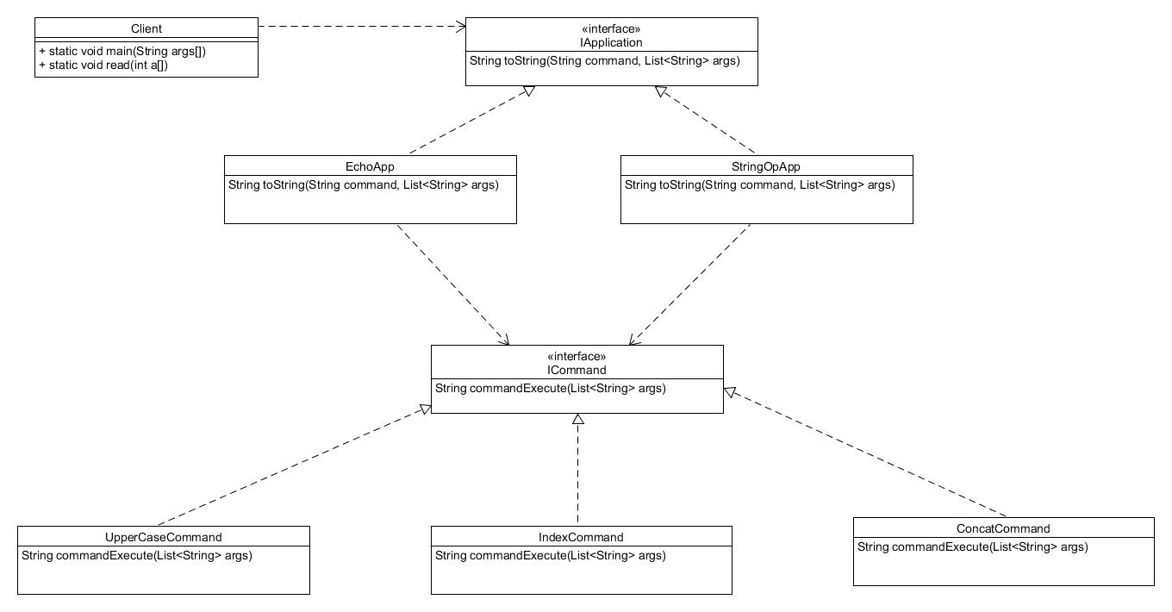Q1.

I decieded to create an interface to take care of all of the application extensions, including the echo and stringop. With the I was able to create a map that will have the class for the extension in with the key. Each of the extension will know it’s own commands and have a map inside of their class doing the same thing for the commands as for the extensions. This makes it easy add new command by just adding them to the map in the extenison class and creating a new class for that command. You can also create a new extension by doing about the same thing. There is a little bit of manentance to create a new command but only a little.