Jordan LaShomb

CM 1809

Take-Home-Exam

1/23/15

**Q1.**

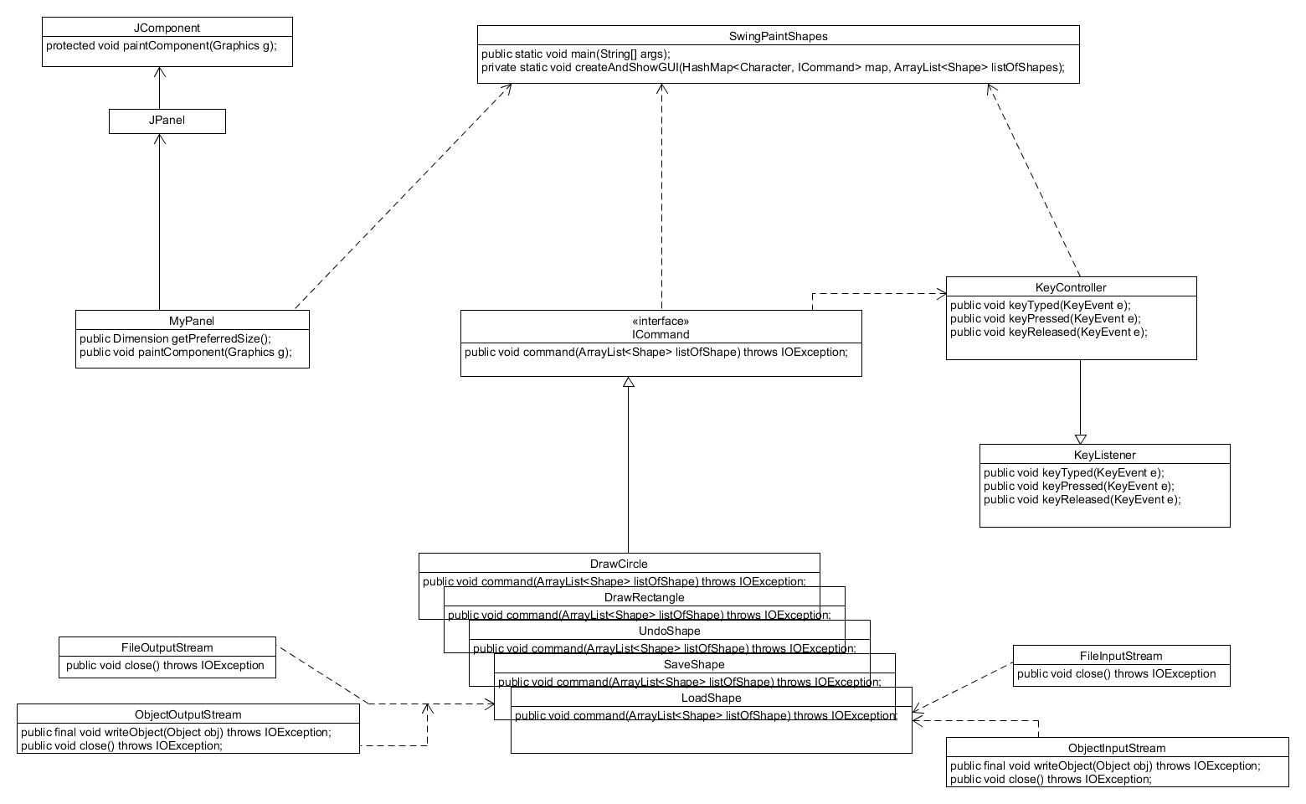For my design I decided I would need use a command pattern. Like in the remote control example project, I had a class that handled every command once a key is pressed, mine was KeyController. So I would be able to just use one command for every single command for the problem I used on array list that created in main to be used for all of my commands. I would add and remove shapes from the array list. For saving and loading I would serialize the array list and create a new one when I wanted to load the last save.