Machine Learning Engineer Nanodegree

Capstone Project
Jonatan Dellagostin
March 15th, 2018

I Definition

Project Overview

Surface electromyography (sEMG) is the temporal and spatial superposition of faint bioelectrical signals generated by the muscle nerve cells during muscle contraction [1]. It is collected and recorded through skin surface electrodes. Compared to conventional EMG signal acquisition that requires inserting a needle electrode into muscle tissue, the sEMG signal has the advantages of being noninvasive and providing the convenience of collection [2]. Besides, it is known [3] that information extracted from intramuscular MES (myoelectric signal) results in the same classification accuracy compared to information extracted from surface MES.
Knowing the daily life of hand amputees can be extremely difficult compared to what it was before the amputation, the research involving hand prosthetics is of great importance. The development of open source state-of-the-art algorithms in hand movement classification is crucial in this field, parallel with the development of open-source easy-to-print 3d robotic hands, both contributing to the development of cheaper and more accessible prosthesis to amputees, since commercial devices are too expensive and unaffordable for most of them.
All articles that guided the present work are properly cited in the References section.

Problem Statement

Amputees that lack some part of the arm, specially the hand, suffer from not being able to perform simple and crucial task in everyday life. A robotic hand is a proposed solution in the field of prosthetics. In a real hand, electrical impulses sent by the brain travel through the nerves until reaching the arm muscles innervations, which are then activated and produces the muscular activity responsible for the hand movements.

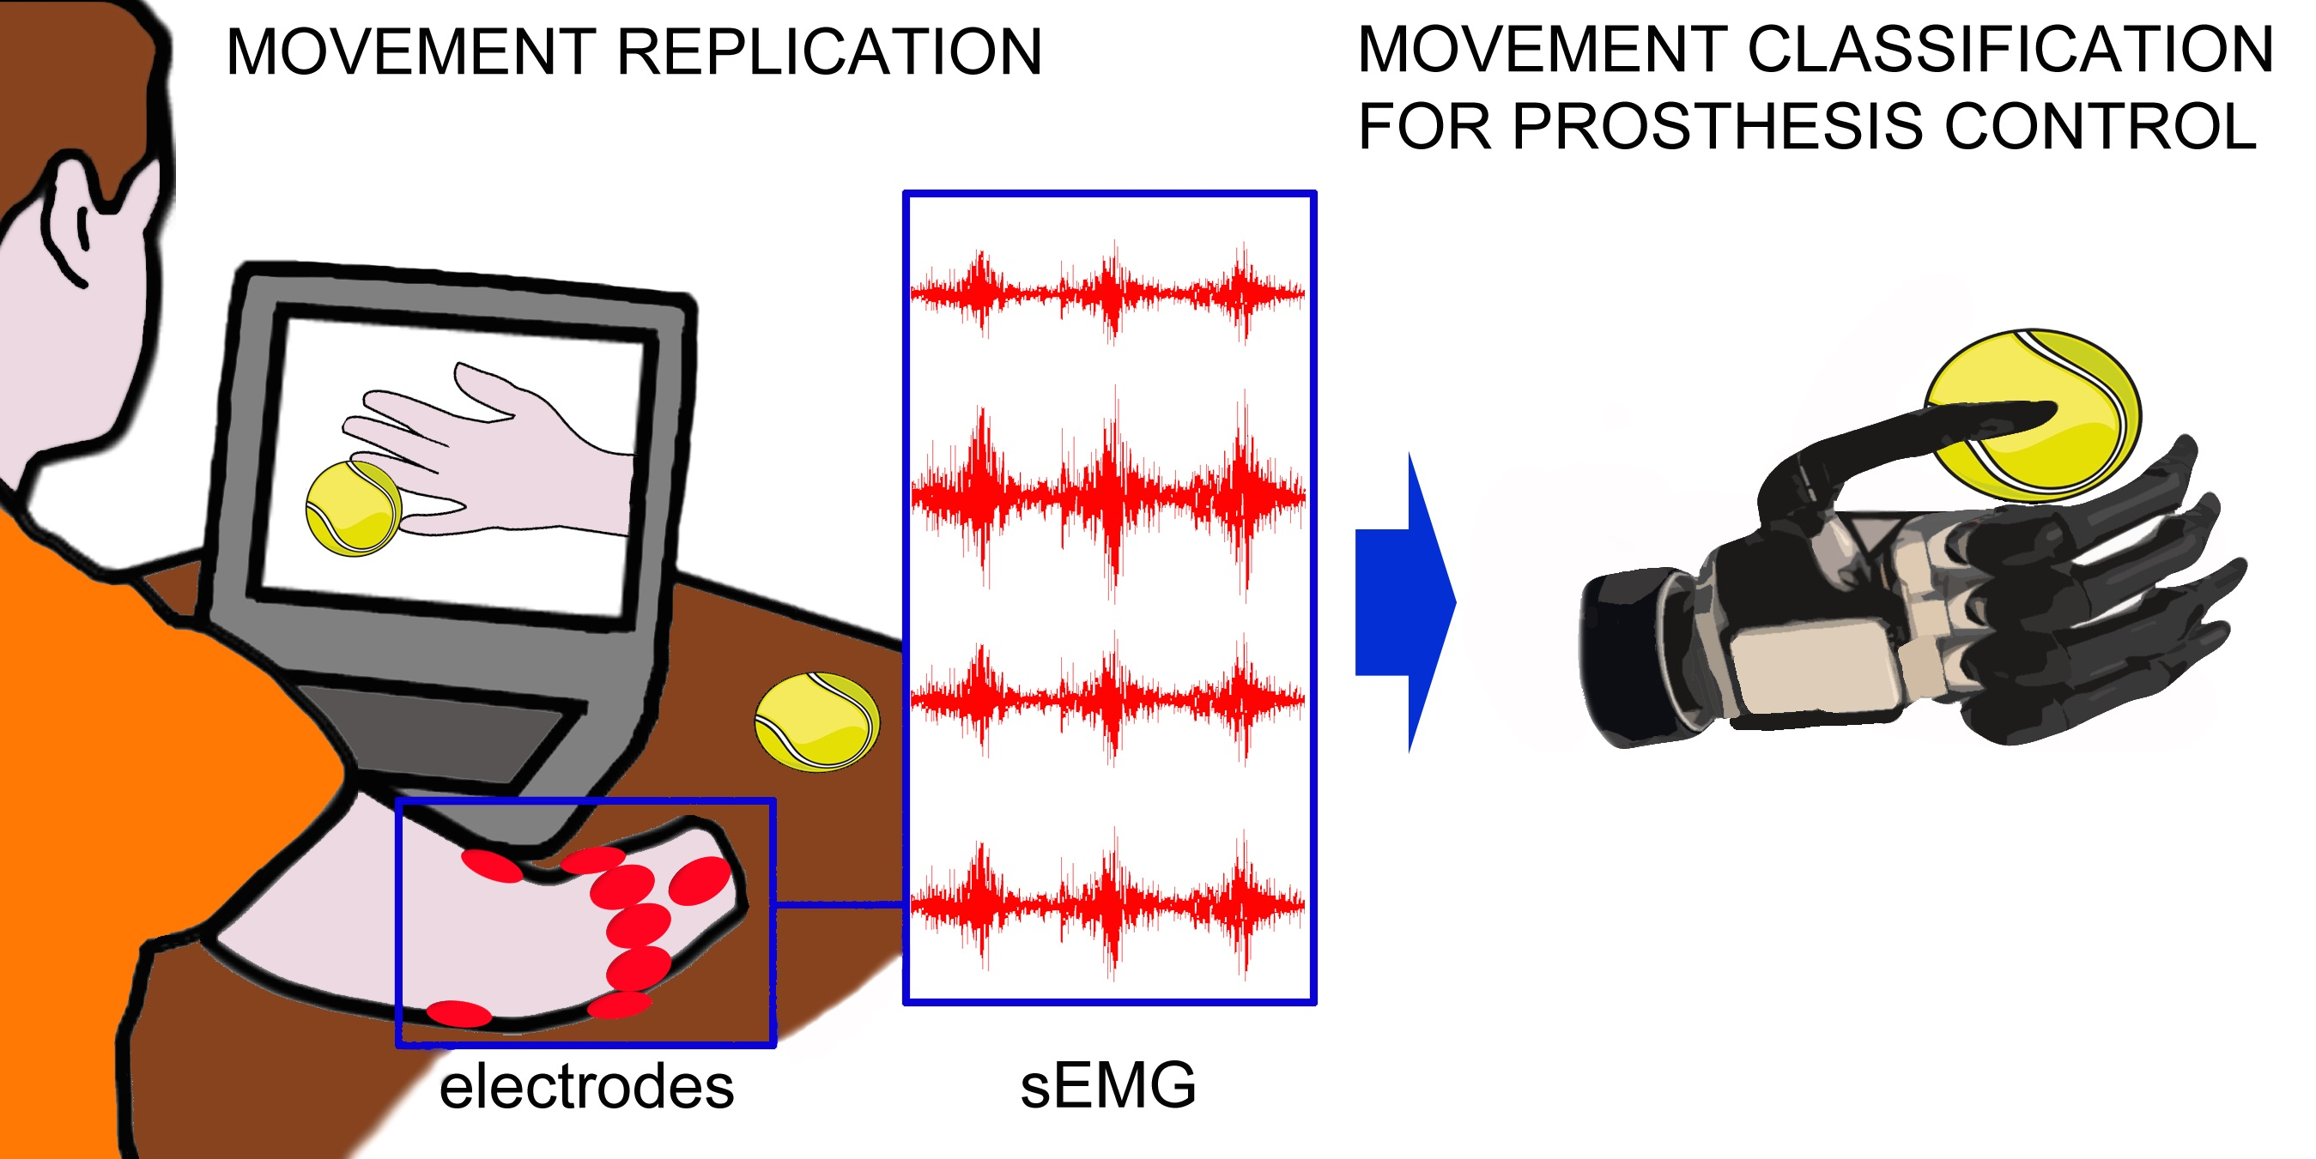
Figure 1: Illustration of prosthesis training and operation (source: http://ninapro.hevs.ch)
A common and established approach in the literature to mimic this behavior is to capture arm muscle’s electric signals through sEMG techniques, preprocess them in a computer, apply some classification algorithm to map this signals into a class from a pre-determined finite set of hand motions, and send to the robotic hand the appropriate electrical signals in order to perform the required movement. Our problem then, in the present work, comprises of finding and training an appropriate classifier for the task of predicting the output class (hand movement) given the input data collected (preprocessed sequences of electrical signals converted to the digital world).

Metrics

For the datatasets used in this project, the classes are balanced by definition (the acquisition phase took the same number of examples for each class), the classification accuracy (number of correct classifications/ number of trials) seems a reasonable metric to be used when comparing the performance of different algorithms (in fact, this is the usual metric found in the literature).
Nevertheless, we pretend to report some other metrics along, like the chance level (classification accuracy / number of classes) and the training and classification average times (given a certain CPU or GPU used). Since the model training could be done offline (after the data acquisition phase), but the classification couldn’t, the classification average time is of great importance: a delay of more than 300 ms between the muscular activation an the prosthesis response can be noted by the patient and degrade the usability of the device.

II Analysis

Data Exploration

Our research into the field led us to the first successful initiative to establish an open sEMG database, the NinaPro - Non-Invasive Adaptive Hand Prosthetics. The goal of this project is to develop a family of algorithms able to significantly augment the dexterity, and reduce the training time, for sEMG controlled prosthesis. The project is thoroughly described in [4].
By testing researchers findings on a very large collection of data, this project pave the way for a new generation of prosthetic hands. The Data Acquisition is done with the goal of developing a reproducible protocol to acquire large data sets for healthy patients performing certain movements and amputated patients also making complex movements, while analyzing and assessing the data as they become available. The data acquisition includes collecting signal data calibrating the sensors to limit the noise in data. Relevant clinical data is acquired at the same time such as age, gender, height, weight and for amputated patients also the exact place of the amputation and the time between amputation and tests performed.
From its beginning (2014) until the present day, the NinaPro has collected seven databases, which one comprising of data collected in a uniform way (Ninapro protocol) from several healthy and disabled patients, while performing a variety of hand movements. Each database collection and posterior analysis was performed by a group of researchers and is thoroughly described in academic papers. All of the databases are available online in a dedicated website: http://ninapro.hevs.ch/.
The present work will focus on the database number 1 to 3 (http://ninapro.hevs.ch/data1, http://ninapro.hevs.ch/data2 and http://ninapro.hevs.ch/datah3). The specific data we are interested in is the raw sEMG time-series samples collected from all individuals in these datasets, along with the associated labeled vector, containing the movement corresponding to each sEMG sample.
From these databases, the more important are database 1 (healthy patients, sensors acquisition frequency of 100 Hz) and database 3 (disabled patients, sensors acquisition frequency of 2kHz), since it seems more logical comparing the proposed model performance against both healthy and disabled patients. Due to limited computational resources, the analysis of database 2 (healthy patients, sensors acquisition frequency of 2 kHz) will be considered optional and of secondary importance.
Lets see in more depth the characteristics of each database:
Database 1:
The first Ninapro database includes data acquired with the acquisition protocol described into the papers: "Manfredo Atzori, Arjan Gijsberts, Ilja Kuzborskij, Simone Heynen, Anne-Gabrielle Mittaz Hager, Olivier Deriaz, Claudio Castellini, Henning Müller and Barbara Caputo. Characterization of a Benchmark Database for Myoelectric Movement Classification. IEEE Transactions on Neural Systems and Rehabilitation Engineering, 2014" (http://publications.hevs.ch/index.php/publications/show/1715) and "Manfredo Atzori, Arjan Gijsberts, Claudio Castellini, Barbara Caputo, Anne-Gabrielle Mittaz Hager, Simone Elsig, Giorgio Giatsidis, Franco Bassetto & Henning Müller. Electromyography data for non-invasive naturally-controlled robotic hand prostheses. Scientific Data, 2014" (http://www.nature.com/articles/sdata201453).
The database data consists of 10 repetitions of 52 different movements of 27 intact subjects.
The subjects have to repeat several movement represented by movies that are shown on the screen of a laptop.
The experiment is divided in three exercises:
1. Basic movements of the fingers
2. Isometric, isotonic hand configurations and basic wrist movements
3. Grasping and functional movements
The sEMG data are acquired using 10 Otto Bock MyoBock 13E200 electrodes (at a rate of 100 Hz), while kinematic data are acquired using a Cyberglove 2 data glove.

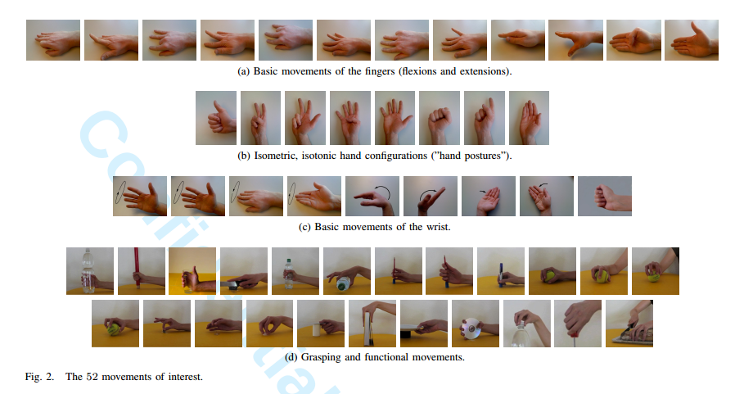
Datasets

For each exercise, for each subject, the database contains one matlab file with synchronized variables.
The variables included in the matlab files are:
- subject: subject number
- exercise: exercise number
- acc (36 columns): three-axes accelerometers of the 12 electrodes
- emg (12 columns): sEMG signal of the 12 electrodes
- glove (22 columns): uncalibrated signal from the 22 sensors of the cyberglove
- inclin (2 columns): signal from the 2 axes inclinometer positioned on the wrist
- stimulus (1 column): the movement repeated by the subject.
- restimulus (1 column): again the movement repeated by the subject. In this case the duration of the movement label is refined a-posteriori in order to correspond to the real movement
- repetition (1 column): repetition of the stimulus
- rerepetition (1 column): repetition of restimulus

Database 3
The third Ninapro database is thoroughly described in the paper: Atzori et al., Electromyography data for non-invasive naturally-controlled robotic hand prostheses. Scientific Data, 2014.
The experiment is divided in three exercises:
1. Basic movements of the fingers and of the wrist
2. Grasping and functional movements
3. Force patterns
In the first two exercises, the subjects naturally try to repeat several movements represented by movies that are shown on the screen of a laptop.
In the last exercise the subjects have to think to press combinations of fingers with an increasing force on a custom made device called Finger Force Linear Sensor.
The muscular activity is gathered using 12 active double–differential wireless electrodes from a Delsys Trigno Wireless EMG system. The electrodes are positioned as shown in the figure: eight electrodes are equally spaced around the forearm in correspondence to the radio humeral joint; two electrodes are placed on the main activity spots of the flexor digitorum and of the extensor digitorum as described in; two electrodes are placed on the main activity spots of the biceps and of the triceps. The described locations have been chosen in order to combine a dense sampling approach with a precise anatomical positioning strategy.
The two electrodes placed on the main activity spots of the flexor digitorum and of the extensor digitorum were not used for subject 6 and 7 due to space reasons.

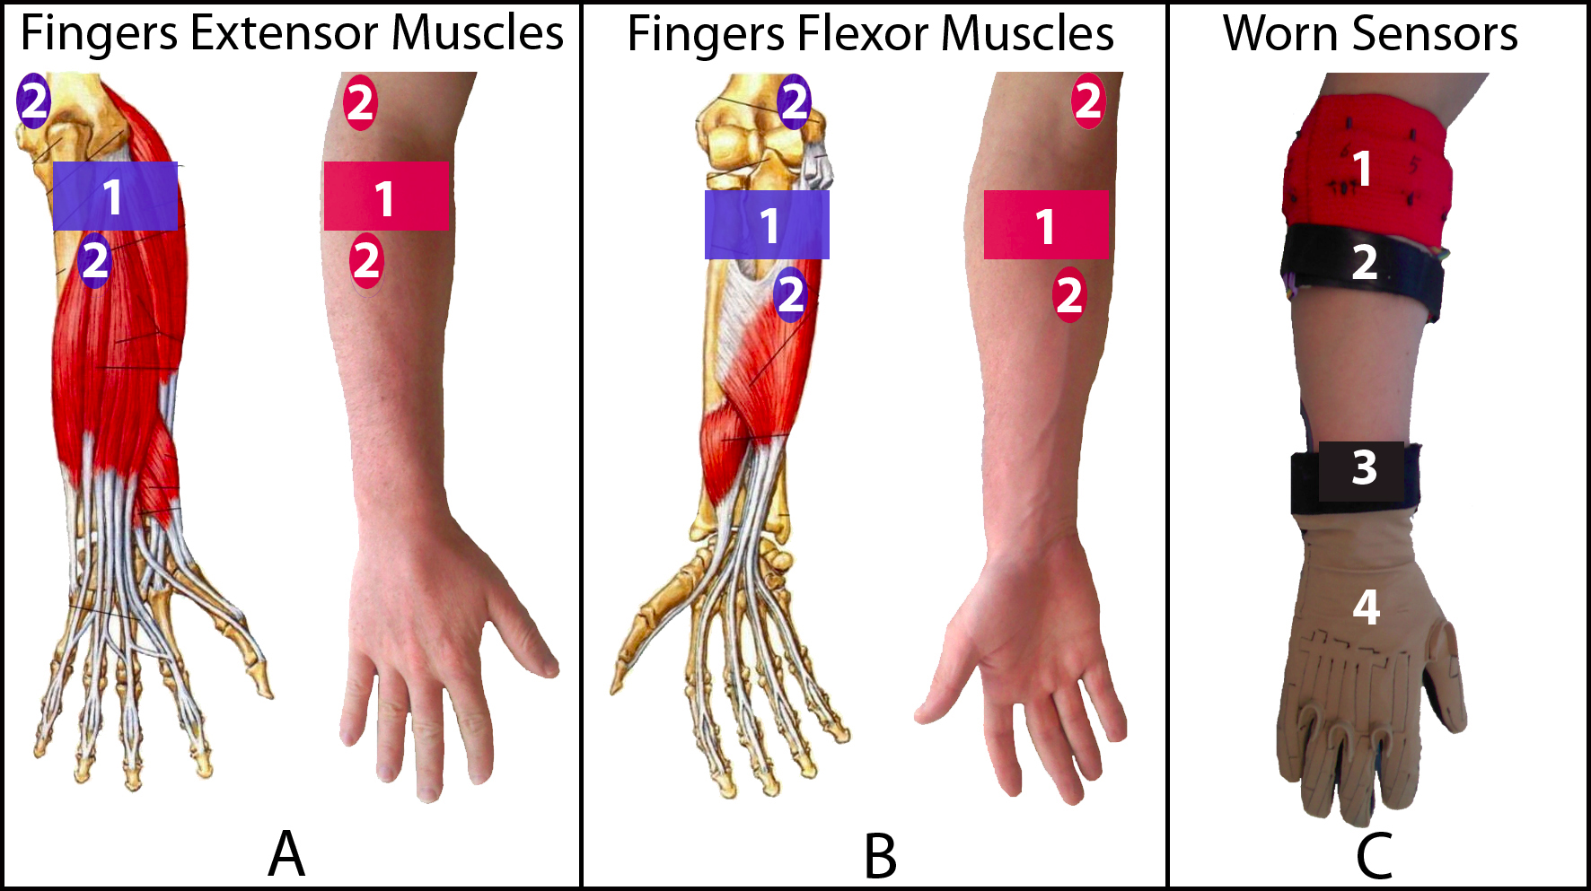

The electrodes were fixed on the forearm using their standard adhesive bands. Moreover, a hypoallergenic elastic latex–free band was placed around the electrodes to keep them fixed during the acquisition.
The sEMG signals are sampled at a rate of 2 kHz.
During the acquisition, the subjects were asked to repeat the movements with the right hand. Each movement repetition lasted 5 seconds and was followed by 3 seconds of rest. The protocol includes 6 repetitions of 49 different movements (plus rest) performed by 11 trans-radial amputated subjects. The movements were selected from the hand taxonomy as well as from hand robotics literature.
The number of movements is reduced in subjects 1(39 plus rest), 3(48 plus rest), and 10(43 plus rest) due to experimental causes, e.g. stress.
The number of repetitions in subject 1 was originally 10 and has been reduced to 6 during post-processing in order to avoid classification biases.
This subject was the first subject being recorded with the acquisition protocol and determined the choice of reducing the number of repetitions to 6.

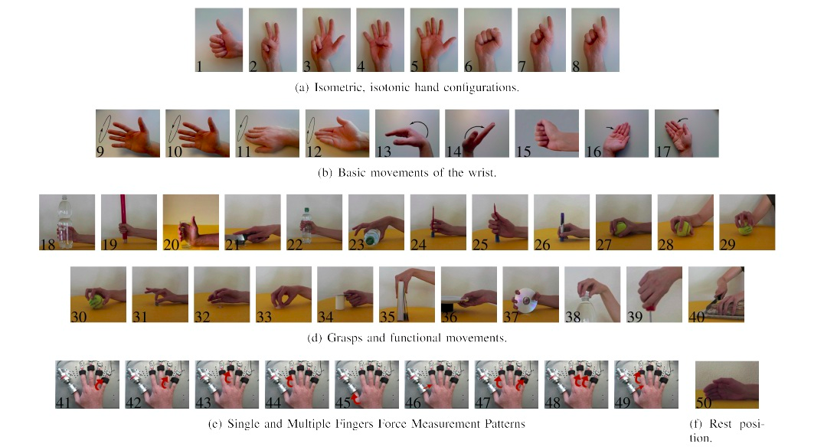

Datasets

For each exercise, for each subject, the database contains one matlab file with synchronized variables.
The variables included in the matlab files are:
- subject: subject number
- exercise: exercise number
- acc (36 columns): three-axes accelerometers of the 12 electrodes
- emg (12 columns): sEMG signal of the 12 electrodes
- glove (22 columns): uncalibrated signal from the 22 sensors of the cyberglove
- inclin (2 columns): signal from the 2 axes inclinometer positioned on the wrist
- stimulus (1 column): the movement repeated by the subject.
- restimulus (1 column): again the movement repeated by the subject. In this case the duration of the movement label is refined a-posteriori in order to correspond to the real movement
- repetition (1 column): repetition of the stimulus
- rerepetition (1 column): repetition of restimulus
- force (6 columns): force recorded during the third exercise
- forcecal (2 x 6 values): the force sensors calibration values, corresponding to the minimal and the maximal force.

Exploratory Visualization

The sEMG data for each one of the subjects is comprised of a long time-series sequence of alternating muscular high activity (movement) and muscular low activity (rest). Thus, it is expected from the data segments of 5 seconds of relative high amplitude electric potential measurements (movement) followed by 3 seconds of lower amplitude electric potential (rest). This behavior is illustrated in the following figure, showing a window of time from subject 10, database 3.
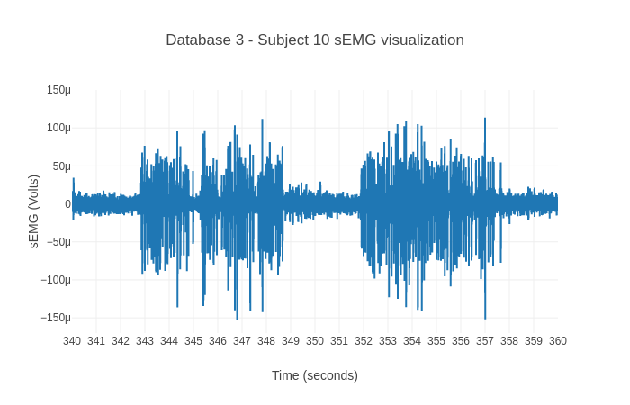
The sEMG frequency decomposition is supposed to be spread typically from 0 to 500 Hz (a bandwidth of 500 Hz), which, by the Nyquist Theorem, requires at least a sampling rate of 2x500=1kH for perfect reconstruction of the signal representation. In the case of database 1 (sampling rate of 100Hz), this will be not possible, resulting in a loss of information. That is not the case for databases 2 and 3 (both use a sampling rate of 2kHz, 2 times more than necessary).
A characteristic to be noted is that the amplitude of the electric signals will vary from subject to subject, and it is expected to be significantly less in amputated subjects than in healthy subjects. This behavior can be seen in the following figure, that shows the power spectral density of a time window of 4 subjects (2 healthy and 2 amputated).
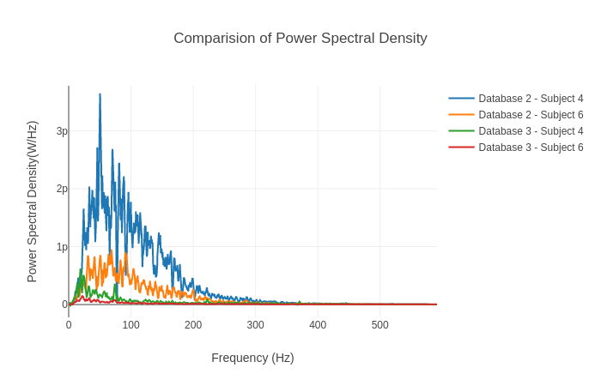

Algorithms and Techniques

Usually, the researchers use classifiers renowned for a long time for being successful in the task of accurately predicting hand movements from sEMG, mostly Random Forests and Support Vector Machines, using a very few number of engineered features.
However, it’s well known that in the last years deep learning based models are surpassing in several fields the performance of other algorithms. These approaches, like in Convolutional Neural Networks, induce some bias into the models about the nature of the inputs, and overcome the burden of feature engineering by learning the features itself.
Since our inputs are basically time-series events, we propose the combination of Convolutional Neural Network layers (for learning the input features from raw data, instead of hand-craft them, as is currently common practice in the sEMG field) followed by Recurrent Neural Network layers, more particularly Long-Short Term Memory Neural Network (LSTM) layers (since LSTM is already known for its overwhelming capacity of dealing with time-series sequences), hoping it will improve the classification performance when compared to other already used models.

1- Data extraction

Our input data will be downloaded from Ninapro database and separated by dataset, specifically datasets one to three. Although there are other variables included in the datasets, we will focus only in the sEMG signals included. The datasets are described as follows:
1 - Database 1 contains data from 27 intact subjects, sEMG captured by 10 electrodes.
2 - Database 2 contains data from 40 intact subjects, sEMG captured by 12 electrodes.
3 - Database 3 contains data from 11 transradial amputees, sEMG captured by 12 electrodes.
Each example in the datasets corresponds to a hand movement performed by a subject during a interval of 5 seconds plus 3 seconds of rest, and the raw sEMG captured during this interval. This raw sEMG, segmented in time windows, will be used as input and the corresponding label (hand movement) will be used as the output class, in order to train the classifier.

2 - Model Implementation
Convolutional neural networks (CNNs) are a type of DNN (deep neural network) with the
ability to act as feature extractors, stacking several convolutional operators to create a hierarchy of
progressively more abstract features. Such models are able to learn multiple layers of feature hierarchies automatically (also called “representation learning”). Long-short-term memory recurrent (LSTMs) neural networks are recurrent networks that include a memory to model temporal dependencies in time series problems.
The combination of CNNs and LSTMs in a unified framework has already offered state-of-the-art results in the speech recognition domain, where modeling temporal information is required. This kind of architecture is able to capture time dependencies on features extracted by convolutional operations.
Our research pointed to a very interesting Deep Neural Network Architecture, described extensively in [4]. The model, called DeepConvLSTM, is a deep learning framework composed of convolutional and LSTM recurrent layers, and is perfectly suitable for our needs, since it is capable of automatically learning feature representations along the Convolutional layers (automating feature extraction from raw sensor data instead of using a time consuming heuristic process of engineering the features) and modeling the temporal dependencies between their activation (using the LSTM units in the recurrent layers). Finally, the model has a softmax layer that outputs the predicted class probability.
The input to the network consists of a data sequence. The sequence is a short time series extracted from the sensor data (sEMG) using a sliding window approach composed of several sensor channels. The number of sensor channels is denoted as D. Within that sequence, all channels
have the same number of samples S^{l} . The length of feature maps S^{l} varies in different convolutional layers. The convolution is only computed where the input and the kernel fully overlap. Thus, the length of a feature map is defined by:

S^{(l+1)} = S^{l} - P^{l} + 1

where P^{l} is the length of kernels in layer l. The length of the kernels is the same for every convolutional layer, being defined as P^{l} =5, ∀ l = 2, . . . , 5.

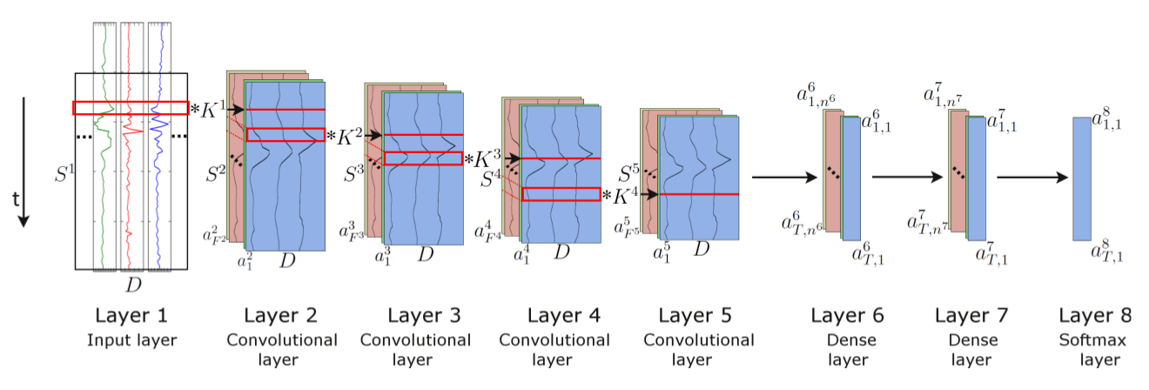
Figure 3. Architecture of the DeepConvLSTM (Conv, convolutional) framework for activity recognition. From the left, the signals coming from the sEMG sensors are processed by four convolutional layers, which allow learning features from the data. Two dense layers then perform a non-linear transformation, which yields the classification outcome with a softmax logistic regression output layer on the right. Input at Layer 1 corresponds to sensor data of size D x S¹ , where D denotes the number of sensor channels and S^{l} the length of features maps in layer l. Layers 2–5 are convolutional layers. S^{l} denotes the kernels in layer l (depicted as red squares). F^{l} denotes the number of feature maps in layer l. In convolutional layers, a^{l}_{i} denotes the activation that defines the feature map i in layer l. Layers 6 and 7 are dense layers. In dense layers, a^{l}_{t,i} denotes the activation of the unit i in hidden layer l at time t. The time axis is vertical.(source: [5])

Convolutional layers process the input only along the axis representing time. The number of
sensor channels is the same for every feature map in all layers. These convolutional layers employ rectified linear units (ReLUs) to compute the feature maps. Layers 6 and 7 are recurrent dense layers. Recurrent dense layers adapt their internal state after each time step. The activation of the recurrent units is computed using the hyperbolic tangent function. The output of the model is obtained from a softmax layer (a dense layer with a softmax activation function), yielding a class probability distribution for every single time step t.
A shorthand description of this model would be: C(64) => C(64) => C(64) => C(64) => R(128) => R(64) => Sm, where C (F^{l}) q denotes a convolutional layer l with F^{l} feature maps, R(n^{l}) a recurrent LSTM layer with n^{l} cells and Sm a softmax classifier.
The model is trained in a fully-supervised way, backpropagating the gradients from the softmax layer through to the convolutional layers. The network parameters are optimized by minimizing the cross-entropy loss function using mini-batch gradient descent with the RMSProp update rule.
For the sake of efficiency, when training and testing, data are segmented on mini-batches of a size of 16 data samples. Using this configuration, an accumulated gradient for the parameters is
computed after every mini-batch. Both models are trained with a learning rate of 0.001 and a decay
factor of ρ = 0.9. Weights are randomly orthogonally initialized. We introduce a drop-out operator
on the inputs of every dense layer, as a form of regularization. This operator sets the activation of
randomly-selected units during training to zero with probability p = 0.5.
The length of the time window is 200 ms, with a step size of 100 ms. The number of instances (segments) obtained after using this sliding window configuration will be approximately 8s(each movement duration plus rest)/100ms =80. Each segment is composed by synchronized sEMG signals captured from D sensors, at a rate of 100 Hz(database 1), or 2 Khz (database 3). The
resulting in an input matrix of dimensions D x 20 (database 1), or D x 400 (database 3). The class associated with each segment corresponds to the hand movement that has been observed during that interval (0.2 seconds).

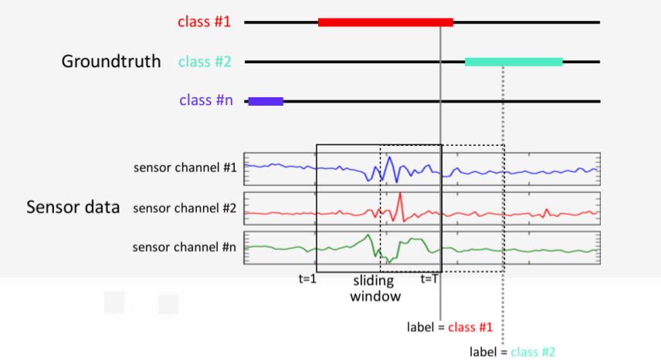

DeepConvLSTM outputs a class probability distribution for every single time step t in the sequence (i.e., the 200-ms window of the sEMG sensor signal). However, we are interested in the class probability distribution once DeepConvLSTM has observed the entire 200-ms sequence.
Since the memory of LSTM units tends to become progressively more informed as a function of the number of samples they have seen, DeepConvLSTM returns the class probability distribution only at the last time step T, when the full sequence has been observed. Thus, at the time of each sample of the original sensor signal, DeepConvLSTM provides a class probability distribution inferred from processing a 200-ms extract of the sEMG sensor signal prior to that time, as illustrated in Figure 6.
This approach of only using the last time step T is encouraged by the results of a previous work [5]. Their investigation demonstrates that misclassifications occur primarily during the movement onset (initial phase) and offset (final phase). The explanation for this phenomenon is that the sEMG signals are not yet (or not anymore) sufficiently discriminative in these transitory phases between movement and rest. Thus, we hope LSTM units will overcome this issue by captioning these temporal dynamics of the sEMG signals.
The model will be splitted in a 1:3(database 1) or a 1:4 (database 3) proportion of test:training set and individually trained using all subjects from Ninapro datasets 1 and 3. After properly trained, the model will be tested and benchmarked, providing the already discussed evaluation metrics for the sake of comparison.

Benchmark

In this section, you will need to provide a clearly defined benchmark result or threshold for comparing across performances obtained by your solution. The reasoning behind the benchmark (in the case where it is not an established result) should be discussed. Questions to ask yourself when writing this section:
- _Has some result or value been provided that acts as a benchmark for measuring performance?_
- _Is it clear how this result or value was obtained (whether by data or by hypothesis)?_

We will benchmark the proposed model against the models used and described in [4]. In this work, the datasets 1, 2 and 3 from NinaPro database were used as input, and a Convolutional Neural Network architecture was chosen as a model for the classifier. This paper compares its own results with earlier works too.
For 50 classes (hand movements), the classifier obtained an average classification accuracy of 66.59 ± 6.40% on dataset 1, 60.27 ± 7.7% on dataset 1 and 38.09 ± 14.29% on dataset 3 (composed only by data collected from amputees – classification accuracy is expected to be lower than the previous datasets, composed only by able subjects).

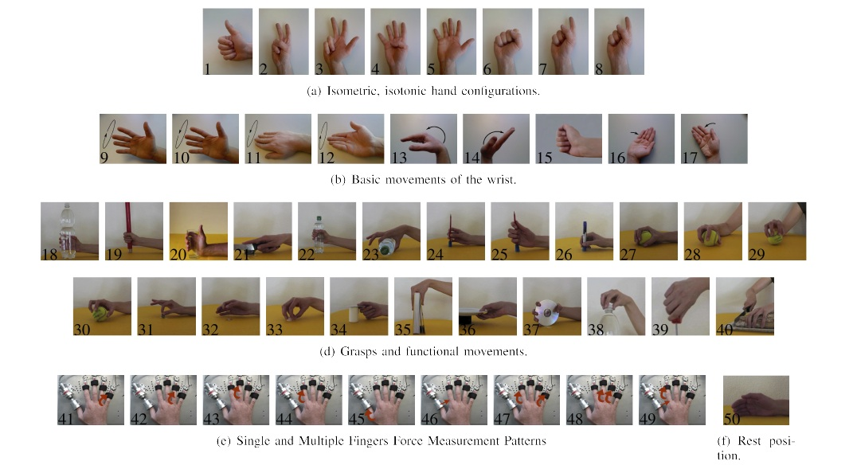
Figure 2: The 50 hand movements used as output classes for the classifier (source: http://ninapro.hevs.ch)

Earlier works cited in the paper got better performance, though; the best classical classification methods were: on dataset 1, Random Forests with all features, with an average classification accuracy of 75.32 ± 5.69%; on dataset 2, Random Forests with all features with an average classification accuracy of 75.27% ± 7.89%; and in dataset 3, a Support Vector Machine with all features, with an average classification accuracy of 46.27% ± 7.89%.

III. Methodology
_(approx. 3-5 pages)_

Data Preprocessing

The Ninapro data will be downloaded from Dryad, an online repository for research data (https://datadryad.org/resource/doi:10.5061/dryad.1k84r). Each subject for each database has an associated zip file, accounting for a total of 78 files. The zip compacted files have 3 *.mat (matlab format) files in it, each one corresponding to data gathered from a different set of movements (Set 1: Basic movements of the fingers; set 2: Isometric, isotonic hand configurations and basic wrist movements; and set 3: Grasping and functional movements).
Once the zip file is downloaded and its files extracted, the sEMG content for each *.mat file and its corresponding classification label (movement associated) will be obtained and gathered together. Then, for every subject, there will be one input vector (sEMG data from all sensors) and its output labeled vector (containing the class or movement associated).
The data will be splitted into training/test sets, in a proportion of 3:1 (database1) and 2:1(database 3). The trainining set will be then normalized and rearranged into time steps for feeding the LSTM layers, being ready for training the neural network.

Implementation

The model already described and all the auxiliary scripts are implemented using python (version 3.5 for CPU and 3.6 for GPU) as the programming language, Keras (version 2.2) as the deep learning framework, using Tensorflow (version 1.8) library as the backend. Keras was chosen as the high-level framework because of its simple and concise interface, allowing the user implement a deep learning model within a few lines of code. Besides, cloud providers, as AWS (Amazon Web Services), provide clean and ready to work powerfull GPU instances for trainining Deep Learning models, powered by conda environments, using Keras.
All processes and results described in this session are easily reproducible, by means of modules specially written for this purpose, along with jupyter notebooks and a README created for guiding the user. The environment (libraries and modules needed) could be set right away by creating a python virtual environment, cloning the repository https://github.com/jonDel/emg_mc.git and installing the dependencies from the requirements file (requirements.txt)
The databases download and decompression are performed by a web scrapping script. Extraction and data pre-processing are performed using nina_helper library (source: https://github.com/Lif3line/nina_helper_package_mk2). This library was forked from github (source: https://github.com/jonDel/nina_helper_package_mk2) and modified in order to support NinaPro database 3 (the original version only supports databases 1 and 2). This library provides methods for extracting all the necessary information from the matlab files (*.mat) into tensors, as well as for splitting the data into test/training sets, normalizing the tranining set and reorganizing the input raw sEMG samples into time steps for feeding the LSTM layers.
The training process is carried out for every one of the subjects from database one (27) and database 3 (11). At the end of each training session, the model is evaluated against the training set and the resulting accuracy is recorded into log files (one for database 1 and other for database 3 results). After all training sessions of every datasets from each database, the mean and standard deviation is calculated and used for benchmarking.

Refinement

We dealt with some problems when running the training process, mostly caused by poor hiperparameter choosing, that will be summarized bellow.
First, we notice that, although the training curve continued improving through time, the validation curve did not. It randomly oscilated, showing signs that the model was badly overfitting and not capturing the variance of the model; instead, it was just memorizing the input data. After some hiperparameters tweaking, we noticed that the initial batch size of 100 was causing this issue, maybe due to the relative low number of input samples when compared to the high capacity of the model. We reduced the batch size to 64, 32 and finally 16 samples, which solved the problem allowing the model to generalize. However, there is no free-lunch: a lower batch size resulted in a much longer training session (Note: batch sizes lower than 16 made the training time impractible).
Second, we notice a discrepancy between the validation accuracy and the training accuracy computed after the end of a training session. That was probably due to a low proportion of training/validation samples (10:1), when compared to training/test (10:3). We correct this value to 3:1, leading the validation accuracy very close to the test accuracy. Again, the no free-lunch theory applies: more validation samples means less training samples, hence less data to train the model.
Third, we felt the need of certain features when training, as progress’ visualization, weights recovering after a crash and training’s early stopping of stalled sessions. This need was overcome by applying the techniques that follows:
- The technique of model checkpoint (save the weights during training process) was applied, using the maximum value of validation set accuracy as a parameter, i.e, at the end of each iteration (epoch), the validation accuracy is taken, and the model weights at that time are saved on disk only if the accuracy outperforms all other iterations. Thus, if the training process is interrupted for some reason, when the training script runs again, it checks in a predefined folder for previous trained weights and loads the best of them into the model before trainining. This step is crucial and saves a lot of time in the case of interruption, since there is no need to run again the training process from scratch.
- The technique of early stopping was used, so there was no need to run the training process for all the predefined number of epochs, when it reachs a point where clearly no more improvements are made. A total number of 150 epochs was defined, and if the training got stuck (no more improvements in validation accuracy) for more than 20 epochs since the last best accuracy value, it was stopped. In addition, before the training beginning, if it finds and loads the weights file saved from a previous session, the iteration when it was saved was recovered and used. Lets say a training session saves its last best weight at epoch 40, and for some reason crashes. Then, when the session is started again, the script will load the best weight into the model, and run again the training, but not for 150 epochs; now it will run for 150 - 40 = 110 epochs, saving time and providing consistency among diferent training sessions.
- A Keras callback to a Tensorboard (https://www.tensorflow.org/programmers_guide/summaries_and_tensorboard) session was attached to the model, so that trainning and validation curves, along with its respective loss curves, could be monitorated at training time, through a browser. This technique proved very usefull, particulary when running the training sessions in the cloud.
Fourth, after running the trainining sessions for all database one subjects, we gathered the results (which will be analised and discussed in the IV session of this report) and thought that maybe these results could be improved by an architectural change. How? At that time, the LSTM cells were only allowed to remember the samples of one time window (200 ms), when the total duration of a movement was 5 seconds plus 3 seconds of rest. Then, the cells were not being fed with a sequence containing all the dynamics of the beggining and the end of each movement. Our proposed solution was to extend the number of input time-steps in order to cover a much greater time window of 1.25 x 8 = 10 seconds (50 times greater than the original). Notice that this increase in input dimensions of course significantly increased the training time.
Fifth, when running the trainining sessions for database 3 subjects, we ran into a system memory problem: the data acquistion rate was 2kHz, or 20x more samples than database one and 20x more memory needed to store the input tensors for the model. It could not fit in our desktop memory of 8 GB. The solution was to choose a GPU cloud instance to train our model. We used an AWS Deep Learning instance, with a Volta V-100 Nvidia GPU attached, powered by conda virtual environments already configured for Keras and Tensorflow.
Sixth, even when running the model for database 3 in a powerfull GPU as V-100 for several hours, not a single session of one subject training was finalized. We got surprised and disapponted, since we hoped the GPU would be much more powerful and fast than our desktop CPU(i5 4 cores). On the opposite, it even performed a bit worse than the CPU. What was happening? We did a research and found an explanation: RNNs in particular performs bad in GPUs, since it can't be parallelized in time because the hidden layer's previous output is required to be known at each current input in the forward pass. So no hope for us? Yes, there are hope somewhere, and it is called CuDNNLSTM, a Keras LSTM cell specially designed for running on Nvidia CUDA GPUs. So the code was changed to support both GPU and CPU LSTM cells automatically, and when ran, the training session showed a fantastic improvement (more than 30 times faster).
Seven, even when running the code in the cloud GPU instance with the CuDNNLSTM cells, the estimated total training time for all subjects of database 3 turns out to be economically unaffordable. So, we choose to subsample the datasets to 1/16 of the original size, at the expense of getting only 1/16 samples to feed our model.

IV. Results
_(approx. 2-3 pages)_

Model Evaluation and Validation
In this section, the final model and any supporting qualities should be evaluated in detail. It should be clear how the final model was derived and why this model was chosen. In addition, some type of analysis should be used to validate the robustness of this model and its solution, such as manipulating the input data or environment to see how the model’s solution is affected (this is called sensitivity analysis). Questions to ask yourself when writing this section:
- _Is the final model reasonable and aligning with solution expectations? Are the final parameters of the model appropriate?_
- _Has the final model been tested with various inputs to evaluate whether the model generalizes well to unseen data?_
- _Is the model robust enough for the problem? Do small perturbations (changes) in training data or the input space greatly affect the results?_
- _Can results found from the model be trusted?_

Justification
In this section, your model’s final solution and its results should be compared to the benchmark you established earlier in the project using some type of statistical analysis. You should also justify whether these results and the solution are significant enough to have solved the problem posed in the project. Questions to ask yourself when writing this section:
- _Are the final results found stronger than the benchmark result reported earlier?_
- _Have you thoroughly analyzed and discussed the final solution?_
- _Is the final solution significant enough to have solved the problem?_

V. Conclusion
_(approx. 1-2 pages)_

Free-Form Visualization
In this section, you will need to provide some form of visualization that emphasizes an important quality about the project. It is much more free-form, but should reasonably support a significant result or characteristic about the problem that you want to discuss. Questions to ask yourself when writing this section:
- _Have you visualized a relevant or important quality about the problem, dataset, input data, or results?_
- _Is the visualization thoroughly analyzed and discussed?_
- _If a plot is provided, are the axes, title, and datum clearly defined?_

Reflection
In this section, you will summarize the entire end-to-end problem solution and discuss one or two particular aspects of the project you found interesting or difficult. You are expected to reflect on the project as a whole to show that you have a firm understanding of the entire process employed in your work. Questions to ask yourself when writing this section:
- _Have you thoroughly summarized the entire process you used for this project?_
- _Were there any interesting aspects of the project?_
- _Were there any difficult aspects of the project?_
- _Does the final model and solution fit your expectations for the problem, and should it be used in a general setting to solve these types of problems?_

Improvement
In this section, you will need to provide discussion as to how one aspect of the implementation you designed could be improved. As an example, consider ways your implementation can be made more general, and what would need to be modified. You do not need to make this improvement, but the potential solutions resulting from these changes are considered and compared/contrasted to your current solution. Questions to ask yourself when writing this section:
- _Are there further improvements that could be made on the algorithms or techniques you used in this project?_
- _Were there algorithms or techniques you researched that you did not know how to implement, but would consider using if you knew how?_
- _If you used your final solution as the new benchmark, do you think an even better solution exists?_

-----------

**Before submitting, ask yourself. . .**

- Does the project report you’ve written follow a well-organized structure similar to that of the project template?
- Is each section (particularly **Analysis** and **Methodology**) written in a clear, concise and specific fashion? Are there any ambiguous terms or phrases that need clarification?
- Would the intended audience of your project be able to understand your analysis, methods, and results?
- Have you properly proof-read your project report to assure there are minimal grammatical and spelling mistakes?
- Are all the resources used for this project correctly cited and referenced?
- Is the code that implements your solution easily readable and properly commented?
- Does the code execute without error and produce results similar to those reported?

