FMR Operations v3
Technical Design, Operations, and Acceptance Documentation
Sprint 1 through Production Readiness

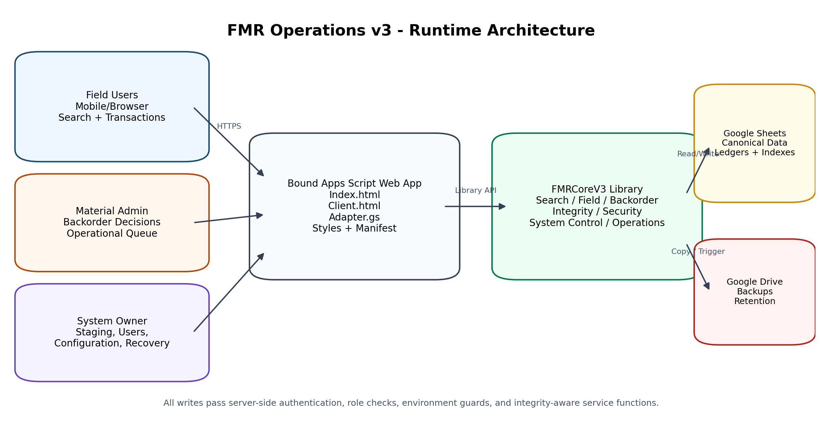
Current alpha.11 runtime architecture
Revision 2.0
3 August 2026
Current implementation: FMRCoreV3 3.0.0-alpha.11 | Apps Script Library 11
Repository: jonaDaniM/FMRv3 | Latest documented commit: 619e477f8f5b2b7b100c2ef0e78931b6dde92e30

Document Control
Item | Value
Document title | FMR Operations v3 Technical Design, Operations, and Acceptance Documentation
Scope | Sprint 1 foundation through Sprint 4B production-readiness controls and production activation plan
Current release | FMRCoreV3 3.0.0-alpha.11; immutable Apps Script library version 11
Current environment | TEST, transaction mode ENABLED after full acceptance; production activation remains a controlled rollout
Operational readiness | Overall health PASS; pilot ready; daily schedule enabled near 02:00 America/Indiana/Indianapolis; production-readiness engineering complete
Latest documented repository commit | 619e477f8f5b2b7b100c2ef0e78931b6dde92e30 - Sprint 4B Operational Readiness serialization fix
Primary audience | Project leadership, Material Management, system owner, maintainers, planners, and technical reviewers
Classification | Internal project documentation

Revision History
Revision | Date | Release basis | Description
1.0 | 2026-08-03 | alpha.11 / library 11 | Initial comprehensive documentation covering Sprint 2D through completed Sprint 4B acceptance.
2.0 | 2026-08-03 | alpha.11 / library 11 | Expanded to cover the complete delivery lifecycle from Sprint 1 requirements and foundation through production-readiness controls, traceability, cutover gates, and operational handoff.

Source Basis
- Initial requirements, workflow decisions, and ownership constraints established during project discovery, including FMR/IWP/ISO relationships, quantity semantics, Bag & Tag reservations, recipient capture, and account-based access.
- Current GitHub repository history and implementation files in jonaDaniM/FMRv3.
- Sprint implementation, migration, and acceptance packages generated from Sprint 1 foundation through Sprint 4B.
- Google Apps Script execution logs supplied during acceptance testing on 2-3 August 2026.
- Acceptance database workbook snapshot containing the canonical data model, indexes, ledgers, and test records.
- User interface screenshots captured during Field, Admin, Owner, operational-readiness, and recovery acceptance.
Authority of this document
This document describes the complete engineering path from Sprint 1 through the validated production-readiness control set. The current accepted runtime remains in TEST. Production activation is a controlled deployment and business-signoff step, not an already completed go-live.

Contents
1. Management and Technical Executive Summary
2. Purpose, Scope, and Operating Principles
3. Delivery Lifecycle: Sprint 1 through Production Readiness
4. System Architecture
5. Data Architecture and Sheet Catalog
6. Core Service Architecture
7. Bound Web Application Architecture
8. Field Workflow and Quantity Model
9. Backorder Lifecycle and Field Exception Notices
10. Admin Operations and Synchronized Detail
11. Owner Controls, Roles, and Environment Management
12. Operational Readiness, Backups, and Scheduling
13. Controlled Recovery and Rollback
14. Search, Indexing, Performance, and Caching
15. Security and Authorization
16. Diagnostics and Acceptance Evidence
17. Deployment, Versioning, and Configuration
18. Production Readiness and Rollout Plan
19. Operations Runbooks
20. Troubleshooting and Known Constraints
Appendix A. Data Dictionary
Appendix B. Public API and Function Inventory
Appendix C. Acceptance Fixtures and Evidence
Appendix D. Commit and Release Reference
Appendix E. Requirements-to-Production Traceability

1. Management and Technical Executive Summary
From Sprint 1 forward, FMR Operations v3 progressed from a requirements-driven Google Sheets and Apps Script foundation into a controlled, owner-managed, production-ready application architecture. The delivery path established the canonical FMR data model and exact search contract, added indexed Bag & Tag and Admin operations, guided and compact Field workflows, hardened quantity and metadata controls, validated the complete Admin backorder lifecycle, closed the Field/Admin communication loop, introduced role and environment governance, and added operational monitoring, scheduled backups, rollout gates, and controlled recovery.

Management Outcome
- Foundation and traceability: The platform began with explicit quantity, reservation, issuance, search, ownership, and audit requirements and now provides a documented path from each requirement to a tested production control.
- Faster Field use: Material lines are compact, description-first, filterable, and optimized for rapid scanning on desktop and iPad-sized displays.
- Stronger data quality: Authenticated identity, normalized storage locations, server-side quantity limits, and duplicate-submit protection reduce inconsistent transaction records.
- Validated Admin lifecycle: Partial confirmation, final confirmation, rejection, return for Field review, and split confirm/return outcomes were proven against isolated acceptance fixtures.
- Closed-loop communication: Field users now receive persistent notices for rejected and returned backorders and informational chips for pending or confirmed commitments.
- Production controls: The System Owner can manage users, roles, defaults, environment identity, maintenance mode, backups, thresholds, and recovery without editing database rows.
- Operational resilience: The platform creates manual and scheduled database backups, records health history, enforces rollout gates, and requires a backup before controlled recovery.
- Acceptance status: Final integrity testing passed with zero line, header, or Bag & Tag index issues. Operational health passed, the daily schedule was installed, pilot readiness passed, and a controlled recovery completed successfully.

Current Validated State
Control | Validated state
Release | FMRCoreV3 3.0.0-alpha.11; library 11
Environment | TEST
Transaction mode | ENABLED after maintenance-mode recovery acceptance
Integrity scan | 7 lines; 6 headers; 9 backorders; 1 active bag item; 0 integrity issues
Operational readiness | PASS; pilotReady = true; productionReady = false because environment is TEST
Backups | Manual, scheduled, and recovery backups validated
Schedule | Daily near 02:00 America/Indiana/Indianapolis
Recovery | SAFE_RECONCILE applied to V3-ADMIN-CONFIRM-0003 with automatic pre-recovery backup

Leadership interpretation
The engineering control set required for production is complete and validated in TEST: identity, role enforcement, transaction guards, backups, health checks, scheduling, recovery, and integrity verification. A separate PRODUCTION database, controlled cutover, realistic pilot, and Material Management signoff remain the final activation steps.

2. Purpose, Scope, and Operating Principles

Purpose
FMR Operations v3 is an owner-controlled Field Material Request platform built on Google Sheets and Google Apps Script. It provides a single operational model for published FMR records, exact indexed search, Field material transactions, Bag & Tag reservations, issuance, backorder review, audit history, user administration, and operational recovery.

Scope Covered by This Document
- Initial operational problem, requirement discovery, and ownership constraints that shaped Sprint 1.
- Sprint 1 architecture, canonical data model, staging/publishing model, role-aware Bound/Core split, and exact indexed search.
- Sprint 2A active Bag & Tag index and Admin active-bag queue.
- Sprint 2B combined Admin operational rail and dashboard integration.
- Sprint 2C guided Field workflow contract and action eligibility model.
- Sprint 2D compact Field presentation, full Field acceptance fixture, and alpha.6 integrity repair.
- Sprint 2E transaction feedback, authenticated metadata, duplicate-submit protection, and flexible location policy.
- Sprint 3A Admin backorder lifecycle acceptance and Sprint 3B Field exception visibility.
- Sprint 4A role administration, environment mapping, defaults, and maintenance mode.
- Sprint 4B operational monitoring, backups, scheduling, rollout gates, and controlled recovery.
- Production-readiness definition, environment cutover, pilot validation, operations handoff, data dictionary, APIs, diagnostics, and limitations.

Operating Principles
Principle | Implementation meaning
Owner-controlled master data | Only the configured System Owner stages, publishes, renumbers, configures users, or performs controlled recovery.
Indexed operational search | Field and Admin interfaces use exact normalized keys and physical row pointers rather than broad sheet scans.
Canonical current state | FMR_Header and FMR_Line_Items store current quantity summaries; append-only ledgers preserve events.
Atomic service writes | A transaction updates the canonical line, header totals, transaction ledger, operational indexes, and audit evidence as one service operation.
No direct spreadsheet corrections | Operational corrections use controlled service functions and recovery workflows.
Authentication over free text | The server derives the performer from the authenticated Google account.
Read-only maintenance windows | Recovery application requires READ_ONLY mode, a reason, a preview token, and an automatic backup.
Immutable library releases | Each Core change advances an Apps Script library version; deployed versions are not edited in place.

Roles
Role profile | Search | Field transactions | Backorder Admin | Owner controls
Read Only | Yes | No | No | No
Field User | Yes | Yes | No | No
Material Admin | Yes | No | Yes | No
System Owner | Yes | Yes | Yes | Yes

3. Delivery Lifecycle: Sprint 1 through Production Readiness
Phase | Release / baseline | Primary objective | Delivered capability and acceptance
Sprint 1 | alpha.1 foundation | Establish the governed FMR platform | Bound/Core separation, authenticated adapter, canonical workbook, Owner staging/publishing, Admin register/backorders, Field search/actions, renumbering, audit, and exact FMR/ISO search.
Sprint 1 hardening | alpha.1-alpha.2 | Prove search and performance assumptions | Combined ISO+sheet parsing, exact key normalization, baseline diagnostics, bootstrap timing, and known-search performance measurements.
Sprint 2A | alpha.3 / library 3 | Operationalize Bag & Tag visibility | Active Bag & Tag status index, backfill migration, indexed Admin active-bag queue, Core API exposure, and Bound queue integration.
Sprint 2B | alpha.3-alpha.4 | Unify Admin operations | Combined backorder and active-bag operational rail, dashboard payload, Bound rendering, queue refresh, and indexed operational filtering.
Sprint 2C | alpha.4-alpha.5 | Guide Field transactions | Server-defined workflow contract, action eligibility and limits, guided material actions, diagnostics, and Bound rendering aligned to Core state.
Sprint 2D | alpha.6 / library 6 | Improve scan speed and prove the full Field flow | Description-first compact rows, collapsed details, material filter, acceptance preflight, repeatable full Field fixture, backorder-state integrity repair, and regression validation.
Sprint 2E | alpha.7-alpha.8 / libraries 7-8 | Harden Field transaction UX and metadata | Authenticated performer, saving state, duplicate-submit protection, immediate line refresh, preserved expansion, required flexible location capture, normalization, and suggestions.
Sprint 3A | alpha.8 / library 8 | Validate the complete Admin lifecycle | Isolated confirm, reject, return, and split fixtures; partial and final decisions; queue/index/ledger/audit reconciliation; zero integrity issues.
Sprint 3B | alpha.9 / library 9 | Close the Field/Admin exception loop | Persistent pending/confirmed chips, sticky rejected/returned notices, quantity-aware resolution, simultaneous split notices, and synchronized open Admin detail.
Sprint 4A | alpha.10 / library 10 | Create the production control plane | Owner-managed roles, activation/deactivation, last login, TEST/PRODUCTION mappings, project defaults, READ_ONLY mode, write guards, and responsive Owner controls.
Sprint 4B | alpha.11 / library 11 | Create operational resilience and recovery | Health history, manual/scheduled backups, retention and stale thresholds, rollout gates, controlled preview/apply recovery, pre-recovery backup, active-database isolation, and response serialization.
Production readiness | alpha.11 accepted in TEST | Prove the complete control set before cutover | Health PASS, current backups, daily schedule enabled, pilotReady true, SAFE_RECONCILE applied with backup, post-recovery integrity PASS, and documented production activation gates.

Repository Milestones
Commit | Message | Significance
b1ae14655ee7 | Initial commit: FMR v3 Bound and FMRCoreV3 Apps Script projects | Sprint 1 foundation: adapter, Field/Admin/Owner UI, public APIs, staging, publishing, search, backorders, and transactions.
a67e2ec96399 | Update SearchService with FMR and combined ISO search parsing | Exact FMR and ISO+sheet search contract.
1319e2fb7a85 | Add Sprint 0 performance baseline diagnostics | Baseline bootstrap and known-search performance evidence used before later sprints.
8794915456b5 | Add active Bag Tag status index maintenance | Operational status indexing for reserved material.
6a04d37fc7b0 | Add indexed Admin Active Bag Queue service | Sprint 2A queue service over the new index.
de9b1c6f2893 | Add combined Admin operation rail payload | Sprint 2B unified backorder and active-bag operations.
0c8dd0261ed2 | Add guided Field workflow contract | Sprint 2C server-defined workflow phases, actions, and limits.
c578079f39be | Render guided Field material workflows | Bound implementation of the Sprint 2C contract.
3c5bc75b0ad7 | Compact Field material lines for faster scanning | Sprint 2D compact description-first presentation.
88b1d2ea1e1a | Add repeatable full Field acceptance fixture | End-to-end Field acceptance evidence.
69ecf2fcafec | Connect Bound to Core alpha.6 integrity release | Bound/Core alpha.6 alignment after state-integrity repair.
8f83a01e77f0 | Align repository with deployed alpha.8 flexible locations | Final Sprint 2E flexible-location alignment.
00c117daacfd | Add Sprint 3A Admin lifecycle acceptance | Repeatable Admin lifecycle fixture and validators.
48be1204e1b8 | Add Field exception notices and synchronized Admin details | Sprint 3B alpha.9.
e4a63ac2e867 | Add role administration and environment controls | Sprint 4A alpha.10.
b25594fa745c | Append Styles changes | Responsive Production Controls correction.
92ec4b08d6ba | Review Owner functionalities | Sprint 4B operational-readiness implementation.
619e477f8f5b | Sprint 4B Operational Readiness Serialization fix | Client-safe response serialization and final Index cleanup.

Versioning note
Sprint 1 through Sprint 2C evolved the initial alpha releases and operational contracts. Sprint 2D aligned with alpha.6/library 6; Sprint 2E used alpha.7 and alpha.8; Sprint 3A reused alpha.8 for acceptance-only fixtures; Sprint 3B advanced to alpha.9; Sprint 4A advanced to alpha.10; and Sprint 4B advanced to alpha.11/library 11. Bound-only presentation corrections did not require a new Core library version.

Initial problem and requirements baseline
The project began with a spreadsheet-based Field Material Request process that needed to preserve the existing FMR template while supporting multiple ISO drawings, an IWP relationship, Field searching, material reservation, issuance, and Admin review. The architecture therefore had to improve control without breaking the field-facing operating model.
- Requested quantity is demand, not proof that material was received or available.
- One IWP may contain many ISO lines, and one line/sheet may have multiple independent FMRs.
- Bagged material is reserved and unavailable to other requests unless an Admin releases or reassigns it.
- Issuance must record the recipient identity; optional badge, foreman, or signature data may supplement it.
- Field and Admin searches must work by exact FMR number and by combined ISO line plus sheet.
- Individual Google accounts are preferred, while shared iPads remain possible under account-based authorization.
- The source code remains owner-controlled through a Core library and a separately deployed Bound web app.
- Canonical state must be auditable, and direct spreadsheet edits must not be the normal correction path.

Sprint 1 - governed platform foundation
Sprint 1 converted the requirements into two Apps Script projects: a Bound web application for Field, Admin, and Owner interfaces, and FMRCoreV3 for domain logic. The initial adapter resolved the signed-in account and delegated every operation through the Core public API.
The first release already contained the long-lived architectural primitives used by later sprints: Owner staging, publication, renumbering, Field search/actions, Admin dashboard/register, backorder review, role checks, canonical quantity fields, ledgers, search indexes, and audit evidence.
- The browser did not receive authority to select a database, role, performer, or transaction limit.
- Published FMRs were separated from staging records so intake could be validated before becoming operational.
- Exact keys and row pointers were introduced to avoid repeated whole-sheet scans.
- The immutable library pattern preserved code ownership while allowing the Bound project to consume controlled versions.

Sprint 1 hardening - exact search and performance baseline
The next foundation work formalized FMR-number parsing and combined ISO/sheet parsing, then added baseline diagnostics before operational queues and richer Field rendering were introduced. This created a measurable performance reference rather than relying on perceived responsiveness.
- Known fixture searches measured exact indexed lookup behavior.
- Bootstrap diagnostics measured user/configuration and Field metadata loading.
- The search contract became stable enough for Admin, Field, and later recovery functions to reuse.

Sprint 2A - indexed Bag & Tag operations
Sprint 2A addressed a production concern that cannot be solved by a simple FMR search: material that is already bagged must remain reserved, visible, and operationally actionable. An active Bag & Tag status index was introduced and backfilled from existing bag records.
The Core service then exposed an indexed Admin active-bag queue, and the Bound dashboard integrated it without reading all bag records for each refresh.
- Active and partially issued bags remain visible while quantity remains in the bag.
- Fully issued or inactive bag items leave the operational queue but remain in history.
- Queue records retain FMR, ISO, material, storage, quantity, and bag-tag context.

Sprint 2B - combined Admin operational rail
Sprint 2B combined backorders awaiting review and active Bag & Tag records into one operational rail. The Admin dashboard could therefore show current exceptions and reservations alongside the FMR register and open-record detail.
This phase established the refresh pattern later reused by Sprint 3B: operational queues and the open detail view are separate client states and must be refreshed together after a decision.
- Combined payloads reduced redundant server calls.
- Indexed operational filters prevented full-ledger scans.
- Admin actions remained separate from Field transactions and retained role-specific authorization.

Sprint 2C - guided Field workflow contract
Sprint 2C moved workflow logic out of ad hoc browser buttons and into a server-defined contract. Core calculated the current workflow phase, eligible actions, maximum quantities, and guidance for each material line. Bound rendered those instructions rather than independently deciding what was legal.
This was a major control point: later UI redesigns could change presentation without changing transaction semantics.
- Confirm Available, Bag & Tag, Issue from Available, Issue from Bag, Locate & Issue, and Submit Backorder were exposed only when eligible.
- Action limits were calculated from requested, located, available, bagged, issued, pending, confirmed, and remaining quantities.
- Returned-for-review records changed the workflow phase and surfaced the Admin reason.

Sprint 2D - compact Field execution and acceptance
Sprint 2D optimized the Field interface for real scanning speed. Material descriptions became primary, commodity codes became compact identifiers, and key quantities remained visible while detail and actions stayed collapsed until needed.
The phase also introduced a repeatable full Field acceptance fixture and an integrity repair for legacy backorder commitments. The final fixture exercised all six supported Field actions against one controlled record.
- The accepted fixture requested 8 units and issued 3 through multiple action paths.
- One pending backorder remained, while available and reserved quantities returned to zero.
- Transactions, bag records, indexes, audits, line totals, and header totals reconciled with zero issues.

Sprint 2E - hardened transaction experience and flexible locations
Sprint 2E hardened live Field execution. The authenticated performer became authoritative; save-state controls prevented accidental double submission; successful transactions updated the active line immediately; and expanded-line state was preserved.
The final alpha.8 release replaced a rigid storage-location allowlist with normalized free text supported by suggestions. This preserved operational flexibility while keeping storage data consistent.
- Confirm Available and Bag & Tag require a location.
- Locate & Issue may include a location but is not blocked when the material is issued immediately.
- Locations are trimmed, whitespace-collapsed, uppercased, and capped at 100 characters.
- Unknown values are preserved rather than silently corrected.

Sprint 3A - Admin lifecycle acceptance
Sprint 3A did not add a new transaction model; it proved the existing backorder engine through isolated fixtures. Partial confirmation, final confirmation, rejection, return for Field review, and partial-confirm-plus-return splitting were executed through the real Admin interface.
The acceptance service inspected line quantities, header totals, queue state, Backorder_Requests rows, operational indexes, transaction ledgers, audit actions, and integrity results after every stage.
- A fully confirmed request left the Admin queue with confirmed commitment preserved.
- A rejected request became inactive and reopened Field resolution without creating confirmed commitment.
- A returned request entered FIELD_REVIEW_REQUIRED with the Admin reason visible.
- A split return preserved the confirmed portion and created a new returned-review request for the remainder.

Sprint 3B - closed-loop Field/Admin communication
Sprint 3B converted backorder decisions into persistent Field-facing notices. Rejected and returned quantities became sticky action-required banners, while pending, partially confirmed, and confirmed quantities became informational chips.
The same release corrected Admin synchronization so a decision refreshes the queue, register, KPIs, and the FMR detail that is currently open. Decision buttons remain disabled while saving.
- Rejected notice quantities reduce only when later Field work actually addresses unresolved material.
- Returned notices remain until the Field workflow creates a new recorded resolution.
- Split records can show confirmed and returned quantities simultaneously.

Sprint 4A - production control plane
Sprint 4A moved access and environment administration out of direct spreadsheet editing. The Owner interface now manages authorized users, fixed permission profiles, activation state, last-login data, project defaults, environment identity, and maintenance mode.
TEST and PRODUCTION database mappings are stored in Bound Script Properties. Core receives the selected database explicitly and re-validates the configured owner and permissions.
- READ_ONLY blocks Field, Admin, staging, publication, renumbering, and recovery application while preserving search and monitoring.
- The configured System Owner cannot be deactivated or reassigned through the portal.
- User-cache invalidation makes access changes take effect immediately.

Sprint 4B - operational resilience and controlled recovery
Sprint 4B added the operational controls expected before production activation: health snapshots, backup-age checks, manual and scheduled database copies, retention settings, stale-item thresholds, pilot/production rollout gates, and controlled recovery.
Recovery is intentionally conservative. The Owner must preview an FMR-specific action, enter READ_ONLY mode, provide a written reason, and create an automatic backup before Core rebuilds indexes, refreshes totals, or synchronizes notices.
- The daily trigger runs under the installing owner account and creates the backup before recording health.
- Database and folder identifiers are shown as fingerprints rather than raw IDs.
- The accepted SAFE_RECONCILE operation rebuilt three search keys per active line, refreshed totals and notices, preserved audit history, and passed post-recovery integrity.
- A serialization correction ensured Date-bearing health responses cross google.script.run safely.

Production-readiness gate
The accepted TEST runtime now contains the technical controls required for production: authenticated roles, exact search, transaction limits, auditable ledgers, exception handling, environment guards, maintenance mode, backups, scheduled health checks, controlled recovery, and regression diagnostics.
Production readiness does not mean the TEST database is itself production. Final activation requires a separately permissioned PRODUCTION database, migrations in that database, a first backup, a successful health check, the daily schedule, realistic multi-user pilot execution, and Material Management signoff.
- Current accepted status: overall health PASS, backup current, daily schedule enabled, pilotReady true, productionReady false because the active environment is TEST.
- The remaining work is deployment governance and operational signoff rather than missing transaction functionality.

4. System Architecture

Figure 1. Runtime architecture and trust boundaries

Component Layers
Layer | Primary artifacts | Responsibility
Browser UI | Bound/Index.html, Client.html, Styles.html, FieldWorkflowStyles.html | Field, Admin, and Owner views; action modals; optimistic UI state; feedback; responsive layout.
Bound adapter | Bound/Adapter.gs | Authenticated caller resolution, active environment/database mapping, Core library calls, scheduled-trigger management, response serialization.
Core public API | FMRCoreV3/PublicApi.gs | Stable entry points for search, transactions, Admin review, staging, user administration, operations, backup, and recovery.
Core domain services | FieldService, BackorderService, SearchService, FieldMetadataService, FieldBackorderNoticeService | Quantity calculations, workflow rules, backorder decisions, notices, search contracts, metadata normalization.
Governance services | Security, SystemControlService, IntegrityService | Role checks, write guard, environment settings, user lifecycle, integrity diagnostics and repairs.
Operational services | OperationalReadinessService | Health checks, backup creation, retention, schedule support, recovery preview and application.
Persistence | Google Sheets workbook | Canonical records, ledgers, indexes, configuration, users, operational history.
Backup storage | Google Drive folder | Timestamped complete spreadsheet copies with retention-managed history.

Trust Boundaries
- The browser is not trusted to define the authenticated performer, role, environment, transaction limits, or database ID.
- The Bound adapter resolves the caller and active environment before invoking the immutable Core library.
- Core services re-check role permissions and transaction mode before write operations.
- Canonical data is stored in Sheets; UI state is considered temporary and is reloaded from indexed search after writes.
- Recovery is intentionally separated from normal writes and requires a maintenance window.

Request Path
- The user opens Field, Admin, or Owner mode through the Bound web deployment.
- The browser calls a Bound adapter function through google.script.run.
- The adapter resolves the signed-in account, active environment, and mapped database.
- The adapter invokes the appropriate FMRCoreV3 public API function.
- Core authenticates the user, validates role and write mode, normalizes input, and executes the domain service.
- The service writes canonical state, ledgers, indexes, notices, and audit evidence.
- The result is serialized into a client-safe object and returned to the browser.
- The client updates the affected line or refreshes the current operational panel.
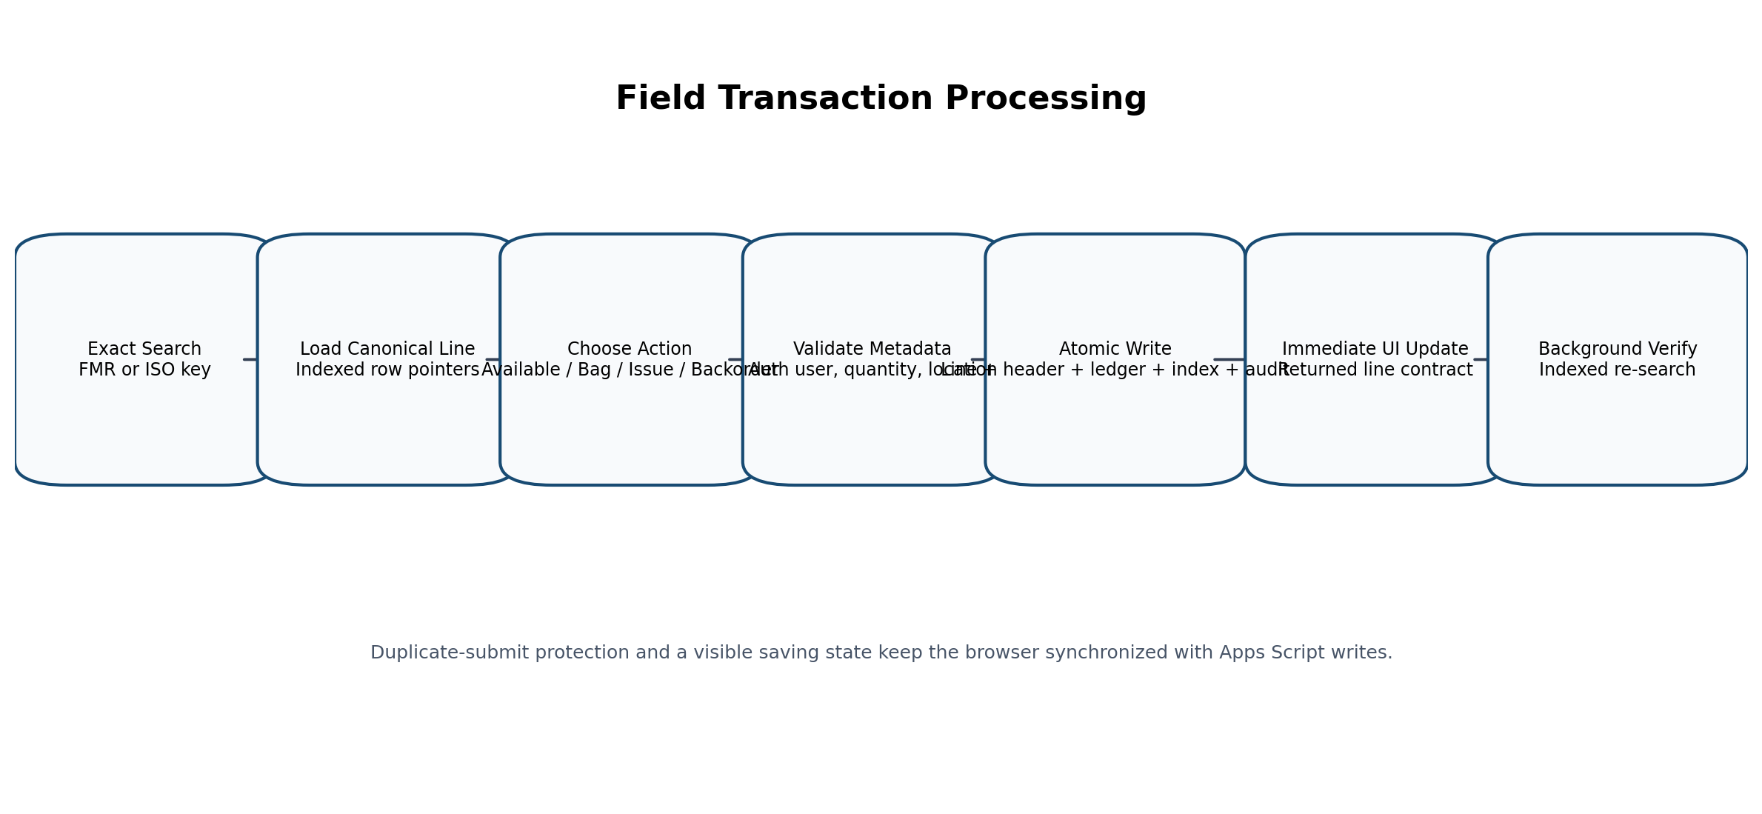
Figure 2. Field transaction processing path

5. Data Architecture and Sheet Catalog
The workbook separates current operational state from append-only evidence and lookup acceleration. Canonical tables answer the current-state question; transaction and audit tables answer what happened; Search_Index and Operational_Index answer how to find active records quickly.
Sheet | Data class | Purpose
README | Reference | Operating model, key formats, sheet purpose.
Dashboard | Derived view | High-level overview; not the canonical source for transactions.
Configuration | Master configuration | Versions, owner, timezone, project defaults, environment, write mode, backup and threshold settings.
Users | Master authorization | Account identity, role flags, active status, lifecycle and login data.
Lists | Reference values | UOM, reasons, statuses, suggestions, and project lists.
Import_Staging_Header | Owner staging | Editable pre-publication header payload.
Import_Staging_Lines | Owner staging | Editable pre-publication material lines.
FMR_Header | Canonical current state | One published FMR header and aggregate quantities.
FMR_Line_Items | Canonical current state | Published material lines and current quantity summaries.
Search_Index | Lookup index | Normalized FMR and ISO keys with physical row pointers.
Material_Transactions | Append-only ledger | Every material movement or exception event.
Bag_Tag_Header | Operational entity | Tag identity, location, creator, and status.
Bag_Tag_Items | Operational entity | Line-level reserved quantity and issuance state.
Backorder_Requests | Lifecycle entity | Field requests, Admin decisions, quantities, reasons, and returned-review state.
Audit_Log | Append-only audit | Administrative and operational actions with correlation IDs.
Operational_Index | Lookup index | Active bags and actionable backorders without scanning operational sheets.
Field_Notifications | Field exception state | Persistent pending, confirmed, returned, and rejected notices by line/source.
Operational_Health_Log | Operations history | Recorded health result, counts, backup age, trigger type, and details.
Backup_History | Operations history | Backup file metadata, trigger, retention, status, and error.
Recovery_Actions | Recovery history | Preview, application, target, backup, before/after payloads, and errors.

Canonical Quantity Fields
Field | Meaning
Qty_Requested | Total quantity required by the FMR line or aggregated header.
Qty_Confirmed_Located | Physical quantity confirmed as located, including quantity later reserved or issued.
Qty_Active_Bagged | Located quantity currently reserved in active Bag & Tag records.
Qty_Available | Located quantity available for reservation or issue.
Qty_Issued | Quantity physically issued to the Field recipient.
Qty_Pending_Backorder | Quantity awaiting an Admin decision.
Qty_Confirmed_Backorder | Quantity accepted as a backorder commitment.
Qty_Not_Yet_Located | Requested quantity not yet physically located.
Qty_Remaining_Requirement | Requested quantity not yet issued; reserved material remains outstanding until issue.

Data integrity rule
Pending or confirmed backorder quantities do not silently create physical availability. Physical availability is established only through location, Bag & Tag, or issue workflows.

Indexing Model
- Search_Index: Stores exact normalized FMR and ISO keys with header and line row pointers. Stable mappings may be cached; live quantities are read from canonical rows.
- Operational_Index: Stores active BAG, BAGLINE, BAGSTATUS, BACKORDER, BACKORDERLINE, and BACKORDERSTATUS entries for queue retrieval.
- Index deactivation: Historical index rows are retained but marked inactive. New status or entity rows are appended when lifecycle state changes.
- Recovery behavior: SAFE_RECONCILE deactivates current Search_Index rows for a target FMR, rebuilds the expected entries, refreshes totals, and re-synchronizes notices.

6. Core Service Architecture
FMRCoreV3 is the immutable server-side library. The following service boundaries are present in the alpha.11 implementation.
Service | Domain | Core responsibilities
FieldService.gs | Field transaction engine | Bootstrap, action limits, line state, confirm available, direct issue, issue available, Bag & Tag, issue from bag, submit backorder, header refresh.
BackorderService.gs | Admin decision engine | Queue retrieval, confirm/reject/return decisions, partial confirmation, split-return creation, returned-review retrieval.
FieldMetadataService.gs | Field metadata normalization | Authenticated performer override, location normalization, required-field enforcement, suggestions, diagnostics.
FieldBackorderNoticeService.gs | Field notice contract | Notice sheet, notice upsert/resolve, rejected quantity reduction, serialization, migration, diagnostics.
SearchService.gs | Portal read contract | Exact indexed search, card serialization, Field workflow contract, returned backorders, notices, active bags.
IntegrityService.gs | Integrity and guard model | Action limits, returned/backorder transitions, canonical/header reconciliation, diagnostics, targeted repair.
Security.gs | Authentication and authorization | User lookup, cached role profile, Search/Field/Admin/Owner assertions, reference list retrieval.
SystemControlService.gs | Governance and environment | User lifecycle, roles, environment identity, READ_ONLY mode, defaults, fingerprints, diagnostics.
OperationalReadinessService.gs | Operations and recovery | Health, backups, retention, thresholds, scheduling support, recovery preview/apply, rollout gates.
PublicApi.gs | Stable library facade | Database-context-aware exported functions consumed by Bound.

FieldService Transaction Pattern
- Resolve the canonical line by FMR_Line_ID.
- Calculate current line state and action-specific maximum quantities.
- Validate quantity and action metadata.
- Plan and apply any backorder transitions affected by physical location or resubmission.
- Append the material transaction.
- Update canonical line summaries and line status.
- Refresh aggregate header totals from indexed active lines.
- Update operational indexes, Bag & Tag records, Field notices, and audit evidence as required.
- Flush the spreadsheet and return the fully serialized updated line.
Representative public API write guard
function performFmrV3FieldAction(databaseId, userEmail, request) {
setFmrV3DatabaseContext_(databaseId);
assertWriteEnabledFmrV3_('Field transaction');
return performFieldActionFmrV3_(userEmail, request || {});
}

BackorderService Decision Semantics
- CONFIRM accepts a positive quantity no greater than the pending balance.
- A partial confirmation keeps the request actionable with status Partially Confirmed.
- Final confirmation removes the request from the Admin review queue but retains the commitment record.
- REJECT clears the pending commitment and deactivates the operational request while creating a persistent Field rejection notice.
- RETURN moves the unresolved amount into FIELD_REVIEW_REQUIRED and preserves the Admin reason.
- If a partially confirmed request is returned, the confirmed original is preserved and a new Returned for Review record is created for the unresolved balance.
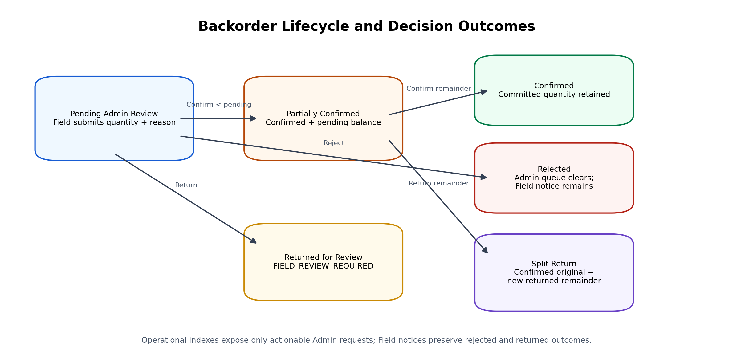
Figure 3. Backorder lifecycle and split-return semantics

7. Bound Web Application Architecture
The Bound Apps Script project is the deployed web application and integration boundary. It contains the browser UI, adapter functions, environment mappings, trigger installation, and client-safe serialization.

Bound Components
Artifact | Responsibility
Index.html | Field, Admin, Owner, Production Controls, Operational Readiness, and modal markup.
Client.html | View activation, server calls, rendering, transaction modals, Admin synchronization, user controls, health/backup/recovery UI.
Adapter.gs | Caller resolution, database selection, Core calls, trigger management, diagnostics, and response serialization.
Styles.html | Global layout, Admin/Owner controls, Production Controls, Operational Readiness, responsive behavior.
FieldWorkflowStyles.html | Compact material rows, workflow chips, notices, action cards, and Field-specific responsive styling.
appsscript.json | Timezone, web-app runtime settings, and Core library version 11 reference.

Response Serialization Correction
Sprint 4B exposed a boundary-specific issue: the Core health object included a raw JavaScript Date used internally for logging. Apps Script could process the value server-side, but google.script.run returned a null object to the browser. The final adapter converts outbound operational responses through JSON serialization before returning them.
Final alpha.11 Bound serialization guard
function serializeBoundResponseV3_(value) {
if (value === undefined || value === null) {
return null;
}
return JSON.parse(JSON.stringify(value));
}

Environment Registry
- The TEST database remains the default fallback.
- Bound Script Properties store TEST and PRODUCTION database mappings and the active environment.
- Changing the active environment requires the current caller to be the System Owner in the current and target databases.
- The browser displays database fingerprints rather than raw spreadsheet IDs.
- Core diagnostics, notices, backups, and recovery were corrected in alpha.11 to respect the active database context.
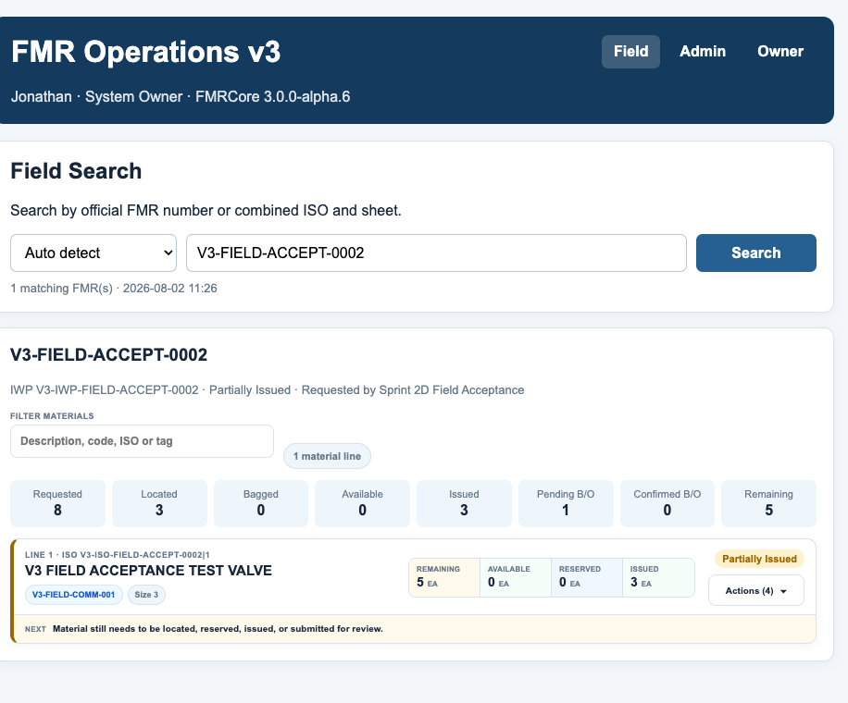
Figure 4. Compact Field search and material line presentation

8. Field Workflow and Quantity Model

Compact Material Presentation
- Material description is the primary line heading.
- Commodity code is displayed as a compact chip.
- Every line loads collapsed for rapid scanning.
- Remaining, Available, Reserved, and Issued are always visible.
- Requested, Located, Not Located, Pending B/O, Confirmed B/O, storage, tags, notices, and actions are shown after expansion.
- Per-FMR filter matches description, commodity, size, ISO, line number, status, storage location, tag number, and backorder notice text.

Supported Field Actions
Action | Primary preconditions | Primary effects
Confirm Available | Positive quantity within locatable limit; storage location required | Increases confirmed located and available; writes location and transaction; may satisfy returned/rejected state.
Locate & Issue | Positive quantity within direct-issue limit; recipient required; location optional | Locates and immediately issues quantity; updates fulfillment and recipient evidence.
Issue From Available | Positive quantity no greater than available; recipient required | Moves available quantity to issued.
Bag & Tag | Positive reservable quantity; storage location required | Creates tag/header/item; increases active bagged; may consume available or newly located quantity.
Issue From Bag | Positive quantity no greater than bag balance; recipient required | Decreases bag balance and active bagged; increases issued; closes tag item when exhausted.
Submit Backorder | Positive quantity within new-backorder limit; reason required | Creates Pending Admin Review request, transaction, operational indexes, notice, and audit evidence.

Metadata Guardrails
- Performed By is read-only in the browser and overwritten by the authenticated account on the server.
- Storage Location is required for Confirm Available and Bag & Tag.
- Locate & Issue may omit location because material is immediately issued.
- The final alpha.8 policy accepts free text, uppercases it, trims it, collapses repeated spaces, and limits it to 100 characters.
- Known locations are autocomplete suggestions, not an allowlist.
- Unknown or misspelled text is preserved after normalization rather than silently corrected.

Transaction Feedback
- The action modal remains visible while the write is in progress.
- The submit button changes to Saving and close/cancel controls are disabled.
- Repeated clicks cannot create duplicate transactions while the current action is pending.
- The affected material line is updated immediately from the server response.
- Expanded lines and filter text are preserved during the background indexed verification search.
- The success alert remains visible while verification completes.
Quantity model caution
Reserved material is not fulfilled material. Bagged quantity remains part of the remaining requirement until it is issued.

9. Backorder Lifecycle and Field Exception Notices

Admin Queue States
Backorder status | Admin queue | Field meaning
Pending Admin Review | Included | Admin decision required.
Partially Confirmed | Included | Some quantity accepted; remaining quantity still requires decision.
Confirmed | Excluded | Commitment accepted; no pending Admin decision.
Rejected | Excluded | Request is inactive; Field must resolve the material need or submit a revised request.
Returned for Review | Excluded from Admin queue | Field action required using the returned reason.

Field Notice Contract
Sprint 3B introduced Field_Notifications so that Admin decisions remain visible after the request leaves the Admin queue. The contract supports multiple notices on one line, which is necessary when a request is partially confirmed and the remaining quantity is returned.
Notice type | Presentation | Action required | Resolution
PENDING_ADMIN_REVIEW | Blue informational chip | No | Changes when Admin decides.
PARTIALLY_CONFIRMED | Informational chip with confirmed and pending amounts | No | Changes after another Admin decision.
CONFIRMED | Green informational chip | No | Remains as commitment evidence until later fulfillment logic resolves it.
RETURNED_FOR_REVIEW | Amber sticky banner with reason | Yes | Field locates, reserves, issues, or resubmits the affected amount.
REJECTED | Red sticky banner with reason | Yes | Field work reduces the unresolved quantity; full resolution closes the notice.

Quantity-Aware Rejection Resolution
Rejected notice quantities are not dismissed in the browser. They are reduced only by later recorded Field actions that address the unresolved material: Confirm Available, newly located Bag & Tag quantity, Locate & Issue, or a revised backorder submission. Partial work reduces the banner quantity; the notice is marked resolved only when the entire rejected amount has been addressed.

Split Return Example
Record | Requested | Confirmed | Pending/Returned | Status
Original request | 2 | 1 | 0 | Confirmed
Split returned record | 1 | 0 | 1 | Returned for Review
Line summary |  | 1 | 0 | FIELD_REVIEW_REQUIRED because returned notice remains

Non-dismissable exception design
Returned and rejected banners are cleared by workflow state, not by an X button. This prevents one browser session from hiding an unresolved project condition.

10. Admin Operations and Synchronized Detail
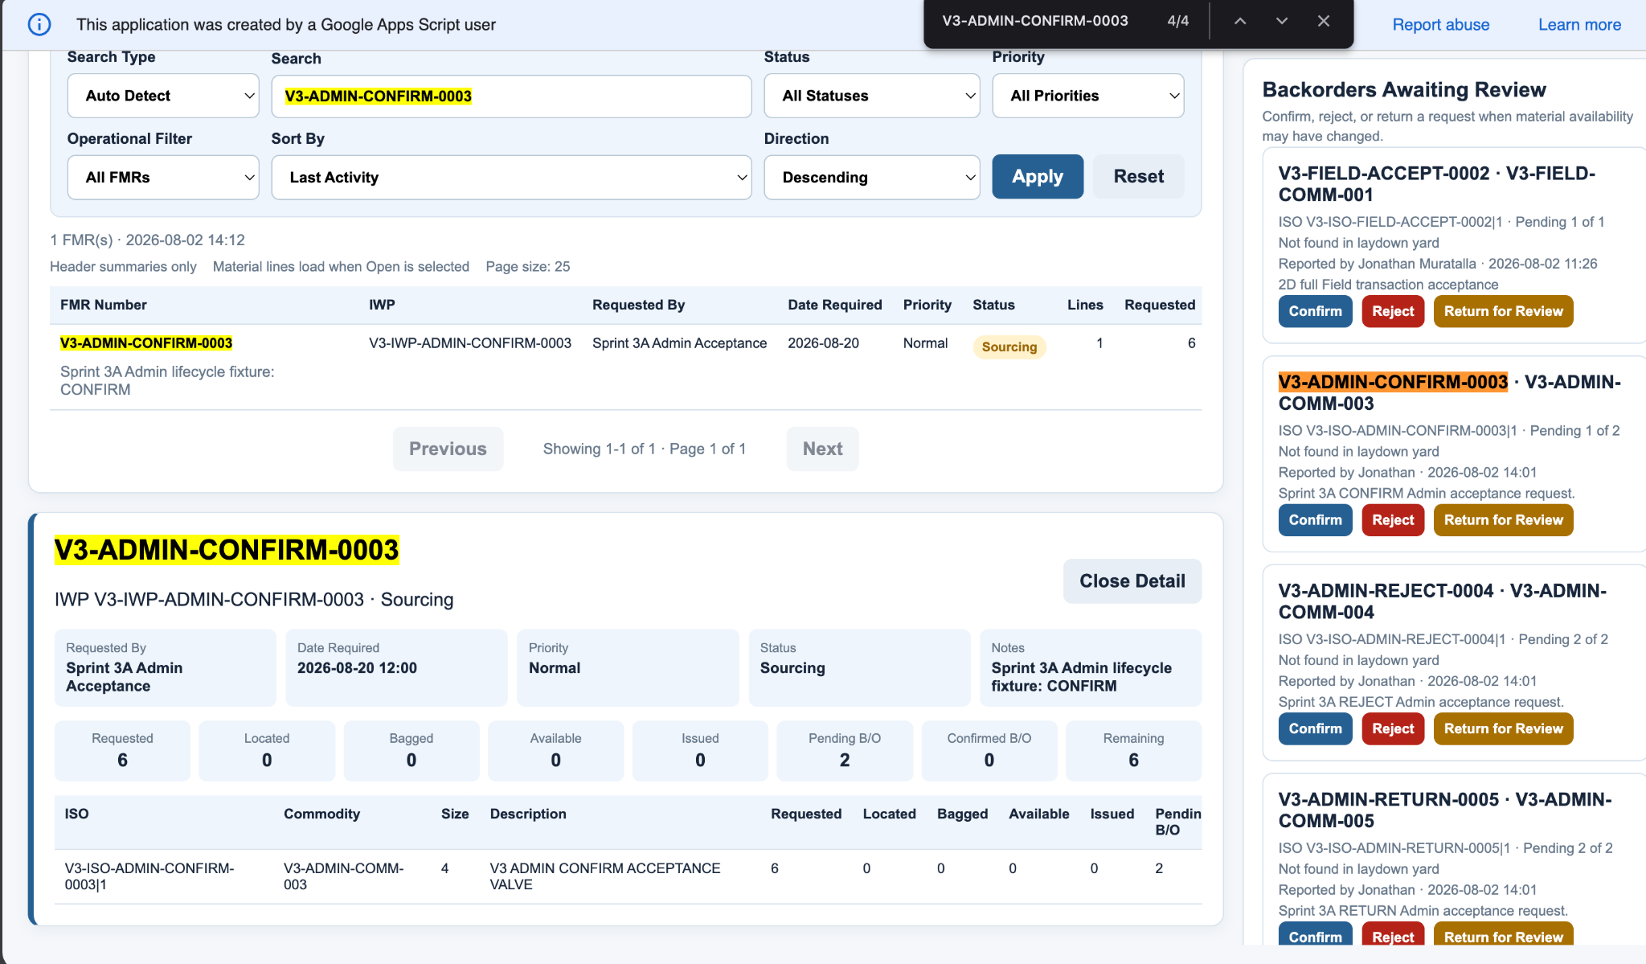
Figure 5. Admin register, open FMR detail, and backorder review rail

Admin Dashboard Responsibilities
- Display aggregate operational KPIs and the published FMR register.
- Load material-line detail on demand using indexed search.
- Display Backorders Awaiting Review and active Bag & Tag records.
- Permit authorized Admin users to confirm, reject, or return backorders.
- Keep confirmed commitments out of the actionable queue while preserving history.
- Synchronize the open FMR detail after a decision without requiring page refresh, Apply, or manual reopen.

Decision Synchronization
Sprint 3A revealed that the queue and register refreshed while a previously opened FMR detail retained a stale client object. Sprint 3B added adminOpenFmrNumber state, a decision busy flag, and a silent detail reload after dashboard refresh. The same detail panel remains open and the updated Pending B/O and Confirmed B/O values are re-rendered.

Duplicate Decision Protection
- All backorder decision buttons are disabled while a decision is being saved.
- The Owner/Admin status text communicates that the decision and selected FMR are refreshing.
- The action is submitted once through the adapter.
- The updated queue, register, KPIs, and current detail are loaded before the success message is shown.

Admin Acceptance Fixtures
Fixture | Scenario | Validated outcome
V3-ADMIN-CONFIRM-0003 | Confirm 1 of 2, then final 1 | Partially Confirmed -> Confirmed; pending 0; confirmed 2; queue 0.
V3-ADMIN-REJECT-0004 | Reject 2 | Request inactive; pending and confirmed 0; queue 0; Field rejection notice retained.
V3-ADMIN-RETURN-0005 | Return 2 | FIELD_REVIEW_REQUIRED; returned reason visible; queue 0.
V3-ADMIN-SPLIT-0006 | Confirm 1, return remaining 1 | Original preserved Confirmed; new returned record; confirmed and returned notices coexist.

11. Owner Controls, Roles, and Environment Management
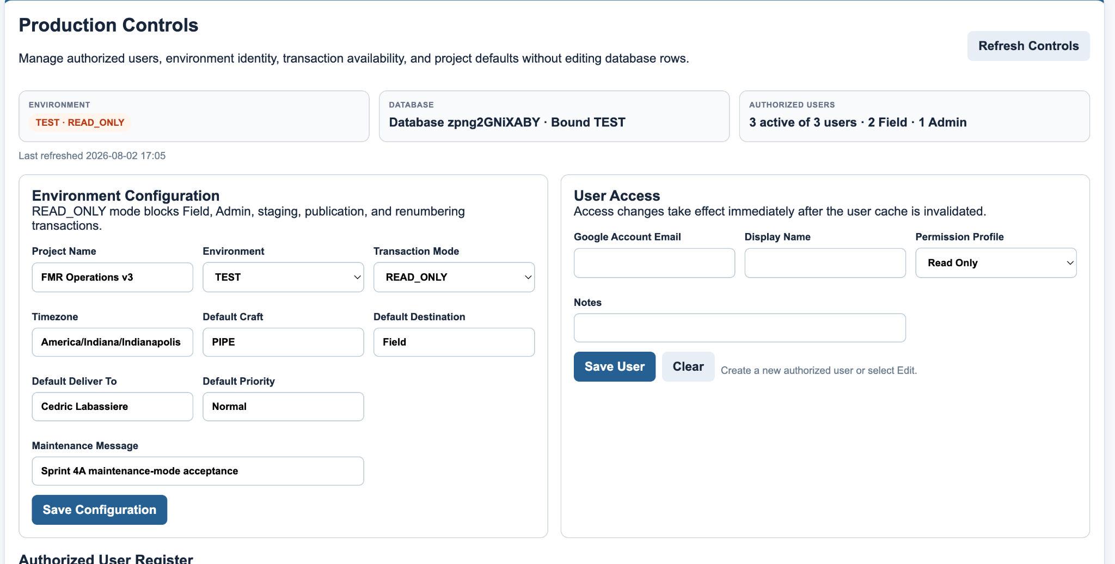
Figure 6. Production Controls and authorized user administration

Authorized User Register
- Creates or updates authorized Google account records without direct Users-sheet editing.
- Applies one of four fixed permission profiles.
- Immediately invalidates the cached user record after a change.
- Supports activation, deactivation with reason, and reactivation.
- Records Updated_By, Updated_At, Last_Login_At, Last_Interface, Deactivated_By, and Deactivated_At.
- Protects the configured System Owner from deactivation and prevents assigning OWNER to another email through the portal.

Environment Configuration
Setting | Purpose
PROJECT_NAME | Display name and backup folder/file prefix.
ENVIRONMENT_NAME | Logical database identity: TEST or PRODUCTION.
TRANSACTION_MODE | ENABLED permits writes; READ_ONLY blocks normal write paths.
MAINTENANCE_MESSAGE | Explains why writes are unavailable during READ_ONLY mode.
TIMEZONE | Application, display, backup, and schedule timezone.
DEFAULT_CRAFT | Default FMR craft.
DEFAULT_DESTINATION | Default destination.
DEFAULT_DELIVER_TO | Default delivery contact.
DEFAULT_PRIORITY | Default priority for new staging.

READ_ONLY Enforcement
The write guard is applied in PublicApi to Field transactions, Admin backorder decisions, staging changes, publication, and renumbering. Search, dashboards, Production Controls, Operational Readiness, and recovery preview remain available. Controlled recovery is the one write family intentionally allowed only after READ_ONLY is enabled.
Conceptual write-mode guard
function assertWriteEnabledFmrV3_(actionLabel) {
const environment = runtimeEnvironmentFmrV3_('');
if (environment.transactionMode !== 'ENABLED') {
throw new Error(actionLabel + ' is unavailable. ' +
(environment.maintenanceMessage || 'System is read only.'));
}
}

Responsive Owner UI
Production Controls use a two-column desktop layout, stack below 1200 pixels, and collapse configuration fields to one column below 700 pixels. This correction was accepted as a Bound-only style change and did not require a Core or library version change.

12. Operational Readiness, Backups, and Scheduling
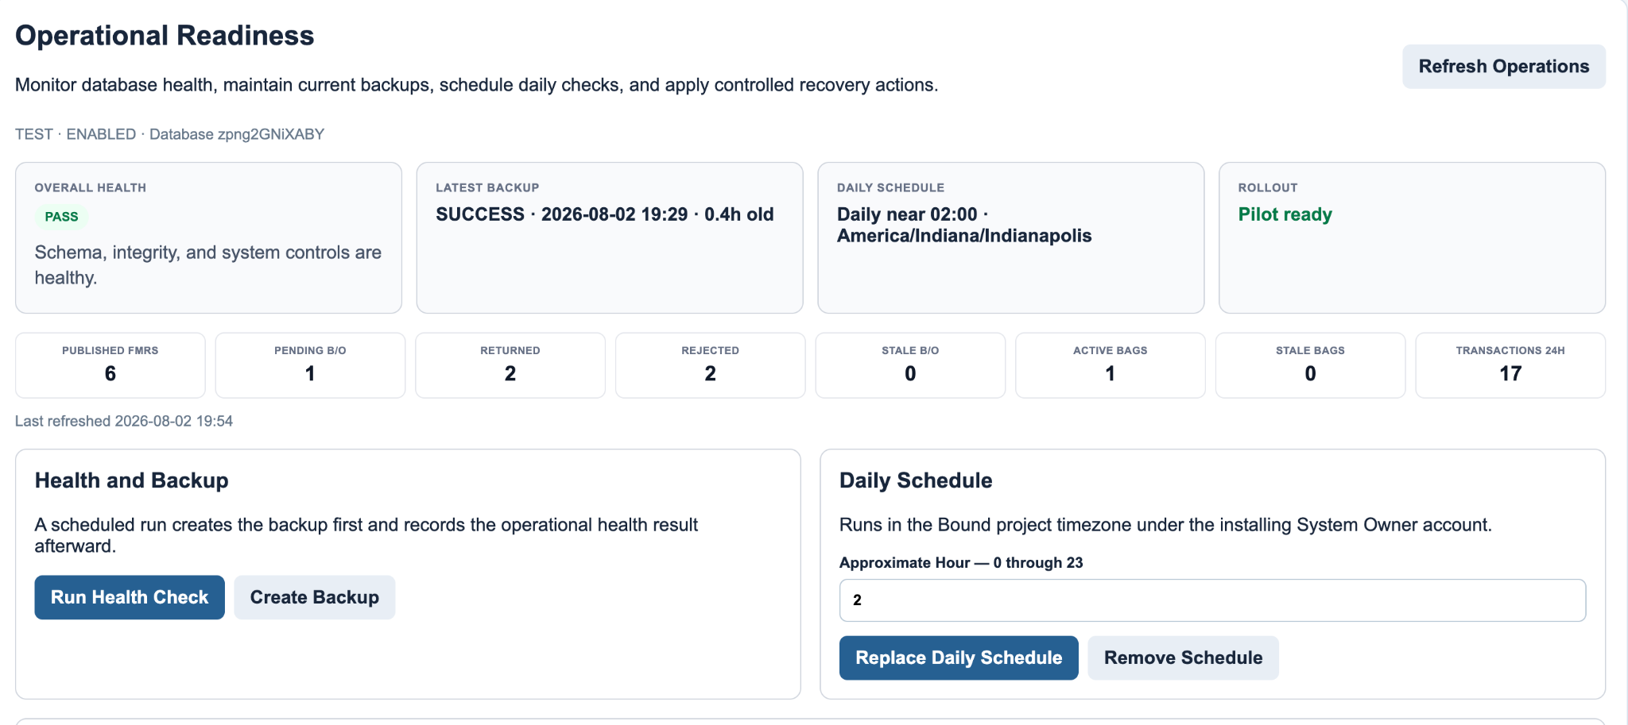
Figure 7. Operational Readiness after backup and daily schedule acceptance

Health Model
Health dimension | Check
Schema | Required sheets exist and header contracts match Config.
Data integrity | Line quantities, header totals, active Bag & Tag indexes, and guard tests pass.
System control | Owner is valid, user emails are unique, lifecycle columns exist, and environment/mode values are valid.
Backup currency | A successful active backup exists and its age is within BACKUP_MAX_AGE_HOURS.
Backorder aging | Pending Admin requests older than STALE_BACKORDER_HOURS produce warnings.
Bag aging | Active bag items older than STALE_BAG_DAYS produce warnings.
Field exceptions | Returned and rejected notices are counted for operational visibility.
Activity | Transactions during the last 24 hours are counted.

Overall Status and Rollout Gates
- FAIL is produced by schema, integrity, or system-control failure.
- WARN is produced by missing/stale backup or stale backorder/Bag & Tag exceptions.
- PASS requires no hard failure and no operational warning.
- pilotReady requires healthy schema/integrity/system control, a current backup, and ENABLED mode.
- productionReady adds ENVIRONMENT_NAME = PRODUCTION.
- The Bound acceptance diagnostic additionally requires an installed daily schedule.

Backup Process
- Resolve the active database and environment.
- Create or reuse the environment-specific backup folder.
- Append an IN_PROGRESS Backup_History record.
- Copy the entire database spreadsheet into the backup folder.
- Mark the record SUCCESS with completion time, size, folder fingerprint, and retention expiry.
- Apply retention cleanup only to successful active backups recorded by this system.
- Append audit evidence.

Scheduled Operations
The Bound project installs one daily time-based trigger for runBoundScheduledOperationsV3. Installation deletes duplicate triggers, records the approximate hour, installer, and installation time in Script Properties, and runs in the Bound project timezone. The scheduled handler creates the database backup first and then records a health check.
Accepted schedule state | Value
Approximate hour | 02:00
Timezone | America/Indiana/Indianapolis
Schedule enabled | true
Final health | PASS
Backup current | true
Pilot ready | true
Production ready | false - TEST environment

13. Controlled Recovery and Rollback
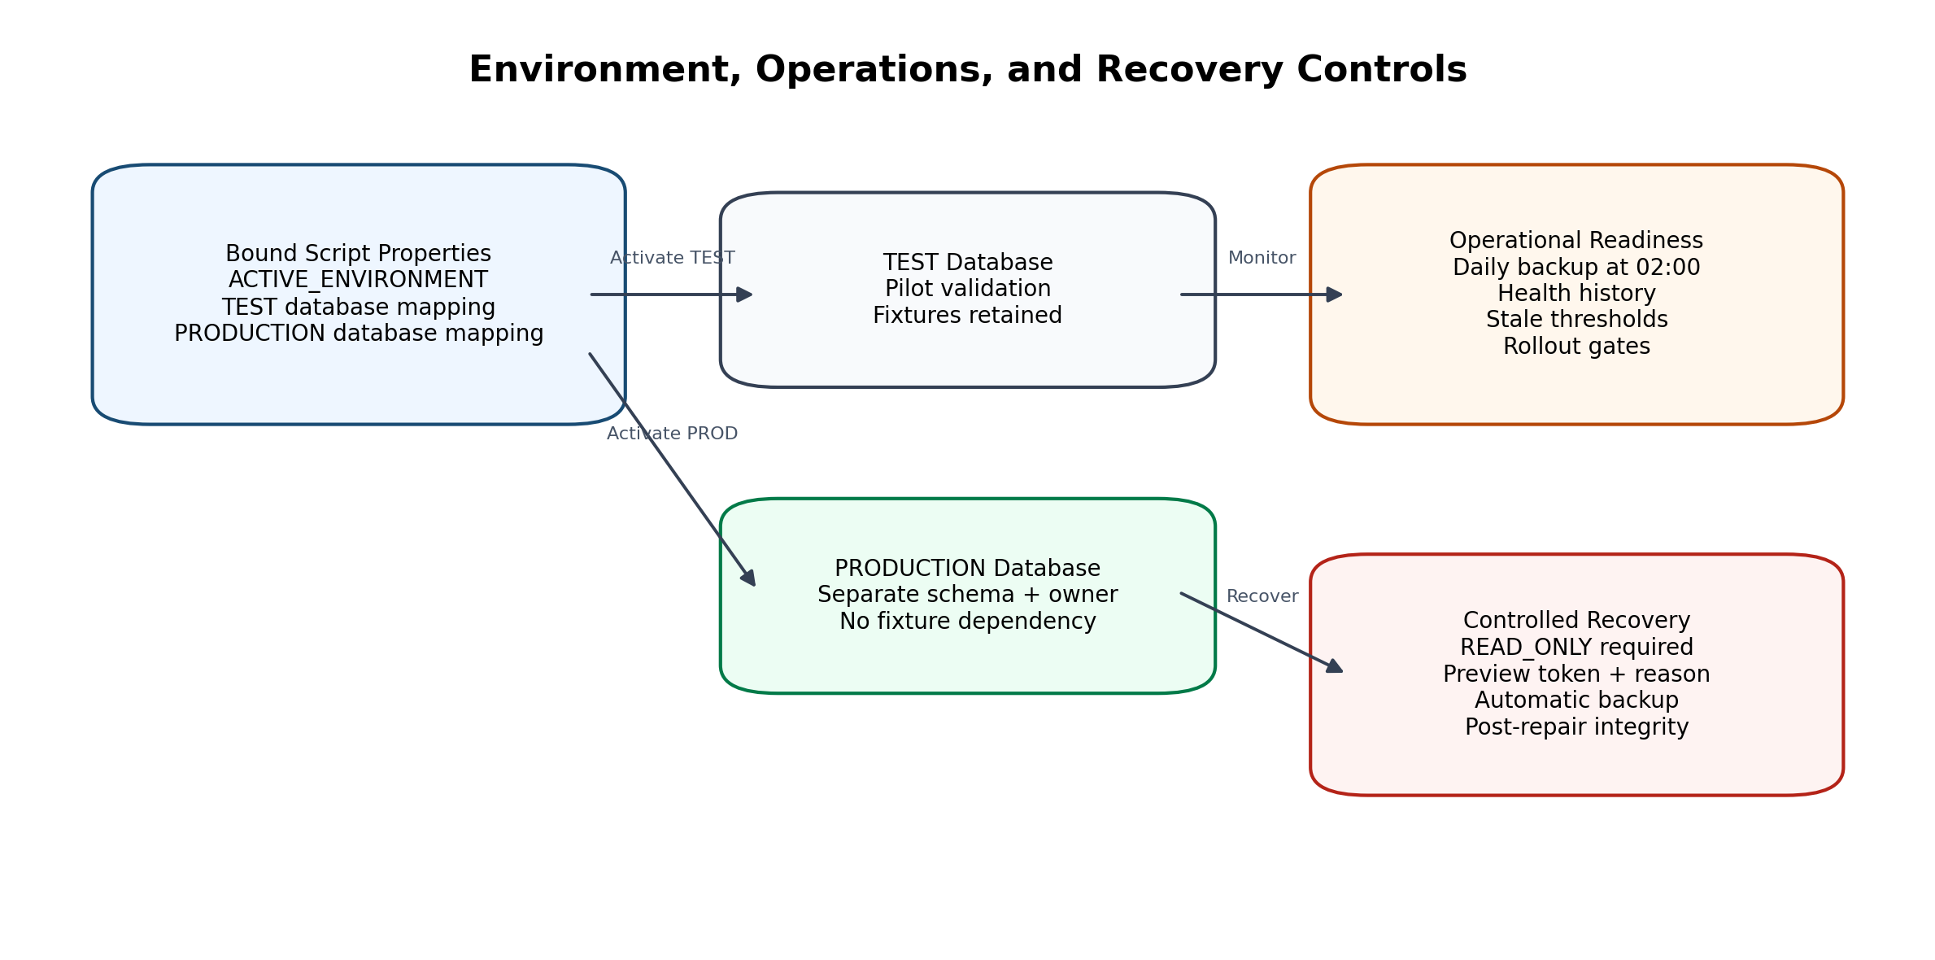
Figure 8. Environment, readiness, and recovery controls

Recovery Safety Model
- The System Owner selects a published FMR and recovery action.
- Preview validates that exactly one active header and at least one active line exist.
- Preview captures header totals, line count, active Search Index count, expected index count, and active notice count.
- A random preview token is cached for 15 minutes and a PREVIEWED Recovery_Actions row is appended.
- Application requires the same owner, same database fingerprint, READ_ONLY mode, a reason of at least 10 characters, and an unexpired token.
- The system creates a RECOVERY backup before changing data.
- The selected repair is applied.
- Post-recovery integrity must pass.
- Recovery_Actions is marked APPLIED with backup ID and before/after JSON; failure is recorded with error details.

Recovery Actions
Action | Behavior
REFRESH_HEADER_TOTALS | Recalculate aggregate header quantities from active canonical lines.
REBUILD_SEARCH_INDEX | Deactivate current active Search_Index rows for the FMR and append exactly three current entries per active line.
SYNC_FIELD_NOTICES | Re-evaluate active backorder records and synchronize line-level Field notices.
SAFE_RECONCILE | Run Search Index rebuild, header refresh, and Field notice synchronization together.

Accepted Recovery
Item | Accepted value
Target FMR | V3-ADMIN-CONFIRM-0003
Action | SAFE_RECONCILE
Mode during apply | READ_ONLY
Reason | Sprint 4B safe reconciliation acceptance for indexed fixture data.
Pre-recovery index | 3 active of 3 expected for one line
Backup | Automatic RECOVERY backup recorded
Result | APPLIED
Post-recovery integrity | Passed with zero issues

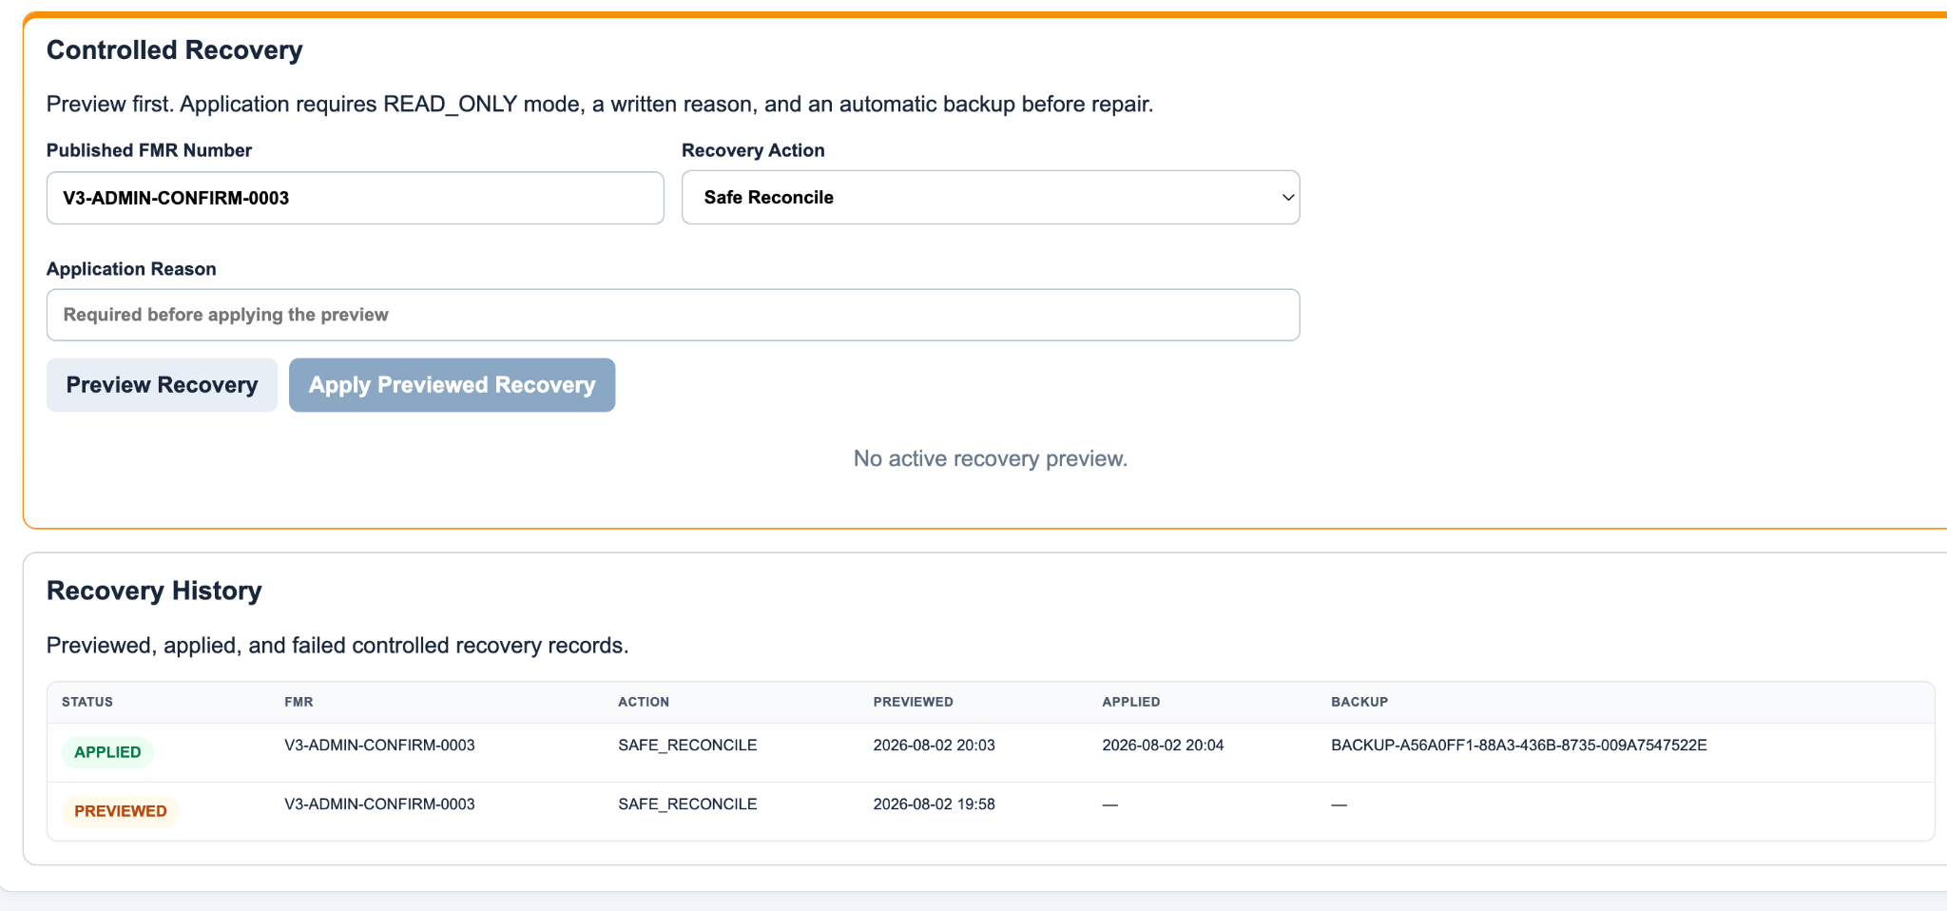
Figure 9. Controlled recovery history showing PREVIEWED and APPLIED records

Rollback Position
Manual restore by design
The platform creates restorable complete spreadsheet copies but does not automatically replace the live database. If a recovery fails after the backup is created, the backup ID is recorded for deliberate owner review and manual rollback.

14. Search, Indexing, Performance, and Caching

Exact Key Formats
FMR:<UPPERCASE OFFICIAL FMR NUMBER>
ISO:<UPPERCASE ISO NUMBER>|<UPPERCASE SHEET>
Examples:
FMR:V3-ADMIN-CONFIRM-0003
ISO:FG-70912_001|3

Search Design
- Search normalizes the input and selects FMR, ISO, or auto-detect behavior.
- Search_Index maps exact keys to physical FMR_Header and FMR_Line_Items row numbers.
- Stable search mappings may be stored in Script Cache for the configured duration.
- Live quantities are re-read from canonical rows; transaction ledgers are not scanned to calculate each card.
- Active Bag & Tag records, returned backorders, and Field notices are loaded in grouped lookups by line IDs.
- Field filters are browser-side and operate on the already loaded card.

Operational Queue Design
Operational_Index prevents the Admin dashboard from scanning Bag_Tag_Items and Backorder_Requests for every refresh. Lifecycle changes deactivate old status entries and append new active entries. The queue includes Pending Admin Review and Partially Confirmed requests only.

Performance Diagnostics
- Known-search performance diagnostic validates the accepted fixture search path.
- Bootstrap performance diagnostic validates user, workflow, and list bootstrap time.
- Data integrity diagnostics operate read-only except for explicitly named repair functions.
- Operational health records diagnostic duration so changes in runtime can be trended.

Caching
Cache | Purpose | Invalidation
User cache | Role and permission lookup | Immediately removed after user create/update/activate/deactivate; otherwise short TTL.
Search mapping cache | Stable key-to-row mappings | Version/configuration change, key invalidation, reindex, or TTL.
List cache | Reference list values | Configuration/list management or TTL.
Recovery preview cache | Owner/database/action preview token | Consumed on apply or expires after 900 seconds.

15. Security and Authorization

Identity
Authentication is provided by the Google account executing the Bound web app. The adapter prefers Session.getActiveUser().getEmail() and falls back to Session.getEffectiveUser().getEmail() for trigger and deployment contexts. Scheduled operations deliberately use the effective user that installed the trigger.

Authorization Checks
Assertion | Required permission | Typical operations
assertSearchUserFmrV3_ | Can_Search | Portal bootstrap and search.
assertFieldUserFmrV3_ | Can_Field_Transact | Field material actions.
assertBackorderAdminFmrV3_ | Can_Admin_Backorder | Admin backorder review.
assertOwnerFmrV3_ | Can_Owner_Edit and email equals OWNER_EMAIL | Staging, publication, users, configuration, operations, backup, recovery.

Defense in Depth
- Browser controls hide inaccessible views but server-side assertions remain authoritative.
- Database selection occurs in the adapter and is passed to every Core public API call.
- System Owner changes are logged in Audit_Log.
- Write mode is enforced by Core public API functions, not only by disabled browser buttons.
- Sensitive database and folder IDs are rendered as one-way fingerprints in the UI.
- Recovery requires a separate set of conditions beyond ordinary owner authorization.
- Direct sheet edits bypass these controls and are not a supported operational practice.

Security Limitations
- The security model depends on Google account and Apps Script deployment configuration.
- Google Workspace domain restrictions and web-app execution settings must be reviewed before production deployment.
- Apps Script quotas, Drive permissions, and Spreadsheet permissions remain external platform controls.
- No independent secrets vault or external identity provider is used.
- The current acceptance record does not include a formal penetration test.

16. Diagnostics and Acceptance Evidence

Diagnostic Families
Family | Functions | Evidence
Connection/bootstrap | verifyBoundFmrV3Connection; runFmrV3BootstrapPerformanceDiagnostic | Library wiring, user bootstrap, version, and performance.
Search | runFmrV3KnownSearchPerformanceDiagnostic | Exact indexed fixture search.
Field workflow | runFmrV3FieldWorkflowContractDiagnostic; verifyBoundFieldWorkflowContractV3 | Action contract, limits, and Bound mapping.
Metadata | runFmrV3FieldMetadataDiagnostic; verifyBoundFieldMetadataContractV3 | Performer identity and flexible location policy.
Integrity | runFmrV3DataIntegrityDiagnostic | Line/header/index consistency and guard tests.
Backorder acceptance | Sprint 3A validators | Partial/final confirm, reject, return, split return.
Field notices | runFmrV3FieldNotificationDiagnostic; verifyBoundFieldBackorderNoticeContractV3 | Confirmed, rejected, returned, and split notice quantities.
System controls | runFmrV3SystemControlDiagnostic; role round trip; verifyBoundSystemControlContractV3 | Owner, roles, lifecycle, environment, mode, and user-cache behavior.
Operations | runFmrV3OperationalReadinessDiagnostic; verifyBoundOperationalReadinessV3 | Operational sheets, backup current, pilot gate, schedule.

Final Integrity Evidence
{
"passed": true,
"version": "3.0.0-alpha.11",
"linesScanned": 7,
"headersScanned": 6,
"backordersScanned": 9,
"activeBagItems": 1,
"lineIssueCount": 0,
"headerIssueCount": 0,
"bagIndexIssueCount": 0,
"guardPassed": true
}

Guard Tests
Guard | Validated behavior
locatableIncludesAuditedConfirmedFulfillment | Previously confirmed commitment fulfillment is handled without corrupting physical-location limits.
newBackorderExcludesConfirmedCommitment | A new backorder cannot double-count quantity already committed as confirmed backorder.
reservableIncludesAvailable | Available located quantity remains eligible for Bag & Tag reservation.

Sprint Acceptance Summary
Phase | Status | Evidence
Sprint 1 | Passed | Bound/Core projects deployed; authenticated bootstrap; staging/publishing, search, Field/Admin/Owner APIs, and exact key behavior established.
Sprint 1 hardening | Passed | Combined ISO/sheet parsing and baseline bootstrap/known-search diagnostics completed.
2A | Passed | Active Bag & Tag index backfill, indexed queue, Core API, and Bound integration.
2B | Passed | Combined Admin operational rail payload and Bound rendering.
2C | Passed | Guided Field workflow contract, action limits, diagnostics, and UI rendering.
2D | Passed | Compact lines, full Field acceptance fixture, alpha.6 integrity repair, and Admin/Owner regression.
2E alpha.8 | Passed | Flexible location policy, authenticated performer, saving state, duplicate protection, and immediate refresh.
3A | Passed | Confirm, reject, return, partial/final decision, and split creation with zero integrity issues.
3B | Passed | Notice contract, rejected/returned visibility, simultaneous split notices, and Admin detail synchronization.
4A | Passed | User lifecycle, READ_ONLY guard, TEST identity, environment mapping, defaults, and responsive Owner controls.
4B | Passed | Manual/scheduled/recovery backups, health PASS, schedule enabled, pilot ready, controlled recovery APPLIED, and post-recovery integrity PASS.
Production activation | Pending controlled rollout | Create and migrate PRODUCTION database, validate productionReady true, conduct realistic pilot, and obtain business signoff.

17. Deployment, Versioning, and Configuration

Two-Project Deployment Model
Project | Deployment responsibility
FMRCoreV3 | Source-controlled Core service code; save, run migrations/diagnostics, then create immutable library version.
Bound | References the immutable Core library version; replace/patch UI and adapter files; update existing web-app deployment.
GitHub | Source of truth for production files after runtime acceptance.
Database spreadsheet | Environment-specific canonical data and operational history.

Release Procedure
- Create or replace Core files in the Apps Script editor.
- Advance FMR_V3.VERSION and Config headers if the release changes schema.
- Run the release migration immediately when Config expects new columns or sheets.
- Run Core diagnostics and any destructive acceptance fixture functions only in TEST.
- Create a new immutable Core library version.
- Update Bound appsscript.json to the new library version.
- Replace/patch Bound files and update the existing web deployment.
- Run Bound diagnostics and visual acceptance.
- Push only production paths to GitHub after runtime acceptance.
- Do not commit ZIP packages, extracted artifacts, patch instruction files, or .DS_Store.

Current Release Mapping
Release | Core version | Library | Major migration
Sprint 2D | 3.0.0-alpha.6 | 6 | None - Bound UI only.
Sprint 2E final | 3.0.0-alpha.8 | 8 | Metadata suggestions/list seeding; no historical correction.
Sprint 3B | 3.0.0-alpha.9 | 9 | Field_Notifications creation and backfill.
Sprint 4A | 3.0.0-alpha.10 | 10 | Users lifecycle columns and system configuration rows.
Sprint 4B | 3.0.0-alpha.11 | 11 | Operational health, backup, and recovery sheets/settings.

Configuration Categories
- Core schema/application versions and cache/index versions.
- Owner identity and role administration.
- Project defaults and timezone.
- TEST/PRODUCTION environment identity and transaction mode.
- Tag prefix and sequence.
- Backup folder, retention, and backup age.
- Stale backorder and Bag & Tag thresholds.
- Health history retention.

18. Production Readiness and Rollout Plan
Current gate
The accepted TEST environment is pilot-ready. Production-ready remains false until a separate PRODUCTION database is initialized, mapped, backed up, scheduled, tested, and signed off.

Production-ready definition
For this platform, production ready means that the application behavior, control model, operational recovery path, and deployment procedure have been validated sufficiently to support a governed production cutover. It does not mean that the current TEST workbook has already been declared the live production database.
Readiness domain | Current evidence | Status
Core transaction model | Field, Bag & Tag, issuance, backorder, Admin decision, staging, publishing, renumbering, ledgers, and audit tested. | Ready
Data integrity | Final scan: 7 active lines, 6 active headers, 9 backorders, 1 active bag item, 0 line/header/bag-index issues. | Ready
Security and roles | Owner, Admin, Field, and Read Only profiles; cache invalidation; owner protection; server-side role checks. | Ready
Environment controls | TEST/PRODUCTION registry, database fingerprint, READ_ONLY write guards, project defaults. | Ready
Operational resilience | Current backups, daily schedule, health history, thresholds, retention, rollout gates. | Ready
Recovery | SAFE_RECONCILE accepted with automatic backup and post-recovery integrity PASS. | Ready
TEST pilot gate | overallStatus PASS; pilotReady true; schedule enabled. | Ready
PRODUCTION database | Separate database not yet activated in the documented evidence. | Pending cutover
Business validation | Real multi-user pilot and Material Management signoff remain. | Pending signoff

Current readiness position
The technical implementation is production-ready, and the TEST environment is pilot-ready. The remaining work is to instantiate the approved PRODUCTION database, run the same migrations and diagnostics in that context, complete a realistic pilot, and obtain formal operational approval.
- Do not relabel the current TEST database as production.
- Do not activate PRODUCTION until the configured owner is valid in the target database and the target has a successful backup.
- Require productionReady = true and all Field/Admin/notice/system-control diagnostics to pass in the target context.
- Record the go-live decision, approving leaders, date, and rollback owner.

Phase 1 - Prepare Production Database
- Duplicate the approved database template into a separately permissioned production spreadsheet.
- Confirm the configured System Owner has access and is the intended production owner.
- Deploy alpha.10 and run migrateFmrV3SystemControls.
- Deploy alpha.11 and run migrateFmrV3OperationalReadiness.
- Set ENVIRONMENT_NAME to PRODUCTION and verify transaction mode is ENABLED.
- Remove or segregate acceptance fixtures according to the project data-retention decision; do not delete audit evidence without approval.
- Configure project defaults, reference lists, approved users, and actual operational thresholds.

Phase 2 - Bind and Validate
- Run configureBoundEnvironmentV3('PRODUCTION', productionSpreadsheetId) from the Bound editor.
- Activate the PRODUCTION environment only after the owner is valid in the target database.
- Run all Core diagnostics in the target context.
- Create the first production backup and confirm Backup_History SUCCESS.
- Install the daily operations schedule and manually run the handler once.
- Run verifyBoundOperationalReadinessV3 and all Field/Admin/notice/system-control diagnostics.
- Confirm productionReady = true.

Phase 3 - Controlled Pilot
- Use separate real Field and Admin Google accounts.
- Publish one realistic multi-line FMR through Owner staging.
- Validate exact FMR and ISO searches on desktop and iPad.
- Execute representative available, Bag & Tag, issue, and backorder workflows.
- Confirm Admin decisions and Field notices.
- Review backup and health history the next day.
- Collect Material Management signoff.

Phase 4 - Go-Live Controls
- Confirm operational owner and backup ownership coverage.
- Document who may change transaction mode and thresholds.
- Establish a daily review of returned/rejected notices and stale items.
- Prohibit direct sheet edits except under an approved recovery procedure.
- Retain deployment and rollback runbooks with the project team.
- Schedule periodic recovery-preview exercises in TEST.

19. Operations Runbooks

Daily Owner Review
- Open Owner -> Operational Readiness.
- Confirm Overall Health is PASS or review each WARN reason.
- Confirm Latest Backup is SUCCESS and within the configured age.
- Review pending and stale backorders, returned/rejected notices, and active/stale bags.
- Review Backup History and Health History for scheduled records.
- Escalate schema or integrity failure immediately; do not continue normal writes.

Add or Change a User
- Open Production Controls -> User Access.
- Enter the exact Google account email and display name.
- Choose Read Only, Field User, or Material Admin. Do not assign Owner to another email.
- Save and verify permission chips.
- For a departing user, Deactivate with a reason. Do not delete the row.
- Confirm the user can no longer access protected services.

Enter Maintenance Mode
- Open Production Controls.
- Set Transaction Mode to READ_ONLY.
- Enter a clear maintenance message.
- Save and confirm the environment badge shows READ_ONLY.
- Verify normal Field/Admin/Owner write paths return the maintenance message.
- Perform only the approved maintenance or recovery work.
- Return to ENABLED and clear the message after validation.

Create a Manual Backup
- Open Operational Readiness.
- Select Create Backup and enter optional notes.
- Wait for the success message.
- Confirm a SUCCESS row appears in Backup History.
- Run Health Check and confirm the backup is current.

Apply Controlled Recovery
- Identify the published FMR and approved repair action.
- Generate a preview and review line count, index count, remaining quantity, and recovery ID.
- Enable READ_ONLY with a maintenance message.
- Enter a reason of at least 10 characters.
- Apply the current preview before the 15-minute token expires.
- Confirm the automatic RECOVERY backup ID.
- Confirm Recovery History is APPLIED and post-recovery integrity passes.
- Return to ENABLED and rerun Bound diagnostics.

Backorder Exception Review
- Admin reviews only Pending Admin Review and Partially Confirmed cards.
- Confirm only the quantity actually accepted by Material Management.
- Reject when the request should be closed and Field must pursue another path.
- Return for Review when Field must recheck a location, specification, or condition.
- Provide actionable notes; those notes are displayed to Field.
- Verify the current FMR detail updates after the decision.

20. Troubleshooting and Known Constraints
Symptom | Likely cause | Resolution
Health check success followed by null overallStatus | Raw Date crossed google.script.run boundary | Final adapter JSON serialization fix; update Bound deployment.
Operational diagnostic passes health but returns passed:false | Daily schedule is not installed | Install the daily schedule, refresh, manually run handler, rerun diagnostic.
READ_ONLY does not save | Maintenance Message is empty | Enter a real message; placeholder text is not a value.
Open Admin FMR detail looks stale | Older Bound client retained the pre-decision object | Use alpha.9+ client; current detail reloads automatically.
Returned/rejected request not in Admin queue | Expected lifecycle behavior | Look for Field notice; queue contains only actionable Admin requests.
Recovery Apply button disabled | No current preview or preview cleared/expired | Generate a new preview; enter reason; switch to READ_ONLY.
Recovery application says preview expired | 15-minute Script Cache token elapsed | Generate a new preview and apply promptly.
Search finds no result | Key normalization or Search_Index issue | Verify exact FMR/ISO format; run preview of REBUILD_SEARCH_INDEX or SAFE_RECONCILE in TEST/maintenance.
User retains old access briefly | Cached role record | Portal service invalidates cache on changes; refresh session. Investigate duplicate Users rows if persistent.
Backup fails | Drive permission, quota, or invalid folder configuration | Review Backup_History error, verify owner Drive access, correct folder setting under controlled maintenance.
Overall health WARN | Stale operational exception or stale/missing backup | Review warnings and thresholds; WARN is not an integrity failure.
Production-ready remains false | Environment is TEST or another rollout gate is unmet | Activate initialized PRODUCTION database and rerun readiness diagnostic.

Known Constraints
- Google Sheets is the persistence layer; extremely high record volume may require archival or migration to a transactional database.
- Apps Script execution, trigger, Drive, and spreadsheet quotas apply.
- Time-based triggers execute near the configured hour, not at an exact second.
- Current acceptance is based on manual Apps Script diagnostics rather than automated GitHub CI.
- Full database restoration is manual by design.
- Recovery actions are targeted to one published FMR at a time.
- Direct sheet edits can invalidate indexes and audit continuity.
- The test database intentionally contains acceptance fixtures and historical metadata variants.
- Production data migration, retention, and fixture-removal decisions require project leadership approval.

Appendix A - Data Dictionary

Configuration
Field or group | Definition
Setting | Unique configuration key.
Value | Current setting value.
Description | Operational meaning.
Editable | Whether the Owner UI may change the value.

Users
Field or group | Definition
User_ID | Stable user identifier.
Email | Authenticated Google account email; unique lookup.
Display_Name | Portal and audit display name.
Role | Human-readable role label.
Can_Search | Search permission flag.
Can_Field_Transact | Field transaction flag.
Can_Admin_Backorder | Backorder Admin flag.
Can_Owner_Edit | System Owner flag.
Active | Access enabled flag.
Created_At | Creation timestamp.
Notes | Administrative notes.
Updated_By / Updated_At | Last access-record change.
Last_Login_At / Last_Interface | Most recent recorded access.
Deactivated_By / Deactivated_At | Deactivation evidence.

FMR_Header
Field or group | Definition
FMR_ID | Internal immutable FMR identifier.
FMR_Number | Official external FMR number.
IWP_Number | Installation Work Package number.
Requested_By | Requester.
Date_Required | Required date.
Priority | Operational priority.
Current_Status | Derived aggregate status.
Total_Lines | Active material-line count.
Qty_* | Aggregate quantity summaries.
Fulfillment_Pct | Issued divided by requested.
Source_Staging_ID | Originating staging record.
Active | Current published record flag.
Created_* / Updated_* / Last_Activity_At | Lifecycle timestamps and users.
Notes | FMR notes.

FMR_Line_Items
Field or group | Definition
FMR_Line_ID | Internal immutable line identifier.
FMR_ID / FMR_Number | Parent references.
Line_Number | Display/order number.
ISO_Number / ISO_Sheet / ISO_Key | Drawing identity.
Commodity_Code | Material code.
Size / Material_Description / UOM | Material attributes.
Qty_* | Canonical current line quantities.
Line_Status | Derived operational status.
Storage_Location | Latest relevant normalized location.
Active | Current line flag.
Source_Staging_Line_ID | Originating staging line.
Created_* / Updated_* | Lifecycle evidence.
Notes | Line notes.

Material_Transactions
Field or group | Definition
Transaction_ID | Append-only event identifier.
Correlation_ID | Groups related writes and audit records.
Transaction_Type | Confirm, issue, bag, backorder, Admin decision event, etc.
FMR / line / commodity references | Target material identity.
Quantity / UOM | Event amount.
Storage / tag / recipient fields | Physical execution metadata.
Performed_By / Timestamp | Authenticated actor and time.
Notes / payload | Operational evidence.

Backorder_Requests
Field or group | Definition
Backorder_Request_ID | Request identity.
Correlation_ID | Originating transaction correlation.
FMR and line references | Target material.
Qty_Requested_Backorder | Original requested amount.
Qty_Confirmed_Backorder | Accepted commitment amount.
Qty_Pending | Still awaiting Admin decision or Field review.
Reason / Field_Notes | Field explanation.
Reported_By / Reported_At | Field actor and time.
Status | Pending, Partially Confirmed, Confirmed, Rejected, Returned for Review.
Admin_Decision / Admin_Notes | Decision and explanation.
Decided_By / Decided_At | Admin actor and time.
Returned_Review_Reason | Instruction shown to Field.
Active | Operational state flag.
Updated_At | Last change.

Field_Notifications
Field or group | Definition
Field_Notice_ID | Notice identity.
Source_Type / Source_ID | Backorder source identity.
FMR / line references | Affected material.
Notice_Type / Severity | Presentation and lifecycle type.
Qty_Original / Qty_Remaining | Original and unresolved quantities.
Qty_Pending / Qty_Confirmed | Commitment state.
Reason / Message | Field-facing explanation.
Action_Required | Sticky exception flag.
Status / Active | Current or resolved state.
Created_At / Updated_At / Resolved_At | Notice lifecycle.

Operational_Health_Log
Field or group | Definition
Health_Run_ID | Health snapshot identity.
Environment / Database_Fingerprint | Runtime context.
Overall_Status | PASS, WARN, or FAIL.
Integrity / Schema / System_Control status | Hard health gates.
Last_Backup_* | Backup condition.
Operational counts | FMRs, users, backorders, notices, bags, recent transactions.
Diagnostic_Duration_Ms | Runtime metric.
Trigger_Type / Run_By / Run_At | Manual or scheduled execution.
Details_JSON | Warnings, rollout, and thresholds.

Backup_History
Field or group | Definition
Backup_ID | Backup event identity.
Backup_File_ID / Name | Drive copy reference and display name.
Database_Fingerprint / Environment | Source context.
Trigger_Type | MANUAL, SCHEDULED, or RECOVERY.
Status | IN_PROGRESS, SUCCESS, or FAILED.
Created_By / Created_At / Completed_At | Ownership and timing.
File_Size_Bytes / Folder_Fingerprint | Backup metadata.
Retention_Expires_At | Retention cutoff.
Error_Message / Notes / Active | Outcome and cleanup state.

Recovery_Actions
Field or group | Definition
Recovery_ID / Correlation_ID | Recovery identity and application correlation.
Action_Type | Header refresh, Search Index rebuild, notice sync, or safe reconcile.
Target_FMR_Number / Target_FMR_ID | Recovery target.
Status | PREVIEWED, APPLIED, or FAILED.
Previewed_By / Previewed_At | Preview evidence.
Applied_By / Applied_At | Application evidence.
Reason | Required written justification.
Backup_ID | Pre-recovery backup.
Before_JSON / After_JSON | State snapshots and result.
Error_Message | Failure details.

Appendix B - Public API and Function Inventory

Core Public API
Function | Domain
getFmrV3Version | General
getFmrV3Bootstrap | Field/Search
searchFmrV3 | Field/Search
performFmrV3FieldAction | Field/Search
getFmrV3AdminDashboard | Admin
getFmrV3AdminRegister | Admin
getFmrV3AdminActiveBags | Admin
reviewFmrV3Backorder | Admin
saveFmrV3Staging | Owner staging
getFmrV3StagingList | Owner staging
getFmrV3StagedFmr | Owner staging
publishFmrV3StagedFmr | Owner staging
renumberFmrV3 | Owner staging
renumberFmrV3ByNumber | Owner staging
getFmrV3SystemControl | System control
saveFmrV3SystemUser | System control
setFmrV3SystemUserActive | System control
saveFmrV3SystemConfiguration | System control
getFmrV3OperationsCenter | Operations
runFmrV3OperationalHealth | Operations
createFmrV3DatabaseBackup | Operations
saveFmrV3OperationalSettings | Operations
previewFmrV3Recovery | Operations
applyFmrV3Recovery | Operations
runFmrV3ScheduledOperations | Operations

Major Internal Services

FieldService
getFieldBootstrapFmrV3_, lineStateFmrV3_, calculateLineStatusFmrV3_, updateLineStateFmrV3_, appendTransactionFmrV3_, finishLineActionFmrV3_, performFieldActionFmrV3_, confirmAvailableFmrV3_, directIssueFmrV3_, issueAvailableFmrV3_, nextTagNumberFmrV3_, bagMaterialFmrV3_
getActiveBagsByLineIdsFmrV3_, issueFromBagFmrV3_, submitBackorderFmrV3_, refreshHeaderFromIndexedLinesFmrV3_

BackorderService
getBackorderQueueFmrV3_, reviewBackorderFmrV3_, getReturnedBackordersByLineIdsFmrV3_

FieldBackorderNoticeService
fieldNoticeSpreadsheetFmrV3_, ensureFieldNoticeSheetFmrV3_, fieldNoticeRowsFmrV3_, fieldNoticeRowValuesFmrV3_, appendFieldNoticeFmrV3_, updateFieldNoticeFmrV3_, fieldNoticeBySourceFmrV3_, activeFieldNoticesForLineFmrV3_, fieldNoticeDescriptorFromBackorderFmrV3_, formatQuantityFieldNoticeFmrV3_, resolveFieldNoticeBySourceFmrV3_, upsertFieldNotificationFromBackorderFmrV3_
createRejectedRemainderFieldNotificationFmrV3_, syncFieldNotificationsForLineFmrV3_, resolveRejectedFieldNotificationsFmrV3_, serializeFieldNoticeFmrV3_, getFieldBackorderNoticesByLineIdsFmrV3_, migrateFmrV3FieldNotifications, noticeSnapshotForFmrFmrV3_, inspectFmrV3FieldNotificationContract, runFmrV3FieldNotificationDiagnostic, createSprint3BAdminRefreshFixtureFmrV3, verifySprint3BAdminRefreshConfirmedFmrV3

IntegrityService
fieldLocatableQuantityFmrV3_, fieldNewBackorderQuantityFmrV3_, fieldReservableQuantityFmrV3_, fieldActionLimitsFromStateFmrV3_, backorderOutstandingReturnedFmrV3_, activeBackordersForLineFmrV3_, transitionBackorderStatusFmrV3_, planLocationBackorderTransitionsFmrV3_, applyLocationBackorderTransitionsFmrV3_, planReturnedBackorderResubmissionFmrV3_, applyReturnedBackorderResubmissionFmrV3_, approximatelyEqualFmrV3_
inspectFmrV3DataIntegrity, runFmrV3DataIntegrityDiagnostic, repairBackorderStateIntegrityFmrV3

SystemControlService
systemControlUserHeadersFmrV3_, ensureSystemControlUserHeadersFmrV3_, ensureSystemControlConfigurationFmrV3_, validSystemUserEmailFmrV3_, systemRoleProfileFmrV3_, inferSystemRoleProfileFmrV3_, userCacheKeyFmrV3_, invalidateUserCacheFmrV3_, serializeSystemUserFmrV3_, databaseFingerprintFmrV3_, normalizeEnvironmentNameFmrV3_, normalizeTransactionModeFmrV3_
runtimeEnvironmentFmrV3_, assertWriteEnabledFmrV3_, recordUserAccessFmrV3_, getSystemControlFmrV3_, upsertSystemUserFmrV3_, setSystemUserActiveFmrV3_, updateSystemConfigurationFmrV3_, migrateFmrV3SystemControls, inspectFmrV3SystemControlContract, runFmrV3SystemControlDiagnostic, runFmrV3RoleAdministrationRoundTripDiagnostic

OperationalReadinessService
operationsSheetDefinitionsFmrV3_, ensureOperationsSheetFmrV3_, operationsConfigurationRowsFmrV3_, ensureOperationsConfigurationFmrV3_, setOperationsConfigurationValueFmrV3_, positiveIntegerOperationsFmrV3_, operationsSettingsFmrV3_, fingerprintOperationsIdFmrV3_, hoursBetweenOperationsFmrV3_, latestRowByDateFmrV3_, ensureBackupFolderFmrV3_, backupHistoryRowsFmrV3_
latestSuccessfulBackupFmrV3_, cleanupExpiredBackupsFmrV3_, createDatabaseBackupFmrV3_, schemaHealthOperationsFmrV3_, activeBagHealthOperationsFmrV3_, backorderHealthOperationsFmrV3_, fieldNoticeHealthOperationsFmrV3_, calculateOperationalHealthFmrV3_, appendOperationalHealthLogFmrV3_, trimOperationalHealthHistoryFmrV3_, runOperationalHealthCheckFmrV3_, serializeBackupHistoryFmrV3_
serializeHealthHistoryFmrV3_, serializeRecoveryHistoryFmrV3_, getOperationsCenterFmrV3_, updateOperationalSettingsFmrV3_, recoveryActionFmrV3_, recoveryTargetSnapshotFmrV3_, recoveryCacheKeyFmrV3_, previewRecoveryFmrV3_, assertRecoveryMaintenanceWindowFmrV3_, updateRecoveryRecordFmrV3_, rebuildSearchIndexForRecoveryFmrV3_, applyRecoveryFmrV3_
runScheduledOperationsFmrV3_, migrateFmrV3OperationalReadiness, inspectFmrV3OperationalReadinessContract, runFmrV3OperationalReadinessDiagnostic

Bound Adapter Public/Diagnostic Functions
normalizeBoundEnvironmentV3_, activeBoundEnvironmentV3_, boundDatabasePropertyKeyV3_, boundDatabaseIdForEnvironmentV3_, boundDatabaseIdFmrV3_, assertCurrentBoundOwnerV3_, configureBoundEnvironmentV3, activateBoundEnvironmentV3, inspectBoundEnvironmentV3, callerEmailFmrV3_, scheduledCallerEmailFmrV3_, getPortalBootstrapV3
searchPortalV3, performFieldActionV3, getAdminDashboardV3, getAdminFmrRegisterV3, getAdminActiveBagsV3, reviewBackorderV3, saveStagingV3, getStagingListV3, getStagedFmrV3, publishStagedFmrV3, renumberPublishedFmrV3, renumberPublishedFmrByNumberV3
getSystemControlV3, saveSystemUserV3, setSystemUserActiveV3, saveSystemConfigurationV3, serializeBoundResponseV3_, getOperationsCenterV3, runOperationalHealthV3, createDatabaseBackupV3, saveOperationalSettingsV3, previewRecoveryV3, applyRecoveryV3, runBoundScheduledOperationsV3
boundOperationsTriggerHandlerV3_, getBoundOperationsScheduleV3, installBoundDailyOperationsV3, removeBoundDailyOperationsV3, verifyBoundFmrV3Connection, isCompatibleFmrV3Alpha_, validBoundActiveBagRecordV3_, uniqueBoundActiveBagRecordsV3_, verifyBoundAdminActiveBagsV3, verifyBoundAdminOperationalRailV3, verifyBoundFieldWorkflowContractV3, verifyBoundFieldTransactionPreflightV3
getBoundFieldAcceptanceSnapshotV3, verifyBoundFieldMetadataContractV3, verifyBoundFieldBackorderNoticeContractV3, verifyBoundSystemControlContractV3, verifyBoundOperationalReadinessV3

Bound Client Major Functions
initializePortalV3_, applyPortalEnvironmentV3_, activateRequestedViewV3_, bindPortalEventsV3_, searchFieldV3_, runFieldSearchV3_, renderFieldResultsV3_, toggleFieldLineV3_, setFieldLineExpandedV3_, fieldFmrViewKeyV3_, captureFieldViewStateV3_, restoreFieldViewStateV3_, applyFieldMaterialFilterV3_, renderSummaryV3_, fieldBackorderNoticeLabelV3_
fieldBackorderNoticeClassV3_, renderFieldBackorderNoticeChipsV3_, renderFieldBackorderNoticeBannersV3_, renderFieldMaterialCardV3_, fieldWorkflowForMaterialV3_, workflowPhaseClassV3_, workflowGroupLabelV3_, findWorkflowActionV3_, renderFieldActionsV3_, addActionButtonV3_, findMaterialV3_, openActionModalV3_, workflowFieldRequiredV3_, workflowHasFieldV3_, buildActionFieldsV3_
syncBagQuantityLimitV3_, submitFieldActionV3_, setFieldActionBusyV3_, applyFieldActionResultV3_, calculateFieldCardTotalsV3_, calculateFieldCardStatusV3_, closeActionModalV3_, refreshAdminV3_, refreshAdminRegisterV3_, adminRegisterRequestV3_, resetAdminRegisterV3_, renderKpisV3_, formatAdminKpiV3_, renderAdminRegisterV3_, applyAdminRegisterOptionsV3_
replaceSelectOptionsV3_, openAdminFmrDetailV3_, renderAdminFmrDetailV3_, renderAdminMetaCellV3_, closeAdminFmrDetailV3_, statusClassV3_, formatPercentV3_, renderBackordersV3_, renderActiveBagsV3_, submitBackorderDecisionV3_, setAdminDecisionBusyV3_, parseOwnerLinesV3_, saveStagingV3_, refreshOperationsCenterV3_, operationsStatusClassV3_
renderOperationsCenterV3_, renderOperationsHealthCountsV3_, renderOperationsBackupHistoryV3_, renderOperationsHealthHistoryV3_, renderOperationsRecoveryHistoryV3_, runOperationalHealthCheckV3_, createDatabaseBackupV3_, saveOperationalSettingsV3_, installDailyOperationsV3_, removeDailyOperationsV3_, previewRecoveryActionV3_, renderRecoveryPreviewV3_, applyRecoveryActionV3_, setOperationsBusyV3_, refreshSystemControlV3_
renderSystemControlV3_, renderSystemRoleProfileOptionsV3_, renderSystemUsersV3_, editSystemUserV3_, clearSystemUserFormV3_, saveSystemUserV3_, changeSystemUserActiveV3_, saveSystemConfigurationV3_, setSystemControlBusyV3_, clearOwnerFormV3_, refreshStagingV3_, renderStagingV3_, loadStagingForEditV3_, renumberPublishedFmrV3_, publishStagingV3_
actionLabelV3_, setBusyV3_, numberValueV3_, valueOfV3_, formatQtyV3_, escapeHtmlV3_, escapeAttributeV3_, hideAlertsV3_, showErrorV3_, showSuccessV3_, callServerV3_

Appendix C - Acceptance Fixtures and Evidence
Fixture | Purpose | Preservation rule
V3-ACCEPT-0001 | Historical multi-line acceptance | Reusable baseline with Bag & Tag, issue, and backorder evidence.
V3-FIELD-ACCEPT-0002 | Full Field transaction acceptance | Confirm available, issue available, bag, issue from bag, direct issue, backorder.
V3-ADMIN-CONFIRM-0003 | Admin confirmation | Partial and final confirmation.
V3-ADMIN-REJECT-0004 | Admin rejection | Inactive rejected request plus Field notice.
V3-ADMIN-RETURN-0005 | Admin return | FIELD_REVIEW_REQUIRED and returned reason.
V3-ADMIN-SPLIT-0006 | Split decision | Confirmed original plus returned remainder.
V3-ADMIN-REFRESH-0007 | Admin detail synchronization | Open detail remains current after confirmation.

Sprint 3A Quantitative Results
Stage | Pending B/O | Confirmed B/O | Queue count | Integrity
Initial fixtures | 2 | 0 | 1 | Passed
Confirm partial | 1 | 1 | 1 | Passed
Confirm final | 0 | 2 | 0 | Passed
Reject final | 0 | 0 | 0 | Passed
Return final | 0 | 0 | 0 | Passed; workflow FIELD_REVIEW_REQUIRED
Split partial | 1 | 1 | 1 | Passed
Split returned | 0 | 1 | 0 | Passed; new returned request

Sprint 4B Acceptance Results
Test | Result
Manual backup | SUCCESS; Backup_History created; current backup visible.
Health check | PASS after adapter serialization correction.
Daily schedule | Installed near 02:00 America/Indiana/Indianapolis.
Scheduled handler | Created scheduled backup and scheduled health record.
Operational diagnostic | passed: true; backup current; pilot ready; schedule enabled.
READ_ONLY guard | Normal staging write blocked with maintenance message.
Recovery preview | Target V3-ADMIN-CONFIRM-0003; SAFE_RECONCILE; 1 line; Search Index 3/3.
Recovery apply | APPLIED with automatic backup and audit evidence.
Post-recovery integrity | Passed; zero line/header/bag-index issues.

Appendix D - Commit and Release Reference
Date | Commit | Message
2026-08-01 | b1ae14655ee7 | Initial commit: FMR v3 Bound and FMRCoreV3 Apps Script projects
2026-08-01 | a67e2ec96399 | Update SearchService with FMR and combined ISO search parsing
2026-08-01 | 1319e2fb7a85 | Add Sprint 0 performance baseline diagnostics
2026-08-01 | 8794915456b5 | Add active Bag Tag status index maintenance
2026-08-01 | 6a04d37fc7b0 | Add indexed Admin Active Bag Queue service
2026-08-01 | de9b1c6f2893 | Add combined Admin operation rail payload
2026-08-01 | 0c8dd0261ed2 | Add guided Field workflow contract
2026-08-01 | c578079f39be | Render guided Field material workflows
2026-08-01 | 3c5bc75b0ad7 | Compact Field material lines for faster scanning
2026-08-02 | 88b1d2ea1e1a | Add repeatable full Field acceptance fixture
2026-08-02 | 8f83a01e77f0 | Align repository with deployed alpha.8 flexible locations
2026-08-02 | 00c117daacfd | Add Sprint 3A Admin lifecycle acceptance
2026-08-02 | 48be1204e1b8 | Add Field exception notices and synchronized Admin details
2026-08-02 | e4a63ac2e867 | Add role administration and environment controls
2026-08-02 | b25594fa745c | Append Styles changes
2026-08-02 | 92ec4b08d6ba | Review Owner functionalities
2026-08-02 | 619e477f8f5b | Sprint 4B Operational Readiness Serialization fix

End State
Accepted technical baseline
FMR Operations v3 alpha.11/library 11 is accepted in TEST from the Sprint 1 architecture through the Sprint 4B production-readiness control set. Operational health is PASS, backups are current, the daily schedule is enabled, pilot readiness is true, controlled recovery is proven, and post-recovery integrity has zero issues. A separately governed PRODUCTION deployment and operational signoff remain the final activation steps.

Appendix E - Requirements-to-Production Traceability
The table below connects the original operating requirements to the implementation phase, persistent control, and accepted evidence. It supports design review, production approval, and future change-impact analysis.
Initial requirement / risk | Implemented control | Primary sprint(s) | Acceptance evidence
Requested quantity must not be treated as received or available. | Separate requested, located, available, bagged, issued, pending backorder, confirmed backorder, and remaining fields with server-side invariants. | Sprint 1; 2C; 2D | Guard tests passed; final line/header integrity issue counts were zero.
Multiple FMRs may exist for the same ISO line and sheet. | Exact Search_Index entries point to independent FMR headers and line records; search returns all matching published FMRs. | Sprint 1 | Known-search diagnostics and multi-record search contract.
Bagged material is reserved and cannot be issued elsewhere. | Bag_Tag_Header/Items ledgers, active-bag index, qty remaining in bag, Admin active-bag queue, and issue-from-bag action. | 2A; 2C; 2D | Full Field fixture created and fully issued a bag; active-bag index remained consistent.
Admin must be able to release or reassign exceptions. | Role-specific Admin queues, decision service, active bag visibility, returned-review workflow, and controlled recovery. | 2B; 3A; 4B | Admin lifecycle fixtures and operational rail diagnostics passed.
Issuance must identify the recipient. | Field action payload requires authenticated performer and captures recipient data for issue transactions. | Sprint 1; 2E | Field contract and acceptance transactions recorded issued quantities and audit identity.
Field users need clear, rapid mobile workflows. | Server-defined workflow contract, compact description-first rows, filters, persistent KPIs, saving state, and expansion preservation. | 2C; 2D; 2E | Compact UI accepted on desktop/iPad-sized layouts; full action sequence passed.
Storage locations must reflect real yard conditions without a brittle allowlist. | Free-text input with suggestions, required by location-establishing actions, uppercase/whitespace normalization, and a 100-character limit. | 2E alpha.8 | Metadata diagnostic and flexible-location acceptance passed.
Field must know whether a backorder was confirmed, rejected, or returned. | Field_Notifications, chips, sticky action-required banners, and quantity-aware rejection resolution. | 3B | Notice contract passed for confirm, reject, return, and split fixtures.
Users and roles must be managed without editing rows directly. | Owner user register, fixed profiles, activation/deactivation, last login, cache invalidation, and owner protection. | 4A | Role round-trip and Bound system-control diagnostics passed.
Maintenance and production environments must be controlled. | TEST/PRODUCTION registry, database fingerprint, active-context APIs, READ_ONLY write guards, and maintenance messages. | 4A; 4B | READ_ONLY staging guard and environment diagnostics passed.
The system must survive operational failures and unsafe corrections. | Manual/scheduled/recovery backups, health history, retention, preview token, reason, READ_ONLY requirement, automatic pre-recovery backup, and audit. | 4B | Schedule enabled; health PASS; SAFE_RECONCILE APPLIED; recovery backup recorded.
Production activation must be deliberate and reversible. | Production-readiness gates, productionReady calculation, cutover phases, rollback ownership, and TEST recovery exercises. | 4B; rollout plan | pilotReady true in TEST; productionReady intentionally false until PRODUCTION is activated.
End of document.

