**Digital Portfolio**

STUDENT NAME:BALAJI S

REGISTER NO AND NMID: 2428K0240,asbrubb242ac2270

DEPARTMENT: AI & DS

COLLEGE: COLLEGE/ UNIVERSITY: VET INSTITUTE OF ARTS AND SCIENCE

PROJECT TITLE: DIGITAL PORTFOLIO



# *1.SimpleResponsiveWebsite 2. Quiz App 3. Personal Blog Design*

21/202

/

3

4

**A**

**nnu**

**al**

**R**

**e**

**v**

**i**

**e**

**w**



**A**

**G**

**E**

**N**

**DA**

1.

Problem Statement

2.

Project Overview

3.

End Users

4.

Tools and Technologies

5.

Portfolio design and Layout

6.

Features and Functionality

7.

Results and Screenshots

8.

Conclusion

9.

Github Link

# PROBLEM STATEMENT

**Many users struggle to find simple, interactive web apps for learning and personal expression that are easy to access on any device. **Goal**: Build a responsive website with an interactive JavaScript quiz app and a personal blog designed in CSS for better user experience on desktops and mobiles.**



# PROJECT OVERVIEW

* **Developed a simple website that works smoothly on desktops, tablets, and mobiles.**



* **Integrated a JavaScript-based Quiz App to help users test their knowledge in various topics.**
* **Created a personal blog section with CSS for easy customization and clean design.**
* **Focused on responsiveness, user interactivity, and simple navigation.**

**WHOARETHEENDUSERS?**

* **Students looking for practice quizzes**
* **Bloggers who want a simple platform for sharing posts.**
* **Learners interested in simple, responsive websites for study purposes.**

## TOOLS AND TECHNIQUES

### * **HTML** – Structure of website * **CSS**



**– Styling and responsiveness (Flexbox, Media Queries) * **JavaScript** – Quiz App functionality (questions, answers, scoring) \***

**\*\*VS Code** – Code editor * **Google Chrome** – Testing & debugging ---**

## POTFOLIO DESIGN AND LAYOUT

### *Clean, minimalistic layout \**

***Responsive navigation bar * Mobile-friendly design (hamburger menu) * Simple color scheme for better readability * Separate sections for Home, Quiz App, and***

8

***Personal Blog ---***



**FEATURES AND FUNCTIONALITY**

***Responsive Design: Works on desktop and mobile devices***



***Interactive Quiz App: – Multiple choice questions – Shows score at the end – User-friendly interface***

***Personal Blog: – Easy to add posts***

***– Simple CSS styling for clean layout***

***Simple navigation bar for easy section switching***



3/21/2024 **AnnualReview**

**RESULTS AND SCREENSHOTS**

10

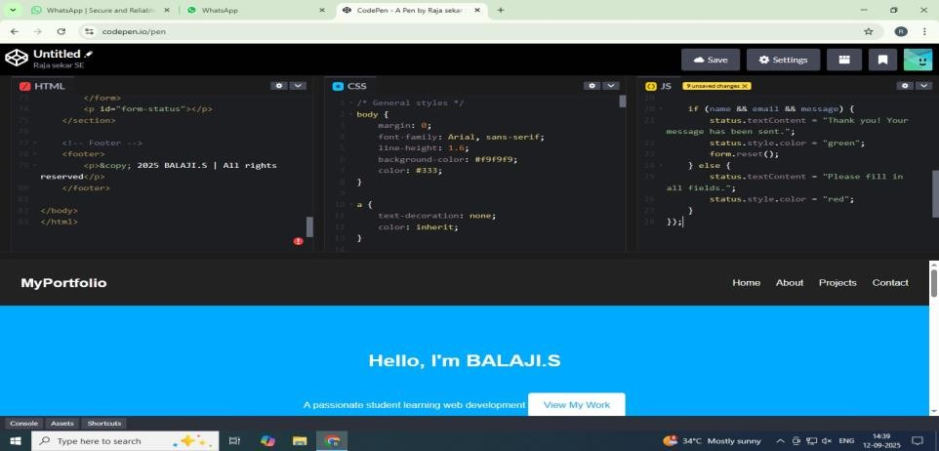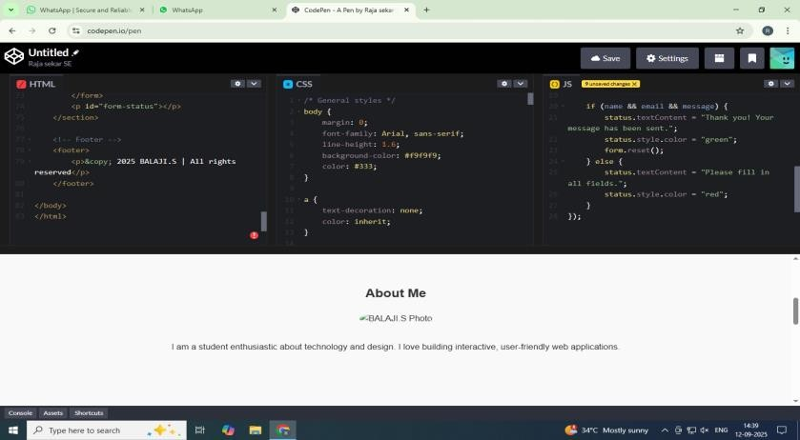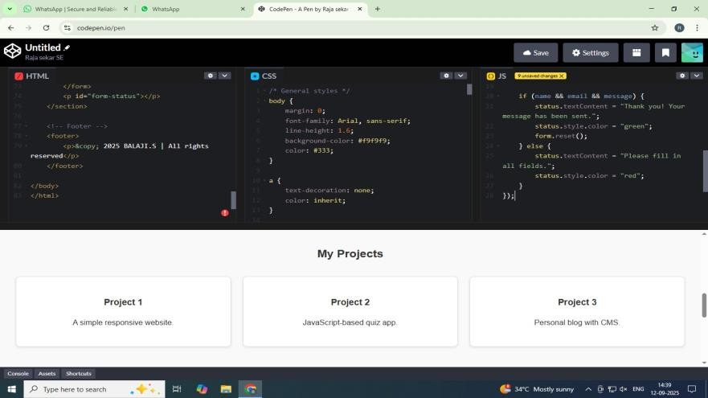

**CONCLUSION**

11

***The Digital Portfolio project demonstrates the effective application of front***

***-***

***end web development***

***skills to create a visually appealing, user***

***-***

***friendly, and responsive personal website. Through the***

***use of modern technologies such as HTML, CSS, JavaScript, and responsive design principles, this***

***portfolio provides a platform to showcase skills, projects, achievements, and contact information in***

***a professional and accessible manner. It serves not only as a personal branding tool but also as a***

***testament to the developer’s proficiency in front***

***-***

***end development. This project highlights the***

***importance of UI/UX considerations and lays a strong foundation for further growth in both web***

***development and digital presence***

***.***

**GIT HUB LINK:**

https://github.com/jonabalaji2228-creator/my-project.git