**Title:** *"Mexico Barely Passes Cybersecurity Knowledge Test"*

**Source:** [El Economista](https://www.eleconomista.com.mx/tecnologia/Mexico-pasa-de-panzazo-prueba-de-conocimientos-en-ciberseguridad-20240813-0052.html)

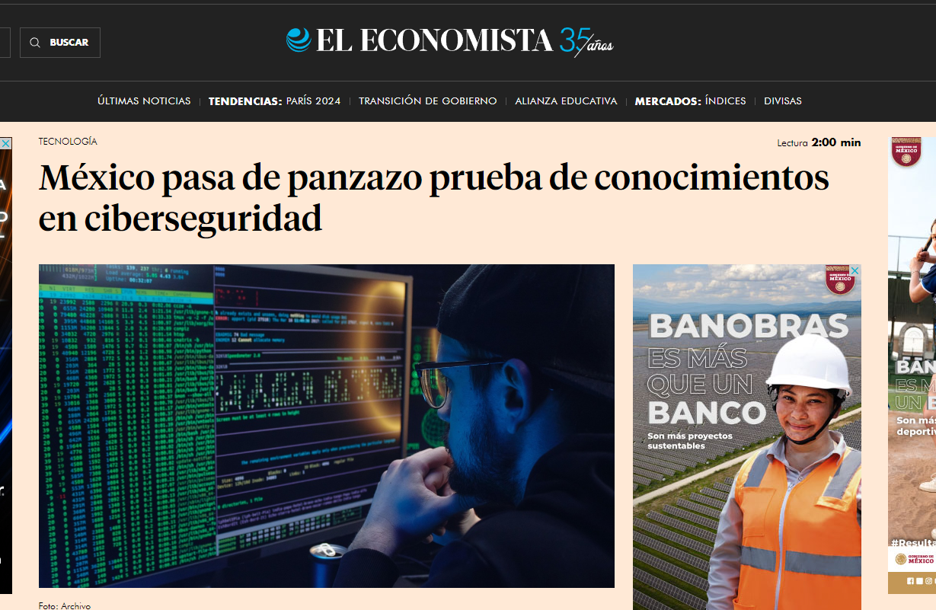

**Summary:** Mexico received a mediocre rating in a recent cybersecurity knowledge assessment. The test, conducted by an international entity, reveals significant deficiencies in the country's preparedness to face cyber threats. Despite some progress, Mexico faces major challenges in infrastructure, training, and digital security policies.

**Point of View:** The poor rating in cybersecurity highlights the urgent need for Mexico to improve its cyber defense capabilities. It is crucial for the government and businesses to invest in education and update their systems to protect against digital threats. Cybersecurity is vital for economic stability and public trust, so addressing these shortcomings should be a priority to strengthen the country's digital infrastructure.

Reference

l Economista. (2024, August 13). *México pasa de panzazo prueba de conocimientos en ciberseguridad*. El Economista. <https://www.eleconomista.com.mx/tecnologia/Mexico-pasa-de-panzazo-prueba-de-conocimientos-en-ciberseguridad-20240813-0052.html>