Homework 2

Jonah Bacon

FISH 621

03 Mar 2022

**Problem 1:**

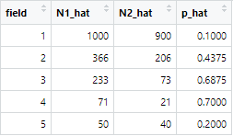

The estimates of rabbit abundance for the beginning of the experiment (N1_hat) for fields 1 through 5 are 100, 366, 233, 71, and 50, respectively. The estimates of rabbit abundance when Observer 2 surveys fields 1 through 5 are 900, 206, 73, 21, and 40, respectively. The probability of rabbit observation in fields 1 through 5 are 0.1, 0.4375, 0.6875, 0.7, and 0.2, respectively.

Assumptions for a removal experiment are that the entire region of the survey is searched, which is easy to ensure by requiring both researchers to search the entire field during their surveys. Another assumption is that animals are equally catchable (with probability *p*). By spending an equal time educating and training both observers on how to detect and capture rabbits, we could reasonably assume that each observer has the same probability of catching animals. To determine whether the final assumption that animals are caught independently of each other is true is a little trickier. It seems likely to me that rabbits associate themselves with cover habitat and/or with familial groups within a field. To ensure that this assumption doesn’t confound our results, it would be good to choose fields that are monotone in their structure. Then you should monitor where you capture rabbits within the field and determine whether rabbits are more likely to be found in close proximity to each other or whether there is an equal chance of capturing rabbits anywhere in the field.

**Problem 2:**

Catchability (*q*) from Pond A and Pond B were 0.01590542 and 0.01714625, respectively. The abundance estimate of pike in Pond A and Pond B at the start of the experiment were 168 and 182 pike, respectively. The following is a plot of the relationship between cumulative catch and CPUE for the two ponds:

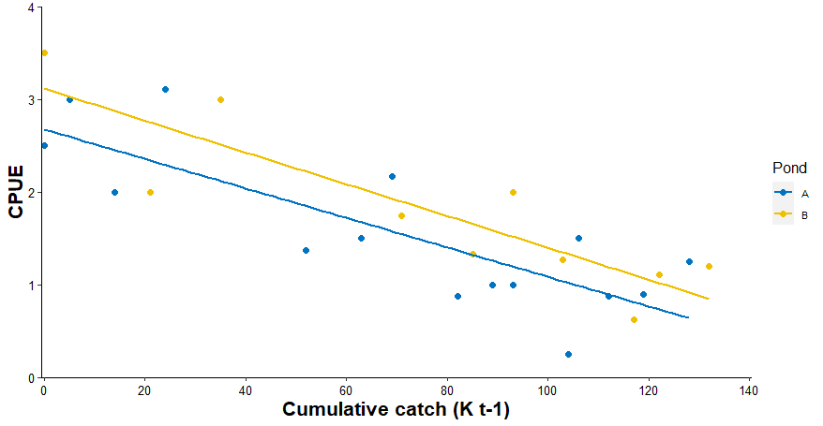

The Leslie depletion estimator makes an assumption that CPUE is proportional to the population at the time of the removal. This assumption may or may not hold, and you should collect some background knowledge upon the study fish in order to make this assumption. Some fish change their location and/or behavior seasonal or throughout their development. Thus, changes in CPUE may actually be detecting increased/decreased catchability as a result of those changes, not as a result of population level changes. You want to design your experiment so as to have an equal chance of catching fish at any point throughout the survey period. If you can do that, then your CPUE estimate should be proportional to the population size.

The catchability coefficient *q* represents the proportion of the population that is removed by 1 unit of fishing effort. This catchability coefficient *q* is a rather abstract quantity, but would be great for bragging rights at the bar after a day of fishing: “Switching to dry flies increased my catchability coefficient from 0.000125 to 0.000143 today” instead of “The dry fly was the hot fly of the day today”.

**Problem 3:**

The following is my table of values computed for this problem, where “N_hat” is the total population estimate for each month, “N.males_hat” is the estimated number of males in the population, and “N.females_hat” is the estimated number of females in the population.

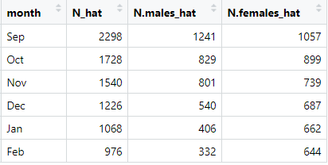

For months Sep – Jan I used the change-in-ratio formula. For the month of Feb, I subtracted the Jan harvest from the Jan population estimate since we did not have an estimate of sex ratio in the month of Mar. To calculate the male and female estimates, I used the estimated ratio of males and females and multiplied that by the total population estimate.

The change in ratio estimation method assumes that the population is closed, the probability of capture is constant for all individuals at each time period, the two surveys are independent, and that you know precisely the number of removals (or additions) to each type (X or Y). As a researcher, you should be able to determine if the closed population assumption is reasonable given the recruitment timing of your study organism and any expected mortality/predation and/or immigration/emigration. The assumption that there is a constant probability of capture is a reasonable assumption provided that you perform the same survey during times 1 and 2. The assumption that the two surveys are independent is reasonable given that the effects of survey 1 doesn’t affect survey 2. By closely monitoring removals through check stations, permit reporting, creel surveys, etc., you can reasonably make the assumption that all removals are known.

**Problem 4:**

Many of the results from this portion can be found in the R script.

1. ui = 86 99 40 48 69 62 55 8 37 94 46 65 50 97 27
2. Mi = 0 86 185 225 273 342 404 459 467 504 598 644 709 759 856
3. Schnabel estimate = 2201
4. Chapman extension to Schnabel estimate = 2192
5. 95% CI to Chapman extension to Schnabel estimate = 1898 – 2543
6. Chapman estimates = 2239.250 3905.000 1581.000 1991.727 2704.889 2429.000 1685.667 2391.000 2140.897 2218.824 1877.088 2074.385 1987.667 2302.188
7. Chapman variances = 920406.71 4791360.00 229917.33 273954.71 622594.97 398925.00 513871.11 451370.40 110157.49 194212.80 62679.22 101108.48 36893.57 192273.82
8. Mean Chapman estimate = 2252
9. Theoretical variance = 45406.76

95% CI = 1792 – 2712

1. Empirical variance = 22444.99

95% CI = 1928 – 2576

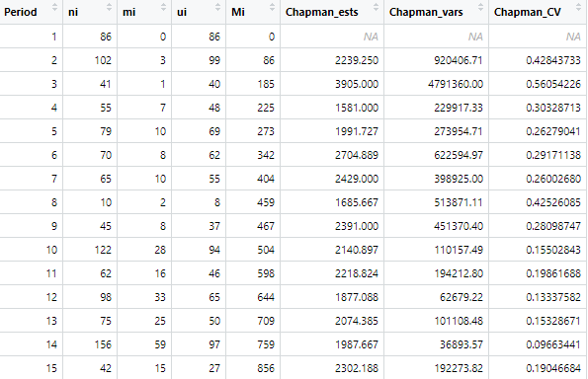

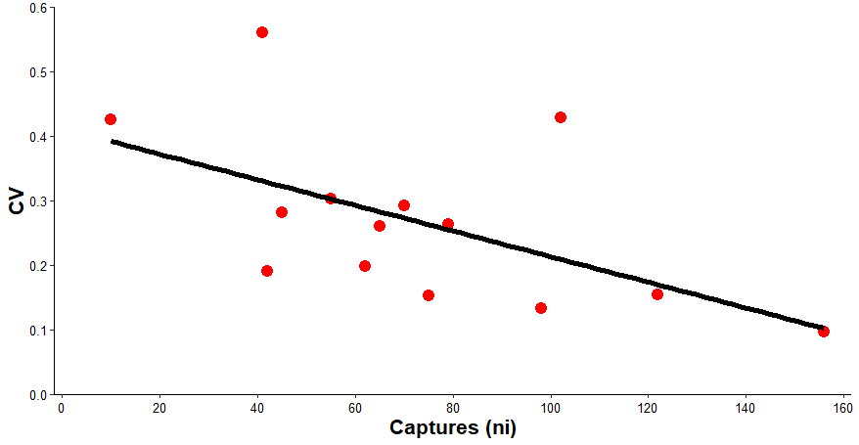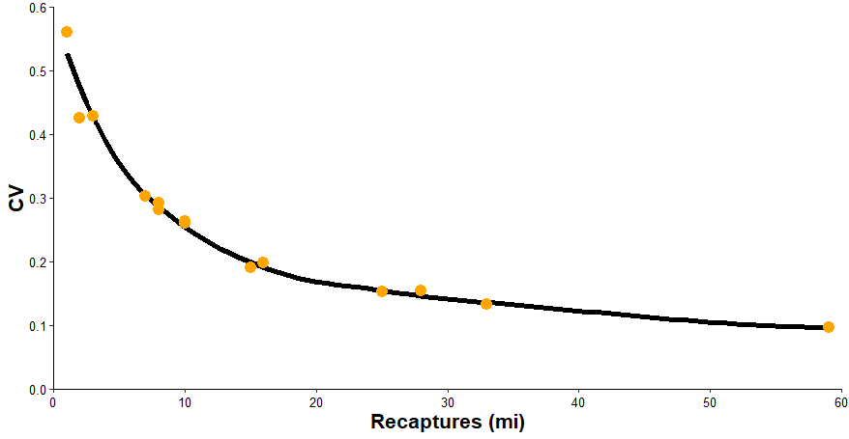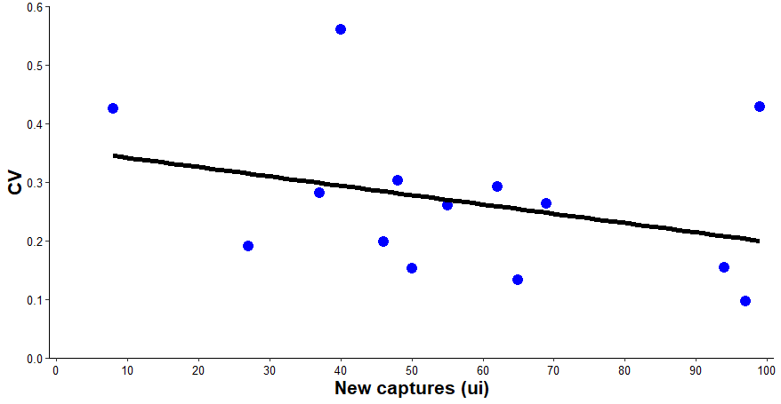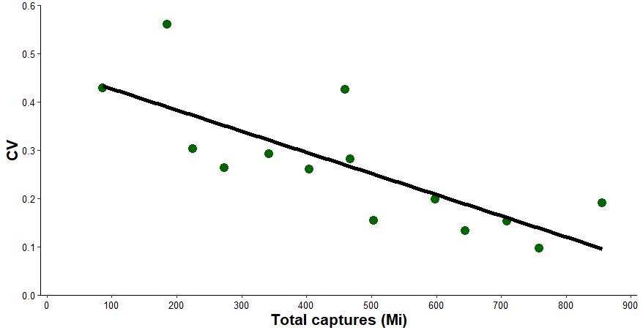

These four figures show the relationship between captures (ni), recaptures (mi), new captures (ui), and total captures (Mi) and the coefficient of variation (CV) in our Chapman estimates. What can be deduced from these plots is that the number of captures (ni) and the total captures (Mi) both have a negative effect on CV and thus a positive effect on precision. The recaptures (mi) and new captures (ui) do not have such a strong linear negative effect on CV. These results offer credence to the Schumacher-Eschmeyer weighted regression methods that we apply to repeated Schnabel mark-recapture data, where we weight our data by ni because increasing ni (and thus increased weight in that Schnabel population estimate) is likely to result in a more accurate estimate according to our calculations of CV in the top left plot.

**TIME ALLOCATION:** 5 hours