Homework 3

Jonah Bacon

FISH 621

28 Mar 2022

**Problem 1:**

1. Tau.hat.h = 1000, 1000, 900 for h = 1, 2, 3 respectively
2. Tau.hat.st = 11000 wolves
3. Var.hat_tau.hat.st = 1180000
4. CV for tau.hat. st = 0.09875255
5. 95% confidence interval for tau.hat.st = (8870.895, 13129.1)
6. y.bar.st = 24.44444, which rounds to 24 wolves
7. Var.hat_y.bar.st = 5.82716
8. 95% confidence interval for y.bar.st = (19.7131, 29.17579)

**Problem 2:**

1. n.h = 39, 38, and 21 for h = 1, 2, 3 respectively
2. y.bar.h = 1.615385, 4.210526, 7.666667 for h = 1, 2, 3 respectively
3. y.bar.st = 15.02488, which rounds to 15 moose
4. s.h^2 = 11.19028, 30.38691, 57.43333 for h = 1, 2, 3 respectively
5. var.hat_y.bar.st = 12.13084
6. 95% confidence interval for y.bar.st = (8.198322, 21.85143)
7. Tau.hat.h = 197.0769, 240, 168.6667, which rounds to 197, 240, 169 moose, for h = 1, 2, 3
8. Tau.hat.st = 605.7436, which rounds to 606 moose
9. Var.hat_tau.hat.st = 3831.652
10. 95% confidence interval for tua.hat.st = (484.4189, 727.0683)

**Problem 3:**

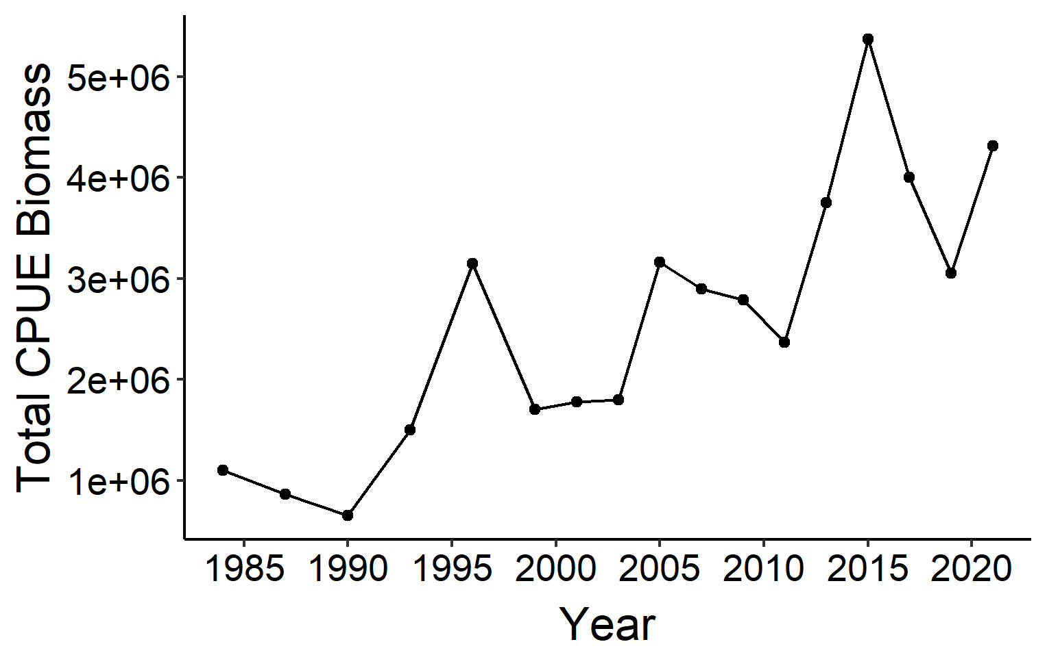

1. It would be inappropriate to accept this plot above as representative of the true relative trend in the population because it does not account for any difference in the number of stations that were sampled in a given year.

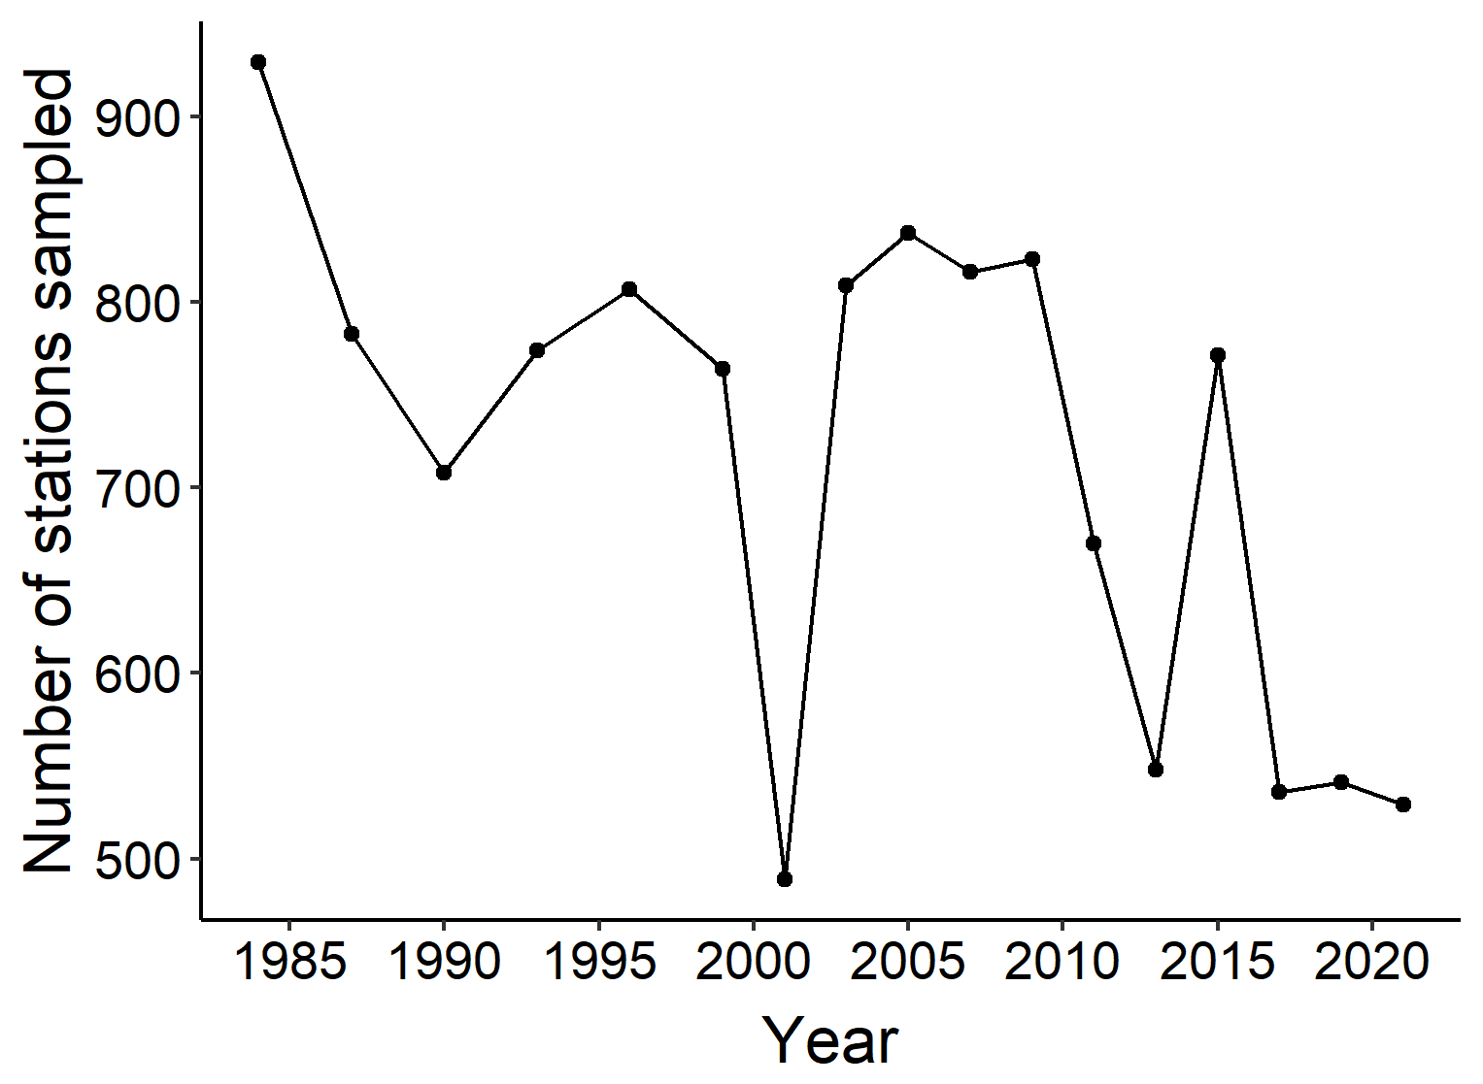

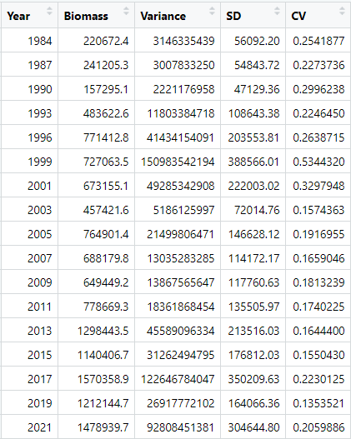

1. **log(Weight.CPUE..kg.km2. + 1) ~ fYear log(Weight.CPUE..kg.km2. + 1) ~ fYear + fStratum**

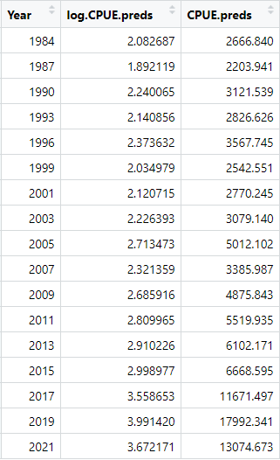 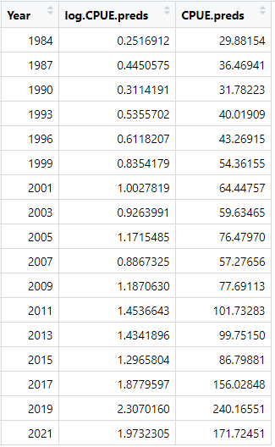

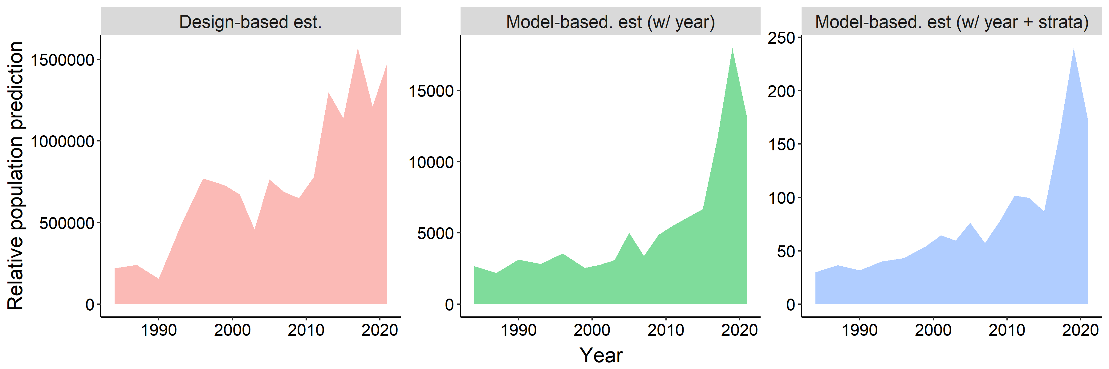

The first panel shows our design-based estimator of biomass CPUE. The second panel shows the model-based estimator of CPUE with year as a predictor variable. The third panel is also a model-based estimator of CPUE but with year and stratum as predictor variables. As can be visually seen by looking at these plots, they all show the same general trend of lower biomass in the past time and then a spike in biomass around 2015. The design-based estimator shows more variability in its CPUE estimate over time as compared to the two model-based estimates.

**TIME ALLOCATION:** 5 hours