Homework 4

Jonah Bacon

FISH 621

20 April 2022

**Problem 1:**

1. 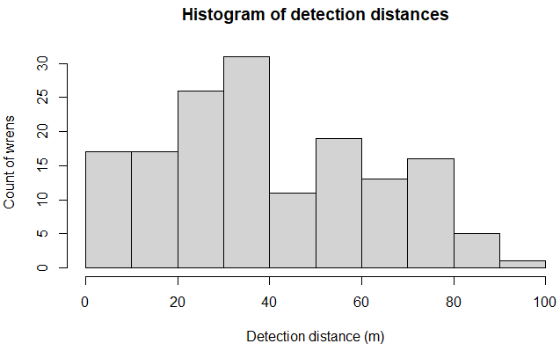 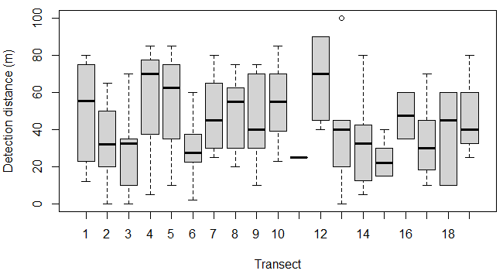

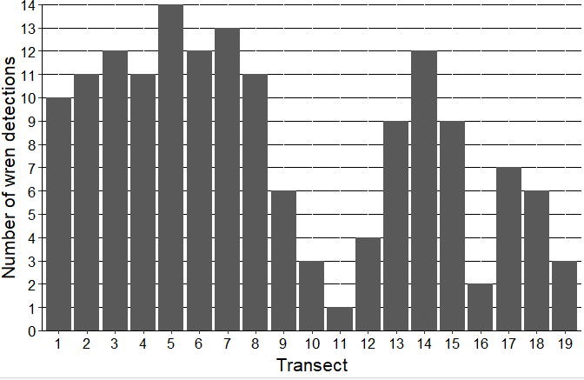

1. 

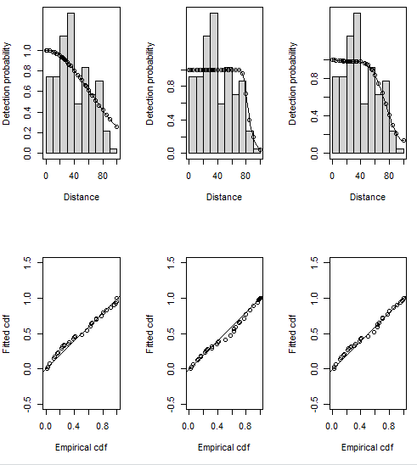

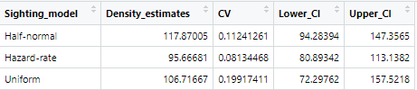

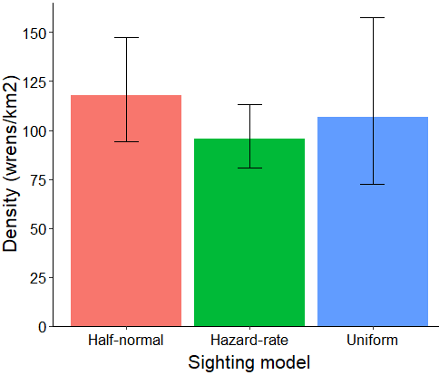

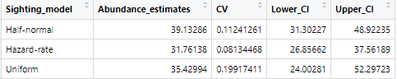

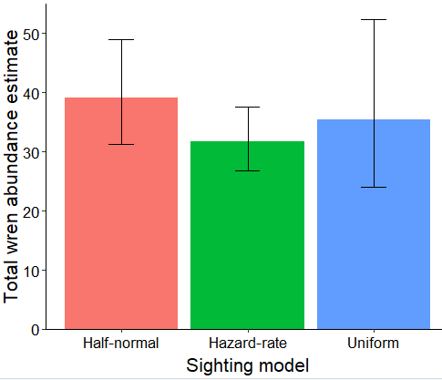

1. The Hazard-rate model has the lowest AIC score of the three models and has the narrowest 95% confidence interval with the lowest CV. The sighting-model for that model fits the detection observations well. Therefore, I’d say that the hazard-rate model is the most reliable.

**Problem 2:**

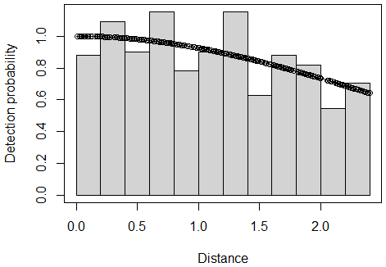

Nest density estimate:



Nest abundance estimate:



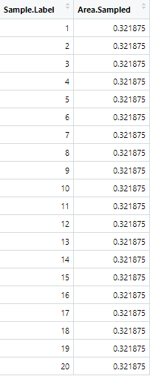

1. 
2. N = (40.47)/(0.00125*2*128.75) = 125.732
3. 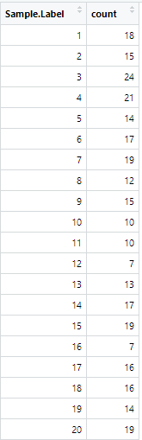

Sample mean = 15.15

Sample variance = 19.81842

Total nest abundance estimate = 1904.84

Estimated variance of the sample mean = 0.8332968

Estimated variance of the total abundance estimate = 13173.21

CV for the total abundance estimate = 0.06025



N = (40.47)/(0.001*2*128.75) = 157.165

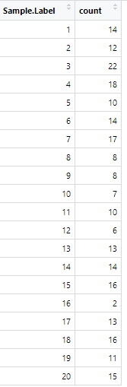

Sample mean = 12.3

Sample variance = 21.90526

Total nest abundance estimate = 1933.13

Estimated variance of the sample mean = 0.9558857

Estimated variance of the total abundance estimate = 23611.19

CV for the total abundance estimate = 0.07949

1. The CV of the two strip transect methods (first with a distance of 1.25 m and then with a distance of 1 m) are both slightly higher than the half-normal distance sighting model. Therefore our distance model does a better job of describing our detections and estimating the population abundance.

Treating the transect data as strip transects makes the assumption that we detect 100% of the nests present. If that assumption was reasonably valid, as in possibly the case where we only have a narrow transect, then we could use the strip transect method. However, a tradeoff of having narrow strip width is that we have to estimate a greater proportion of our total sample area, increasing the total variance in our estimate and causing our CV to rise. We therefore have less confidence in our abundance estimate. On the flip side, if we have a wide strip, we have to estimate less of the total sample area, meaning that our variance will be lower. But with a wide strip transect, our assumption of 100% detection success is most likely not valid.

Therefore, the distance sighting model is a good alternative in that it allows us to sample a relatively large area without the assumption of 100% detection. The model recognizes that our detection probability decreases with distance, models that sighting probability, and overall produces a more accurate estimate with less variance.

**Problem 3:**

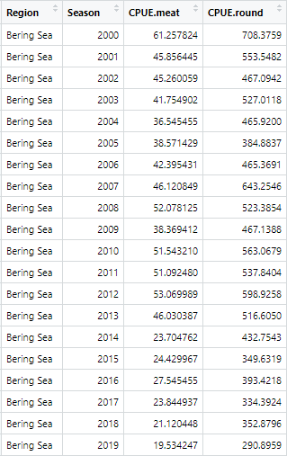

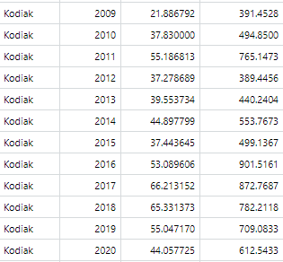

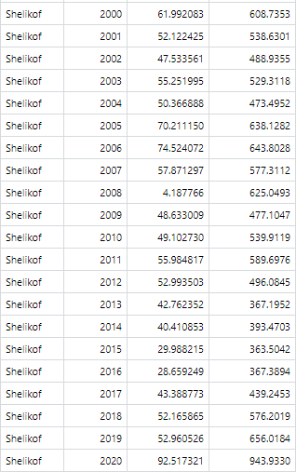

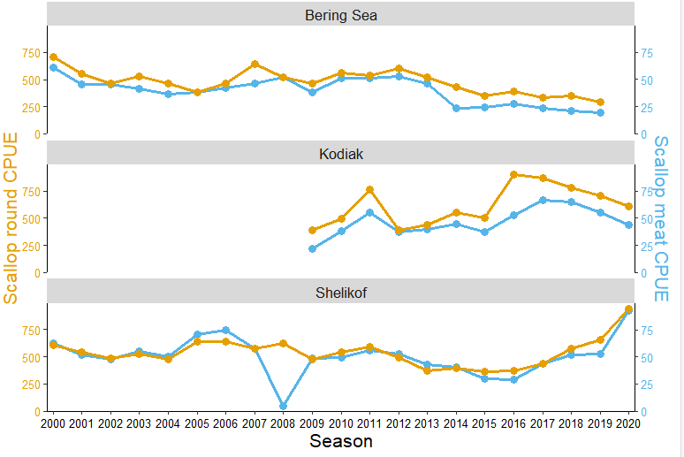

1. f

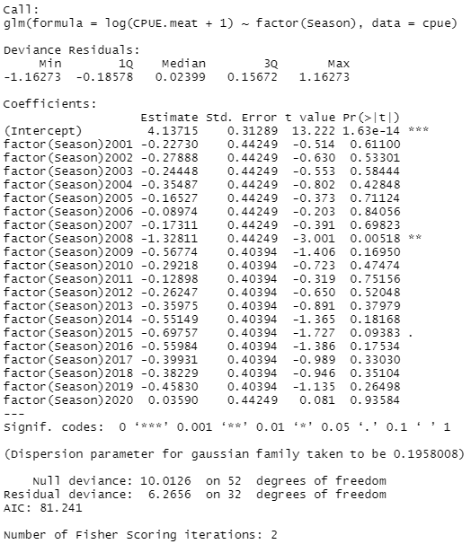

Meat GLM predictions:

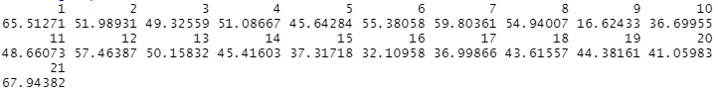

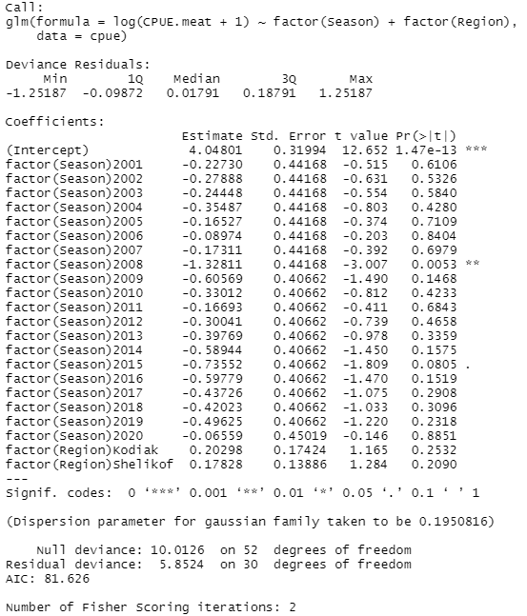

Meat GLM predictions for Shelikof region:

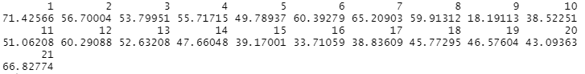

1. 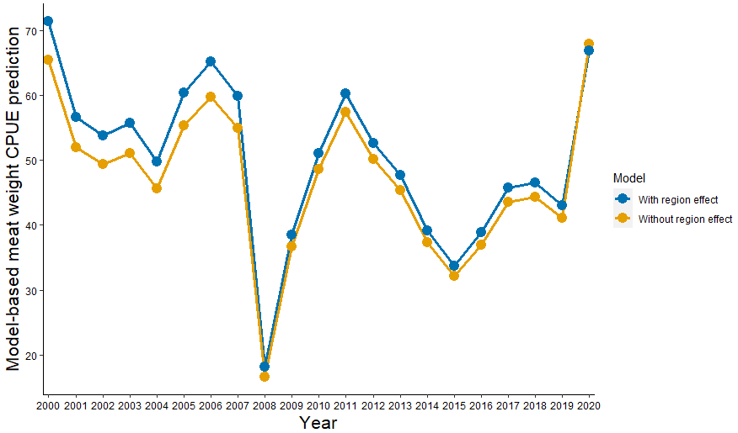

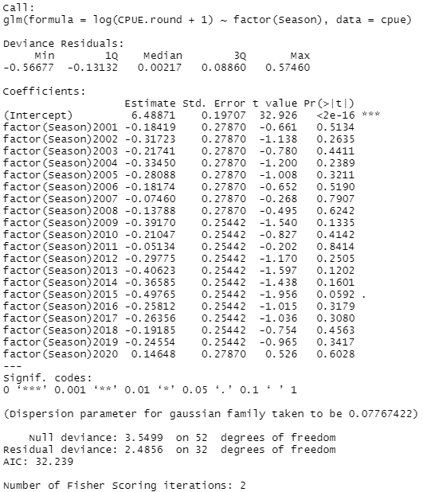

Round GLM predictions:





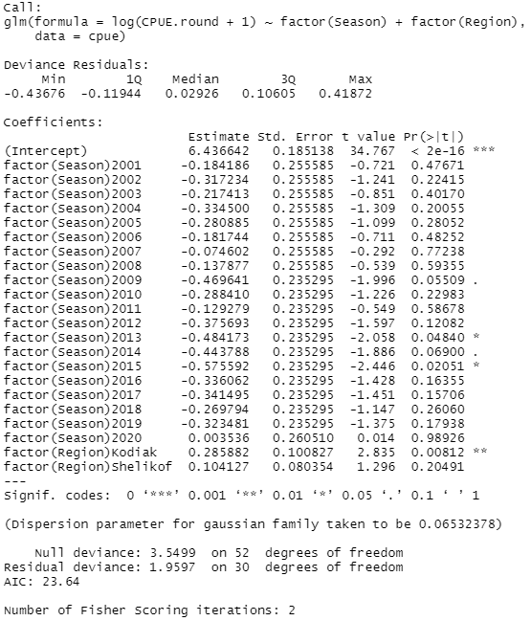

Round GLM predictions for Shelikof region:



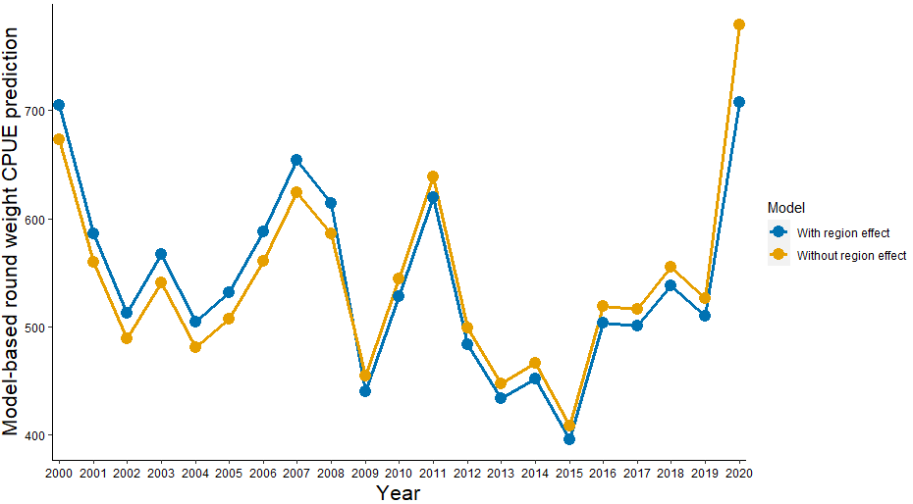

1. 