Beaufort Report Summary of 2022 Season

#### Jonah Bacon

#### October 01, 2022

Season Effort

The total number of hours fished by each site is first divided by 24 to convert hours to days, then divided by 2. This converts cod-end nights (2 per station) to station nights (station nights = net nights; for our purposes here they are the same). A ‘Net Night’ is defined as the number of 24 hour periods fished across the entire season. One net night = 24 hours of fishing by any station. For example, if Station 230 fishes for 24 hours, that site produces 1 net night in that 24 hour period.

In 2022, there were 176.6 “net nights” among all four sampling stations.

At Station 230, there were 48.9 net nights, 49.7 net nights at Station 214, 39.7 net nights at Station 218, and 39.7 net nights at Station 218.

| Station | Effort_netnights |
| --- | --- |
| 214 | 49.7 |
| 218 | 39.7 |
| 220 | 38.3 |
| 230 | 48.9 |

Catch Summary - All Species

## `summarise()` has grouped output by 'Year'. You can override using the  
## `.groups` argument.

| Year | ARCD | ARCH | ARCS | ARFL | BDWF | BRBT | BRCS | CAPE | CHUM | DLVN | ELPT | FHSC | GRAY |
| --- | --- | --- | --- | --- | --- | --- | --- | --- | --- | --- | --- | --- | --- |
| 2001 | 16,242 | 0 | 13,361 | 12,713 | 5,146 | 0 | 21 | 0 | 4 | 2,618 | 1 | 6,277 | 12 |
| 2002 | 425,461 | 0 | 4,493 | 7,094 | 3,558 | 0 | 1 | 1 | 3 | 1,478 | 0 | 4,403 | 12 |
| 2003 | 38,361 | 0 | 5,563 | 10,868 | 7,224 | 0 | 0 | 29 | 4 | 1,597 | 0 | 11,553 | 22 |
| 2004 | 8,178 | 0 | 3,026 | 11,976 | 9,368 | 0 | 0 | 87 | 1 | 1,867 | 0 | 12,731 | 20 |
| 2005 | 15,905 | 0 | 2,394 | 6,911 | 6,713 | 2 | 0 | 61 | 1 | 3,195 | 0 | 6,263 | 22 |
| 2006 | 5,848 | 0 | 1,389 | 6,930 | 4,600 | 0 | 0 | 87 | 0 | 2,378 | 0 | 6,238 | 16 |
| 2007 | 1,973 | 0 | 42,906 | 8,304 | 4,260 | 0 | 4 | 36 | 1 | 2,462 | 0 | 10,539 | 73 |
| 2008 | 840 | 0 | 24,091 | 9,997 | 9,733 | 0 | 4 | 90 | 4 | 2,742 | 0 | 10,784 | 306 |
| 2009 | 890 | 0 | 47,411 | 8,450 | 9,542 | 0 | 6 | 287 | 2 | 1,941 | 0 | 9,994 | 7 |
| 2010 | 832 | 0 | 8,907 | 9,687 | 8,803 | 0 | 14 | 1 | 0 | 1,233 | 0 | 9,182 | 81 |
| 2011 | 429 | 0 | 44,396 | 7,501 | 2,187 | 0 | 2 | 63 | 3 | 924 | 0 | 7,212 | 33 |
| 2012 | 411 | 0 | 6,683 | 11,484 | 15,894 | 0 | 1 | 23 | 0 | 415 | 0 | 6,548 | 31 |
| 2013 | 5,588 | 0 | 7,409 | 17,298 | 24,978 | 1 | 0 | 38 | 0 | 1,382 | 0 | 8,237 | 7 |
| 2014 | 7,172 | 0 | 16,827 | 8,770 | 13,140 | 6 | 0 | 12 | 0 | 2,678 | 0 | 6,379 | 31 |
| 2015 | 4,777 | 0 | 5,532 | 8,842 | 6,004 | 3 | 1 | 15 | 1 | 2,277 | 0 | 4,547 | 37 |
| 2016 | 47,328 | 0 | 5,616 | 13,058 | 14,316 | 2 | 0 | 68 | 4 | 636 | 0 | 6,582 | 22 |
| 2017 | 2,008 | 1 | 2,981 | 16,486 | 19,345 | 2 | 0 | 42 | 2 | 684 | 0 | 8,464 | 102 |
| 2018 | 13,251 | 0 | 12,172 | 10,549 | 9,248 | 3 | 0 | 10 | 2 | 1,895 | 0 | 5,741 | 13 |
| 2019 | 510 | 0 | 6,538 | 7,640 | 8,744 | 4 | 0 | 13 | 10 | 321 | 0 | 3,643 | 10 |
| 2020 | 234 | 0 | 648 | 2,688 | 1,372 | 0 | 0 | 15 | 0 | 40 | 0 | 1,060 | 6 |
| 2021 | 833 | 0 | 4,428 | 11,371 | 6,863 | 0 | 0 | 4 | 0 | 731 | 0 | 4,917 | 23 |
| 2022 | 843 | 0 | 6,466 | 5,200 | 7,550 | 0 | 0 | 15 | 0 | 880 | 0 | 4,416 | 178 |

| Year | HBWF | HYCS | KPGL | KPSF | LIPA | LNSK | LSCS | NNSB | PCHG | PINK | RBSM | RDWF | RKGL |
| --- | --- | --- | --- | --- | --- | --- | --- | --- | --- | --- | --- | --- | --- |
| 2001 | 1,357 | 6 | 0 | 0 | 1 | 0 | 17,197 | 51 | 2 | 0 | 11,327 | 217 | 0 |
| 2002 | 901 | 0 | 0 | 0 | 0 | 0 | 15,300 | 71 | 2 | 8 | 5,389 | 412 | 0 |
| 2003 | 3,428 | 0 | 0 | 0 | 56 | 0 | 29,744 | 369 | 91 | 29 | 4,870 | 935 | 0 |
| 2004 | 3,097 | 0 | 0 | 0 | 2 | 0 | 27,385 | 559 | 41 | 29 | 3,203 | 395 | 0 |
| 2005 | 2,924 | 4 | 0 | 0 | 0 | 0 | 14,481 | 773 | 2 | 29 | 2,225 | 185 | 0 |
| 2006 | 1,737 | 5 | 0 | 0 | 0 | 0 | 24,036 | 302 | 8 | 7 | 2,773 | 427 | 0 |
| 2007 | 2,612 | 0 | 0 | 0 | 1 | 0 | 6,801 | 3,046 | 35 | 3 | 1,956 | 434 | 0 |
| 2008 | 2,085 | 0 | 0 | 0 | 5 | 0 | 8,502 | 99 | 114 | 284 | 3,978 | 399 | 0 |
| 2009 | 514 | 0 | 0 | 0 | 0 | 0 | 7,097 | 25 | 82 | 6 | 3,203 | 20 | 3 |
| 2010 | 1,382 | 0 | 0 | 0 | 0 | 0 | 11,089 | 18 | 2 | 18 | 2,489 | 187 | 0 |
| 2011 | 1,032 | 0 | 0 | 0 | 1 | 0 | 6,147 | 53 | 7 | 3 | 1,048 | 518 | 0 |
| 2012 | 1,340 | 0 | 0 | 0 | 0 | 0 | 10,210 | 237 | 6 | 1 | 5,825 | 352 | 0 |
| 2013 | 1,937 | 0 | 0 | 0 | 2 | 1 | 10,222 | 585 | 4 | 1 | 9,891 | 209 | 0 |
| 2014 | 2,706 | 0 | 0 | 0 | 1 | 0 | 12,692 | 122 | 4 | 8 | 5,076 | 661 | 0 |
| 2015 | 1,129 | 0 | 0 | 0 | 0 | 0 | 5,899 | 363 | 0 | 26 | 4,025 | 416 | 0 |
| 2016 | 1,554 | 0 | 2 | 0 | 6 | 0 | 8,207 | 1,658 | 41 | 25 | 3,694 | 408 | 6 |
| 2017 | 1,651 | 8 | 0 | 4 | 0 | 0 | 6,923 | 393 | 40 | 31 | 4,669 | 700 | 0 |
| 2018 | 1,243 | 1 | 0 | 0 | 0 | 0 | 10,414 | 269 | 6 | 22 | 5,755 | 579 | 0 |
| 2019 | 1,272 | 0 | 0 | 0 | 0 | 0 | 5,821 | 84 | 76 | 417 | 4,399 | 294 | 0 |
| 2020 | 330 | 0 | 0 | 0 | 0 | 0 | 2,079 | 6 | 158 | 98 | 767 | 0 | 0 |
| 2021 | 1,813 | 1 | 0 | 0 | 0 | 0 | 7,645 | 25 | 73 | 3 | 5,267 | 140 | 0 |
| 2022 | 1,598 | 0 | 0 | 0 | 0 | 0 | 3,373 | 36 | 6 | 3 | 8,609 | 23 | 0 |

| Year | SFCD | SHSC | SLEB | SLSC | SOCK | STFL | THSB | UNKN | WOLF | WSGL |
| --- | --- | --- | --- | --- | --- | --- | --- | --- | --- | --- |
| 2001 | 1,733 | 0 | 0 | 0 | 0 | 0 | 0 | 0 | 0 | 0 |
| 2002 | 74 | 0 | 0 | 0 | 0 | 0 | 2 | 0 | 0 | 0 |
| 2003 | 250 | 0 | 0 | 0 | 0 | 0 | 40 | 0 | 0 | 0 |
| 2004 | 122 | 0 | 0 | 0 | 0 | 0 | 50 | 0 | 1 | 0 |
| 2005 | 452 | 0 | 0 | 0 | 0 | 0 | 1 | 0 | 0 | 0 |
| 2006 | 782 | 0 | 0 | 0 | 0 | 0 | 21 | 0 | 0 | 0 |
| 2007 | 575 | 0 | 0 | 0 | 0 | 0 | 42 | 0 | 0 | 0 |
| 2008 | 4,193 | 0 | 0 | 0 | 0 | 0 | 123 | 0 | 0 | 0 |
| 2009 | 6,568 | 0 | 0 | 0 | 0 | 0 | 9 | 1 | 1 | 0 |
| 2010 | 2,341 | 0 | 0 | 0 | 0 | 0 | 14 | 0 | 0 | 0 |
| 2011 | 1,863 | 1 | 1 | 0 | 0 | 0 | 3 | 0 | 0 | 0 |
| 2012 | 5,717 | 0 | 0 | 0 | 0 | 0 | 27 | 1 | 0 | 0 |
| 2013 | 12,519 | 0 | 1 | 0 | 0 | 0 | 13 | 0 | 1 | 0 |
| 2014 | 6,381 | 0 | 0 | 0 | 0 | 0 | 6 | 0 | 0 | 0 |
| 2015 | 838 | 0 | 0 | 1 | 0 | 0 | 0 | 0 | 0 | 0 |
| 2016 | 1,691 | 0 | 0 | 4 | 0 | 0 | 120 | 0 | 0 | 0 |
| 2017 | 1,822 | 1 | 0 | 0 | 1 | 0 | 54 | 0 | 0 | 2 |
| 2018 | 2,831 | 0 | 0 | 1 | 0 | 0 | 52 | 0 | 0 | 0 |
| 2019 | 752 | 0 | 0 | 0 | 0 | 2 | 600 | 0 | 0 | 48 |
| 2020 | 35,047 | 0 | 0 | 0 | 0 | 1 | 56 | 0 | 0 | 19 |
| 2021 | 13,709 | 0 | 0 | 0 | 1 | 0 | 48 | 0 | 0 | 0 |
| 2022 | 1,176 | 0 | 0 | 0 | 0 | 0 | 18 | 0 | 0 | 0 |

Individual Species Summaries

## `summarise()` has grouped output by 'Station'. You can override using the  
## `.groups` argument.  
## Joining, by = "LengthGroup"  
## Joining, by = "LengthGroup"  
## `summarise()` has grouped output by 'Group'. You can override using the  
## `.groups` argument.  
## `summarise()` has grouped output by 'LG'. You can override using the `.groups`  
## argument.

Broad Whitefish

2022 - All Sites and Length Groups combined

| TotalCatch | MeanLength | LengthRange |
| --- | --- | --- |
| 7,550 | 163.6 | 40-503 |

2022 - By Station & Length Group

| Station | LengthGroup | TotalCatch | CPUE_netnight |
| --- | --- | --- | --- |
| 214 | 1 | 2,504 | 50.4 |
| 214 | 2 | 753 | 15.2 |
| 214 | 3 | 305 | 6.1 |
| 218 | 1 | 279 | 7.0 |
| 218 | 2 | 108 | 2.7 |
| 218 | 3 | 190 | 4.8 |
| 220 | 1 | 194 | 5.1 |
| 220 | 2 | 47 | 1.2 |
| 220 | 3 | 219 | 5.7 |
| 230 | 1 | 2,086 | 42.7 |
| 230 | 2 | 577 | 11.8 |
| 230 | 3 | 288 | 5.9 |

2022 - By Station

| Station | TotalCatch | CPUE_netnight |
| --- | --- | --- |
| 214 | 3,562 | 71.7 |
| 218 | 577 | 14.5 |
| 220 | 460 | 12.0 |
| 230 | 2,951 | 60.3 |

2022 - By Length Group, All Sites Combined

| LengthGroup | TotalCatch | CPUE_netnight | MeanLength_mm | MinLength_mm | MaxLength_mm |
| --- | --- | --- | --- | --- | --- |
| 1 | 5,063 | 28.7 | 95.5 | 40 | 119 |
| 2 | 1,485 | 8.4 | 158.5 | 120 | 249 |
| 3 | 1,002 | 5.7 | 345.7 | 250 | 503 |

|  | CPUE_netnights | Catch | Catch Rank | CPUE Rank |
| --- | --- | --- | --- | --- |
| 2001 | 26.9 | 5,146 | 6 | 6 |
| 2002 | 21.4 | 3,558 | 3 | 4 |
| 2003 | 46.4 | 7,224 | 10 | 11 |
| 2004 | 48.9 | 9,368 | 15 | 12 |
| 2005 | 36.4 | 6,713 | 8 | 9 |
| 2006 | 23.3 | 4,600 | 5 | 5 |
| 2007 | 19.9 | 4,260 | 4 | 2 |
| 2008 | 52.7 | 9,733 | 17 | 13 |
| 2009 | 76.5 | 9,542 | 16 | 18 |
| 2010 | 56.6 | 8,803 | 13 | 14 |
| 2011 | 14.8 | 2,187 | 2 | 1 |
| 2012 | 103.3 | 15,894 | 20 | 20 |
| 2013 | 154.5 | 24,978 | 22 | 22 |
| 2014 | 71.7 | 13,140 | 18 | 17 |
| 2015 | 32.7 | 6,004 | 7 | 7 |
| 2016 | 86.1 | 14,316 | 19 | 19 |
| 2017 | 104.7 | 19,345 | 21 | 21 |
| 2018 | 57.4 | 9,248 | 14 | 15 |
| 2019 | 59.9 | 8,744 | 12 | 16 |
| 2020 | 20.9 | 1,372 | 1 | 3 |
| 2021 | 35.8 | 6,863 | 9 | 8 |
| 2022 | 42.8 | 7,550 | 11 | 10 |

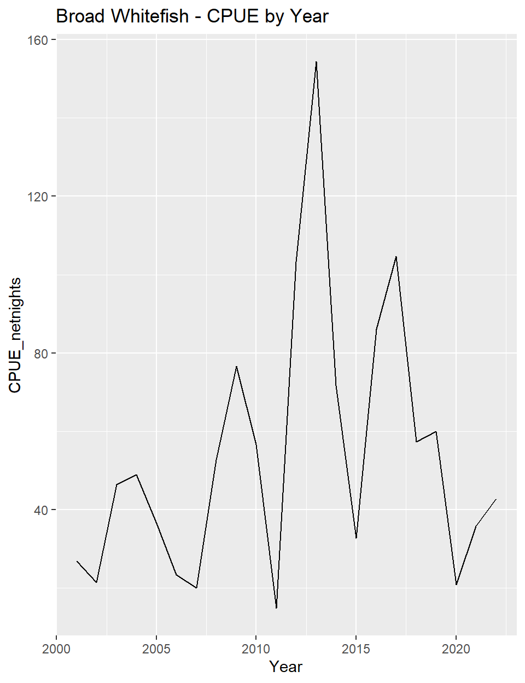

Three Year Comparison

| Group | Year | MeanLength_mm | TotalCatch | Netnights | CPUE_netnights |
| --- | --- | --- | --- | --- | --- |
| 1 | 2020 | 107.7 | 491 | 65.8 | 7.5 |
| 1 | 2021 | 76.4 | 3,194 | 191.7 | 16.7 |
| 1 | 2022 | 95.5 | 5,063 | 176.6 | 28.7 |
| 2 | 2020 | 189.5 | 594 | 65.8 | 9.0 |
| 2 | 2021 | 174.7 | 2,180 | 191.7 | 11.4 |
| 2 | 2022 | 158.5 | 1,485 | 176.6 | 8.4 |
| 3 | 2020 | 337.7 | 287 | 65.8 | 4.4 |
| 3 | 2021 | 328.1 | 1,489 | 191.7 | 7.8 |
| 3 | 2022 | 345.7 | 1,002 | 176.6 | 5.7 |

## `summarise()` has grouped output by 'Station'. You can override using the  
## `.groups` argument.  
## Joining, by = "LengthGroup"  
## Joining, by = "LengthGroup"  
## `summarise()` has grouped output by 'Group'. You can override using the  
## `.groups` argument.  
## `summarise()` has grouped output by 'LG'. You can override using the `.groups`  
## argument.

Arctic Cisco

2022 - All Sites and Length Groups combined

| TotalCatch | MeanLength | LengthRange |
| --- | --- | --- |
| 6,466 | 168.1 | 48-414 |

2022 - By Station & Length Group

| Station | LengthGroup | TotalCatch | CPUE_netnight |
| --- | --- | --- | --- |
| 214 | 1 | 1,202 | 24.2 |
| 214 | 2 | 1,917 | 38.6 |
| 214 | 3 | 280 | 5.6 |
| 218 | 1 | 280 | 7.1 |
| 218 | 2 | 331 | 8.3 |
| 218 | 3 | 365 | 9.2 |
| 220 | 1 | 47 | 1.2 |
| 220 | 2 | 91 | 2.4 |
| 220 | 3 | 143 | 3.7 |
| 230 | 1 | 1,079 | 22.1 |
| 230 | 2 | 527 | 10.8 |
| 230 | 3 | 204 | 4.2 |

2022 - By Station

| Station | TotalCatch | CPUE_netnight |
| --- | --- | --- |
| 214 | 3,399 | 68.4 |
| 218 | 976 | 24.6 |
| 220 | 281 | 7.3 |
| 230 | 1,810 | 37.0 |

2022 - By Length Group, All Sites Combined

| LengthGroup | TotalCatch | CPUE_netnight | MeanLength_mm | MinLength_mm | MaxLength_mm |
| --- | --- | --- | --- | --- | --- |
| 1 | 2,608 | 14.8 | 105.2 | 48 | 119 |
| 2 | 2,866 | 16.2 | 157.8 | 120 | 247 |
| 3 | 992 | 5.6 | 299.6 | 250 | 414 |

|  | CPUE_netnights | Catch | Catch Rank | CPUE Rank |
| --- | --- | --- | --- | --- |
| 2001 | 69.9 | 13,361 | 17 | 16 |
| 2002 | 27.0 | 4,493 | 7 | 7 |
| 2003 | 35.7 | 5,563 | 9 | 10 |
| 2004 | 15.8 | 3,026 | 5 | 4 |
| 2005 | 13.0 | 2,394 | 3 | 3 |
| 2006 | 7.0 | 1,389 | 2 | 1 |
| 2007 | 200.9 | 42,906 | 20 | 20 |
| 2008 | 130.5 | 24,091 | 19 | 19 |
| 2009 | 380.3 | 47,411 | 22 | 22 |
| 2010 | 57.3 | 8,907 | 15 | 15 |
| 2011 | 300.1 | 44,396 | 21 | 21 |
| 2012 | 43.5 | 6,683 | 13 | 12 |
| 2013 | 45.8 | 7,409 | 14 | 14 |
| 2014 | 91.9 | 16,827 | 18 | 18 |
| 2015 | 30.2 | 5,532 | 8 | 8 |
| 2016 | 33.8 | 5,616 | 10 | 9 |
| 2017 | 16.1 | 2,981 | 4 | 5 |
| 2018 | 75.5 | 12,172 | 16 | 17 |
| 2019 | 44.8 | 6,538 | 12 | 13 |
| 2020 | 9.9 | 648 | 1 | 2 |
| 2021 | 23.1 | 4,428 | 6 | 6 |
| 2022 | 36.6 | 6,466 | 11 | 11 |

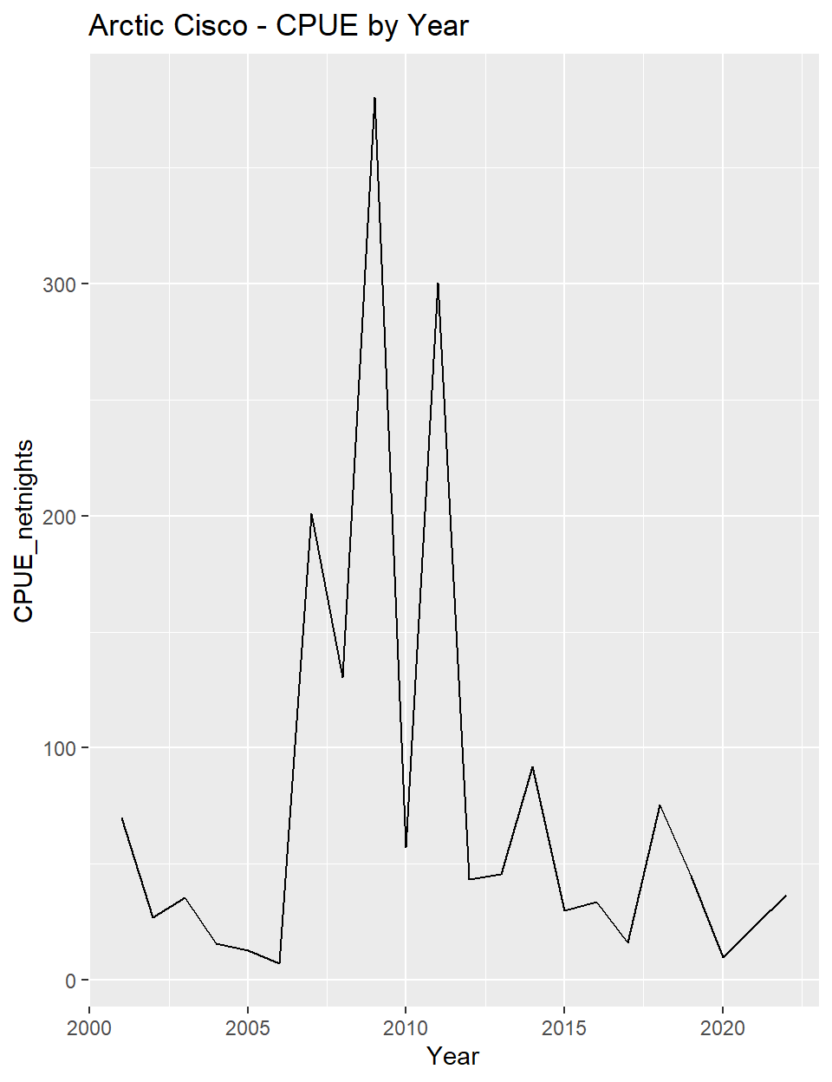

Three Year Comparison

| Group | Year | MeanLength_mm | TotalCatch | Netnights | CPUE_netnights |
| --- | --- | --- | --- | --- | --- |
| 1 | 2020 | 108.5 | 71 | 65.8 | 1.1 |
| 1 | 2021 | 106.4 | 962 | 191.7 | 5.0 |
| 1 | 2022 | 105.2 | 2,608 | 176.6 | 14.8 |
| 2 | 2020 | 196.2 | 453 | 65.8 | 6.9 |
| 2 | 2021 | 162.6 | 2,275 | 191.7 | 11.9 |
| 2 | 2022 | 157.8 | 2,866 | 176.6 | 16.2 |
| 3 | 2020 | 325.3 | 124 | 65.8 | 1.9 |
| 3 | 2021 | 290.5 | 1,191 | 191.7 | 6.2 |
| 3 | 2022 | 299.6 | 992 | 176.6 | 5.6 |

## `summarise()` has grouped output by 'Station'. You can override using the  
## `.groups` argument.  
## Joining, by = "LengthGroup"  
## Joining, by = "LengthGroup"  
## `summarise()` has grouped output by 'Group'. You can override using the  
## `.groups` argument.  
## `summarise()` has grouped output by 'LG'. You can override using the `.groups`  
## argument.

Least Cisco

2022 - All Sites and Length Groups combined

| TotalCatch | MeanLength | LengthRange |
| --- | --- | --- |
| 3,373 | 276.7 | 79-425 |

2022 - By Station & Length Group

| Station | LengthGroup | TotalCatch | CPUE_netnight |
| --- | --- | --- | --- |
| 214 | 1 | 114 | 2.3 |
| 214 | 2 | 1,081 | 21.8 |
| 218 | 1 | 105 | 2.6 |
| 218 | 2 | 1,252 | 31.5 |
| 220 | 1 | 25 | 0.7 |
| 220 | 2 | 538 | 14.0 |
| 230 | 1 | 62 | 1.3 |
| 230 | 2 | 196 | 4.0 |

2022 - By Station

| Station | TotalCatch | CPUE_netnight |
| --- | --- | --- |
| 214 | 1,195 | 24.0 |
| 218 | 1,357 | 34.2 |
| 220 | 563 | 14.7 |
| 230 | 258 | 5.3 |

2022 - By Length Group, All Sites Combined

| LengthGroup | TotalCatch | CPUE_netnight | MeanLength_mm | MinLength_mm | MaxLength_mm |
| --- | --- | --- | --- | --- | --- |
| 1 | 306 | 1.7 | 114.4 | 79 | 178 |
| 2 | 3,067 | 17.4 | 295.7 | 180 | 425 |

|  | CPUE_netnights | Catch | Catch Rank | CPUE Rank |
| --- | --- | --- | --- | --- |
| 2001 | 89.9 | 17,197 | 19 | 18 |
| 2002 | 92.0 | 15,300 | 18 | 19 |
| 2003 | 191.0 | 29,744 | 22 | 22 |
| 2004 | 142.9 | 27,385 | 21 | 21 |
| 2005 | 78.6 | 14,481 | 17 | 17 |
| 2006 | 122.0 | 24,036 | 20 | 20 |
| 2007 | 31.8 | 6,801 | 6 | 3 |
| 2008 | 46.1 | 8,502 | 11 | 9 |
| 2009 | 56.9 | 7,097 | 8 | 11 |
| 2010 | 71.3 | 11,089 | 15 | 16 |
| 2011 | 41.6 | 6,147 | 5 | 8 |
| 2012 | 66.4 | 10,210 | 12 | 14 |
| 2013 | 63.2 | 10,222 | 13 | 12 |
| 2014 | 69.3 | 12,692 | 16 | 15 |
| 2015 | 32.2 | 5,899 | 4 | 4 |
| 2016 | 49.4 | 8,207 | 10 | 10 |
| 2017 | 37.5 | 6,923 | 7 | 5 |
| 2018 | 64.6 | 10,414 | 14 | 13 |
| 2019 | 39.9 | 5,821 | 3 | 7 |
| 2020 | 31.6 | 2,079 | 1 | 2 |
| 2021 | 39.9 | 7,645 | 9 | 6 |
| 2022 | 19.1 | 3,373 | 2 | 1 |

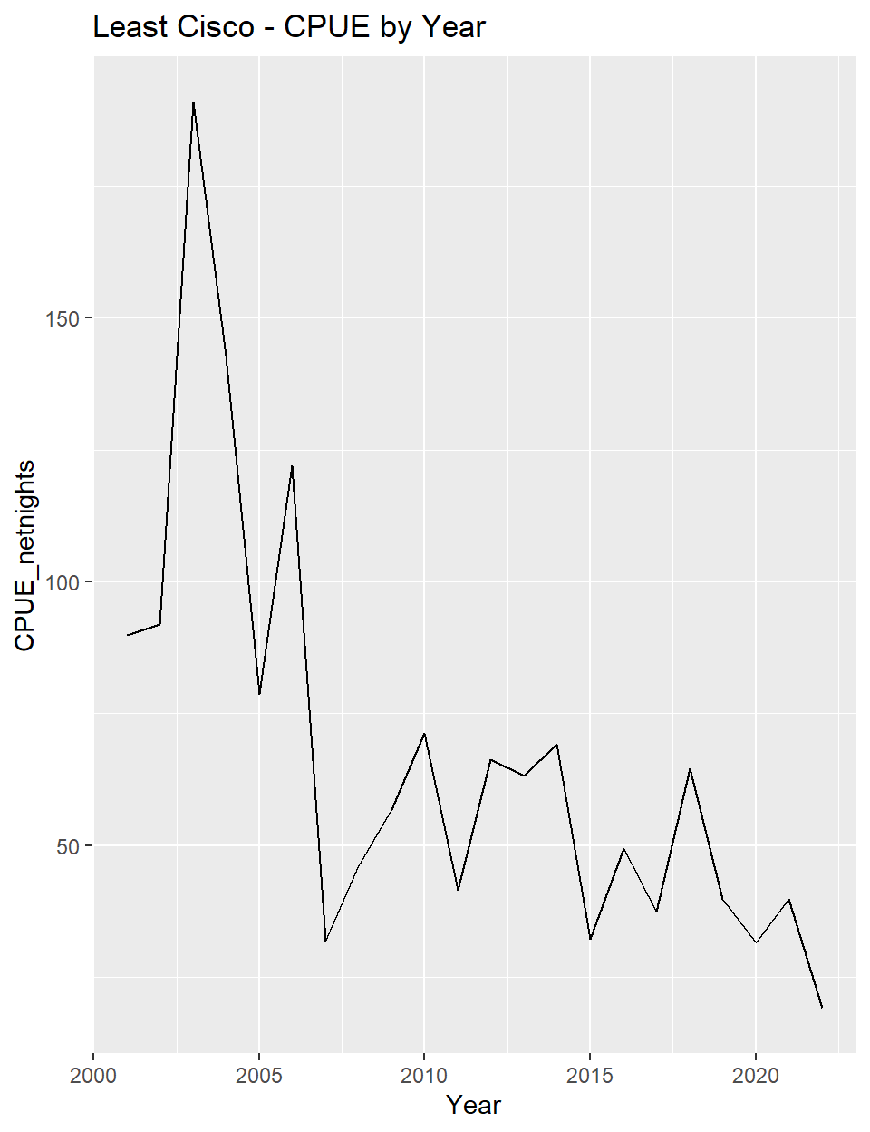

Three Year Comparison

| Group | Year | MeanLength_mm | TotalCatch | Netnights | CPUE_netnights |
| --- | --- | --- | --- | --- | --- |
| 1 | 2020 | 126.1 | 229 | 65.8 | 3.5 |
| 1 | 2021 | 140.0 | 2,202 | 191.7 | 11.5 |
| 1 | 2022 | 114.4 | 306 | 176.6 | 1.7 |
| 2 | 2020 | 275.6 | 1,850 | 65.8 | 28.1 |
| 2 | 2021 | 263.7 | 5,443 | 191.7 | 28.4 |
| 2 | 2022 | 295.7 | 3,067 | 176.6 | 17.4 |

## `summarise()` has grouped output by 'Station'. You can override using the  
## `.groups` argument.  
## Joining, by = "LengthGroup"  
## Joining, by = "LengthGroup"  
## `summarise()` has grouped output by 'Group'. You can override using the  
## `.groups` argument.  
## `summarise()` has grouped output by 'LG'. You can override using the `.groups`  
## argument.

Dolly Varden

2022 - All Sites and Length Groups combined

| TotalCatch | MeanLength | LengthRange |
| --- | --- | --- |
| 880 | 275.1 | 94-650 |

2022 - By Station & Length Group

| Station | LengthGroup | TotalCatch | CPUE_netnight |
| --- | --- | --- | --- |
| 214 | 1 | 294 | 5.9 |
| 214 | 2 | 184 | 3.7 |
| 218 | 1 | 179 | 4.5 |
| 218 | 2 | 24 | 0.6 |
| 220 | 1 | 96 | 2.5 |
| 220 | 2 | 15 | 0.4 |
| 230 | 1 | 74 | 1.5 |
| 230 | 2 | 14 | 0.3 |

2022 - By Station

| Station | TotalCatch | CPUE_netnight |
| --- | --- | --- |
| 214 | 478 | 9.6 |
| 218 | 203 | 5.1 |
| 220 | 111 | 2.9 |
| 230 | 88 | 1.8 |

2022 - By Length Group, All Sites Combined

| LengthGroup | TotalCatch | CPUE_netnight | MeanLength_mm | MinLength_mm | MaxLength_mm |
| --- | --- | --- | --- | --- | --- |
| 1 | 643 | 3.6 | 195.5 | 94 | 347 |
| 2 | 237 | 1.3 | 485.3 | 355 | 650 |

|  | CPUE_netnights | Catch | Catch Rank | CPUE Rank |
| --- | --- | --- | --- | --- |
| 2001 | 13.7 | 2,618 | 19 | 18 |
| 2002 | 8.9 | 1,478 | 11 | 11 |
| 2003 | 10.3 | 1,597 | 12 | 13 |
| 2004 | 9.7 | 1,867 | 13 | 12 |
| 2005 | 17.3 | 3,195 | 22 | 22 |
| 2006 | 12.1 | 2,378 | 17 | 16 |
| 2007 | 11.5 | 2,462 | 18 | 14 |
| 2008 | 14.9 | 2,742 | 21 | 20 |
| 2009 | 15.6 | 1,941 | 15 | 21 |
| 2010 | 7.9 | 1,233 | 9 | 9 |
| 2011 | 6.2 | 924 | 8 | 8 |
| 2012 | 2.7 | 415 | 3 | 3 |
| 2013 | 8.5 | 1,382 | 10 | 10 |
| 2014 | 14.6 | 2,678 | 20 | 19 |
| 2015 | 12.4 | 2,277 | 16 | 17 |
| 2016 | 3.8 | 636 | 4 | 6 |
| 2017 | 3.7 | 684 | 5 | 4 |
| 2018 | 11.8 | 1,895 | 14 | 15 |
| 2019 | 2.2 | 321 | 2 | 2 |
| 2020 | 0.6 | 40 | 1 | 1 |
| 2021 | 3.8 | 731 | 6 | 5 |
| 2022 | 5.0 | 880 | 7 | 7 |

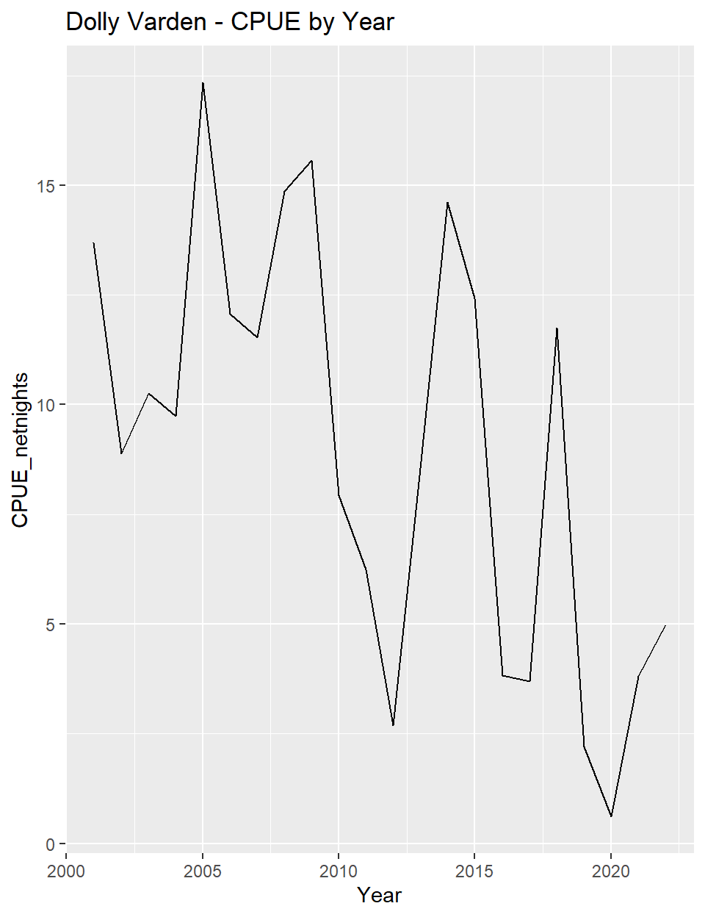

Three Year Comparison

| Group | Year | MeanLength_mm | TotalCatch | Netnights | CPUE_netnights |
| --- | --- | --- | --- | --- | --- |
| 1 | 2020 | 276.7 | 12 | 65.8 | 0.2 |
| 1 | 2021 | 213.0 | 444 | 191.7 | 2.3 |
| 1 | 2022 | 195.5 | 643 | 176.6 | 3.6 |
| 2 | 2020 | 459.5 | 28 | 65.8 | 0.4 |
| 2 | 2021 | 446.7 | 287 | 191.7 | 1.5 |
| 2 | 2022 | 485.3 | 237 | 176.6 | 1.3 |

## `summarise()` has grouped output by 'Station'. You can override using the  
## `.groups` argument.  
## Joining, by = "LengthGroup"  
## Joining, by = "LengthGroup"  
## `summarise()` has grouped output by 'Group'. You can override using the  
## `.groups` argument.  
## `summarise()` has grouped output by 'LG'. You can override using the `.groups`  
## argument.

Humpback Whitefish

2022 - All Sites and Length Groups combined

| TotalCatch | MeanLength | LengthRange |
| --- | --- | --- |
| 1,598 | 346.2 | 145-475 |

2022 - By Station & Length Group

| Station | LengthGroup | TotalCatch | CPUE_netnight |
| --- | --- | --- | --- |
| 214 | NA | 325 | 6.5 |
| 218 | NA | 916 | 23.1 |
| 220 | NA | 274 | 7.2 |
| 230 | NA | 83 | 1.7 |

2022 - By Station

| Station | TotalCatch | CPUE_netnight |
| --- | --- | --- |
| 214 | 325 | 6.5 |
| 218 | 916 | 23.1 |
| 220 | 274 | 7.2 |
| 230 | 83 | 1.7 |

2022 - By Length Group, All Sites Combined

| LengthGroup | TotalCatch | CPUE_netnight | MeanLength_mm | MinLength_mm | MaxLength_mm |
| --- | --- | --- | --- | --- | --- |
| NA | 1,598 | 9 | 346.2 | 145 | 475 |

|  | CPUE_netnights | Catch | Catch Rank | CPUE Rank |
| --- | --- | --- | --- | --- |
| 2001 | 7.1 | 1,357 | 9 | 6 |
| 2002 | 5.4 | 901 | 3 | 3 |
| 2003 | 22.0 | 3,428 | 22 | 22 |
| 2004 | 16.2 | 3,097 | 21 | 21 |
| 2005 | 15.9 | 2,924 | 20 | 20 |
| 2006 | 8.8 | 1,737 | 14 | 10 |
| 2007 | 12.2 | 2,612 | 18 | 18 |
| 2008 | 11.3 | 2,085 | 17 | 16 |
| 2009 | 4.1 | 514 | 2 | 1 |
| 2010 | 8.9 | 1,382 | 10 | 11 |
| 2011 | 7.0 | 1,032 | 4 | 5 |
| 2012 | 8.7 | 1,340 | 8 | 8 |
| 2013 | 12.0 | 1,937 | 16 | 17 |
| 2014 | 14.8 | 2,706 | 19 | 19 |
| 2015 | 6.2 | 1,129 | 5 | 4 |
| 2016 | 9.3 | 1,554 | 11 | 14 |
| 2017 | 8.9 | 1,651 | 13 | 12 |
| 2018 | 7.7 | 1,243 | 6 | 7 |
| 2019 | 8.7 | 1,272 | 7 | 9 |
| 2020 | 5.0 | 330 | 1 | 2 |
| 2021 | 9.5 | 1,813 | 15 | 15 |
| 2022 | 9.0 | 1,598 | 12 | 13 |

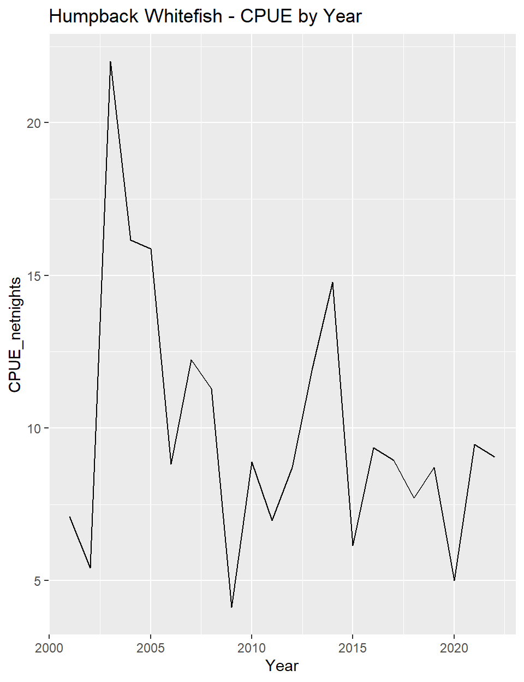

Three Year Comparison

| Group | Year | MeanLength_mm | TotalCatch | Netnights | CPUE_netnights |
| --- | --- | --- | --- | --- | --- |
| NA | 2020 | 299.8 | 330 | 65.8 | 5.0 |
| NA | 2021 | 307.7 | 1,813 | 191.7 | 9.5 |
| NA | 2022 | 346.2 | 1,598 | 176.6 | 9.0 |

## `summarise()` has grouped output by 'Station'. You can override using the  
## `.groups` argument.  
## Joining, by = "LengthGroup"  
## Joining, by = "LengthGroup"  
## `summarise()` has grouped output by 'Group'. You can override using the  
## `.groups` argument.  
## `summarise()` has grouped output by 'LG'. You can override using the `.groups`  
## argument.

Arctic Cod

2022 - All Sites and Length Groups combined

| TotalCatch | MeanLength | LengthRange |
| --- | --- | --- |
| 843 | 97.7 | 54-208 |

2022 - By Station & Length Group

| Station | LengthGroup | TotalCatch | CPUE_netnight |
| --- | --- | --- | --- |
| 214 | NA | 78 | 1.6 |
| 218 | NA | 494 | 12.4 |
| 220 | NA | 237 | 6.2 |
| 230 | NA | 34 | 0.7 |

2022 - By Station

| Station | TotalCatch | CPUE_netnight |
| --- | --- | --- |
| 214 | 78 | 1.6 |
| 218 | 494 | 12.4 |
| 220 | 237 | 6.2 |
| 230 | 34 | 0.7 |

2022 - By Length Group, All Sites Combined

| LengthGroup | TotalCatch | CPUE_netnight | MeanLength_mm | MinLength_mm | MaxLength_mm |
| --- | --- | --- | --- | --- | --- |
| NA | 843 | 4.8 | 97.7 | 54 | 208 |

|  | CPUE_netnights | Catch | Catch Rank | CPUE Rank |
| --- | --- | --- | --- | --- |
| 2001 | 84.9 | 16,242 | 19 | 18 |
| 2002 | 2,557.9 | 425,461 | 22 | 22 |
| 2003 | 246.4 | 38,361 | 20 | 20 |
| 2004 | 42.7 | 8,178 | 16 | 16 |
| 2005 | 86.4 | 15,905 | 18 | 19 |
| 2006 | 29.7 | 5,848 | 14 | 13 |
| 2007 | 9.2 | 1,973 | 10 | 10 |
| 2008 | 4.6 | 840 | 7 | 6 |
| 2009 | 7.1 | 890 | 9 | 9 |
| 2010 | 5.3 | 832 | 5 | 8 |
| 2011 | 2.9 | 429 | 3 | 2 |
| 2012 | 2.7 | 411 | 2 | 1 |
| 2013 | 34.6 | 5,588 | 13 | 14 |
| 2014 | 39.2 | 7,172 | 15 | 15 |
| 2015 | 26.1 | 4,777 | 12 | 12 |
| 2016 | 284.8 | 47,328 | 21 | 21 |
| 2017 | 10.9 | 2,008 | 11 | 11 |
| 2018 | 82.2 | 13,251 | 17 | 17 |
| 2019 | 3.5 | 510 | 4 | 3 |
| 2020 | 3.6 | 234 | 1 | 4 |
| 2021 | 4.3 | 833 | 6 | 5 |
| 2022 | 4.8 | 843 | 8 | 7 |

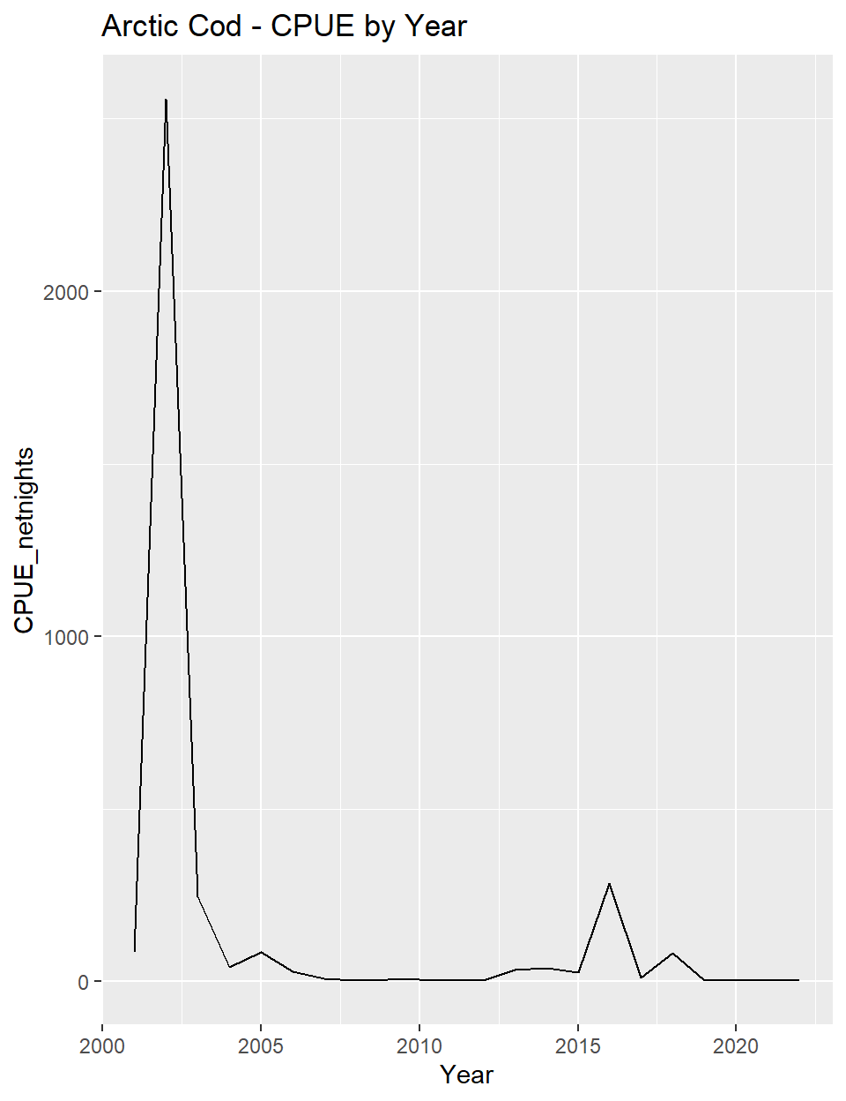

Three Year Comparison

| Group | Year | MeanLength_mm | TotalCatch | Netnights | CPUE_netnights |
| --- | --- | --- | --- | --- | --- |
| NA | 2020 | 116.1 | 234 | 65.8 | 3.6 |
| NA | 2021 | 96.6 | 833 | 191.7 | 4.3 |
| NA | 2022 | 97.7 | 843 | 176.6 | 4.8 |

## `summarise()` has grouped output by 'Station'. You can override using the  
## `.groups` argument.  
## Joining, by = "LengthGroup"  
## Joining, by = "LengthGroup"  
## `summarise()` has grouped output by 'Group'. You can override using the  
## `.groups` argument.  
## `summarise()` has grouped output by 'LG'. You can override using the `.groups`  
## argument.

Saffron Cod

2022 - All Sites and Length Groups combined

| TotalCatch | MeanLength | LengthRange |
| --- | --- | --- |
| 1,176 | 179.8 | 39-501 |

2022 - By Station & Length Group

| Station | LengthGroup | TotalCatch | CPUE_netnight |
| --- | --- | --- | --- |
| 214 | NA | 431 | 8.7 |
| 218 | NA | 512 | 12.9 |
| 220 | NA | 83 | 2.2 |
| 230 | NA | 150 | 3.1 |

2022 - By Station

| Station | TotalCatch | CPUE_netnight |
| --- | --- | --- |
| 214 | 431 | 8.7 |
| 218 | 512 | 12.9 |
| 220 | 83 | 2.2 |
| 230 | 150 | 3.1 |

2022 - By Length Group, All Sites Combined

| LengthGroup | TotalCatch | CPUE_netnight | MeanLength_mm | MinLength_mm | MaxLength_mm |
| --- | --- | --- | --- | --- | --- |
| NA | 1,176 | 6.7 | 179.8 | 39 | 501 |

|  | CPUE_netnights | Catch | Catch Rank | CPUE Rank |
| --- | --- | --- | --- | --- |
| 2001 | 9.1 | 1,733 | 11 | 10 |
| 2002 | 0.4 | 74 | 1 | 1 |
| 2003 | 1.6 | 250 | 3 | 3 |
| 2004 | 0.6 | 122 | 2 | 2 |
| 2005 | 2.5 | 452 | 4 | 4 |
| 2006 | 4.0 | 782 | 7 | 6 |
| 2007 | 2.7 | 575 | 5 | 5 |
| 2008 | 22.7 | 4,193 | 16 | 16 |
| 2009 | 52.7 | 6,568 | 19 | 19 |
| 2010 | 15.0 | 2,341 | 14 | 14 |
| 2011 | 12.6 | 1,863 | 13 | 13 |
| 2012 | 37.2 | 5,717 | 17 | 18 |
| 2013 | 77.4 | 12,519 | 20 | 21 |
| 2014 | 34.8 | 6,381 | 18 | 17 |
| 2015 | 4.6 | 838 | 8 | 7 |
| 2016 | 10.2 | 1,691 | 10 | 12 |
| 2017 | 9.9 | 1,822 | 12 | 11 |
| 2018 | 17.6 | 2,831 | 15 | 15 |
| 2019 | 5.2 | 752 | 6 | 8 |
| 2020 | 532.7 | 35,047 | 22 | 22 |
| 2021 | 71.5 | 13,709 | 21 | 20 |
| 2022 | 6.7 | 1,176 | 9 | 9 |

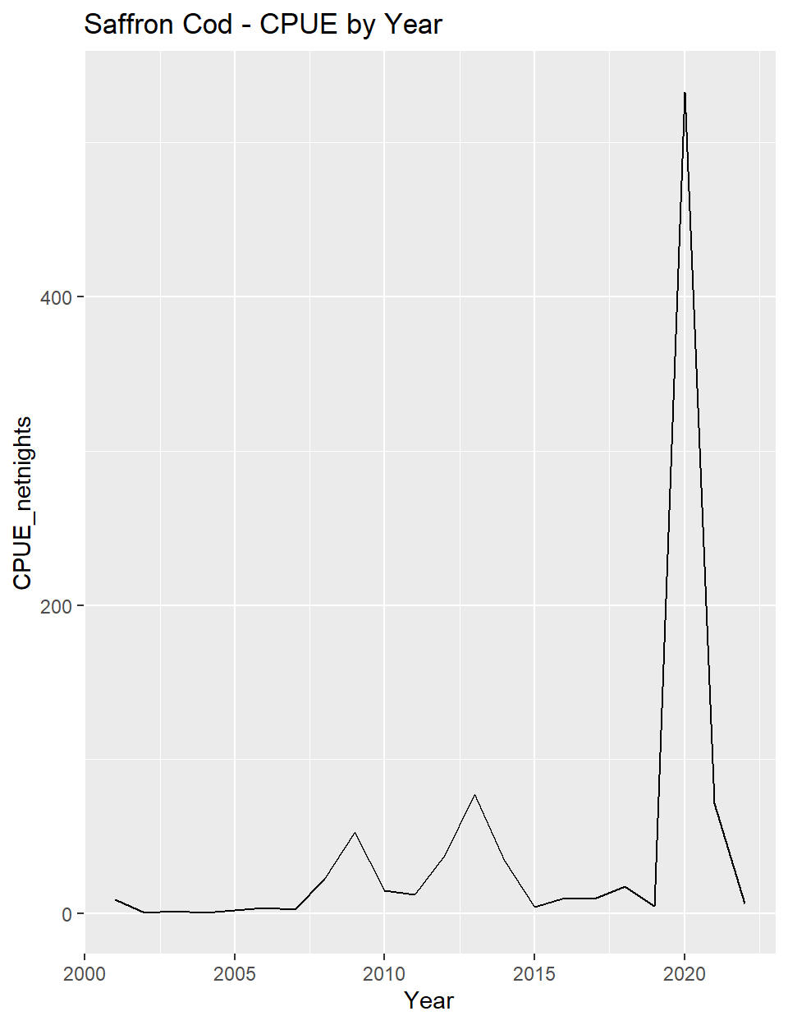

Three Year Comparison

| Group | Year | MeanLength_mm | TotalCatch | Netnights | CPUE_netnights |
| --- | --- | --- | --- | --- | --- |
| NA | 2020 | 115.9 | 35,047 | 65.8 | 532.7 |
| NA | 2021 | 172.2 | 13,709 | 191.7 | 71.5 |
| NA | 2022 | 179.8 | 1,176 | 176.6 | 6.7 |

## `summarise()` has grouped output by 'Station'. You can override using the  
## `.groups` argument.  
## Joining, by = "LengthGroup"  
## Joining, by = "LengthGroup"  
## `summarise()` has grouped output by 'Group'. You can override using the  
## `.groups` argument.  
## `summarise()` has grouped output by 'LG'. You can override using the `.groups`  
## argument.

Rainbow Smelt

2022 - All Sites and Length Groups combined

| TotalCatch | MeanLength | LengthRange |
| --- | --- | --- |
| 8,609 | 100.4 | 33-265 |

2022 - By Station & Length Group

| Station | LengthGroup | TotalCatch | CPUE_netnight |
| --- | --- | --- | --- |
| 214 | 1 | 1,611 | 32.4 |
| 214 | 2 | 340 | 6.8 |
| 214 | 3 | 39 | 0.8 |
| 214 | NA | 1,078 | 21.7 |
| 218 | 1 | 1,104 | 27.8 |
| 218 | 2 | 256 | 6.4 |
| 218 | 3 | 7 | 0.2 |
| 220 | 1 | 77 | 2.0 |
| 220 | 2 | 27 | 0.7 |
| 230 | 1 | 1,057 | 21.6 |
| 230 | 2 | 138 | 2.8 |
| 230 | 3 | 11 | 0.2 |
| 230 | NA | 2,864 | 58.6 |

2022 - By Station

| Station | TotalCatch | CPUE_netnight |
| --- | --- | --- |
| 214 | 3,068 | 61.7 |
| 218 | 1,367 | 34.4 |
| 220 | 104 | 2.7 |
| 230 | 4,070 | 83.2 |

2022 - By Length Group, All Sites Combined

| LengthGroup | TotalCatch | CPUE_netnight | MeanLength_mm | MinLength_mm | MaxLength_mm |
| --- | --- | --- | --- | --- | --- |
| 1 | 3,849 | 21.8 | 86.5 | 33 | 99 |
| 2 | 761 | 4.3 | 124.2 | 100 | 199 |
| 3 | 57 | 0.3 | 216.2 | 200 | 265 |
| NA | 3,942 | 22.3 | NA | NA | NA |

|  | CPUE_netnights | Catch | Catch Rank | CPUE Rank |
| --- | --- | --- | --- | --- |
| 2001 | 59.2 | 11,327 | 22 | 21 |
| 2002 | 32.4 | 5,389 | 17 | 17 |
| 2003 | 31.3 | 4,870 | 14 | 16 |
| 2004 | 16.7 | 3,203 | 8 | 7 |
| 2005 | 12.1 | 2,225 | 4 | 4 |
| 2006 | 14.1 | 2,773 | 6 | 5 |
| 2007 | 9.2 | 1,956 | 3 | 2 |
| 2008 | 21.6 | 3,978 | 10 | 8 |
| 2009 | 25.7 | 3,203 | 8 | 12 |
| 2010 | 16.0 | 2,489 | 5 | 6 |
| 2011 | 7.1 | 1,048 | 2 | 1 |
| 2012 | 37.9 | 5,825 | 19 | 19 |
| 2013 | 61.2 | 9,891 | 21 | 22 |
| 2014 | 27.7 | 5,076 | 15 | 14 |
| 2015 | 22.0 | 4,025 | 11 | 9 |
| 2016 | 22.2 | 3,694 | 9 | 10 |
| 2017 | 25.3 | 4,669 | 13 | 11 |
| 2018 | 35.7 | 5,755 | 18 | 18 |
| 2019 | 30.1 | 4,399 | 12 | 15 |
| 2020 | 11.7 | 767 | 1 | 3 |
| 2021 | 27.5 | 5,267 | 16 | 13 |
| 2022 | 48.8 | 8,609 | 20 | 20 |

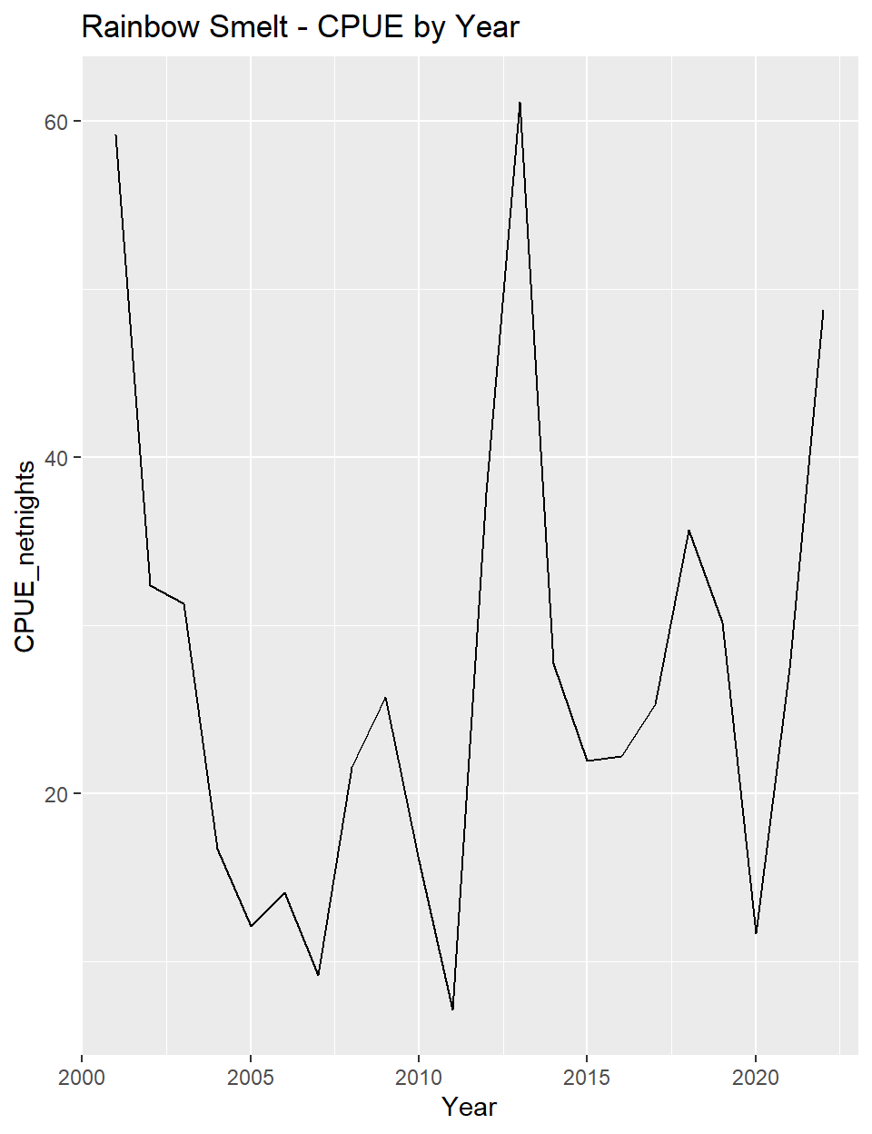

Three Year Comparison

| Group | Year | MeanLength_mm | TotalCatch | Netnights | CPUE_netnights |
| --- | --- | --- | --- | --- | --- |
| 1 | 2022 | 86.5 | 3,849 | 176.6 | 21.8 |
| 2 | 2022 | 124.2 | 761 | 176.6 | 4.3 |
| 3 | 2022 | 216.2 | 57 | 176.6 | 0.3 |

Arctic Flounder

2022 - By Station

| Station | TotalCatch | CPUE_netnight |
| --- | --- | --- |
| 214 | 3,423 | 68.9 |
| 218 | 990 | 24.9 |
| 220 | 221 | 5.8 |
| 230 | 566 | 11.6 |

2022 - All Sites Combined

| TotalCatch | CPUE_netnight |
| --- | --- |
| 5,200 | 29.4 |

|  | CPUE_netnights | Catch | Catch Rank | CPUE Rank |
| --- | --- | --- | --- | --- |
| 2001 | 66.5 | 12,713 | 19 | 16 |
| 2002 | 42.6 | 7,094 | 5 | 6 |
| 2003 | 69.8 | 10,868 | 15 | 18 |
| 2004 | 62.5 | 11,976 | 18 | 14 |
| 2005 | 37.5 | 6,911 | 3 | 3 |
| 2006 | 35.2 | 6,930 | 4 | 2 |
| 2007 | 38.9 | 8,304 | 8 | 4 |
| 2008 | 54.2 | 9,997 | 13 | 11 |
| 2009 | 67.8 | 8,450 | 9 | 17 |
| 2010 | 62.3 | 9,687 | 12 | 13 |
| 2011 | 50.7 | 7,501 | 6 | 9 |
| 2012 | 74.7 | 11,484 | 17 | 19 |
| 2013 | 107.0 | 17,298 | 22 | 22 |
| 2014 | 47.9 | 8,770 | 10 | 7 |
| 2015 | 48.2 | 8,842 | 11 | 8 |
| 2016 | 78.6 | 13,058 | 20 | 20 |
| 2017 | 89.3 | 16,486 | 21 | 21 |
| 2018 | 65.4 | 10,549 | 14 | 15 |
| 2019 | 52.4 | 7,640 | 7 | 10 |
| 2020 | 40.9 | 2,688 | 1 | 5 |
| 2021 | 59.3 | 11,371 | 16 | 12 |
| 2022 | 29.4 | 5,200 | 2 | 1 |

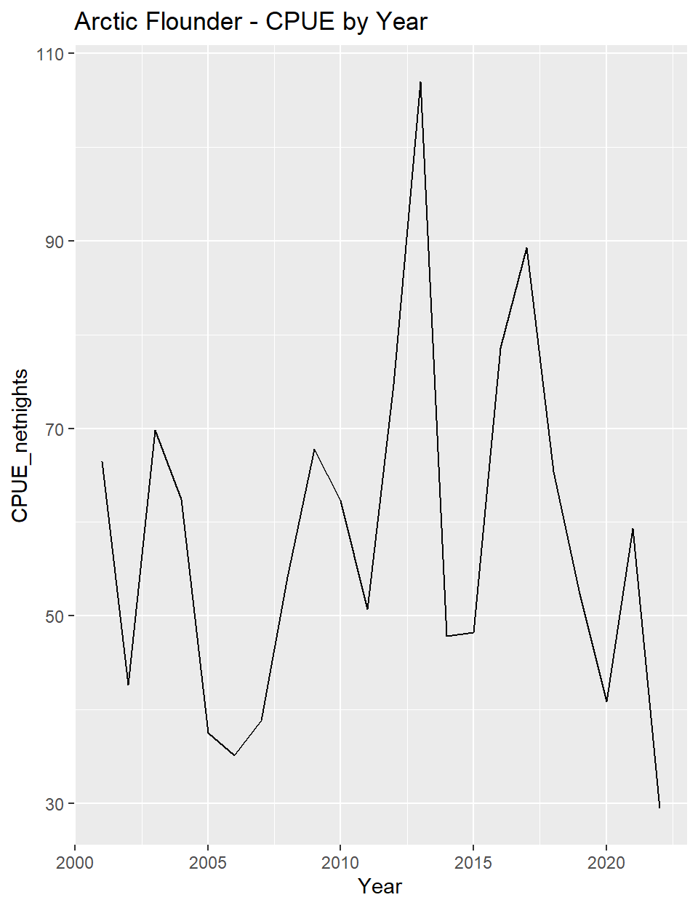

Fourhorn Sculpin

2022 - By Station

| Station | TotalCatch | CPUE_netnight |
| --- | --- | --- |
| 214 | 2,495 | 50.2 |
| 218 | 945 | 23.8 |
| 220 | 213 | 5.6 |
| 230 | 763 | 15.6 |

2022 - All Sites Combined

| TotalCatch | CPUE_netnight |
| --- | --- |
| 4,416 | 25 |

|  | CPUE_netnights | Catch | Catch Rank | CPUE Rank |
| --- | --- | --- | --- | --- |
| 2001 | 32.8 | 6,277 | 10 | 8 |
| 2002 | 26.5 | 4,403 | 3 | 6 |
| 2003 | 74.2 | 11,553 | 21 | 21 |
| 2004 | 66.4 | 12,731 | 22 | 20 |
| 2005 | 34.0 | 6,263 | 9 | 9 |
| 2006 | 31.7 | 6,238 | 8 | 7 |
| 2007 | 49.4 | 10,539 | 19 | 16 |
| 2008 | 58.4 | 10,784 | 20 | 18 |
| 2009 | 80.2 | 9,994 | 18 | 22 |
| 2010 | 59.0 | 9,182 | 17 | 19 |
| 2011 | 48.8 | 7,212 | 14 | 15 |
| 2012 | 42.6 | 6,548 | 12 | 13 |
| 2013 | 50.9 | 8,237 | 15 | 17 |
| 2014 | 34.8 | 6,379 | 11 | 10 |
| 2015 | 24.8 | 4,547 | 5 | 2 |
| 2016 | 39.6 | 6,582 | 13 | 12 |
| 2017 | 45.8 | 8,464 | 16 | 14 |
| 2018 | 35.6 | 5,741 | 7 | 11 |
| 2019 | 25.0 | 3,643 | 2 | 3 |
| 2020 | 16.1 | 1,060 | 1 | 1 |
| 2021 | 25.6 | 4,917 | 6 | 5 |
| 2022 | 25.0 | 4,416 | 4 | 4 |

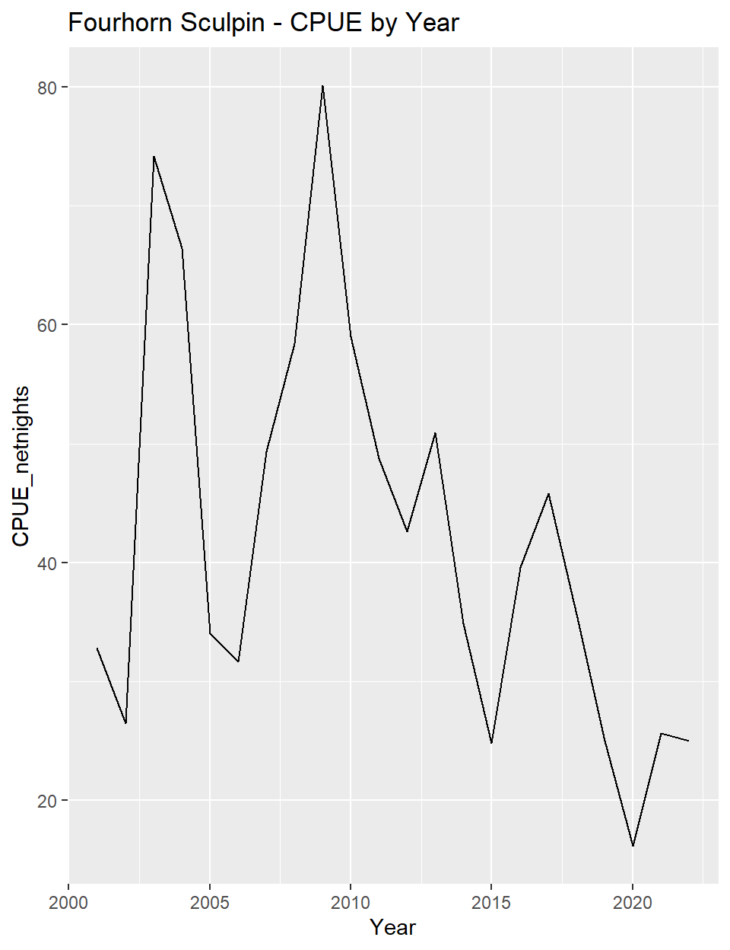

Pink Salmon

2022 - By Station

| Station | TotalCatch | CPUE_netnight |
| --- | --- | --- |
| 218 | 1 | 0 |
| 220 | 1 | 0 |
| 230 | 1 | 0 |

2022 - All Sites Combined

| TotalCatch | CPUE_netnight |
| --- | --- |
| 3 | 0 |

|  | CPUE_netnights | Catch | Catch Rank | CPUE Rank |
| --- | --- | --- | --- | --- |
| 2001 | 0.0 | 0 | 1 | 1 |
| 2002 | 0.0 | 8 | 10 | 10 |
| 2003 | 0.2 | 29 | 17 | 19 |
| 2004 | 0.2 | 29 | 17 | 16 |
| 2005 | 0.2 | 29 | 17 | 17 |
| 2006 | 0.0 | 7 | 9 | 8 |
| 2007 | 0.0 | 3 | 6 | 4 |
| 2008 | 1.5 | 284 | 21 | 21 |
| 2009 | 0.0 | 6 | 8 | 11 |
| 2010 | 0.1 | 18 | 12 | 12 |
| 2011 | 0.0 | 3 | 6 | 7 |
| 2012 | 0.0 | 1 | 2 | 3 |
| 2013 | 0.0 | 1 | 2 | 2 |
| 2014 | 0.0 | 8 | 10 | 9 |
| 2015 | 0.1 | 26 | 15 | 14 |
| 2016 | 0.2 | 25 | 14 | 15 |
| 2017 | 0.2 | 31 | 19 | 18 |
| 2018 | 0.1 | 22 | 13 | 13 |
| 2019 | 2.9 | 417 | 22 | 22 |
| 2020 | 1.5 | 98 | 20 | 20 |
| 2021 | 0.0 | 3 | 6 | 5 |
| 2022 | 0.0 | 3 | 6 | 6 |

