**CALCULATIONS OF SOLAR ENERGY OUTPUT**

**How much energy can a photovoltaic module produce?**

Electrical energy is generally measured in kilowatt-hours (kWh). Thus, if a module produces 100 Watts for 1 hours, it has produced 100 Watt-hours or 0.1 kWh. The amount of energy produced on a given day will depend on location, shading, and module orientation (direction and tilt).

In a good area for solar power (such as **Phoenix, Arizona), a properly oriented module which produces 100 Watts at noon on a clear day will produce an average of about 0.5 kWh/day in January and 0.8 kWh/day in May and June**. (Fluctuations result from the amount of variation in direct sunlight on a typical day).

In a relatively "poor" area for solar power (such as Albany, NY), the same module will still produce about 0.25 kWh/day in January and 0.6 kWh/day in July.

**HOW TO CALCULATE THE ANNUAL SOLAR ENERGY OUTPUT OF A PHOTOVOLTAIC SYSTEM**

The global formula to estimate the electricity generated in output of a photovoltaic system is :  
 **E = A \* r \* H \* PR**

**E** =Energy(kWh)   
**A** =TotalsolarpanelArea(m²)   
**r** =solarpanelyield(%)   
**H** = Annual average solar radiation on tilted panels (shadings not included)   
**PR** = Performance ratio, coefficient for losses (range between 0.5 and 0.9, default value = 0.75)

**r** is the yield of the solar panel given by the ratio : electrical power (in kWp) of one solar panel divided by the area of one panel  
Example : the solar panel yield of a PV module of 250 Wp with an area of 1.6 m² is 15.6%   
Be aware that this nominal ratio is given for standard test conditions (STC) : radiation=1000 W/m², cell temperature=25 °C, Wind speed=1 m/s, AM=1.5 The unit of the nominal power of the photovoltaic panel in these conditions is called "Watt-peak" (Wp or kWp=1000 Wp or MWp=1000000 Wp).   
  
**H** You can find this global radiation value here : solar radiation data   
You have to find the global annual irradiation incident on your PV panels with your specific inclination (slope, tilt) and orientation (azimut).   
  
**PR** : PR (Performance Ratio) is a very important value to evaluate the quality of a photovoltaic installation because it gives the performance of the installation independently of the orientation, inclination of the panel. It includes all losses.  
  
**Example of losses details that gives the PR value (depend on the site, the technology, and sizing of the system) :**  
- Inverter losses (4% to 15 %)   
- Température losses (5% to 18%)   
- DC cables losses (1 to 3 %)   
- AC cables losses (1 to 3 %)   
- Shadings 0 % to 80% !!! (specific to each site)   
- Losses weak radiation 3% to 7%   
- Losses due to dust, snow... (2%)   
- Other Losses (?)

**The amount of sun your solar cells are exposed to (and hence how much energy they will generate) depends upon:**

* The [orientation and tilt](http://www.solarchoice.net.au/blog/solar-panel-tilt-and-orientation-in-australia.html) of your installation (which will be optimised by your installer)
* Whether there are shadows cast over your cells (due to trees, buildings etc)
* The number of daylight hours (governed by where you live)
* The intensity of the sunlight (governed by where you live)
* The number of hours of full sun vs cloudy days (governed by where you live)

**How much power do you need?**

Electrical power is measured in **Watts** and Energy consumption is measured in **kiloWatt hours (kWh).** A kiloWatt hour is simply:

The amount of electricity used (1000 Watts = 1 kiloWatts), in kiloWatts

*multiplied by*

The number of hours the energy is used.

Usually the calculation states the time period such as one day, one month or one year.

**For example:** if a 100 W light bulb is on for 10 hours a day then:

*100/1000 (kilowatt) x 10 (hours) = 1 kWh per day.*

In one month, that same 100 W light bulb, turned on for 10 hours a day will consume:

*100/1000 (kiloWatt) x 10 (hours) x 30 days = 30 kWh hours per month.*

Your electrical bill will usually show how many kWh all of your electrical devices used over the last billing period (usually around 30 days).

**Determine Your Energy Requirements**

Before converting to solar power, look at your electricity bills from the last year, and determine your energy usage. Some of us will use more energy in the summer when the air-conditioner is running. Others, who live in colder climates, will use more electricity in the winter, when the nights are cold and long. Make a good estimate at how much power you’ll need per day. If this is for a new installation, such as a cottage, then here are some average numbers to get you started\*\*:

* 16 W bulb (on 10 hours) – 4.8 kWh/month (57.6 kWh/year)
* 100 W bulb (on 10 hours) – 30 kWh/month (360 kWh/year)
* Refrigerator – 36.7 kWh/month (440 kWh/year)
* Dishwasher – 41 kWh/month (492 kWh/year)
* Clothes Washer – 24.9 kWh/month (299 kWh/year)
* Electric Clothes Dryer – 74.7 kWh/month (896 kWh/year)
* Stove & Oven (self-cleaning) – 61.25 kWh/month (735 kWh/year)

**Determine Your Energy Requirements**

Before converting to solar power, look at your electricity bills from the last year, and determine your energy usage. Some of us will use more energy in the summer when the air-conditioner is running. Others, who live in colder climates, will use more electricity in the winter, when the nights are cold and long. Make a good estimate at how much power you’ll need per day. If this is for a new installation, such as a cottage, then here are some average numbers to get you started\*\*:

* 16 W bulb (on 10 hours) – 4.8 kWh/month (57.6 kWh/year)
* 100 W bulb (on 10 hours) – 30 kWh/month (360 kWh/year)
* Refrigerator – 36.7 kWh/month (440 kWh/year)
* Dishwasher – 41 kWh/month (492 kWh/year)
* Clothes Washer – 24.9 kWh/month (299 kWh/year)
* Electric Clothes Dryer – 74.7 kWh/month (896 kWh/year)
* Stove & Oven (self-cleaning) – 61.25 kWh/month (735 kWh/year)

### Power and its units

Power is always represented in watt (W) or kilowatt (kW). A thousand (1000) watts make one kilowatt. So if any appliance is rated as 1.2 kW then it means that it consumes electricity at a rate of 1200 W. Now as we discussed earlier that power is the rate at which electricity is consumed and not the actual electricity consumed, Watt or Kilowatt just represent the rate at which electricity is consumed per hour. Which means that when you buy a 100 W bulb, it does not consume 100 units of electricity but consumes at a rate of 100 W.

### Energy/Electricity and its units

A unit (as mentioned on the electricity bills) is represented in kWH or Kilowatt Hour. This is the actual electricity or energy used. If you use 1000 Watts or 1 Kilowatt of power for 1 hour then you consume 1 unit or 1 Kilowatt-Hour (kWH) of electricity. So the reading on the electricity meter represents the actual electricity used. Just like the odometer on your vehicle that shows the actual distance travelled by the vehicle, electricity meter shows the amount of electricity that is used. So a 100-Watt bulb if kept on for 10 hours will consume:

100 x 10 = 1000 Watt-Hour = 1 Kilowatt-Hour (kWH) = 1 units (on your meter).

https://www.bijlibachao.com/electricity-bill/what-are-watt-kilowatt-and-a-unit-of-electricity.html

**http://completesolar.com/10-things-to-consider**

**FACTORS CONSIDERED TO UNDERSTAND ROI OF SOLAR INSTALLATION**

**Return on Investment (Residential)**

Guarantee yourself a low, fixed, electrical rate for the next 30 years and relax as the cost of electricity continues to rise.

* The cost of installing a solar electric system has dropped almost 50% since 2008
* Reduce or eliminate your bill entirely, with an investment return of 10-25%
* Avoid electricity rate increases
* Increase your home value without increasing your property taxes

We all know electrical rates from the utilities will be sharply increasing.

Here’s how it works. The net cost of your solar system will be determined by 3 variables:

* Solar system size (kilowatts)
* Government rebates
* Feed-In Tariff

**RETURN ON INVESTMENT**

Although Photovoltaics upfront cost may be higher than other energy technologies, the ***long-term costs are lower and the impact on the environment is almost zero.***

There are a number of different factors that **affect the ROI for any given PV project-**

**The major factors to consider are:**

* Available Sunlight (kWh/m2)
* Cost of electricity from the utility provider including inflation
* Hardware and installation costs (**Cost of solar panels)**
* Local and National Gov’t incentives
* Financing

**10 Pitfalls to Consider Before Installing Solar Panels**

There are many benefits to installing solar panels on your home, everything from lowering your energy bills to reducing your carbon footprint. Here are 10 things to consider before making an investment in solar.

1.   What is the cost of installation?

2.   When will you start saving?

3.   How much solar power can you expect to receive?

4.   What type of panels should you use?

5.   Is there any financial assistance available? Are you taking advantage of all the federal, state and local rebates and incentives available?

6.   Who will do the installation and are they reliable?

7.   How long does it take after you sign the contract until your panels are producing electricity?

8.   How much sun does your house get throughout the year?

9.   What kind of roof do you have, and does the company you are considering have expertise in those roof types?

10.   What kind of building permits do you require?

# The Effect of Shade on Solar Panels

Just a little shade can affect a [solar panel ‘s](http://www.wholesalesolar.com/solar-panels.html) power output dramatically. Diffuse shade from a “soft” source, like a distant tree branch or cloud can significantly reduce the amount of light reaching a solar panel’s cells. “Hard” sources stop light from reaching solar cells, such as debri or bird dropping sitting on top of the panel. If even one full cell is hard shaded, the voltage of a solar panel drops to half in order to protect itself. If enough cells are hard shaded, the module will not convert any energy and will, in fact, become a significant drain of energy on the entire system over time.

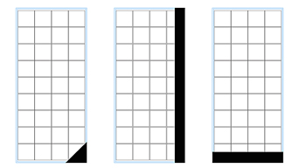

Partial cell shading that reduce solar panel power by half.

Partial shading of even one [cell](http://www.wholesalesolar.com/Information-SolarFolder/celltypes.html)on a 36-cell solar panel will reduce its power output. Because all cells are connected in a series string, the weakest cell will bring the others down to its reduced power level. Therefore, whether half of one cell is shaded, or half a row of cells is shaded, the power decrease will be the same and proportional to the percentage of area shaded, in this case 50 percent.

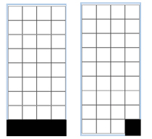When a full cell is shaded, it can use energy produced by the remainder of the cells, and trigger the solar panel to protect itself. The solar panel will route the power around that series string. If even one full cell in a series string is shaded, as seen on the right, it will most likely cause the module to reduce its power level to half of its full available value. If a row of cells at the bottom of a solar panel is fully shaded, the power output may drop to zero. The best way to avoid a drop in output power is to avoid shading whenever possible.

A solar panel affects an array in much the same way a single cell affects a solar panel. In a centralized inverter system, where panels are strung in series, if only one of the solar panels is shaded in an array, the rest of the solar panels’ output diminishes.

When choosing a [grid tie solar power system](http://www.wholesalesolar.com/gridtie.html) for their home or business, folks often prefer the tried and true technology of a centralized inverter systems. And the price tag on these is pretty good. When you consider the effects of shading, however, it’s easy to understand how microinverter and SolarEdge systems have become so popular.

While using different technologies, both [SolarEdge](http://www.wholesalesolar.com/gridtie.html#SolarEdgeGridtieTrina) and [Microinverter](http://www.wholesalesolar.com/enphase-solar-power-system.html)systems allow each solar panel in an array to maximize power output independently, thereby maximizing a system’s power generation. If one solar panel is shaded in either of these systems, the rest of the array’s panels can still operate at full capacity. (SolarEdge provides DC to DC power optimization for each solar panel, while microinverters provide DC to AC optimization at the module level.) Both of these systems allow solar panels to be facing different orientations giving you more design flexibility if part of your installation site is in the shade. A centralized inverter system requires panels to facing the same direction.

Read more about [SolarEdge](http://www.wholesalesolar.com/solaredge.html), [Enphase Microinverter](http://www.wholesalesolar.com/enphase-solar-power-system.html" \o "Enphase Microinverter Solar Power Systems" \t "_blank) and [Centralized Inverter Systems](http://www.wholesalesolar.com/gridtie.html" \t "_blank).

**Shading Analysis in Photovoltaics**

**SHADING ANALYSIS**

Shading analysis is one of the most essential steps in phase of solar energy system design or analysis. In photovoltaics it is important to analyse shading caused by surrounding objects and/or vegetation. In special cases like analysis or design of BIPV systems, exact analysis of "shadow-voltaic" systems (overhangs, vertical shading fins, awnings etc.) is also very important. Similar analysis is also part of passive house or solar house design - overhangs must also be planned very carefully in such case. Basic calculations can be done by some simple equations - formulas for some typical simple cases you may find below. Some graphical tools like solar path calculator (pilkington) are also available. For analysis of complex objects several computer tools are available. Some of them offer even 3D simulation. Shading is especially important in photovoltaics. It should be eliminated as much as possible. Even small obstacles like chimneys, telephone poles etc. shouldn't be neglected. To minimise influence of photovoltaic array shading (if shading can not be avoided) different system optimisation techniques can be used. Detailed explanation of such cases you may find on this page below.

**SHADING CALCULATIONS**

Shading devices, general

For different simple cases it is in general not difficult to calculate shadows for particular day and time. Below you will find some formulae's end equations which may help you to calculate shadows for most common particular cases in engineering practice.

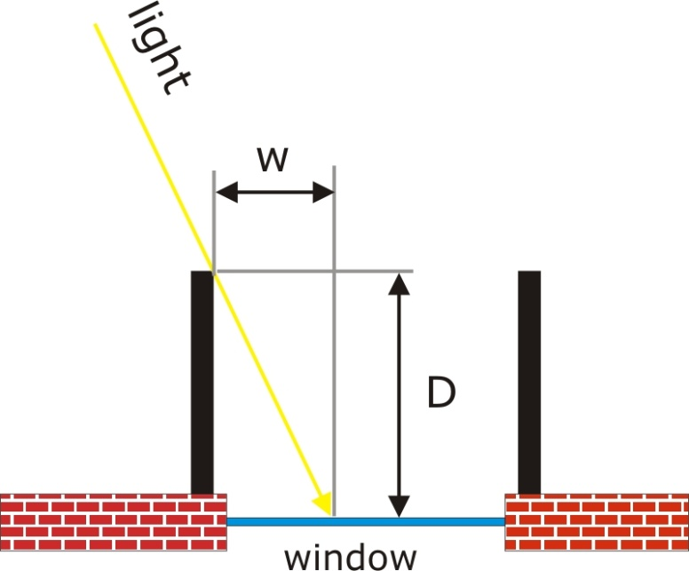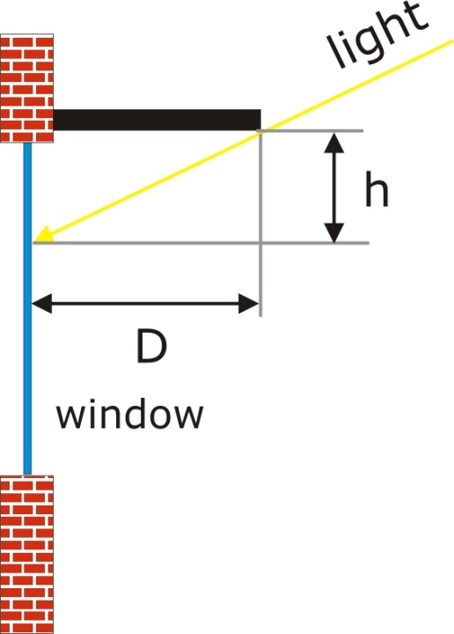

Horizontal shading device, overhang, side view (left)  
vertical shading device, vertical fin, top view (right)

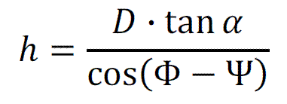

h, D - geometry of horizontal shading device (overhang dimension, see picture above)  
α - sun height, Φ - solar azimuth, Ψ - plane azimuth

http://www.pvresources.com/portals/0/Images/SiteAnalysis/Shading/shading_equ2.gif

w, D - geometry of vertical shading device (vertical fin, see picture above)  
Φ - solar azimuth, Ψ - plane azimuth

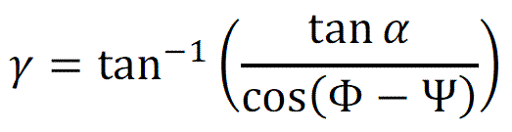

γ = vertical shadow angle (VSA)  
w, D - geometry of vertical shading device (see picture above)  
Φ - solar azimuth, Ψ - plane azimuth

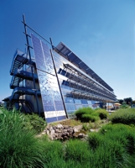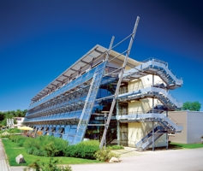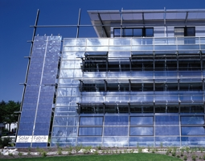

Solar-Fabrik, modules used as shading devices and as part of a facade  
(courtesy: [Solar-Fabrik AG](http://www.solar-fabrik.de/), Freiburg)