

**Lab Report 6**

**Submitted by: Submitted to:**

Pratyush Nepal Birodh Rijal

0519 (Artificial Intelligence Lecturer)

2019 ‘A’

Find the Jaccard similarity of each of the above documents to all other documents.

**Answer:**

The Jaccard similarity is defined as,

$JS\left(A,B\right)= \frac{A ∩B}{A∪B}$

Where, A and B are two documents, $A ∩B$ denote the total number of unique words on both of them and $A∪B$ denotes the number of common words both the documents have.

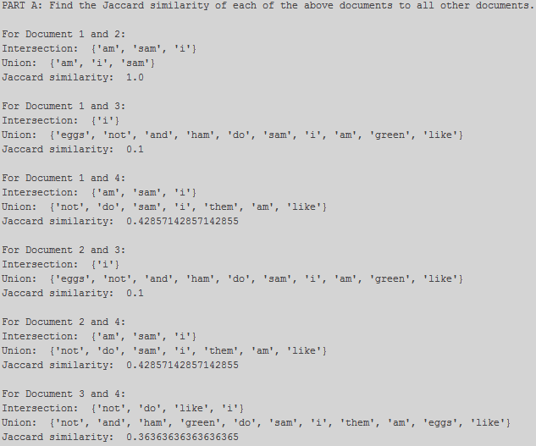

Calculate the Cosine similarity of the above documents.

**Answer:**

Cosine similarity is calculated as,

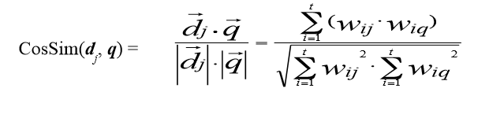

Where $\vec{d_{j}}$ is a document vector which is calculated by the weights of all the words in both the documents with respect to document j. It is computed as

*wij = tfij idfi = tfij* log2 (*N/ dfi*)

where,

*tfij =fij / maxi*{*fij*}

*fij* is the frequency of ith word in jth document.

*df i* = document frequency of term *i*

