GOVERNMENT POLYTECHNIC COLLEGE
NEDUMANGADU

INTEGRATED COLLEGE PLACEMENT CELL PORTAL

A PROJECT REPORT
Submitted by

Name 1 | 1234567890
Name 2 | 1234567890
Name 3 | 1234567890
Name 4 | 1234567890
Name 5 | 1234567890

to
The State Board of Technical Education (SBTE) in partial fulfilment of the requirements
for the award of

Diploma in Computer Hardware Engineering


Department of Computer Hardware Engineering

2022 – 2025

GOVERNMENT POLYTECHNIC COLLEGE
NEDUMANGADU
DEPARTMENT OF COMPUTER HARDWAREENGINEERING



CERTIFICATE

This is to certify that the project report entitled “INTEGRATED COLLEGE PLACEMENT CELL PORTAL” is a bonafied recored of the Major Project done by SEFIN R R (2201150650), JAYASOORYA J S (2201150636),
NANDHANA A (2201150642), ANANDHU A (2201150625), SARAN C (2201150649), ABHINAND S A (2201150629) under our guidance in partial fulfilment for the award of Diploma in Computer Hardware Engineering from the State Board of Technical Education Kerala during the academic year 2022 – 2025.

Smt. Sheena C Sri. Ratheesh Kumar R
Project Coordinator & Project Guide
Head of Department. Lecturer in Computer
Hardware Engineering Hardware Engineering

Internal Examiner External Examiner

ACKNOWLEDGEMENT

I would also like to extend my heartfelt thanks to the faculty and staff of the Department of Computer Hardware Engineering at Government Polytechnic College, Nedumangad. I am particularly grateful to our College Principal, Mrs. Leena Mary John, whose visionary leadership and commitment to academic excellence have greatly inspired me. Additionally, my sincere appreciation goes to our Head of Department, Mrs. Sheena C, for her unwavering support and guidance throughout this endeavor.

I am deeply grateful to all those who have supported and guided me throughout the development of this project, "Integrated College Placement Cell Portal." First and foremost, I would like to express my sincere gratitude to my project guide, Mr. Ratheesh Kumar R, whose expertise, encouragement, and insightful suggestions have been invaluable in steering this work in the right direction. His constant support not only enriched my learning experience but also played a pivotal role in the successful completion of this project.

Special thanks are due to my colleagues and friends, whose constructive feedback and collaborative spirit helped refine various aspects of this project. Their readine ss to share ideas and assist during challenging phases has been deeply appreciated.

Finally, I am profoundly grateful to my family for their unwavering support and encouragement. Their belief in my abilities and constant motivation have been the driving force behind my academic and personal achievements.

This project stands as a testament to the collective efforts and guidance of everyone mentioned above, and I am truly thankful for all the contributions that made it possible.

SEFIN R R
JAYA SOORYA J S
SARAN C
NANDHANA A
ANANDHU A
ABHINAND S A

ABSTRACT

Colleges and universities conduct a wide range of academic and co-curricular events
such as seminars, workshops, quizzes, and cultural programs. However, many institutions still depend on manual or partially digital methods to manage these activities. Tasks like event registration, quiz conduction, result calculation, and certificate distribution are often handled using paper forms or spreadsheets, which makes the process slow, error-prone, and difficult to manage as participation grows. Communication delays, record mismatches, and lack of proper engagement with alumni and external participants are common challenges.
Most existing systems focus only on individual features such as student information management, event registration, or certificate verification. Because of this, institutions are forced to use multiple disconnected tools, which increases administrative effort and reduces efficiency.
This project proposes a unified web-based platform specifically designed for college environments. The system integrates event management, quiz automation, secure user registration, QR-based certificate generation and verification, gallery management, role- based feedback, and analytical reporting into a single platform. The application is developed using HTML5, CSS3, JavaScript, Bootstrap 5, Django, and SQLite3, and can be deployed on cloud platforms such as PythonAnywhere, ensuring scalability and easy access.
By automating quiz evaluation, certificate generation, and role-specific dashboards, the platform significantly reduces manual work and improves transparency. The use of QR codes for certificate verification enhances authenticity and prevents duplication or forgery. Experimental deployment of the system shows improved operational efficiency, better user experience, and stronger support for alumni and public participation when compared to traditional methods and single-purpose systems

INDEX

CHAPTER 1 7
PROJECT BACKGROUND 7
1.1. INTODUCTION 7
Scope 8
1.2. PROJECT OVERVIEW 8
1.3. FUTURE ENHANCEMENTS 9
1.4. SYSTEM STUDY ANALYSIS 9
1.5. SYSTEM SPECIFICATION 10
Software Requirements 10
Hardware Requirements 11
CHAPTER 2 11
2. LITERATURE REVIEW 11
2.1. EXISTING PLACEMENT MANAGEMENT SYSTEMS: 11
Identified Challenges in Existing Systems 12
2.3. GAP ANALYSIS: 12
Identified Gaps in Existing Systems 13
Comparative Analysis 13
2.3. IMPROVED FEATURES IN PROPOSED SYSTEM: 13
CHAPTER 3 14
3. TECHNOLOGIES AND TOOLS USED 14
3.1 Frontend Technologies 14
3.2 Backend Technologies 15
3.3 Database 17
CHAPTER 4 18
4. FEASIBILITY STUDY 18
4.1 Technical Feasibility 18
4.2 Operational Feasibility 19
4.3 Behavioural Feasibility 20
4.4 Legal and Ethical Feasibility 22
CHAPTER 5 24
5. SYSTEM DESIGN 24
5.1 Input Design 24
5.1.1 Objectives of Input Design: 24
5.1.3 Input Integrity Controls: 25
5.2 OUTPUT DESIGN 26
5.2.1 Objectives of Output Design: 26
5.2.2 Types of Outputs: 26
5.3 NORMALIZATION 26
5.3.1 Normal Forms: 27
5.3.2 First Normal Form (1NF): 27
5.3.3 Second Normal Form (2NF): 27
5.3.4 Third Normal Form (3NF): 28
5.4 MODULE DESIGN 28
5.4.1 Admin Module: 28
5.4.2 Placement Cell Module: 29
5.4.4 Company Module: 29
6.1. Basic Components of DFD 30
6.2. Level 0: Context Diagram 30
6.4. Level 2 DFD for Key Modules 31
Actor 32
CHAPTER 8 39
9. CODING AND TESTING 39
8.2. TESTING 40
8.3. SECURITY TESTING 41
8.4. PERFORMANCE TESTING 41
8.5. BACKUP AND RECOVERY MECHANISM 41
CHAPTER 9 43
10. SOFTWARE MAINTENANCE 43
9.1. IMPORTANCE OF SOFTWARE MAINTENANCE 43
9.2. TYPES OF SOFTWARE MAINTENANCE 43
9.8. RISK MANAGEMENT IN MAINTENANCE 44

CHAPTER 1

PROJECT BACKGROUND

INTODUCTION
In modern educational institutions, events such as workshops, seminars, exhibitions, and technical competitions play a vital role in enhancing students’ knowledge, skills, and practical exposure. These events provide opportunities for students to participate in academic activities beyond classroom learning, encouraging innovation, collaboration, and professional development.
However, in many colleges, event management processes are still handled manually. Event registration, participant management, question paper distribution, result calculation, and certificate generation are often performed using spreadsheets or paper-based systems. These traditional approaches are time-consuming, prone to human error, and inefficient when handling large numbers of participants.
The CHESA Web Platform for College Event Management, Quiz Automation and Secure Certificate Verificationis developed to overcome these challenges by providing a centralized digital platform to manage all event-related activities efficiently. The system enables coordinators to create events, manage registrations, conduct MCQ-based assessments, and automatically generate certificates for participants.
The system also provides role-based access for coordinators and students. Coordinators can manage events, questions, galleries, and participant data, while students can view upcoming events, register for events, attend assessments, and download certificates. By automating these processes, the system reduces administrative workload and improves accuracy and efficiency.
Purpose
The primary purpose of the CHESA Web Platform for College Event Management, Quiz Automation and Secure Certificate Verificationis to automate and streamline the management of academic events within a college environment. The system provides a centralized platform where:
- Coordinators can create and manage events such as workshops, seminars, and competitions.
- Students can register for events and track their participation status.
- MCQ-based assessments can be conducted for evaluating student performance.
- Certificates for participation and achievements can be automatically generated and verified using QR codes.
- Event galleries and notifications can be maintained for better engagement.
By reducing manual work and improving system efficiency, the platform enhances event organization and student participation.

Scope
The scope of the CHESA Web Platform for College Event Management, Quiz Automation and Secure Certificate Verificationincludes the digital management of academic events within educational institutions. The system provides:
- Centralized event creation and management.
- Student registration and participation tracking.
- Online MCQ-based assessments for events.
- Automated certificate generation with QR verification.
- Event gallery management for storing images and media.
- Notification system for informing students about upcoming events.
The system ensures efficient event management by providing a secure, scalable, and user-friendly environment for coordinators and students.

1.2. PROJECT OVERVIEW
The CHESA Web Platform for College Event Management, Quiz Automation and Secure Certificate Verificationis a web-based platform designed to simplify the organization and management of academic events in educational institutions. The system integrates multiple functionalities such as event registration, online assessments, certificate generation, and event galleries into a single platform.
The system consists of two main user roles:

Coordinator (Admin/Staff)
The coordinator manages the overall event lifecycle including:
- Creating and editing events
- Managing participant registrations
- Creating MCQ assessments for events
- Uploading event galleries
- Monitoring student performance
- Generating event reports
- Sending event notifications

Student Portal
Students interact with the system through a dedicated portal where they can:
- View upcoming events
- Register for events
- Participate in MCQ assessments
- View results and performance
- Download certificates
- Track their event participation history
The backend of the system is developed using Python Django, ensuring secure data handling and efficient server-side processing. The frontend uses HTML, CSS, and JavaScript, providing a responsive and user-friendly interface. The database is managed using SQLite3, which stores all event, user, and assessment data.

1.3. FUTURE ENHANCEMENTS
The CHESA Web Platform for College Event Management, Quiz Automation and Secure Certificate Verificationcan be further enhanced with several advanced features to improve functionality and user experience.
Future improvements may include:
- Mobile Application Integration for Android and iOS platforms.
- Real-time Notifications via email or SMS for event updates.
- AI-based Recommendation System for suggesting events to students based on interests.
- Advanced Analytics Dashboard for tracking participation statistics and event success rates.
- Online Payment Integration for paid events or workshops.
- Video Conference Integration for conducting virtual events and webinars.
- Cloud Deployment to improve scalability and data security.

1.4. SYSTEM STUDY ANALYSIS
System analysis is the process of studying the current system to understand its operations and identify limitations. The purpose of system analysis is to determine the requirements for developing a more efficient system.
The analysis involves:
- Studying the current manual event management process
- Identifying problems in the existing system
- Defining system requirements
- Evaluating feasibility and cost-benefit aspects
Through this analysis, a digital solution is designed to improve event management efficiency and accuracy
1.4.1. EXISTING SYSTEM
In many educational institutions, event management is handled manually using spreadsheets, printed forms, and manual record keeping. Event coordinators collect student registrations through forms, maintain attendance records manually, and calculate results using traditional methods.
This approach has several limitations:
- Time-consuming registration and record management
- High chances of human errors
- Difficulty in managing large numbers of participants
- Manual result calculation
- Delays in certificate generation
- Lack of centralized data storage
These challenges make the event management process inefficient and difficult to scale.

1.4.2. PROPOSED SYSTEM
The CHESA Web Platform for College Event Management, Quiz Automation and Secure Certificate Verificationreplaces the manual event management process with a fully digital platform.
The proposed system offers:
- Centralized event creation and management
- Online student registration
- Automated MCQ assessment system
- Automatic result calculation
- Instant certificate generation with QR verification
- Event gallery management
- Secure role-based user access
By automating these processes, the system improves efficiency, reduces errors, and provides a better experience for both coordinators and students.

1.5. SYSTEM SPECIFICATION

1.5.1 Software Requirements
- Frontend: HTML, CSS, JavaScript
- Backend: Python (Django Framework)
- Database: SQLite3
- Web Server: Django Development Server
- Operating System: Windows / Linux

1.5.2 Hardware Requirements
- Processor: Intel i3 or higher
- RAM: Minimum 4 GB
- Hard Disk: 250 GB or above
- Display: Standard resolution (1366 × 768 or higher)

CHAPTER 2

LITERATURE REVIEW

EXISTING PLACEMENT MANAGEMENT SYSTEMS:
Event and academic management systems are widely used in educational institutions to manage events, student records, assessments, and academic activities. Traditionally, these processes were handled manually using paper records, spreadsheets, and basic digital tools. Such methods required significant administrative effort and often resulted in inefficiencies in managing event registrations, student participation, and certificate distribution.
In many colleges, event coordinators manually collect student registration details, manage attendance, prepare quizzes or assessments, and later generate certificates for participants. As the number of events and participants increases, manual management becomes difficult and prone to errors.
Several systems have been developed to automate different aspects of academic management. According to previous studies, web-based event management systems provide centralized platforms for scheduling events and managing participants. However, many of these systems focus only on event scheduling and do not provide integrated assessment or certificate generation features.
Other research has explored the use of MERN stack web applications for club and event management platforms, allowing real-time event registration and improved user interaction. Similarly, academic dashboards have been developed using web analytics platforms to monitor student academic performance through visual data representations.
Recent studies have also explored advanced technologies such as blockchain-based certificate verification systems to ensure secure digital credential validation. Additionally, distributed microservice architectures have been proposed for scalable academic systems that manage multiple institutional services efficiently.
Although these systems demonstrate improvements in managing specific academic activities, most of them address only individual components such as event scheduling, student information management, or certificate verification rather than providing a unified solution.
  - EXISTING SYSTEMS AND PROPOSED SOLUTIONS:
Several research works have proposed different technological approaches to address academic and event management challenges.
An Event Management System developed in 2022 utilized a web-based centralized architecture to manage institutional event records and automate event scheduling. While the system simplified event organization, it faced limitations in scalability when handling larger institutional environments.
A Club Management Platform implemented using the MERN stack in 2023 enabled real-time event registration and management of student club participation. However, the system lacked integration with academic institutional systems.
Another system, the Academic Dashboard, used web analytics platforms to visualize student academic performance and monitor progress. Although this system improved performance monitoring, it lacked predictive analytics capabilities for forecasting student outcomes.
The Blockchain Certificate System introduced secure digital credential verification using blockchain technology. While it ensured authenticity of certificates, it required complex infrastructure and high implementation costs.
Similarly, the Student Information System focused on centralized student record management using a database-driven web system. However, its monolithic architecture limited system scalability and flexibility.
Recent research on Microservice Academic Systems proposed distributed architectures that allow scalable service modules for managing institutional data. Despite their scalability benefits, these systems introduced complex service orchestration challenges.
Other systems such as Educational Data Platforms and Student Development Dashboards focused on automated data processing and visual tracking of academic performance. While these systems provided useful insights, they lacked advanced analytics and adaptive recommendation capabilities.
These studies demonstrate significant advancements in academic system development. However, most existing systems focus on individual functionalities rather than offering a unified platform for event management, assessments, and certificate verification.

2.2.1 Identified Challenges in Existing Systems:
Several challenges have been identified in the existing systems studied in the literature:
• Fragmented System Architecture – Many systems handle only specific functionalities such as event scheduling or student record management.
• Limited Integration – Event management systems are often not integrated with academic databases or assessment systems.
• Manual Evaluation Processes – In many platforms, assessment results still require manual evaluation.
• High Infrastructure Requirements – Advanced systems such as blockchain certificate verification require complex and expensive infrastructure.
• Limited Data Analytics – Most systems lack predictive analytics and advanced reporting features.
• Complex System Architectures – Distributed microservice systems introduce challenges in service orchestration and maintenance.

2.3. GAP ANALYSIS:
Although several event management platforms exist, many do not fully meet the needs of academic institutions. The major gaps identified include:

Identified Gaps in Existing Systems
• Lack of centralized academic event management
• Absence of integrated MCQ assessment systems
• Limited automation in certificate generation
• Lack of secure verification mechanisms for certificates
• Limited analytics for monitoring event participation and performance
• Complex or expensive system architectures
Comparative Analysis
Feature | Existing Systems | Proposed System
Event Management | Basic event scheduling | Complete event lifecycle management
Assessment | Manual or separate systems | Integrated automated MCQ assessment
Certificate Verification | Manual or blockchain-based | Automated certificate generation with QR verification
System Architecture | Monolithic or distributed systems | Integrated web-based architecture
Data Management | Separate academic databases | Centralized event and academic database
Analytics | Limited visualization | Event participation analytics and reporting

IMPROVED FEATURES IN PROPOSED SYSTEM:
The proposed CHESA Web Platform for College Event Management, Quiz Automation, and Secure Certificate Verification addresses the limitations of existing systems by providing an integrated solution that combines event management, assessment automation, and certificate verification.
Key improvements include:
• Centralized Event Management – All events, participants, assessments, and certificates are managed within a single platform.
• Automated MCQ Assessment System – Coordinators can create quizzes and assessments that are automatically evaluated by the system.
• Automated Certificate Generation – Certificates are generated automatically after successful event participation or assessment completion.
• QR Code Verification – Each certificate includes a unique QR code that allows instant verification of authenticity.
• User-Friendly Interface – The platform provides intuitive interfaces for both administrators and students.
• Digital Event Gallery – Event images and media can be stored and organized within the system.
These improvements significantly enhance the efficiency, reliability, and usability of academic event management systems.

CHAPTER 3

3. TECHNOLOGIES AND TOOLS USED

3.1 Frontend Technologies
3.1.1 HTML
HTML, or Hypertext Markup Language, is the standard markup language used by web developers to structure and present content on the World Wide Web. Unlike programming languages that execute logical operations, HTML serves as a descriptive language that defines the meaning and organization of different content elements within a web document.
Developers use HTML to specify the nature of various content segments—whether they constitute a heading, a paragraph, a list item, or specially formatted text. This markup is achieved through a system of tags, which are keywords enclosed within angle brackets (< and >). Each tag carries a distinct semantic significance, instructing the web browser on how to interpret and render the enclosed content. The collective use of these tags transforms plain text into a structured, meaningful webpage.
Most HTML directives operate in pairs: an opening tag to initiate the formatting and a closing tag to terminate it. For instance, the <b> tag indicates that the subsequent text should be displayed in a bold typeface. To conclude the bold formatting, the corresponding closing tag </b> is employed. This paired-tag system surrounds and defines the affected text content.
Beyond basic formatting, HTML tags establish the foundational document structure, including headings (<h1> to <h6>), paragraphs (<p>), lists (<ul>, <ol>, <li>), links (<a>), and images (<img>). This structured approach not only dictates visual presentation but also enhances accessibility, search engine optimization, and overall content organization, forming the essential backbone of all modern web development.

3.1.2 CSS
CSS, which stands for Cascading Style Sheets, is the language used to describe the visual presentation and layout of web pages. It works alongside HTML to control how content appears on screen, including aspects such as colours, fonts, spacing, positioning, and responsive design for different devices.
CSS operates on a rule-based system where developers define styles for HTML elements. Each style rule consists of a selector that identifies which HTML elements to style, and a declaration block containing one or more property-value pairs that define the actual styles. This separation of content (HTML) and presentation (CSS) allows for cleaner code, easier maintenance, and greater design flexibility across multiple pages.
The "cascading" aspect refers to how multiple style rules can apply to the same element, with the browser determining which styles take precedence based on specificity, source order, and importance. CSS also supports inheritance, where child elements can inherit styles from their parent elements, creating consistent design patterns throughout a website.
Modern CSS includes powerful features such as Flexbox and Grid layout systems for complex page structures, media queries for responsive design that adapts to different screen sizes, and CSS variables for maintaining consistent design systems. These capabilities enable developers to create visually appealing, accessible, and user-friendly interfaces for web applications like the Placement Management System.
3.1.3 Bootstrap
Bootstrap is a free, open-source frontend framework that provides a comprehensive collection of tools for building responsive, mobile-first websites and web applications. Developed by Twitter engineers Mark Otto and Jacob Thornton, Bootstrap combines HTML, CSS, and JavaScript components to streamline web development while ensuring consistency across different browsers and devices.
The framework addresses common web development challenges, particularly cross-browser compatibility issues, by providing a standardized set of styles and components that work consistently across all major browsers including Chrome, Firefox, Safari, and Internet Explorer. Bootstrap implements a responsive grid system based on a 12-column layout that automatically adapts content to different screen sizes—from desktops and tablets to smartphones—ensuring optimal viewing experiences on all devices.
Bootstrap includes pre-designed components such as navigation bars, buttons, forms, cards, modals, and carousels, along with extensive CSS utilities for spacing, typography, colors, and flexbox layouts. These ready-to-use elements significantly reduce development time while maintaining professional design standards. The framework also features a powerful JavaScript plugin system that enhances functionality without requiring extensive custom coding.
For the Placement Management System, Bootstrap enables the creation of a modern, user-friendly interface with responsive layouts that ensure accessibility for all stakeholders—administrators, faculty, students, and company representatives—regardless of the device they use to access the portal.

3.2 Backend Technologies
3.2.1 Python
Python is a high-level, interpreted programming language renowned for its simplicity, readability, and versatility. Created by Guido van Rossum and first released in 1991, Python emphasizes code readability through its clean syntax and significant use of whitespace, making it accessible to both beginners and experienced developers. As an object-oriented language that supports multiple programming paradigms, Python serves as the backbone for the Placement Management System's backend logic and server-side operations.
The language's extensive standard library and vast ecosystem of third-party packages—particularly the Django web framework—enable rapid development of complex web applications. Python's dynamic typing and automatic memory management streamline the development process, allowing developers to focus on application logic rather than low-level implementation details. Its cross-platform compatibility ensures consistent performance across Windows, Linux, and macOS environments.
For the Placement Management System, Python provides the computational foundation for handling user authentication, database operations, business logic, and AI integration. The language's excellent support for scientific computing and machine learning libraries facilitates the implementation of intelligent features like CGPA extraction and analytics. Python's scalability and maintainability make it ideal for educational institution applications that require long-term evolution and adaptation to changing requirements.
3.2.2 Django Framework
Django is a powerful, high-level Python web framework designed for the rapid development of secure, scalable, and maintainable web applications. It follows the Model–View–Template (MVT) architectural pattern, which separates application logic, data handling, and presentation layers. This structured approach enables developers to build complex web platforms efficiently while maintaining clean and organized code. Django is widely known for its “batteries-included” philosophy, meaning it provides a comprehensive set of built-in tools and libraries that simplify common web development tasks such as authentication, database management, and form handling.
One of Django’s most important features is its Object-Relational Mapping (ORM) system. The ORM allows developers to interact with databases using Python code rather than writing raw SQL queries. This abstraction layer simplifies database operations such as creating, retrieving, updating, and deleting records. It also improves application security by preventing common vulnerabilities such as SQL injection attacks. Additionally, Django supports multiple database systems, allowing seamless switching between SQLite for development and PostgreSQL or MySQL for production environments without major changes to the application code.
Django also provides a built-in administrative interface, which automatically generates a management panel based on the project’s database models. This feature allows administrators or event coordinators to easily manage events, student registrations, MCQ questions, and certificates without writing additional backend code. The admin panel is highly customizable and provides powerful tools for data management, filtering, and reporting.
For user authentication and authorization, Django includes a comprehensive authentication framework that supports secure login, logout, password management, and permission-based access control. This functionality is essential for systems with multiple user roles, such as coordinators and students in the College Event Management System. The framework ensures that users can only access the features and data appropriate to their role within the platform.
Django also includes several built-in security mechanisms that protect web applications from common cyber threats. These protections include safeguards against Cross-Site Scripting (XSS), Cross-Site Request Forgery (CSRF), SQL injection, and clickjacking attacks. Such security features make Django particularly suitable for educational platforms that manage sensitive data such as student information, event participation records, and examination results.
The scalability and flexibility of Django make it ideal for building systems like the College Event Management System, where multiple components such as event creation, MCQ assessments, participant tracking, certificate generation, and gallery management must work together efficiently. By providing a stable and well-structured development framework, Django enables developers to create robust web applications that can easily adapt to future enhancements and institutional growth.

3.3 Database
3.3.1 SQLite3

SQLite3 is a lightweight, serverless, self-contained relational database management system (RDBMS) written in the C programming language. Unlike traditional client-server database systems that require a separate server process, SQLite3 operates as a library within the application itself, reading and writing directly to ordinary disk files. This makes it an ideal choice for development, testing, and deployment scenarios where simplicity, ease of setup, and minimal configuration are priorities.
SQLite3 implements most of the SQL-92 standard and supports common SQL operations including table creation, data insertion, updates, deletions, and complex queries with joins, subqueries, and aggregations. Despite its compact size (typically less than 1MB), it provides full ACID (Atomicity, Consistency, Isolation, Durability) compliance, ensuring reliable transaction processing even in the event of system failures or crashes. The database stores all tables, indexes, triggers, and views in a single cross-platform disk file, simplifying backup and portability.
For the Placement Management System during development and smaller deployments, SQLite3 offers several advantages: zero-configuration setup, no separate server process to administer, transactional integrity, and excellent performance for low to moderate traffic applications. Its seamless integration with Django through the built-in database backend allows rapid prototyping and iteration without complex database infrastructure. The single-file storage approach also simplifies project sharing among development team members and ensures consistent data persistence across different development environments.

CHAPTER 4

4. FEASIBILITY STUDY
A feasibility study is an important step in system development that evaluates whether a proposed system is practical and beneficial before its implementation. It involves analyzing different aspects such as technical requirements, operational capabilities, cost effectiveness, and legal considerations. The purpose of conducting a feasibility study is to determine whether the proposed CHESA Web Platform for College Event Management, Quiz Automation and Secure Certificate Verificationcan be successfully developed and implemented within the available resources and constraints.
The feasibility study helps in identifying potential risks, required technologies, and the benefits that the system will provide to the institution. By examining multiple feasibility factors, developers and stakeholders can ensure that the system is both viable and valuable. For the College Event Management System, the feasibility study confirms that the project is achievable using available technologies and resources while providing significant improvements over traditional manual event management methods.

4.1 Technical Feasibility
Technical feasibility examines whether the required technology, hardware, software, and technical expertise are available to develop and maintain the system. The CHESA Web Platform for College Event Management, Quiz Automation and Secure Certificate Verificationis built using widely used and reliable technologies such as Python, Django Framework, HTML, CSS, and SQLite database.
These technologies are open-source and well supported by a large developer community. The development environment requires only standard computing resources such as a personal computer with moderate processing power and memory. Additionally, the Django framework simplifies backend development by providing built-in features such as authentication, database management, and security mechanisms.
Since the required technologies are readily available and easy to implement, the technical feasibility of the system is considered highly achievable. The system can also be scaled or upgraded in the future if the institution expands its requirements.

4.2 Operational Feasibility
Operational feasibility evaluates how effectively the proposed system can function within the existing institutional environment. It examines whether users will accept the system and whether it will improve current operational processes.
The CHESA Web Platform for College Event Management, Quiz Automation and Secure Certificate Verificationreplaces traditional manual event management procedures with an automated digital platform. Coordinators will be able to create and manage events, upload MCQ questions, monitor student participation, and generate certificates automatically. Students can easily view upcoming events, register online, participate in assessments, and download certificates.
The system provides a user-friendly interface that simplifies interactions for both coordinators and students. Training requirements for using the system are minimal because the platform is designed to be intuitive and easy to navigate.
By reducing manual workload and improving efficiency, the system significantly enhances the operational workflow of event management in educational institutions.

4.3 Behavioural Feasibility
Behavioural feasibility focuses on the acceptance of the system by users and the impact it will have on their working habits. For any system to be successful, it must be welcomed and used effectively by the people who interact with it.
The CHESA Web Platform for College Event Management, Quiz Automation and Secure Certificate Verificationis designed to be simple, user-friendly, and accessible. Students are already familiar with web-based systems, making it easy for them to adopt the platform. Similarly, event coordinators will benefit from automated features that reduce administrative workload.
The system encourages active participation by students through easy registration and instant access to event information. Since the platform improves convenience and efficiency for all users, it is expected to receive positive acceptance from both students and faculty members.

4.4 Legal and Ethical Feasibility
Legal and ethical feasibility ensures that the proposed system complies with relevant regulations, policies, and ethical standards. The CHESA Web Platform for College Event Management, Quiz Automation and Secure Certificate Verificationis designed to follow standard data protection practices to ensure that user information is handled securely.
Student data such as names, academic details, and participation records are stored securely within the system database. Access to sensitive information is controlled through authentication and role-based permissions.
The system also ensures ethical use of data by preventing unauthorized access or misuse of information. Certificates generated through the system include verification mechanisms such as QR codes, ensuring authenticity and preventing duplication.
Since the system adheres to general software development standards and institutional policies regarding data usage and privacy, it satisfies legal and ethical feasibility requirements.

CHAPTER 5

5. SYSTEM DESIGN
System design is a feasible solution on how to approach the implementation of the new system. This phase is composed of several steps that provide the procedural details necessary for implementing the system based on the feasibility study. Emphasis is given to how the information gathered during the analysis phase can be transformed into a structured design for the proposed system.
The design process includes both logical design and physical design stages. Logical design focuses on defining system functionalities such as input and output requirements, while physical design focuses on how the system will be implemented using hardware, software, and database structures.
For the College Event Management System, system design focuses on managing events, student registrations, MCQ assessments, and automated certificate generation through an efficient and organized system architecture.

5.1 Input Design
In an information system, input refers to the raw data that is entered into the system and processed to produce meaningful outputs. During input design, developers must consider the devices and interfaces through which users interact with the system, such as computers, mobile devices, and web browsers.
The quality of system input directly affects the quality of system output. Therefore, well-designed input forms and interfaces are essential for ensuring accurate data entry and smooth system operation.
Well-designed input forms and screens have the following properties:
• They serve specific purposes effectively such as storing, recording, and retrieving information.
• They ensure proper completion of required information with accuracy.
• They are easy to use and simple to understand.
• They focus on user attention, consistency, and clarity.
• They follow good interface design principles to reduce confusion and errors.

5.1.1 Objectives of Input Design:
• To design efficient data entry procedures for the system
• To reduce the volume of unnecessary input data
• To design effective input forms and user interface screens
• To provide proper validation checks for input data
• To minimize data entry errors through clear interface design
• To ensure data consistency and accuracy
• To maintain data integrity within the system
• To provide user-friendly input mechanisms for students and coordinators

5.1.2 Data Input Methods:
In the College Event Management System, data is entered directly by users through web forms.
The system accepts input from two primary user groups:

Coordinator Inputs
Event coordinators provide information such as:
• Event title
• Event description
• Event category
• Event date and location
• Registration deadline
• MCQ questions and answer options
• Event gallery images

Student Inputs
Students provide information such as:
• Name
• Email address
• Department and academic year
• Event registration details
• MCQ answers during assessments
To reduce errors during data entry, the system includes several input support mechanisms:
• Clear form layout and instructions
• Dropdown menus for selecting predefined values
• Automatic validation for email and date formats
• Required field indicators
• Real-time validation messages
• Auto-complete suggestions where applicable

5.1.3 Input Integrity Controls:
Input integrity controls help eliminate errors that may occur during data entry. These controls ensure that only valid and complete data is stored in the database.
Input integrity controls include validation checks for both individual fields and entire forms.
The system also maintains audit logs to track important system activities, ensuring accountability and data security.

Types of Input Controls

1. Field Validation Controls
• Data type validation (text, numeric, date)
• Range validation (valid event dates and limits)
• Format validation (email address format)
• Required field validation
• Cross-field consistency validation

2. Form-Level Controls
• Cross-field validation
• Business rule validation
• Duplicate event or registration prevention
• Referential integrity checks

3. Transaction Controls
• Activity logging for important operations
• User authentication for administrative actions
• Transaction rollback in case of system errors
• Concurrent access control for multiple users

5.2 OUTPUT DESIGN
Output design is one of the most important aspects of system development. It focuses on how processed data is presented to users in a meaningful and understandable format.
In the College Event Management System, outputs include dashboards, reports, event results, and downloadable certificates.

5.2.1 Objectives of Output Design:
- To design outputs that serve the intended purpose effectively.
- To ensure outputs meet the requirements of users.
- To present outputs in the correct quantity and format.
- To deliver outputs to the appropriate users.
- To make outputs available at the right time for decision-making.
- To present information clearly and concisely.
- To ensure outputs are accurate and reliable.
- To minimize processing time and resource usage.

5.2.2 Types of Outputs:

5.2.2.1External Outputs
External outputs include documents or files generated by the system that can be downloaded or printed.
Examples include:
• Event participation certificates
• Event reports
• Student performance results
Certificates generated by the system include QR code verification to ensure authenticity.

5.2.2.2Internal Outputs
Internal outputs are displayed within the system interface and help administrators and students monitor system activities.
Examples include:
• Event dashboards
• Participant lists
• MCQ test results
• Event analytics
There are three types of reports generated in the system.

5.2.2.3 Detailed Reports
Detailed reports provide complete information about events and participants.
Examples:
• Complete participant list for an event
• MCQ test results for students

5.2.2.4 Summary Reports
Summary reports provide condensed information useful for decision making.
Examples:
• Total number of participants in each event
• Event participation statistics

5.2.2.5 Exception Reports
Exception reports highlight unusual conditions that require attention.
Examples:
• Students who failed to complete assessments
• Events with low participation rates

5.3 NORMALIZATION
Normalization is the process of organizing database tables to reduce redundancy and improve data integrity.
Normalization helps ensure that:
• Data is stored efficiently
• Data duplication is minimized
• Database maintenance becomes easier
• Data anomalies are avoided
Primary keys are used to uniquely identify records in each table. The CHESA Web Platform for College Event Management, Quiz Automation and Secure Certificate Verificationdatabase is designed up to the Third Normal Form (3NF) to ensure efficient data organization.

5.3.1 Normal Forms:
Three main normal forms are used in database design:
• First Normal Form (1NF)
• Second Normal Form (2NF)
• Third Normal Form (3NF)

5.3.2 First Normal Form (1NF):
A relation is in First Normal Form (1NF) if and only if all its attributes are based on a single domain. The objective of normalizing a table is to remove its repeating groups and ensure that all entries of the resulting table have at most a single value. The objective of 1NF is to divide the database into logical units called tables. When each table has been designed, primary keys are assigned to most or all tables.
Characteristics of 1NF:
- Each table cell contains a single value
- Each column has a unique name
- Values in each column are of the same type
- The order of columns and rows does not matter
- No duplicate rows in the table

5.3.3 Second Normal Form (2NF):
A table is said to be in Second Normal Form (2NF) when it is in 1NF and satisfies functional dependency. Functional dependency means that every non-primary attribute is fully dependent on the primary key. The objective of 2NF is to take data that is partially dependent on the primary key and enter that data into another table.
Characteristics of 2NF:
- Must be in 1NF
- All non-key attributes must be fully functionally dependent on the primary key
- No partial dependency on composite primary keys
- Elimination of redundant data

5.3.4 Third Normal Form (3NF):
A table is said to be in 3NF when it is in 2NF and every non-key attribute is functionally dependent only on the primary key. The objective of 3NF is to remove data in a table that is not dependent on the primary key.
Characteristics of 3NF:
- Must be in 2NF
- No transitive dependencies (non-key attributes dependent on other non-key attributes)
- All non-key attributes depend only on the primary key
- Elimination of redundant data through transitive dependency removal

5.4 MODULE DESIGN

The CHESA Web Platform for College Event Management, Quiz Automation and Secure Certificate Verification is divided into several modules based on user roles and functionalities.

5.4.1 Admin (Coordinator) Module:
The Admin module provides overall system management capabilities.
Key Functions:
- Create, edit, and delete events
• Manage student registrations
• Create MCQ questions for events
• Upload and manage event gallery images
• Generate participation and achievement certificates
• Monitor student participation and performance
• Manage system settings and configurations
• Generate event reports and analytics
• Manage user roles and permissions

5.4.2 Event Management Module:
This module handles the lifecycle of events within the system.
Key Functions:
- Create and schedule events
- Manage event categories
- Set registration deadlines
- Track event participants
- Manage event galleries
- Generate event reports
5.4.3 Student Module:
The Student module allows students to interact with the system.
Key Functions:

• View available events
• Register for events
• Participate in MCQ assessments
• View event results
• Download participation certificates
• Track event participation history
• Receive notifications about upcoming events

5.4.4 Assessment and Certificate Module
This module manages MCQ-based assessments and certificate generation.
Key Functions:
- Create MCQ question banks
- Conduct event assessments
- Automatically evaluate student responses
- Generate results instantly
- Generate digital certificates with QR verification
- Allow students to download certificates.

CHAPTER 6
6. DATA FLOW DIAGRAM
A Data Flow Diagram is a graphical representation of the flow of data through a system. It illustrates how data is processed, stored, and transferred between external entities, processes, and data stores. DFDs are essential tools for system analysis and design, providing a clear and logical view of system operations.

6.1. Basic Components of DFD
- Process: Represents a function or operation that transforms input data into output data. In the College Event Management System, processes include activities such as event creation, student registration, MCQ assessment evaluation, and certificate generation. It is usually represented using a circle or a rectangle with rounded corners.
- External Entity: Represents an external source or destination of data that interacts with the system but is not part of the system itself. In this system, examples include Student and Coordinator/Admin. External entities are represented using rectangles.
- Data Flow: Represents the movement of data between processes, external entities, and data stores. Examples include event details, registration information, MCQ answers, and certificate data. Data flow is represented using arrows.
- Data Store: Represents a location where data is stored within the system. In the College Event Management System, examples include the Event Database, Student Database, MCQ Question Database, and Certificate Records. Data stores are usually represented using two parallel lines or an open-ended rectangle.

6.2. Level 0: Context Diagram
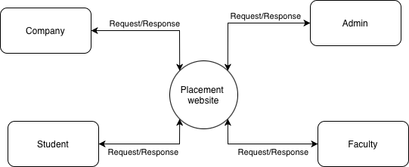

6.4. Level 2 DFD for Key Modules
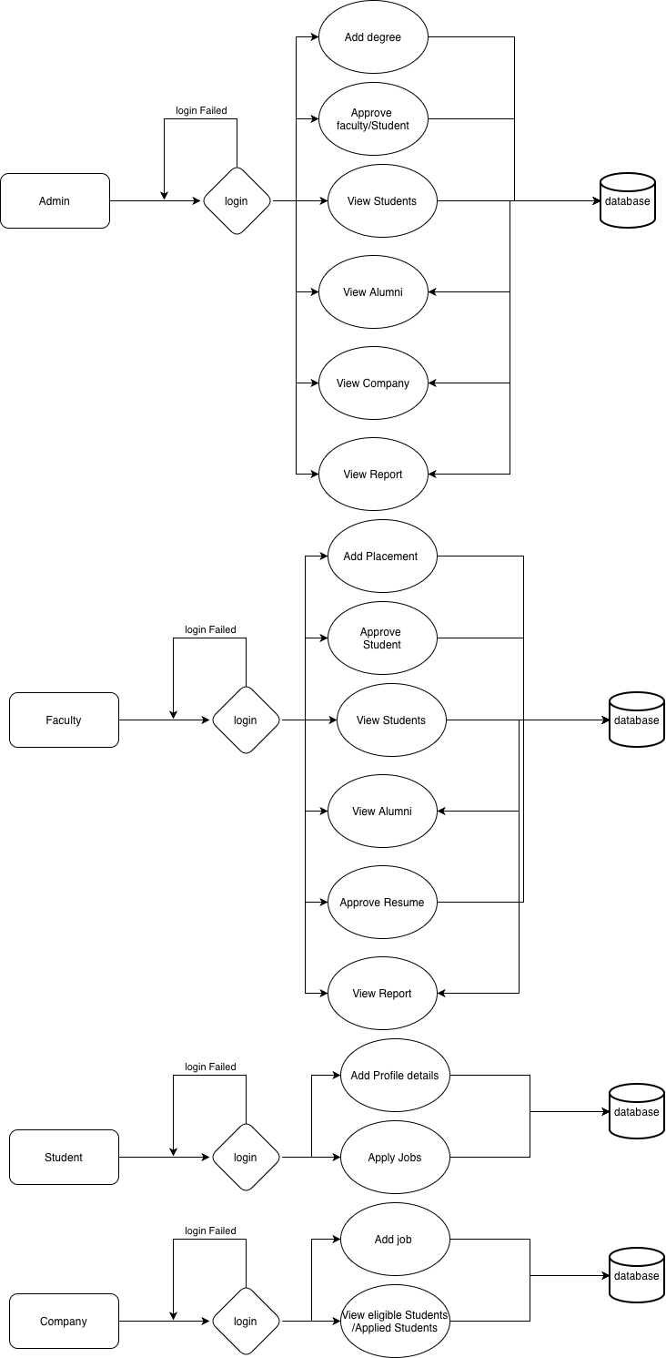

6.1. USE CASE DIAGRAM
A Use Case Diagram illustrates how different users (actors) interact with a system and what functions the system provides. It is mainly used to capture the functional requirements of a system at a high level.
Use Case Diagrams help to:
- Identify system functions and how different roles interact with them.
- Provide an overall view of the system.
- Recognize both internal and external actors.
- Collect requirements influenced by users and outside systems.
The two primary elements of a Use Case Diagram are Actors and Use Cases.

Actor
An represents any entity that interacts with the system. This can be a person, an organization, or another external system. An actor does not belong to the system itself but communicates with it to achieve some goal. Actors are commonly represented using a stick-figure symbol

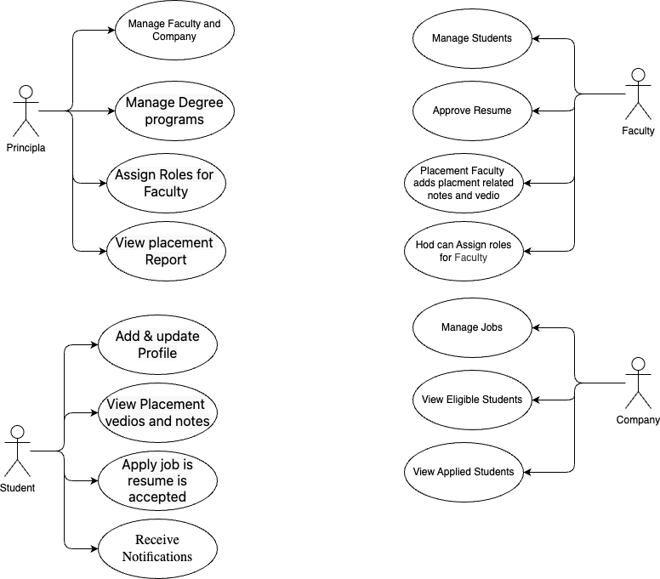

Sequence Diagram:

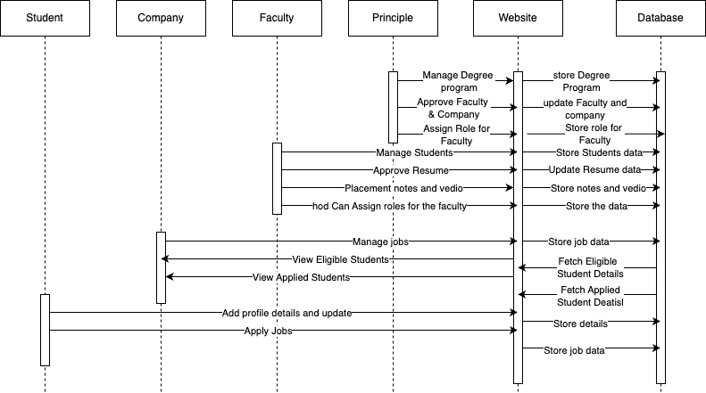

Activity Diagram:

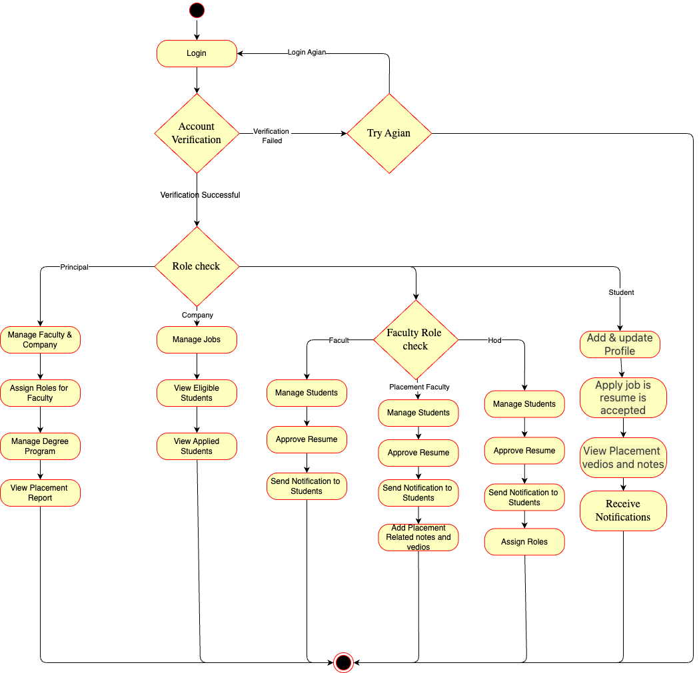

CHAPTER 7
7. DATABASE DESIGN

Database Name :db.sqlite3

Table structure for table User

Field Name | Type | Constraints | Description
id | AutoField | PK | Primary key
username | CharField | UNIQUE | Login username
email | EmailField | UNIQUE | User email
password | CharField | — | Hashed password
first_name | CharField | — | First name
last_name | CharField | — | Last name
is_active | BooleanField | Default True | Account status
is_staff | BooleanField | Default False | Staff access
is_superuser | BooleanField | Default False | Admin access

Table structure for table StudentProfile

Field Name | Type | Constraints | Description
id | AutoField | PK | Primary key
user | OneToOneField(User) | UNIQUE | Linked auth user
roll_number | CharField | UNIQUE | Student roll no
department | CharField | — | Academic department
batch | IntegerField | — | Graduation year
cgpa | DecimalField | 0–10 | Academic score
phone | CharField | — | Contact number
resume | FileField | PDF only | Uploaded resume
is_approved | BooleanField | Default False | Admin approval
created_at | DateTimeField | Auto | Created time
updated_at | DateTimeField | Auto | Updated time

Table structure for table CompanyProfile

Field Name | Type | Constraints | Description
id | AutoField | PK | Primary key
user | OneToOneField(User) | UNIQUE | Recruiter account
company_name | CharField | — | Company name
industry | CharField | — | Business sector
website | URLField | — | Company website
description | TextField | — | Overview
logo | ImageField | JPG/PNG | Company logo
is_approved | BooleanField | Default False | Admin approval
created_at | DateTimeField | Auto | Created
updated_at | DateTimeField | Auto | Updated

Table structure for table JobPosting

Field Name | Type | Constraints | Description
id | AutoField | PK | Primary key
company | ForeignKey(CompanyProfile) | CASCADE | Posting company
title | CharField | — | Job title
description | TextField | — | Job details
requirements | TextField | — | Qualifications
location | CharField | — | Job location
job_type | CharField | — | Full-time / Intern
salary_min | DecimalField | ≤ salary_max | Minimum salary
salary_max | DecimalField | ≥ salary_min | Maximum salary
deadline | DateField | Future date | Apply by
is_active | BooleanField | Default True | Status
created_at | DateTimeField | Auto | Created
updated_at | DateTimeField | Auto | Updated

Table structure for table JobApplication

Field Name | Type | Constraints | Description
id | AutoField | PK | Primary key
student | ForeignKey(StudentProfile) | CASCADE | Applicant
job | ForeignKey(JobPosting) | CASCADE | Target job
status | CharField | — | Applied / Accepted
cover_letter | TextField | — | Optional letter
applied_at | DateTimeField | Auto | Applied time
updated_at | DateTimeField | Auto | Status update

Table structure for table PlacementDetail

Field Name | Type | Constraints | Description
id | AutoField | PK | Primary key
student | ForeignKey(StudentProfile) | PROTECT | Placed student
company_name | CharField | — | Hiring company
position | CharField | — | Job title
package | DecimalField | — | Annual CTC
joining_date | DateField | — | Start date
placement_type | CharField | — | On/Off campus
created_at | DateTimeField | Auto | Created
updated_at | DateTimeField | Auto | Updated

Table structure for table Domain

Field Name | Type | Constraints | Description
id | AutoField | PK | Primary key
name | CharField | — | Domain name
description | TextField | — | Overview
icon | CharField | — | UI icon
color | CharField | — | Theme color
is_active | BooleanField | Default True | Status
created_at | DateTimeField | Auto | Created

Table structure for table Resource

Field Name | Type | Constraints | Description
id | AutoField | PK | Primary key
domain | ForeignKey(Domain) | CASCADE | Parent domain
title | CharField | — | Resource title
description | TextField | — | Details
resource_type | CharField | — | Video / Article
url | URLField | Nullable | External link
file | FileField | Nullable | Uploaded file
order | IntegerField | — | Display order
created_at | DateTimeField | Auto | Created

CHAPTER 8

CODING AND TESTING
This chapter details the implementation phase of the Placement & Alumni System Website, covering the coding standards, architectural patterns, testing methodologies, and quality assurance practices adopted during development.
8.1. CODING
Coding is the process of translating system design specifications into executable source code. The implementation follows structured programming principles, modular design, and industry best practices to ensure maintainability, scalability, and security.

8.1.1. Development Environment
The system was developed in a controlled environment to ensure consistency and compatibility across development, testing, and production stages. The development environment included modern integrated development environments (IDEs) with debugging tools, version control systems for collaborative development, and containerization where applicable to replicate production conditions. The technology stack was carefully selected to balance performance, developer productivity, and future maintainability.

8.1.2. Project Structure and Architecture
The project follows the Model-View-Template (MVT) architectural pattern inherent to Django framework. This separation of concerns ensures that data management, business logic, and presentation layers remain independent and maintainable. The application was organized into discrete Django apps, each representing a functional module of the system. This modular approach facilitates team collaboration, simplifies debugging, and enables independent testing of system components.

8.1.3. Coding Standards and Conventions
Adherence to established coding standards was rigorously maintained throughout the development process. Python code follows PEP 8 conventions for consistency and readability. Meaningful naming conventions were employed for variables, functions, and classes to enhance code comprehensibility. Comprehensive documentation through docstrings and comments was integrated into the development workflow to ensure code maintainability and facilitate knowledge transfer.

8.1.4. Security Considerations in Coding
Security was embedded into the coding process from inception. All user inputs undergo validation and sanitization to prevent injection attacks. Authentication mechanisms implement industry-standard practices including secure password hashing and session management. Authorization checks are implemented at multiple levels to ensure users can only access resources appropriate to their roles. Security headers and protections against common web vulnerabilities were integrated following OWASP guidelines.

8.2. TESTING
Testing ensures that the system functions correctly, meets specified requirements, and delivers a quality user experience. A comprehensive, multi-level testing strategy was implemented to validate the system from individual components through complete integrated operation.

8.2.1. Testing Philosophy and Strategy
The testing approach combines both proactive and reactive methodologies. Test-driven development principles were applied where practical, with tests written before implementation for critical functionality. Continuous testing was integrated into the development workflow, with automated test execution triggered by code changes. The testing strategy prioritizes user-centric validation, ensuring that system behavior aligns with stakeholder expectations and real-world usage patterns.

8.2.2. Levels of Testing

8.2.2.1. Unit Testing
Unit testing focuses on verifying the correctness of individual system components in isolation. Each function, method, and class was tested independently with various input conditions, including edge cases and error scenarios. Mock objects and test doubles were employed to isolate units from dependencies, ensuring that test failures precisely identify problematic components.

8.2.2.2. Integration Testing
Integration testing validates the interactions between different system modules and components. These tests ensure that data flows correctly across interfaces and that integrated components function cohesively. Integration testing addresses interface compatibility, data exchange protocols, and error handling across module boundaries.

8.2.2.3. System Testing
System testing evaluates the complete, integrated system against specified requirements. End-to-end workflows are tested to validate that the system performs correctly in scenarios that mimic real-world usage. System testing includes functional validation, performance assessment, and compatibility verification across different environments.

8.2.2.4. User Acceptance Testing (UAT)
User Acceptance Testing involves system validation by actual stakeholders to ensure the solution meets business needs and user expectations. UAT was conducted with representative users from each stakeholder category, employing realistic scenarios and actual data where appropriate. Feedback from UAT sessions informed iterative refinements to enhance usability and functionality.

8.2.3. Test Coverage and Metrics
Comprehensive test coverage metrics were tracked throughout development to ensure adequate validation of system functionality. Code coverage analysis identified untested code segments, while requirement traceability matrices mapped tests to specific system requirements. These metrics guided testing efforts and provided objective evidence of testing completeness.

8.3. SECURITY TESTING
Security testing systematically evaluates the system's resistance to malicious attacks and unauthorized access. This testing category validates that security controls function as intended and that vulnerabilities are identified and addressed.

8.3.1. Authentication and Authorization Testing
Authentication mechanisms were tested for resistance to credential guessing, session hijacking, and other authentication bypass techniques. Authorization controls were validated to ensure users can access only permitted resources, with particular attention to role-based access boundaries and privilege escalation vulnerabilities.

8.3.2. Vulnerability Assessment
The system was assessed for common web application vulnerabilities including injection flaws, cross-site scripting, insecure direct object references, and security misconfigurations. Automated vulnerability scanning tools complemented manual penetration testing to identify potential security weaknesses.

8.3.3. Data Protection Validation
Data protection measures were tested to ensure sensitive information is adequately safeguarded. This included validation of encryption implementations, assessment of data transmission security, and verification of privacy controls governing data collection, storage, and processing.

8.4. PERFORMANCE TESTING
Performance testing evaluates system behaviour under various load conditions to ensure responsiveness, stability, and scalability meet requirements.

8.4.1. Load Testing
Load testing simulates expected user concurrency to verify system performance under typical operational conditions. Response times, throughput, and resource utilization were measured to identify performance bottlenecks and optimization opportunities.

8.4.2. Stress Testing
Stress testing assesses system behavior under extreme conditions beyond normal operational parameters. These tests identify breaking points, validate error handling under resource constraints, and ensure graceful degradation when system limits are approached.

8.5. BACKUP AND RECOVERY MECHANISM
Robust backup and recovery mechanisms are essential for system resilience and data protection. These mechanisms ensure business continuity in the event of data loss, corruption, or system failure.

8.5.1. Backup Strategy
A comprehensive backup strategy was implemented with multiple backup types and retention periods. Regular automated backups capture system state, with incremental backups minimizing storage requirements while ensuring recovery point objectives can be met.

8.5.2. Recovery Procedures
Documented recovery procedures provide step-by-step guidance for restoring system functionality following disruptions. Recovery time objectives and recovery point objectives were established based on business requirements, with corresponding technical implementations to meet these targets.

8.5.3. Data Integrity Assurance
Data integrity mechanisms verify backup completeness and consistency. Regular restoration tests validate backup reliability, while checksums and validation routines ensure data remains uncorrupted throughout backup, storage, and restoration processes.

CHAPTER 9

SOFTWARE MAINTENANCE
Software maintenance is the process of modifying and updating a software system after delivery to correct faults, improve performance, adapt to changing environments, or enhance functionality. For the Placement & Alumni System Website, maintenance is a critical ongoing activity that ensures the system remains reliable, secure, and aligned with evolving institutional needs.

9.1. IMPORTANCE OF SOFTWARE MAINTENANCE
Maintenance is essential for the long-term viability and usefulness of any software system. It addresses several key objectives:
- System Reliability: Ensures continuous and error-free operation.
- Security: Protects against emerging threats and vulnerabilities.
- Adaptability: Allows the system to evolve with changing requirements and technologies.
- Performance Optimization: Improves efficiency and user experience over time.
- Cost-Effectiveness: Extends the system's lifespan and maximizes return on investment.

9.2. TYPES OF SOFTWARE MAINTENANCE
Software maintenance can be categorized into four distinct types, each addressing different aspects of system evolution:

9.2.1. Corrective Maintenance
Corrective maintenance involves identifying and fixing errors, bugs, and faults discovered during system operation. This type of maintenance is reactive, responding to issues reported by users or identified through system monitoring.
Examples for Placement System:
- Fixing a bug in the job application submission process
- Resolving database connection errors during peak usage
- Correcting calculation errors in eligibility checking algorithms
- Repairing broken links or navigation issues

9.2.2. Adaptive Maintenance
Adaptive maintenance modifies the system to accommodate changes in the external environment, such as new operating systems, updated web browsers, changes in regulatory requirements, or integration with new institutional systems.
Examples for Placement System:
- Updating the system to support new web browser versions
- Adapting to changes in university academic structures or policies
- Modifying data export formats to meet new reporting requirements
- Integrating with new authentication systems or single sign-on solutions

9.2.3. Perfective Maintenance
Perfective maintenance enhances system functionality, improves performance, or modifies features to better meet user needs. This type of maintenance is proactive, driven by user feedback and strategic improvements rather than fixing problems.
Examples for Placement System:
- Adding new search filters for company job listings
- Optimizing database queries to improve response times
- Enhancing the user interface based on usability feedback
- Adding new report formats for placement statistics
- Implementing advanced analytics features

9.2.4. Preventive Maintenance
Preventive maintenance involves activities that prevent future problems, improve maintainability, or prepare the system for anticipated changes. This proactive approach reduces the likelihood and impact of future failures.
Examples for Placement System:
- Refactoring complex code modules for better maintainability
- Updating third-party libraries and dependencies
- Implementing additional logging for troubleshooting
- Creating comprehensive documentation for future maintenance
- Setting up automated monitoring and alert systems

9.8. RISK MANAGEMENT IN MAINTENANCE

9.8.1. Risk Identification
- Technical risks (compatibility issues, performance degradation)
- Operational risks (downtime, data loss)
- Security risks (vulnerabilities, unauthorized access)
- Resource risks (staff turnover, budget constraints)

9.8.2. Risk Mitigation Strategies
- Comprehensive backup and recovery procedures
- Phased rollout of significant changes
- Fallback plans for failed deployments
- Regular security audits and penetration testing

9.8.3. Contingency Planning
- Emergency maintenance procedures
- Disaster recovery plans
- Alternative communication channels during outages
- Escalation procedures for critical issues

