GOVERNMENT POLYTECHNIC COLLEGE NEDUMANGADU

FLASK-BASED E-COMMERCE PLATFORM

A PROJECT REPORT
Submitted by
ANANDHU A | (2201150625)
JAYASOORYA J S | (2201150636)
NANDHANA A | (2201150642)
SARAN C | (2201150649)
SEFIN R R | (2201150650)
ABHINAND S A | (2201150896)
to
The State Board of Technical Education (SBTE) in partial fulfilment of the requirements for the award of
Diploma in Computer Hardware Engineering


Department of Computer Hardware Engineering 2022 – 2025

GOVERNMENT POLYTECHNIC COLLEGE NEDUMANGADU

DEPARTMENT OF COMPUTER HARDWAREENGINEERING

CERTIFICATE

This is to certify that the project report entitled “FLASK-BASED E-COMMERCE PLATFORM” is a bonafied recored of the Major Project done by SEFIN R R (2201150650), JAYASOORYA J S (2201150636), NANDHANA A (2201150642), ANANDHU A (2201150625), SARAN C (2201150649), ABHINAND S A (2201150629) under our guidance in partial fulfilment for the award of Diploma in Computer Hardware Engineering from the State Board of Technical Education Kerala during the academic year 2022 – 2025.

Sri. Ratheesh Kumar R

Project Guide Lecturer in Computer Hardware Engineering

External Examiner

Smt. Sheena C
Project Coordinator & Head of Department.
Department of Computer Hardware Engineering

Internal Examiner

ACKNOWLEDGEMENT
I would also like to extend my heartfelt thanks to the faculty and staff of the Department of Computer Hardware Engineering at Government Polytechnic College, Nedumangad. I am particularly grateful to our College Principal, Mrs. Leena Mary John, whose visionary leadership and commitment to academic excellence have greatly inspired me. Additionally, my sincere appreciation goes to our Head of Department, Mrs. Sheena C, for her unwavering support and guidance throughout this endeavor.
I am deeply grateful to all those who have supported and guided me throughout the development of this project, "Integrated College Placement Cell Portal." First and foremost, I would like to express my sincere gratitude to my project guide, Mr. Ratheesh Kumar R, whose expertise, encouragement, and insightful suggestions have been invaluable in steering this work in the right direction. His constant support not only enriched my learning experience but also played a pivotal role in the successful completion of this project.
Special thanks are due to my colleagues and friends, whose constructive feedback and collaborative spirit helped refine various aspects of this project. Their readiness to share ideas and assist during challenging phases has been deeply appreciated.
Finally, I am profoundly grateful to my family for their unwavering support and encouragement. Their belief in my abilities and constant motivation have been the driving force behind my academic and personal achievements.
This project stands as a testament to the collective efforts and guidance of everyone mentioned above, and I am truly thankful for all the contributions that made it possible.
SEFIN R R
JAYA SOORYA J S SARAN C NANDHANA A ANANDHU A ABHINAND S A

ABSTRACT

E-commerce platforms have become a vital component of modern digital business ecosystems, enabling organizations to reach customers efficiently and manage transactions digitally. With the increasing demand for secure, scalable, and user-friendly online shopping systems, the need for customizable web-based e-commerce solutions has grown significantly. This project presents the design and development of a Flask-based e-commerce platform that supports Customers, Sellers, and Administrators within a single integrated system.
The system is designed to handle complete e-commerce operations including user authentication, product listing, inventory management, shopping cart operations, order processing, and feedback management. Secure access control mechanisms are implemented to ensure that users can only access functionalities permitted to their roles. Customers can browse products, place orders, track order status, and provide reviews. Sellers can manage products, monitor inventory levels, process customer orders, and analyze sales data. Administrators are responsible for overseeing the system, managing users, verifying sellers, organizing categories, and monitoring overall platform activity.
The application is developed using Python and the Flask framework, with SQLite as the backend database managed through Flask-SQLAlchemy ORM. Security is enforced using password hashing and session-based authentication. The platform follows a modular and scalable architecture that supports maintainability and future enhancements. This project demonstrates the practical implementation of a full-stack e-commerce system and provides a strong foundation for real-world deployment with scope for advanced features such as enhanced analytics, recommendation systems, and cloud-based scalability.

CHAPTER 1

Project Background
- INTODUCTION

The rapid advancement of web technologies and widespread internet accessibility have significantly transformed how businesses operate and how consumers interact with products and services. In today’s digital-first economy, electronic commerce (e-commerce) has become a fundamental component of modern business, enabling organizations to reach a global audience, operate beyond physical and time limitations, and provide convenient online shopping experiences. From small startups to large enterprises, e-commerce platforms are now essential for remaining competitive in an increasingly technology-driven market.
An e-commerce platform is not merely an online storefront but a complete digital ecosystem that integrates multiple business functions. These include user authentication, product catalog management, order tracking, inventory control, and customer feedback mechanisms. As customer expectations continue to rise, users demand fast, secure, and intuitive platforms that offer accurate product details, smooth browsing experiences, and reliable order fulfillment processes. Simultaneously, sellers and administrators require efficient backend systems to manage operations, monitor performance, and maintain system reliability. Relying on manual methods or poorly designed systems often results in errors, inefficiencies, and reduced customer satisfaction.
The Flask-based E-commerce Platform is developed to address these challenges through a unified, role-based web application that supports Customers, Sellers, and Administrators. Built using the Flask web framework, the system emphasizes modular design, scalability, and maintainability, making it suitable for evolving business needs. Flask’s lightweight and flexible architecture allows the platform to be easily extended while maintaining a clean and organized codebase.
Customers benefit from a complete online shopping experience, including secure registration and login, product browsing, shopping cart management, order placement, order history tracking, and product reviews. Sellers are provided with tools for product management, inventory monitoring, order fulfillment, and sales analytics, enabling data-driven decision-making. Administrators oversee platform operations through dashboards that support user management, seller moderation, and category control.
Overall, the Flask-based E-commerce Platform demonstrates a practical and scalable solution for modern online commerce, showcasing how contemporary web technologies can be used to build efficient, secure, and user-centric e-commerce systems.

PURPOSE
The primary purpose of this project is to design and implement a comprehensive web-based e-commerce platform that simplifies and automates online retail management. Traditional retail and semi-digital systems often rely on manual processes for handling products, orders, and customer data, which can lead to inefficiencies, human errors, and delays in service delivery. This project aims to overcome such limitations by providing a centralized and automated solution that streamlines all core e-commerce operations.
By digitalizing product management, order processing, and inventory tracking, the platform significantly reduces manual workload and improves data accuracy. Sellers can efficiently manage product listings, monitor stock levels in real time, and handle customer orders without redundant paperwork or fragmented systems. Automated workflows ensure faster order processing and consistent updates across the system, thereby enhancing overall operational efficiency.
The platform is also designed to deliver a smooth and reliable shopping experience for customers. Features such as easy product browsing, shopping cart management, order placement, order tracking, and review management improve user convenience and build trust in the system. Customers benefit from transparent order status updates and a user-friendly interface that simplifies online shopping.
In addition, the system provides administrators with complete control over platform activities. Through an administrative dashboard, administrators can manage users, approve or suspend sellers, organize product categories, and monitor system performance. This level of control ensures platform security, data integrity, and proper governance. Overall, the purpose of this project is to create a scalable, secure, and efficient e-commerce platform that supports business growth, enhances customer satisfaction, and demonstrates the practical application of modern web development technologies.

SCOPE
The scope of this project involves the design and development of a complete end-to-end e-commerce platform that supports the essential functionalities required for online retail operations. The system covers core features such as user registration and authentication, product browsing by categories, shopping cart management, order placement, and order status tracking. These features together provide customers with a smooth and reliable online shopping experience while ensuring secure and efficient handling of orders.
From a business operations perspective, the project includes inventory tracking and product management capabilities that allow sellers to add, update, and remove products while monitoring stock levels in real time. User management is also a key component of the system, enabling role-based access for customers, sellers, and administrators. This structured approach ensures proper separation of responsibilities and enhances system security and maintainability.
The platform is primarily designed to meet the needs of small and medium-scale businesses seeking a cost-effective and efficient solution for establishing an online presence. Its modular architecture allows easy customization and scalability, making it adaptable to different business models and future growth.
Additionally, the project has strong potential for future enhancements. The system can be extended to include advanced features such as personalized recommendation systems based on user behavior, advanced analytics, and mobile application support for Android and iOS platforms. These extensions would further improve user engagement, business insights, and accessibility, making the platform suitable for larger-scale commercial deployment.

1.2 Project Overview

Electronic commerce (e-commerce) has become a key component of modern business, enabling organizations to sell products and services online while reaching a wider customer base. With the growth of internet access and web technologies, businesses increasingly rely on digital platforms to improve efficiency, reduce operational costs, and enhance customer convenience. However, many small and medium-scale businesses still use manual or partially automated systems for managing products, inventory, and orders, which are often inefficient and error-prone.
To overcome these challenges, this project focuses on the development of a web-based e-commerce platform that automates and simplifies online retail operations. The system provides a centralized solution for managing products, users, orders, and transactions, thereby reducing manual workload and improving data accuracy. By integrating core business processes into a single platform, the system enhances operational efficiency and ensures a smooth online shopping experience.
The platform is developed using the Flask web framework along with Python, SQLAlchemy, HTML, CSS, and JavaScript. Flask’s lightweight and modular architecture makes the system flexible, scalable, and easy to maintain. The database-driven design ensures efficient handling of data related to customers, products, orders, and inventory.
The system follows a role-based access model supporting customers, sellers, and administrators. Customers can register, browse products, manage shopping carts, place orders, and track order status. Sellers manage product listings, inventory levels, orders, and sales data through dedicated dashboards. Administrators oversee users, verify sellers, manage product categories, and monitor overall system activity.
Automation of order processing and inventory tracking reduces errors and ensures real-time updates across the system. The user-friendly and responsive interface enables easy navigation with minimal training. The platform is scalable and can be extended in the future to include advanced features such as recommendation systems, enhanced analytics, and mobile application support.
.

1.3 Future Enhancements

The Flask-based e-commerce platform is designed with a modular and scalable architecture, allowing it to be enhanced and expanded as business requirements evolve. While the current system effectively supports core e-commerce functionalities, several future enhancements can be implemented to improve performance, usability, and business value.
One significant enhancement is the integration of advanced data analytics and reporting tools. These features can provide deeper insights into customer behavior, sales trends, and inventory movement, helping sellers and administrators make informed, data-driven decisions. Visual dashboards and automated reports would further improve monitoring and strategic planning.
Another potential improvement is the implementation of personalized recommendation systems. By analyzing user browsing history, purchase patterns, and product interactions, the system can suggest relevant products to customers, thereby increasing engagement and improving sales conversion rates.
The platform can also be extended to support mobile application integration for Android and iOS devices. A dedicated mobile app would enhance accessibility and convenience, allowing users to shop and manage orders directly from their smartphones. Additionally, performance optimization techniques such as caching, load balancing, and cloud deployment can be introduced to handle higher traffic and ensure system reliability.
Further enhancements may include multi-language and multi-currency support, advanced search and filtering options, improved security mechanisms, and integration with external services for notifications and logistics tracking. Overall, these future enhancements would make the platform more robust, scalable, and suitable for large-scale commercial deployment.

1.4 SYSTEM STUDY ANALYSIS
System analysis is a detailed study of the operations performed by a system and the relationships among its components, both within the system and with external entities. In simple terms, system analysis involves understanding what needs to be built before actually building it. It helps in identifying problems in the existing system, defining requirements, and proposing an improved solution.
System analysis can be broadly categorized into the following five parts:
- System planning and investigation
- Information gathering
- Applying analytical tools for structured analysis
- Feasibility study
- Cost–benefit analysis

1.4.1 EXISTING SYSTEM

In the existing e-commerce setup, many processes are handled either manually or through poorly integrated systems. Product management, inventory updates, order tracking, and customer record maintenance often require significant human intervention. This results in increased workload for business owners and staff, especially as the number of products and customers grows.
Since most operations are not fully automated, there is a high possibility of errors such as incorrect inventory levels, delayed order processing, and inconsistent customer data. Searching, sorting, and updating product or order information becomes time-consuming and inefficient as data volume increases. Additionally, limited system integration leads to poor coordination between different business functions. Customer communication is often minimal, and real-time updates regarding order status or product availability may not be consistently available. Overall, the existing system is slow, error-prone, and difficult to scale, which negatively impacts business efficiency and customer satisfaction.
1.4.2PROPOSED SYSTEM
The proposed Flask-based E-commerce Platform is designed to overcome the limitations of the existing system by introducing automation, accuracy, and centralized control. The system replaces manual processes with a fully digital, web-based solution that manages products, users, orders, and inventory in an integrated manner. This significantly reduces human effort and minimizes errors.
The proposed system provides role-based access for customers, sellers, and administrators, ensuring secure and organized system usage. Automated inventory tracking and order processing improve speed and reliability, while advanced search, sorting, and data management features make handling large volumes of information easier. Real-time updates ensure data consistency across the platform.
Overall, the proposed system offers a cost-effective, efficient, and scalable solution for online retail management. It enhances operational efficiency, improves customer experience, and enables businesses to compete effectively in the modern digital marketplace.

.
- SYSTEM SPECIFICATION

Hardware requirements
- Processor: Intel Core i5 / AMD Ryzen 5 or higher
- RAM: Minimum 8 GB (16 GB recommended for better performance)
- Storage: SSD with at least 256 GB free space
- Drives: Optional (DVD drive if required)
- Display: 15-inch or higher color monitor
- Screen Resolution: Full HD (1920 × 1080 pixels) or higher
- Color Palette: True Color (24-bit)
- Keyboard: Standard PC/AT enhanced keyboard
- Mouse: Any standard USB or wireless mous
Software requirements
• Operating System: Windows 10 / 11 (Linux or macOS can also be used)
• Frontend Technologies: HTML5, CSS3, JavaScript
• Backend Framework: Python with Flask
• Programming Language: Python
• Database: SQLite (can be extended to MySQL or PostgreSQL)
• ORM: Flask-SQLAlchemy
• IDE / Code Editor: VS Code / PyCharm / any Python-supported IDE
• Web Server: Flask Development Server (Apache/Nginx for deployment)
• Web Browser: Google Chrome / Mozilla Firefox / Safari / Edge

- SOFTWARE SPECIFICATION

About the Operating System :

The proposed e-commerce system is designed to run on modern Microsoft Windows operating systems such as Windows 10 or Windows 11. These operating systems are stable, secure, and widely used, making them suitable for web application development and deployment. They provide a reliable environment with good performance, improved security, and strong support for modern development tools.
Windows is built on the NT (New Technology) kernel, which ensures better stability, memory management, and reduced system crashes. It supports multitasking, networking, and smooth internet connectivity, all of which are essential for developing and running web-based applications. The operating system is compatible with a wide range of hardware, software, web servers, databases, and browsers.

Features of the Operating System
- User-friendly interface
- Easy system and file management
- High compatibility with modern hardware and software
- Improved stability and performance
- Strong networking and internet support
- Enhanced security for application development

CHAPTER 2

2 Literature Review

2.1 EXISTING E-COMMERCE SYSTEMS:

E-commerce systems play a crucial role in modern digital business by enabling organizations to sell products and services online while managing customers, orders, and inventory efficiently. Over the years, numerous e-commerce platforms and web applications have been developed to simplify online retail operations. Early e-commerce systems were primarily static websites that displayed product information and relied heavily on manual processes for order handling and inventory updates. These systems lacked automation, real-time updates, and secure user management.
With advancements in web technologies, more dynamic e-commerce systems emerged, incorporating features such as user authentication, product catalogs, shopping carts, and order tracking. Popular platforms focused on improving usability, transaction handling, and backend management. However, many of these systems were either costly, difficult to customize, or overly complex for small and medium-scale businesses. In addition, some platforms required extensive third-party integrations to achieve full functionality, increasing maintenance complexity.
Several academic and open-source projects explored building custom e-commerce platforms using technologies such as HTML, CSS, Python, Flask, Django, PHP, MySQL, and SQLite. These systems demonstrated the feasibility of role-based access, database-driven product management, and modular architectures. While they improved efficiency compared to manual systems, many lacked scalability, advanced analytics, or flexible customization options.

2.2EXISTING SYSTEMS AND PROPOSED SOLUTIONS:
Traditional retail management systems often relied on manual record keeping or basic spreadsheet-based solutions to track products, inventory, and sales. These approaches required significant human effort, were prone to errors, and did not support real-time updates. As online sales volumes increased, such systems became inefficient and difficult to manage.
Later, basic web-based e-commerce solutions were introduced to centralize data and automate some operations. These systems allowed businesses to manage products and orders digitally but often suffered from limitations such as poor user interfaces, lack of role-based access, minimal reporting features, and weak security mechanisms. Some platforms supported customers effectively but provided limited tools for sellers or administrators.
Recent systems introduced role-based e-commerce models where customers, sellers, and administrators interact within a single platform. While these systems improved organization and workflow, many still lacked full automation, centralized analytics, and scalability. In several cases, inventory management and reporting features were basic and not suitable for growing businesses.
Identified Challenges in Existing Systems

Through comparative analysis, several significant challenges were identified in earlier e-commerce platforms and online retail management systems:
- Manual Inventory and Order Handling: Many traditional systems relied on manual updates for inventory levels and order status, leading to delays, inaccuracies, and inefficient workflows.
- Limited Mobile Accessibility: Several platforms lacked mobile-responsive designs, restricting users from accessing the system conveniently on smartphones and tablets, which reduced customer engagement and seller responsiveness.
- Complex User Interfaces: Poorly designed navigation structures and outdated user interfaces negatively affected usability, making it difficult for customers to browse products and for sellers to manage operations effectively.
- Decentralized Data Management: In some systems, product data, customer information, and order records were stored separately or managed through multiple tools, preventing centralized data tracking and consistency.
- Data Security Issues: Older e-commerce solutions often lacked strong authentication mechanisms and role-based access control, making them vulnerable to unauthorized access and data breaches.
- Lack of Automated Notifications: Many platforms did not provide real-time notifications for order updates, stock changes, or user activities, resulting in delayed communication between customers, sellers, and administrators.
- Absence of Advanced Analytics: Business owners and administrators had limited visibility into sales trends, customer behavior, and inventory performance, restricting informed decision-making.
- Rigid Customization Options: Several existing platforms were inflexible and difficult to customize, limiting their ability to scale or adapt to changing business requirements.
These challenges highlight the need for a centralized, secure, user-friendly, and scalable e-commerce platform that automates operations and enhances both business efficiency and customer experience.

  - GAP ANALYSIS:
A detailed analysis of existing e-commerce systems reveals several limitations:
- Heavy dependence on manual processes for inventory updates and order verification
- Lack of centralized data management across users, products, and orders
- Poor scalability for growing product catalogue and user bases
- Limited role-based access and weak security controls
- Inefficient reporting and absence of business analytics
- Inadequate user experience due to outdated or non-responsive interfaces
These gaps highlight the need for a unified, secure, and scalable e-commerce platform that can automate operations and improve overall efficiency.
Feature | Existing Systems | Proposed System
Data Management | Manual / Local databases | Centralized web-based database
Accessibility | Limited responsiveness | Fully responsive UI
Security | Basic authentication | Secure login & role-based access
User Experience | Complex or outdated UI | Modern and intuitive interface
Inventory Handling | Manual updates | Automated tracking
Reporting | Limited or unavailable | Integrated reports & analytics
2.4 IMPROVED FEATURES IN PROPOSED SYSTEM:
The proposed Flask-based E-commerce Platform is designed to address the identified gaps and enhance system functionality through the following features:
- Automated Inventory and Order Management: Reduces manual effort and ensures real-time data accuracy
- Centralized Secure Database: Stores all user, product, and order data securely with controlled access
- Role-Based Access Control: Separate modules for Customers, Sellers, and Administrators
- User-Friendly Interface: Responsive design for easy navigation across devices
- Efficient Product and Order Tracking: Enables sellers and administrators to manage operations effectively
- Scalable Architecture: Supports future expansion such as analytics, recommendations, and mobile integration
- Reduced Manual Work: Fully digitalized workflows minimize paperwork and errors
- Improved Reporting: Enables business insights and performance monitoring

CHAPTER 3
- TECHNOLOGIES AND TOOLS USED
  - PHP

PHP is a server-side and general-purpose scripting language that is especially suited for web development. PHP originally stood for Personal Home Page. However, now, it stands for Hypertext Preprocessor. It’s a recursive acronym because the first word itself is also an acronym. PHP was created by Rasmus Lerdorf in 1994. It’s currently maintained by the PHP Development Team.
When it comes to the purpose of the programming languages, there are two main types: domain-specific and general-purpose languages. The domain-specific languages are used within specific application domains. For example, SQL is a domain-specific language. It’s used mainly for querying data from relational databases. And SQL cannot be used for other purposes. On the other hand, PHP is a general-purpose language because PHP can develop various applications.
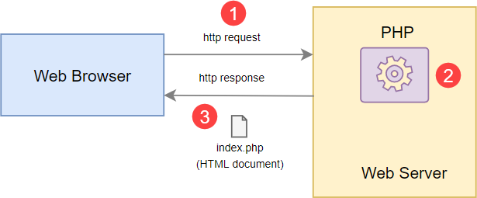
PHP can run on all major operating systems, including Linux, Windows, and macOS. You can use PHP with all leading web servers such as Nginx, OpenBSD, and Apache. Some cloud environments also support PHP like Microsoft Azure and Amazon AWS. PHP is quite flexible. It’s not just limited to processing HTML. PHP has built-in support for generating PDF, GIF, JPEG, and PNG images. One notable feature of PHP is that it supports many databases, including MySQL, PostgreSQL, MS SQL, db2, Oracle Database, and MongoDB.
PHP has two main applications :

Server-side scripting – PHP is well-suited for developing dynamic websites and web applications.
Command-line scripting – like Python and Perl, you can run PHP script from the command line to perform administrative tasks like sending emails and generating PDF files.
- MYSQL

A database is a structured collection of data. It may be anything from a simple shopping list to a picture gallery or the vast amounts of information in a corporate network. To add, access, and process data stored in a computer database, you need a database management system such as MySQL Server. Since computers are very good at handling large amounts of data, database management systems play a central role in computing, as standalone utilities, or as parts of other applications.

MySQL is a relational database management system based on the Structured Query Language, which is the popular language for accessing and managing the records in the database. MySQL is open-source and free software under the GNU license. It is supported by Oracle Company.

MySQL is currently the most popular database management system software used for managing the relational database. It is open-source database software, which is supported by Oracle Company. It is fast, scalable, and easy to use database management system in comparison with Microsoft SQL Server and Oracle Database. It is commonly used in conjunction with PHP scripts for creating powerful and dynamic server-side or web-based enterprise applications.
- APACHE HTTP SEVER

Apache is a popular open-source, cross-platform web server that is, by the numbers, the most popular web server in existence. It’s actively maintained by the Apache Software Foundation.
Some high-profile companies using Apache include Cisco, IBM, Salesforce, General Electric, Adobe, VMware, Xerox, LinkedIn, Facebook, Hewlett-Packard, AT&T, Siemens, eBay, and many more File servers, database servers, mail servers, and web servers use different kinds of server software. Each of these applications can access files stored on a physical server and use them for various purposes.

The job of a web server is to serve websites on the internet. To achieve that goal, it acts as a middleman between the server and client machines. It pulls content from the server on each user request and delivers it to the web.

- Javascript

JavaScript is a cross-platform, object-oriented scripting language used to make webpages interactive (e.g., having complex animations, clickable buttons, popup menus, etc.). There are also more advanced server-side versions of JavaScript such as Node.js, which allow you to add more functionality to a website than downloading files (such as Realtime collaboration between multiple computers). Inside a host environment (for example, a web browser), JavaScript can be connected to the objects of its environment to provide programmatic control over them.JavaScript was invented by Brendan Eich in 1995, and became an ECMA standard in 1997. ECMA-262 is the official name of the standard. ECMAScript is the official name of the language.
- NETBEANS IDE
NetBeans IDE is a free, open source, integrated development environment (IDE) that enables you to develop desktop, mobile and web applications. The IDE supports application development in various languages, including Java, HTML5, PHP and C++. The IDE provides integrated support for the complete development cycle, from project creation through debugging, profiling and deployment. The IDE runs on Windows, Linux, Mac OS X, and other UNIX-based systems.

NetBeans is a software development platform written in Java. The NetBeans Platform allows applications to be developed from a set of modular software components called modules. Applications based on the NetBeans Platform, including the NetBeans integrated development environment (IDE), can be extended by third party developers. The NetBeans Team actively support the product and seek feature suggestions from the wider community. Every release is preceded by a time for Community testing and feedback NetBeans IDE is an open-source integrated development environment. NetBeans IDE supports development of all Java application types (Java SE (including JavaFX), Java ME, web, EJB and mobile applications) out of the box. Among other features are an Ant-based project system, Maven support, refactoring, version control (supporting CVS, Subversion, Git, Mercurial and ClearCase).

- HTML
HTML, or Hypertext Markup Language, is used by web programmers to describe the contents of a web page. It is not a programming language. You simply use HTML to indicate what a certain chunk of text is-such as a paragraph, a heading or specially formatted text. All HTML directives are specified using matched sets of angle brackets and are usually called tags. Every HTML tag has an individual meaning associated with it. The tag adds a meaning to the document content. The webpage formatting is possible using the various HTML tags. For example <B> means that the following text should be
displayed in bold. To stop the bold text, use the </B> directive. Most HTML directives come in pairs and surround the affected text.

- CSS
CSS stands for Cascading Style Sheets. It is the language for describing the presentation of Web pages, including colours, layout, and fonts, thus making our web pages presentable to the users.
CSS is designed to make style sheets for the web. It is independent of HTML and can be used with any XML-based markup language. Now let’s try to break the acronym:

- Cascading: Falling of Styles
- Style: Adding designs/Styling our HTML tags
- Sheets: Writing our style in different documents

- BOOTSTRAP

Bootstrap is a free and open-source tool collection for creating responsive websites and web applications. It is the most popular HTML, CSS, and JavaScript framework for developing responsive, mobile-first websites. It solves many problems which we had once, one of which is the cross-browser compatibility issue. Nowadays, the websites are perfect for all the browsers (IE, Firefox, and Chrome) and for all sizes of screens (Desktop, Tablets, Phablets, and Phones). All thanks to Bootstrap developers -Mark Otto and Jacob Thornton of Twitter, though it was later declared to be an open-source project.

CHAPTER 4

- Feasibility Study

The prime objective of feasibility study is to ensure that the problem is worth to be solved. At the stage a cost benefit analysis is performed to assertion that the benefit from the system will over rule the cost association with the whole analysis, design and development of the new system. An important outcome of the preliminary investigation determining whether the system required is feasible.

Steps in Feasibility Analysis:
Feasibility Analysis involves eight steps :

- Form a project team and appoint a project leader.
- Prepare a system flow chart.
- Enumerate potential candidate systems.
- Describe and identify characteristics of candidate systems.
- Describe and evaluate performance and cost effectiveness of each candidate systems.
- Weight system performance and cost data.
- Select the best candidate system.
- Prepare and report final project directive and management.

The proposed system is tested in all three aspects of feasibility :
- Technical Feasibility study
- Operational Feasibility study
- Financial and Economic Feasibility study
- Behavioural Feasibility
- TECHNICAL FEASIBILITY

Technical feasibility center on existing system and to what extent it can support proposed modifications. It involves financial enhancement. This evaluation determines whether the technology needed for the proposed system is available or not. This is concerned with specifying satisfy the user requirements. The technical needs of the system may include front-end and back - end selection. An important issue for the development of a project is the selection of the suitable front - end and back - end. Based on some aspects, we select the most suitable platform that suits the needs of the organization. so in our system technically feasible

- OPERATIONAL FEASIBILITY

There is no difficulty in implementing the system. The proposed system is effective & user friendly. The user of the system must be completely unaware of the internal working of the system so that the users will not face any problem running the system. The system thus reduces the responsive time of computer thereby; the system is found to be operationally feasible. Operational feasibility is a measure of how people are able to work with the system.in our system consists of Admin Module, Hospital Module, Lab Module, Quarantine centre, Public Module etc. So, all these users can easily to work with our portal. Since the proposed system fulfil all the requirements that it has supposed to do therefore, we can say that the system is operationally feasible.

- ECONOMICAL FEASIBILITY

Economic and Financial analysis is used for evaluating the effectiveness of the system. This study is carried out to check the economic impact that the system will have on the organization. The amount of fund that the company can pour into the research and
development of the system is limited. The expenditure must be justified. Comparison between the benefits and savings expected from the candidate system with cost incurred is done. If benefits outweigh cost, then decision will be to design and implement system. Otherwise, alterations will have to be made to the proposed system. The proposed system is economically feasible.

- BEHAVIOURAL FEASIBILITY

The Behavioural feasibility depends upon whether the system performed in the expected way or not. Feasibility study is a test of system proposal according to it workability, impact on organization, ability to meet the user’s need and effective use of resources. However, a feasibility study provides a useful starting point for full analysis. The Behavioural feasibility depends upon whether the system performed in the expected way or not. Feasibility study is a test of system proposal according to it workability, impact on organization, ability to meet the user’s need and effective use of resources. However, a feasibility study provides a useful starting point for full analysis. The main problem faced during development of a new system is getting acceptance from the user. People are inherently resistant to changes and computers have been known to facilitate changes. It is mainly related to human organizational and political aspects.
The points to be considered are

- What changes will be bought with the system?
- What new skills will be required? Do the existing staff members have these skills? If not can they be trained due course of time?
This feasibility study is carried out by small group of people who are familiar with information testing techniques, who understand the parts of the problems of existing system that are relevant to the project and are skilled in analysis and design process.

CHAPTER 5

- SYSTEM DESIGN

System design is a feasible solution on how to approach to certain of the new system. This phase is composed of several steps. It provides procedure detail necessary for implementing the system in the feasibility study. Emphasis is given to how better we can transform the details of analysis phase to the design stage of the proposed system design goes through logical and physical stage of development. Logical design revives the present input and output specification, the physical design maps out the details of physical system plants the system implementation.

- INPUT DESIGN

In an information system, input is the raw data that is processed to produce output. During the input design, the developers must consider the input devices such as PC, MICR, OMR, etc. Therefore, the quality of system input determines the quality of system output. Well designed input forms and screens have following properties:
- It should serve specific purpose effectively such as storing, recording, and retrieving the information.
- It ensures proper completion with accuracy.
- It should be easy to fill and straight forward.
- It should focus on user’s attention, consistency, and simplicity.,
- All these objectives are obtained using the knowledge of basic design principles regarding
- What are the inputs needed for the system ?
- How end users respond to different elements of forms and screens.
- Objectives of input design :

- To design data entry and input procedures
- To reduce input volume
- To design source documents for data capture or devise other data capture methods
- To design input data records, data entry screens, user interface screens etc.
- To use validation checks and develop effective input controls

- Data input methods :

It is important to design appropriate data input methods to prevent errors while entering data. These methods depend on whether the data is entered by users in forms manually and later entered by data entry operators, or data is directly entered by users on the PCs .A system should prevent user from making mistakes by:

- Clear form design by leaving enough space for writinglegibly.
- Clear instructions to fillform
- Clear formdesign.
- Reducing keystrokes.
- Immediate errorfeedback

Some of the popular data input methods are :
- Batch input method (Offline data inputmethod)
- Online data inputmethod
- Computer readableforms
- Interactive datainput
- Input integrity Controls

Input integrity controls include a number of methods to eliminate common input errors by end-users. They also include checks on the value of individual fields; both for format and the completeness of all inputs. Audit trails for data entry and other system operations are created using transaction logs which gives a record of all changes introduced in the database to provide security and means of recovery in case of any failure.

- OUTPUT DESIGN
The design of output is the most important task of any system. During output design, developers identify the type of outputs needed, and consider the necessary output controls and prototype report layouts.

- Objectives of output design :

- To develop output design that serves the intended purpose and eliminates the production of unwanted output.
- To develop the outputdesign that meets the end users requirements.
- To deliver the appropriate quantity of output.

- To form the output in appropriate format and direct it to the right person.

- To make the output available on time for making good decisions.
- External Outputs

Manufacturers create and design external outputs for printers. External outputs enable the system to leave the trigger actions on the part of their recipients or confirm actions to their recipients. Some of the external outputs are designed as turnaround outputs, which are implemented as a form and re-enter the system as an input.

Internal outputs are present inside the system, and used by end-users and managers. They support the management in decision making and reporting.
There are three types of reports produced by management information :

- Detailed Reports:
They contain present information which has almost no filtering or restriction generated to assist management planning and control

- Summary Reports:
They contain trends and potential problems which are categorized and summarized that are generated for managers who do not want details.

- Exception Reports :
They contain exceptions, filtered data to some condition or standard before presenting it to the manager, as information.

- Output integrity constraint:

Output integrity controls include routing codes to identify the receiving system, and verification messages to confirm successful receipt of messages that are handled by network protocol. Printed or screen- format reports should include a date/time for report printing and the data. Multipage reports contain report title or description, and pagination. Pre- printed forms usually include a version number and effective date.
- Normalization

Normalization is the process of decomposing the attributes is an applicationwhich result in a set of tables with very simple structure. The purpose of normalization is to make tables as simple as possible. Normalization is carried out in this system for the following reasons:
- To structure the data so that there is no repetition ofdata.

- To permit simple retrieval of data in response of query and reportrequest.

- To simplify the maintenance of data through updations, insertions anddeletions.

- To reduce the need to restructure of reorganize data which new application requirements arise.

Primary key is assigned for this purpose. The primary field in almost all tables help to ease the search and improve efficiency. The proposed system is using second normal form as it is found most suitable. In second normal form each row must contain associated field that describes an attribute of the entry that the table describes. All tables were created according to the rules of normalization. Three normal forms are common. First normal form(1NF), second normal form(2NF) and third normal form(3NF), although several other have been defined as part of the theoretical background to relational theory including Boyce/code normal form(BCNF),Fourth normal form(4NF),Fifth normal form(5NF).Here, in SMART JOURNEY system there are 23 tables and are satisfied up to third normal form. The table consist of atomic values, does not have any functional dependencies. However certain tables are modified to reduce the number of tables and the extend of linking required to retrieve data from these tables. These modifications do not affect normalization but could lead to insertion and deletion anomaly. Hence intense care has been taken to avoid such situations and the user interface has been designed keeping this problem in mind.
First Normal Form (1NF) :
A relation is in First Normal Form (1NF), if and only if all its attributes are based on a signal domain. The objective of normalizing a table is to remove its repeating groups and ensure that all entries of the resulting table have at most single value. The objective of 1NF is to divide the database into logical units called tables. When each table has been designed, primary key is assigned to most or all tables.

Secon Normal Form (2NF) :
A table is said to be in Second Normal Form (2NF), when it is in 1NF and it satisfies functional dependency. Functional dependency means that every non-primary attributes is fully dependent on a key. The objective of 2NF is to take data that is partially depend on the primary key, enter that data into another table

Third Normal Form (3NF) :

A table is said to be in 3NF, when it is in 2NF and every non-key attribute is functionally dependent only on the primary key. The objective of 3NF is to remove data in a table that is not dependent on the primary key.

Module Design :

Admin :
- Add Course and department
- Add Placement Cell
- View Students
- View Teachers
- View Placed Student
Placement Cell :
- Add Students
- Add Company
- Update Placed Student
- Search Students
- View Student bio data

Students :
- Update Student Qualification, resume
- View Companies

Company :
- Search Students
- View students’ info
- Add academic info
- View Placed Students

CHAPTER 6

- Data Flow Diagram

A DFD is a network that describes the flow of data throughout a system, data stores, and the process that change or transform data flows. Data Flow Diagrams are also known as Data Flow Graphs. DFDs are commonly used during the problem analysis stage. They are useful in understanding a system and can be effectively used for partitioning during analysis.

The DFD network is a formal, logical abstract of a system that may have many possible physical configurations. This reason a set of symbols that do not imply a physical form are used to represent data source, data flows, data transformations and data storage.
The basic element of DFD are:

- Process: A process that represents some amount of work being performed on data.

Circle or Bubble

- External Entity: This represents any outside agency, which interact with the system. It represents the source or destination of data for the system under consideration.

Rectangle
- Data Flow: The data flow portrays an interface among different components in a DFD. It represents flow of data between a process and an external entity or between a process and data store.

Arrow

- Data Stores: A data store is a place for holding information within the system.

One-end opened rectangle
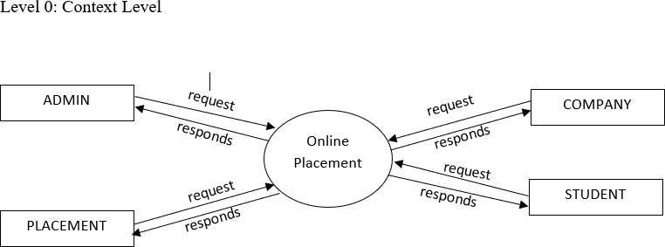
Level 1 : Admin
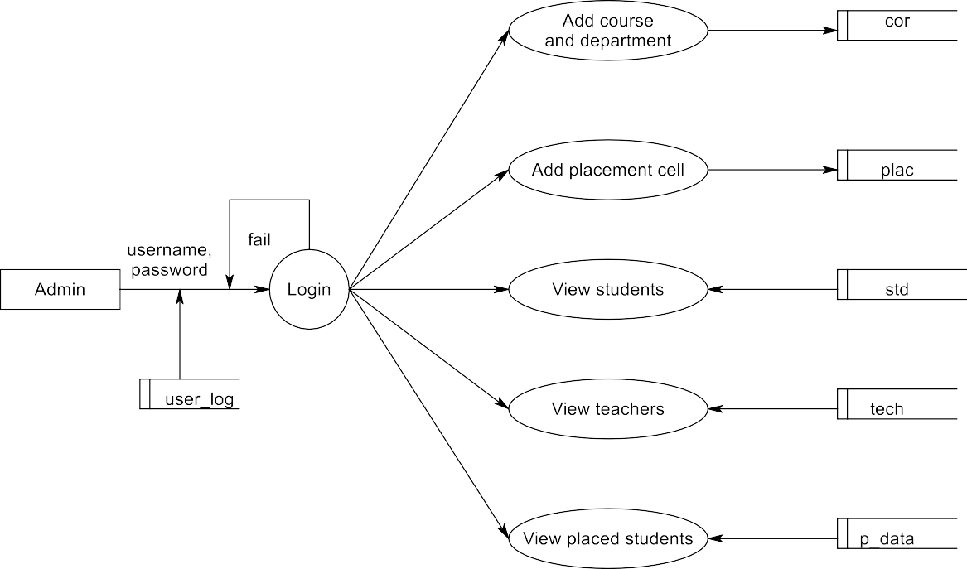
Level 2 : Placement Cell
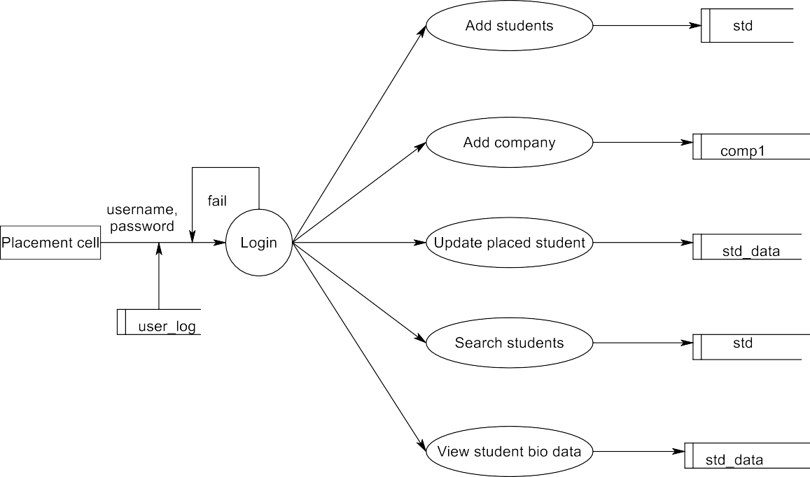
Level 3 : Student
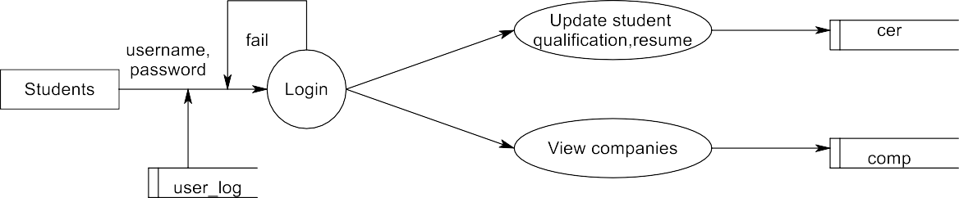
Level 4 : Company
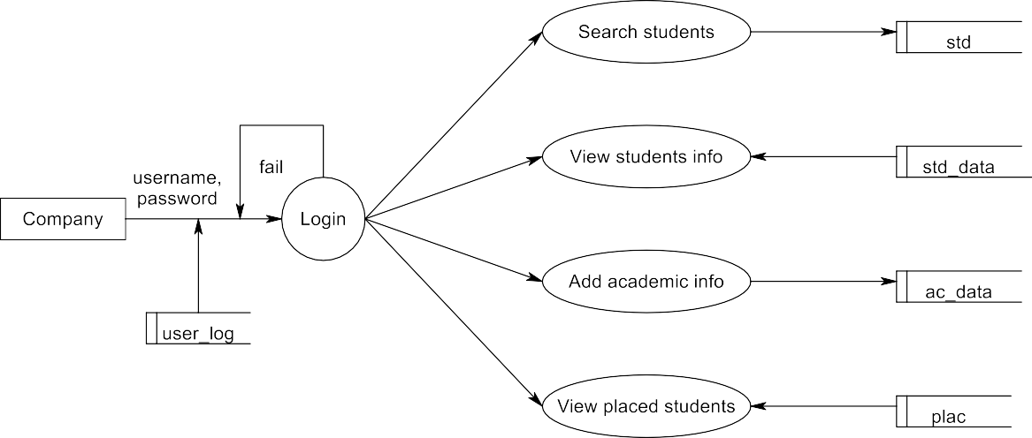
- USE CASE DIAGRAM

A Use Case Diagram displays the relationship among actors and Use Cases. Use Case Diagrams are drawn to capture the functional requirements of a system. Use case diagrams are used to gather the requirements of a system including internal and external influences. These requirements are mostly design requirements.
- To identify functions and how roles interact with them.
- For a high-level view of the system.
- To identify internal and external actors The two main components of Use Case Diagrams are actor and cases.
- Actor
Actor in a Use Case Diagrams is any entity that performs a role in one given system. This could be a person, organization or an external system and usually drawn like skeleton shown below:

- Use case
A Use case represents a function or an action within the system. It is drawn as an oval and named with the function. Symbol of Use case is shown below:

Admin
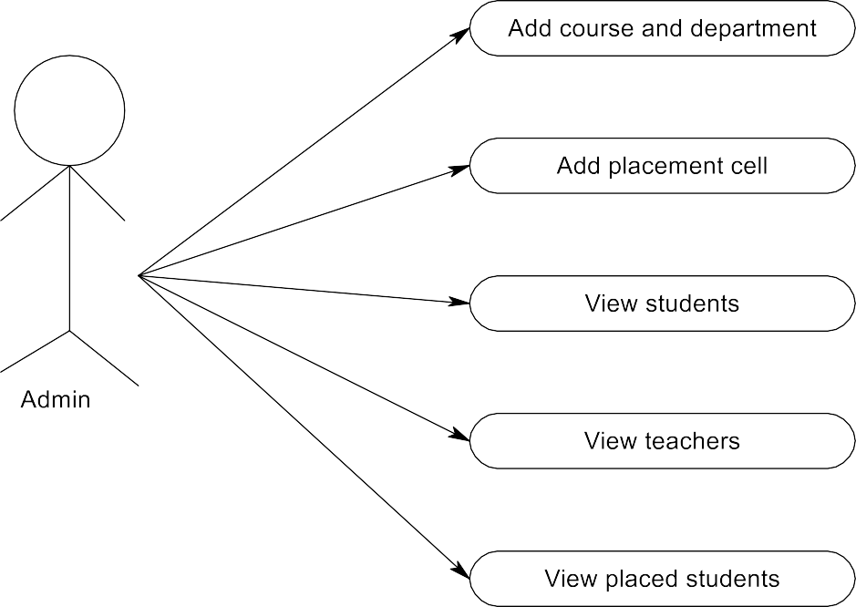
Placement Cell
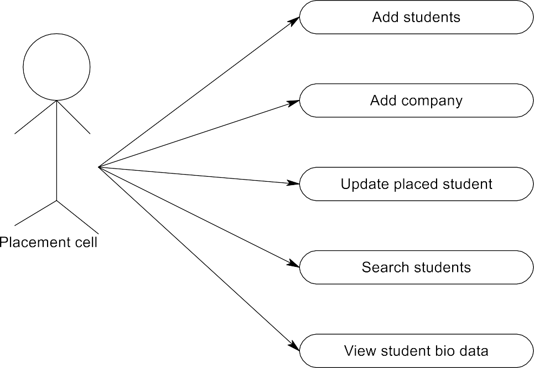
Student
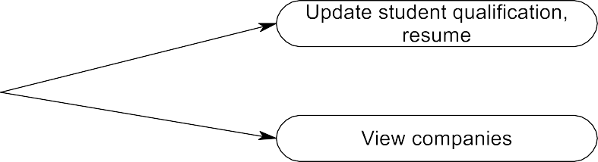
Company
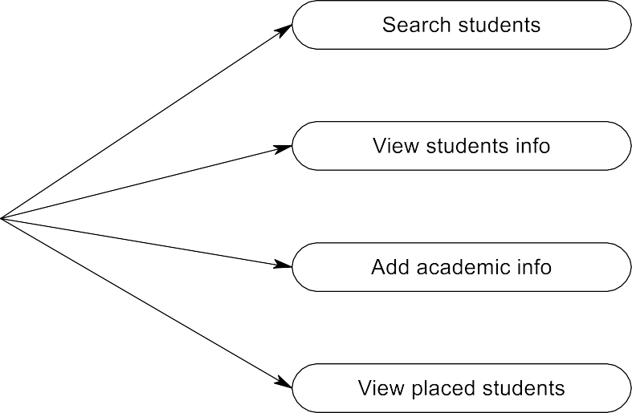
MENU TREE

STRUCTURE CHART

E-R DIAGRAM
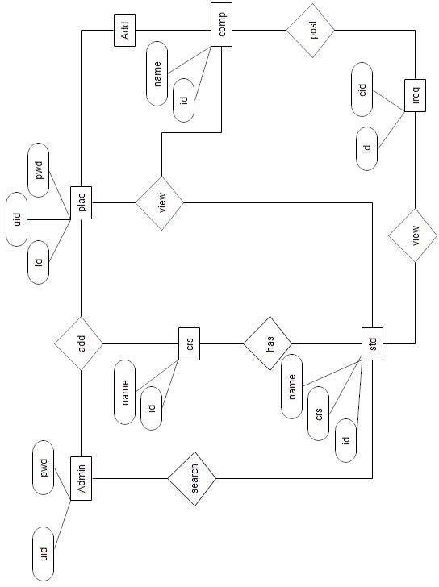

CHAPTER 7

- Database Design

Column | Type | Null | Constraints
id | int(11) | No | Primary Key
sem | varchar(150) | No | Not Null
sid | varchar(150) | No | Foreign Key
mk | varchar(150) | No | Not Null
att | varchar(150) | No | Not Null
ov | varchar(150) | No | Not Null
st | int(11) | No | Not Null
Database Name : placement3 Table structure for table acc_data

Table structure for table cer

Column | Type | Null | Constraints
id | int(11) | No | Primary Key
sid | varchar(150) | No | Foreign Key
tit | varchar(150) | No | Not Null
ph | varchar(150) | No | Not Null
st | int(11) | No | Not Null

Table structure for table com

Column | Type | Null | Constraints
id | int(11) | No | Primary Key
tit | varchar(150) | No | Not Null
nme | varchar(150) | No | Not Null
c_dt | text | No | Not Null
cont | varchar(150) | No | Not Null
em | varchar(150) | No | Unique
cor | varchar(150) | No | Foreign Key
dpt | varchar(150) | No | Foreign Key
desc | text | No | Not Null
ph | varchar(150) | No | Not Null
dt | date | No | Not Null
uid | varchar(150) | No | Foreign Key
st | int(11) | No | Not Null

Table structure for table com1

Column | Type | Null | Constraints
id | int(11) | No | Primary Key
tit | varchar(150) | No | Not Null
nme | varchar(150) | No | Not Null
c_dt | text | No | Not Null
cont | varchar(150) | No | Not Null
em | varchar(150) | No | Foreign Key
cor | varchar(150) | No | Foreign Key
dpt | varchar(150) | No | Foreign Key
desc | text | No | Not Null
ph | varchar(150) | No | Not Null
dt | date | No | Not Null
uid | varchar(150) | No | Foreign Key
st | int(11) | No | Not Null

Table structure for table comp

Column | Type | Null | Constraints
id | int(11) | No | Primary Key
sid | varchar(150) | No | Foreign Key
adid | varchar(150) | No | Foreign Key
dt | date | No | Not Null
tit | varchar(150) | No | Not Null
msg | text | No | Not Null
tid | varchar(150) | No | Foreign Key
st | int(11) | No | Not Null

Table structure for table com_data

Column | Type | Null | Constraints
id | int(11) | No | Primary Key
nme | varchar(150) | No | Not Null
addr | text | No | Not Null
cont | varchar(150) | No | Not Null
em | varchar(150) | No | Not Null
st | int(11) | No | Not Null

Table structure for table cor

Column | Type | Null | Constraints
id | int(11) | No | Primary Key
nme | varchar(150) | No | Not Null
st | int(11) | No | Not Null

Table structure for table dpt

Column | Type | Null | Constraints
id | int(11) | No | Primary Key
cid | varchar(150) | No | Foreign Key
nme | varchar(150) | No | Not Null
st | int(11) | No | Not Null

Table structure for table i_req

Column | Type | Null | Constraints
id | int(11) | No | Primary Key
pid | varchar(150) | No | Foreign Key
uid | varchar(150) | No | Foreign Key
cid | varchar(150) | No | Foreign Key
dt | varchar(150) | No | Not Null
st | int(11) | No | Not Null

Table structure for table mrk

Column | Type | Null | Constraints
id | int(11) | No | Primary Key
nme | varchar(150) | No | Not Null
des | varchar(150) | No | Not Null
sem | varchar(150) | No | Not Null
ph | varchar(150) | No | Not Null
dt | date | No | Not Null
dpt | varchar(150) | No | Foreign Key
st | int(11) | No | Not Null

Table structure for table msg

Column | Type | Null | Constraints
id | int(11) | No | Primary Key
dt | date | No | Not Null
nme | varchar(150) | No | Not Null
msg | text | No | Not Null
sid | varchar(150) | No | Foreign Key
st | int(11) | No | Not Null

Table structure for table plac

Column | Type | Null | Constraints
id | int(11) | No | Primary Key
nme | varchar(150) | No | Not Null
cont | varchar(150) | No | Not Null
em | varchar(150) | No | Not Null
pas | varchar(150) | No | Not Null
st | int(11) | No | Not Null
Table structure for table p_req

Column | Type | Null | Constraints
id | int(11) | No | Primary Key
pid | varchar(150) | No | Foreign Key
uid | varchar(150) | No | Foreign Key
cid | varchar(150) | No | Foreign Key
dt | varchar(150) | No | Not Null
st | int(11) | No | Not Null
Table structure for table p_std

Column | Type | Null | Constraints
id | int(11) | No | Primary Key
sid | varchar(150) | No | Foreign Key
cid | varchar(150) | No | Foreign Key
st | int(11) | No | Not Null
Table structure for table std

Column | Type | Null | Constraints
id | int(11) | No | Primary Key
ad_no | varchar(150) | No | Unique
y_ad | varchar(150) | No | Not Null
nme | varchar(150) | No | Not Null
age | int(11) | No | Not Null
gen | varchar(150) | No | Not Null
sem | varchar(150) | No | Foreign Key
dob | varchar(150) | No | Not Null
con | varchar(150) | No | Not Null
em | varchar(150) | No | Unique
pass | varchar(150) | No | Not Null
addr | text | No | Not Null
gard | varchar(150) | No | Not Null
rela | varchar(150) | No | Not Null
d_con | varchar(150) | No | Not Null
d_em | varchar(150) | No | Not Null
d_addr | text | No | Not Null
d_pass | varchar(150) | No | Not Null
ph | varchar(150) | No | Not Null
cor | varchar(150) | No | Not Null
dpt | varchar(150) | No | Not Null
st | int(11) | No | Not Null

Table structure for table tech
Column | Type | Null | Constraints
id | int(11) | No | Primary Key
y_ad | int(11) | No | Not Null
nme | varchar(150) | No | Not Null
age | int(11) | No | Not Null
gen | varchar(150) | No | Not Null
sem | varchar(150) | No | Not Null
dob | date | No | Not Null
con | varchar(150) | No | Not Null
em | varchar(150) | No | Foreign Key
adt | text | No | Not Null
pas | varchar(150) | No | Not Null
ph | varchar(150) | No | Not Null
cor | varchar(150) | No | Not Null
dpt | varchar(150) | No | Foreign Key
st | int(11) | No | Not Null
Table structure for table user_login

Column | Type | Null | Constraints
id | int(11) | No | Primary Key
uid | varchar(150) | No | Unique
pas | varchar(150) | No | Not Null
typ | varchar(150) | No | Not Null
st | int(11) | No | Not Null

CHAPTER 8

- Coding And Testing

- CODING

The coding is the process of transforming the design of a system into a computer language format. This coding phase of software development is concerned with software translating design specification into the source code. It is necessary to write source code & internal documentation so that conformance of the code to its specification can be easily verified.Coding is done by the coder or programmers who are independent people than the designer. The goal is not to reduce the effort and cost of the coding phase, but to cut to the cost of a later stage. The cost of testing and maintenance can be significantly reduced with efficient coding.

- TESTING

Software testing is a critical element of software quality assurance and represent the ultimate review of specification, design and coding. System testing is actually a series of different test whose purpose is to fully exercise the computer-based system. Although each has a different purpose, all of them work to verify that all system elements have been properly integrated and all of them perform allocated functions. If the test is conducted successfully, it will uncover errors in the software. A second benefit is that the software is appearing to be working according to specification and that performance requirements appear to have been met.
System testing is an inexpensive but critical process that can take as much as 50|% of budget for development, the view of testing holds by users that is performed to prove
that there is no error in the program. However, this is virtually impossible since analysis cannot prove that software is free and clear to errors. Testing is the process of executing a program with explicit intensions of finding errors.

- LEVELS OF TESTING

Unit Testing :

Unit testing comprises of a set of tests performed by an individual programmer prior to the integration of unit into large system. A large program unit is usually small enough that the programmer who developed and that can be in great detail and certainly in greater detail than possible when the unit is integrated into an evolving software project. Module unit testing should be as exhaustive as possible to ensure that each representation is handled by each module that has been tested. All the units that make up the system were tested independently to ensure that they work as required. These types of test are usually written by developers as they work on code (white-box style), to ensure that the specific function might have multiple tests, to catch corner cases or other branches I the code. Unit testing alone cannot verify the functionality of a piece of software, but rather is used to assure that the building blocks the software uses work independently of each other.

Integration Testing :
Integration testing is a system technique for constructing program structure while at the same time conducting tests to uncover errors associated with interfacing. The objective is to take the unit tested modules and build a program structure that has been dictated by design.
Integration testing is any type of software testing that seeks to verify the interfaces between components against a software design. Software components may be integrated in an iterative way or all together (“big bang”). Normally, the former is considered as a
better practice since it allows interface issues to be located more quickly and fixed. Integration testing works to defects in the interfaces and interaction between integrated components (modules). Progressively larger groups of tested software components corresponding to elements of the architectural design are integrated and tested until the software works as system.
System Testing :

System testing is actually a series of different tests, whose purpose is to test the completed system in it’s entirely as a whole exercise. System testing involves security testing, performance testing and recovery testing.After output testing the whole system is tested in different platforms and browsers for testing the overall functionality and user interface of the system in various environment. This testing is done after completing all the testing, ie system testing is the final phase of the testing process.
Validation Testing :

At the culmination of integration testing, the software was completely assembled as a package, interfacing errors have been uncovered and corrected and a final series of software validation testing began.In validation testing the entered data validated for correct format, and correct order.
Output Testing :

After performing validation test, the next phase is output test of the system, since no system could be useful if it does not produce desired output in the desired format. The output format was considered in two ways: one is on the screen and the other as a printed form.
User Acceptance Testing (UAT) is a type of testing performed by the end user or the client to verify/accept the software system before moving the software application to the production environment. UAT is done in the final phase of testing after functional, integration and system testingis done.
- SECURITY, BACKUP, AND RECOVERY

Security

In an organization, there are many users of the system, security measures are most. An organization can suffer a loss if security is in adequate. There are three types of losses that an organization doesn’t want its system suffer.
- Loss of availability
- Loss of integrity
- Loss of confidentiality The possible threats are:
  - Accidental destruction of hardware
  - Accidental modification of software
  - Deliberate removal of programs
  - Deliberate disclosure of information
Security refers to the production of the data against unauthorized access, alteration or destruction. Security is critical in system development. The amount of protection depends on the sensitivity of date, the reliability of the user, and the complexity of the system. Security measures are used in different levels. The data stored in the database is of high importance. This tampering the data by unauthorized user should be restricted. Granting access to specify users will give a high range of security to the database. Security is provided in two levels.
Application level
Password protection is provided at the application level, so that unauthorized users have no access to the application and the information in the database through the application. In order to avoid loss of password to someone who accesses the database directly, the password is encrypted in the database level. That is the system encrypts the password, stores into the register in an ineligible format.
For protecting from unauthorized users, the administrator username and password can be stored in the login table and call them during the execution.
File level :
File level security is provided in case the database gets accidently deleted or destroyed. In such cases the system provides mechanism for restoration of the database from the backup file stored in the floppy or hard disk. Here the system being PC Based Programming Scheduling.

- BACKUP AND RECOVERY MECHANISM

At the time of developing our software, we can place the backup copy of our software files into CD and other drives. This helps to secure our software files from missing the files or documents. Back up the files helps to taking no risk for doing the work for developing the software. When something wrong can occur in the file, we cannot disappoint because there are some back up files.
Recovery mechanism is a method for recovering the files that can go by missing or any other unsecured protection. Recovery is an automatic mechanism for re initialization, Check pointing mechanism, data recovery and restart that are evaluated for re- correctness. If any files contain mistakes, we can replace the file from the backup folder and paste to the original destination. After this, we should add the existing item from the solution explorer. Through this, we can recover wrong files. Through recovery mechanism, we can recover corrupted files or destroyed files.

CHAPTER 9
- Software Maintenance
Maintenance is a characteristic of design and implementation, which is expressed, as the probability that can an item will be retained in or restored to a specific condition within a given period of time, when maintenance is performed to accordance with the prescribed procedures and resource.
Maintenance is the enigma of system development. It holds the software industry captive, tying up programming resources. Analyst and programmers spend far more time maintaining program than they do writing them.
Maintenance can be classified as corrective, adaptive or prefecture. Corrective maintenance means repairing processing or performance failures or making changes because of previously uncorrected problem or false assumptions. Adaptive maintenance means repairing processing or performance or modifying the program to respond to the users additional or changing needs. Of this type more time and money are spent on prefecture than on corrective and adaptive maintenance.
Technical and management approaches to the maintenance phase can be implemented with little upheaval. However, tasks performed during the software engineering process define maintainability and have an important on the success of any maintenance approach. 6.1 Types of maintenance
There are mainly three types of maintenance. They are corrective, adaptive and perceptive maintenance
Corrective Maintenance :
Corrective maintenance removed the software faults in our project. Corrective maintenance should be of overriding priority for the software maintenance which improves the system without changing its functionality.
Adaptive Maintenance :
Adaptive Maintenance was used because of changing in the user requirement changes in the target platform. Or change in the external interface.
Perceptive Maintenance :
Perspective maintenance was done to prevent the failure and optimize the software; adaptive maintenance modifies the software to keep it up to date with its operative.
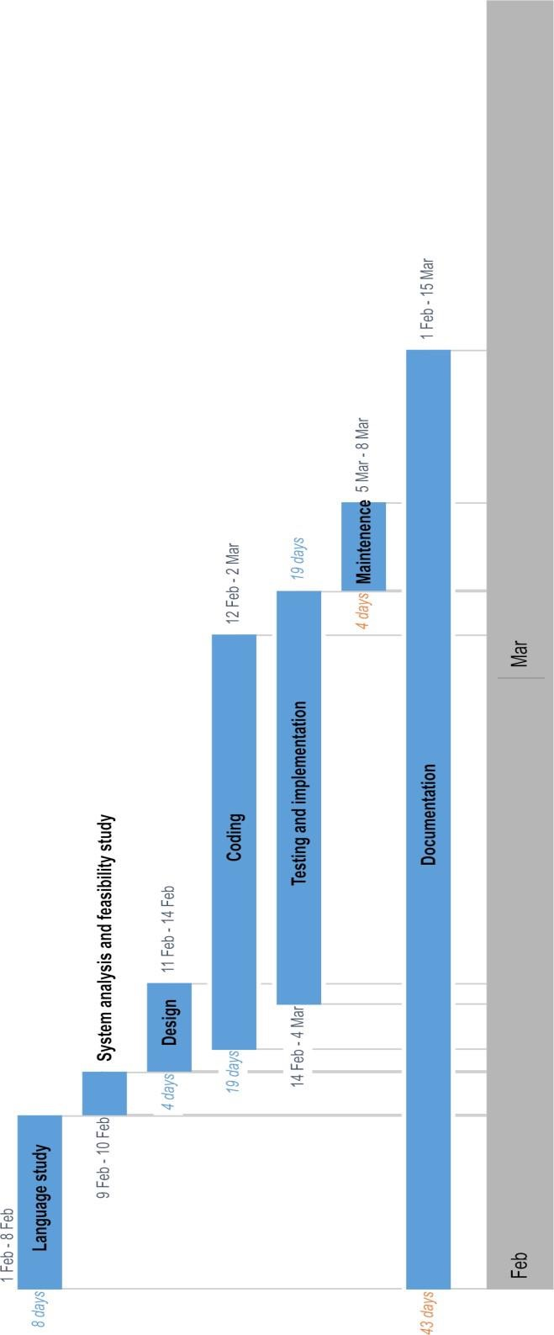
CHAPTER 10 CONCLUSION

The "Integrated College Placement Cell Portal" embodies a significant leap in leveraging technology to enhance the management of placement activities within an educational institution. This project marks the transformation of traditional manual systems into a dynamic, efficient, and scalable web-based portal tailored to meet the evolving demands of placement management. By integrating advanced technologies such as HTML, CSS, PHP, MySQL, and Bootstrap, the portal ensures a user-friendly interface, robust functionality, and seamless operation for all stakeholders involved.
The developed system not only reduces the dependency on labor-intensive processes but also minimizes the risk of errors and redundancies. With its login-enabled access, users across different modules—whether they are Placement Officers, students, or companies—can interact with the system efficiently. The features enabling secure storage and real-time access to student information, automated generation of candidate lists based on company eligibility criteria, and effortless navigation of data ensure that this portal enhances the productivity and performance of placement departments. Furthermore, the facility for students to update their academic details and for Placement Officers to streamline communication fosters a collaborative and transparent environment.
From an operational perspective, the system underscores its feasibility by delivering a practical, accessible, and secure solution for placement activities. Placement Officers benefit from the ease of managing student profiles and records, while students gain improved access to opportunities and clarity in recruitment processes. Companies, too, are empowered with targeted search options to identify eligible candidates effectively.
The project fulfills all specified requirements and demonstrates its versatility through customizable and scalable design, ensuring adaptability to future needs. In addition, its
integration with modern web technologies establishes a reliable platform that not only streamlines placement management but also serves as a sustainable solution for the long term.
In conclusion, the "Integrated College Placement Cell Portal" is more than a technical achievement; it is a testament to innovation, collaboration, and a commitment to improving operational efficiency in educational institutions. This project bridges the gap between manual systems and modern technological advancements, enabling a streamlined and effective placement process that benefits students, educational organizations, and recruiting companies alike. It stands as a milestone in harnessing technology to empower institutions and their stakeholders, paving the way for a brighter and more efficient future in campus placements.

References

- Kumar, S., & Rajasekaran, C. (2018). Design and Implementation of Campus Recruitment System. International Journal of Computer Applications, 179(31), 24–30.
- Gupta, P., & Bhatia, P. (2017). Automation of Placement Process: A Web-based Application. International Journal of Advanced Research in Computer Science, 8(5), 2004–2009.
- Mishra, S., & Singh, R. (2016). Campus Placement Management System Using Cloud Computing. International Journal of Emerging Technologies and Innovative Research (JETIR), 3(5), 379–383.
- Patil, S., & Jadhav, V. (2015). Student Recruitment System: A Web Application. International Journal of Computer Applications Technology and Research, 4(7), 546–549.
- Bootstrap Documentation. (n.d.). Introduction to Bootstrap. Retrieved from https://getbootstrap.com/docs
- W3Schools. (n.d.). HTML, CSS, PHP, and MySQL Tutorials. Retrieved from https://www.w3schools.com
- Chandran, D., & Krishnan, A. (2019). Online Campus Placement Management System. International Journal of Engineering Research and Technology (IJERT), 8(3), 450–453.

Source Code

Connection.php :
<?php
$title="GPTC NEDUMANGAD PLACEMENT CELL PORTAL";
$dbcon=mysqli_connect("localhost","root","","placement3");
?>
<script type="text/javascript"> function nme(b2)
{
var k5=b2.length; var ch2=/([a-z])$/;
if(ch2.test(b2)==false)
{
document.getElementById("np3").innerHTML="<font color='red'>*Only Alphabets*</font>";
$("#btn").hide(); return false;
}

else
{
document.getElementById("np3").innerHTML="";
$("#btn").show();
}
}
function chkc(b2)
{
var k5=b2.length; var ch2=/([0-9])$/;
if(ch2.test(b2)==false)
{
document.getElementById("o3").innerHTML="<font color='red'>*Only Numbers*</font>";
$("#btn").hide(); return false;
}
else if(k5!=10)
{
document.getElementById("o3").innerHTML="<font color='red'>*Please Check Your Mobile Number*</font>";
$("#btn").hide(); return false;
}
else
{
document.getElementById("o3").innerHTML="";
$("#btn").show();
}
}

function chkp(c)
{
var s=document.getElementById("p10").value;

if(s==c)
{
document.getElementById("p").innerHTML="<font color='Green'>*Password is Correct*</font>";
$("#btn").show(); return false;
}
else
{
document.getElementById("p").innerHTML="<font color='red'>*Verfy Password*</font>";
$("#btn").hide();
}
}

function vem(a)
{
//var a = document.myform.email.value; var atposition = a.indexOf("@");
var dotposition = a.lastIndexOf(".");
if (atposition<1 || dotposition<atposition+2 || dotposition+2>=a.length)
{
document.getElementById("em").innerHTML="<font color='red'>*Please Check Your Email Address*</font>";
$("#btn").hide();
}
else
{
document.getElementById("em").innerHTML="";
$("#btn").show();
}
}
</script>
Add_comp_c.php :

<?php
include '../connection.php'; ob_start();
session_start();
$usr=$_SESSION['uid'];

?>
<?php

if($usr=$_SESSION['uid'])
{

}
else
{
header("location:../index.php");
}
?>
<?php if(isset($_POST['b1']))
{

$t1=$_POST['t1'];

$t2=$_POST['t2'];
$t3=$_POST['t3'];
$t4=$_POST['t4'];
$t5=$_POST['t5'];
$log1=mysqli_query($dbcon,"select * from com_data where nme='$t1'"); if(mysqli_num_rows($log1)>0)
{
echo '<script>alert("Data Already Added")</script>';
}
else
{

$log1=mysqli_query($dbcon,"select * from com_data where em='$t4'"); if(mysqli_num_rows($log1)>0)
{
echo '<script>alert("Email Already Added")</script>';
}
else
{
$ins=mysqli_query($dbcon,"insert into com_data values('','$t1','$t2','$t3','$t4','0')"); if($ins>0)
{
$ins1=mysqli_query($dbcon,"insert into user_login values('','$t4','$t5','comp','1')"); if($ins1>0)
{

header("location:add_comp.php?suss=1");
}
}
}

}
}

?>
<!DOCTYPE html>
<html lang="en">

<head>
<meta http-equiv="Content-Type" content="text/html; charset=UTF-8">
<!-- Meta, title, CSS, favicons, etc. -->
<meta charset="utf-8">
<meta http-equiv="X-UA-Compatible" content="IE=edge">
<meta name="viewport" content="width=device-width, initial-scale=1">

<title>Placement Managment </title>

<!-- Bootstrap core CSS -->

<link href="../temp/css/bootstrap.min.css" rel="stylesheet">

<link href="../temp/fonts/css/font-awesome.min.css" rel="stylesheet">
<link href="../temp/css/animate.min.css" rel="stylesheet">

<!-- Custom styling plus plugins -->
<link href="../temp/css/custom.css" rel="stylesheet">
<link href="../temp/css/icheck/flat/green.css" rel="stylesheet">
<!-- editor -->
<link href="../temp/http://netdna.bootstrapcdn.com/font-awesome/3.0.2/css/font-awesome.css" rel="stylesheet">
<link href="../temp/css/editor/external/google-code-prettify/prettify.css" rel="stylesheet">
<link href="../temp/css/editor/index.css" rel="stylesheet">
<!-- select2 -->
<link href="../temp/css/select/select2.min.css" rel="stylesheet">
<!-- switchery -->
<link rel="stylesheet" href="../temp/css/switchery/switchery.min.css" />
<script src="../temp/js/jquery.min.js"></script>

<!--[if lt IE 9]>
<script src="../temp/../assets/js/ie8-responsive-file-warning.js"></script>
<![endif]-->

<!-- HTML5 shim and Respond.js for IE8 support of HTML5 elements and media queries -->
<!--[if lt IE 9]>
<script src="../temp/https://oss.maxcdn.com/html5shiv/3.7.2/html5shiv.min.js"></script>
<script src="../temp/https://oss.maxcdn.com/respond/1.4.2/respond.min.js"></script>
<![endif]-->

</head>

<body class="nav-md">

<div class="container body">

<div class="main_container">

<!-- top navigation -->
<div class="top_nav">

<div class="nav_menu">
<nav class="" role="navigation">

</nav>
</div>

</div>
<!-- /top navigation -->

<!-- page content -->
<div class="right_col" role="main">
<div class="">

<div class="page-title">
<div class="title_left">
<h3>Registered Company</h3>
</div>

</div>
<div class="clearfix"></div>
<div class="row">
<div class="col-md-12 col-sm-12 col-xs-12">
<div class="x_panel">
<div class="x_content">

<table id="myTable" class="table table-striped table-bordered projects">
<thead>
<tr>
<th style="width: 1%">#</th>
<th style="width: 20%">Name</th>

<th>Address</th>
<th>Contact</th>
<th>Email</th>

</tr>
</thead>
<tbody>
<?php

$sel_gal=mysqli_query($dbcon,"select * from com_data"); if(mysqli_num_rows($sel_gal)>0)
{$i=0;
while($r_gal=mysqli_fetch_row($sel_gal))
{

<tr>
<td>#</td>
<td>
$i++;
?>
<a href="#"><?php echo $r_gal[1] ?></a>

</td>

<td>
<?php echo $r_gal[2] ?>
</td>
<td>
<?php echo $r_gal[3] ?>
</td>
<td>
<?php echo $r_gal[4] ?>
</td>

</tr>

<?php
}
}
?>

</tbody>
</table>

</div>
</div>
</div>
</div>

<script type="text/javascript">
$(document).ready(function() {
$('#birthday').daterangepicker({ singleDatePicker: true, calender_style: "picker_4"
}, function(start, end, label) { console.log(start.toISOString(), end.toISOString(), label);
});
});
</script>

</div>
<!-- /page content -->

<!-- footer content -->

<!-- /footer content -->

</div>

</div>
</div>

<div id="custom_notifications" class="custom-notifications dsp_none">
<ul class="list-unstyled notifications clearfix" data-tabbed_notifications="notif-group">
</ul>
<div class="clearfix"></div>
<div id="notif-group" class="tabbed_notifications"></div>
</div>

<script src="../temp/js/bootstrap.min.js"></script>

<!-- bootstrap progress js -->
<script src="../temp/js/progressbar/bootstrap-progressbar.min.js"></script>
<script src="../temp/js/nicescroll/jquery.nicescroll.min.js"></script>
<!-- icheck -->
<script src="../temp/js/icheck/icheck.min.js"></script>
<!-- tags -->
<script src="../temp/js/tags/jquery.tagsinput.min.js"></script>
<!-- switchery -->
<script src="../temp/js/switchery/switchery.min.js"></script>
<!-- daterangepicker -->
<script type="text/javascript" src="../temp/js/moment/moment.min.js"></script>
<script type="text/javascript" src="../temp/js/datepicker/daterangepicker.js"></script>
<!-- richtext editor -->
<script src="../temp/js/editor/bootstrap-wysiwyg.js"></script>
<script src="../temp/js/editor/external/jquery.hotkeys.js"></script>
<script src="../temp/js/editor/external/google-code-prettify/prettify.js"></script>
<!-- select2 -->
<script src="../temp/js/select/select2.full.js"></script>
<!-- form validation -->
<script type="text/javascript" src="../temp/js/parsley/parsley.min.js"></script>
<!-- textarea resize -->
<script src="../temp/js/textarea/autosize.min.js"></script>
<script> autosize($('.resizable_textarea'));
</script>
<!-- Autocomplete -->
<script type="text/javascript" src="../temp/js/autocomplete/countries.js"></script>
<script src="../temp/js/autocomplete/jquery.autocomplete.js"></script>
<!-- pace -->
<script src="../temp/js/pace/pace.min.js"></script>

<script src="../temp/js/custom.js"></script>

<!-- select2 -->

<!-- /select2 -->
<!-- input tags -->

<!-- /input tags -->
<!-- form validation -->

<!-- /form validation -->
<!-- editor -->

<!-- /editor -->
</body>

</html>
<script>

window.print();

</script>
Man_c.php

<?php
include '../connection.php'; ob_start();
session_start();
$usr=$_SESSION['uid'];

?>
<?php

if($usr=$_SESSION['uid'])
{

}
else
{
header("location:../index.php");
}
?>
<?php

$sel1=mysqli_query($dbcon,"select * from tech where em='$usr'");
$r=mysqli_fetch_row($sel1);
?>
<?php if(isset($_GET['pr']))
{
$pr=$_GET['pr'];
$st=mysqli_query($dbcon,"select * from std where id='$pr'");
$st1=mysqli_fetch_row($st);
$date=date('Y-m-d');

$ins1=mysqli_query($dbcon,"insert into att values('','$pr','$st1[1]','$st1[6]','$date','$usr','1')");

if($ins1>0)
{

header("location:man.php");
}
}

?>
<?php if(isset($_GET['ab']))
{
$ab=$_GET['ab'];
$sta=mysqli_query($dbcon,"select * from std where id='$ab'");
$sta1=mysqli_fetch_row($sta);
$date=date('Y-m-d');

$ins2=mysqli_query($dbcon,"insert into att values('','$ab','$sta1[1]','$sta1[6]','$date','$usr','2')");

if($ins2>0)
{

header("location:man.php");
}
}

?>

<!DOCTYPE html>
<html lang="en">

<head>
<meta http-equiv="Content-Type" content="text/html; charset=UTF-8">
<!-- Meta, title, CSS, favicons, etc. -->
<meta charset="utf-8">
<meta http-equiv="X-UA-Compatible" content="IE=edge">
<meta name="viewport" content="width=device-width, initial-scale=1">

<title>Placement Managment </title>

<!-- Bootstrap core CSS -->

<link href="../temp/css/bootstrap.min.css" rel="stylesheet">

<link href="../temp/fonts/css/font-awesome.min.css" rel="stylesheet">
<link href="../temp/css/animate.min.css" rel="stylesheet">

<!-- Custom styling plus plugins -->
<link href="../temp/css/custom.css" rel="stylesheet">
<link href="../temp/css/icheck/flat/green.css" rel="stylesheet">

<script src="../temp/js/jquery.min.js"></script>

<!--[if lt IE 9]>
<script src="../temp/../assets/js/ie8-responsive-file-warning.js"></script>
<![endif]-->

<!-- HTML5 shim and Respond.js for IE8 support of HTML5 elements and media queries -->
<!--[if lt IE 9]>
<script src="../temp/https://oss.maxcdn.com/html5shiv/3.7.2/html5shiv.min.js"></script>
<script src="../temp/https://oss.maxcdn.com/respond/1.4.2/respond.min.js"></script>
<![endif]-->
</head>

<body class="nav-md">

<div class="container body">

<div class="main_container">

<!-- top navigation -->
<div class="top_nav">

<div class="nav_menu">

</div>

</div>
<!-- /top navigation -->

<!-- page content -->
<div class="right_col" role="main">

<div class="">
<div class="page-title">
<div class="title_left">
<h3>Manage <small>Placement Cell</small></h3>
</div>

</div>
<div class="clearfix"></div>

<div class="row">
<div class="col-md-12">
<div class="x_panel">
<div class="x_title">

<ul class="nav navbar-right panel_toolbox">
<li><a class="collapse-link"><i class="fa fa-chevron-up"></i></a>
</li>
<li class="dropdown">
<a href="#" class="dropdown-toggle" data-toggle="dropdown" role="button" aria- expanded="false"><i class="fa fa-wrench"></i></a>
<ul class="dropdown-menu" role="menu">
<li><a href="#">Settings 1</a>
</li>
<li><a href="#">Settings 2</a>
</li>
</ul>
</li>
<li><a class="close-link"><i class="fa fa-close"></i></a>
</li>
</ul>
<div class="clearfix"></div>
</div>
<div class="x_content">

<!-- start project list -->
<table class="table table-striped table-bordered projects">
<thead>
<tr>
<th style="width: 1%">#</th>
<th style="width: 20%">Name</th>

<th>Course</th>

<th>Email</th>
<th>Contact</th>
<th>Address</th>

</tr>
</thead>
<tbody>
<?php

$sel_gal=mysqli_query($dbcon,"select * from tech"); if(mysqli_num_rows($sel_gal)>0)
{$i=0;
while($r_gal=mysqli_fetch_row($sel_gal))
{
$i++;
?>
<tr>
<td>#</td>
<td>
<a href="#"><?php echo $r_gal[2] ?></a>

</td>

<td>
<?php
$sel1=mysqli_query($dbcon,"select * from cor where id='$r_gal[12]'");
$r1=mysqli_fetch_row($sel1);

echo"$r1[1]";
?>
</td>

<td>
<?php echo $r_gal[8] ?>
</td>
<td>
<?php echo $r_gal[7] ?>
</td>
<td>
<?php echo $r_gal[9] ?>
</td>

</tr>

<?php
}
}
?>
</tbody>
</table>
<!-- end project list -->

</div>
</div>
</div>
</div>
</div>

<!-- footer content -->

<!-- /footer content -->

</div>
<!-- /page content -->
</div>

</div>

<div id="custom_notifications" class="custom-notifications dsp_none">
<ul class="list-unstyled notifications clearfix" data-tabbed_notifications="notif-group">
</ul>
<div class="clearfix"></div>
<div id="notif-group" class="tabbed_notifications"></div>
</div>

<script src="../temp/js/bootstrap.min.js"></script>

<!-- bootstrap progress js -->
<script src="../temp/js/progressbar/bootstrap-progressbar.min.js"></script>
<script src="../temp/js/nicescroll/jquery.nicescroll.min.js"></script>
<!-- icheck -->
<script src="../temp/js/icheck/icheck.min.js"></script>

<script src="../temp/js/custom.js"></script>
<!-- pace -->
<script src="../temp/js/pace/pace.min.js"></script>

</body>

</html>
<script>

window.print();

</script>

Screenshots
