GUI Design Prototypes

Version 1 mock:
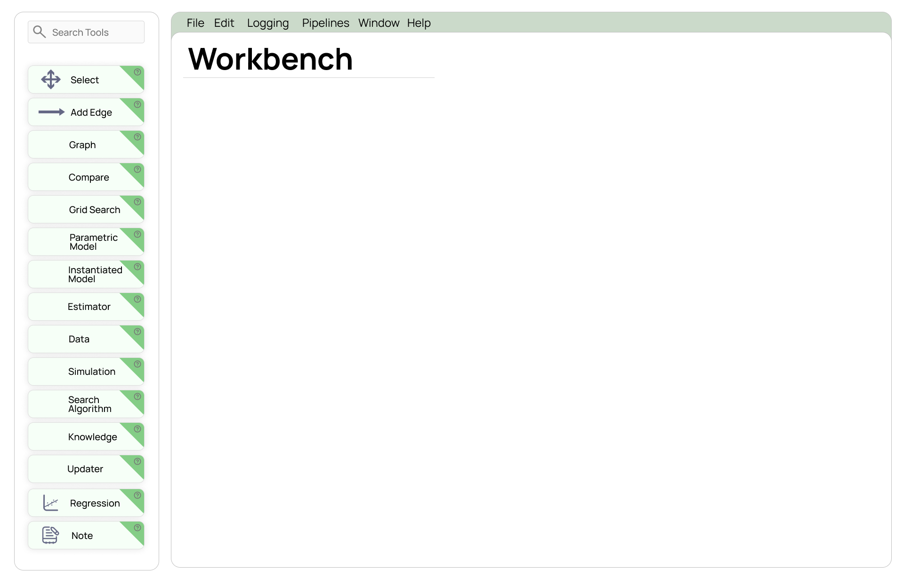
Designed using Figma

Original TETRAD GUI | MOCK TETRAD GUI | Benefit
Plain, un-styled buttons | Rounded cards with faint green highlights | Visual hierarchy and aesthetics making the cards appear obviously clickable
Unable to search for tools | Noticeable search bar at the top | Recognition over recall means users can type to avoid scanning through the whole list of tools
No help beyond menu items | Small “?” icons on each card | Contextual help for novice users to get guidance when needed
Monochrome tool list | Consistent colour accent, and clear labels with icons | Consistency and standardisation with uniform style and text to allow fast scanning of tools
Unlabelled blank canvas | “Workbench” header establishes the workspace as a key area | Visibility of system status to reassure users where they are

Improvements to be made:
- Hover activated “?” buttons rather than a persistent “?” on every tool
- Collapsible categories of tools to avoid displaying all 15 in a long list
- Highlight activated items, e.g. colour change when tool is selected
- “Learn” sidebar that opens to show step by step instructions and video tutorials for beginners to the software

