Project Definition

TETRAD is a tool providing a framework for statistical testing and graphical modelling of causal structures. A drawback of TETRAD is that its current user interface is complex and difficult to navigate for new users, especially those without a technical background. University level researchers may struggle to effectively use TETRAD due to the poor usability design creating a steep learning curve, particularly for those in education or social sciences. This barrier to entry for university students lowers the benefit that use of advanced causal modelling techniques could otherwise yield.
Accessible causal analysis tools are critically important to research in many fields, however there are currently no GUI’s that are designed for non-expert users or for universities educational and research purposes. Existing GUI’s prioritise expert use and have no emphasis on clarity and accessibility of the software. There remains to be a solution which integrates guided workflows, intuitive model editing and tutorial driven interfaces for beginners.
My project will address this gap by designing a custom GUI for TETRAD to enable students and inexperienced researchers to more easily load data. This will enable a wider range of users to construct and visualise causal graphs, perform statistical tests and interpret the results with better guidance. The interface will focus on usability and education.

Other Causal Modelling Tools

Causal Wizard - https://causalwizard.app/
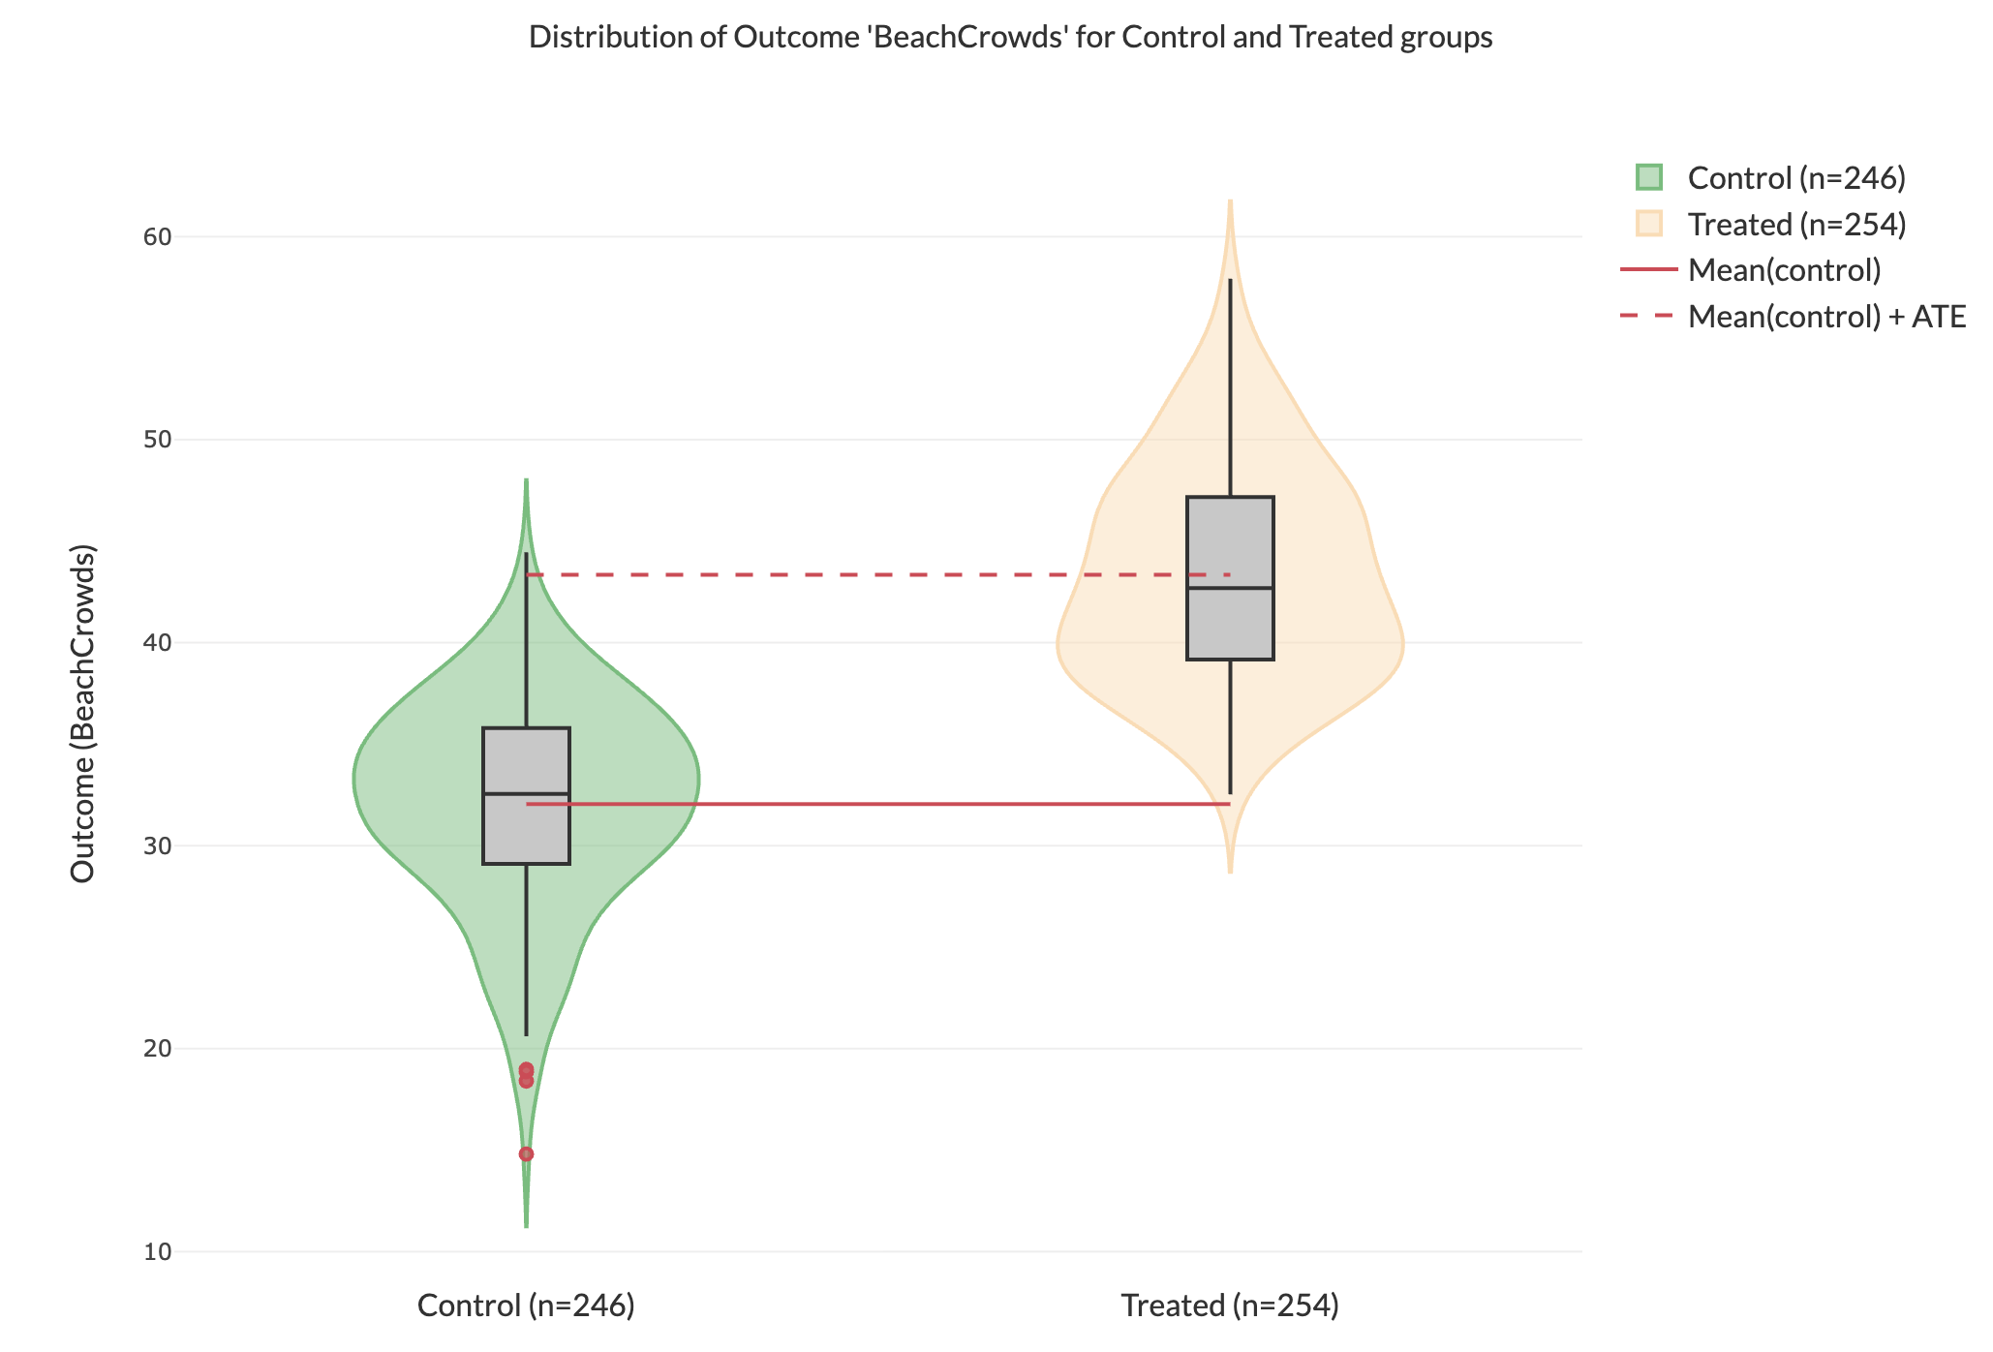

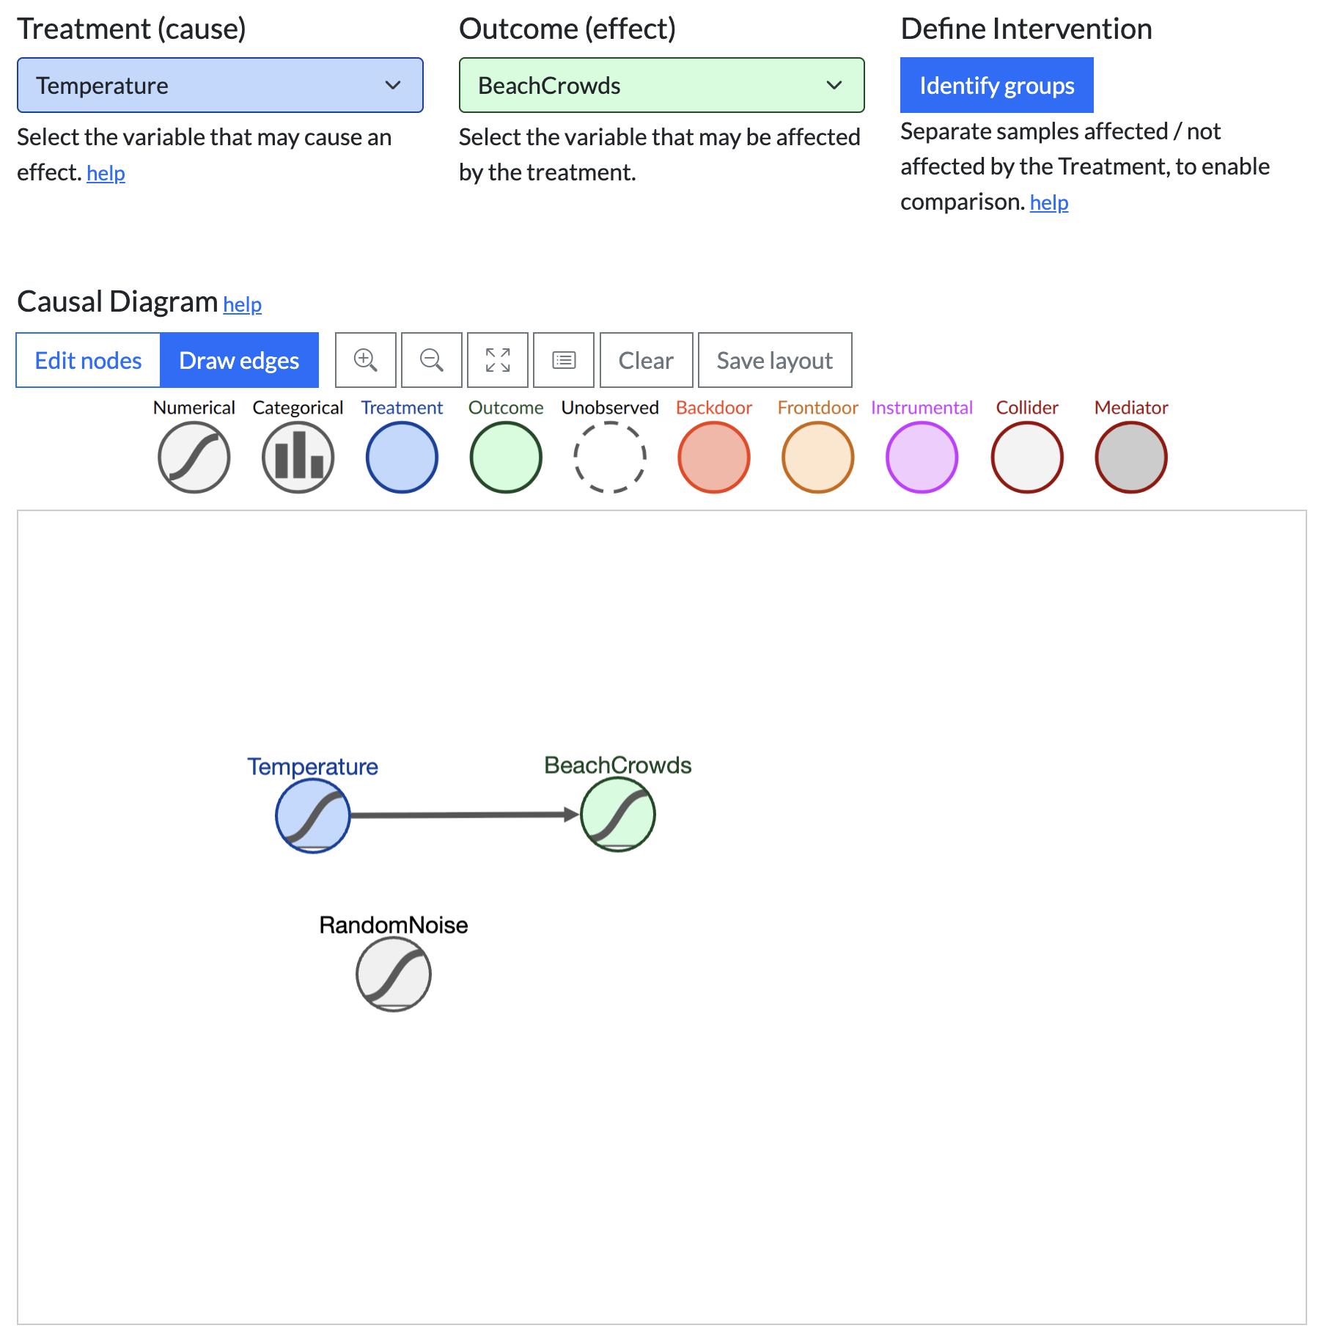

Figma: GUI Design Prototyping Tool
Figma basics – tutorial:
