Contents
Abstract 2
Acknowledgements 3
Chapter 1: Introduction 4
Chapter 2: Research 4
Chapter 3: Background 4
Chapter 4: Project Specification 4
Chapter 5: Design 4
Chapter 6: Project Management 4
Chapter 7: Implementation 4
Chapter 8: Testing 4
Chapter 9: Evaluation 4
Chapter 10: Conclusion 4
References 4
Appendix 4

Abstract

Acknowledgements
I would like to thank my supervisor, Dr Samuel Antonio Montero Hernandez, for providing continuous support throughout the entirety of my Master’s project. His advice and interest in my work exceeded my expectations and has helped me get a lot more out of the project. I also want to thank the support from family and friends which has not gone unrecognised.

Chapter 1: Introduction

Motivation & Context

Problem Statement

1.3 Research Questions & Objectives

1.4 Contributions

1.5 Scope & Assumptions

1.6 Report Roadmap

Chapter 2: Research

2.1 Foundations of Causality
Causality goes beyond simple association in explaining real world phenomena. Two variables can be correlated without one causing the other. This can be explained by confounding variables, selection effects or possible coincidences. Structural Causal Models (SCMs) formalise cause and effect relationships as structural equations and can represent these with Directed Acyclic Graphs (DAG). These encode which variables directly cause other variables. With these rules, missing arrows in the graph imply conditional independencies between variables via the concept of d-separation. These independencies are what causal discovery algorithms search for in observational data
There are two core assumptions which link data to the learned graph. The Markov assumption states that each variable is independent of its non-descendants given its parents in the true DAG. This implies that d-separations map to conditional independences in the population distribution. The faithfulness assumption posits that all statistical independences observed in the data are direct consequences of the underlying causal structure. They are not a coincidence or result of cancellation effects. This means conditional independencies implied by the causal graph match the observed conditional independencies. Together these assumptions allow inference of causal structure from observational data using conditional independence tests. In practice, this yields an equivalence class of DAGs (CPDAG), which intervention effects can still be estimated via intervention calculus (IDA).
Interventions are represented by do-operations. Interventional distributions differ from observational data and resolve ambiguities that observational data cannot on its own. In practice, causal discovery purely from observational data involved recovering an equivalence class of DAGs which share the same independencies. When allowing for latent confounding variables, the target output becomes a Partial Ancestral Graph (PAG). The edge marks in PAGs allow for uncertainty and unmeasured hidden causes.
These ideas motivate the algorithms my GUI wraps. PC is a constraint-based method which starts from a complete undirected graph. Edges are removed and oriented using conditional-independence tests (Fisher-Z for Gaussian data, G²/χ² for discrete), The output is a CPDAG which represents a DAG equivalence class under Markov and faithfulness assumptions. GFCI is a hybrid algorithm that combines both constraint-based FCI with score-based search. This aims to improve robustness with latent confounding variables and outputs a PAG. FGES (Fast Greedy Equivalence Search) is a score-based method. It searches equivalence classes choosing the one which most optimises a score (e.g. BIC) and outputs a CPDAG. My GUI interface conveys these differences by showing edge endpoint mark semantics and by saving the test/score choices in captions and exported figures.
Why this matters for the GUI: the independence-based logic (d-separation), the equivalence classes, and the role of assumptions (Markov, faithfulness, possible latent confounding variables) explain why there may be disagreements across algorithms on edge direction or “uncertain” relationships. Designing a GUI for novice users therefore requires clear labelling of algorithm types (score vs constraint-based), display of used parameters/tests/scores, and plain English explanations of why an edge is present/absent. This is exactly what the edge explanation, “Why not connected?” and algorithm comparison tabs provide (Chapter 7).

2.2 Causal Discovery Algorithms, Data Types, Tests & Scores
This project implements a small set of causal discovery algorithms deliberately chosen for novice users to learn the core ideas while avoiding the risk of overwhelming the user. The GUI involves one constraint-based method (PC), one score-based method (FGES), and one hybrid method (GFCI). These three algorithms cover common assumptions in causal modelling and outputs consistently rendered and explainable graphs.
Algorithms covered:
PC (constraint-based; CPDAG output): searches for a graph by: 1) Skeleton phase - remove edges that contradict conditional independence (CI) tests. This progressively conditions on larger sets up to the depth controlled by the user, and 2) Orientation phase – collider detection and Meek’s rules are applied to orient edges which the data allows. Output: CPDAG (completed partially directed acyclic graph). This represents the Markov equivalence class of DAGs. The GUI renders directed arrows for fixed orientation edges and undirected endpoints when no direction is determined. Parameters exposed by the GUI: significance level α, depth, and data type (appropriate test).
GFCI (hybrid; PAG output; latent confounding allowed): GFCI begins with a score-based search to find a graph structure. Edges are validated and pruned via CI tests then these are oriented. Due to GFCI being able to reason about possible unmeasured confounding variables, edges can be partially oriented. Output: PAG (partial ancestral graph) which captures uncertainty due to latent confounding variables with uncertain endpoints. Parameters exposed: α, depth, and data type (appropriate test/score).
FGES (score-based; CPDAG output): FGES optimises a global score with a greedy equivalence search involving both a forward (adding edges) and backward (removing edges) pass. Edges are then oriented to match the equivalence class. Output: CPDAG. Parameters exposed: penalty discount c for BIC-style score and data type (appropriate score). FGES does not use α or depth.
Data types and statistical tests
The GUI supports two broad data types. The choice determines both scores (for FGES) and CI tests (for PC/GFCI).
Continuous data:
- CI test: Fizer-Z test on partial correlation. Residuals are computed for a candidate separating set S. The Pearson r is taken of residuals and transformed with Fisher-Z. A two-sided p-value is then compared to α.
- Score: SEM-BIC is a linear Gaussian structural equation modelling with BIC penalty. The penalty discount c scales complexity. A large c = sparser graphs (fewer edges).
Discrete data:
- CI test: conditional χ² / G² test aggregated over a strata of S. Independence is accepted when p≥α.
- Score: BDeu (or discrete BIC variants). Also controlled by the penalty discount in FGES.
Auto detect in the GUI
When users select “auto”, columns are classified via simple transparent heuristics. Integer columns with small cardinality are treated as discrete data. Otherwise, data is treated as continuous. This sets both the CI test (PC/GFCI) and the score family (FGES). Users have the option to manually override this.

2.3 Usability, Transparency & Explainability in Scientific Tools

2.4 Related Tools & Systems

2.5 Design Principles

Chapter 3: Background & Terminology

3.1 Quick-start Glossary
Concise definitions for key terms used throughout this report.
- Observational vs interventional data: Observational data are collected passively (no controlled experiments). Whereas interventional data come from controlling a variable (e.g. Do(X=x). Observational data is focused on in this project.
- Causal graph / causal model: A graph where each node is a variable and each edge between nodes represents a possible causal relationship under the model’s assumptions.
- DAG (Directed Acyclic Graph): A causal graph with arrows and no cyclical relationships (no arrow paths circle back to themselves). Encodes which variable causes another.
- CPDAG (Completed Partially Directed Acyclic Graph): A summary of all DAGs which all fit the data equally as well (this is a Markov equivalence class). Contains directed and undirected edges where orientation can’t be deduced purely from data/assumptions.
- PAG (Partial Ancestral Graph): like CPDAG except hidden confounders are allowed. Special endpoint markers with circles and double headed arrows show uncertainty and latent causes.
- Edge marks shown in the GUI:
A --> B: A is very likely a cause of B (ruling out B causing A).
A --- B: Undirected adjacency (unresolved orientation in a CPDAG).
A o->: Certain arrowhead at B but uncertain at A (either A --> B or A <-> B).
A o-o B: Both ends are uncertain. This is an adjacency that can’t be oriented.
A <-> B: Association is likely explained by an unmeasured confounder.
- d-separation: a rule which decides when variables should be independent given other variables. Used by constraint-based algorithms when deciding to remove, add or orient edges.
- Conditional independence test: A statistical test which constraint-based methods use. Fisher-Z for continuous, roughly Gaussian data and χ² / G² for discrete data.
- Score / scoring function: A score which trades fit vs complexity. These methods search for the graph which gives the best score. E.g. BIC
- Constraint-based vs score-based vs hybrid:
Constraint-based (e.g. PC) use independence tests + α.
Score-based (e.g. FGES) optimise an appropriate score (e.g. BIC) with the given data.
Hybrid (e.g. GFCI) combines constraint and score-based methods and outputs PAGs.
- PC algorithm: constraint-based search algorithm which outputs a CPDAG. Key parameters include α (significance value) and depth (maximum size of conditioning sets)
- FGES algorithm: score-based greedy search algorithm which outputs a CPDAG computed using the best scoring equivalence class. The key parameter is penalty discount that controls sparsity (higher sparsity = fewer edges, lower sparsity = more edges) of the CPDAG.
- GFCI algorithm: hybrid search algorithm that allows representation of confounding variables. This outputs a PAG and uses independence tests (like PC) alongside scoring (like FGES).
- α (alpha, significance value): The threshold for independence tests. A smaller α = fewer edges. A larger α = more edges
- depth (maximum conditioning set size): this limits how many variables an independence test conditions on. Lower depth = faster processing time and stabilises testing. -1 is used for no limit.
- Penalty discount (used by FGES): determines the complexity penalty in BIC-like scores. Higher values = sparser graphs = fewer edges.
- Separating set (sepset): S is a set of variables that means A and B are independent when conditioned on (A ⟂ B | S). The “Why not connected?” tab in the GUI calculates a sepset for chosen variables and displays one if found.
- Latent confounder / causal sufficiency: a latent confounder is an unmeasured common cause of two variables. Causal sufficiency assumes there are no hidden causes meaning no latent confounders exist outside of the given data. Many real-world datasets violate this assumption which is why GFCI is useful and outputted PAGs matter.
- Markov assumption (Causal Markov Condition): once you know a node’s direct causes and its parents in a DAG, non-descendants add no extra information about this variable. This allows independencies to be read from the graph. If A --> B --> C, A and C are generally dependent, but the Markov assumption states A tells you nothing about C
- Faithfulness assumption: all conditional independencies in the data come from the graph’s structure. It states there are no coincidental rulings out of any causal effects in the DAG.
- Collider & back-door path: A collider is an A --> C <-- B relationship. This creates a spurious association between X and Y. A back-door path from X to Y is any path Conditioning on colliders opens paths. Blocking back-door paths with conditioned removes confounding variables.
These are terms consistently used in the GUI and in this report which readers should understand to follow the design choices, results, and limitations of this project.

3.2 TETRAD & py-tetrad
TETRAD is a well-established, open-source toolkit for causal discovery and causal inference (developed at CMU). It implements the different search algorithms used in this GUI:
- Constraint-based: PC with conditional independence tests (Fisher-Z for continuous, χ²/G² for discrete data)
- Score-based: FGES searches for the graph with the optimal score (e.g. BIC)
- Hybrid: GFCI combines constraint tests with scores (handles latent confounding variables)
Py-tetrad is a Python bridge to TETRAD’s Java engine. It initiates a JVM to expose Python wrappers for datasets, test/scores and causal searches. This product uses a thin adapter (TetradRunner) to hide the Java functionality. The GUI passes a pandas.DataFrame and parameters to the runner which returns a NetworkX graph. The graph is annotated with endpoint metadata and is rendered and explained by the GUI.
A small set of parameters are standardised across algorithms in the GUI:
- PC/GFCI: α (significance value), search depth (-1 for unlimited), and dtype (auto/continuous/discrete) to select the correct test (Fisher-Z or χ²/G²).
- FGES: penalty_discount (BIC scaling) and dtype to select the correct score
At startup, the application checks for a suitable JDK for TETRAD as it runs inside the JVM. If missing, clear setup guidance is reported. One JVM instance is kept per session, and calls are safe guarded with try/except to catch Java exceptions and report with user-friendly dialogs.
Finally, TETRAD’s graph outputs are normalised with consistent edge endpoints (e.g. -->, ---, o->, o-o). These are attached to edges in the NetworkX graph to be used in the Graph View, Edge Explanation and Compare tabs. (Endpoint mark semantics are explained next in 3.3.)

3.3 Graph Types & Edge Marks
The kinds of graphs shown by the GUI: causal discovery returns a pattern rather than a “true” DAG. Different mark semantics are used depending on the type of search algorithm that was run:
- DAG (Directed Acyclic Graph): each edge has a single direction (e.g. A --> B). Usually, observational data alone is not enough for this to be the direct output in causal discovery.
- CPDAG (Completed Partially Directed Acyclic Graph): An equivalence class of DAGs that matches the assumptions and data. Allows undirected edges where the direction of causality can’t be determined purely by the observational data. PC and FGES both output CPDAGs (no latent variables are assumed)
- PAG (Partial Ancestral Graph) An equivalence class that allows latent confounders. PAGs can have regular arrowhead endpoints as well as circles (for unknown relationships). GFCI outputs PAGs
This GUI normalises the endpoints into a readable set of edge marks on the rendered graphs and in the right-hand edge list tab:
- A --> B (directed): A is a cause of B (possibly an indirect cause) within the equivalence class. This rules out the idea that B causes A but can’t guarantee there are no hidden common causes between the two variables.
- A --- B (undirected): A and B are adjacent in the equivalence class, but orientation can’t be determined purely from observational data. CPDAG can output this relationship.
- A o-> B (circle to arrow): B is an effect, but A’s status cannot be resolved. Could either mean A causes B or A and B share a hidden cause or both.
- A o-o B: (circle to circle): A and B are adjacent but with high uncertainty. The direction of the relationship or possibility of confounding variables is not resolved purely by the data or assumptions of the search.
How to read these in context:
- PC/FGES (CPDAG): consists of --> and --- relationships. Undirected --- indicates the edge exists but no direction can be determined by the DAG in that equivalence class
- GFCI (PAG): consists of --> and o-> and o-o. Can detect hidden confounding variables and allows uncertainty.
What the marks can’t tell us: they do not encode the size or linearity of the causal effects. They are conditional on the Markov and faithfulness assumptions as well as the test/score used. Arrows express claims that are true in all graphs in the equivalence class, which is why circles are used to show varying endpoints across valid graphs.
Where the GUI uses this: the edge explanations require these endpoint marks (to click an edge in the list), and the comparison tab to report orientation and type disagreements between the three implemented algorithms. The “Why not connected?” tab uses endpoint marks to report a separating set for missing edges.

Chapter 4: Project Specification

4.1 System Overview
This project delivers a GUI for causal discovery designed to make running and interpreting standard causal discovery algorithms accessible to students and novice researchers. My application guides users from CSV import -> deciding algorithm (PC, GFCI or FGES) -> visualisation of graph -> graph explanation -> export, emphasising education, clarity and reproducibility of generated results.
The core workflow involves a left-hand “Tools” panel providing actions: “Import Data”, “PC Search”, “GFCI Search”, “FGES Search” and a top-hand tool bar with actions: “Help”, “Tutorials”, “Export Graph”, “Export Edges”, and “Export Comparisons”. The central workspace consists of a stacked view with a Data Preview canvas which confirms the loaded CSV, and a Graph View which displays generated DAG’s. Searches call py-tetrad on the backend and accept user inputted parameters via dialogs (e.g. depth, data type). Results are drawn by converting to a NetworkX graph.
Learned graphs display labelled nodes with edge endpoint styles matching conventional PAG/CPDAG rules. The layout uses Graphviz “dot” if available or a fallback to retry with safe-IDs. Nodes can be dragged by users to customise the DAG’s layout. The canvas summarises parameters used in the graph’s subtitle for reproducibility.
The right-hand panel contains an “Edges” tab which explains the selected edge type in plain language, a “Why not connected?” tab showing reporting separating sets which explain missing edges via conditional independence testing, and a “Compare” tab that runs the other algorithms on the same data/parameters and reports unique differences.
A “learn by doing” approach is utilised with tutorial wizards and concise tooltips for beginner users.
Users can export graphs as PNGs, edge lists as TXTs and comparison reports as TXTs. A status bar reports progress and error messages allowing for a stable experience. The software runs offline preventing any chance of data protection issues.

4.2 End Users
This GUI targets three groups:
- Students who are learning causal discovery for the first time
- Novice researchers and analysists applying PC, GFCI, and FGES searches to their own datasets
- Instructors/teaching staff demonstrating causal discovery algorithms in classes
All users access the same features (accounts and roles are unnecessary): loading CSVs, running searches, exporting graphs/edges/comparisons, and using tutorials and explanations to interpret results.

4.3 Functional Requirements
The functional requirements are written using the MoSCoW prioritisation format and are organised into eight categories that relate to the interface’s key areas. Structuring the functional requirements this way supports testing and evaluation steps.
general
- The system must launch and display the main window
- The system must display a tool panel listing “Import Data”, “PC Search”, “GFCI Search”, and “FGES Search”
- The system must present a central workspace with a “Graph View” widget
- The system must show a status bar to report progress and error messages
- The system could offer a light/dark theme in the menu and remember the selection
- The system could launch as a single packaged executable
Data handling
- The system must open an OS native file picker when clicking “Import Data”
- The system must accept CSV files and load them into a pandas DataFrame
- The system should show a small data preview of the first N rows of the CSV in the data page
- The system should warn on clear errors in the CSV (e.g. missing headers)
- The system could warn on extremely large datasets (e.g. >10,000 variables)
- The system could support drag and drop CSV into the window
Algorithm execution
- The system must run PC with the users inputted alpha, depth and datatype in the parameter wizard
- The system must run GFCI with the users inputted alpha, depth and datatype in the parameter wizard
- The system must run FGES with the users inputted penalty discount and datatype in the parameter wizard
- The system must convert Tetrad output to a NetworkX graph that has correct edge endpoint marks
- The system must pass parameter choices from the parameter dialog and correctly pass them to py-tetrad
- The system should capture the correct data type/test/score used using auto detection and display in the graphs subtitle
- The system could cache the users previous result from Tetrad so that layout changes do not re-run the algorithm
Visualisation
- The system must render nodes as rounded boxes and render edges with the correct endpoint markers (e.g. arrows, circle and undirected)
- The system must use Graphviz dot layout if it is available with a safe-ID fall back option
- The system must allow repositioning of nodes by clicking and dragging and for edges to be updated
- The system should avoid overlap of variable labels and edge endpoints
- The system could support zooming and panning via mouse
- The system could highlight a selected node and its connected neighbours
Explainability & Comparison
- The system must provide a “Why not connected?” tab that attempts to find a separating set using conditional independence testing to interpret why an edge does not exist
- The system must provide an “Edges” tab which lists all edges and their types. Clicking an item explains that edges relationship
- The system must provide a “Compare” tab which runs PC, GFCI and FGES on the same data using the same parameters and lists all the disagreeing edges between the algorithms
- The system should display the parameters at the top of the comparison tab
- The system could allow you to switch between viewing graphs from each of the PC, GFCI and FGES algorithms
Usability & Learning Aids
- The system must include tutorial wizards for “Import”, “PC’, “GFCI”, “FGES” with “don’t show again” options
- The system must include a “Tutorials” hub on the toolbar where you can launch any of the tutorials at any time
- The system should add concise tooltips to tool items and parameter fields to explain their meaning
- The system could add a first run tutorial overlay of the UI for new users
export & Reproducibility
- The system must export the rendered graph to PNG with the title and subtitles
- The system must export the graphs edge list with markers to TXT
- The system must export the current comparison report to TXT
- The system should stamp exports with the algorithms name and parameters used
- The system could export edges to CSV as well as TXT
Error Handling & Robustness
- The system must show an error message if a search is requested with no loaded data
- The system must catch exceptions from py-tetrad and show an error message without crashing the UI
- The system must handle the absence or failure of Graphviz using the fall-back methods
- The system should write exceptions and layout decisions to a log and the status bar for troubleshooting purposes
- The system could validate parameter ranges with a pop-up message

4.4 Non-Functional Requirements
The non-functional requirements are written using the MoSCoW system and specify quality attributes the GUI should exhibit under normal use.
Performance
- The system must launch and render the main window in < 1.5 seconds on a mid-range desktop (8 GB RAM)
- The system must respond to UI actions in < 300 milliseconds (not including algorithm runtime)
- The system must export a DAG to PNG in < 500 milliseconds after clicking save in the users native file explorer
- The system should complete PC Fisher-Z test with default parameters on a 2,000 x 12 CSV in < 1 second on the test machine
Compatibility
- The system must run on Python 3.9-3.12 on macOS 12+ and Windows 10/11
Usability & Accessibility
- The system must let a first-time user load a CSV, run PC, GFCI and FGES algorithms, and view a DAG within 5 minutes without external help
Reliability
- The system must handle invalid CSVs, missing Java or py-tetrad, or any layout errors with no crashes
- The system must preserve loaded data and chosen parameters when resizing windows or switching between tabs
- The system should timestamp errors in a log txt file
Security
- The system must run entirely offline to keep all user data local
Maintainability
- The system must keep the UI, controller, and Tetrad interface modules separate
- The system should centralise the algorithm parameter mapping for the PC, GFCI and FGES algorithms in one place
Portability & Build
- The system should provide clear guidance for setting up when Java or py-tetrad is missing with start instructions

4.5 Datasets
To validate the GUI end to end, I used three public datasets as a benchmark with well-known structures, with small numbers of variables for fast, interactive test runs:
- LUCAS (Lung Cancer Simple) discrete, 12 variables. Used to check sensible DAGs, Edge explanations and “Why not connected?”, and exports
- ASIA (Chest Clinic) discrete, 8 variables
- Sachs (protein signalling) continuous, 11 variables
These datasets checked sensible DAGs, edge explanations, the “Why not connected?” tab, the “Compare” tab, exports, and contrast score vs constraint-based searches.
All datasets were loaded as CSVs with original variable names. No personal data are involved. Minimal preprocessing was applied to consistently test all datasets as CSVs.

4.6 Constraints & Risks
Development of this GUI was done using a 2022 MacBook Air (M2, 8GB RAM) running macOS Ventura 13.2. The software depends on Python (3.9-3.12), PyQt5, matplotlib, NetworkX, py-tetrad, and Graphviz. All software is open source, and literature is accessed with open access or University of Birmingham institutional login. Key constraints/risks are: i) hardware limits which could slow algorithm runtime and exhaust memory on large datasets, and ii) third-party dependencies (Java/Graphviz availability, version mismatches). All datasets used are public and data is processed locally. Licensing is discussed later in this report.

4.7 Success Criteria & Evaluation Plan
Success criteria. The GUI is completed when a new user can load a CSV, run PC, GFCI or FGES on their data, view and interpret the DAG, interpret edge explanations, use the “Why not connected?” tab, and export DAG PNG, edge lists, and comparisons within 5 minutes, unassisted. With LUCAS, ASIA, and Sachs, all must produce a graph and comparison list for each algorithm. The app should launch in under 1.5 seconds and respond to UI actions in under 200 milliseconds. Invalid CSVs or missing Graphviz should not cause crashes, and exports should match the displayed graph and parameters. The codebase should separate the Qt UI, controller, and Tetrad interface.
Evaluation plan. Verification will use a functional test matrix with LUCAS/ASIA/Sachs datasets to follow the full workflow, with pass and fail notes. The launch and UI latency and a PC search will be benchmarked on the reference machine. A quick usability spot test (3 novices) will time the core workflow and collect brief task ease ratings. Robustness checks will remove Graphviz to confirm stability. Export validation will compare PNG and TXT outputs to the current canvas and edge list. An accessibility audit will check colour contrast and text size in tutorial wizards and pop-ups.

Chapter 5: Design
This chapter outlines the design choices of the causal discovery GUI. It covers the architecture and components, the data/control flow and integration of algorithms (PC, GFCI, FGES), visualisation and UX design, and robustness and performance. These sections cover the practical blueprint that was implemented in development and frames the evaluation later in this report.

5.1 Architecture & Components
Architecture. The application is an offline desktop app which runs from a single process with a light layered MVC structure: Presentation uses Qt widgets and tutorial wizards, Controller uses interaction logic, caching results and error handling, Algorithm module bridges to py-tetrad, and a visualisation module uses NetworkX and Matplotlib. This ensures responsibilities are separated without complex services or a need for a database. This is an appropriate design for this application to run entirely on a student laptop with low latency.
Key components.
- UI (presentation). A “MainWindow” built using Qt Designer holds the “Tool panel” (Import Data, PC, GFCI, FGES), the “Tool Bar” (Help, Tutorials, Export Graph, Export Edges, Export Comparisons), a central “Graph” tab, “Data Preview” tab, and right-hand tabs (Edges, Why not connected?, Compare). New users are guided by wizard tutorial dialogs (PcWizard, GfciWizard, FgesWizard) and parameter dialogs (GfciParamDialog, FgesParamDialog). EdgeExplanationDialog formats explanations of edge types.
- Controller. Controller connects user inputs to functions. It loads CSVs into panda dataframes, runs searches, draws graphs, populates side panels, builds comparisons, and exports PNGs and TXTs. It also shows actionable messages on errors
- Algorithm bridge. TetradRunner wraps py-tetrad/Java calls for PC, GFCI, and FGES searches, maps GUI parameters to Tetrad and returns NetworkX graphs with correct endpoint markers (-->, ---, o->, o-o). A helper exposes a Python sepset finder for the “Why not connected?” tab to explain missing edges.
- Visualisation. The controller sends a Matplotlib canvas to Qt to draw variable nodes as rounded rectangles and edges with correct arrowheads for each endpoint. Graphviz “dot” layout is preferred if available and a fall back is in place to a spring layout. Users can click and drag nodes to customise DAG layouts. Redraws keep interaction with the graph smooth.
Caching & data flow. “Import Data” reads the CSV into a DataFrame and invalidates caches. Running PC/GFCI/FGES has the controller call TetradRunner and draws the result, populates the “Edges” list and caches information for the other algorithms. A results cache is maintained holding algorithm, data, and parameters and a comparison cache is maintained holding data and parameters. Text is generated for the “Compare” tab once and gets reused when exporting comparisons to avoid re-running algorithms if data and parameters are unchanged.
Robustness & fallbacks. When Graphviz is missing there is an automatic fall-back layout. If Java/py-tetrad or CSV parsing fails, the user sees a clear error message and no crash. Loaded data and parameters are remembered when switching tabs or resizing the UI, and graphs are exported as seen on the GUI.
Extensibility. New algorithms are easily added using the same py-tetrad bridge along with a new tutorial wizard and parameters dialog.

5.2 Data & Control Flow & Algorithms
Data path: Tool panel allows users to import their CSV. The file is loaded into a pandas DataFrame, basic checks are run on headers and quantity, and a lightweight cache of filename, rows, and column names is recorded. The “dtype” setting (auto/continuous/discrete) is passed to statistical tests. Auto aims to infer the correct py-tetrad test from the inputted data.
Control flow: UI actions are handled by the Controller: i) read CSV and invalidate caches, ii) open a tutorial wizard and parameter dialog then call “TetradRunner”, iii) convert to a NetworkX graph with endpoint annotated edges and render with Matplotlib, iv) populate the edge list and node pickers in the “Why not connected?” tab, and v) enable exports.
Algorithms. TetradRunner is the algorithm bridge which wraps py-tetrad for PC, GFCI, and FGES. GUI parameters are mapped to Tetrad, and the search algorithm is executed returning a standardised graph. PC and GFCI use constraint-based conditional independence testing (α, depth). FGES uses score-based search with the penalty discount parameter. The “Why not connected?” tab uses a Python sepset finder. The “Compare” tab generates edge sets for each algorithm and reports unique edges and disagreements between searches and saves current parameters in the header for reproducibility.

5.3 Visualisation & UX
This GUI has a high contrast graph view (black, white, and grey with navy accents). Rounded rectangles display for nodes and specific endpoint marks are used for edges (-->, ---, o->, o-o). A clean dot layout using Graphviz is prioritised over a reproducible spring layout if unavailable. Graph layout can be tidied and customised by the user. Custom positions are preserved when running another search. A status bar relays progress and error messages, and exports are one click buttons for quick tasks.
The right panel shows an “Edges” list mirroring what is shown in the DAG. Any row clicked opens an edge explanation pop-up with a navy heading highlighting the selected edge (e.g. A o-> B), followed by “Meaning:” in bold with a regular weighted body of text explaining the edge. A & B are substituted for the selected variable names. Text can be selected and copied.
Two tabs are built in to aid the users understanding. “Why not connected?” tab allows selection of two variables and a short reason behind the two variables lacking an edge if a separating set S is found. “Compare” tab shows search algorithm comparisons generated from cached graphs keeping a low-latency experience.
Overall usability is guided by clarity and jargon is kept to a minimum. Key usability features are tooltips on all major controls, tutorials shown before running searches, consistent labels, and no reliance on colour allowing shapes and text to convey meaning. Minimal colour palette of black, white, grey and navy with appropriate font size enhances readability and gives all dialogs and tutorial wizards a consistent visual style.

5.4 Robustness, Performance & Dependencies
Robustness: the GUI blocks common failure modes and avoids crashes. File I/O and search algorithm calls are embedded in try/excepts with understandable dialogs. If Graphviz dot is not found a fall back to a spring layout is used for graphs meaning a DAG is always rendered. Explanations substitute A/B variables with HTML, so pop ups match the list item clicked by the user. Graphs and comparison text get cached and are invalidated when changing data or parameters. Exporting graphs and comparisons read information from cache. UI state (position of nodes, window size, parameter choices) is preserved.
Performance: minimal startup work and progress shown by status bar. All algorithm’s graphs are fetched and caches when a search completes. The “Compare” tab and “Export Comparisons” tool read from cache rather than re-running all search algorithms. If Graphviz fails, the seeded spring layout generates fast and reproducible node positions. The “Why not connected?” tab searches for sepsets with a small k (e.g. 3) for efficient interactivity. This keeps interactions snappy and practical even on mid-range hardware.
Dependencies: the app runs completely offline and uses local libraries:
- Core: Python 3.9-3.12, PyQt5, Pandas, NumPy, NetworkX, Matplotlib
- Causal engine: tetrad_iface (Python wrapper) and Tetrad Java .jar (tested with OpenJDK 21)
- Optional Graphviz and pydot for “dot” layouts
All dependencies used are open source with the versions documented in “requirements.txt”. the Java/Tetrad versions are found in the README). If Java/Tetrad or Graphviz are missing, errors are caught and explained with a setup guide, rather than the application crashing.

Chapter 6: Project Management

6.1 Development Methodology
The project used a lightweight Kanban approach suited to the evolving requirements of the application. Tasks were tracked on a simple board consisting of backlog, in progress, verify, and done. This had strict work in progress limits to maintain a productive flow. Each iteration delivered a small, testable feature which was quickly checked with integration testing ensuring the application was always in a usable state. The task backlog implemented MoSCoW prioritisation. Should/could items were only pulled when capacity allowed. The continuous flow of this development strategy led to steady progress towards the requirements defined in Chapter 4, without the need for sprints.

6.2 Timeline
To keep steady development of the application, I planned the project with a lightweight Gantt chart (Figure 6.2) alongside the Kanban workflow. The chart maps the summer timeline across the main phases of the project (literature review, design, GUI + py-tetrad integration, tutorials/explainability, exports, testing, report writing and final submission). The tasks were sequenced in a sensible order to reduce risk in development (e.g. py-tetrad algorithms before DAG rendering) and some tasks intentionally overlap when necessary (e.g. user testing during the report writing phase). The Gantt chart was an adjustable schedule functioning as a baseline progress tracker to help pull work across the Kanban board. This allowed for re-prioritisation if issues arose and ensured delivery of a working application within the project deadline.

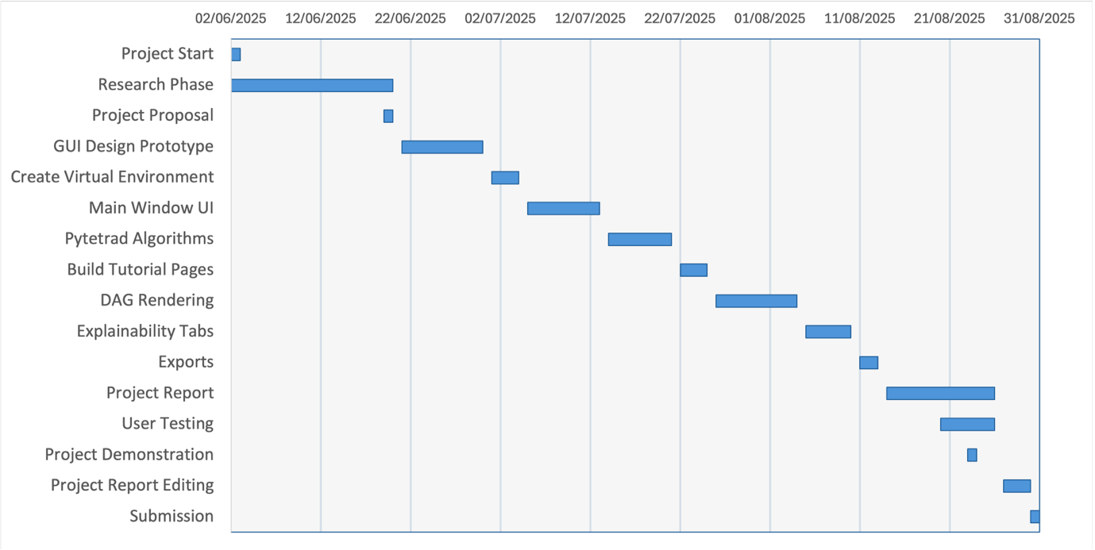
Figure 6.2: Gantt chart

6.3 Risk Management
Due to this project mostly being developed on a single personal laptop, the main risk to manage is hardware failure or corruption of the application’s files. To avoid any extreme loss of progress, all files related to this project were pushed to GitHub at regular intervals and backed up on a personal OneDrive folder, enabling recovery. This also allowed progress to be made on any machine when access to the main laptop used was not possible, contributing to efficient progress. No other major risks were identified.

Chapter 7: Implementation

7.1 Technologies Used
The GUI desktop interface is implemented in Python with PyQt5. CSV loading uses pandas. DAG modelling and rendering uses NetworkX and Matplotlib. Running search algorithms uses the Java Tetrad library locally. Optional high-quality layouts use Graphviz then a spring layout to fall back on, keeping the app robust. A lightweight QSS stylesheet is used for consistent theming. This stack is effective for efficient cross platform development. Python and PyQt allow fast iteration and native desktop feel, and py-tetrad ensures reliable causal discovery rather than re-implementing algorithms.

7.2 Modules & Key Files
The application’s codebase is small and modular with each file having a clear specific role.
- app.py: Creates “QApplication”, loads “ui/main_window.ui”, applies “styles.qss”, creates a “Controller” instance, connects UI functionality (tool panel, exporting, tutorial wizards) and surfaces environment checks for Java and Graphviz using the status bar and dialogs.
- controllers.py: manages the user facing aspects.
  - state & parameters: holds loaded DataFrame, alpha/depth/dtype/penalty_discount, the current networkx.DiGraph, and the last_algo
  - caches: _result_cache (per-algo graph), _compare_cache (comparison text) and _invalidate_caches() on data/parameter changes
  - runs: run_algorithm(algo) calls TetradRunner.run_search(), populates edge list and node pickers, then builds the comparison tab using caches
  - visualisation: draw_graph() renders nodes as rounded rectangular labels and endpoint marks with Matplotlib. Hover and dragging is supported. _graphviz_pos() uses Graphviz “dot” or spring fall back
  - explainability: populate_edge_list(), _parse_edge_label(), show_edge_explanation() opens the explanatory dialog and lists edges (-->, ---, o->, o-o)
  - why not connected: separating sets and missing edge reports are generated with explain_non_edge()
  - comparison & exports: _build_comparison_text(), export_graph_png(), export_edges_txt(), export_comparisons_txt() run the text exports for nodes, edges and parameters
  - error handling: exceptions get converted into actionable dialogs the status bar displays
- dialogs.py: modal UI.
  - Tutorial wizards: “ImportWizard”, “PcWizard”, “GfciWizard”, “FgesWizard” and “TutorialsHub”. “QSettings” remembers the “Don’t show again” preference
  - Parameter dialogs: “GfciParamDialog” (also used for PC with a renamed header), “FgesParamDialog”
  - Edge explanations: “EdgeExplanationDialog” renders navy heading and bold text with HTML, and the green styled Continue button with QSS.
- tetrad_iface.py: bridge to py-tetrad.
  - Load_dataframe(path)
  - Run_search(df, algo, alpha, depth, dtype, penalty_discount) generates networkx.DiGraph with edge attributes and endpoints (-->, ---, o->, o-o)
  - Find_sepset_py() is called for the edge explanation tab.
- styles.qss: Styles the application using neutral black/white and grey with navy accents. This also styles lists, dialogs, and green continue buttons for tutorial wizards.
- ui/main_window.ui: Tool panel with “Import Data”, “PC Search”, “GFCI Search”, “FGES Search” and tool bar with “Help”, “Tutorials”, “Export Graph”, “Export Edges”, “Export Comparisons”. Right hand “Edges”, “Why not connected?”, and “Compare” tabs and a status bar

7.3 Algorithm Integration & Edge Mark Rendering
Integration: when clicking either PC, GFCI, or FGES search, TetradRunner.run_search(df, algo, depth, dtype, penalty_discount) is called via the controller. Py-tetrad is configured with the constraint test, score and given parameters. A networkx.DiGraph is returned. Edges are annotated with:
- “mark” (-->, ---, o->, o-o) for CPDAG and PAG edge meanings
- Endpoint flags “ep1/ep2” (ARROW, CIRCLE) used for graph drawing
Algorithm specifics:
- PC (constraint-based algorithm): For continuous data, Fisher-Z is used. For Discrete data χ²/G² is used. Users input desired alpha and depth parameters (unlimited when depth = -1). CPDAGs are usually outputted with directed (-->) and undirected (---) edges.
- GFCI (hybrid): Uses a combination of independence testing and scoring. Outputs PAG style marks (o->, o-o) to represent latent confounding variables and orientation uncertainty.
- FGES (score-based): maximises a data appropriate score (e.g. BIC/BDeu). CPDAGs are outputted with directed (-->) and undirected (---) edges. The penalty_discount parameter is recorded with results
Parameter mapping & dtype: For PC and GFCI, user inputted alpha, depth, and dtype (cont/disc/auto) are passed to py-tetrad. For FGES the user inputs penalty_discount and dtype. For auto dtype, the bridge infers the dtype from the DataFrame and picks the most appropriate test/score. Py-tetrad errors are caught, and an actionable dialog is displayed.
Caching & reproducibility: Results are cached (algo, data, parameters, comparison text) so any re-rendering or file exports does not cause re-runs of search algorithms. Nodes, parameters, and edge lists are exportable for reproducibility.
Mark normalisation: Consistency across lists, pop-ups, and drawings is ensured by edge labels (e.g. -> and ) being normalised to -->. The edge list on the right panel uses the exact same “mark” strings so the edge markings are consistent between the drawn graph and edge explanation tabs.
Rendering model: the controller converts “mark” to endpoint symbols:
- --> = ARROW head
- --- = undirected, no endpoints
- o-> = CIRCLE tail, ARROW head
- o-o = CIRCLE tail, CIRCLE head
First a base line is drawn (---), then circles and arrowheads are overlayed. Arrowheads use matplotlib annotations with readable sizes for accessibility.
Layout & readability: When Graphviz “dot” is available its layout is preferred. If unavailable, a seeded spring layout calculates stable node positions instead. Node labels are displayed with rounded rectangles and are draggable to reposition. Live edge re-computation maintains clear attachment when moving nodes
Explainability link: When an edge in the edge list is clicked, the “Edge Explanation” dialog opens. The title “A mark B” replaces A and B with selected variable names and mark with the specified end point. A concise interpretation of the selected edge meaning is given below.
This design keeps a consistent presentation of the orientation calculated by py-tetrad across lists, pop-ups, exports and the rendered DAG.

7.4 Comparison Generation & Export
Workflow: Once a search algorithm has run, the controller generates a cross-algorithm report with _build_comparison_text(). _get_or_run_graph() computes all three graphs for PC, GFCI, and FGES and constructs lists of edges and their endpoint marks. Parameters (alpha, depth, dtype, FGES penalty) and algorithm specific edge counts are recorded in the header. The report body contains: i) algorithm unique edges (present in only one search result) and ii) orientation and type disagreements when variable pairs differ in direction or endpoint mark between algorithms. Stable sorting of results displayed in the “Compare” panel improves interpretability.
Caching & Performance: Comparison text is cached so that opening or exporting the “Compare” tab reuses cached text and graphs. This prevents re-running of algorithms, so “Export Comparisons” is instant. Caches are invalidated if data or parameters are changed.
Exports: Three export actions:
- Export Graph: saves PNG of the current rendered graph from matplotlib at 300 dpi.
- Export Edges: saves TXT of the numbered edge list with the run parameters.
- Export Comparisons: saves TXT of the exact comparison block in the UI’s “Compare” tab (header, counts, unique edges, disagreeing edges) plus the DAG title / CSV filename.
Sensible default filenames used by exports come from the DAG title or CSV filename if untitled. Conformations of exports are shown by the status bar. Combining clear headings, cached generation and endpoint mark consistency allows a reproducible way to interpret the differences between PC, GFCI, and FGES searches on the same dataset.

7.5 Tutorial Wizards
Purpose: Tutorials reduce parameter anxiety (the selection burden novice users experience) making the GUI usable for beginners to causality. The GUI has lightweight, context sensitive tutorials for “Import Data”, “PC Search”, “GFCI Search”, and “FGES Search”, and a central “Tutorials Hub”. Each tutorial wizard covers when to use the algorithm, required assumptions (e.g. data type, independence tests, scores), important parameters (e.g. depth, penalty discount) and understanding the output (edge marks). Wizards finish with a concise list of advantages and disadvantages so users can select the most appropriate algorithm with confidence.
Launch & persistence: Wizards open automatically when a tool is used and can be revisited from the “Tutorials Hub”. Users can toggle “Don’t show again” which persist via QSettings (show_pc_qizard, show_gfci_wizard, show_fges_wizard) to avoid tutorials interrupting. Cancelling a tutorial for each search algorithm proceeds to the parameter dialog.
Implementation: dialogs.py houses tutorial wizard dialogs. They are styled to match the apps consistent theming and use a green continue button as other instructional pop ups do. HTML based pages embed the content and figures. The “Tutorials Hub” is a selection list which launches tutorial wizards and returns the selected title.
Maintenance & extensibility: Copy on template pages allows for new topics to be implemented in the future without changing the controller. Tutorial wizards do not change state beyond the “Don’t show again” option keeping them low risk and easy to be updated as new tools are added.

Chapter 8: Testing

8.1 Unit Tests
I have used unit testing to verify that small functions in the code work as intended in isolation. I used pytest and log capture to focus on testing the most critical functionality to reliability and responsiveness in the GUI. One unit test simulated the absence of Graphviz by having the _graphviz_pos() function return None. This triggers the documented fallback to nx.spring_layout without crashing and outputs an understandable debug message to the console. The second unit test validated the result-caching path that prevent redundant re-runs of search algorithms. _df_signature, _param_signature, and _graph_key were checked for stability (same data and parameters = same key) and sensitivity (changing parameters or data = different key). When _invalidate_caches() runs, the call sequence displays “CACHE MISS -> run_search() -> CACHE HIT” in the captured test logs.
These tests provide reliable pass/fail signals when testing edge cases early (e.g. missing dependencies or cache). This directly supports the non-functional goals including reliability, responsiveness, and maintainability.
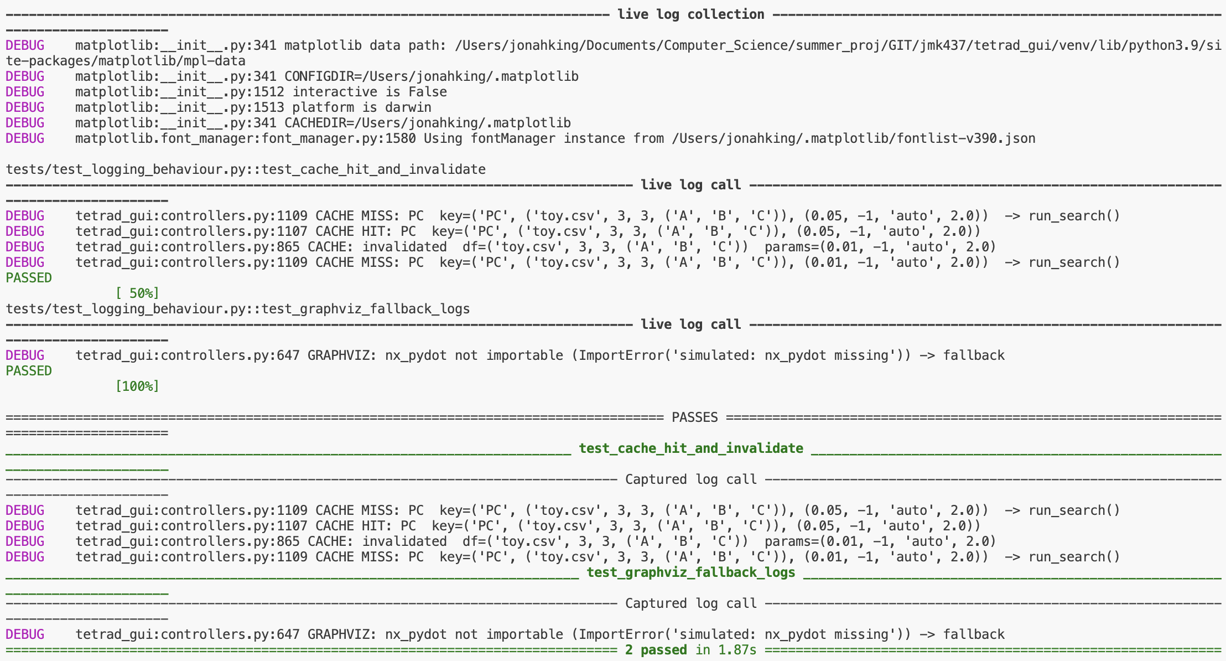
Figure 8.1.1: Console logs from unit tests showing cache miss/hit/invalidate outputs and the “not importable -> fallback” message when Graphviz is not found.

8.2 Integration Tests
Integration testing was used to verify that UI events, controller logic, the Tetrad runner, and render/export worked end to end as each feature was added. The user flow was tested for each new component as it was added and verified it was working as intended. For example, when the “FGES Search” button was added, tests ensured it opened the tutorial wizard pop up, and then the parameter dialog. Tests were done to check pressing run produced and rendered a DAG in the central UI canvas and that the edge list was populated with the correct causal relationships.
Exports were also tested and verified. “Export Graph” opens the native file explorer and saves the current DAG layout to PNG. “Export Edges” saves the list of edges and their marks to a text file. “Export Comparisons” matches and saves what is displayed in the GUI’s “Compare” tab to a text file without re-running search algorithms. Guard rails were also tested. For example, clicking “Run” with no data was tested to confirm a warning is displayed. All these checks confirmed the modules interconnect as intended under both normal and erroneous conditions.

8.3 UI/UX Testing

8.4 Performance & Responsiveness
The performance of three different functionalities was measured using performance counters as a timer: application launch, exporting DAG to PNG (from clicking save to completion of saving PNG), and PC execution on the LUCAS dataset (2000x12). Each test was run three times on a MacBook Air M2 (8GB RAM, macOS 13.2). Figure 8.4.1 reports all three runs and the mean for each feature. App launch took on average 190 ms (181 – 196), exporting a DAG to PNG too on average 159 ms (154 – 163), and PC search took on average 841 ms (805 – 895). These satisfy the non-functional requirements stated in section 4.4 of this report: app launch < 1.5 s, DAG to PNG < 0.5 s, and PC on a 2000x12 dataset < 1 s. The variability in export time reflects first run warmup effects. Algorithm timings will vary with increased sample size of datasets, variable count, and parameters. Overall, the measurements conform a responsive UI with large headroom around the stated non-functional requirements of the application.
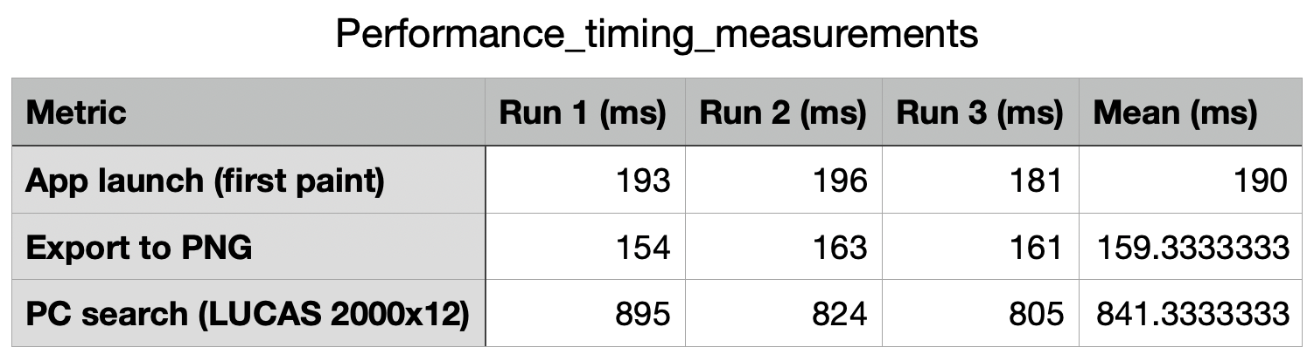
Figure 8.4.1: per functionality timings (ms) for app launch, export DAG to PNG, and PC search (on 2000x12 dataset). Measured with three runs on a MacBook Air M2 (8GB RAM, macOS 13.2). the table reports the timings of all three runs and the mean for each feature.

8.5 Summary

Chapter 9: Evaluation

9.1 Requirements Satisfaction
Functional Requirements:
Figure 9.1.1 summarises the requirements pass/fail rates grouped into MoSCoW categories (must have, should have, could have). All Must requirements were met which cover the core workflow (“Import Data” -> set parameters -> run PC/GFCI/FGES -> render DAG -> explain/compare output -> exports). This includes the tool panel, central graph workspace, status bar, feedback, CSV import, parameter dialogs and correct integration to py-tetrad with robust error handling. Edge marks are normalised and visualised using Graphviz (or spring fallback). The right-hand panel houses the “Compare”, “Edges”, and “Why not connected?” tabs, and the tool bar contains export buttons (PNG, edge list to TXT, comparisons to TXT).
5/8 should items were delivered. Three were deferred to prioritise correct algorithm functionality, explainability and stability under the time constraints of this project: FR9) data preview of first N rows; FR23) no overlap of labels/endpoints; FR38) stamping exports with algorithm and parameter metadata (these details are reported inside the app via subtitles/compare tab). These features should be prioritised in future updates to the application.
2/4 could items were delivered. The deferred functional requirements were FR30) toggling between PC/GFCI/FGES graph views (compare tab already reports differences across algorithms) and FR39) edge export to CSV (TXT exports already implemented).
Overall, the pie charts show the prototype satisfies all critical capabilities for novice users to load data, run their choice of causal discovery algorithms with appropriate tests/scores, interpret outputted edges and absent relationships, compare outputs, and export results.
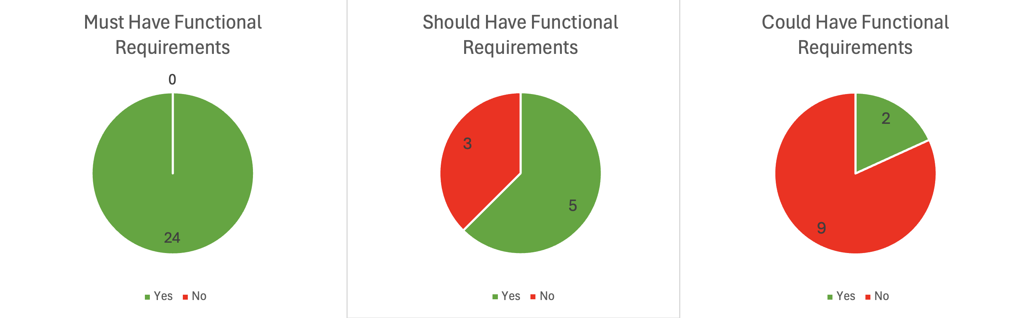
Figure 9.1.1: pie charts showing the number of functional requirements successfully met by my completed GUI application. These are categorised into must have, should have, and could have requirements.
Non-Functional Requirements:
Figure 9.1.2 summarises the non-functional requirements (NFRs) categorised into MoSCoW prioritisation and status. Of the 9 must have NFRs, 8 passed testing and 1 is untested. Of the 4 should have NFRs, 2 passed testing and 2 did not (with no untested). This gives 10/13 passed, 2/13 unmet, and 1/13 untested requirements overall.
For the must have NFRs, performance and responsiveness targets were met when measured. Chapter 8.4 shows a mean launch time of 190 ms and PNG export time of 159 ms, both within the 1.5 s and 500 ms thresholds respectively. The NFR “UI action < 300 ms” remains untested due to time constraints for this project, though observed interactions appear instantaneous on the reference machine used for testing. First time user flow < 5 minutes, and robustness (handling of invalid CSVs, missing Java or py-tetrad, and Graphviz spring fallback) were all satisfied and discussed in Chapter 5 and Chapter 8 (unit/integration logs and error dialogs).
For the should have NFRs, two passed: PC search on a 2000x12 dataset completed in <1 s on the reference machine (Chapter 8.4), and centralised algorithm parameter mapping (PC/GFCI/FGES) for maintainability is evidenced in Chapter 7.3. Two NFRs were not met: timestamped error logging to a file and a first-run setup guide for missing Java or py-tetrad. Both were unimplemented to prioritise the core features ensuring usability and explainability and can be listed as minimal effort future enhancements.
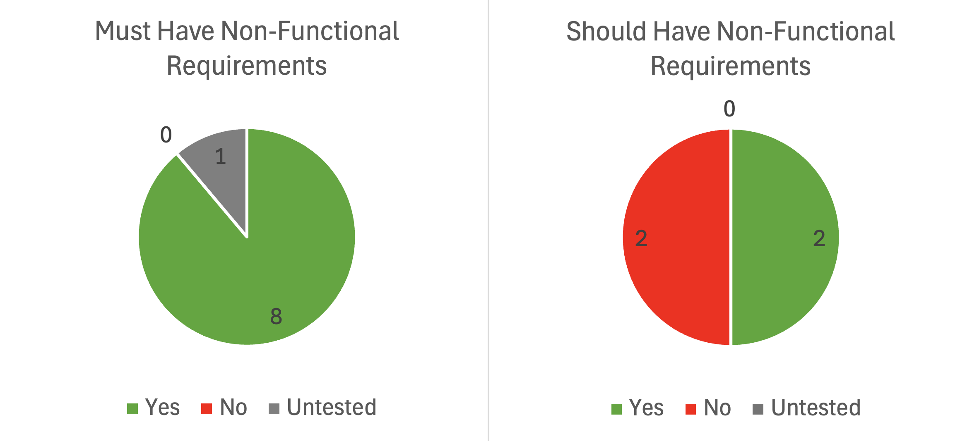
Figure 9.1.2: pie charts showing the number of non-functional requirements successfully met by my completed GUI application. These are categorised into must have, should have, and could have non-functional requirements.

9.2 Usability Assessment

9.3 Case Studies / Example Analyses
Datasets:
- LUCAS (Lung Cancer Simple set): Synthetic, binary dataset for lung-cancer risk factors with a known causal Bayesian network. Features 12 binary variables with 2000 samples, ideal for testing a causal discovery method’s ability to recover the causal structure for reproducible demos.
- Sachs (protein-signalling in human T-cells): Real biological dataset that captures causal interactions between signalling molecules in human T cells. The dataset used in causal discovery has 11 variables with thousands of measurements. It is widely used as a benchmark in causal discovery as many edges are supported by real world experimental interventions
- ASIA (Asia/Tuberculosis network): A classic toy Bayesian network consisting of 8 variables (Asia travel, Tuberculosis, Smoking, Lung Cancer, Bronchitis, Either, X-ray, Dyspnea). It is commonly used for teaching and sanity checking causal discovery algorithms due to its small size allowing quick testing.
These three datasets jointly demonstrate the GUI functioning correctly across small examples, synthetic benchmarks, and real-world intervention-based data.
To test that the GUI functions end-to-end as intended, searches were run on three representative datasets to capture the learned graphs, exports, and explanations.
LUCAS (PC, α=0.05, depth=-1): The GUI produced a 12 edge DAG with a readable layout showing clear endpoint marks (Figure 9.3.1). The exported edge list (with marks and run parameters) is shown in Figure 9.3.4. Running the comparison tab generated a concise report of all orientation/edge type disagreements across the three algorithms (Figure 9.3.5 (A)) and edges unique to one of the algorithms (Figure 9.3.5 (B)). GFCI often returned o-> when PC and FGES gave -->. This report was exported without re-running algorithms. The “Why not connected?” tab explained absences via conditional independence tests. For Born an Even Day with Allergy the sepset S was found with G² p = 0.1365, stating that the edge was not supported under the current run parameters (Figure 9.3.6). PNG and TXT exports preserved titles, parameters, and edge marks.
Sachs (GFCI, α=0.05, depth=-1): The result (Figure 9.3.2) showed a mixture of directed and partially oriented edges. This illustrates the GUI rendering endpoint shapes to communicate uncertainty of edges, a typical phenomenon in real biological datasets. Targeted “Why not connected?” queries aided interpretation of missing links, finding statistically supported conditional independencies.
ASIA (FGES, penalty=2.0): The small graph (Figure 9.3.3) served as a fast sanity check of the score-based search algorithm, interactive node replacement via clicking and dragging, live edge redrawing, and PNG export.
Across all three cases the GUI successfully: i) rendered correct edge mark semantics, ii) produced reproducible exports (PNG, edge list, comparison report), and iii) provided beginner friendly explanations for missing edges in the learned graphs. The comparison view highlighted algorithmic differences, helping relate algorithm choice to DAG structure. Overall, these examples demonstrate the reliable functionality of this tool across small, synthetic, and real-world datasets at interactive speeds providing a responsive user experience.
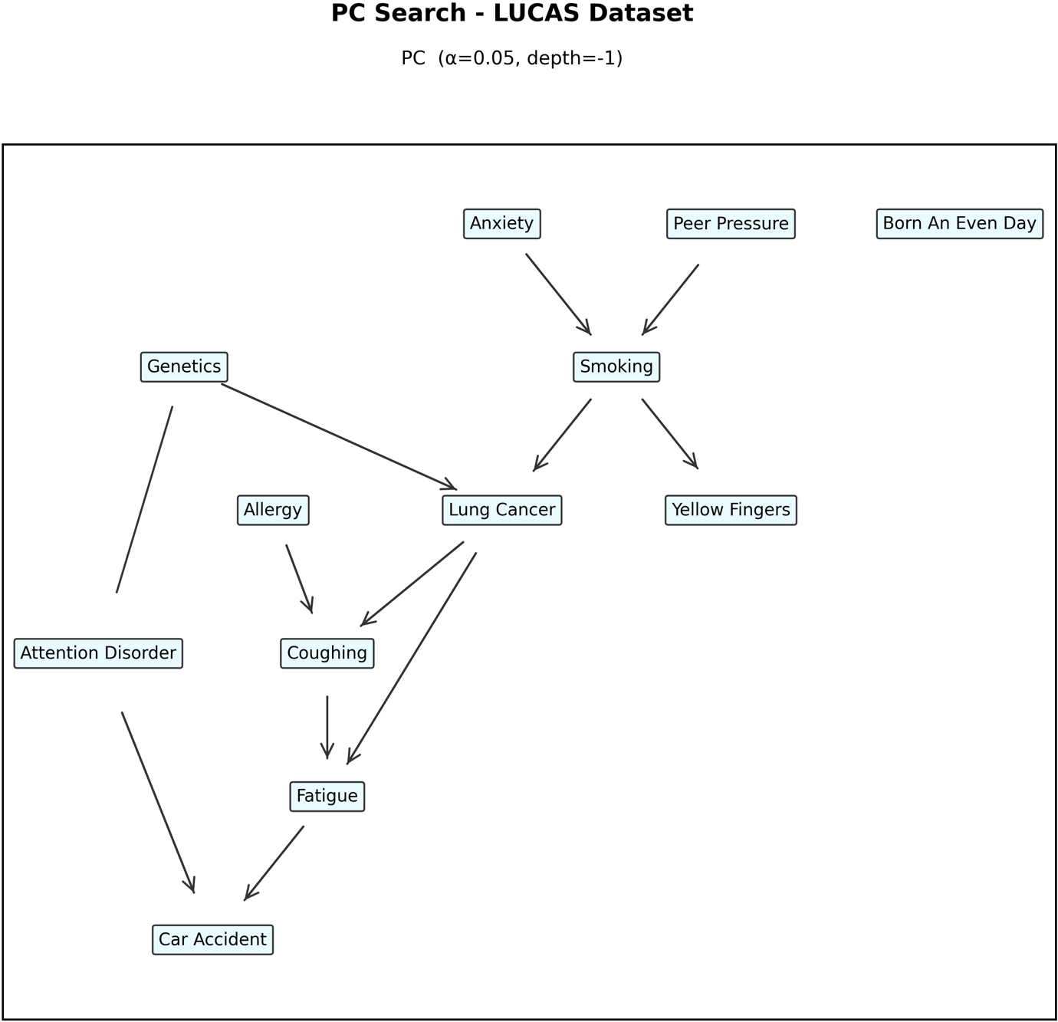Figure 9.3.1: PC DAG on LUCAS dataset (α=0.05, depth=-1).
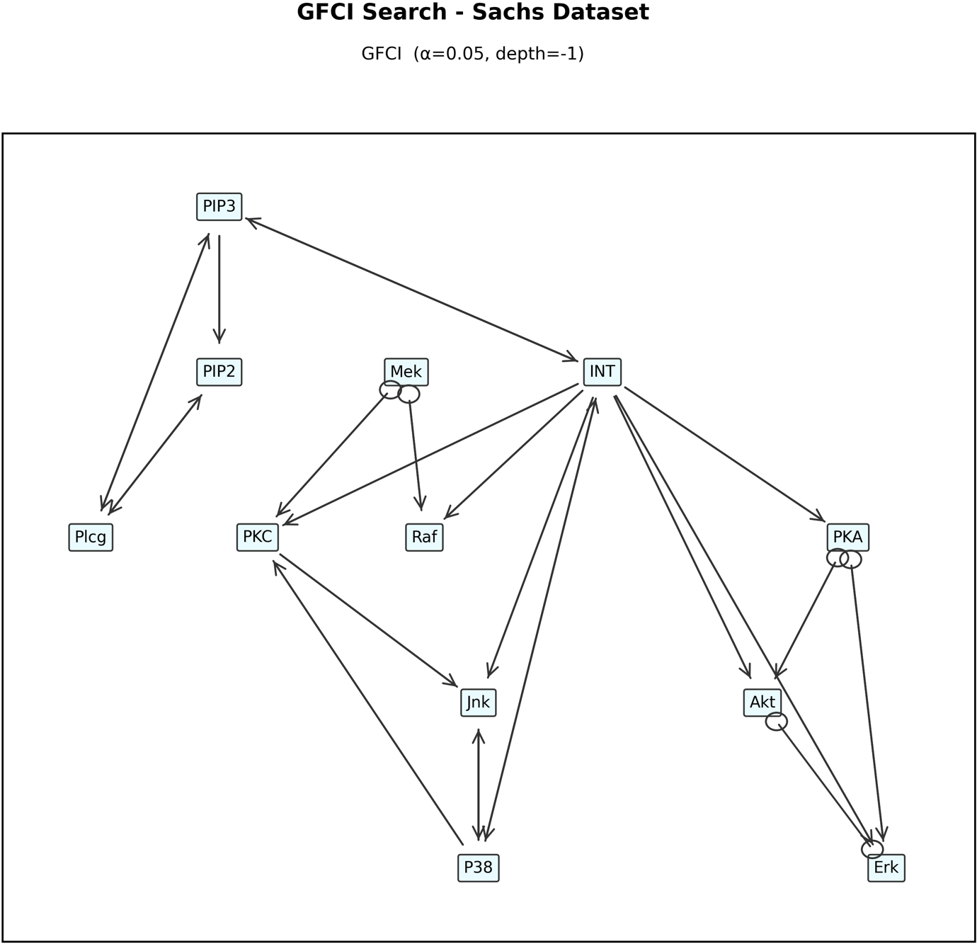
Figure 9.3.2: GFCI DAG on Sachs dataset (α=0.05, depth=-1).
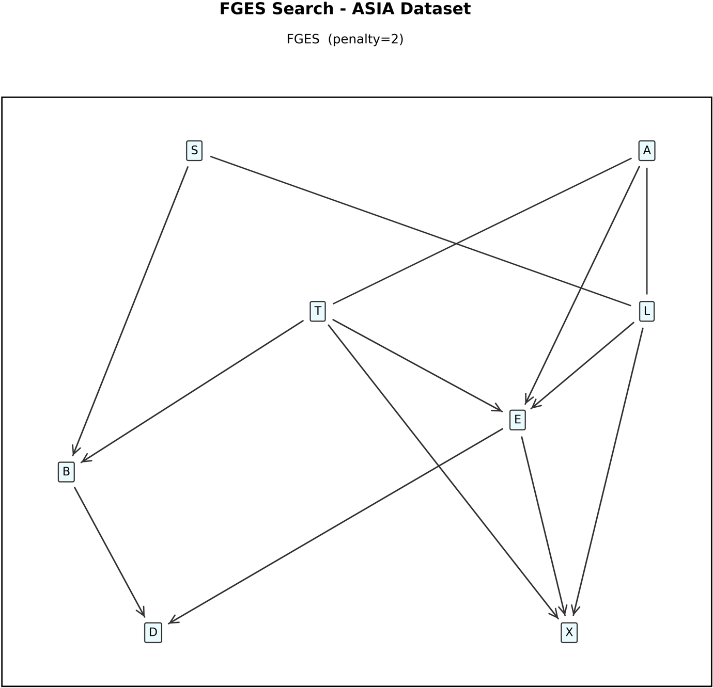
Figure 9.3.3: FGES DAG on ASIA dataset (penalty=2.0).

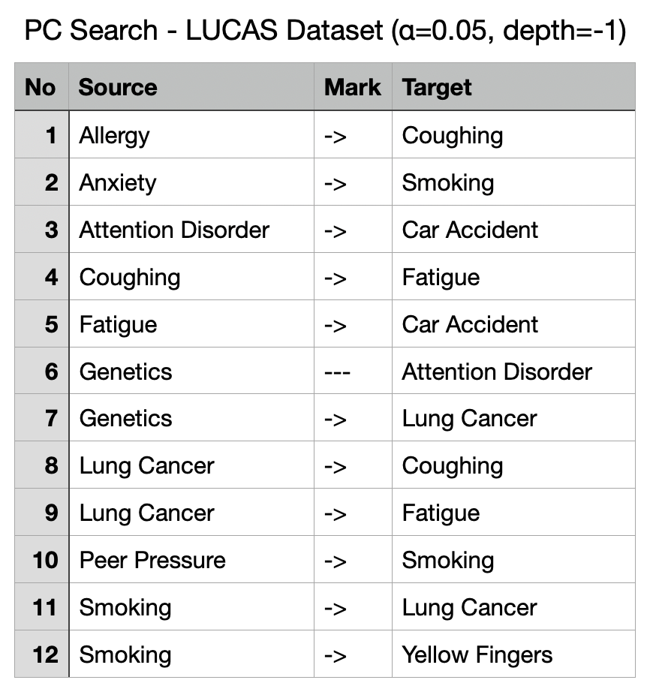
Figure 9.3.4: PC Search edge list on LUCAS dataset (α=0.05, depth=-1). Rows list pairs of variables with the specific edge mark returned by the search algorithm.
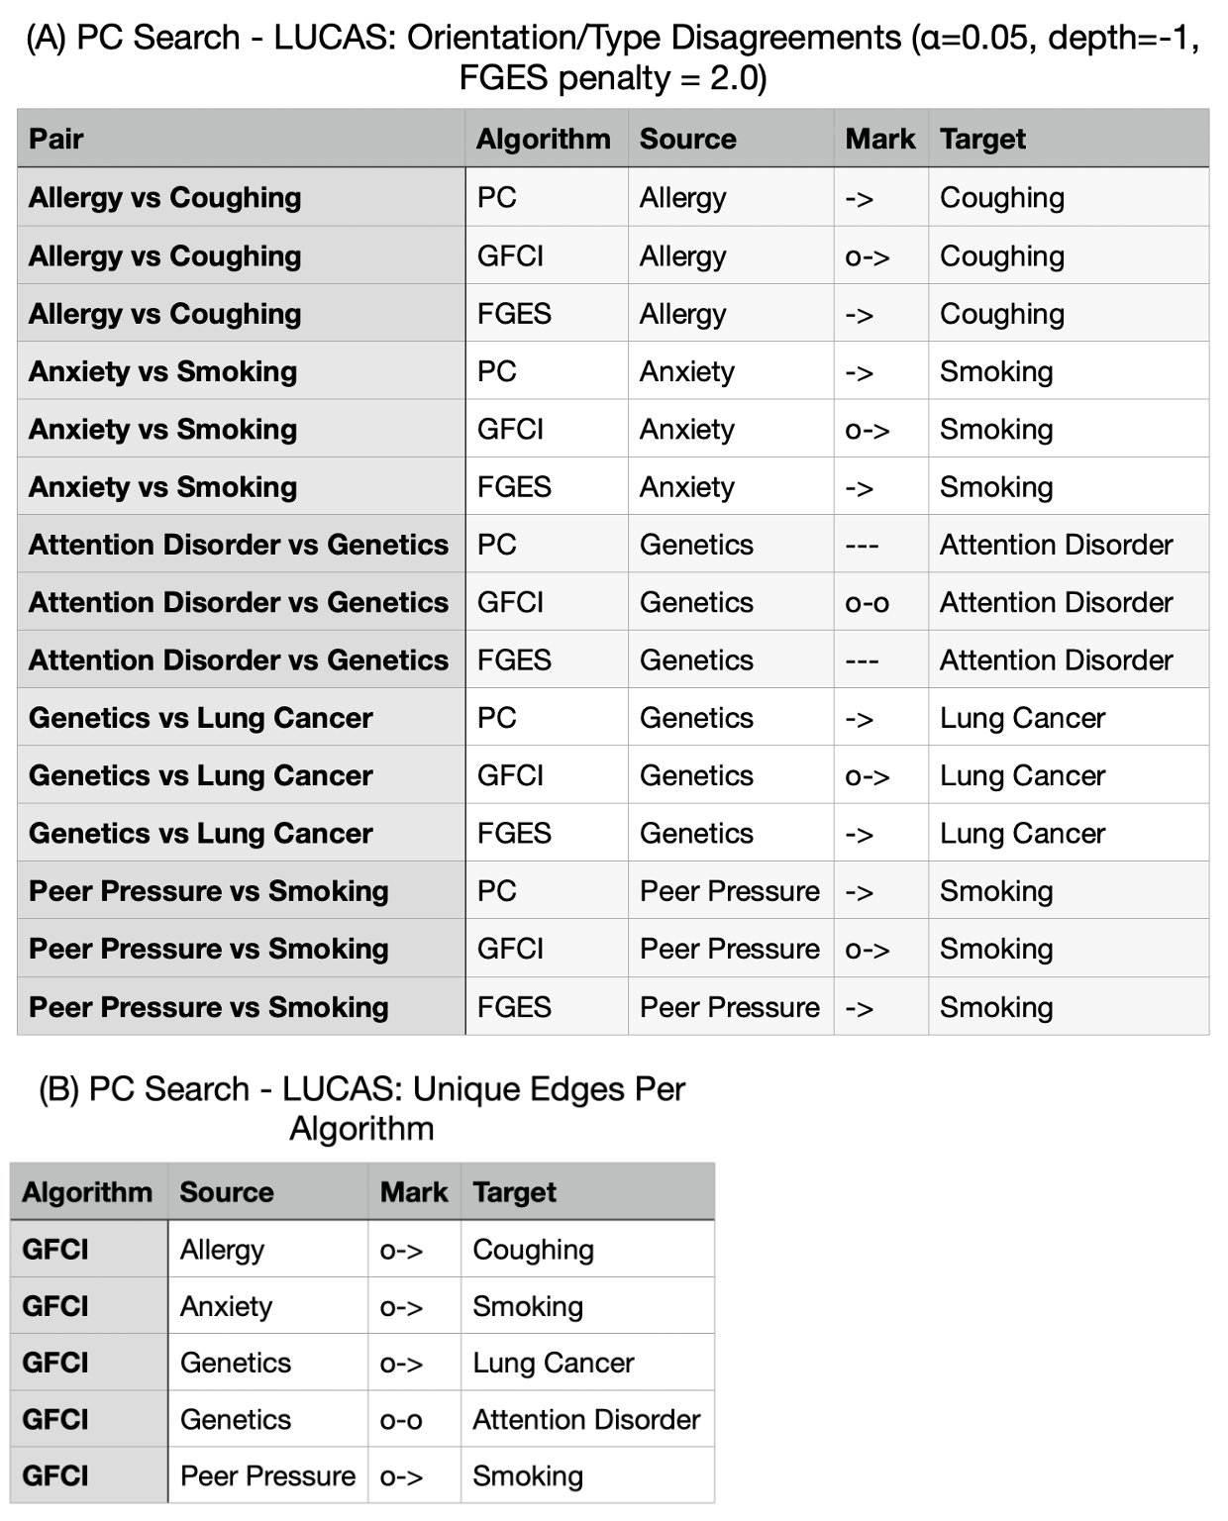
Figure 9.3.5: (A) Orientation/type disagreements between PC, GFCI, and FGES run on the LUCAS dataset (α = 0.05, depth = −1; FGES penalty = 2.0). Rows list pairs of variables with the edge marks returned by each algorithm. (B) Unique edges per algorithm run on the same data (only GFCI produced unique edges with these settings). Rows list pairs of variables with the edge mark uniquely returned by the specific algorithm.
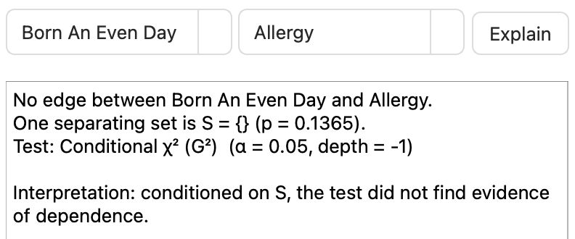
Figure 9.3.6: “Why not connected?” tab in the GUI for PC search on LUCAS (α = 0.05, depth = −1). Selecting “Born An Even Day” and “Allergy” detects the separating set S = {} (p = 0.1365) which indicated no evidence of dependence at the selected significance threshold.

9.4 Comparison to Existing Tools
To evaluate this prototype, I compared it against current causal tools: TETRAD’s desktop GUI, GeNIe, and Dagitty. The comparison involved factors matching this project’s goals: i) usability and workflow, ii) explainability/readability of results, and iii) exports & reproducibility. The PC graphs on LUCAS (α=0.05, depth=–1) show complete agreement on edges across my GUI and TETRAD’s output, confirming correctness. However, Figure 9.4.1 highlights a usability difference. The default hierarchical layout my GUI uses avoids any edge overlaps whereas in TETRAD’s circular layout it shows “Born An Even Day” being connected due to overlapping the edge between “Attention Disorder” and “Car Accident”. This requires manual moving of the node to discover no relationship is present. This supports the choice to prioritise legibility by design. In short, the causal graphs match across tools, validating the correctness of my GUI with the primary differentiator of this project being usability. This encompasses simplified parameterisation, clearer layouts, and integrated explainability (algorithm comparisons and “Why not connected?”) with minimal setup.
Figure 9.4.2 (parameter dialogs) demonstrates the GUI’s trade-off between customisability and approachability. TETRAD contains a wider range of advanced options for the user to customise, whereas my dialogs only expose essential parameters for the chosen algorithm (α/depth/test type for PC & GFCI; penalty for FGES). These parameters all have plain language hints to accompany them. This reduces “parameter anxiety” for first time users with limited understanding of how these settings affect the output. Figure 9.4.3 contrasts TETRAD’s broader algorithm chooser with my tool list containing the three implemented search algorithms (PC, GFCI, FGES). This reflects the scope decision discussed in Chapter 4-5 opting for narrower algorithm coverage, but emphasis on guidance and simpler decisions.
Figure 9.4.4 shows the comparison table summarising differences between current causal discovery tools and my GUI. Dagitty (web application) is excellent for designing causal diagrams, d-separation and adjustment identification. However, it does not feature the ability to run searches on local CSV files and requires an internet connection to use. GeNIe’s purpose is focused on Bayesian networks and decision analysis. It can learn Bayesian network structures but is not intended for algorithm comparison or separating set explanations which my application focuses on. TETRAD is the most comprehensive causal discovery tool and is open source allowing for my GUI to call its algorithms. My GUI instead emphasises usability with tutorial wizards and tooltips, explainability with the “Why not connected?” tab, separating sets, edge mark meanings, and per-run comparison reports. It is also tailored for offline use with the ability to run searches on local CSV files and export outputs offline, just as TETRAD’s desktop GUI does.
In summary, the prototype GUI complements existing tools by lowering the barrier to entry for new students to try running PC/GFCI/FGES searches on their own observational data and aiding in interpreting results. The main limitations relative to TETRAD and GeNIe respectively are fewer algorithms/options which experts in the field would desire, and no time-series/intervention tooling. These are trade-offs acknowledged for designing a beginner-friendly GUI and are listed as future work in Chapter 10.
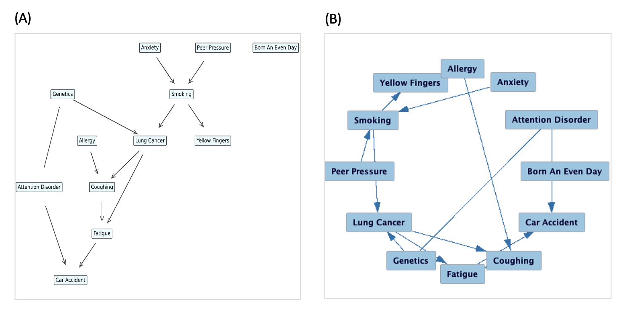
Figure 9.4.1: PC Search on LUCAS dataset (α = 0.05, depth = –1). (A) my GUI’s hierarchal Graphviz layout containing no confusing overlaps vs (B) TETRAD’s desktop GUI’s circular layout, which can visually overlap (“Born An Even Day” overlapping neighbouring arrows) by default. Edge sets are identical between the two DAGs.
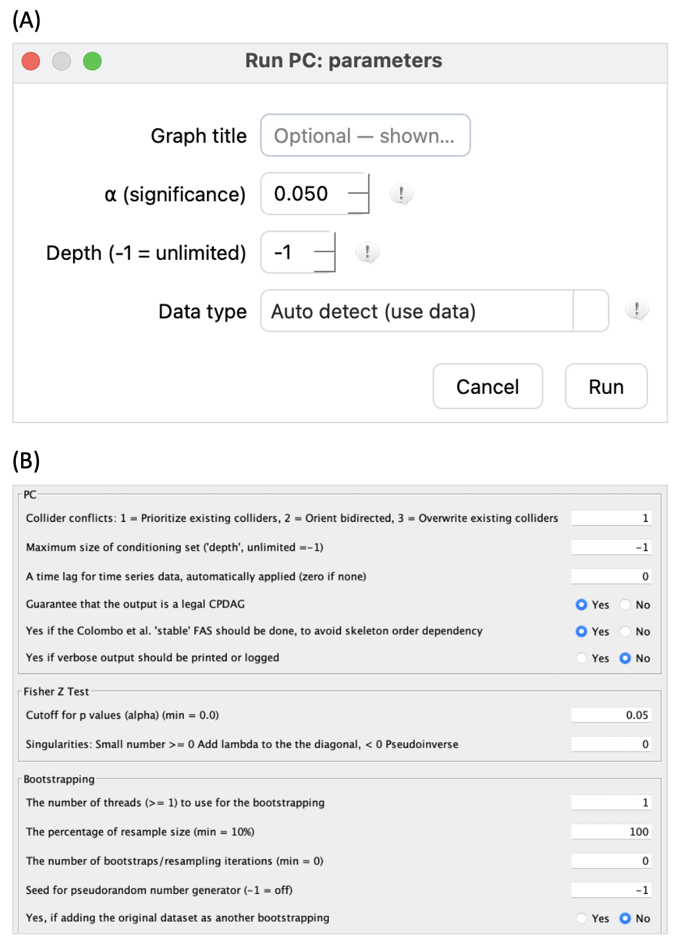
Figure 9.4.2: Parameter dialogs for PC search: (A) my GUI’s minimal format (title, α, depth, data type) targeted towards first-time users, and (B) TETRAD’s advanced dialog housing many additional options for expert tuning of the search parameters.
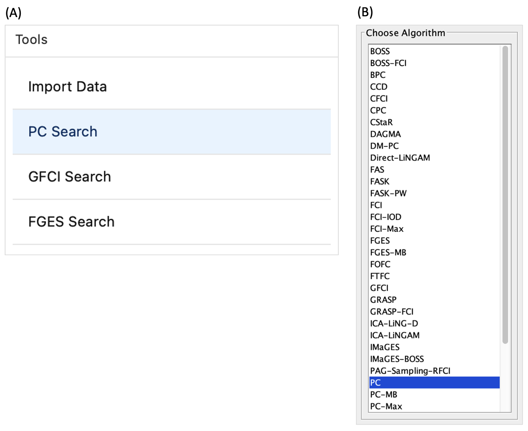
Figure 9.4.3: Algorithm selection: (A) my GUI’s focused tool list (Import Data, PC Search, GFCI Search, FGES Search) to reduce choice overload for new users, and (B) TETRAD’s vast array of algorithms with broad coverage for expert users at the cost of higher complexity and a more overwhelming choice.
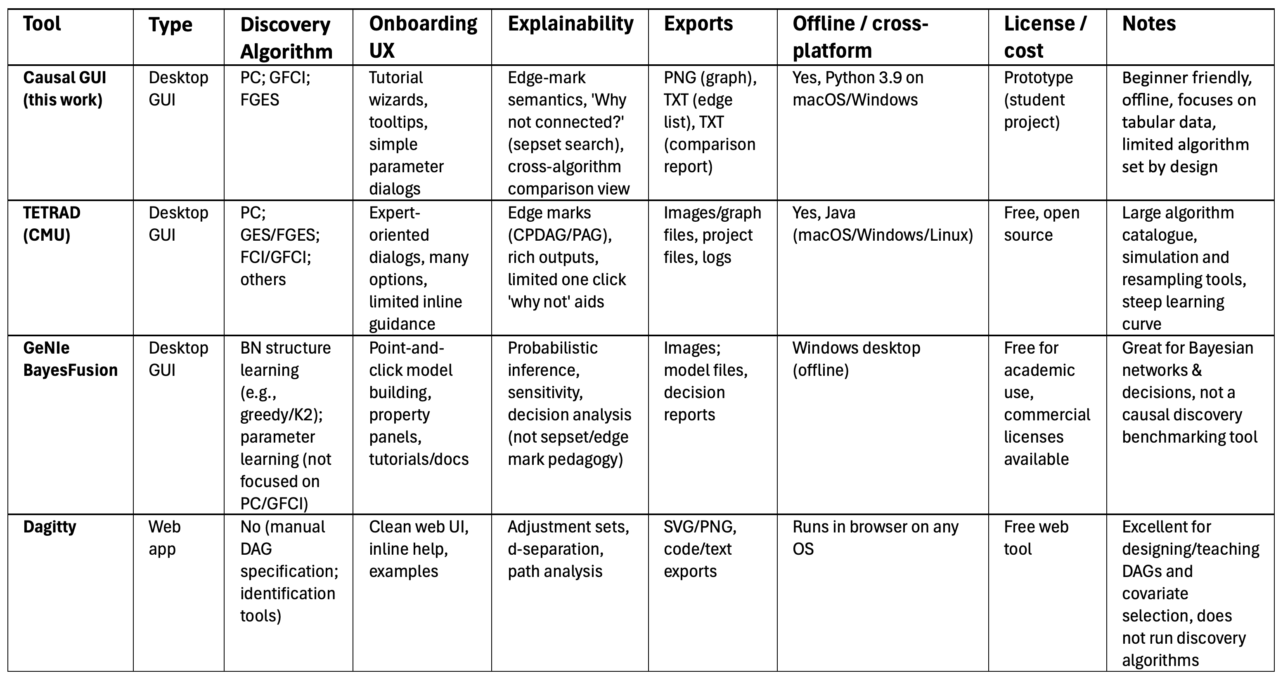
Figure 9.4.4: Comparison of causal tools (My GUI, TETRAD’s desktop GUI, GeNIe, Dagitty web application). Categories compared: Discovery coverage, onboarding UX, explainability features, export options, offline / cross-platform support, licensing/cost, and notable features.

9.5 Limitations & Threats to Validity
This section highlights validity threats to the claims made throughout Chapter 9 and addresses mitigations in place. The GUI demonstrates its goals were met (Chapters 4-8), but there are several limiting factors to generalisation.
Algorithm coverage: The tool integrates three causal discovery algorithms (PC, GFCI, FGES) on tabular, independent and identically distributed data. However, it does not cover time-series/temporal models, or non-linear methods (e.g. LiNGAM/NOTEARS), or mixed-type dataset modelling. Impact: findings cannot be generalised to those settings. Mitigations: the scope of this project is stated throughout the report. Future work discussed in Chapter 10 aims to broaden algorithm support and cover time-series data.
Scale & layout: Evaluation focused on graphs learned from small to moderate sized datasets (e.g. 8-12 variables, ≈2000 measurements). Very high dimensional datasets could cause issues with overly long runtimes and readability with overcrowded outputs. The hierarchical graph layout also depends on Graphviz (with a spring-layout fallback) and can still generate endpoint overlaps. Mitigation: manual click and dragging of variables, seeded layouts, and clear endpoint rendering are implemented. Future work will focus on zooming/panning, label overlap avoidance, and background algorithm execution.
Explainability approximations: “Why not connected?” uses a bounded search (looks at small candidate sets with capped conditioning sizes) and heuristic tests. These are dependent on the selected data type. The separating sets generated for explainability are only illustrative rather than guaranteed explanations of edge cancellation. Mitigation: the UI text describes results as explanations rather than proofs. Future work will expose exact sepsets found by the search algorithm run when available.
Measurement validity: Performance timings (Figure 8.4.1) were taken on a singular MacBook with three test runs per action. UI latency < 300 ms was also untested for all UI interactions. Impact: limited external validity of recorded timings. Mitigation: hardware specifications and raw tests are mentioned in this report, and planned future testing involves cross-platform testing and UI event timing.
User study limits. The usability survey (Chapter 8.3) targets novice users and involves a survey with self-report scales. The sample size is small, and the order of tasks could threaten validity. Participants took the survey only after the GUI demo, which may introduce learning effects. Impact: conclusions may not generalise to expert users. Mitigation: future iterations of user testing will increase the participant pool size, randomise task order, and involve a more standardised measurement (e.g. SUS).
Tool comparisons: The side-by-side comparison with TETRAD’s desktop GUI (Chapter 9.4) used search algorithms and identical parameters on three different datasets. Differences in default parameters which are not exposed in my GUI can affect outputs. Mitigation: comparisons are to convey qualitative UX contrasts. The DAG comparison across the two tools uses edge list equivalence to verify my GUI’s correctness, rather than claiming superiority.
Environment/version dependence & reproducibility: My GUI’s functionality depends on py-tetrad, Java and Graphviz versions and platform. Mitigation: versions are pinned in the READ.ME document.
Taking these limitations into account, the evidence supports the project’s main aims: a beginner-friendly, student oriented, offline GUI capable of learning correct causal graphs for supported algorithms. It provides lightweight explanations and is responsive on small-medium sized datasets (beneficial for teaching and benchmarking algorithms). The clear focus to strengthening the validity of this project is broadening the number of implemented algorithms, UI latency measurements, parallel algorithm execution, and a larger, more balanced user study.

Chapter 10: Conclusion

10.1 Summary of Contributions & Findings

10.2 Practical Impact

10.3 Future Work

10.4 Closing Remarks

References

Appendix

