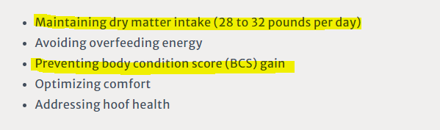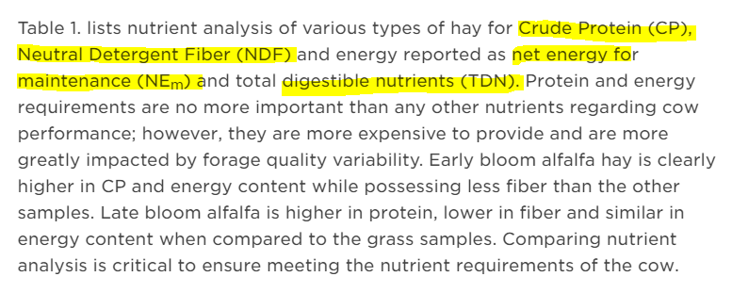**DMI (Dry Matter Intake) = $\frac{cow body weight* .011}{NDF\%}$**

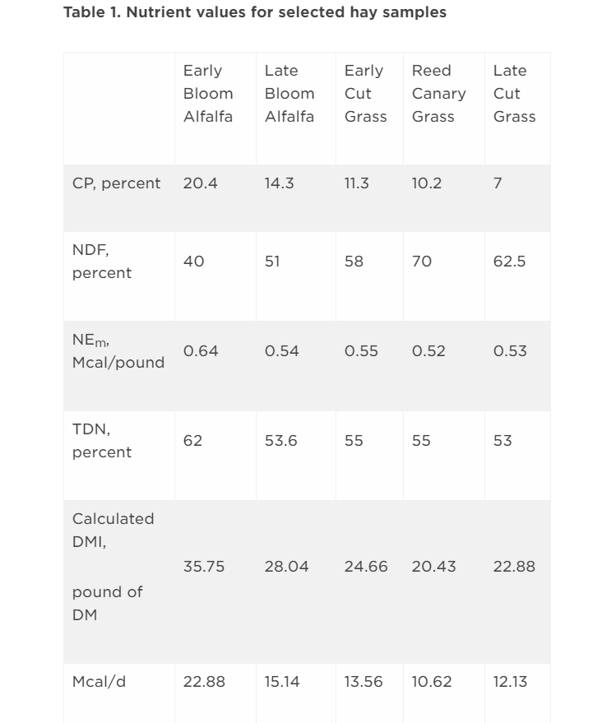 indicator of the amount of nutrients that are available to the animal in a particular feed

**Mcal (Megacalorie) = $DMI* {NE}_{m}$**

estimate forage and energy intake

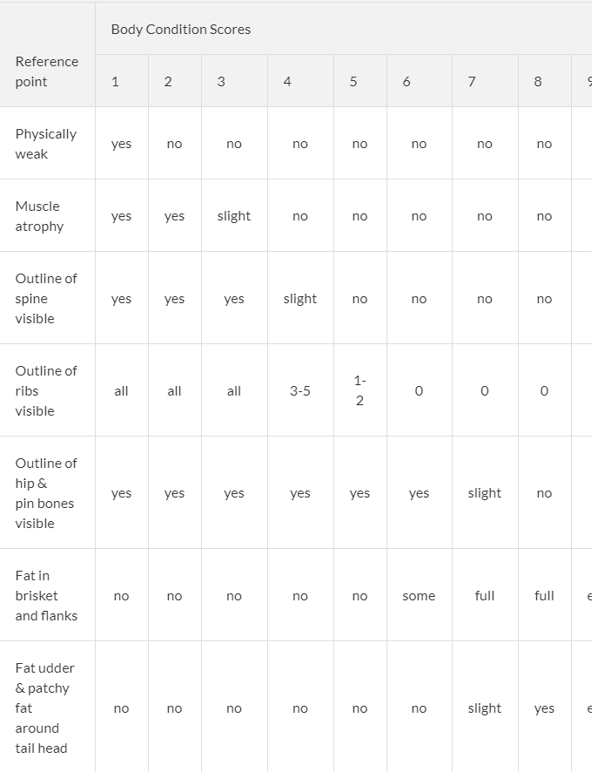BCS = $\frac{score}{9}$





**Input:** NDF (Neutral Detergent Fiber)

|  |  |  |  |  |  |
| --- | --- | --- | --- | --- | --- |
| .1.0 |  |  |  |  |  |
| .9 |  |  |  |  |  |
| .8 |  |  |  |  |  |
| .7 |  | **small** | **medium** |  |  |
| .6 |  |  |  |  |  |
| .5 |  |  |  |  |  |
| .4 |  |  |  |  |  |
| .3 |  |  |  | **large** |  |
| .2 |  |  |  |  |  |
| .1 |  |  |  |  |  |
| 40 | 50 | 60 | 70 | 80 |

**Input:** Cow Body Weight (pounds)

|  |  |  |  |  |  |  |  |  |  |  |
| --- | --- | --- | --- | --- | --- | --- | --- | --- | --- | --- |
| .1.0 |  |  |  |  |  |  |  |  |  |  |
| .9 |  |  |  |  |  |  |  |  |  |  |
| .8 |  |  |  |  |  |  |  |  |  |  |
| .7 |  |  | **small** |  |  |  |  |  |  |  |
| .6 |  |  |  |  |  |  | **medium** |  |  | **large** |
| .5 |  |  |  |  |  |  |  |  |  |  |
| .4 |  |  |  |  |  |  |  |  |  |  |
| .3 |  |  |  |  |  |  |  |  |  |  |
| .2 |  |  |  |  |  |  |  |  |  |  |
| .1 |  |  |  |  |  |  |  |  |  |  |

|  |  |  |  |  |  |  |  |  |  |
| --- | --- | --- | --- | --- | --- | --- | --- | --- | --- |
| 1000 | 1100 | 1200 | 1300 | 1400 | 1500 | 1600 | 1700 | 1800 | 1900 |

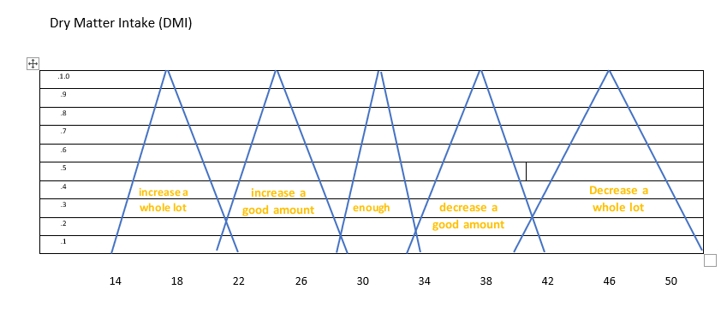

**increase**

**increase**

**decrease**

**decrease**

**Cow body weight**

**ndf**

|  |  |  |  |
| --- | --- | --- | --- |
|  | S | M | L |
| S | enough | decrease a good amount | decrease a whole lot |
| M | increase a good amount | enough | Decrease a good amount |
| L | increase a whole lot | increase a good amount | enough |