Trends in Educational Attainment

October 05, 2018

## Data Notes

* Years 2008- 2016
* Non-institutionalized population
* Ages 25-34
* Excludes Puerto Rico
* Race/Ethnicity: If Respondent indicated Hispanic, marked as Hispanic (i.e. Black Hispanic=Hispanic)

## Trend Methodology

### Growth

“Growth” is just the difference between 2016 and 2008. It only uses data from those two years.

### Trends

A “Trend” in this document is a linear regression coefficient, regressing the measure of attainment on a linear year variable. True trends are unlikely to be linear; however, the coefficient from the linear model can still be interpreted as the average linear change over the course of the study period (i.e. 2008-2016). In particular, positive coefficients indicate increasing trends, on average—this would not rule out plateaus or or decreasing trends over part of the study period—it refers only to overall averages.

Age is a strong predictor of educational attainment, and changes in the age composition of the population may induce changes in average educational attainment, even absent policy relevant effects. The “age adjusted trends,” or “Trend (Adj)” reported here accounts for the age composition by including age fixed effects in the linear models. Since age predicts educational attainment, in many cases this has the effect of reducing residual error and increasing precision, even if age compositions remained constant.

To estimate a trend in, say, high school completion, we first estimated average completion overall and within each age category in each study year, along with standard errors. These estimates and standard errors used the survey weights and replication weights provided in the ACS. Then, we estimated weighted least squares models with these averages as data, and the reciprical of the squared standard error as weights. To estimate unadjusted trends, we used overall averages, and to to estimate adjusted trends, we used age-specific averages.

### Multiplicity Adjustment and Hypothesis Tests

Each estimate in this report is accompanied by an 95% margin of error, denoted with a $±$ symbol. These, combined with the estimates themselves, define 95% confidence intervals for the appropriate population quantity. For instance, we estimate that in 2016 84% of deaf females had attained a high school diploma, with a margin of error of 3.09 percentage points. Therefore, a confidence interval for the true percentage of female deaf Americans with a high school diploma in 2016 is (80.9, 87.1). These intervals are not adjusted for multiplicity; therefore, we may assume that roughly 95% of them are “correct,” in that they include the true population parameter.

We also conducted a series of explicit hypothesis tests, testing for the existance (and direction) of age-adjusted linear trends over time for subgroups of deaf Americans. We tested hypothesis about *only* age-adjusted trends; though we estimated non-adjusted trends, we did not conduct explicit hypothesis tests for them.

We corrected these hypothesis tests for multiplicity with the following procedure. First, we tested for overall trends in high school, associate degree, and bachelor degree completion for deaf Americans with a Holm procedure. If those were significant, we went on to test for trends within subgroups of deaf Americans; these hypothesis tests were adjusted with the Bejnamini-Hochberg procedure, which controls the “false discovery rate” (Benjamini & Hochberg 1995). False discovery rate control implies that we may expect, say, 5% of rejections at the $α=0.05$ level to be incorrect; it is a more liberal control of multiplicity than the usual “familywise error rate.” We conducted this procedure using three different levels: null hypotheses rejected at the 0.05 level are denoted with a *, at the 0.01 level with **, and at the 0.001 level with ***.

Note that we did not test for trends among hearing Americans or differences between hearing and deaf Americans, and did not test hypotheses about attainment in any given year or about growth from 2008 to 2016.

Since the hypothesis tests were multiplicity-adjusted and the confidence intervals were not, they frequently do not agree—there are 95% confidence intervals that do not contain zero but whose associated null hypotheses were not rejected at the 0.05 level.

## Overall Attainment

### High School

High School completion from 2008-2016.

|  |  |  |  |
| --- | --- | --- | --- |
|  | Deaf | Hearing | Difference |
| 2008 | 78.7 $±$ 2.7 | 85.5 $±$ 0.2 |  |
| 2009 | 80.5 $±$ 2.5 | 86.4 $±$ 0.2 |  |
| 2010 | 79.2 $±$ 3.1 | 86.3 $±$ 0.3 |  |
| 2011 | 81.2 $±$ 2.6 | 87.3 $±$ 0.2 |  |
| 2012 | 79.9 $±$ 2.5 | 87.7 $±$ 0.2 |  |
| 2013 | 79.9 $±$ 2.8 | 88.1 $±$ 0.2 |  |
| 2014 | 80.9 $±$ 2.5 | 88.9 $±$ 0.2 |  |
| 2015 | 84.4 $±$ 2.2 | 89.3 $±$ 0.2 |  |
| 2016 | 83.4 $±$ 2.2 | 89.6 $±$ 0.2 |  |
| Growth | 4.7 $±$ 3.5 | 4.1 $±$ 0.3 | 0.6 $±$ 3.5 |
| Trend | 0.6 $±$ 0.3 | 0.5 $±$ 0.1 | 0 $±$ 0.3 |
| Trend (Adj) | 0.5 $±$ 0.3** | 0.5 $±$ 0 | 0 $±$ 0.3 |
| Sample Size/year | 1,472 | 162,167 |  |

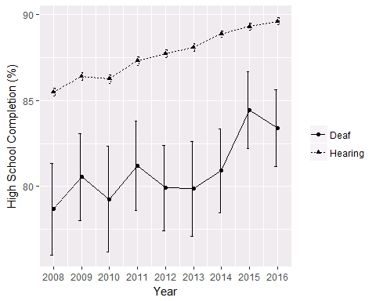 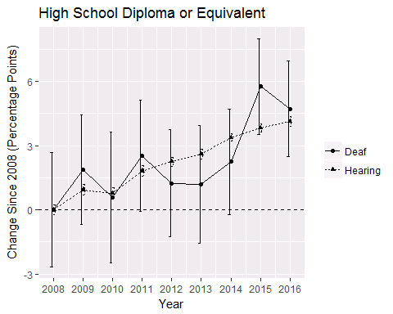

### Associates

Associates completion from 2008-2016.

|  |  |  |  |
| --- | --- | --- | --- |
|  | Deaf | Hearing | Difference |
| 2008 | 19.7 $±$ 2.4 | 37.5 $±$ 0.3 |  |
| 2009 | 21.3 $±$ 2.7 | 38.9 $±$ 0.3 |  |
| 2010 | 21 $±$ 2.4 | 39.2 $±$ 0.3 |  |
| 2011 | 21.4 $±$ 2.5 | 40 $±$ 0.3 |  |
| 2012 | 23.9 $±$ 2.4 | 40.7 $±$ 0.4 |  |
| 2013 | 23.5 $±$ 2.6 | 41.1 $±$ 0.4 |  |
| 2014 | 24.4 $±$ 2.6 | 41.9 $±$ 0.3 |  |
| 2015 | 22.8 $±$ 2.2 | 42.9 $±$ 0.3 |  |
| 2016 | 25.2 $±$ 2.7 | 43.5 $±$ 0.3 |  |
| Growth | 5.5 $±$ 3.6 | 6 $±$ 0.5 | -0.5 $±$ 3.7 |
| Trend | 0.6 $±$ 0.2 | 0.7 $±$ 0.1 | -0.1 $±$ 0.2 |
| Trend (Adj) | 0.6 $±$ 0.4** | 0.7 $±$ 0.1 | -0.1 $±$ 0.4 |
| Sample Size/year | 1,472 | 162,167 |  |

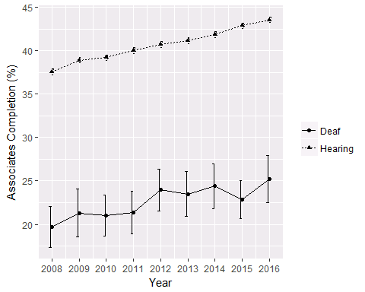 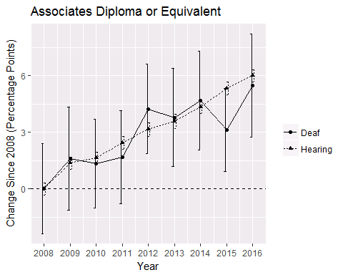

### Bachelors

Bachelor’s degree attainment from 2008-2016.

|  |  |  |  |
| --- | --- | --- | --- |
|  | Deaf | Hearing | Difference |
| 2008 | 13 $±$ 2.2 | 29.4 $±$ 0.3 |  |
| 2009 | 13.1 $±$ 2.2 | 31 $±$ 0.3 |  |
| 2010 | 14.4 $±$ 2.1 | 31.2 $±$ 0.3 |  |
| 2011 | 12.7 $±$ 1.9 | 31.6 $±$ 0.3 |  |
| 2012 | 13.3 $±$ 2.1 | 32.2 $±$ 0.3 |  |
| 2013 | 14.3 $±$ 2.1 | 32.6 $±$ 0.3 |  |
| 2014 | 16.2 $±$ 2.3 | 33.1 $±$ 0.3 |  |
| 2015 | 15.1 $±$ 2.2 | 34.2 $±$ 0.3 |  |
| 2016 | 16.9 $±$ 2.2 | 34.9 $±$ 0.3 |  |
| Growth | 4 $±$ 3.1 | 5.4 $±$ 0.4 | -1.4 $±$ 3.1 |
| Trend | 0.5 $±$ 0.2 | 0.6 $±$ 0.1 | -0.1 $±$ 0.2 |
| Trend (Adj) | 0.5 $±$ 0.3** | 0.6 $±$ 0.1 | -0.1 $±$ 0.3 |
| Sample Size/year | 1,472 | 162,167 |  |

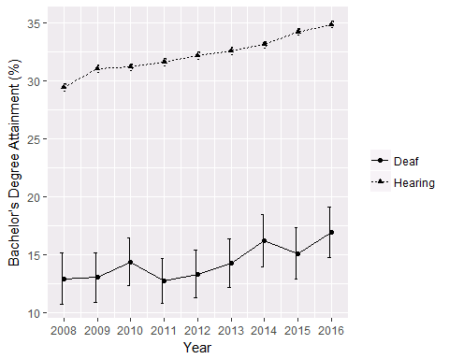 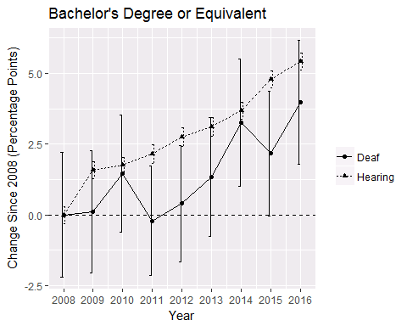

## Attainment By Gender

### High School

Percentage of deaf Americans by gender attaining a High School diploma or equivalent.

|  |  |  |
| --- | --- | --- |
|  | Female | Male |
| 2008 | 80.1 $±$ 4.4 | 77.7 $±$ 3.2 |
| 2009 | 81.2 $±$ 4.3 | 80.1 $±$ 3.2 |
| 2010 | 77.9 $±$ 5 | 80.2 $±$ 3.9 |
| 2011 | 82.1 $±$ 4.3 | 80.6 $±$ 2.8 |
| 2012 | 79.3 $±$ 4.2 | 80.3 $±$ 3.1 |
| 2013 | 82.2 $±$ 3.8 | 78.2 $±$ 3.6 |
| 2014 | 81 $±$ 4.1 | 80.9 $±$ 3.5 |
| 2015 | 86.4 $±$ 3.2 | 83.2 $±$ 2.9 |
| 2016 | 84 $±$ 3.1 | 82.9 $±$ 2.9 |
| Growth | 3.9 $±$ 5.4 | 5.2 $±$ 4.3 |
| Trend | 0.6 $±$ 0.5 | 0.5 $±$ 0.3 |
| Trend (Adj) | 0.6 $±$ 0.5 | 0.5 $±$ 0.4. |
| Sample Size/year | 582 | 890 |

Percentage of hearing Americans by gender attaining a High School diploma or equivalent.

|  |  |  |
| --- | --- | --- |
|  | Female | Male |
| 2008 | 88 $±$ 0.2 | 83 $±$ 0.4 |
| 2009 | 88.6 $±$ 0.3 | 84.3 $±$ 0.3 |
| 2010 | 88.5 $±$ 0.3 | 84.1 $±$ 0.3 |
| 2011 | 89.2 $±$ 0.3 | 85.5 $±$ 0.3 |
| 2012 | 89.6 $±$ 0.3 | 85.9 $±$ 0.3 |
| 2013 | 89.7 $±$ 0.3 | 86.4 $±$ 0.3 |
| 2014 | 90.6 $±$ 0.2 | 87.1 $±$ 0.3 |
| 2015 | 91 $±$ 0.2 | 87.6 $±$ 0.3 |
| 2016 | 91.2 $±$ 0.3 | 88 $±$ 0.3 |
| Growth | 3.2 $±$ 0.4 | 5 $±$ 0.5 |
| Trend | 0.4 $±$ 0.1 | 0.6 $±$ 0.1 |
| Trend (Adj) | 0.4 $±$ 0 | 0.6 $±$ 0.1 |
| Sample Size/year | 81,309 | 80,858 |

Differences in growth and trends between deaf and hearing Americans for males and females. Positive Differences indicate faster growth for deaf Americans.

|  |  |  |
| --- | --- | --- |
|  | Female | Male |
| Growth | 0.7 $±$ 5.4 | 0.2 $±$ 4.4 |
| Trend | 0.2 $±$ 0.5 | -0.1 $±$ 0.3 |
| Trend (Adj) | 0.2 $±$ 0.5 | -0.1 $±$ 0.4 |

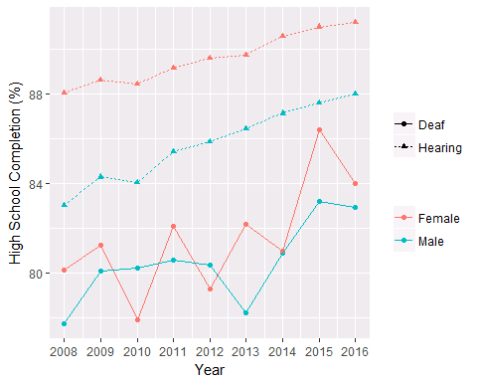 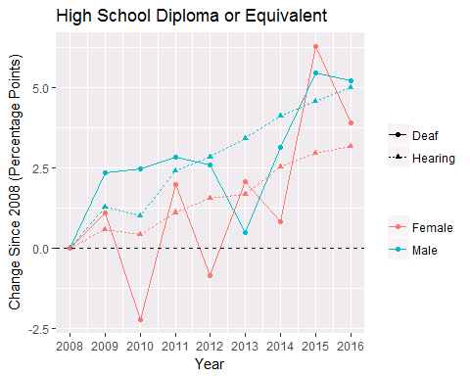

### Associates

Percentage of deaf Americans by gender attaining a Associates diploma or equivalent.

|  |  |  |
| --- | --- | --- |
|  | Female | Male |
| 2008 | 26.8 $±$ 4 | 15.1 $±$ 2.8 |
| 2009 | 24.6 $±$ 4.1 | 19.1 $±$ 3 |
| 2010 | 22.1 $±$ 3.9 | 20.3 $±$ 3.4 |
| 2011 | 27.5 $±$ 4.1 | 17.1 $±$ 3.3 |
| 2012 | 26.4 $±$ 4.4 | 22.2 $±$ 3.7 |
| 2013 | 29.9 $±$ 4.4 | 19 $±$ 3 |
| 2014 | 27.6 $±$ 4.5 | 22.3 $±$ 3.7 |
| 2015 | 25 $±$ 4 | 21.4 $±$ 3.2 |
| 2016 | 29.9 $±$ 4.6 | 22 $±$ 3.1 |
| Growth | 3.1 $±$ 6.1 | 6.9 $±$ 4.2 |
| Trend | 0.4 $±$ 0.6 | 0.7 $±$ 0.5 |
| Trend (Adj) | 0.5 $±$ 0.6 | 0.7 $±$ 0.5* |
| Sample Size/year | 582 | 890 |

Percentage of hearing Americans by gender attaining a Associates diploma or equivalent.

|  |  |  |
| --- | --- | --- |
|  | Female | Male |
| 2008 | 42.4 $±$ 0.4 | 32.9 $±$ 0.4 |
| 2009 | 44 $±$ 0.4 | 34.1 $±$ 0.4 |
| 2010 | 44.2 $±$ 0.4 | 34.2 $±$ 0.4 |
| 2011 | 44.9 $±$ 0.4 | 35.1 $±$ 0.5 |
| 2012 | 45.8 $±$ 0.4 | 35.7 $±$ 0.4 |
| 2013 | 46.2 $±$ 0.5 | 36.2 $±$ 0.4 |
| 2014 | 46.8 $±$ 0.5 | 37 $±$ 0.4 |
| 2015 | 47.5 $±$ 0.4 | 38.3 $±$ 0.4 |
| 2016 | 48.4 $±$ 0.4 | 38.7 $±$ 0.4 |
| Growth | 6.1 $±$ 0.6 | 5.8 $±$ 0.6 |
| Trend | 0.7 $±$ 0.1 | 0.7 $±$ 0.1 |
| Trend (Adj) | 0.7 $±$ 0.1 | 0.7 $±$ 0.1 |
| Sample Size/year | 81,309 | 80,858 |

Differences in growth and trends between deaf and hearing Americans for males and females. Positive Differences indicate faster growth for deaf Americans.

|  |  |  |
| --- | --- | --- |
|  | Female | Male |
| Growth | -3 $±$ 6.1 | 1.1 $±$ 4.3 |
| Trend | -0.3 $±$ 0.6 | 0 $±$ 0.5 |
| Trend (Adj) | -0.2 $±$ 0.6 | 0 $±$ 0.5 |

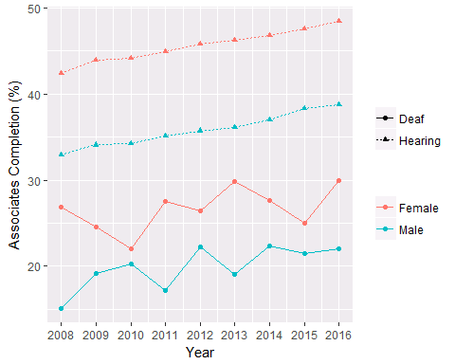 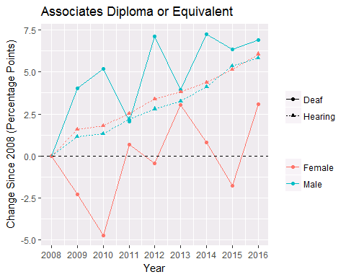

### Bachelors

Percentage of deaf Americans by gender attaining a Bachelor’s degree.

|  |  |  |
| --- | --- | --- |
|  | Female | Male |
| 2008 | 16.4 $±$ 3.5 | 10.7 $±$ 2.6 |
| 2009 | 15.5 $±$ 3.5 | 11.4 $±$ 2.6 |
| 2010 | 13.9 $±$ 3.7 | 14.7 $±$ 2.8 |
| 2011 | 18.9 $±$ 3.9 | 8.4 $±$ 2.2 |
| 2012 | 15 $±$ 3.4 | 12.2 $±$ 2.5 |
| 2013 | 19.6 $±$ 3.8 | 10.6 $±$ 2.2 |
| 2014 | 17.5 $±$ 4 | 15.4 $±$ 3 |
| 2015 | 17.7 $±$ 3.7 | 13.5 $±$ 2.9 |
| 2016 | 21.9 $±$ 4.3 | 13.6 $±$ 2.4 |
| Growth | 5.4 $±$ 5.6 | 2.9 $±$ 3.6 |
| Trend | 0.6 $±$ 0.5 | 0.4 $±$ 0.5 |
| Trend (Adj) | 0.6 $±$ 0.5 | 0.4 $±$ 0.4 |
| Sample Size/year | 582 | 890 |

Percentage of hearing Americans by gender attaining a Bachelor’s degree.

|  |  |  |
| --- | --- | --- |
|  | Female | Male |
| 2008 | 33.2 $±$ 0.4 | 25.8 $±$ 0.4 |
| 2009 | 35.1 $±$ 0.4 | 27.1 $±$ 0.4 |
| 2010 | 35.2 $±$ 0.4 | 27.2 $±$ 0.4 |
| 2011 | 35.3 $±$ 0.4 | 27.9 $±$ 0.4 |
| 2012 | 36.1 $±$ 0.4 | 28.3 $±$ 0.4 |
| 2013 | 36.7 $±$ 0.4 | 28.5 $±$ 0.4 |
| 2014 | 37.1 $±$ 0.4 | 29.2 $±$ 0.3 |
| 2015 | 38 $±$ 0.4 | 30.5 $±$ 0.4 |
| 2016 | 38.8 $±$ 0.4 | 31 $±$ 0.4 |
| Growth | 5.6 $±$ 0.6 | 5.2 $±$ 0.5 |
| Trend | 0.6 $±$ 0.1 | 0.6 $±$ 0.1 |
| Trend (Adj) | 0.6 $±$ 0.1 | 0.6 $±$ 0.1 |
| Sample Size/year | 81,309 | 80,858 |

Differences in growth and trends between deaf and hearing Americans for males and females. Positive Differences indicate faster growth for deaf Americans.

|  |  |  |
| --- | --- | --- |
|  | Female | Male |
| Growth | -0.2 $±$ 5.6 | -2.3 $±$ 3.6 |
| Trend | 0 $±$ 0.5 | -0.2 $±$ 0.5 |
| Trend (Adj) | 0 $±$ 0.5 | -0.2 $±$ 0.4 |

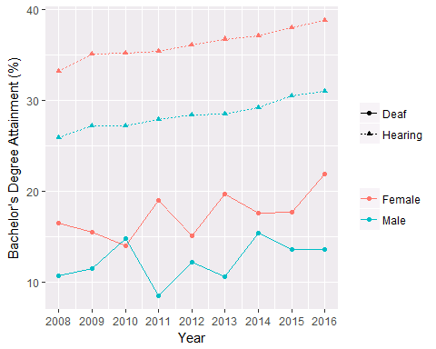 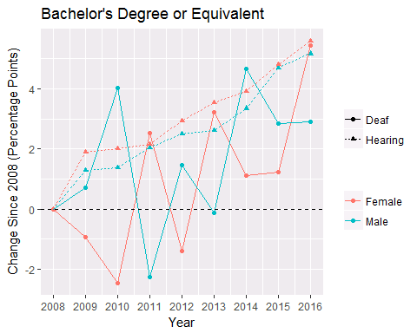

## Attainment By Race/Ethnicity

### High School

Percentage of deaf Americans by race/ethnicity attaining a High School diploma or equivalent.

|  |  |  |  |  |
| --- | --- | --- | --- | --- |
|  | African American | Hispanic | Other | White |
| 2008 | 72.4 $±$ 7.5 | 63 $±$ 7.1 | 84.6 $±$ 7.4 | 84.5 $±$ 3.2 |
| 2009 | 77.1 $±$ 6.6 | 68.2 $±$ 5.8 | 76.9 $±$ 9.3 | 85.7 $±$ 3.1 |
| 2010 | 78.3 $±$ 7.4 | 64.2 $±$ 9.3 | 82.8 $±$ 7.7 | 83.3 $±$ 2.9 |
| 2011 | 79.1 $±$ 7.5 | 75.8 $±$ 5.4 | 80.1 $±$ 7.6 | 83.6 $±$ 3.3 |
| 2012 | 79.6 $±$ 6 | 67.6 $±$ 6.8 | 79.5 $±$ 9.3 | 84.5 $±$ 3 |
| 2013 | 74.2 $±$ 8.6 | 70.8 $±$ 7.3 | 77.5 $±$ 10.7 | 84.8 $±$ 2.9 |
| 2014 | 72 $±$ 8.9 | 68.6 $±$ 7.4 | 83.3 $±$ 6.8 | 86.2 $±$ 2.8 |
| 2015 | 80.1 $±$ 7.1 | 74.4 $±$ 5.8 | 83.5 $±$ 9.4 | 89 $±$ 2.1 |
| 2016 | 75.9 $±$ 8.4 | 73.8 $±$ 6.5 | 83.2 $±$ 7.9 | 88.2 $±$ 2.6 |
| Growth | 3.5 $±$ 11.3 | 10.8 $±$ 9.6 | -1.4 $±$ 10.8 | 3.8 $±$ 4.1 |
| Trend | 0.1 $±$ 0.9 | 1.1 $±$ 0.9 | 0.2 $±$ 0.7 | 0.6 $±$ 0.4 |
| Trend (Adj) | 0.2 $±$ 0.9 | 1 $±$ 0.8. | 0.5 $±$ 1.1 | 0.5 $±$ 0.3* |
| Sample Size/year | 173 | 271 | 127 | 901 |

Percentage of hearing Americans by race/ethnicity attaining a High School diploma or equivalent.

|  |  |  |  |  |
| --- | --- | --- | --- | --- |
|  | African American | Hispanic | Other | White |
| 2008 | 86 $±$ 0.7 | 65.6 $±$ 0.6 | 93.5 $±$ 0.5 | 92.8 $±$ 0.2 |
| 2009 | 86.8 $±$ 0.7 | 67.4 $±$ 0.6 | 94 $±$ 0.5 | 93.3 $±$ 0.2 |
| 2010 | 86 $±$ 0.6 | 67.8 $±$ 0.7 | 93.9 $±$ 0.4 | 93.3 $±$ 0.2 |
| 2011 | 87.1 $±$ 0.5 | 69.9 $±$ 0.8 | 94.1 $±$ 0.4 | 93.6 $±$ 0.2 |
| 2012 | 87.4 $±$ 0.6 | 71.3 $±$ 0.7 | 93.9 $±$ 0.4 | 93.8 $±$ 0.2 |
| 2013 | 87.4 $±$ 0.6 | 72.6 $±$ 0.6 | 94.4 $±$ 0.4 | 93.8 $±$ 0.2 |
| 2014 | 88 $±$ 0.6 | 74.6 $±$ 0.5 | 94.3 $±$ 0.4 | 94.3 $±$ 0.2 |
| 2015 | 88.3 $±$ 0.6 | 75.7 $±$ 0.6 | 94.8 $±$ 0.4 | 94.4 $±$ 0.2 |
| 2016 | 88.3 $±$ 0.6 | 77.7 $±$ 0.6 | 94.6 $±$ 0.4 | 94.1 $±$ 0.2 |
| Growth | 2.3 $±$ 0.9 | 12.1 $±$ 0.8 | 1.1 $±$ 0.6 | 1.3 $±$ 0.3 |
| Trend | 0.3 $±$ 0.1 | 1.5 $±$ 0.1 | 0.1 $±$ 0 | 0.2 $±$ 0 |
| Trend (Adj) | 0.3 $±$ 0.1 | 1.5 $±$ 0.1 | 0.1 $±$ 0.1 | 0.2 $±$ 0 |
| Sample Size/year | 18,043 | 33,683 | 17,574 | 92,866 |

Differences in growth and trends between deaf and hearing Americans for each age category. Positive Differences indicate faster growth for deaf Americans.

|  |  |  |  |  |
| --- | --- | --- | --- | --- |
|  | African American | Hispanic | Other | White |
| Growth | 1.2 $±$ 11.3 | -1.2 $±$ 9.7 | -2.5 $±$ 10.8 | 2.4 $±$ 4.1 |
| Trend | -0.2 $±$ 0.9 | -0.4 $±$ 0.9 | 0.1 $±$ 0.7 | 0.4 $±$ 0.4 |
| Trend (Adj) | -0.1 $±$ 0.9 | -0.5 $±$ 0.8 | 0.3 $±$ 1.1 | 0.4 $±$ 0.3 |

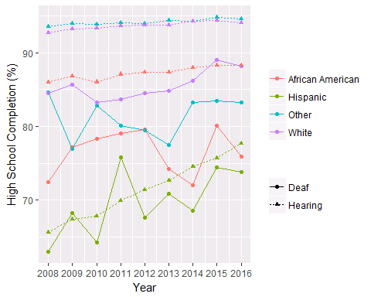 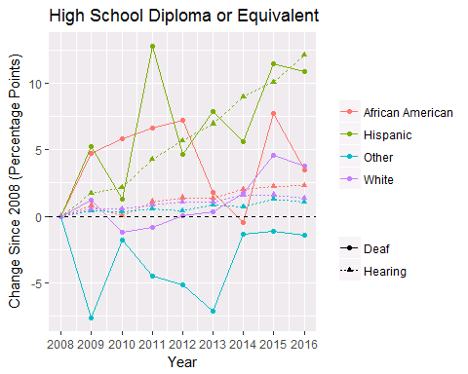

### Associates

Percentage of deaf Americans by race/ethnicity attaining a Associates diploma or equivalent.

|  |  |  |  |  |
| --- | --- | --- | --- | --- |
|  | African American | Hispanic | Other | White |
| 2008 | 9.1 $±$ 5.4 | 12.4 $±$ 5.1 | 31 $±$ 9.3 | 23.1 $±$ 3.4 |
| 2009 | 17.4 $±$ 6.2 | 13.1 $±$ 5 | 26.3 $±$ 10.2 | 24.2 $±$ 3.4 |
| 2010 | 19.1 $±$ 7.1 | 18.5 $±$ 6.7 | 20.7 $±$ 8.2 | 22.2 $±$ 3.4 |
| 2011 | 10.4 $±$ 6.6 | 15.9 $±$ 5.2 | 26.6 $±$ 10.5 | 24.8 $±$ 3.3 |
| 2012 | 18.8 $±$ 6.1 | 17.3 $±$ 5.4 | 34.4 $±$ 9.8 | 26.2 $±$ 3.5 |
| 2013 | 12.6 $±$ 6.5 | 15.4 $±$ 5.3 | 30.4 $±$ 9.9 | 28.2 $±$ 3.5 |
| 2014 | 13.7 $±$ 5.6 | 12.4 $±$ 3.7 | 34.6 $±$ 10.6 | 28.8 $±$ 3.5 |
| 2015 | 10.8 $±$ 5 | 17.6 $±$ 4.9 | 28.9 $±$ 10.4 | 26.2 $±$ 2.8 |
| 2016 | 21.2 $±$ 6.3 | 14.9 $±$ 4 | 25.8 $±$ 8.6 | 29.4 $±$ 3.8 |
| Growth | 12.1 $±$ 8.3 | 2.4 $±$ 6.5 | -5.2 $±$ 12.7 | 6.3 $±$ 5.1 |
| Trend | 0.4 $±$ 1.2 | 0.2 $±$ 0.6 | 0.3 $±$ 1.2 | 0.8 $±$ 0.4 |
| Trend (Adj) | 0.5 $±$ 0.9 | 0.3 $±$ 0.6 | 0.3 $±$ 1.2 | 0.8 $±$ 0.5* |
| Sample Size/year | 173 | 271 | 127 | 901 |

Percentage of hearing Americans by race/ethnicity attaining a Associates diploma or equivalent.

|  |  |  |  |  |
| --- | --- | --- | --- | --- |
|  | African American | Hispanic | Other | White |
| 2008 | 27.4 $±$ 0.9 | 18.1 $±$ 0.5 | 59.1 $±$ 1.1 | 44.9 $±$ 0.4 |
| 2009 | 26.7 $±$ 0.7 | 18.7 $±$ 0.5 | 59.5 $±$ 0.8 | 47 $±$ 0.4 |
| 2010 | 26.8 $±$ 0.9 | 19.4 $±$ 0.5 | 59.2 $±$ 0.8 | 47.4 $±$ 0.4 |
| 2011 | 28.1 $±$ 0.7 | 19.9 $±$ 0.5 | 59.2 $±$ 1.1 | 48 $±$ 0.5 |
| 2012 | 27.5 $±$ 0.9 | 20.9 $±$ 0.6 | 60.9 $±$ 0.9 | 48.7 $±$ 0.5 |
| 2013 | 28.1 $±$ 0.8 | 21.4 $±$ 0.6 | 61.3 $±$ 0.9 | 49 $±$ 0.5 |
| 2014 | 28.7 $±$ 0.8 | 22.4 $±$ 0.6 | 60.4 $±$ 1 | 50.1 $±$ 0.4 |
| 2015 | 29.2 $±$ 1 | 23.6 $±$ 0.6 | 62.1 $±$ 0.8 | 50.7 $±$ 0.4 |
| 2016 | 30.1 $±$ 0.9 | 25 $±$ 0.6 | 62.3 $±$ 0.8 | 51.1 $±$ 0.4 |
| Growth | 2.8 $±$ 1.3 | 6.8 $±$ 0.8 | 3.3 $±$ 1.3 | 6.2 $±$ 0.6 |
| Trend | 0.4 $±$ 0.1 | 0.8 $±$ 0.1 | 0.4 $±$ 0.1 | 0.7 $±$ 0.1 |
| Trend (Adj) | 0.4 $±$ 0.1 | 0.8 $±$ 0.1 | 0.4 $±$ 0.1 | 0.7 $±$ 0.1 |
| Sample Size/year | 18,043 | 33,683 | 17,574 | 92,866 |

Differences in growth and trends between deaf and hearing Americans for each age category. Positive Differences indicate faster growth for deaf Americans.

|  |  |  |  |  |
| --- | --- | --- | --- | --- |
|  | African American | Hispanic | Other | White |
| Growth | 9.3 $±$ 8.4 | -4.4 $±$ 6.5 | -8.4 $±$ 12.7 | 0.1 $±$ 5.1 |
| Trend | 0 $±$ 1.2 | -0.6 $±$ 0.6 | -0.1 $±$ 1.2 | 0.1 $±$ 0.4 |
| Trend (Adj) | 0.1 $±$ 0.9 | -0.6 $±$ 0.6 | -0.1 $±$ 1.2 | 0.1 $±$ 0.5 |

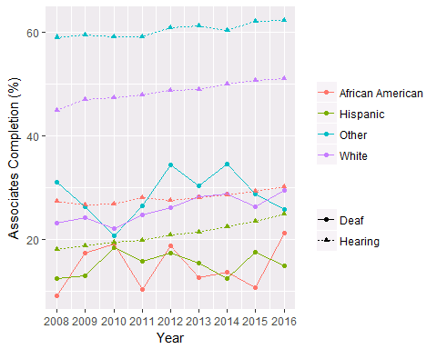 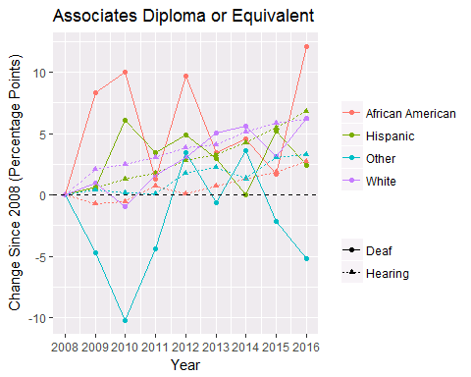

### Bachelors

Percentage of deaf Americans by race/ethnicity attaining a Bachelor’s degree.

|  |  |  |  |  |
| --- | --- | --- | --- | --- |
|  | African American | Hispanic | Other | White |
| 2008 | 2.8 $±$ 1.8 | 8.4 $±$ 3.7 | 23.7 $±$ 8.4 | 15.5 $±$ 3 |
| 2009 | 11.1 $±$ 5.2 | 9.9 $±$ 4.1 | 12.6 $±$ 6.9 | 14.6 $±$ 2.6 |
| 2010 | 9.9 $±$ 5.3 | 10.2 $±$ 5 | 15.4 $±$ 7.1 | 16.3 $±$ 2.9 |
| 2011 | 5.6 $±$ 4.3 | 6.9 $±$ 3.7 | 18.7 $±$ 9.1 | 15.4 $±$ 2.7 |
| 2012 | 11.1 $±$ 5.2 | 6.1 $±$ 3 | 21.1 $±$ 8.5 | 15.5 $±$ 2.9 |
| 2013 | 6.6 $±$ 5 | 7.7 $±$ 3.5 | 23 $±$ 8.9 | 17.4 $±$ 3.1 |
| 2014 | 8.5 $±$ 4.8 | 6.1 $±$ 2.5 | 22.3 $±$ 8.7 | 20 $±$ 3.1 |
| 2015 | 6.3 $±$ 3.6 | 12.8 $±$ 4.5 | 21.2 $±$ 10.1 | 16.9 $±$ 2.9 |
| 2016 | 15.4 $±$ 5.3 | 8.3 $±$ 3.1 | 20.3 $±$ 8.4 | 19.7 $±$ 3.2 |
| Growth | 12.6 $±$ 5.6 | -0.1 $±$ 4.9 | -3.4 $±$ 11.9 | 4.2 $±$ 4.4 |
| Trend | 0.6 $±$ 0.9 | 0.1 $±$ 0.6 | 0.5 $±$ 0.9 | 0.5 $±$ 0.3 |
| Trend (Adj) | 0.6 $±$ 0.7 | 0.1 $±$ 0.5 | 0.5 $±$ 1 | 0.5 $±$ 0.4. |
| Sample Size/year | 173 | 271 | 127 | 901 |

Percentage of hearing Americans by race/ethnicity attaining a Bachelor’s degree.

|  |  |  |  |  |
| --- | --- | --- | --- | --- |
|  | African American | Hispanic | Other | White |
| 2008 | 19.6 $±$ 0.8 | 12.2 $±$ 0.4 | 51 $±$ 1.2 | 35.8 $±$ 0.4 |
| 2009 | 19.2 $±$ 0.6 | 12.7 $±$ 0.5 | 51.6 $±$ 0.9 | 38.2 $±$ 0.4 |
| 2010 | 19.3 $±$ 0.8 | 13.1 $±$ 0.4 | 52 $±$ 0.9 | 38.4 $±$ 0.4 |
| 2011 | 20.4 $±$ 0.7 | 13.6 $±$ 0.5 | 51.5 $±$ 1.1 | 38.4 $±$ 0.5 |
| 2012 | 19.4 $±$ 0.8 | 14.1 $±$ 0.5 | 53.1 $±$ 0.9 | 39.2 $±$ 0.4 |
| 2013 | 20.1 $±$ 0.7 | 14.7 $±$ 0.5 | 53.3 $±$ 0.9 | 39.4 $±$ 0.4 |
| 2014 | 20.2 $±$ 0.7 | 14.9 $±$ 0.5 | 53.3 $±$ 0.9 | 40.4 $±$ 0.4 |
| 2015 | 21.1 $±$ 0.8 | 16.1 $±$ 0.5 | 54.7 $±$ 0.9 | 41.2 $±$ 0.4 |
| 2016 | 21.8 $±$ 0.8 | 17.1 $±$ 0.5 | 55.1 $±$ 0.8 | 41.6 $±$ 0.4 |
| Growth | 2.2 $±$ 1.1 | 4.9 $±$ 0.6 | 4.1 $±$ 1.4 | 5.9 $±$ 0.6 |
| Trend | 0.3 $±$ 0.1 | 0.6 $±$ 0.1 | 0.5 $±$ 0.1 | 0.6 $±$ 0.1 |
| Trend (Adj) | 0.3 $±$ 0.1 | 0.6 $±$ 0.1 | 0.5 $±$ 0.1 | 0.6 $±$ 0.1 |
| Sample Size/year | 18,043 | 33,683 | 17,574 | 92,866 |

Differences in growth and trends between deaf and hearing Americans for each age category. Positive Differences indicate faster growth for deaf Americans.

|  |  |  |  |  |
| --- | --- | --- | --- | --- |
|  | African American | Hispanic | Other | White |
| Growth | 10.5 $±$ 5.7 | -5.1 $±$ 4.9 | -7.5 $±$ 12 | -1.7 $±$ 4.5 |
| Trend | 0.3 $±$ 0.9 | -0.5 $±$ 0.6 | 0 $±$ 0.9 | -0.1 $±$ 0.4 |
| Trend (Adj) | 0.4 $±$ 0.7 | -0.5 $±$ 0.5 | 0 $±$ 1 | -0.1 $±$ 0.4 |

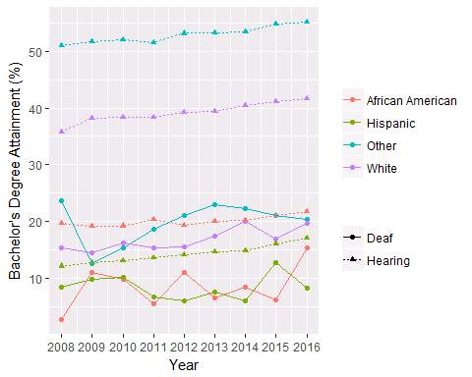 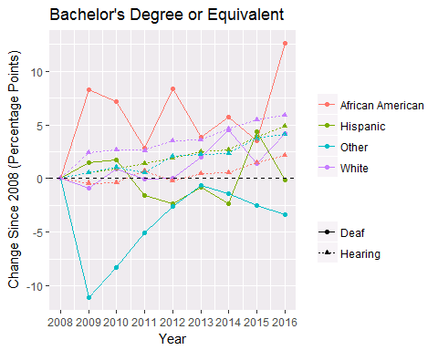

## Attainment By Race/Ethnicity And Gender

### High School

#### Deaf Female

Percentage of female deaf Americans by race/ethnicity attaining a High School diploma or equivalent.

|  |  |  |  |  |
| --- | --- | --- | --- | --- |
|  | African American | Hispanic | Other | White |
| 2008 | 64.6 $±$ 12.4 | 63.7 $±$ 10.3 | 79.7 $±$ 12.3 | 87.5 $±$ 4.7 |
| 2009 | 81.1 $±$ 8.3 | 77.1 $±$ 8.2 | 76.7 $±$ 15.2 | 83.2 $±$ 5.4 |
| 2010 | 87.2 $±$ 8 | 62.7 $±$ 13.3 | 91.6 $±$ 6.7 | 78.9 $±$ 5.2 |
| 2011 | 80.8 $±$ 11.3 | 78.4 $±$ 7.5 | 85 $±$ 9.8 | 83.5 $±$ 5.6 |
| 2012 | 88.6 $±$ 7.3 | 60.7 $±$ 10.7 | 86.5 $±$ 8.6 | 83.8 $±$ 4.7 |
| 2013 | 81 $±$ 10.7 | 79 $±$ 9.8 | 79.9 $±$ 12.1 | 84 $±$ 4.4 |
| 2014 | 77.6 $±$ 11 | 69.2 $±$ 12.5 | 81.9 $±$ 11.3 | 84.7 $±$ 4.9 |
| 2015 | 81.9 $±$ 10.8 | 80 $±$ 8.6 | 81.3 $±$ 18.1 | 90.8 $±$ 3.4 |
| 2016 | 77.8 $±$ 11.2 | 77.9 $±$ 8.5 | 75.8 $±$ 15.8 | 88.7 $±$ 4.2 |
| Growth | 13.2 $±$ 16.7 | 14.3 $±$ 13.3 | -3.8 $±$ 20 | 1.2 $±$ 6.3 |
| Trend | 0.7 $±$ 1.8 | 1.3 $±$ 2 | -0.5 $±$ 1.3 | 0.6 $±$ 0.8 |
| Trend (Adj) | 1.1 $±$ 1.6 | 1.3 $±$ 1.2 | -0.3 $±$ 1.6 | 0.6 $±$ 0.7 |
| Sample Size/year | 74 | 108 | 54 | 346 |

#### Deaf Male

Percentage of male deaf Americans by race/ethnicity attaining a High School diploma or equivalent.

|  |  |  |  |  |
| --- | --- | --- | --- | --- |
|  | African American | Hispanic | Other | White |
| 2008 | 76.6 $±$ 9.3 | 62.6 $±$ 8.7 | 88.8 $±$ 7.9 | 82.3 $±$ 3.8 |
| 2009 | 72.9 $±$ 11.8 | 62.4 $±$ 8.2 | 77.1 $±$ 12.1 | 87.2 $±$ 3.4 |
| 2010 | 70.8 $±$ 11.6 | 65.6 $±$ 10.6 | 75.7 $±$ 12.6 | 86.1 $±$ 3.6 |
| 2011 | 77.4 $±$ 10.6 | 73.6 $±$ 8.2 | 76.5 $±$ 9.9 | 83.7 $±$ 3.5 |
| 2012 | 71.4 $±$ 11.3 | 73.3 $±$ 8 | 73.1 $±$ 14.7 | 85 $±$ 3.6 |
| 2013 | 67.8 $±$ 12.7 | 66.3 $±$ 9.1 | 75.1 $±$ 15 | 85.4 $±$ 3.1 |
| 2014 | 67.9 $±$ 12.5 | 68.3 $±$ 8.9 | 84.8 $±$ 7.4 | 87.1 $±$ 3.4 |
| 2015 | 78.6 $±$ 11 | 70.6 $±$ 8.1 | 84.6 $±$ 8.6 | 88 $±$ 3 |
| 2016 | 74.8 $±$ 10.9 | 70.9 $±$ 9.4 | 89.2 $±$ 8.4 | 87.9 $±$ 3.4 |
| Growth | -1.8 $±$ 14.3 | 8.3 $±$ 12.8 | 0.4 $±$ 11.5 | 5.6 $±$ 5.1 |
| Trend | -0.1 $±$ 1.1 | 0.9 $±$ 0.9 | 0.8 $±$ 1.6 | 0.5 $±$ 0.4 |
| Trend (Adj) | -0.1 $±$ 1.2 | 1 $±$ 1.1 | 1.1 $±$ 1.5 | 0.5 $±$ 0.4. |
| Sample Size/year | 99 | 163 | 73 | 555 |

#### Hearing Female

Percentage of female hearing Americans by race/ethnicity attaining a High School diploma or equivalent.

|  |  |  |  |  |
| --- | --- | --- | --- | --- |
|  | African American | Hispanic | Other | White |
| 2008 | 88.3 $±$ 0.6 | 70.1 $±$ 0.8 | 94.2 $±$ 0.6 | 94.1 $±$ 0.3 |
| 2009 | 89.6 $±$ 0.7 | 71 $±$ 0.8 | 94.3 $±$ 0.5 | 94.4 $±$ 0.2 |
| 2010 | 89.1 $±$ 0.7 | 71.6 $±$ 0.8 | 94.5 $±$ 0.6 | 94.6 $±$ 0.3 |
| 2011 | 89.4 $±$ 0.7 | 73 $±$ 0.9 | 94.8 $±$ 0.5 | 94.7 $±$ 0.3 |
| 2012 | 89.6 $±$ 0.7 | 74.9 $±$ 0.8 | 94.7 $±$ 0.5 | 94.8 $±$ 0.3 |
| 2013 | 89.4 $±$ 0.7 | 75.6 $±$ 0.8 | 94.7 $±$ 0.6 | 94.8 $±$ 0.3 |
| 2014 | 90.2 $±$ 0.7 | 78 $±$ 0.7 | 94.8 $±$ 0.5 | 95.2 $±$ 0.3 |
| 2015 | 91 $±$ 0.6 | 79.2 $±$ 0.8 | 95 $±$ 0.5 | 95.2 $±$ 0.2 |
| 2016 | 90.9 $±$ 0.7 | 80.9 $±$ 0.7 | 94.9 $±$ 0.5 | 94.9 $±$ 0.2 |
| Growth | 2.6 $±$ 1 | 10.8 $±$ 1.1 | 0.7 $±$ 0.8 | 0.8 $±$ 0.4 |
| Trend | 0.3 $±$ 0.1 | 1.4 $±$ 0.1 | 0.1 $±$ 0 | 0.1 $±$ 0 |
| Trend (Adj) | 0.3 $±$ 0.1 | 1.4 $±$ 0.1 | 0.1 $±$ 0.1 | 0.1 $±$ 0 |
| Sample Size/year | 9,227 | 16,456 | 9,177 | 46,449 |

#### Hearing Male

Percentage of male hearing Americans by race/ethnicity attaining a High School diploma or equivalent.

|  |  |  |  |  |
| --- | --- | --- | --- | --- |
|  | African American | Hispanic | Other | White |
| 2008 | 83.5 $±$ 1.1 | 62 $±$ 0.8 | 92.8 $±$ 0.7 | 91.4 $±$ 0.4 |
| 2009 | 83.8 $±$ 1 | 64.4 $±$ 0.8 | 93.6 $±$ 0.7 | 92.2 $±$ 0.3 |
| 2010 | 82.6 $±$ 0.8 | 64.3 $±$ 1 | 93.2 $±$ 0.7 | 92.1 $±$ 0.3 |
| 2011 | 84.6 $±$ 0.8 | 67.1 $±$ 0.9 | 93.3 $±$ 0.6 | 92.6 $±$ 0.3 |
| 2012 | 84.9 $±$ 0.8 | 68.1 $±$ 0.9 | 93.1 $±$ 0.6 | 92.8 $±$ 0.2 |
| 2013 | 85.2 $±$ 0.9 | 69.9 $±$ 0.9 | 94 $±$ 0.6 | 92.9 $±$ 0.3 |
| 2014 | 85.5 $±$ 0.9 | 71.4 $±$ 0.8 | 93.7 $±$ 0.6 | 93.4 $±$ 0.3 |
| 2015 | 85.3 $±$ 0.9 | 72.6 $±$ 0.9 | 94.6 $±$ 0.5 | 93.6 $±$ 0.2 |
| 2016 | 85.5 $±$ 0.9 | 74.8 $±$ 0.7 | 94.3 $±$ 0.5 | 93.3 $±$ 0.3 |
| Growth | 2 $±$ 1.4 | 12.8 $±$ 1.1 | 1.5 $±$ 0.9 | 1.9 $±$ 0.5 |
| Trend | 0.3 $±$ 0.2 | 1.5 $±$ 0.1 | 0.2 $±$ 0.1 | 0.2 $±$ 0.1 |
| Trend (Adj) | 0.3 $±$ 0.1 | 1.5 $±$ 0.1 | 0.2 $±$ 0.1 | 0.2 $±$ 0 |
| Sample Size/year | 8,816 | 17,227 | 8,397 | 46,417 |

#### Deaf Hearing Differences by Race: Female

Differences in growth and trends between female deaf and hearing Americans for each race/ethicity category. Positive Differences indicate faster growth for deaf Americans.

|  |  |  |  |  |
| --- | --- | --- | --- | --- |
|  | African American | Hispanic | Other | White |
| Growth | 10.6 $±$ 16.7 | 3.5 $±$ 13.4 | -4.5 $±$ 20 | 0.4 $±$ 6.3 |
| Trend | 0.4 $±$ 1.8 | -0.1 $±$ 2 | -0.6 $±$ 1.3 | 0.5 $±$ 0.8 |
| Trend (Adj) | 0.8 $±$ 1.6 | -0.1 $±$ 1.2 | -0.4 $±$ 1.6 | 0.5 $±$ 0.7 |

#### Deaf Hearing Differences by Race: Male

Differences in growth and trends between male deaf and hearing Americans for each race/ethicity category. Positive Differences indicate faster growth for deaf Americans.

|  |  |  |  |  |
| --- | --- | --- | --- | --- |
|  | African American | Hispanic | Other | White |
| Growth | -3.8 $±$ 14.4 | -4.5 $±$ 12.8 | -1 $±$ 11.6 | 3.7 $±$ 5.1 |
| Trend | -0.4 $±$ 1.1 | -0.7 $±$ 0.9 | 0.6 $±$ 1.6 | 0.3 $±$ 0.4 |
| Trend (Adj) | -0.4 $±$ 1.2 | -0.6 $±$ 1.1 | 0.9 $±$ 1.5 | 0.3 $±$ 0.4 |

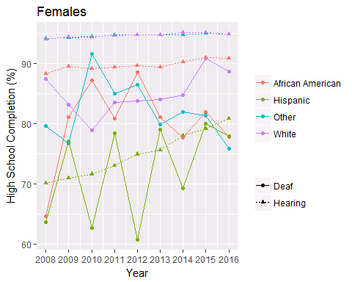 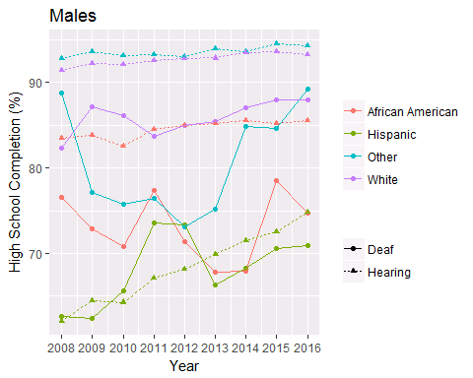

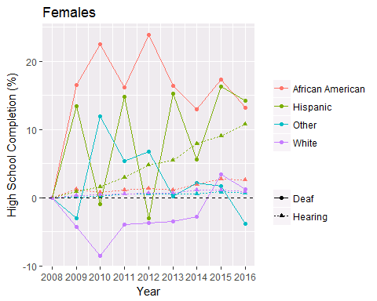 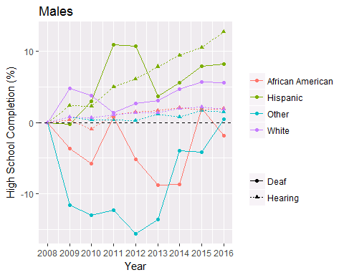

### Associates

#### Deaf Female

Percentage of female deaf Americans by race/ethnicity attaining a Associates diploma or equivalent.

|  |  |  |  |  |
| --- | --- | --- | --- | --- |
|  | African American | Hispanic | Other | White |
| 2008 | 9.5 $±$ 6 | 19 $±$ 11.2 | 29 $±$ 13 | 32 $±$ 5.7 |
| 2009 | 23.8 $±$ 9.4 | 14.7 $±$ 8 | 29.8 $±$ 19.2 | 27.3 $±$ 5.4 |
| 2010 | 23.9 $±$ 13.3 | 20 $±$ 8.6 | 17 $±$ 10.3 | 23.3 $±$ 5.4 |
| 2011 | 17.7 $±$ 11.6 | 18.6 $±$ 7.2 | 42.7 $±$ 17.2 | 31.4 $±$ 6.3 |
| 2012 | 26.6 $±$ 11.6 | 14.9 $±$ 8.4 | 34.5 $±$ 16.4 | 30.1 $±$ 5.6 |
| 2013 | 13.4 $±$ 7.9 | 17.7 $±$ 8.2 | 37.9 $±$ 13 | 37.6 $±$ 6.6 |
| 2014 | 18.2 $±$ 10.6 | 17.6 $±$ 7.7 | 40.4 $±$ 15.2 | 29.9 $±$ 5.8 |
| 2015 | 12.6 $±$ 10 | 20.7 $±$ 7 | 37.3 $±$ 18.7 | 28.3 $±$ 5.4 |
| 2016 | 27.2 $±$ 11.4 | 17.9 $±$ 6.4 | 23.8 $±$ 13 | 35.6 $±$ 6.2 |
| Growth | 17.7 $±$ 12.9 | -1.1 $±$ 12.9 | -5.2 $±$ 18.4 | 3.6 $±$ 8.4 |
| Trend | 0.3 $±$ 1.8 | 0.2 $±$ 0.6 | 0.7 $±$ 2.2 | 0.6 $±$ 1.1 |
| Trend (Adj) | 0.6 $±$ 1.5 | 0.5 $±$ 1 | 0.4 $±$ 1.8 | 0.6 $±$ 0.8 |
| Sample Size/year | 74 | 108 | 54 | 346 |

#### Deaf Male

Percentage of male deaf Americans by race/ethnicity attaining a Associates diploma or equivalent.

|  |  |  |  |  |
| --- | --- | --- | --- | --- |
|  | African American | Hispanic | Other | White |
| 2008 | 8.9 $±$ 7.5 | 9.3 $±$ 4.6 | 32.7 $±$ 13.8 | 16.7 $±$ 3.9 |
| 2009 | 10.6 $±$ 7 | 12 $±$ 6 | 24 $±$ 11.3 | 22.2 $±$ 4.1 |
| 2010 | 15 $±$ 9.7 | 17.2 $±$ 8.7 | 23.8 $±$ 12.6 | 21.5 $±$ 4.4 |
| 2011 | 3.4 $±$ 4.4 | 13.6 $±$ 7.2 | 14.8 $±$ 9.3 | 20.8 $±$ 4.5 |
| 2012 | 11.6 $±$ 7.6 | 19.3 $±$ 6.6 | 34.3 $±$ 13.8 | 23.8 $±$ 4.9 |
| 2013 | 11.8 $±$ 10.1 | 14.1 $±$ 6.4 | 23 $±$ 12.2 | 22 $±$ 3.7 |
| 2014 | 10.4 $±$ 6.1 | 9.9 $±$ 4.1 | 27.9 $±$ 12.5 | 28.1 $±$ 5.1 |
| 2015 | 9.2 $±$ 6.5 | 15.5 $±$ 6.4 | 24.1 $±$ 11.4 | 25.1 $±$ 3.9 |
| 2016 | 17.5 $±$ 8.2 | 12.7 $±$ 5.7 | 27.5 $±$ 11.3 | 25.3 $±$ 4.3 |
| Growth | 8.6 $±$ 11.1 | 3.5 $±$ 7.3 | -5.2 $±$ 17.8 | 8.6 $±$ 5.8 |
| Trend | 0.5 $±$ 1 | 0.2 $±$ 0.9 | 0 $±$ 1.6 | 1 $±$ 0.5 |
| Trend (Adj) | 0.5 $±$ 1 | 0.2 $±$ 0.9 | 0.1 $±$ 1.5 | 1 $±$ 0.6* |
| Sample Size/year | 99 | 163 | 73 | 555 |

#### Hearing Female

Percentage of female hearing Americans by race/ethnicity attaining a Associates diploma or equivalent.

|  |  |  |  |  |
| --- | --- | --- | --- | --- |
|  | African American | Hispanic | Other | White |
| 2008 | 31.3 $±$ 1.1 | 22 $±$ 0.7 | 61.8 $±$ 1.3 | 49.9 $±$ 0.5 |
| 2009 | 31.5 $±$ 1.1 | 22.7 $±$ 0.8 | 62.1 $±$ 1 | 52.2 $±$ 0.6 |
| 2010 | 32.1 $±$ 1.2 | 23.4 $±$ 0.7 | 61.7 $±$ 1 | 52.9 $±$ 0.5 |
| 2011 | 32 $±$ 0.9 | 24 $±$ 0.8 | 62.8 $±$ 1.5 | 53.3 $±$ 0.6 |
| 2012 | 32.7 $±$ 1.2 | 25.4 $±$ 0.7 | 65.3 $±$ 1 | 53.9 $±$ 0.6 |
| 2013 | 33.4 $±$ 1.2 | 25.4 $±$ 0.8 | 64.4 $±$ 1.3 | 54.6 $±$ 0.6 |
| 2014 | 33.3 $±$ 1.1 | 26.2 $±$ 0.9 | 64 $±$ 1.3 | 55.5 $±$ 0.6 |
| 2015 | 34 $±$ 1.2 | 27.7 $±$ 0.9 | 65.1 $±$ 1 | 55.7 $±$ 0.6 |
| 2016 | 34.4 $±$ 1.3 | 29.5 $±$ 0.9 | 65.1 $±$ 1.1 | 56.5 $±$ 0.5 |
| Growth | 3.1 $±$ 1.7 | 7.5 $±$ 1.1 | 3.3 $±$ 1.7 | 6.6 $±$ 0.8 |
| Trend | 0.4 $±$ 0.1 | 0.9 $±$ 0.1 | 0.5 $±$ 0.2 | 0.7 $±$ 0.1 |
| Trend (Adj) | 0.4 $±$ 0.2 | 0.9 $±$ 0.1 | 0.5 $±$ 0.2 | 0.7 $±$ 0.1 |
| Sample Size/year | 9,227 | 16,456 | 9,177 | 46,449 |

#### Hearing Male

Percentage of male hearing Americans by race/ethnicity attaining a Associates diploma or equivalent.

|  |  |  |  |  |
| --- | --- | --- | --- | --- |
|  | African American | Hispanic | Other | White |
| 2008 | 23.1 $±$ 1.2 | 15 $±$ 0.6 | 56.3 $±$ 1.5 | 40 $±$ 0.6 |
| 2009 | 21.5 $±$ 1.1 | 15.4 $±$ 0.7 | 56.9 $±$ 1.4 | 41.9 $±$ 0.5 |
| 2010 | 21 $±$ 1.1 | 15.7 $±$ 0.6 | 56.5 $±$ 1.3 | 42 $±$ 0.5 |
| 2011 | 23.9 $±$ 1.1 | 16.1 $±$ 0.7 | 55.2 $±$ 1.5 | 42.8 $±$ 0.6 |
| 2012 | 21.7 $±$ 1.2 | 16.9 $±$ 0.7 | 56.1 $±$ 1.3 | 43.7 $±$ 0.6 |
| 2013 | 22.3 $±$ 1.1 | 17.9 $±$ 0.7 | 58 $±$ 1.1 | 43.6 $±$ 0.6 |
| 2014 | 23.5 $±$ 1.1 | 19 $±$ 0.6 | 56.6 $±$ 1.4 | 44.7 $±$ 0.5 |
| 2015 | 24.1 $±$ 1.1 | 19.8 $±$ 0.7 | 58.9 $±$ 1.2 | 45.9 $±$ 0.5 |
| 2016 | 25.6 $±$ 1.2 | 20.7 $±$ 0.8 | 59.4 $±$ 1 | 45.8 $±$ 0.6 |
| Growth | 2.6 $±$ 1.7 | 5.7 $±$ 1 | 3.1 $±$ 1.8 | 5.8 $±$ 0.8 |
| Trend | 0.4 $±$ 0.3 | 0.7 $±$ 0.1 | 0.4 $±$ 0.3 | 0.7 $±$ 0.1 |
| Trend (Adj) | 0.4 $±$ 0.2 | 0.7 $±$ 0.1 | 0.4 $±$ 0.2 | 0.7 $±$ 0.1 |
| Sample Size/year | 8,816 | 17,227 | 8,397 | 46,417 |

#### Deaf Hearing Differences by Race: Female

Differences in growth and trends between female deaf and hearing Americans for each race/ethicity category. Positive Differences indicate faster growth for deaf Americans.

|  |  |  |  |  |
| --- | --- | --- | --- | --- |
|  | African American | Hispanic | Other | White |
| Growth | 14.6 $±$ 13 | -8.7 $±$ 13 | -8.5 $±$ 18.5 | -3.1 $±$ 8.5 |
| Trend | -0.1 $±$ 1.8 | -0.7 $±$ 0.6 | 0.2 $±$ 2.2 | -0.2 $±$ 1.1 |
| Trend (Adj) | 0.2 $±$ 1.5 | -0.3 $±$ 1 | -0.1 $±$ 1.8 | -0.1 $±$ 0.8 |

#### Deaf Hearing Differences by Race: Male

Differences in growth and trends between male deaf and hearing Americans for each race/ethicity category. Positive Differences indicate faster growth for deaf Americans.

|  |  |  |  |  |
| --- | --- | --- | --- | --- |
|  | African American | Hispanic | Other | White |
| Growth | 6 $±$ 11.3 | -2.3 $±$ 7.4 | -8.4 $±$ 17.9 | 2.8 $±$ 5.9 |
| Trend | 0.2 $±$ 1 | -0.5 $±$ 0.9 | -0.4 $±$ 1.6 | 0.3 $±$ 0.5 |
| Trend (Adj) | 0.1 $±$ 1 | -0.5 $±$ 0.9 | -0.3 $±$ 1.5 | 0.3 $±$ 0.6 |

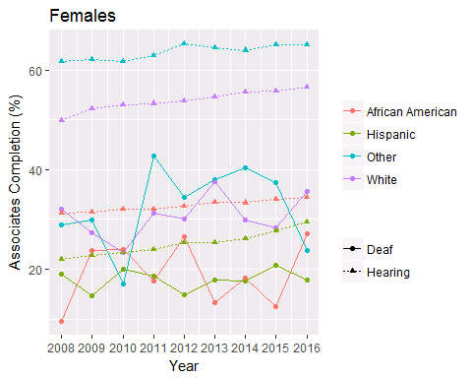 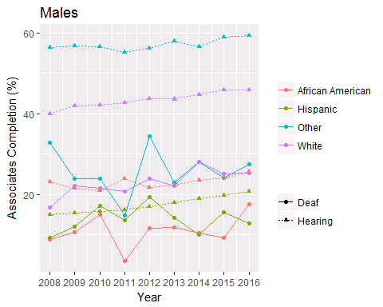

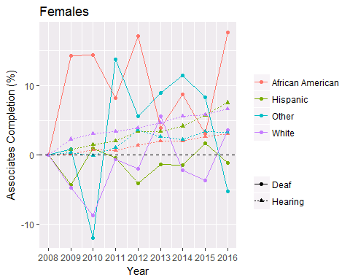 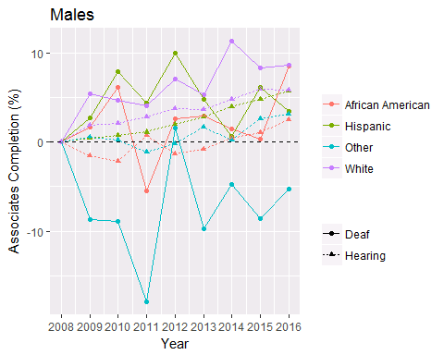

### Bachelors

#### Deaf Female

Percentage of female deaf Americans by race/ethnicity attaining a Bachelors Degree. Bachelors degree or equivalent.

|  |  |  |  |  |
| --- | --- | --- | --- | --- |
|  | African American | Hispanic | Other | White |
| 2008 | 5.3 $±$ 4.3 | 10.4 $±$ 7.4 | 20.4 $±$ 11.2 | 19.6 $±$ 4.8 |
| 2009 | 16.3 $±$ 9 | 10.4 $±$ 7.3 | 16 $±$ 13 | 16.8 $±$ 4.1 |
| 2010 | 15 $±$ 9.8 | 8.2 $±$ 6.6 | 11.2 $±$ 8.5 | 16.2 $±$ 5 |
| 2011 | 10.3 $±$ 7.4 | 6.9 $±$ 4.5 | 31.9 $±$ 17 | 24.2 $±$ 6.3 |
| 2012 | 13.5 $±$ 8.5 | 6.1 $±$ 4.8 | 20.6 $±$ 12.2 | 18.5 $±$ 4.7 |
| 2013 | 5.3 $±$ 4.6 | 11.3 $±$ 7.4 | 30.6 $±$ 13.4 | 24.9 $±$ 6 |
| 2014 | 11.3 $±$ 8.7 | 8.2 $±$ 5.7 | 23.4 $±$ 12.2 | 20.3 $±$ 5.4 |
| 2015 | 6.6 $±$ 6.2 | 16 $±$ 6.2 | 26.7 $±$ 17.3 | 19.9 $±$ 5.1 |
| 2016 | 22.8 $±$ 10.8 | 9.2 $±$ 5.2 | 16.9 $±$ 11.6 | 26.8 $±$ 6.5 |
| Growth | 17.5 $±$ 11.7 | -1.3 $±$ 9 | -3.5 $±$ 16.2 | 7.2 $±$ 8.1 |
| Trend | 0.3 $±$ 1.5 | 0.4 $±$ 0.8 | 0.6 $±$ 1.8 | 0.7 $±$ 0.8 |
| Trend (Adj) | 0.6 $±$ 1.1 | 0.5 $±$ 0.8 | 0.4 $±$ 1.5 | 0.8 $±$ 0.7 |
| Sample Size/year | 74 | 108 | 54 | 346 |

#### Deaf Male

Percentage of male deaf Americans by race/ethnicity attaining a Bachelors degree or equivalent.

|  |  |  |  |  |
| --- | --- | --- | --- | --- |
|  | African American | Hispanic | Other | White |
| 2008 | 1.4 $±$ 1.8 | 7.5 $±$ 4.4 | 26.5 $±$ 13.8 | 12.5 $±$ 3.7 |
| 2009 | 5.6 $±$ 4.4 | 9.5 $±$ 5.4 | 10.3 $±$ 8.4 | 13.1 $±$ 3.4 |
| 2010 | 5.7 $±$ 6.2 | 11.9 $±$ 6.6 | 18.7 $±$ 12.2 | 16.4 $±$ 3.8 |
| 2011 | 1.2 $±$ 2.5 | 6.8 $±$ 5.1 | 8.9 $±$ 8.3 | 10 $±$ 3 |
| 2012 | 9 $±$ 7.8 | 6.2 $±$ 4.5 | 21.5 $±$ 11.7 | 13.7 $±$ 3.4 |
| 2013 | 7.9 $±$ 8.8 | 5.7 $±$ 3.9 | 15.6 $±$ 9.8 | 12.4 $±$ 2.7 |
| 2014 | 6.5 $±$ 5.8 | 5 $±$ 2.6 | 21.1 $±$ 11.7 | 19.8 $±$ 4.4 |
| 2015 | 6 $±$ 4.5 | 10.6 $±$ 5.7 | 18.1 $±$ 11.4 | 15.2 $±$ 3.6 |
| 2016 | 10.8 $±$ 6 | 7.7 $±$ 4.5 | 23.1 $±$ 11.9 | 14.9 $±$ 3.2 |
| Growth | 9.4 $±$ 6.3 | 0.2 $±$ 6.2 | -3.4 $±$ 18.2 | 2.4 $±$ 4.9 |
| Trend | 0.8 $±$ 0.6 | -0.1 $±$ 0.6 | 0.4 $±$ 1.6 | 0.4 $±$ 0.7 |
| Trend (Adj) | 0.8 $±$ 0.7 | -0.2 $±$ 0.7 | 0.5 $±$ 1.4 | 0.4 $±$ 0.5 |
| Sample Size/year | 99 | 163 | 73 | 555 |

#### Hearing Female

Percentage of female hearing Americans by race/ethnicity attaining a Bachelors degree or equivalent.

|  |  |  |  |  |
| --- | --- | --- | --- | --- |
|  | African American | Hispanic | Other | White |
| 2008 | 22.4 $±$ 0.9 | 14.9 $±$ 0.6 | 53.3 $±$ 1.4 | 39.7 $±$ 0.5 |
| 2009 | 22.9 $±$ 0.9 | 15.8 $±$ 0.7 | 53.9 $±$ 1.3 | 42.4 $±$ 0.5 |
| 2010 | 23 $±$ 0.9 | 16.1 $±$ 0.6 | 54.5 $±$ 1 | 42.9 $±$ 0.5 |
| 2011 | 22.9 $±$ 0.9 | 16.7 $±$ 0.7 | 54.5 $±$ 1.4 | 42.5 $±$ 0.6 |
| 2012 | 22.8 $±$ 1.1 | 17.2 $±$ 0.6 | 56.9 $±$ 1 | 43.4 $±$ 0.6 |
| 2013 | 24 $±$ 1.1 | 17.8 $±$ 0.7 | 55.8 $±$ 1.2 | 44.1 $±$ 0.5 |
| 2014 | 23.9 $±$ 1 | 17.3 $±$ 0.7 | 56.1 $±$ 1.1 | 45.1 $±$ 0.6 |
| 2015 | 24.6 $±$ 1.1 | 19 $±$ 0.7 | 57.5 $±$ 1.1 | 45.3 $±$ 0.6 |
| 2016 | 24.7 $±$ 1.2 | 20.4 $±$ 0.7 | 57.3 $±$ 1 | 46.3 $±$ 0.5 |
| Growth | 2.2 $±$ 1.5 | 5.4 $±$ 0.9 | 4 $±$ 1.7 | 6.6 $±$ 0.8 |
| Trend | 0.3 $±$ 0.1 | 0.6 $±$ 0.1 | 0.5 $±$ 0.2 | 0.7 $±$ 0.2 |
| Trend (Adj) | 0.3 $±$ 0.2 | 0.6 $±$ 0.1 | 0.5 $±$ 0.2 | 0.7 $±$ 0.1 |
| Sample Size/year | 9,227 | 16,456 | 9,177 | 46,449 |

#### Hearing Male

Percentage of male hearing Americans by race/ethnicity attaining a Bachelors degree or equivalent.

|  |  |  |  |  |
| --- | --- | --- | --- | --- |
|  | African American | Hispanic | Other | White |
| 2008 | 16.6 $±$ 1.1 | 10 $±$ 0.5 | 48.6 $±$ 1.6 | 31.8 $±$ 0.6 |
| 2009 | 15.2 $±$ 0.9 | 10.2 $±$ 0.6 | 49.2 $±$ 1.4 | 34.1 $±$ 0.5 |
| 2010 | 15.1 $±$ 1 | 10.4 $±$ 0.5 | 49.3 $±$ 1.4 | 34 $±$ 0.5 |
| 2011 | 17.6 $±$ 1.2 | 10.8 $±$ 0.6 | 48.2 $±$ 1.5 | 34.3 $±$ 0.6 |
| 2012 | 15.7 $±$ 1 | 11.4 $±$ 0.6 | 49 $±$ 1.4 | 35.2 $±$ 0.5 |
| 2013 | 15.9 $±$ 1 | 11.9 $±$ 0.6 | 50.5 $±$ 1.2 | 34.8 $±$ 0.6 |
| 2014 | 16.1 $±$ 0.9 | 12.6 $±$ 0.4 | 50.3 $±$ 1.3 | 35.8 $±$ 0.5 |
| 2015 | 17.4 $±$ 0.9 | 13.4 $±$ 0.6 | 51.8 $±$ 1.2 | 37.2 $±$ 0.5 |
| 2016 | 18.8 $±$ 1 | 14.1 $±$ 0.6 | 52.8 $±$ 1.1 | 37.1 $±$ 0.5 |
| Growth | 2.1 $±$ 1.5 | 4.1 $±$ 0.8 | 4.1 $±$ 1.9 | 5.3 $±$ 0.8 |
| Trend | 0.3 $±$ 0.3 | 0.5 $±$ 0.1 | 0.5 $±$ 0.2 | 0.6 $±$ 0.1 |
| Trend (Adj) | 0.3 $±$ 0.1 | 0.5 $±$ 0.1 | 0.5 $±$ 0.2 | 0.6 $±$ 0.1 |
| Sample Size/year | 8,816 | 17,227 | 8,397 | 46,417 |

#### Deaf Hearing Differences by Race: Female

Differences in growth and trends between female deaf and hearing Americans for each race/ethicity category. Positive Differences indicate faster growth for deaf Americans.

|  |  |  |  |  |
| --- | --- | --- | --- | --- |
|  | African American | Hispanic | Other | White |
| Growth | 15.2 $±$ 11.8 | -6.7 $±$ 9 | -7.5 $±$ 16.2 | 0.6 $±$ 8.1 |
| Trend | 0.1 $±$ 1.5 | -0.2 $±$ 0.8 | 0.1 $±$ 1.8 | 0.1 $±$ 0.8 |
| Trend (Adj) | 0.3 $±$ 1.2 | -0.1 $±$ 0.8 | -0.1 $±$ 1.5 | 0.1 $±$ 0.8 |

#### Deaf Hearing Differences by Race: Male

Differences in growth and trends between male deaf and hearing Americans for each race/ethicity category. Positive Differences indicate faster growth for deaf Americans.

|  |  |  |  |  |
| --- | --- | --- | --- | --- |
|  | African American | Hispanic | Other | White |
| Growth | 7.3 $±$ 6.5 | -3.9 $±$ 6.3 | -7.5 $±$ 18.3 | -2.9 $±$ 5 |
| Trend | 0.5 $±$ 0.7 | -0.7 $±$ 0.6 | -0.1 $±$ 1.6 | -0.1 $±$ 0.7 |
| Trend (Adj) | 0.5 $±$ 0.7 | -0.7 $±$ 0.7 | 0 $±$ 1.4 | -0.1 $±$ 0.5 |

