1. **Calculate the number and percentage of observations that are complete.**

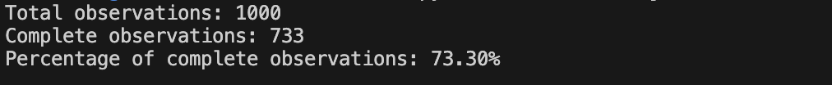

1. **Checking with rules:**

What percentage of the data has no errors (i.e., rows that don’t violate the rules)?



1. **Dataset descriptive insights after fixing Gender, Income, and Tax. Below is the screenshot of before and after normalizing and Imputing :**

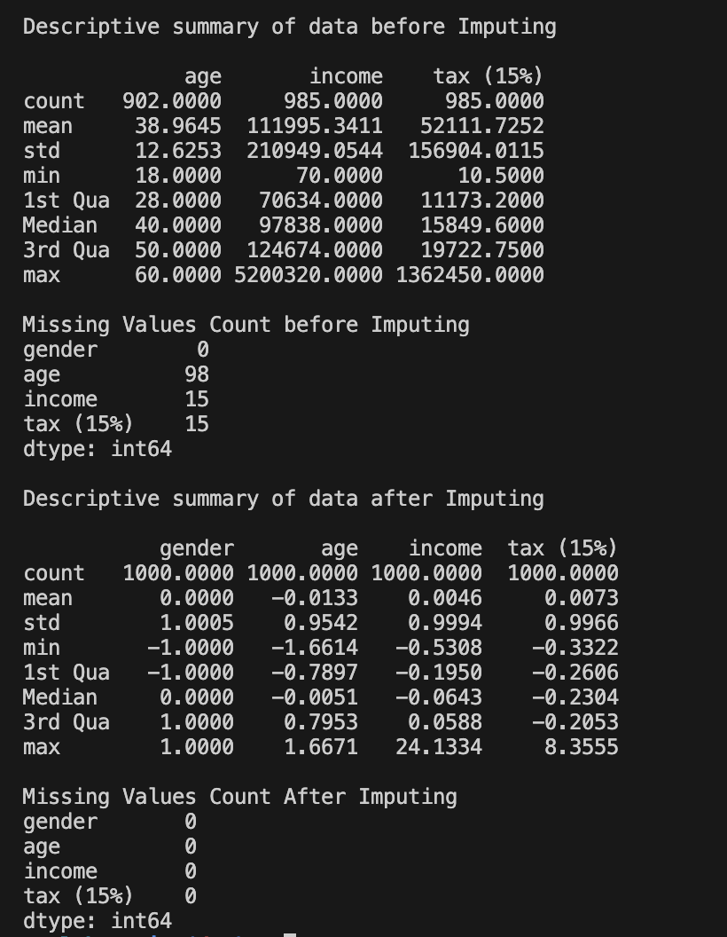

1. **Importance of cleaning a dataset before providing further analytics about the data.**

Cleaning a dataset before conducting further analytics is crucial for several reasons. Cleaning data ensures that the data is accurate and free from errors. Incorrect or inconsistent data can lead to inaccurate analysis and flawed conclusions. It also helps in maintaining consistency within the dataset. This includes standardizing formats, units, and values across different data points, making analysis easier and more reliable. Data cleaning ensures that there are no missing values or incomplete records. Missing data can skew analysis results and lead to biased interpretations. Moreover, it also helps in identifying and removing irrelevant or redundant data variables or features. Focusing only on relevant variables improves the efficiency of analysis and leads to more meaningful insights. Cleaning the dataset streamlines the analysis process by reducing the time and effort required to handle data issues during analysis. It allows analysts to focus on interpreting the data rather than fixing errors.

Clean data leads to more accurate and reliable insights, which in turn support better decision-making processes. Decision-makers can have greater confidence in the results and recommendations derived from clean data. Overall, cleaning a dataset before proceeding with analytics ensures that the data is trustworthy, relevant, and suitable for analysis, thereby maximizing the value of the insights generated from it.