**Visualization:**

1. Sales and advertising

*Screenshot 1: Scatter plot for Sales Vs. Advertising*

1. Sales and airplay

*Screenshot 2: Scatter plot for Sales Vs. Airplay*

1. Sales and attractiveness

*Screenshot 3: Scatter plot for Sales Vs. Attractiveness*

**Linear Regression**

1. **Solution:**

F-Statistic: 98.04

P-values: 4.95e-19



Screenshot 4 : F-statistic and P-value

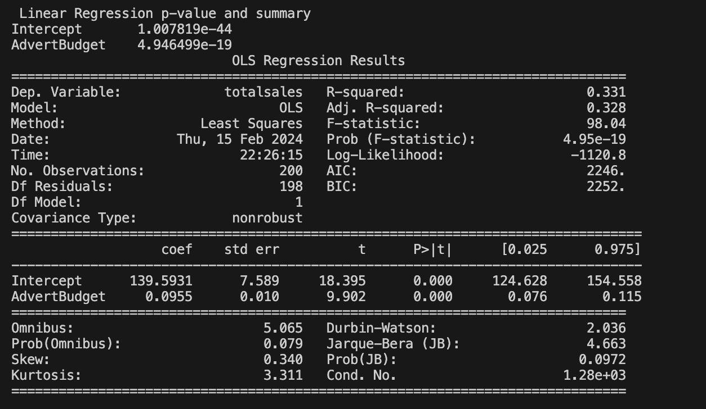

*Screenshot 5: Linear Regression Summary*

1. Solution:

F-statistic represents the ratio of how good the model is compared to how

bad it is. The F-statistic measures the overall significance of the regression model. It assesses whether the linear regression model as a whole is statistically significant in explaining the variability in the dependent variable (response variable). The F-statistic value of the model is **98.04** which is greater than 1, which indicates that the model is statistically significant, meaning the independent variables can explain the variance of the dependent variable.

The p-value of the model is **4.95e-19** which is very close to 0, and way less than 0.05. The p-value associated with the F-statistic indicates the probability of obtaining the observed F-statistic (or a more extreme value) under the null hypothesis. In this case, the null hypothesis typically states that all the regression coefficients are equal to zero, meaning the independent variables do not affect the dependent variable. A low p-value (typically below a chosen significance level, e.g., 0.05) suggests that the F-statistic is statistically significant, and we can reject the null hypothesis.

1. Solution:

**Intercept Value:** 139.593120

**Coefficient (adverts):** 0.095517

*Screenshot 6: Intercept & Coefficient for Adverts (Model Parameters)*

1. **Solution**:

The prediction/estimation on the number of record sales after $135,000 in Advertising is 13, 034. It means the model predicts that the 13,034 records will be sold after spending $135,000 in advertising.



*Screenshot 7: Estimation of record sale after $135000 in Advert*.

**Multiple Regression**

1. **Solution**.

F-statistic: 105.2

P-value: 1.27e-40



*Screenshot 8: F-statistic and P-value*

1. **Solution:**

Looking at the R-squared value, the multiple regression model between outcome: Sales and the predictors (advertising, airplay, attractiveness) has a good fit in comparison to the linear model between Sales and advertising, as the R-squared value **0.617** for the multiple regression(model-2) is greater than the R-squared value **0.331** of the linear model between Sales and Advertising (model-1).

Moreover, when looking at the p-value, if the p-value is less than **0.05**, the test can be considered statistically significant. Here, both the p-values are less than **0.05**. In comparison, the p-value of the multiple linear regression model (model-2) is **1.27e-40**, which is way less than the p-values **4.95e-19** of a single independent variable linear model (model-1), which makes the multiple linear regression model (model-2) more statistically significant and is better at fitting the line than the linear model (model-1) based on R-squared value.