K4P NUCLEAR DECOMMISSIONING COMMUNITY (NDKM)

AI-assisted submission of knowledge products in K4P
The idea, implementation options and prototype · November 2026

1. The idea in brief
A future Knowledge for Policy (K4P) community on nuclear decommissioning would give its members a submit button: nuclear promoters and operators, regulators, private companies, public companies and the JRC itself.
Behind that button, an AI turns each contribution into a record in the format of the NDKM database on SharePoint, so that extraction into the database is automatic. K4P records the submission and manages the review until publication.
The AI can be built into K4P or, if K4P cannot host it, run in an external tool under the JRC umbrella, reached through a link. In both cases the record and the review stay in K4P.

2. Actors and roles
The JRC approves publication. Other members submit, comment or produce depending on the permissions they are given; whether all members or only some profiles can submit is still to be decided.
Actor | Examples | What they can do
Nuclear promoter or operator | Licensees of plants being decommissioned | Submit knowledge inputs or KPs and reply to comments
Regulator | National nuclear safety authorities | Submit knowledge inputs; possibly comment as reviewer
Private company | Engineering firms and contractors | Submit inputs or KPs; produce a KP from a proposal
Public company | Waste management agencies | Submit inputs or KPs; produce a KP
JRC | NDKM team | Approve, comment, return versions and publish; also produce KPs
Normalisation AI | Built into K4P or external JRC tool | Generate the proposal or convert the KP format

3. The two submission routes
Both routes share the submit button and the record in K4P; what changes is what the AI does and what it produces.
 | Route A · knowledge input | Route B · existing knowledge product
What the member provides | Experience, data, notes or loose documents | A finished KP in its own format
What the AI does | Drafts a knowledge proposal and fills in every database field | Only converts the format to NDKM and fills in the metadata, without rewriting the content
Output | Proposal ready to extract into SharePoint | KP in NDKM format, ready for review
After approval | A company or the JRC produces the KP with the knowledge inputs attached | The KP is published

4. Where the AI runs: two options
The choice depends on whether K4P can host the AI. Only the AI step moves; the rest of the flow is the same.
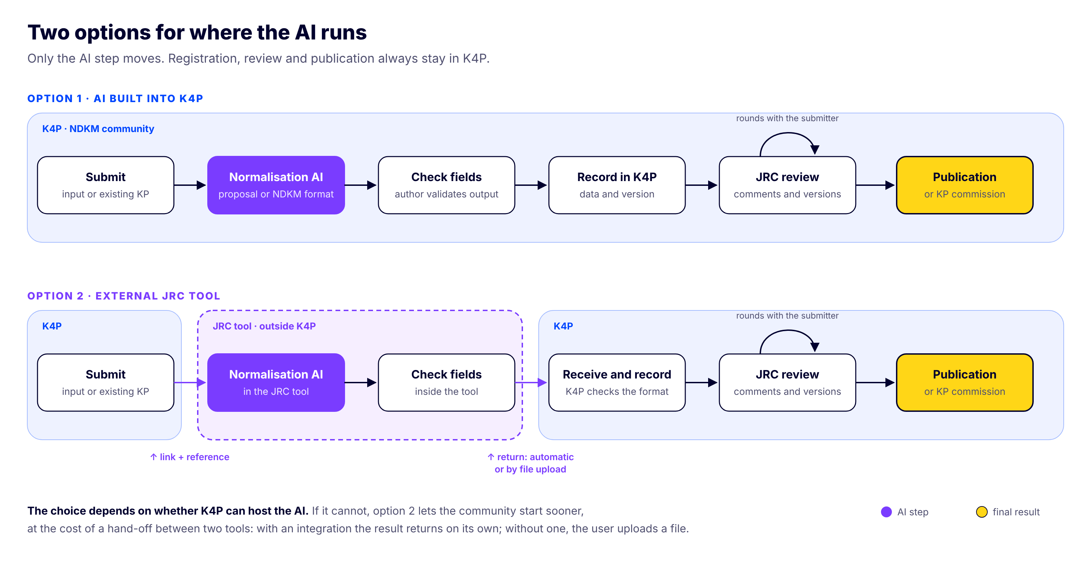
Figure 1. The two options. Purple marks the AI step; yellow marks the final result.
 | Option 1 · AI built into K4P | Option 2 · external JRC tool
Where the AI is used | Inside the K4P community, in the same submission form | In a separate JRC tool, opened from a K4P link that carries a submission reference
How the result returns | Saved directly as a submission in K4P | Automatically if there is an integration; otherwise the user downloads a file and uploads it to K4P
Record and review | In K4P | Also in K4P, once the result is back
What it needs from K4P | Building or connecting the AI inside the platform | Only the link and the ability to receive the result
Main advantage | One place and a seamless experience | Does not depend on the K4P roadmap and can be ready sooner
Main drawback | Depends on K4P being able and willing to build it | Two places; the hand-off must not lose anything

When to choose each
- Option 1 if K4P can host the AI within a reasonable time and a single-place experience is wanted.
- Option 2 if K4P cannot host it or would take too long. It can start with file return and move to automatic return once an integration exists.
- The two are compatible: the community can start with option 2 and move to option 1 without changing the record or the review.

5. Review and publication
Nothing is published without JRC approval. Comment rounds repeat until the final version is agreed:
- The author submits; K4P records the submission data and version.
- The JRC approver comments field by field or in general.
- If changes are needed, the JRC returns the submission; the author edits, replies to each comment and submits a new version.
- Once it is right, the JRC approves. A KP is published in K4P.
- An approved proposal is commissioned to a company or to the JRC, together with its knowledge inputs. The resulting KP enters through route B, goes through the same review, and the proposer can compare it with the proposal.

6. Assumptions, open questions and risks
The idea rests on three assumptions: the NDKM database has a stable schema, K4P can host the record and the review, and the JRC can offer an AI under its control.

Open questions
- Which exact fields does the SharePoint database have, and which are mandatory?
- Can every community member submit, or only some profiles?
- Can K4P host the AI? This decides between option 1 and option 2.
- For option 2, will there be an integration for automatic return, or does it start with files?
- Who decides who produces the KP from an approved proposal?
- Is there a maximum number of review rounds or a deadline per round?

Risks
Risk | Why it matters | Possible mitigation
Sensitive information in inputs | Physical security or commercial data would reach an AI | AI hosted by the JRC, automatic warning and confirmation before submitting
The AI invents or alters content | It would damage the credibility of NDKM | The author validates the output before submitting; the JRC always approves
The database schema changes | Automatic extraction breaks | Schema version on every record and validation on submission
Losses in the hand-off between tools (option 2) | A result that does not return, or returns to the wrong submission | Unique submission reference and validation on receipt
Reviews that never end | Products stuck for months | Visible statuses, deadlines per round and reminders

7. Prototype
A clickable HTML prototype with a simulated AI and fictional data walks through the whole flow. It lets you see the community as a submitter, as a producing company or as the JRC approver, and switch between the two AI options.
- Both submission routes, with sample text and file upload.
- The simulated AI fills in the NDKM fields, shows its confidence for each field and warns about possible sensitive information.
- Preview of the SharePoint row and the JSON that would be exported.
- External option: leaving K4P with a reference, the JRC tool, and automatic or file-based return.
- Field-level review, replies, versions with highlighted changes, KP commissioning and comparison with the proposal.
Link (access by invitation): NDKM assisted submission prototype
The prototype's AI is a set of simple keyword rules. It validates the experience and the data format, not the quality of a real AI or the technical integration with K4P or SharePoint.

8. Next steps
- Get the field list of the NDKM SharePoint database and align the prototype with it.
- Ask K4P whether it can host the AI, to choose between option 1 and option 2.
- Decide which profiles can submit and which can only comment.
- Show the prototype to the NDKM team and one or two promoters to gather feedback.
- Depending on the feedback, test a real AI with sample documents.

