**2.7 Parameteridentifikation des Dämpfungswiderstands Rd**

V2_R_1.mat

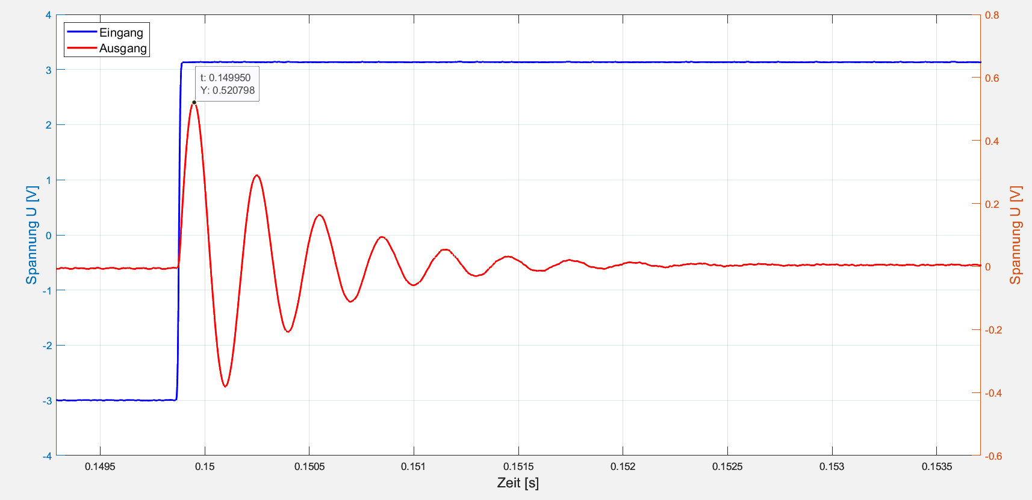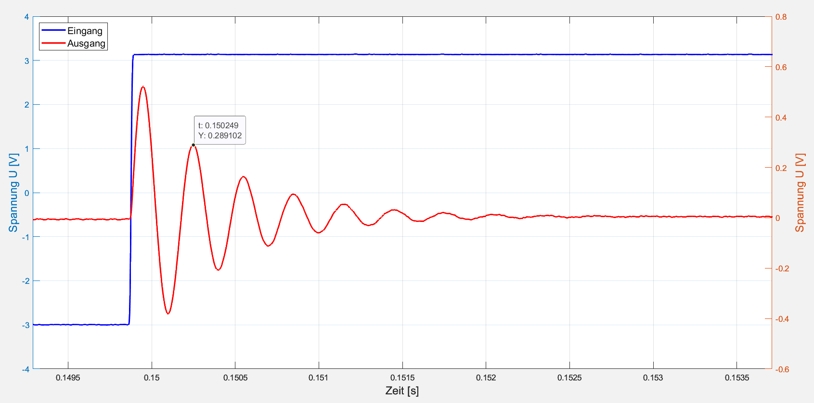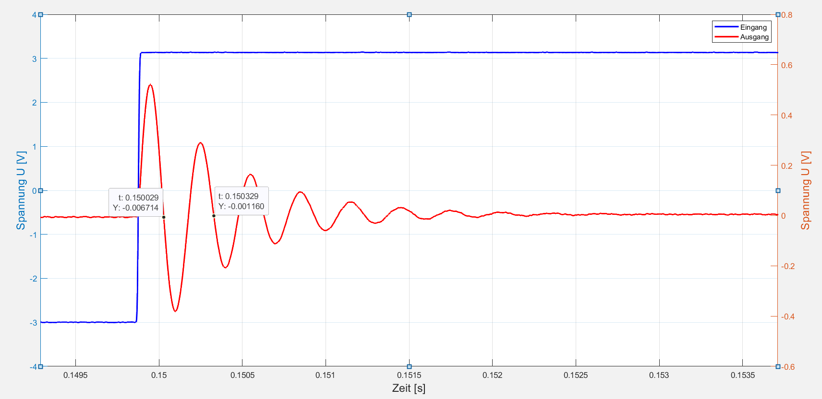

V2_R_2.mat

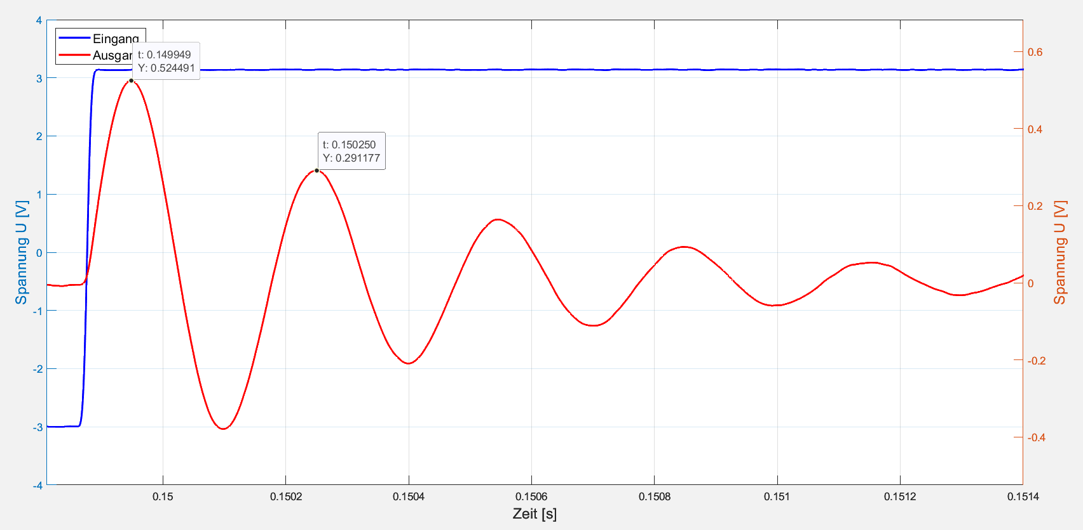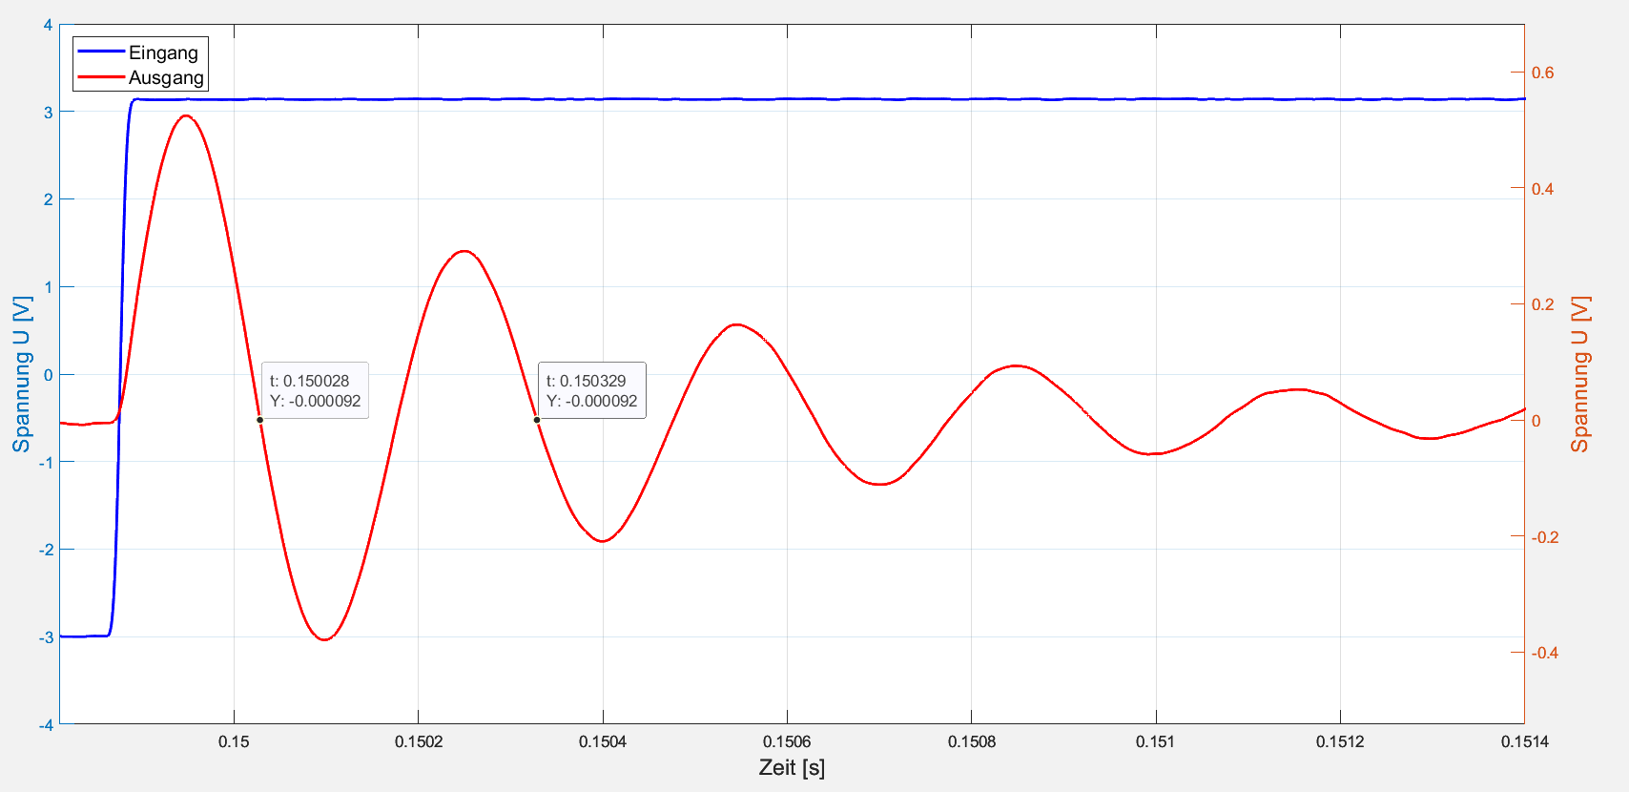

V2_R_3.mat

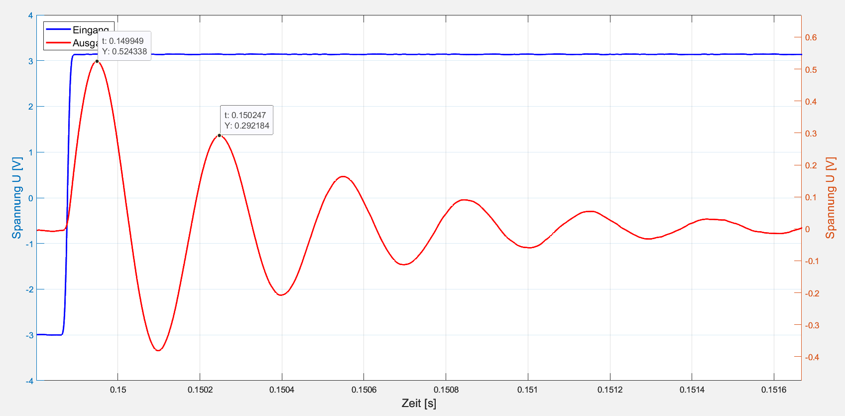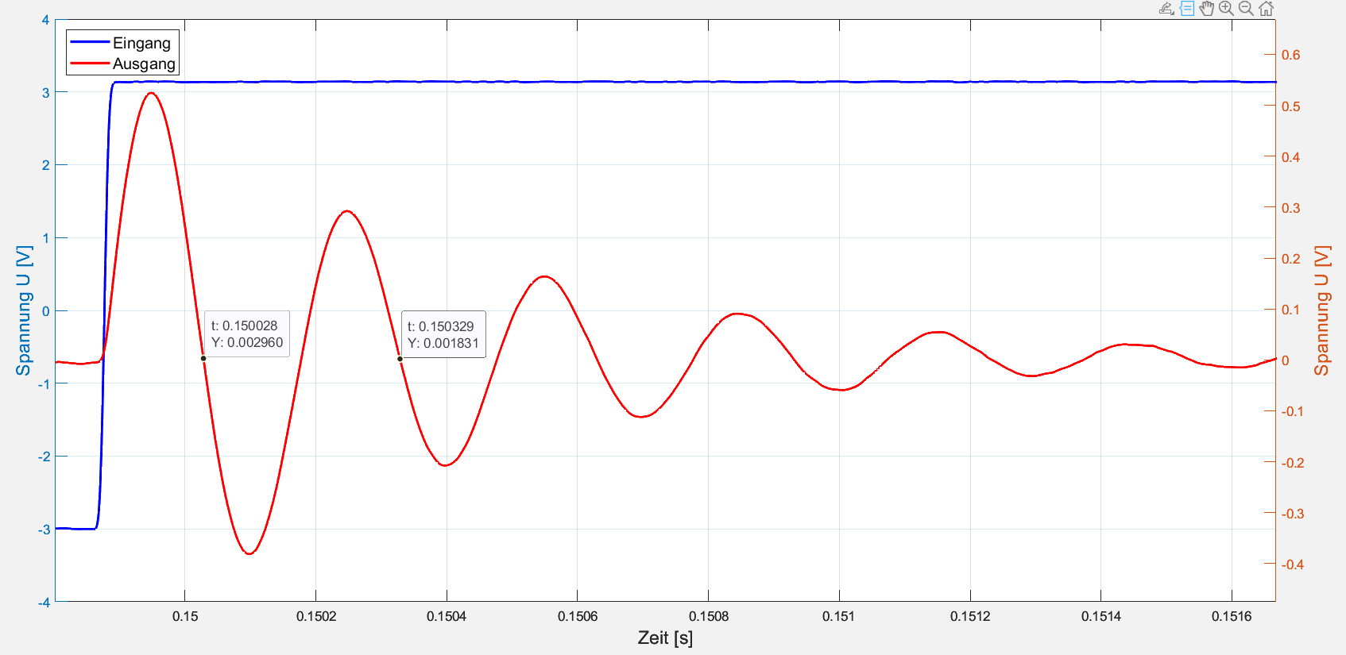

|  |  |  |  |  |  |  |
| --- | --- | --- | --- | --- | --- | --- |
| **Messung** | M1 | M2 | τ | D | ω0 | Rd |
| [-] | [V] | [V] | [s] | [-] | [s-1] | [Ω] |
| V2_R_1.mat | 0,520798 | 0,289102 | 3*10-4 | 0,093268 | 21035,64456 | 658,796835 |
| V2_R_2.mat | 0,524491 | 0,291177 | 3,01*10-4 | 0,093254 | 20965,73108 | 653,313623 |
| V2_R_3.mat | 0,524338 | 0,292184 | 3,01*10-4 | 0,092666 | 20964,57513 | 664,200330 |
| **Mittelwert** | - | - | - | - | - | 658,770263 |

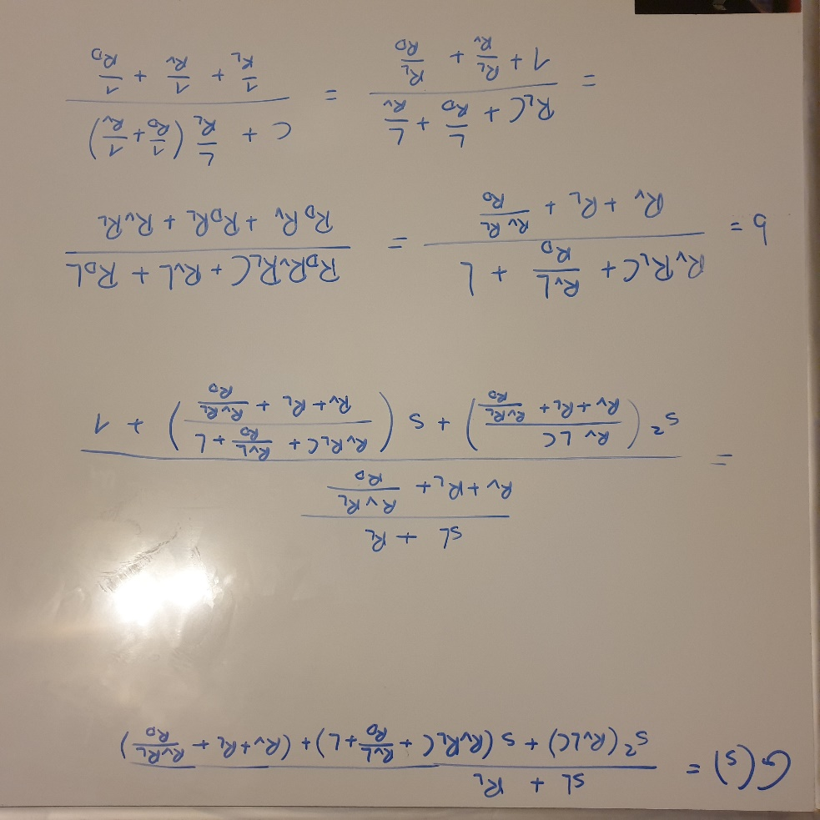Anhang

